**Sprint 2A: ScumInvaders Design Document**

The team ScrumInvaders have chosen to do an implementation of Space Invaders for our ICS 168 project, called ScumInvaders.

**General Gameplay:**

Our game will be a full screen experience with an illusion of scrolling up (the background simply moves down).

We plan to have the game to have multiple players (up to 4) on one screen shooting enemies together.. For players, their controls are “A” and “D” or “Left” and “Right” for simple left and right movement. Players will not have the ability to move forward from the bottom of the screen. “Space” will be used to fire missiles. The missiles are capped depending on the level the player has reached. For example, for level one, the default amount of missiles allowed to be shot at one time is 3. As the game progresses and the enemies grow stronger, the missile count increases accordingly.

As for enemies, they will start from the top of the screen and come down at a constant speed. Instead of the typical movement where the enemies come down every time they reach the edge of the screen, ours has the enemies snake down alternatively depending on its row. For example, the even rows start by moving left and the odd rows start by moving right. The enemies have an intrinsic point value that increases by level. Basically, as the enemies get stronger, the enemies reward more points.

Leveling up (clearing all the scum invaders) is infinite and follows a simple equation of adding health or speed to the enemies. We have it programmed to increase the speed on even levels and increase the health on odd levels. To compensate with the difficulty, the missile cap also goes up every two levels whenever the enemies’ health goes up.

The end game is when all the players have died. Whoever has the highest score wins. We will have a end game page that shows everyone’s score in order to show who the winner is.

**Multiplayer GamePlay:**

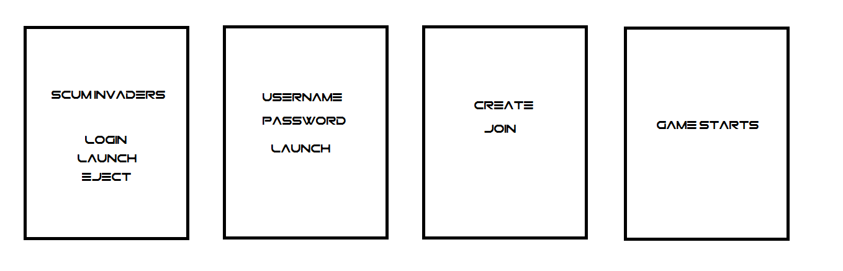

We intend to have a main menu screen at the beginning of the game with the options of multiplayer, single player, and exit. If single player, the game will start. If multiplayer, the game will take the player to the login screen will ask for a username and password. The login screen will store the player’s information into a table for future play. If the player were to type in a username that does not exist in the system, a new account will be created on the database with that username and password. If the player were to type in a username that is already in the table, the database will not make a new entry in the table and will update that particular username with its new information (if any) at the end of the game. Under each username, the table stores the amount of wins that player has had and their highest score.

After logging in, the user will be brought to a lobby screen from which they can join or create game rooms. After a player has joined a room, they can choose to click ready if they are ready to play the game. If a player is a host, they can choose to start the game whenever everyone in the room is ready.

When the game starts, the player(s) will all spawn (depending on who connects onto the server first, they will be Player 1-4 according to that order) in different places on the bottom depending on their player number. Each player’s interface will only have their own information (missiles and lives) on the bottom left of their screen.

The gameplay is both cooperative and competitive. The players work together to defeat the enemies to get to the next level; however, the players also compete to see who can get the highest score for that game. Since there is only a limited of invaders per level, the players can steal each other’s kills. (Players overlap on the bottom when they pass by one another). Each missile is coded to know who has shot them for tallying the points.

When a player dies, they can watch the rest of the players play until the last player dies. The game ends when the last person dies. The win condition is whoever has accumulated the highest score, so just surviving to the end does not guarantee victory.

**Server and Client Communication:**

We will most likely to be using UDP where the server receives a message from the clients of what the players are doing. Once the server recognizes that they have received a message from all 1-4 players, the server will then send an update for all the clients. We will be implementing NTP to make sure the server knows which missile hit an enemy first to ensure fair gameplay among players. The database will most likely only be updated for each player at the end of the game. We will take the inputs given during the login and update the high score and wins accordingly.