TITLE (less than 100 characters):

**The *cis*-regulatory logic of the type I interferon enhancer allows for tunable, pathogen-specific responses**

Z. Cheng, D. Ourthiague, and A. Hoffmann

Running title (less than 40 characters): Modeling the IFNβ enhancer

Keywords: interferon-β, Boolean logic gates, thermodynamic models, gene regulatory circuits, NFκB, interferon regulatory factors (IRF), Rig-I, TLR

**Abstract** (no more than 300 words)

The expression of type I interferon (IFNβ), a critical determinant of the innate immune response, is tightly controlled by several key transcriptional activators (AP1, NFκB and IRF) that are coordinated by a highly conserved enhancer sequence. The established model - the enhanceosome model - indicated a synergistic AND gate function between NFκB and IRF at the IFN enhancer sites, but this was challenged by recent biophysical and mouse knockouts studies. Here we iteratively develop a quantitative model to account for both literature data and novel measurements. We find that the enhancer operates in two alternate modes: 1) high induction when both IRF binding sites are occupied following viral infection, or 2) partial induction when one IRF dimer and one NFκB dimer are bound, typically in response to extra-cellular stimuli. Indeed, we find that the second IRF site affinity may be tuned by competing repressor factors thereby determining the NFκB dependence and responsiveness of IFNβ expression to some pathogen threats but not others. Thus, this study provides novel insights in how tunable IFN expression is achieved.

**INTRODUCTION**

Type I interferon (IFNβ) expression is a critical step in initiating and amplifying the innate immune response during both viral and bacterial infections (5). However. inappropriate IFNβ expression causes autoimmune diseases (6). Thus, proper expression of IFNβ is critical for a properly functioning immune system and for human health.

The primary regulatory step that controls interferon expression is the initiation of transcription. Transcriptional initiation is regulated by three transcription factors: interferon regulatory factor-3 (IRF3), nuclear factor κB (NFκB), and activated protein-1 (AP1) (7-9). These three factors bind to the IFNβ enhancer region, which is proximally upstream of the IFNβ transcriptional start site (TSS) and includes four adjacent positive regulatory domains (PRD) I-IV that are conserved among mammalian species (***Figure 1A***) (2, 10). Classic studies determined that PRD-II binds NFκB, PRD-I and PRD-III bind IRF3/7, and PRD-IV binds AP1. Together they function within one of the most well-studied models of mammalian gene regulation known as the “enhanceosome” (11). In this model, these TFs function together to drive robust IFNβ expression following viral infection, but not when only a subset of these factors are activated with cytokine stimuli (7). As such the IFN enhancer was thought to be a prominent example of a Boolean AND gate (12). However, the mechanism by which these factors function synergistically has remained unclear. A seminal study determined that a nucleosome over the core promoter could be moved only when all three factors are present, thus allowing for general transcription factor IID (TFIID) binding and pre-initiation complex assembly (7). Yet, biophysical studies have failed to identify cooperativity in the binding of the three factors (in fact, binding of IRF and NFκB may be anti-cooperative (2)). This still allows for the possibility that synergy may be mediated by the cooperative recruitment of a co-activator (as suggested in a synthetic model system (13)), or by sequential, essential functions mediated by each factor.

Furthermore, recent genetic studies have yielded results that are not compatible with the AND gate logic. While combined IRF3 and IRF7 deficiency (*IRF3-/-IRF7-/-*) results in abrogation of virus-induced gene expression (14, 15), the NFκB requirement, presumed based on earlier studies (16, 17), was not borne out when mutant mice became available (18). In particular, Beg and colleagues have reported that deficiency in any one of the NFκB subunits RelA/p65, p50 or cRel (the constituents of NFκB dimers activated by the TLR and Rig-I-induced canonical signaling pathway) does not lead to defects in IFNβ expression (19). To address potential functional compensation among the NFκB family genes, some combination knockouts were produced in murine embryo fibroblasts (MEFs) and only those lacking both RelA and p50 IFNβ expression were found to be affected; however, this constituted a delay rather than reduced induction (20). Further, the defective IFNβ expression was reported only in response to TLR stimulation, not in response to RLR stimulation (21).

Thus it still remains unclear what regulatory logic between NFκB and IRF best describes the expression control of IFNβ. Here we undertake an unbiased approach to identify the simplest gene regulatory network model that accounts for the available genetic and biophysical data. We start by constructing 2-site models that abstract IFNβ regulation to one binding event each for NFκB and IRF; however, we find this model framework to be insufficient to account for the data. We then test 3-site models that recapitulate the fact that there are two IRF binding sites (and one NFκB binding site); we find that this framework is sufficient to account for the data in a subset of the parameter space. We then test all possible models with additional novel combination mouse knockout cells that address compensation within the NFκB system and cross-regulation between NFκB and IRF. This approach yields a single model in which two IRF binding sites have differential functions: the occupancy of the second IRF site is functionally redundant with NFκB binding to the κB site, however, its accessibility is tunable by the NFκB repressor p50:p50 homodimer. The model is tested in several different scenarios, and it accounts for the expression patterns of interferon-stimulated genes (ISGs) in available datasets.

**Materials and Methods**

**Mathematical Modeling.** IFNβ mRNA production ([m]) may be described by the ODE: , where kt and kd are the mRNA transcription and degradation rate constant, respectively, and *f*, represents the *cis*-regulatory logic function which is dependent on the concentration of concentrations of active IRF (I) and NFκB (N). Then, the steady-state of IFNβ mRNA is determined by , which is proportional to *f*. By adapting the thermodynamic state ensemble model framework, *f* can be written as: , where **S** is the state vector, **β** is the affinities for each state, vector ***t*** determines the transcriptional activity of the state and × denotes the pairwise element multiply (27). In essence, this function is equivalent to the sum of transcription by each state divided by the sum of the total states. In this study, because we are using the maximum activity for IRF and NFκB activity (***Figure 1A***), we can then predict the maximum IFNβ expression level for each condition based on *f* function. Then the predicted IFNβ expression level is compared with summarized data (***Figure 1A***) after scaling to the maximum in all conditions.

In order to select the 3-site model, Akaike’s information criteria (AIC) is calculated using: , where RSS is the residual sum of squares, n is the number of experimental data points, k is the number of parameters in each model (28). AIC is a standard criterion in model selection and the smaller the AIC value, the better model (29).

**Parameterization.** We used an unbiased, exhaustive parameter scanning approach for the 2-site model to find the value of C (within the range 10-2 to 102) searching for the minimal RMSD between experimental data (***Figure 1A***) and model’s prediction. For the 3-site model, we sampled from the distributions of NFκB and IRF activities in Fig.1A and generated 100 experimental data sets (see dots in ***Figure 1D***). Then we applied least RMSD optimization for each 3-site model (Models β1 to β4) to find the values for t1 to t6 (between 0 and 1), KI2 and/or C (between 10-2 to 102) to match each experimental data set. The search procedure is as follow: 1) randomly selected 1000 parameter sets uniformly distributed in the parameter space as starting points. 2) For each initiate parameter set, we employed the MATLAB optimization function “fmincon” function (using interior point algorithm) to search parameters that provides the best fit to the data (least RMSD) given that initial value. In the end, we can get 1000 ‘locally’ best parameter sets for each experimental data set. Then we further selected the best solution of those 1000 sets to get one best-fit parameter set that can explain the experimental data.

**Experimental data used for model fitting.** We generated a panel of combinatorial gene knockout primary murine embryo fibroblasts, measured IRF and NFκB activation biochemically, and IFNβ mRNA expression in response LPS (sensed by TLR4) and transfected poly(I:C) (tPIC, sensed by Rig-I). For the model development purposes, we summarized observations from our experiments (***Fig.S1***) and literature (4) using a normalized 0-to-1 scale (***Figure 1A***,genetic observations) to indicate activity levels in different conditions. IFNβ expression values are based on qPCR measurements in ***Fig.S1A***. ***and B***. For IRF activity, the maximum activity is at 3hr in response to tPoly I:C in *Rela-/-cRel-/-* (***Fig.S1C***) and this is set as 1. In wild-type, the IRF activation in response to tPoly I:C is set as 0.75 (***Fig.S1C***). In response to LPS, based on very low biochemical signals, we assume the IRF activity is 0.1 in wildtype and 0.25 in *Rela-/-cRel-/-*. In *IRF3-/-IRF7-/-*, the IRF activity was set to 0.1 of wild-type response (considering that there is the remaining IRF5 activity). The NFκB activity is set as 1 in wild-type when treated with LPS and 0.5 when treated as tPIC, because tPIC is a weaker NFκB stimulus than LPS (26). NFκB activity is unaltered in *Irf3-/-Irf7-/-* and *Irf3-/-Irf5-/-Irf7-/-* but set to zero in *Rela-/-cRel-/-*because knocking out both NFκB canonical pathway effectors RelA and cRel results in no detectable NFκB activity (by EMSA) in response to either stimulus (22). We found that while LPS-induced IFNβ mRNA production is largely abrogated, IFNβ is still induced in response to tPIC (***Fig.S1A***), consistent with Wang et al. 2007 (19).

**Experimental Methods used for model hypothesis testing. Cell culture.** Primary *RelA-/-cRel-/-, RelA-/-cRel-/-RelB-/-,* and *RelA-/-cRel-/-Nfkb1-/-* mouse embryo fibroblasts (MEFs) were generated from littermate C57BL/6J embryos (E12.5) as previously described (22). Cells were maintained in Dulbecco’s Modified Eagle medium (DMEM) supplemented with 10% heat-inactivated bovine calf-serum (BCS, Sigma-Aldrich) and Penicillin-Streptomycin solution (100X, VA, U.S.A). **Biochemical analysis.** Cells were collected in ice-cold PBS and proteins were harvested as previously described (1, 22). For immunoblots the antibodies used in this study include anti-p50 (BioBharati Ltd, Cat#BB-AB0080), phosphor-IRF3 [4D4G, Ser396] (Cell Signaling), and anti-tubulin (Santa Cruz). EMSAs and antibody supershifts were performed as previously described (1, 22-24). **Gene expression Analysis.** RNA was harvested from cells with TRIzol (Invitrogen) according to the manufacturer’s instructions. Contaminating DNA was then eliminated by recombinant DNase I (Roche), and further purified by phenol-chloroform. Purified RNA was used to synthesize cDNA and then subjected to qPCR analysis (25). Primers were: *IFNβ*: (F) 5’-GCACTGGGTGGAATGAGACT-3', and (R) 5’-AGTGGAGAGCAGTTG AGGACA-3’. Primers for *GAPDH*: (F) 5’-AGCTTGTCATCAACGGGAAG-3’, and (R) 5’-TTTGATGTTAGTGGGGTCTCG-3’. Microarray analysis was undertaken with Illumina bead arrays 2.0 as described (1). Using our published dataset (GSM669580 and GSM669581 from GEO) genes induced ≥ 8 fold by IFNβ (2500 units/ml) treatment in wild-type MEF at 8hr were considered ISGs. The resulting 74 genes/probes were then analyzed in the LPS (0.1μg/ml) knockout MEF dataset (ArrayExpress, accession id: E-MTAB-4412).

**RESULTS**

***The IFNβ cis-regulatory function does not conform to a simple Boolean logic***

The IFNβ enhancer contains evolutionarily conserved binding sites for two IRF transcription factors and one NFκB transcription factor (***Figure 1A***). While early studies suggested a model of synergistic function between IRF and NFκB, subsequent biophysical studies have shown that IRF and NFκB binding to the promoter is definitely not cooperative, though there may be cooperativity between two IRF binding events (***Figure 1A***). Genetic studies provided a similarly nuanced picture in which IFNβ expression is IRF dependent in all conditions, but the NFκB requirement is conditional: it is observed in response to LPS, but not polyIC, which activates higher amounts of IRF (***Figure 1A***).

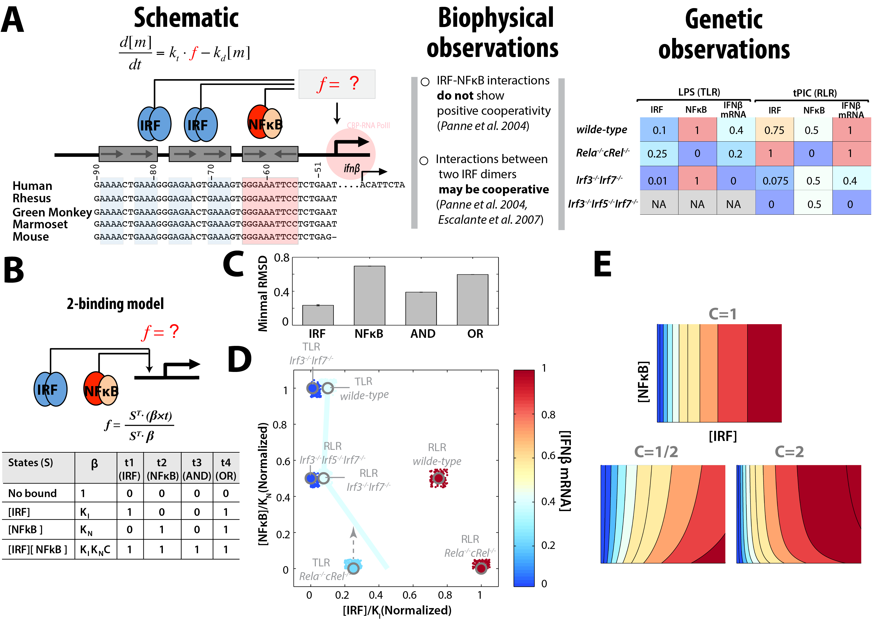

**Figure 1**: **A 2-site model may only account for the experimental observations if NFκB and IRF binding is cooperative.** (A) Schematic of the IFNβ enhancer, showing the sequences for five indicated species. The conserved binding site sequences are highlighted using color. f=? indicates that the goal of this study is to determine the *cis*-regulatory logic function of NFκB and IRF on the enhancer. Results from biophysical studies are indicated: (i) IRF-NFκB interactions are not cooperative (2); (ii) interactions between two IRF dimers may be cooperative (2, 3). Genetic observations are summarized by relative values for the TF activities and IFNβ mRNA levels, and are based on literature (4) and our own experiments (e.g. ***Fig.S1*)**. NA means not available. (B) Schematic of a 2-site model of independent binding events. The bound TFs define four states as shown in the table. The relative probability of the states is shown in the β column. t1 to t4 are the four different transcription capability vectors for the four states, in which 1 and 0 represent “on” and “off” states of transcription, respectively. (C) Minimal RMSD of each logic model against experimental data. (D) Mapping the experimental data into an IRF and NFκB expression space with the z-axis color gradient representing the relative expression level. The solid line in the map indicates a contour line suggested by the data. The dashed line with arrow demonstrates a direction of increase in IFNβ expression level. The small dots represent 100 sets of uniformly randomized experimental data (see Materials and Methods). (E) The heatmap of the IFNβ expression level against active IRF and NFκB concentrations for different interdependence values for the IRF-control model. Only values larger than 1 (i.e. cooperativity, shown 2 as an example) match the direction of the contour line shown in panel (D). As the binding of NFκB and IRF to the IFNβ enhancer was shown not to be cooperative (2), we conclude that the 2-site model is insufficient to account for the data.

First, we addressed whether the described datasets can be accounted for by a simple logical-gate model, first proposed for the IFNβ enhancer (1, 12). We formalized a two-site model (which assumes that the two IRFs function as a single unit) by adapting the thermodynamic state model framework (see Materials and Methods section and (27)) which may be driven by IRF or NFκB alone or in OR or AND gate configurations (***Figure 1B***). Given the assignment of the values of the **t** vector, the implicit logic can map to each gate (see table in ***Figure 1B***). We also introduce the binding interdependence between these two sites, by which TF function on the first site may help (C>1) or inhibit (C<1) the second TF. This constitutes four logic model categories and the C parameter is the only one to be determined by the data.

Systematic exploration the parameter space for each logic model category revealed that the IRF-control model is the only one with a reasonably small RMSD value (***Figure 1C***). However, the IRF-control model required positive interdependence (cooperativity) between IRE and κB sites to ensure the correct contour line direction in a plot that summarizes the data of NFκB and IRF contributions (***Figure 1D-E***). However, biophysical studies of the IFNβ enhancer are not compatible with cooperativity in the binding of NFκB and IRF, concluding either no or mild negative interdependence (antagonism) (2). Besides this inconsistency in the cooperativity between the model and literature, the error in the best IRF-control model was also quite high (RMSD ~ 0.2, given the experimental data scale is 0 to 1). Thus, we conclude that the simple two-site model is insufficient to describe the IFNβ expression data, which suggests that the *cis*-regulatory logic of the IFNβ enhancer is not a simple AND or OR gate of IRF and NFκB but a more complex model is required.

***Comparisons of different 3-site models identifies the best-fit cis-regulatory logic***

Given the poor performance of the coarse-grained 2-site model, we considered a more realistic 3-site model (Materials and Method, ***Figure 2A***), in which two IRF dimers can bind independently to the two IRE sites, and NFκB can bind to the κB site, resulting in 8 (23) different binding states for the enhancer (**S**). We allowed the transcription capability vector (**t**) to be any value between 0 and 1, assuming that the fully occupied state has the maximum (i.e. =1) and the fully unoccupied enhancer the minimum (i.e. =0) transcriptional activity. In this way, we turned the model from a discrete parameter space to a continuous space to allow for optimal fit to the available quantitative data. Using this basic framework, we considered four possibilities of how IRF-IRE interactions are regulated as described by a relative probability vector: β1 describes that the two binding events are independent and have equal affinity, β2 allows them to have different affinities, β3 allows them to be interdependent (cooperative or antagonistic), and β4 allows them to have both differential affinity and interdependence.

To select the parameter values for each model type, we used the available experimental data but considered the uncertainty in the data, by sampling 100 sets of IRF and NFκB activities from a range of (value ± 0.05) (see dots in ***Figure 1D***). During the experimental data sampling, we imposed two reasonable constraints: (i) LPS-induced IRF activity is always higher in *wild-type* than *Irf3-/-Irf7-/-* cells; (ii) The tPIC-induced IRF activity in *Irf3-/-Irf7-/-* is always higher than *Irf3-/-Irf5-/-Irf7-/-*. Thus within our workflow, every generated experimental data set was tested for all model types by performing unbiased and extensive automatic parameter searches using RMSD as the objective function (see Materials and Method). This approach found that model β1 only satisfied 4 of 100 experimental data sets, whereas other model types could match at least 90% of the experimental data sets (by match we mean R2>0.9. n=90 for model β2; n= 92 for model β3; n=90 for model β4). Moreover, AIC values for the best-fit β1 models are substantially higher than others (p<2.2e-16 than β2 or β3 or β4 models, ***Figure 2B***). Furthermore, the residual plots indicate that the best β1 models failed to correctly predict IFNβ expression in *Rela-/-cRel-/-*, showing a high prediction error for the second and fifth residual, while the residuals for β2-4 models range between -0.1 and 0.1 (***Figure 2C***). Thus model β1 was eliminated from further consideration.

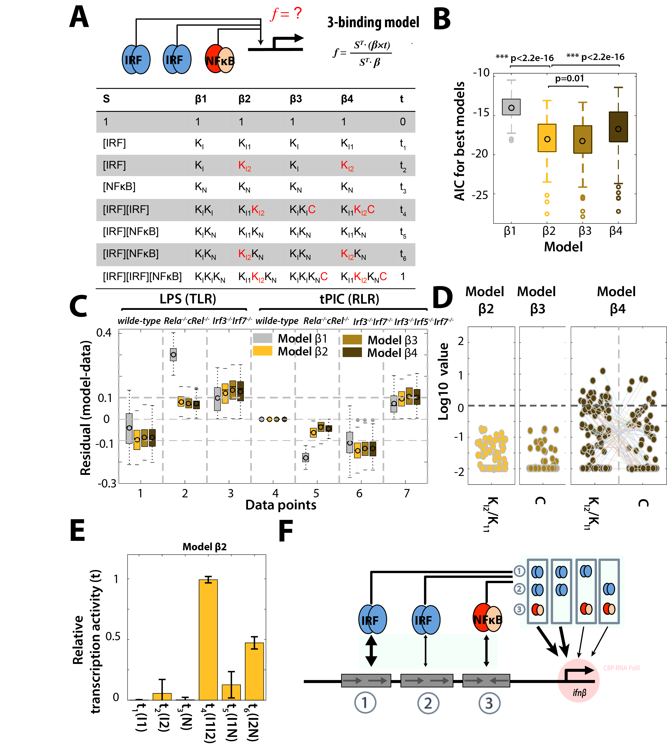

**Figure** **2**: **A 3-site model may account for all available data.** (A) Schematic of the three binding events that are the basis for four model versions. Models β1 to β4 differ by allowing for differential IRF affinity (β2 and β4) or interdependence between IRF dimers (β3 and β4). (B) Boxplot of AICs of best fit models for the 100 sampled experimental data sets in each model category. P-values are calculated using paired one-side Student-t test for the alternative hypotheses: AICs for model β2 are less than model β1, β2 are less than β4, β2 are greater than β3. (C) The residuals for the models in (B). (D) Values of affinity ratio (KI1/KI2) or cooperativity (C) in those solutions which show R2>=0.9. For model β4, it shows the parameter pairs. n=90 for model β2; n= 92 for model β3; n=90 for model β4. (E) The relative transcriptional activity for each state (t vector), indicating that the single bound states (I1, I2 or N) has little (close to 0) transcription activity; the state in which both IRF sites are occupied (I1I2) has the maximum transcriptional activity (close to 1); when one IRF and the NFκB sites are occupied (I1N or I2N) partial transcriptional activity results (from 0.15 to 0.5). Bars indicate mean ± s.d. (*n* = 90 of 100 best-fit parameter sets with R2>=0.9). (F) A graphical summary of the best model from (D).

Examining the solutions with R2>=0.9 of models β3 in more detail revealed that they relied on a negative interdependence (antagonism) between the two IRF binding events (***Figure 2D***), although the AICs for models β3 are slightly lower than β2 (p=0.01, mean difference is 0.2, ***Figure 2B***). However, biophysical studies are consistent with independent or cooperative IRF binding to the two sites (2) indicating that β3 models are a poor match for experimental observations. Comparing β2 and β4 models, they give largely equivalent RMSD fits to the data (***Figure S2***), but β2 is intrinsically simpler with sustained smaller AIC (p<2.2e-16, mean difference is 1.4, ***Figure 2B***). Both models rely on differential IRF binding site affinities but β4, in addition, posits cooperativity between them for some solutions (***Figure 2D***), though without substantial gain in fitness. Hence we conclude that model β2 is the preferred model that can accounts for all available functional/genetic and biophysical data.

**FC-SSD:Users:zhangcheng:Dropbox:Current:4. IFN:IFNb_Expression_2015:manuscript:2nd_submission_eLife:figs-v14:Fig3.pdf**

**Figure 3.** The predicted *f* function in Model β2 (A) The IFNβ enhancer activity as a function of IRF and NFκB activity. (B) Assessing the responsiveness of the IFNβ enhancer to IRF3 for given NFκB activity (left) and to NFκB for a given IRF activity (right). Graphs show enhancer activity in arbitrary units (up to 100) as a function of NFκB (left) when no IRF (min line) or maximal IRF activity (max line) is present, or as a function of IRF (right) when no NFκB (min line) or maximum NFκB (max line) is present.

**Two modes of transcriptional activation account for the observed conditional NFκB requirement**

Examining the values of the **t** vector for the acceptable β2 models (***Figure 2E***) shows that there is no transcription when only one site is bound (I1 or I2 or N), but close to maximum transcription when the two IRF binding sites are occupied (I1I2). When one IRF and one κB site are bound (I1N or I2N), there is only partial transcription (around 15% ~ 50% of the maximum). These **t** vector values thus suggest two modes for inducing IFNβ transcription: (i) Full induction via both bound IRF sites but independent of NFκB – this reflects our observations with tPIC stimulation; and (ii) Partial induction via one bound IRF and one NFκB – this reflects our observations with LPS stimulation, where IRF is only modestly activated and NFκB is required to support IFNβ gene expression. Taken together, these then define two levels of regulation of IFNβ enhancer activity (***Figure 2F***): differential binding affinities of the two IRE sites, and differential transcriptional activation activity of the two possible pairs of bound TFs (IRF-IRF vs. IRF-NFκB).

The newly defined *cis*-regulation function was numerically explored and presented as a heat-map in ***Figure 3A*** (model β2’s best-fit result). The function matches all available experimental observations and further predicts expression for any value of IRF or NFκB activity. As shown, IRF activity (x-axis) is the key determinant of IFNβ expression, regulating its levels from lowest (close to 0) to maximum (close to 1), whereas NFκB (y-axis) contributes at low (but non-zero) IRF activities. This may also be visualized by considering the contribution of IRF and NFκB to an assumed 100-fold induction of the enhancer: regardless of the given NFκB activity, the amount of IRF3 is critical for determining IFNβ enhancer activity (***Figure 3B***, left panel). In contrast, NFκB contributes to IFNβ enhancer activation primarily when IRF activity is between 5 and 20% of its maximum (***Figure 3B***, right panel).

***NFκB p50 homodimer limits IRF-driven IFNβ expression in response to LPS***

Previous studies revealed that the NFκB p50:p50 homodimer may bind so-called G-rich IREs in *vitro* and *in vivo*, attenuating IRF-responsive gene expression by a proposed competition model (1). Indeed, the second IRE in the IFNβ enhancer was shown to be such a G-IRE (containing a “GAGA” motif) supporting p50:p50 binding (***Figure 1A***). As a result, the effective binding affinity for IRF at this IRE site is a function of p50 homodimer concentration (***Fig.S3***). This difference between the two IREs could explain the different affinities predicted by the 3-site model, but it also suggests that the affinity of the second IRE is tunable (***Figure 4A***).

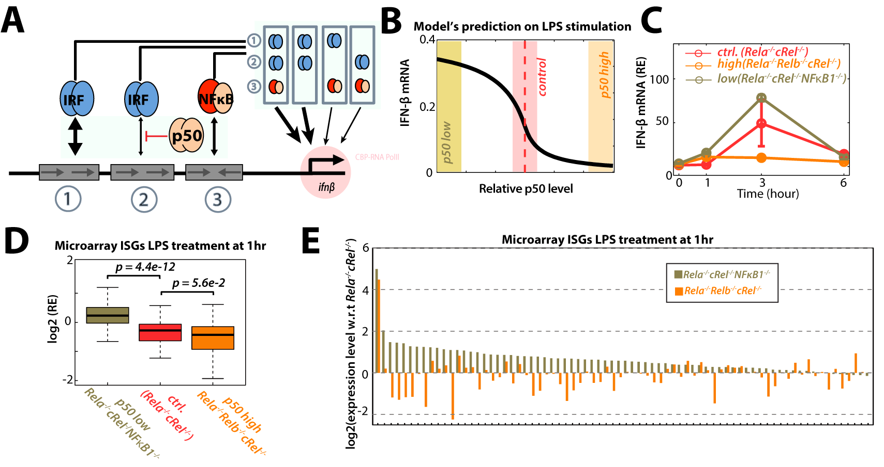

**Figure 4: A role for p50 homodimer in tuning IRF responsiveness.**

(A) p50 homodimer competes with IRF at G-IRE to reduce the effective IRF binding affinity (1). (B) Predicted LPS-induced IFNβ level as a function of p50:p50 levels in the context of NFκB deficiency. The IRF activity is assumed to be unaltered and NFκB activity is set to 0. (C) *Rela-/-cRel-/- (control for p50:p50 level)*, *Rela-/-Relb-/-cRel-/-(p50:p50 high), a*nd *Rela-/-cRel-/-Nfkb1-/-(p50:p50 low)* MEFs were stimulated with LPS (0.1µg/mL). Total RNA was harvested at the indicated time point. mRNA levels of IFNβ was determined by RT-qPCR. Results are presented relative to the expression of *Gapdh*. Data are representative of three independent experiments. Bars indicate technical replicates with mean ± s.d. (D) The ISG mRNA expression levels upon one hour LPS stimulation in *Rela-/-cRel-/-* MEFs and analyzed by genome-wide microarray transcriptome profiling with Illumina 2.0 chips. The p-values are obtained by paired-single side Student *t*-est. (E) The ranked relative expression level of ISGs in indicated hyper-p50 homodimer (*Rela-/-Relb-/-cRel-/-*) and hypo-p50 homodimer (*Rela-/-cRel-/-Nfkb1-/-*) genotypes relative to the level in *Rela-/-cRel-/-*.

We set out to examine this hypothesis genetically using hyper- and hypo-p50-homodimer mutants. As p50 forms high affinity interactions with RelA, cRel and RelB, homodimer levels are a function of the availability of these binding partners. RelA and cRel also contribute to nfkb1/p50 expression (30), but we reasoned that additional deficiency of RelB results in elevated p50 homodimer levels, whereas compound nfkb1-deficiency would abrogate p50 homodimer levels (***Fig.S3***). We applied the best-fit model β2 to predict IFNβ expression in response to LPS in these mutants containing different p50:p50 levels. We assumed IRF activity to be the same among these mutants (equal to 0.25 as in *Rela-/-cRel-/-*, ***Figure 1A***) and NFκB activity as 0. Our model predicts that the hyper-p50 homodimer mutant (*Rela-/-Relb-/-cRel-/-*) would induce lower levels of IFNβ mRNA compared to the *Rela-/-cRel-/-* control, while the hypo-homodimer mutant (*Rela-/-cRel-/-Nfkb1-/-*) would produce higher levels (***Figure 4B***). Testing IFNβ expression using qPCR of mRNA extracted from MEFs confirmed this prediction (***Figure 4C***), as the expression level in the control *Rela-/-cRel-/-* cells was in between the two triple knockouts that are either hyper- or hypo-p50 homodimer.

We also performed microarray analysis in these cells to study how the different IFNβ expression may have downstream effects on the expression of ISGs. We defined ISGs using IFNβ treatment of MEFs and applied a stringent threshold of 8-fold to any of the 1hr, 3hr or 8hr timepoints, yielding 74 probes/genes. Then we compared expression of these ISGs in wild-type, *Rela-/-cRel-/-*, *Rela-/-cRel-/-Nfkb1-/-*, *Rela-/-Relb-/-cRel-/-* in response to LPS at 1 hr (***Figure 4D***). We found that overall, expression of ISGs was significantly higher in *Rela-/-cRel-/-Nfkb1-/-* than *Rela-/-cRel-/-* control MEFs (paired-single side Student t test, p = 4.4e-12), and lower in *Rela-/-Relb-/-cRel-/-* (paired-single side Student t test, p=5.6e-2). The same conclusions could be drawn by ranking relative gene expression levels in the three genotypes (***Figure 4E***).

**Discussion**

DNA regulatory elements associated with enhancers and promoters allow cells to control gene expression programs in response to extra-cellular and intra-cellular changes. As most eukaryotic genes are regulated by multiple transcription factors, these *cis*-regulatory elements form the essential scaffold for the gene regulatory network, and they have been described to perform a computation: the rate of transcription is a function of the active concentrations of each of the input transcription factors (31-33). Mutations in *cis*-regulatory elements associate with wide range of human diseases (34). However, a predictive understanding of the function of these elements has only been achieved for a number of genes in model organisms where detailed datasets have been available (31, 35-38).

The proper expression of interferon is critical for the mammalian immune response (5), and numerous studies over the last 30 years have contributed to the identification and characterization of the IFNβ enhancer. Here we present a formalized quantitative description of the gene regulatory logic function of the IFNβ enhancer that accounts for the available data. We use it to develop new predictions that are then tested experimentally. While ultimately we seek a fine-grained mathematical modeling description of the physical events and mechanisms (such as precise affinities, co-activator recruitment, DNA looping, interchromosal interactions (39), etc) understanding the *cis*-regulatory logic function may be considered a first step that captures the functional relationship between the known regulatory factors, providing a compact phenomenological description that has particular utility for further studies (32). Furthermore, it is falsifiable, and thus as a research tool, it may be challenged by subsequent rounds of testing and refinement. One such refinement may be to address potential differences between human and mouse IFNβ, which differ by only two out of the 45 base pairs ***(Figure 1A)***. Indeed, other type I interferons (IFNα) show greater difference between mouse and human (40).

Our approach was iterative, beginning with a simple two-site/four-state model (***Figure 1B-E***); however, no parameter set satisfied the available data, forcing us to consider the more complex 3-site model (***Figure 2***). Rather than a simple AND or OR gate, the 3-site model enabled us to identify a more complex gene regulatory logic capable of both stimulus-specific sensitivities and tuning by crosstalk or prior history. Specifically, the available data is consistent only with a more complex hybrid in which one IRF functions in an AND gate with either a second IRF OR an NFκB, depending on which is available; indeed, the degree to which IRF and NFκB are activated is stimulus-specific.

Prior work suggested that the responsiveness of the second IRF motif may be tuned by the NFκB p50 homodimer thereby affecting IFNβ gene induction; in the context of the newly identified logic function, we show that NFκB p50 homodimer tuning occurs in a stimulus-specific manner, rendering IFNβ expression more or less dependent on the NFκB activators, and hence stimuli that activate them. As p50:p50 abundance may be induced by specific stimuli (41) and may be a function of inflammatory history (42), this control mechanism may tailor IFNβ expression control to specific physiological scenarios. Thus, physiologically, we may broadly distinguish between innate immune responses elicited by extra-cellular/endosomal pathogen-derived substances via Toll-like receptors, versus actual viral infections that the cells senses through Rig-I like receptors. Our analysis of the IFN enhancer suggests that robust interferon responses to viral infections are assured regardless of the state of NFκB whereas the mere sensing of PAMPs may elicit IFNβ expression only in some conditions, i.e. when there is little inflammatory history that produced p50 homodimers, or when NFκB is also robustly activated. Given that the canonical NFκB pathway undergoes inflammatory tolerance by several mechanisms, including IκBδ (43) and A20 (44), only strong PAMP stimulation would generate sufficient NFκB activity. Thus we hypothesize that the inflammatory history may determine the responsiveness of IFNβ to TLR ligands, but not to viral infections detected by cytosolic sensors such as Rig-I.

To explore this hypothesis further, future studies may integrate the present model into a larger, multi-modular mathematical model of the innate immune signaling network. We have generated experimentally tested models of the NFκB signaling module (45), the TLR-responsive IKK module via MyD88 and TRIF (46). Similarly, models for the TBK1/IRF signaling module, and the IFNAR-ISGF3 module may be added upstream and downstream to the present model of the IFNβ enhancer logic, enabling the comprehensive quantitative characterization of the innate immune signaling space as a function of diverse ligands and cellular histories.

**Author Contributions**

Z.C. and A.H. designed the research; Z.C. performed all computational research, D.O. performed experimental research; all authors analyzed data; Z.C. and A.H. wrote the manuscript.

**Acknowledgements**

The authors acknowledge helpful early discussions with Daniel Panne (EMBL Grenoble), Michael David (UCSD) and Amer A. Beg (H. Lee Moffitt Cancer Center and Research Institute). The work was supported by grants by the NIH to AH (R01AI127864 and R01AI132835).

**References:**

1. Cheng CS*, et al.* (2011) The Specificity of Innate Immune Responses Is Enforced by Repression of Interferon Response Elements by NF-kappa B p50. *Sci Signal* 4(161).

2. Panne D, Maniatis T, & Harrison SC (2007) An atomic model of the interferon-beta enhanceosome. *Cell* 129(6):1111-1123.

3. Escalante CR, Nistal-Villan E, Shen LY, Garcia-Sastre A, & Aggarwal AK (2007) Structure of IRF-3 bound to the PRDIII-I regulatory element of the human interferon-beta enhancer. *Mol Cell* 26(5):703-716.

4. Lazear HM*, et al.* (2013) IRF-3, IRF-5, and IRF-7 coordinately regulate the type I IFN response in myeloid dendritic cells downstream of MAVS signaling. *PLoS pathogens* 9(1):e1003118.

5. Theofilopoulos AN, Baccala R, Beutler B, & Kono DH (2005) Type I interferons (alpha/beta) in immunity and autoimmunity. *Annu Rev Immunol* 23:307-336.

6. Banchereau J & Pascual V (2006) Type I interferon in systemic lupus erythematosus and other autoimmune diseases. *Immunity* 25(3):383-392.

7. Agalioti T*, et al.* (2000) Ordered recruitment of chromatin modifying and general transcription factors to the IFN-beta promoter. *Cell* 103(4):667-678.

8. Panne D, Maniatis T, & Harrison SC (2004) Crystal structure of ATF-2/c-Jun and IRF-3 bound to the interferon-beta enhancer. *Embo J* 23(22):4384-4393.

9. Ford E & Thanos D (2010) The transcriptional code of human IFN-beta gene expression. *Bba-Gene Regul Mech* 1799(3-4):328-336.

10. Thanos D & Maniatis T (1995) Virus induction of human IFN beta gene expression requires the assembly of an enhanceosome. *Cell* 83(7):1091-1100.

11. Munshi N*, et al.* (1999) The IFN-beta enhancer: a paradigm for understanding activation and repression of inducible gene expression. *Cold Spring Harb Symp Quant Biol* 64:149-159.

12. Arnosti DN & Kulkarni MM (2005) Transcriptional enhancers: Intelligent enhanceosomes or flexible billboards? *J Cell Biochem* 94(5):890-898.

13. Carey M, Lin YS, Green MR, & Ptashne M (1990) A mechanism for synergistic activation of a mammalian gene by GAL4 derivatives. *Nature* 345(6273):361-364.

14. Honda K, Takaoka A, & Taniguchi T (2006) Type I inteferon gene induction by the interferon regulatory factor family of transcription factors. *Immunity* 25(3):349-360.

15. Sato M*, et al.* (2000) Distinct and essential roles of transcription factors IRF-3 and IRF-7 in response to viruses for IFN-alpha/beta gene induction. *Immunity* 13(4):539-548.

16. Merika M, Williams AJ, Chen GY, Collins T, & Thanos D (1998) Recruitment of CBP/p300 by the IFN beta enhanceosome is required for synergistic activation of transcription. *Mol Cell* 1(2):277-287.

17. Thanos D & Maniatis T (1995) Identification of the rel family members required for virus induction of the human beta interferon gene. *Molecular and cellular biology* 15(1):152-164.

18. Peters KL, Smith HL, Stark GR, & Sen GC (2002) IRF-3-dependent, NFkappa B- and JNK-independent activation of the 561 and IFN-beta genes in response to double-stranded RNA. *Proc Natl Acad Sci U S A* 99(9):6322-6327.

19. Wang X*, et al.* (2007) Lack of essential role of NF-kappa B p50, RelA, and cRel subunits in virus-induced type 1 IFN expression. *J Immunol* 178(11):6770-6776.

20. Wang JM*, et al.* (2010) NF-kappa B RelA Subunit Is Crucial for Early IFN-beta Expression and Resistance to RNA Virus Replication. *J Immunol* 185(3):1720-1729.

21. Wang X*, et al.* (2014) Differential requirement for the IKKbeta/NF-kappaB signaling module in regulating TLR- versus RLR-induced type 1 IFN expression in dendritic cells. *J Immunol* 193(5):2538-2545.

22. Hoffmann A, Leung TH, & Baltimore D (2003) Genetic analysis of NF-kappaB/Rel transcription factors defines functional specificities. *Embo J* 22(20):5530-5539.

23. Werner SL, Barken D, & Hoffmann A (2005) Stimulus specificity of gene expression programs determined by temporal control of IKK activity. *Science* 309(5742):1857-1861.

24. Ourthiague DR*, et al.* (2015) Limited specificity of IRF3 and ISGF3 in the transcriptional innate-immune response to double-stranded RNA. *J Leukoc Biol* 98(1):119-128.

25. Schmittgen TD & Livak KJ (2008) Analyzing real-time PCR data by the comparative C-T method. *Nat Protoc* 3(6):1101-1108.

26. Reimer T, Brcic M, Schweizer M, & Jungi TW (2008) poly(I:C) and LPS induce distinct IRF3 and NF-kappaB signaling during type-I IFN and TNF responses in human macrophages. *J Leukoc Biol* 83(5):1249-1257.

27. Sherman MS & Cohen BA (2012) Thermodynamic state ensemble models of cis-regulation. *PLoS Comput Biol* 8(3):e1002407.

28. Burnham KP & Anderson DR (2002) Model selection and multimodel inference: a practical information-theoretic approach. (springer, new york).

29. Johnson JB & Omland KS (2004) Model selection in ecology and evolution. *Trends Ecol Evol* 19(2):101-108.

30. Ten RM*, et al.* (1992) The characterization of the promoter of the gene encoding the p50 subunit of NF-kappa B indicates that it participates in its own regulation. *Embo J* 11(1):195-203.

31. Setty Y, Mayo AE, Surette MG, & Alon U (2003) Detailed map of a cis-regulatory input function. *Proc Natl Acad Sci U S A* 100(13):7702-7707.

32. Bintu L*, et al.* (2005) Transcriptional regulation by the numbers: applications. *Curr Opin Genet Dev* 15(2):125-135.

33. Hansen AS & O'Shea EK (2015) cis Determinants of Promoter Threshold and Activation Timescale. *Cell Rep* 12(8):1226-1233.

34. Mathelier A, Shi W, & Wasserman WW (2015) Identification of altered cis-regulatory elements in human disease. *Trends Genet* 31(2):67-76.

35. Hippel PHV, Revzin A, Gross CA, & Wang AC (1974) Nonspecific DNA Binding of Genome Regulating Proteins as a Biological-Control Mechanism .1. Lac Operon - Equilibrium Aspects. *P Natl Acad Sci USA* 71(12):4808-4812.

36. Ackers GK, Johnson AD, & Shea MA (1982) Quantitative Model for Gene-Regulation by Lambda-Phage Repressor. *P Natl Acad Sci-Biol* 79(4):1129-1133.

37. Shea MA & Ackers GK (1985) The or Control-System of Bacteriophage-Lambda - a Physical-Chemical Model for Gene-Regulation. *J Mol Biol* 181(2):211-230.

38. Janssens H*, et al.* (2006) Quantitative and predictive model of transcriptional control of the Drosophila melanogaster even skipped gene. *Nat Genet* 38(10):1159-1165.

39. Apostolou E & Thanos D (2008) Virus infection induces NF-kappa B-dependent interchromosomal associations mediating monoallelic IFN-beta gene expression. *Cell* 134(1):85-96.

40. Chen JB, Baig E, & Fish EN (2004) Diversity and relatedness among the type I Interferons. *J Interf Cytok Res* 24(12):687-698.

41. Tong X, Yin L, Washington R, Rosenberg DW, & Giardina C (2004) The p50-p50 NF-kappa B complex as a stimulus-specific repressor of gene activation. *Mol Cell Biochem* 265(1-2):171-183.

42. Bohuslav J*, et al.* (1998) Regulation of an essential innate immune response by the p50 subunit of NF-kappa B. *J Clin Invest* 102(9):1645-1652.

43. Shih VFS*, et al.* (2012) Control of RelB during dendritic cell activation integrates canonical and noncanonical NF-kappa B pathways. *Nat Immunol* 13(12):1162-+.

44. Werner SL*, et al.* (2008) Encoding NF-kappaB temporal control in response to TNF: distinct roles for the negative regulators IkappaBalpha and A20. *Genes Dev* 22(15):2093-2101.

45. Basak S, Behar M, & Hoffmann A (2012) Lessons from mathematically modeling the NF-kappaB pathway. *Immunol Rev* 246(1):221-238.

46. Cheng Z, Taylor B, Ourthiague DR, & Hoffmann A (2015) Distinct single-cell signaling characteristics are conferred by the MyD88 and TRIF pathways during TLR4 activation. *Sci Signal* 8(385):ra69.