**IST370 Practice Worksheet (under construction)**

**Theme: Single-Row Functions**

**Write corresponding queries to produce the query results shown as below:**

SELECT **LOWER (firstname) firstname, LOWER(lastname) lastname** FROM customers

WHERE state = 'IL';



SELECT **INITCAP(firstname) firstname, INITCAP lastname) lastname** FROM customers

WHERE state = 'IL';



SELECT **INITCAP** firstname) || ‘ ‘ ||**INITCAP** (lastname) name FROM customers

WHERE **LOWER**(lastname) = 'smith';



SELECT name, phone, SUBSTR(phone 1,3) areacode FROM publishers;



SELECT name, phone, SUBSTR(phone, 5) last4 FROM publishers;

SELECT name, phone, SUBSTR(phone, 9,4) last4 FROM publishers;

SELECT name, phone, SUBSTR(phone, -4,4) last4 FROM publishers;



SELECT name,

**SUBSTR(name, 1, INSTR(name, ' ') - 1)** firstname,

**SUBSTR(name, INSTR(name, ' ') + 1)** lastname

FROM instructors;

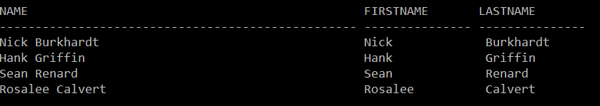

SELECT MAX **(LENGTH**(title)) "Max Book Title Length"

FROM books;



MORE TO COME …