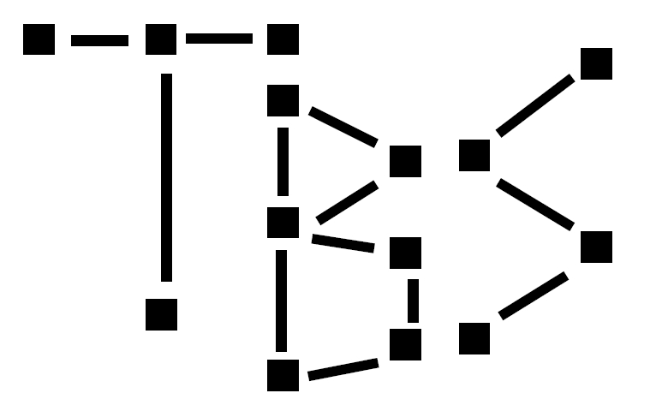

Tree-Building Survey
BRD
Decmeber 15, 2009
Version 1.0

Revision History
Version | Author | Description | Date
0.1 | Biran White | Initial Version of Applet | 30 September 2009
0.2 | Nancy Walenten | Added use cases | 29 July 2008
0.3 | Nancy Walenten | Added more detail based on meeting with Systems on Aug 4, 2008 | 06 August 2008
0.4 | Nancy Walenten |  | 13 August 2008
0.5 | Nancy Walenten | Removed Use Cases / Wire Frames and added more detail to requirements. When design is finalized, use cases will be added. | 18 August 2008
0.6 | Nancy Walenten | Updated based on ppt prepared by Systems with new navigation | 20 August 2008
0.7 | Nancy Walenten |  | 6 October 2008
0.8 | Valerie Tyler | Added Filter Screen details | 3 April 2009
0.9 | Meg Salgado | Updated with new product vision, use cases, global requirements and scope. | 13-15 April 2009
0.10 | Valerie Tyler | Updated Filter Screen details | 16 April 2009
0.11 | Meg Salgado | Additional edits to use cases | 17 April 2009
0.12 | Meg Salgado | Added Update Status use case | 22 April 2009
0.13 | Meg Salgado | Additional updates to Status Use Case following design session on 4/22 | 23 April 2009
0.14 | Meg Salgado  Valerie Tyler | Updates to Status Use Case  Additional Detail updates to the Filter, Summary and Details screens | 1 May 2009
0.15 | Meg Salgado | Detailed updates throughout | 11 May 2009
0.16 | Valerie Tyler  Meg Salgado | Updates | 14 May 2009
0.17 | Valerie Tyler  Meg Salgado | Added Use Case: Cancel Confirmation and Use Case: Update Multiple Trades | 15 May 2009
0.18 | Valerie Tyler  Meg Salgado |  | 18 May 2009
0.19 | Valerie Tyler  Meg Salgado | Additional use case, wireframe and data updates. | 19 May 2009
0.22 | Valerie Tyler  Meg Salgado | Updates to use cases, wireframes and data requirements following final BRD review | 27 May 2009
0.23 | Valerie Tyler  Meg Salgado | Updates to use cases, wireframes and data requirements following final BRD review | 28 May 2009
0.24 | Valerie Tyler  Meg Salgado | Updates to use cases, wireframes and data requirements following final BRD review | 29 May 2009
0.25 | Valerie Tyler  Meg Salgado | Updates to use cases, wireframes and data requirements following final BRD review | 08 June 2009
1.0 | Valerie Tyler  Meg Salgado | Final draft for SPR | 09 June 2009

