Auswertung MSW Aviation 22.02.2025

HB-CXQ (Cessna C150 Aerobat)
An Bord: 20187B und 202096 (Log)

HB-YLA (Votec 322)
An Bord: 201879 und 201195 (Log)

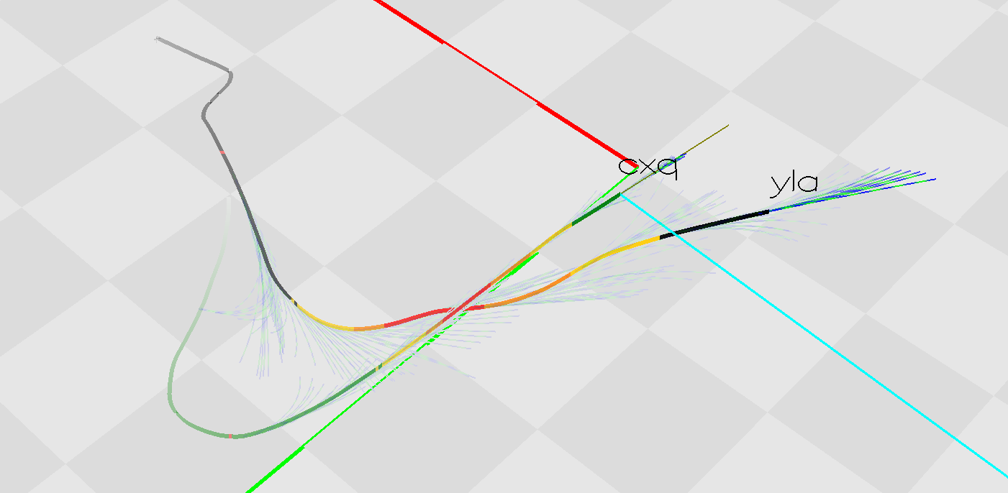

14:08:44 / YLA:
$PFLAU,2,1,,,1,25,215,2,215,216,20187B,25
$PFLAU,2,1,,,1,25,211,2,211,213,20187B,24
$PFLAU,2,1,,,1,22,196,2,196,197,20187B,22
$PFLAU,2,1,,,1,20,192,2,192,193,20187B,20
$PFLAU,2,1,,,1,20,182,2,182,183,20187B,18
$PFLAU,2,1,,,1,20,177,2,177,178,20187B,16
$PFLAU,2,1,,,1,18,173,2,173,174,20187B,18
$PFLAU,2,1,,,1,15,162,2,162,163,20187B,13
$PFLAU,2,1,,,1,14,159,2,159,159,20187B,12
$PFLAU,2,1,,,1,14,155,2,155,156,20187B,11
$PFLAU,2,1,,,1,13,151,2,151,151,20187B,11
$PFLAU,2,1,,,1,13,147,2,147,148,20187B,9
14:09:03
$PFLAU,2,1,,,2,13,143,2,143,144,20187B,20
$PFLAU,2,1,,,2,13,139,2,139,139,20187B,21
$PFLAU,2,1,,,1,13,135,2,135,136,20187B,6
$PFLAU,2,1,,,1,12,131,2,131,131,20187B,6
$PFLAU,2,1,,,1,11,126,2,126,127,20187B,6
$PFLAU,2,1,,,1,10,122,2,122,123,20187B,5
$PFLAU,2,1,,,2,7,119,2,119,119,20187B,16
$PFLAU,3,1,,,2,6,115,2,115,116,20187B,18
$PFLAU,3,1,,,1,6,112,2,112,112,20187B,2
$PFLAU,3,1,,,2,6,107,2,107,107,20187B,14
$PFLAU,3,1,,,3,6,103,2,103,103,20187B,19
$PFLAU,3,1,,,2,6,100,2,100,100,20187B,11
14:09:15
$PFLAU,3,1,,,2,5,95,2,95,95,20187B,12

