

School of Computing and Information Technology

Department of Computer Science & Engineering

Minor Project Progress Report

Date:22-03-2021

|  |  |
| --- | --- |
| Name of student | Aahan Singh Charak |
| Registration Number | 189301024 |
| Section | CSE-A |
| Contact Number | 9149884838 |
| E-mail id | aahancharak@gmail.com |
|  |  |
| Project Title | Quantification of infection patterns on tomato leaves due to various pathogens using image processing and machine learning techniques. |
| Type of Project | Technical |
| Duration of Project  (in months) | 2.5 Months |
| Project start date | 22/02/2021 |
| Likely completion date | 30/04/2021 |
|  |  |
| Internal Guide | Mr. Aditya Sinha |

**Project overview/ brief:** This project aims at quantification of infection patterns on tomato leaves due to various pathogens using image processing and machine learning techniques.Raters are prone to tiredness , which might eventually lead to inaccurate measurements.A lot of resources are required to constantly train the raters.They often require some reference to quantify disease severity e.g Standard Area Diagram. Raters can’t cover a large area and as such many plants are left with no inspection at all. Some plant diseases show symptoms after a long time. Till the time we are able to see the symptoms, most of the harm is done.So, the best alternative to visual estimation is using images to carry out the quantification. Images can be analysed in visual spectrum or non-visual spectrum. Visual spectrum is that part of the light spectrum in which humans can see objects. Other techniques include capturing images in the hyperspectral or multispectral forms. But it requires sophisticated sensor technology which is currently out of our scope and reach. So we will work with images captured using a camera in the visual range. By using image processing techniques we will segment out the diseased portion of the tomato-leaves and quantify the disease severity in them either using the nominal or percentage scale. We will mainly be using ROI segmentation and binary thresholding to achieve this.

1. **Gantt Chart:**

|  |  |  |  |  |  |  |  |
| --- | --- | --- | --- | --- | --- | --- | --- |
|  | **Schedule for Research Work** | **Months ( Year=2020)** | | | | | |
| **Feb 22- March 1** | **March 2- March 10** | **March 11- March 22** | **March 23- April 5** | **April 5 - April 16** | **April 17- April 30** |
| 1. | Dataset Acquisition and Analysis |  |  |  |  |  |  |
| 2. | Image Pre-processing |  |  |  |  |  |  |
| 3. | Color Analysis |  |  |  |  |  |  |
| 4. | ROI  Segmentation |  |  |  |  |  |  |
| 5. | Quantification technique |  |  |  |  |  |  |
| 6 | Result Analysis/ Ground Truth Validation |  |  |  |  |  |  |

1. **Project Status:**

|  |  |  |  |  |
| --- | --- | --- | --- | --- |
| Task/ Activity | % Done (Approx.) | Scheduled Finish Date | Actual Finish Date | Proposed Finish Date (if not completed as per schedule |
| Data Set Acquisition | 100 | 1/03/2020 | 23/02/2020 |  |
| Image Pre-Processing | 100 | 10/03/2020 | 3/03/2020 |  |
| Color Analysis | 100 | 22/03/2020 | 15/03/2020 |  |
| ROI Segmentation | 75 | 5/04/2020 | In Progress |  |
| Quantification | 50 | 16/04/2020 | In Progress |  |
| Result Analysis | 0 | 30/04/2020 | Not Started |  |

1. **Snapshots:**

**Data Set Acquisition:**

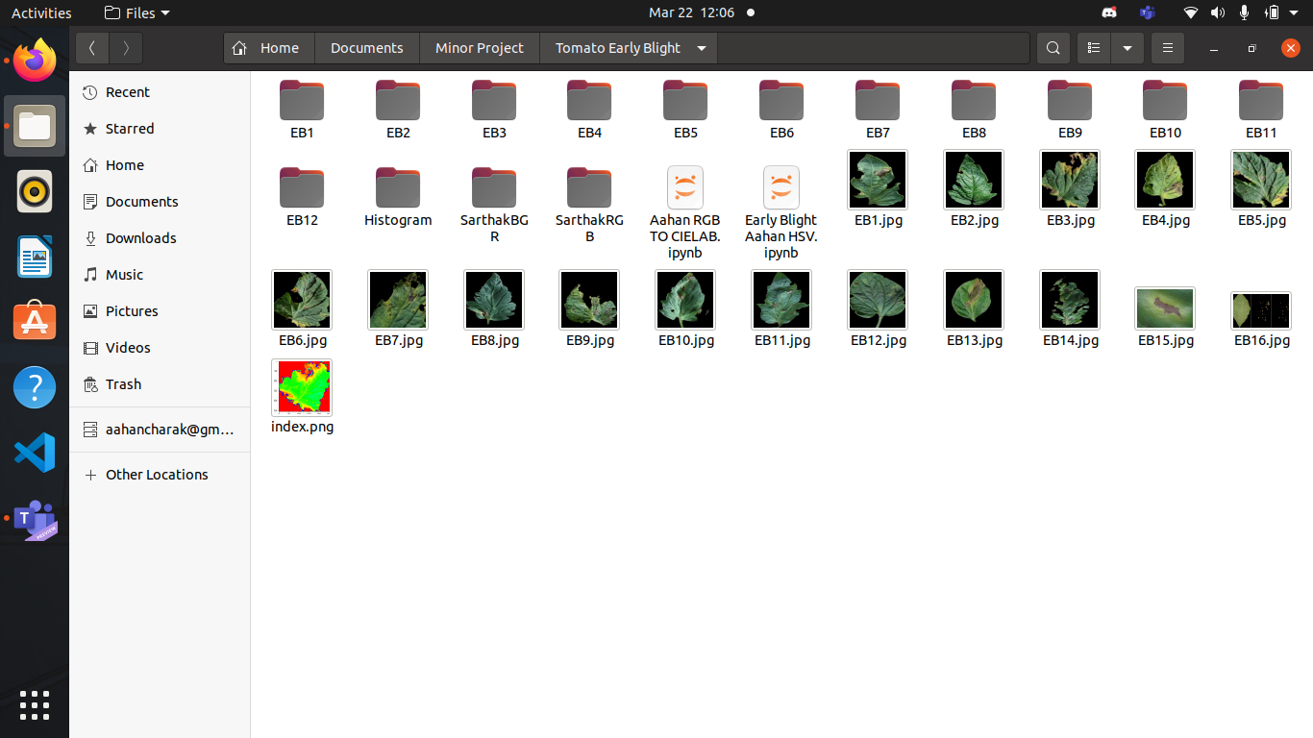

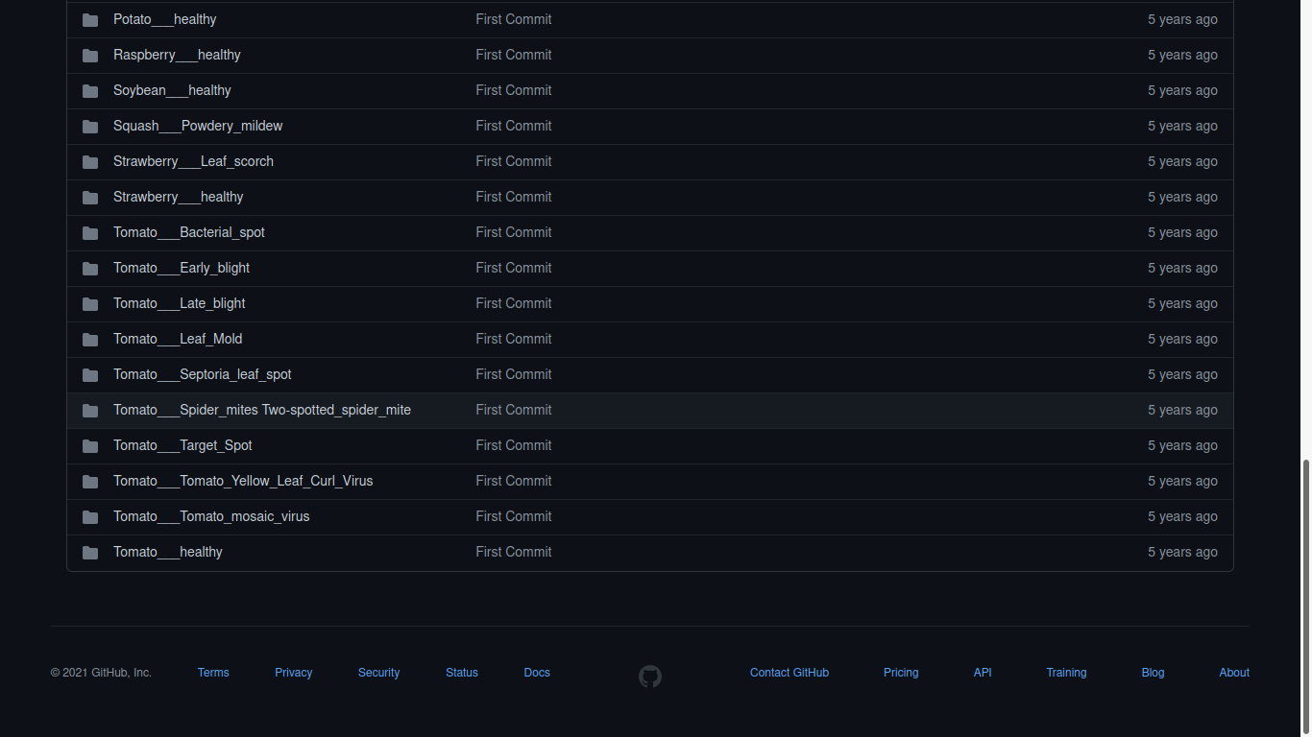

**Color-Analysis:**

**HSV:**

Original Image

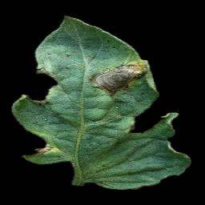

H-CHANNEL

“ *Here,we are analysing hue channel of the leaf with 100 percent saturation and 100 percent brightness so that the image can be analysed based on the natural color of the leaf.”*

↙ ↘

(Hue=Original,Saturation=100, (Hue=Original,Saturation=100,Value=100)Gray-

Value=100) RGB Analysis Scale Analysis

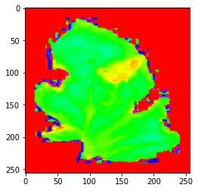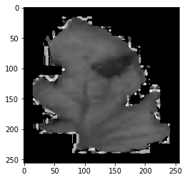

S-CHANNEL

***“****Here we are analysing the image based on the amount of white light mixed with it . Saturation is the same for each pixel, and hue too. Brightness is set to 100 so that black light has no effect on the analysis.”*

↙ ↘

(Hue=Original,Saturation=Org., (Hue=Original,Saturation=Org.,Value=100)Gray-

Value=100) RGB Analysis Scale Analysis

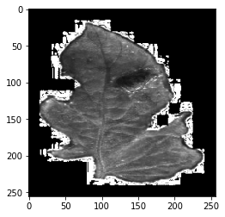

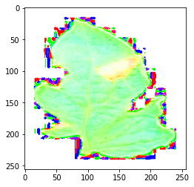

V-CHANNEL

***“****Here we are analysing the image based on the amount of black light mixed with it . Brightness is the same for each pixel, and hue too. Saturation is set to 100 so that white light has no effect on the analysis.”*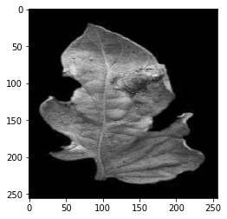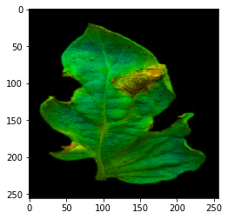

(Hue=Org.,Saturation=100,Value=Org.) (Hue =Org,Saturation=100,Val=Org.)Gray

RGB Analysis

La*b*:

L Channel :

*The L channel specifies the Luminosity or the black and white tones of the image , that’s why we kept the value 0 in code .*

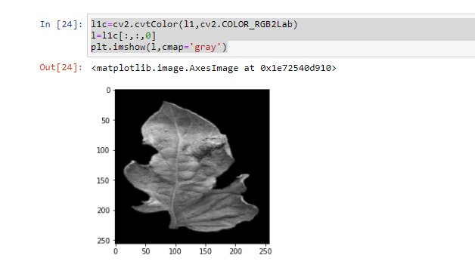

a* Channel :

*In a channel we are adding chromatic dimension by setting value to 1 .*

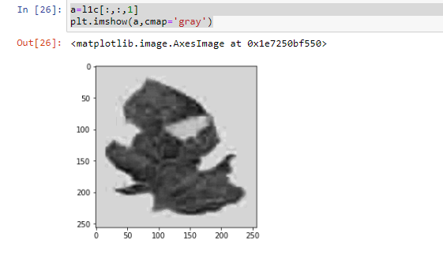

b* Channel :

*In b channel we are adding a different chromatic dimension by setting value to 2 .*

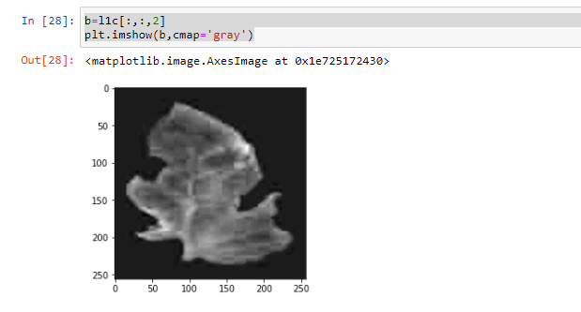

**ROI SEGMENTATION:**

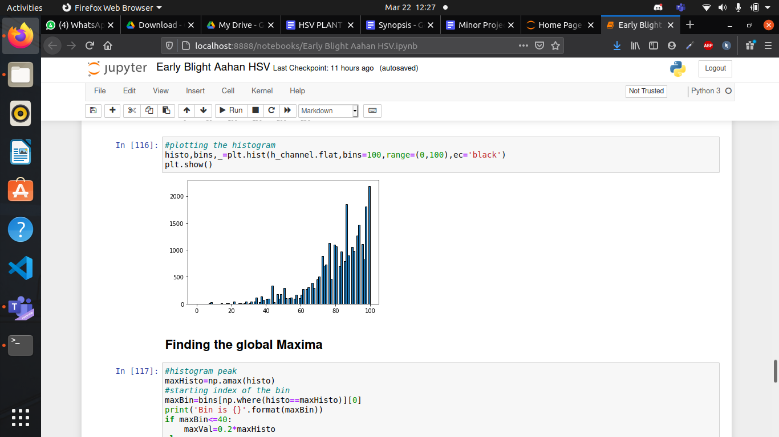

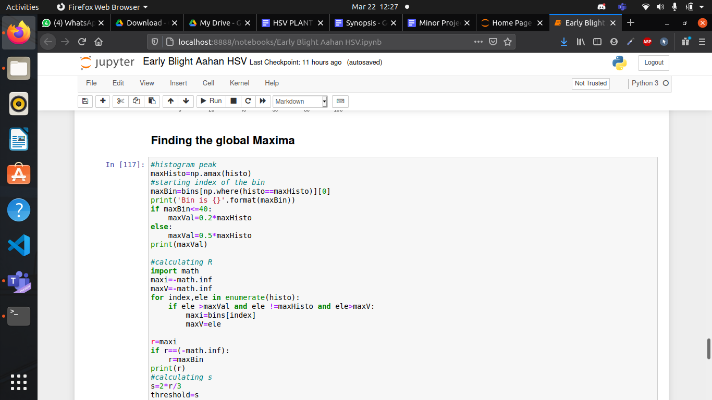



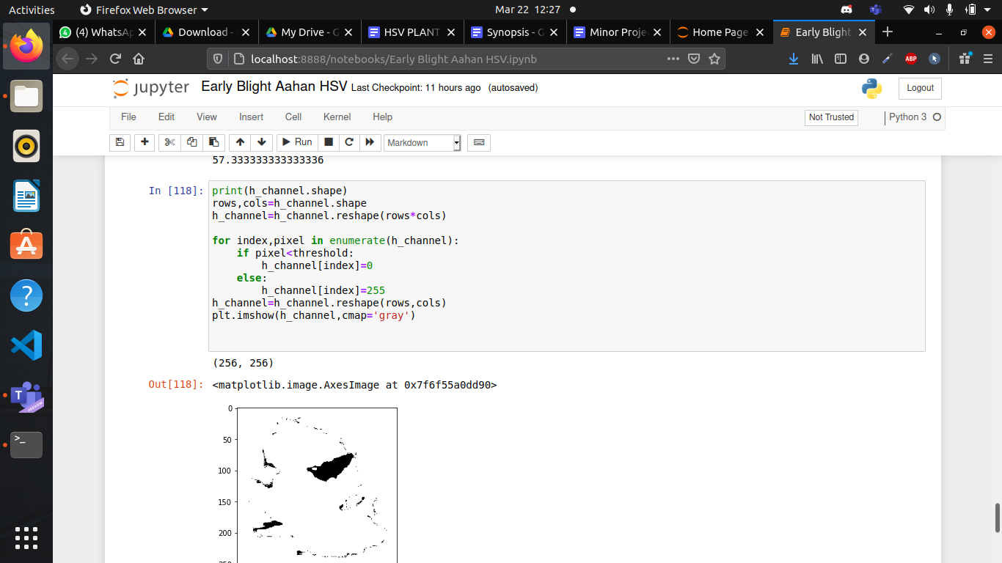

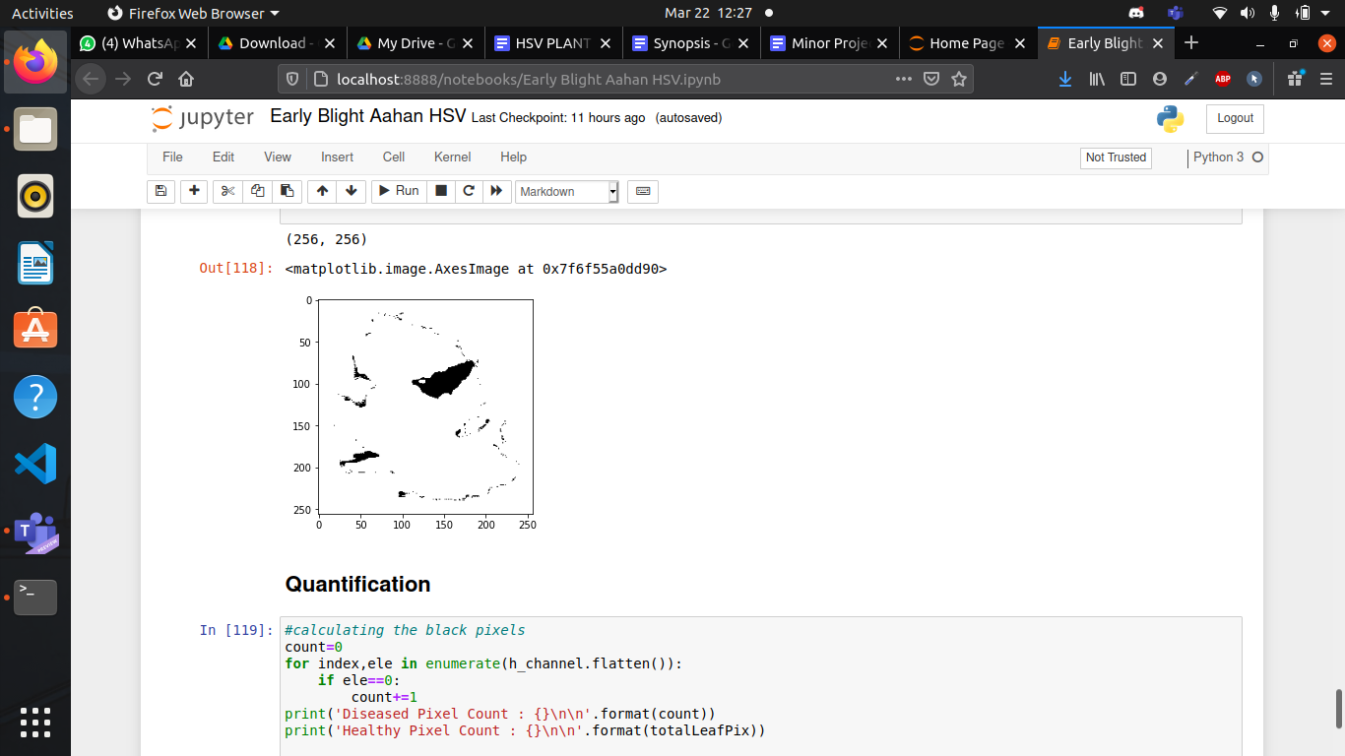

**Quantification:**

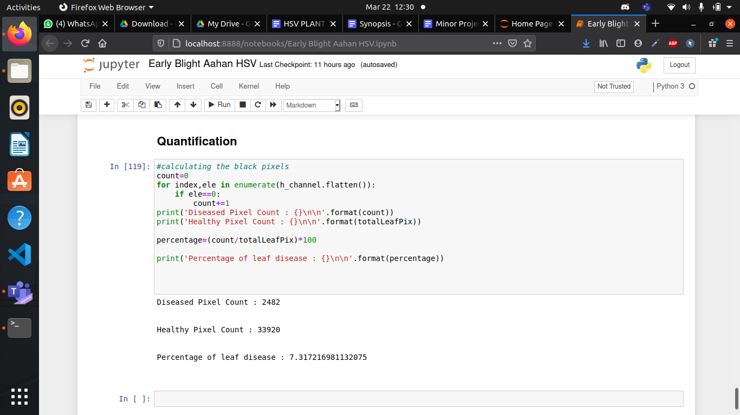

1. **Summary/ Conclusion:**

From the above analysis we can clearly see that infection patterns are clearly most visible in the h-channel analysis as compared to the v-channel and s-channel analyses.

For La*b* a channel is the best. H-channel/a-channel analysis would make it easier for us to visually estimate the disease severity, so that we can compare our estimates with the quantification results. Though in the segmentation results we can clearly see that, some healthy-portions of the leaves are also included in the diseased segment, which results in inaccuracies. Also shading and light-effect might also render the algorithm ineffective.Ground truth validation is also required to verify our results.