A Minor Project Synopsis on

Quantification of infection patterns on tomato leaves due to various pathogens using image processing and machine learning techniques.

Submitted to Manipal University, Jaipur
Towards the partial fulfillment for the Award of the Degree of

BACHELORS OF TECHNOLOGY (B-TECH)
In
In Computer Science and Engineering
2018-2022

By
Aahan Singh Charak
189301024



Under the guidance of :
Prof. Aditya Sinha

Faculty of Engineering

School of Computing and Information Technology

Manipal University Jaipur, Dahmi Kalan, Rajasthan, India – 303007

Introduction

Agriculture plays a very important role in our daily lives. From providing food to everyone, livelihood to the farmers and reducing the pollution levels , agriculture plays an important role in the survival of human beings.

Plants play a very vital role in the nature. They are one of the forces keeping global-warming away from us. But plants aren’t resistant to diseases. So, it becomes necessary for us to study the diseases occuring in plants, in order to develop measures to prevent and cure them. Let’s take a look at the chart given below, showing the total area of tomato harvests vs the year of harvests in India.

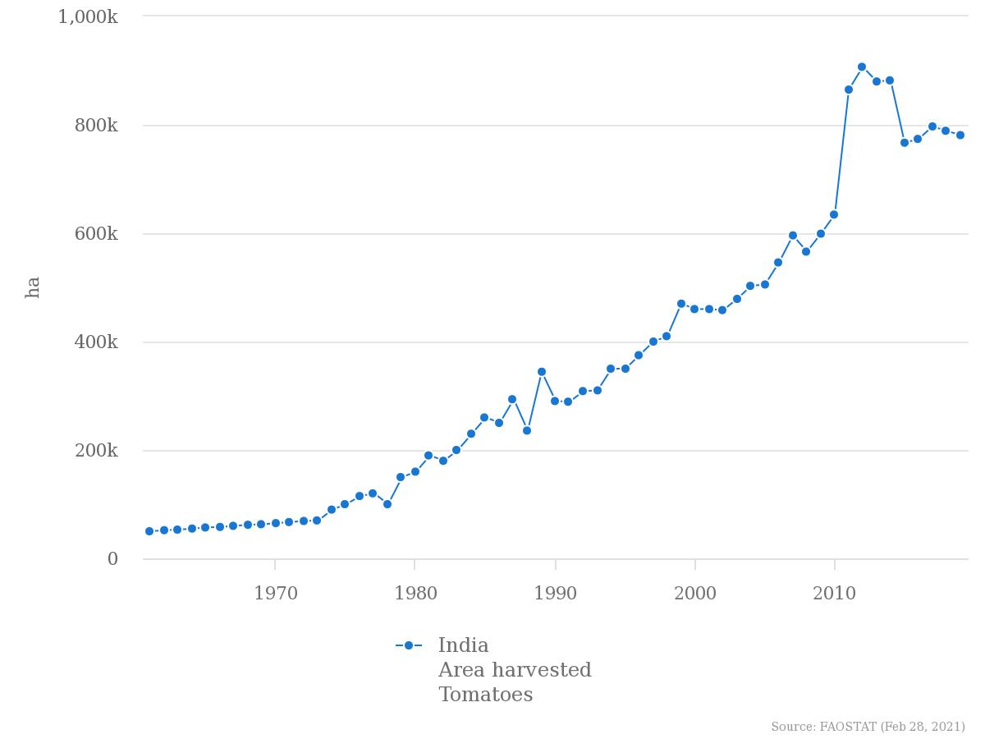

From the above given trend we can clearly see that production takes a dip starting from round about late 2014’s. One of the main factors behind this is diseases happening in plants, but if we are able to correctly identify them and calculate the severity of infection, we will surely be able to boost the productivity. Being aware of the infection patterns and severity of infection well in advance can help to reduce the risk of disease spreading over a large area of crops. Diseases in plants are quite ubiquitous, so identifying them well in advance will be a great help to us. Visual estimation is one of the ways to achieve this but reqiures a lot of hardwork and human resources which isn’t cost efficient. Visual analysis of images for quantification can help estimate the severity of infection over a large area without much effort and is also cheap. Moreover market is filled with many softwares which make our jobs easier as we don’t have to develop our own algorithms to achieve this task and they also help us save a lot of precious time.

Motivation

In most of the cases estimation about the severity of plant diseases in done by humans visually. These individuals who excel in the field of visual estimation of plant disease severity are called Raters. If they are trained effectively, they can make accurate estimations
about the plant disease severity. But there can be a lot of disadvantages in quantifying the plant diseases visually. According to Bock et al.(as cited in Jayme Garcia, [7) there are many disadvantages of visual estimation. Some of them are discussed below :

- Raters are prone to tiredness , which might eventually lead to inaccurate measurements.
- A lost of resources are required to constantly train the raters.
- They often require some reference to quantify disease severity e.g Standard Area Diagram.
- Raters can’t cover a large area and as such many plants are left with no inspection at all.
- Some plant diseases show symptoms after a long time. Till the time we are able to see the symptoms, most of the harm is done.

So, the best alternative to visual estimation is using images to carry out the quantification. Images can be analysed in visual spectrum or non-visual spectrum. Visual spectrum is that part of the visual spectrum in which humans can see objects. Other techniques include capturing images in the hyperspectral or multispectral forms. But it requires sophisticated sensor technologywhich is currently out of our scope and reach. So we will work with images captured using camera in the visual range. By using image processing techniques we will segment out the diseased portion of the tomato-leaves and quantify the disease severity in them either using the nominal or percentage scale. Example of tomato leaf image in visible spectrum is given below.

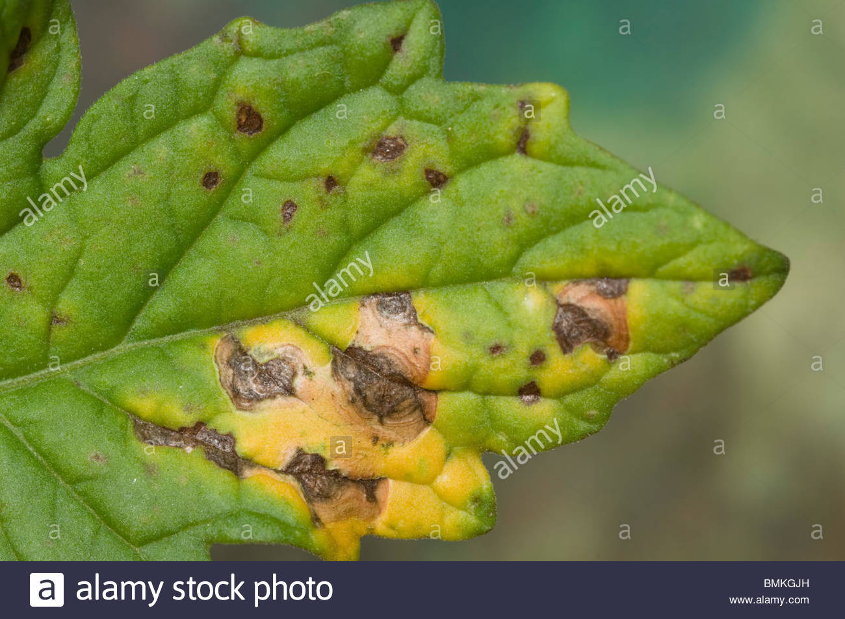

Example of mold infection pattern on a tomato leaf. Image is captured in the visual spectrum.
Objective

This project aims at quantification of infection patterns on tomato leaves due to various pathogens using image processing and machine learning techniques.

Technique | Method | Advantages | Disadvantages | References
Visual Estimation | Severity of disease estimation by visually analyzing the leaves with human eyes. | - Accurate if trained raters hired.  - Raters are mostly experienced individuals who can quickly estimate disease severity in plants.  - They providegood estimation especially during on field measurements. | - Raters may tire or loose concentration.  - They mostly need tools like SAD to carry out the measurement processes.  - They are generally expensive and require a lot of resources to train efficiently. | Bock et al. (as cited in Jayme Garcia [7)
Visible Spectrum Image Analysis | Quantifying the severity of diseases in plants by using image processing techniques like segmentation, thresholding, binarization etc... on images lying in the visible range of electromagnetic spectrum. | - We can work over large datasets so our work can cover a large area.  - Tools like neural networks can be used to automate quantification process thus saving our time.  - Gives very high accuracy if measurements are being performed under controlled conditions. | - Highly inaccurate if used in on-field analysis.  - Shadows and light can interfere with proper quantification. | Bock et al.(77
HSI/MSI image analysis | Quantifying plant diseases by analysis of images lying in the hyperspectral or multispectral regions. | - We can analyse images which are outisde the visible band.  - We can segment and detect disease patterns which otherwise would be invisible to the naked eye.  - Use in thermal imaging , x-ray imaging etc..  - MSI/HSI images deal with the wavelengths associated with the light waves from diseased regions. This provides us with more insights. | - Factors like solar altitude,illumination and dust can be problematic while performing measurements.  - Motion of crop due to factors like wind, storms etc.. can also cause errors.  - Disease quantification using hsi/msi techniques is also error prone if there is a presence of multiple diseases on the same plant or leaf. | Bock et al.(7

Requirements for the Project

Operating System :

- Windows: 7 or newer
- MAC: OS X v10.7 or higher
- Linux: Ubuntu

Software Requirements:

- OpenCV

- Python Programming Language

- Python libraries for Image Processing and Machine Learning like scikit-learn,opcncv-python ,numpy etc..

Hardware Requirements:

Processor: Minimum 1 GHz; Recommended 2GHz or more
Hard Drive: Minimum 32 GB; Recommended 64 GB or more
Memory (RAM): Minimum 1 GB; Recommended 4 GB or above

*We strongly recommend using a PC device fewer than 5 years old because OpenCv requires high computational power.

Bibliography/References

- 1.Bock, C.H., Barbedo, J.G.A., Del Ponte, E.M. et al. From visual estimates to fully automated sensor-based measurements of plant disease severity: status and challenges for improving accuracy. Phytopathol Res 2, 9 (2020). https://doi.org/10.1186/s42483-020-00049-8

- Arnal Barbedo, J.G. Digital image processing techniques for detecting, quantifying and classifying plant diseases. SpringerPlus 2, 660 (2013). https://doi.org/10.1186/2193-1801-2-660

