Document History
Document Name | Detail | Status | Date | View able | Reviewer& Responsible
HanDIYcraft-SDD-V.0.1.docx | -Introduction  -Overall Description  -System Architecture | Draft | 30/4/14 | Advisor | NK, PS
HanDIYcraft -SDD-0.2.docx | -Update Introduction | Draft | 8/2/14 | Advisor | NK, PS
HanDIYcraft -Project Plan-0.3.docx | -Update Business Review  - Quality Standard | Draft | 27/2/14 | Advisor | NK, PS
HanDIYcraft -Project Plan-0.4.docx | -Deliverables and Limit  -Future Work | Draft | 28/2/14 | Advisor | NK, PS
HanDIYcraft -Project Plan-0.5.docx | - Motivation  - Aim and Object  - Architecture Review  - Schedule and Milestone | Draft | 3/2/14 | Advisor | NK, PS
HanDIYcraft -Project Plan-0.6.docx | -Update Aims and Object  - Abstract  - References | Draft | 4/2/14 | Advisor | NK, PS
HanDIYcraft -Project Plan-1.0.docx | -Update Architecture  -Update Aims  -Update Features  -Update Milestone | Release | 26/3/14 | Advisor | NK, PS

NK : Nahathai Kaewtatib
PS : Pimchanok Sripraphan

…………………………
Ms. Nahathai Kaewtatib
Project Proposal Writer

…………………………
Ms. Pimchanok Sripraphan
Project Proposal Writer

28th May 2014

Table of Contents
Chapter One| Introduction 5
1.1 Objective 7
1.2 Intended Audience and Reading Suggestions 9
1.3 Project Scope 9
1.4 Acronyms and Definitions 9
Chapter Two | Overall Description 7
2.1 Product Perspective 7
2.2 Product Features 7
2.3 User Classes and Characteristics 7
2.3.1 Users 18
2.3.2 Bloggers 18
2.3.3 Shopkeepers 18
2.4 Operation Environment 7
2.5 Design and Implementation Constraints 7
Chapter Three | System Architecture 18
Chapter Four | Detailed Design 20
4.1 Class Diagram 20
4.1.1 Web Application Class Diagram 21
4.1.2 Android Application Class Diagram 21
4.2 Class Diagram Description 21
4.2.1 Web Application Class Diagram Description 21
4.2.2 Android Application Class Diagram Description 21
4.3 Sequence Diagram 22
Chapter Five | Data Architecture 20
5.1 ER Diagram 20
5.2 Database Design 21

Chapter Six | User Interface Design 18

Chapter One | Introduction

1.1 Objective
HanDIYcraft is a web application, and mobile application for smartphone that supports Android operating system. It is an application that guide users the method how to recycle things by themselves. This application provides several tutorials for users to learn. Moreover, in case the users do not have the needed materials and have no idea where to buy, this application provides a feature to let the users check out the shops that sell related materials for making their DIY artworks and find the location of the shop via Google Maps. Apart from just exploring, the bloggers can directly communicate with the shopkeepers by sending private messages, and among each other by the comment. They can also share their favorite DIY tutorial to the social network like Facebook too.
This Software Requirement Specification document defines more about the abilities and features of the system in details. It includes the scope and limitations of the project, product function, user characteristics, functional requirements, non-functional requirements, use cases and activity diagrams to explain how the system works.

  - Intended Audience an Reading Suggestions

This Software Requirement Specification is designed for the people who are involved and related with the HanDIYcraft project. It may benefit to these people as followed:

Development Team
- Specifies the abilities and actions, including the scope of the system. From this point, it helps everyone to have the same understanding towards the project.
- Verifies and validates the working of software whether it works as it is defined in the document or not.
- Helps in achieving the quality of the product as much as possible.
- Used for the discussion among the related people about the project.

Customer
- Ensure that the development team understands and interprets in the same thing, in order to satisfy the customer needs.
- Helps customer to understand the technical things such as the quality, scope and limitations.

  - Project Scope

- Available only in English.
- Provide understandable symbols and language.
- Provide member system
- Able to work with Google Maps to pin and see shops’ location.
- Able to work with Facebook in order to share tutorials.
- Provide communication system to make an interaction among bloggers, and also with the shopkeepers.
- Provide the tutorial management system on mobile application, and web application for bloggers to manage their tutorials easier.
- Provide tutorials for users and bloggers to explore.
- Let shopkeepers manage their shops in order to advertise them.

  - Acronyms and Definitions
- Acronyms
PMP = Project Management Plan
SDD = Software Design Document
SRS = Software Requirement Specification
URS = User Requirement Specification
UC = Use Case
AD = Activity Diagram
UI = User Interface
SW = Siraprapa Wattanakul
NK = Nahathai Kaewtatib
PS = Pimchanok Sripraphan

Chapter Two | Overall Description

  - Product Perspective

HanDIYcraft is a software system that able to operate as web and Android mobile application. It helps users to obtain ideas to build DIY artworks. Plus, it also helps user to save their time to find the right place via Google Maps in order to get the material the want. More than that, it also helps the shopkeepers who sell DIY materials to advertise their shops too.

  - Product Features

Main features of HanDIYcraft are listed as follows:
Feature 1: Authorization Management
- Develop register, log in, and log out system for bloggers. (On both web and mobile)
- Develop register, log in, and log out system for shopkeepers. (On mobile)
- The system can display user’s (blogger/shopkeeper) profile and let the users edit their information.

Feature 2: Tutorial Management (On both web and mobile)
- Bloggers can manage tutorials.
- Bloggers can add detail of the tutorial step by step.
- Bloggers can pictures for the tutorial.
- Bloggers can add a video for the tutorial.
- Bloggers and users can search tutorials by keyword.
- The system can display tutorials that exist in the database.

Feature 3: Shop Management (On mobile)
- Shopkeepers can manage shops.
- Shopkeepers can add information of the shop.
- Shopkeepers can add pictures of the shop.

Feature 4: Map Management
- Develop Map using Google Maps API. (On both web and mobile)
- Bloggers can see the location of shops. (On both web and mobile)
- Shopkeepers can pin the location of the shop. (On mobile)

Feature 5: Communication Management
- Bloggers can communicate to each other via comment. (On both web and mobile)
- Bloggers and shopkeepers can communicate to each other via private message. (On both web and mobile)
- Shopkeepers can search bloggers using their username. (On mobile)
- Bloggers can give likes on tutorials. (On both web and mobile)
- Bloggers can follow other bloggers. (On both web and mobile)
- Bloggers can share a tutorial on Facebook. (On both web and mobile)

Feature 6: The system provides notifications. (On both web and mobile.

  - User Classes and Characteristics

There are three types of users for our system. Information and characteristics are listed below:

    - Users
These are the general users that did not register to the system. What the can do the most is just exploring the DIY tutorials that exist in the system.

    - Bloggers
These are the people who have registered as a blogger. Apart from just exploring, they are able to create their own tutorials and manage it. Besides, they can do the communication through comments and private messages too.

    - Shopkeepers
These are the people who have registered as a shopkeeper. They can literally advertise their own shops via the application. Apart from that, they can communicate with the bloggers through private message.

  - Operation Environment

  - Design and Implementation Constraints

- The mobile application of the system is able to operate only on Android platform, version 4.2 or above.
- Require the internet connection.
- There is no security for inappropriate information.
- The users that did not log in can visit only some part of the system.

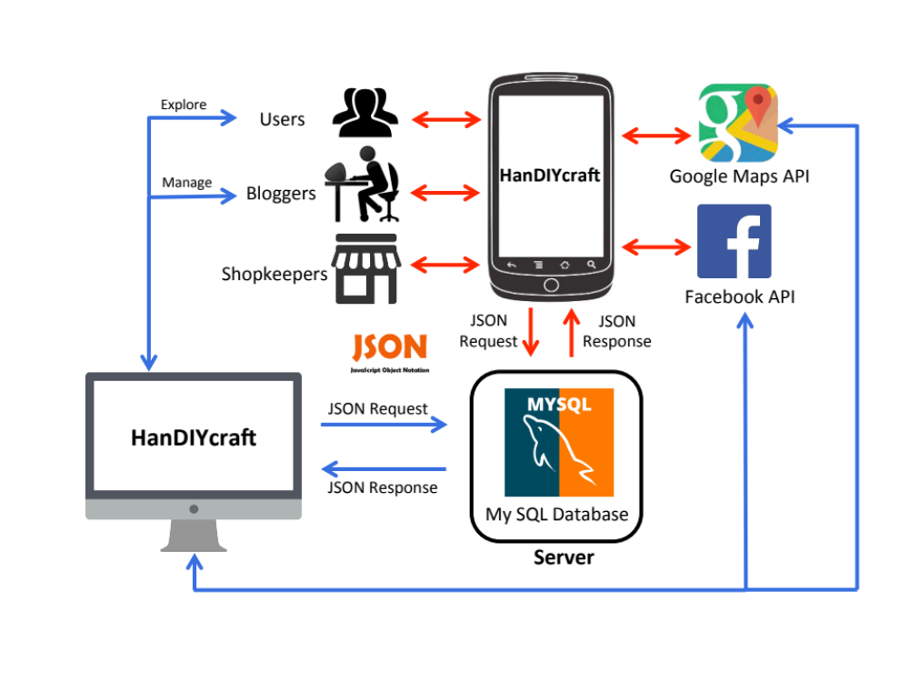
Chapter Three | System Architecture

HanDIYcraft application is a social application on Android OS smart phones and web application. Whenever the user interacts with the application, the system will query data through JSON from MySQL database system and response the result back to the user via the application’s user interface.

Users, bloggers and shopkeepers can access to the data differently.
- Users will be able to only explore tutorials and shops’ location that are provided in the application.
- Bloggers can manage (create/edit/delete) tutorials. They can communicate among each other via the comments, and to the shopkeepers via private messages. Also, be able to explore others’ tutorials just like the users. On the other hand, they can do those activities on the web application, and be able to interact with Facebook too.
- Shopkeepers can manage shops, and be able to communicate with the bloggers via private messages. They can search to a specific blogger by username.

