Document History
Document Name | Detail | Status | Date | Viewable | Reviewer& Responsible
HanDIYcraft-SRS-0.1.docx | -Introduction | Draft | 15/4/14 | Advisor | NK, PS
HanDIYcraft -SRS-0.2.docx | -Update Introduction  -Overall Description | Draft | 16/4/14 | Advisor | NK, PS
HanDIYcraft -SRS-0.3.docx | -Update Overall Description  -User Requirements | Draft | 17/4/14 | Advisor | NK, PS
HanDIYcraft -SRS-0.4.docx | -Update User Requirements | Draft | 18/4/14 | Advisor | NK, PS
HanDIYcraft -SRS-0.5.docx | -Update User Requirements | Draft | 19/4/14 | Advisor | NK, PS
HanDIYcraft -SRS-0.6.docx | -Update User Requirements | Draft | 20/4/14 | Advisor | NK, PS
HanDIYcraft -SRS-0.7.docx | -Update User Requirements  - System Features | Draft | 21/4/14 | Advisor | NK, PS
HanDIYcraft -SRS-0.8.docx | -Update System Features | Draft | 5/7/14 | Advisor | NK, PS
HanDIYcraft -SRS-1.0.docx | -Update System Features | Release | 7/7/14 | Advisor | NK, PS
HanDIYcraft -SRS-1.1.docx | -Update Overall Description  -Update User Requirements | Draft | 21/7/14 | Advisor | NK, PS
HanDIYcraft -SRS-1.2.docx | -Update User Requirements | Release | 24/7/14 | Advisor | NK, PS
HanDIYcraft -SRS-1.3.docx | -Update User Requirements | Draft | 23/9/14 | Advisor | NK, PS
HanDIYcraft -SRS-1.4.docx | -Update User Requirements | Draft | 24/9/14 | Advisor | NK, PS
HanDIYcraft -SRS-1.5.docx | -Update System Features | Draft | 25/9/14 | Advisor | NK, PS
HanDIYcraft -SRS-1.6.docx | -Update User Requirements | Draft | 11/10/14 | Advisor | NK, PS
HanDIYcraft -SRS-1.7.docx | -Update User Requirements | Draft | 12/10/14 | Advisor | NK, PS
HanDIYcraft -SRS-1.8.docx | -Update User Requirements  -Update System Features | Draft | 14/10/14 | Advisor | NK, PS
HanDIYcraft -SRS-1.9.docx | -Update User Requirements | Draft | 16/10/14 | Advisor | NK, PS
HanDIYcraft -SRS-1.10.docx | -Update User Requirements | Draft | 20/10/14 | Advisor | NK, PS
HanDIYcraft -SRS-1.11.docx | -Update User Requirements | Draft | 21/10/14 | Advisor | NK, PS
HanDIYcraft -SRS-2.0.docx | -Update User Requirements | Release | 22/10/14 | Advisor | NK, PS
HanDIYcraft -SRS-2.1.docx | -Update System Requirements | Release | 10/11/14 | Advisor | NK, PS
HanDIYcraft -SRS-2.2.docx | -Update User Requirements | Draft | 24/11/14 | Advisor | NK, PS
HanDIYcraft -SRS-2.3.docx | -Update User Requirements  -Update System Features | Draft | 28/11/14 | Advisor | NK, PS
HanDIYcraft -SRS-2.4.docx | -Update User Requirements | Draft | 28/11/14 | Advisor | NK, PS

NK : Nahathai Kaewtatib

PS : Pimchanok Sripraphan

…………………………

Ms. Nahathai Kaewtatib

Project SRS Writer

…………………………

Ms. Pimchanok Sripraphan

Project SRS Writer

11th December 2014

Table of Contents
Chapter One| Introduction 4
1.1 Objective 4
1.2 Intended Audience and Reading Suggestions 4
1.3 Project Scope 5
1.4 Acronyms and Definitions 5
Chapter Two | Overall Description 6
2.1 Product Perspective 6
2.2 Product Features 6
2.3 User Classes and Characteristics 7
2.3.1 Users 7
2.3.2 Bloggers 7
2.3.3 Shopkeepers 7
2.4 Operation Environment 7
2.5 Design and Implementation Constraints 8
Chapter Three | User Requirements 9
3.1 Use Cases 9
3.1.1 HanDIYcraft Use Case for Web Application 9
3.1.2 HanDIYcraft Use Case for Mobile Application 10
3.2 User Requirement Specification 11
3.2.1 User Requirement Specification for Web Application 11
3.2.2 User Requirement Specification for Mobile Application 13
3.3 User Requirement Description and Activity Diagram 15
3.3.1 User Requirement Description for Web Application 15
3.3.2 User Requirement Description for Mobile Application 89
Chapter Four | System Features 188
4.1 Software Requirement Specification 188
4.1.1 Software Requirement Specification for Web Application 188
4.1.2 Software Requirement Specification for Mobile Application 189
4.2 Quality Requirement 200

Chapter One | Introduction

1.1 Objective
HanDIYcraft is a web application, and mobile application for smartphone that supports Android operating system. It is an application that guide users the method how to recycle things by themselves. This application provides several tutorials for users to learn. Moreover, in case the users do not have the needed materials and have no idea where to buy, this application provides a feature to let the users check out the shops that sell related materials for making their DIY artworks and find the location of the shop via Google Maps. Apart from just exploring, the bloggers can directly communicate with the shopkeepers by sending private messages, and among each other by the comment. They can also share their favorite DIY tutorial to the social network like Facebook too.
This Software Requirement Specification document defines more about the abilities and features of the system in details. It includes the scope and limitations of the project, product function, user characteristics, functional requirements, non-functional requirements, use cases and activity diagrams to explain how the system works.

  - Intended Audience an Reading Suggestions

This Software Requirement Specification is designed for the people who are involved and related with the HanDIYcraft project. It may benefit to these people as followed:

Development Team
- Specifies the abilities and actions, including the scope of the system. From this point, it helps everyone to have the same understanding towards the project.
- Verifies and validates the working of software whether it works as it is defined in the document or not.
- Helps in achieving the quality of the product as much as possible.
- Used for the discussion among the related people about the project.

Customer
- Ensure that the development team understands and interprets in the same thing, in order to satisfy the customer needs.
- Helps customer to understand the technical things such as the quality, scope and limitations.

  - Project Scope

- Available only in English.
- Provide understandable symbols and language.
- Provide member system
- Able to work with Google Maps to pin and see shops’ location.
- Able to work with Facebook in order to share tutorials.
- Provide communication system to make an interaction among bloggers, and also with the shopkeepers.
- Provide the tutorial management system on mobile application, and web application for bloggers to manage their tutorials easier.
- Provide tutorials for users and bloggers to explore.
- Let shopkeepers manage their shops in order to advertise them.

  - Acronyms and Definitions
- Acronyms
PMP = Project Management Plan
SDD = Software Design Document
SRS = Software Requirement Specification
URS = User Requirement Specification
UC = Use Case
AD = Activity Diagram
SW = Siraprapa Wattanakul
NK = Nahathai Kaewtatib
PS = Pimchanok Sripraphan

Chapter Two | Overall Description

  - Product Perspective

HanDIYcraft is a software system that able to operate as web and Android mobile application. It helps the users to obtain ideas to build DIY artworks. Plus, it also helps user to save their time to find the right place via Google Maps in order to get the material the want. More than that, it also helps the shopkeepers who sell DIY materials to advertise their shops too.

  - Product Features

Main features of HanDIYcraft are listed as follows:

Feature 1: User's Profile and Authorization Management
- Develop register, log in, and log out system for bloggers. (On both web and mobile)
- Develop register, log in, and log out system for shopkeepers. (On mobile)
- Display blogger's profile which contain profile picture, username, email, number of following and follower people, and created tutorials, and let the him/her edit their information.
- Display shopkeeper's profile, which contain profile picture, username, email, and created shops, and let him/her edit their information.

Feature 2: Tutorial Management (On both web and mobile)
- Add a tutorial, which contain pictures, descriptions, and a video by blogger.
- Manage (edit/delete) tutorials by blogger.
- Search tutorials title by keyword.
- Display tutorials that exist in the database by random, popular, and following.
- Display tutorial's detail, which contain tutorial owner username, number of likes, tutorial title, pictures, material, descriptions, a video, and comments.

Feature 3: Shop Management (On mobile)
- Add a shop, which contain pictures, descriptions, and a video by shopkeeper.
- Manage (edit/delete) shops by shopkeeper.
- Search shop name by keyword.
- Display shops that exist in the database randomly.
- Display shop's detail, which contain shop name, shop owner username, branch, telephone number, information, shop's pictures, and location.

Feature 4: Map Management
- See the shop's location via Google Maps. (On both web and mobile)
- Pin shop's location via Google Maps by shopkeeper. (On mobile)

Feature 5: Communication Management
- See and add comments on tutorials by blogger (On both web and mobile)
- Communicate via private messages (On both web and mobile)
- Search bloggers by username by shopkeeper. (On mobile)
- Giving and undo likes on tutorials by blogger. (On both web and mobile)
- Follow and unfollow bloggers by blogger. (On both web and mobile)
- See list of follower and following bloggers. (On both web and mobile)
- Share tutorials to Facebook (On both web and mobile)

Feature 6: The system provides notifications. (On both web and mobile)
- Display list of news when there is new tutorial comment, tutorial like, or follower.
- Display a sign when there is a new message.

  - User Classes and Characteristics

There are three types of users for our system. Information and characteristics are listed below:

    - Visitors
These are the general users that did not register to the system. What the can do the most is just exploring the DIY tutorials that exist in the system.

    - Bloggers
These are the people who have registered as a blogger. Apart from just exploring, they are able to create their own tutorials and manage it. Besides, they can do the communication through comments and private messages too.

    - Shopkeepers
These are the people who have registered as a shopkeeper. They can literally advertise their own shops via the application. Apart from that, they can communicate with the bloggers through private message.

  - Operation Environment
HanDIYcraft operates on both web and mobile application. Whenever the user requests any information to perform some tasks, the information will be requested from web application and response back to the mobile application.

Server Environment
Windows server platform is supported for this system. It is capable for web-server, database-server, and internet connection.

Client Environment
The system supports only Android OS, which has version 4.2 or later in order to run the system properly and be able to connect to the internet. It also requires GPS to identify location from Google Maps.

  - Design and Implementation Constraints

- The mobile application of the system is able to operate only on Android platform, version 4.2 or above.
- The system always requires internet connection.
- The system still has no security for inappropriate information.
- The users that did not log in can visit only some part of the system.

Chapter Three | User Requirements

  - Use Cases
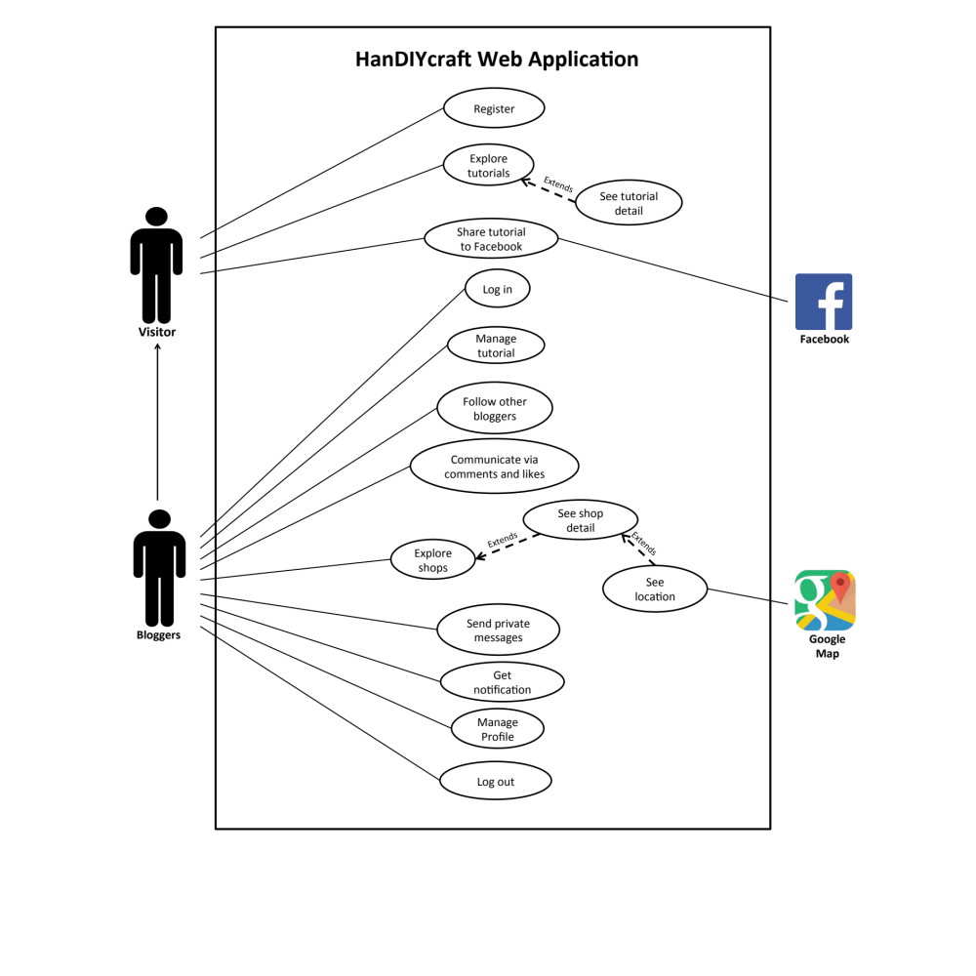
    - HanDIYcraft Use Case Web Application

    - HanDIYcraft Use Case for Mobile Application
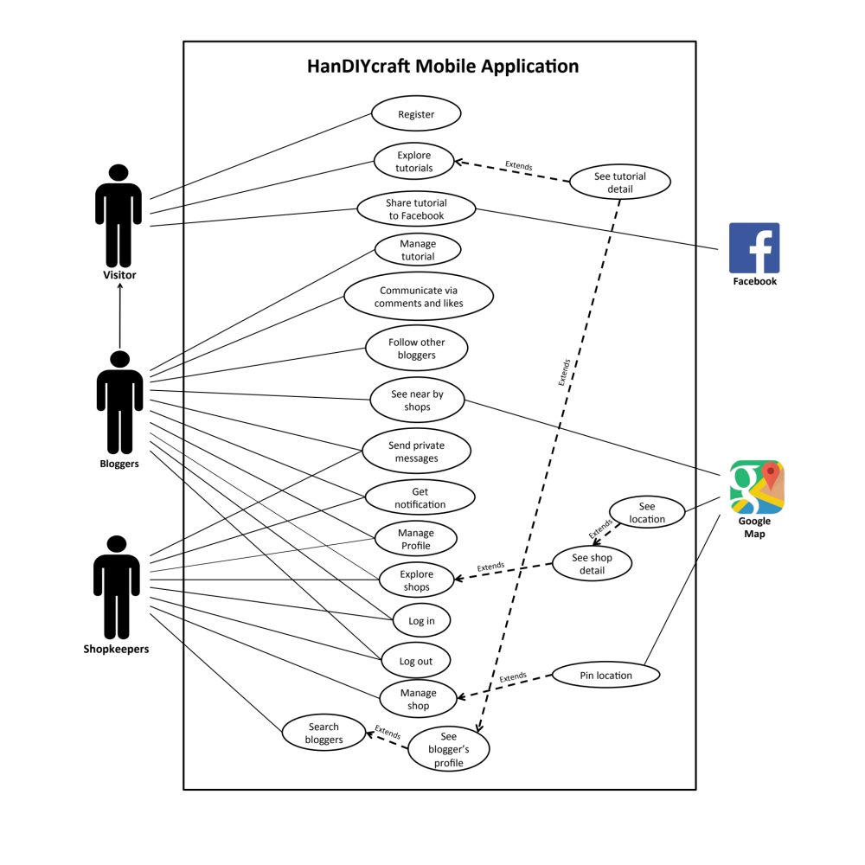

  - User Requirement Specification (URS)

    - User Requirement Specification for Web Application
No. | Feature Name | URS No. | URS Name | Actor
1 | User’s Profile and Authorization Management | W-URS-01 | The user registers as a blogger. | Visitor
1 | User’s Profile and Authorization Management | W-URS-02 | The user logins to the system by username and password. | Blogger
1 | User’s Profile and Authorization Management | W-URS-03 | The user logouts from the system. | Blogger
1 | User’s Profile and Authorization Management | W-URS-04 | The user sees his/her profile. | Blogger
1 | User’s Profile and Authorization Management | W-URS-05 | The user edits his/her email. | Blogger
1 | User’s Profile and Authorization Management | W-URS-06 | The user adds profile picture. | Blogger
1 | User’s Profile and Authorization Management | W-URS-07 | The user changes profile picture. | Blogger
1 | User’s Profile and Authorization Management | W-URS-08 | The user changes his/her password. | Blogger
1 | User’s Profile and Authorization Management | W-URS-09 | The user deletes his/her account. | Blogger
2 | Tutorial Management | W-URS-10 | The user randomly sees tutorials that exist in database. | Visitor, Blogger
2 | Tutorial Management | W-URS-11 | The user sees tutorials that exist in database by popularity according to number of likes. | Visitor, Blogger
2 | Tutorial Management | W-URS-12 | The user sees tutorials that exist in database by choosing a category. | Visitor, Blogger
2 | Tutorial Management | W-URS-13 | The user search tutorials’ title that exist in database by inputting a keyword. | Visitor, Blogger
2 | Tutorial Management | W-URS-14 | The user sees tutorials that exist in database from following bloggers. | Blogger
2 | Tutorial Management | W-URS-15 | The user sees selected tutorial information. | Visitor, Blogger
2 | Tutorial Management | W-URS-16 | The user creates his/her own tutorial, which includes tutorial detail. | Blogger
2 | Tutorial Management | W-URS-17 | The user sees detail of his/her own tutorial. | Blogger
2 | Tutorial Management | W-URS-18 | The user edits detail of his/her own tutorial. | Blogger
2 | Tutorial Management | W-URS-19 | The user deletes his/her own tutorial. | Blogger
3 | Shop Management | W-URS-20 | The user randomly sees list of shops that exist in database. | Blogger
3 | Shop Management | W-URS-21 | The user sees shops that exist in database by choosing a category. | Blogger
3 | Shop Management | W-URS-22 | The user search shops’ name that exist in database by inputting a keyword. | Blogger
3 | Shop Management | W-URS-23 | The user sees selected shop information. | Blogger
4 | Map Management | W-URS-24 | The user sees shop’s location on Google Map. | Blogger
5 | Communication Management | W-URS-25 | The user sees comments on tutorial. | Visitor, Blogger
5 | Communication Management | W-URS-26 | The user adds comment on tutorial. | Blogger
5 | Communication Management | W-URS-27 | The user likes a tutorial. | Blogger
5 | Communication Management | W-URS-28 | The user undo likes from the liked tutorial. | Blogger
5 | Communication Management | W-URS-29 | The user follows other bloggers. | Blogger
5 | Communication Management | W-URS-30 | The user undo follows from the followed bloggers. | Blogger
5 | Communication Management | W-URS-31 | The user sees list of bloggers whom the user is following. | Blogger
5 | Communication Management | W-URS-32 | The user sees list of bloggers who follows the user. | Blogger
5 | Communication Management | W-URS-33 | The user sends private message. | Blogger
5 | Communication Management | W-URS-34 | The user receives private message. | Blogger
5 | Communication Management | W-URS-35 | The user sees list of shopkeepers that has been communicate with. | Blogger
5 | Communication Management | W-URS-36 | The user shares tutorial to Facebook. | Visitor, Blogger
6 | Notification Management | W-URS-37 | The user sees list of notifications when there is new like, comment, or follower. | Blogger
6 | Notification Management | W-URS-38 | The user goes to the activity that has been notified. | Blogger

    - User Requirement Specification for Mobile Application
No. | Feature Name |  | URS No. | URS Name | Actor
1 | User’s Profile and Authorization Management |  | M-URS-01 | The user registers as a blogger or shopkeeper. | Visitor
1 |  |  | M-URS-02 | The user logins to the system by username and password. | Blogger, Shopkeeper
1 |  |  | M-URS-03 | The user logouts from the system. | Blogger, Shopkeeper
1 |  |  | M-URS-04 | The user sees his/her profile. | Blogger, Shopkeeper
1 |  |  | M-URS-05 | The user edits his/her email. | Blogger, Shopkeeper
1 |  |  | M-URS-06 | The user changes profile picture. | Blogger, Shopkeeper
1 |  |  | M-URS-07 | The user changes his/her password. | Blogger, Shopkeeper
1 |  |  | M-URS-08 | The user deletes his/her account. | Blogger, Shopkeeper
2 | Tutorial Management |  | M-URS-09 | The user randomly sees tutorials that exist in database. | Visitor, Blogger, Shopkeeper
2 |  |  | M-URS-10 | The user sees tutorials that exist in database by popularity according to number of likes. | Visitor, Blogger, Shopkeeper
2 |  |  | M-URS-11 | The user sees tutorials that exist in database by choosing a category. | Visitor, Blogger, Shopkeeper
2 |  |  | M-URS-12 | The user search tutorials’ title that exist in database by inputting a keyword. | Visitor, Blogger, Shopkeeper
2 |  |  | M-URS-13 | The user sees tutorials that exist in database from following bloggers. | Blogger
2 |  |  | M-URS-14 | The user sees selected tutorial information. | Visitor, Blogger, Shopkeeper
2 |  |  | M-URS-15 | The user creates his/her own tutorial, which includes tutorial detail. | Blogger
2 |  |  | M-URS-16 | The user sees detail of his/her own tutorial. | Blogger
2 |  |  | M-URS-17 | The user edits detail of his/her own tutorial. | Blogger
2 |  |  | M-URS-18 | The user deletes his/her own tutorial. | Blogger
3 | Shop Management |  | M-URS-19 | The user randomly sees list of shops that exist in database. | Blogger, Shopkeeper
3 |  |  | M-URS-20 | The user sees shops that exist in database by choosing a category. | Blogger, Shopkeeper
3 |  |  | M-URS-21 | The user search shops’ name that exist in database by inputting a keyword. | Blogger, Shopkeeper
3 |  |  | M-URS-22 | The user sees selected shop information. | Blogger, Shopkeeper
3 |  |  | M-URS-23 | The user creates his/her own shop, which includes shop detail. | Shopkeeper
3 |  |  | M-URS-24 | The user sees detail of his/her own shop. | Shopkeeper
3 |  |  | M-URS-25 | The user edits detail of his/her own shop. | Shopkeeper
3 |  |  | M-URS-26 | The user deletes his/her own shop. | Shopkeeper
4 | Map Management |  | M-URS-27 | The user sees near by shops’ location on Google Map. | Blogger
4 |  |  | M-URS-28 | The user sees shop’s location on Google Map. | Blogger, Shopkeeper
4 |  |  | M-URS-29 | The user identifies his/her shop’s location on Google Map. | Shopkeeper
5 | Communication Management |  | M-URS-30 | The user sees comment on tutorial. | Visitor, Blogger
5 |  |  | M-URS-31 | The user adds comment on tutorial. | Blogger
5 |  |  | M-URS-32 | The user likes a tutorial. | Blogger
5 |  |  | M-URS-33 | The user undo likes from the liked tutorial. | Blogger
5 |  |  | M-URS-34 | The user follows other bloggers. | Blogger
5 |  |  | M-URS-35 | The user undo follows from the followed bloggers. | Blogger
5 |  |  | M-URS-36 | The user sees list of bloggers whom the user is following. | Blogger
5 |  |  | M-URS-37 | The user sees list of bloggers who follows the user. | Blogger
5 |  |  | M-URS-38 | The user sends private message. | Blogger, Shopkeeper
5 |  |  | M-URS-39 | The user receives private message. | Blogger, Shopkeeper
5 |  |  | M-URS-40 | The user sees list of people that has been communicate with. | Blogger, Shopkeeper
5 |  |  | M-URS-41 | The user shares tutorial to Facebook. | Visitor, Blogger, Shopkeeper
5 |  |  | M-URS-42 | The user sees bloggers that exist in database by searching. | Shopkeeper
5 |  |  | M-URS-43 | The user sees list of searched bloggers. | Shopkeeper
5 |  |  | M-URS-44 | The user sees blogger’s profile. | Visitor, Blogger, Shopkeeper
6 |  | Notification Management | M-URS-45 | The user sees list of notifications when there is new like, comment, or follower. | Blogger, Shopkeeper
 |  | Notification Management | M-URS-46 | The user goes to the activity that has been notified. | Blogger, Shopkeeper

  - User Requirement Description and Activity Diagram

    - User Requirement Description for Web Application

Feature 1: User’s Profile and Authorization Management
W-URS-01: The user registers as a blogger.

Input and Output
No | Input Name | Description | Example | Remarks | Output
1 | Username | The length of Username must be between 1-20 characters | “hideandseek05” | The word should not contain any symbol. | The system shows “HideandSeek05” on the screen
2 | Password | The length of Password must be between 1-20 characters | “12345” | The word should not contain any symbol. | The system shows “●●●●●” on the screen
3 | Re-Password | Re-password must match with the password. | “12345” | The word should not contain any symbol. | The system shows “●●●●●” on the screen
4 | Email | Email must be the one that the user is currently using. | “hello@gmail.com” | The word should be in Email format | The system shows “hello@gmail.com” on the screen

Description
URS ID | W-URS-01
URS Name | The user registers as a blogger.
Actor | Visitor
Description | This function allows user who does not have his/her own account to register in order to use more functions of the application.
Trigger | The user selects “Sign Up” to register to be a member of the system.
Pre-condition | - Open the application
Post-condition | - The system saves user’s information into database.
Normal flow | 1) System provides registration interface for user to fill information, which are username, password, re-password, and e-mail.  3) User input his/her information.  4) User clicks done to finish the registration.  5) System validates username, password, re-password, and email format.  6) System saves the user’s information into the database.  7) System goes back to log in page.
Alternative flow | - In step 1, the user clicks back button to go to the previous page in case he/she wants to cancel the registration.  - In step 5, the system shows an error message if the user has input wrong information.
Exception | - In all steps of normal flow, in case there is no internet connection.
Include | -

W-AD-01
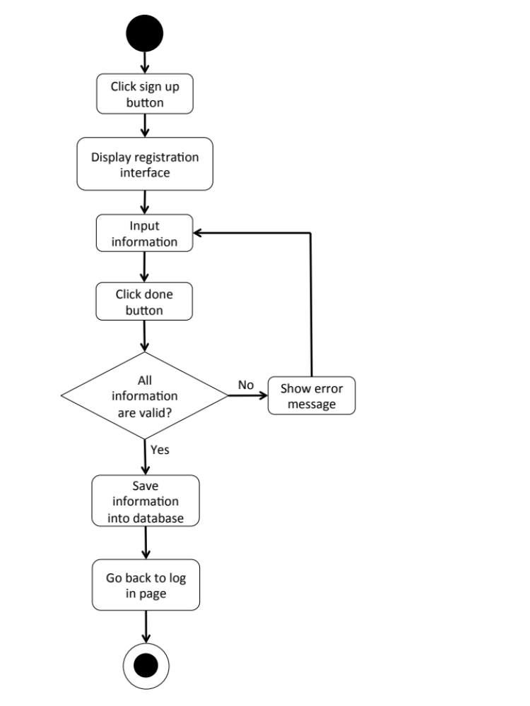

W-URS-02: The user logins to the system by username and password.

Input and Output
No | Input Name | Description | Example | Remarks | Output
1 | Username | The length of Username must be between 1-20 characters | “hideandseek05” | The word should not contain any symbol. | The system shows “HideandSeek05” on the screen
2 | Password | The length of Password must be between 1-20 characters | “12345” | The word should not contain any symbol. | The system shows “●●●●●” on the screen

Description
URS ID | W-URS-02
URS Name | The user logins to the system by username and password.
Actor | Blogger
Description | This function allows user, who has registered, logs in to the system.
Trigger | The user selects “Log in” to log in to the system.
Pre-condition | - User has registered to the system.
Post-condition | - User goes to home page for blogger.
Normal flow | 1) User goes to log in page.  2) System provides log in interface for user to fill information, which are username and password.  3) User input his/her username and password.  4) Users clicks log in button.  5) System validates username, and password format.  6) System verifies username and password from the database.  7) System goes to blogger home page.
Alternative flow | -In step 1, the user clicks back button to go to the previous page in case he/she wants to cancel the process.  In step 5, the system shows an error message if the user has input wrong information.
Exception | - In all steps of normal flow, in case there is no internet connection.
Include | W-URS-01

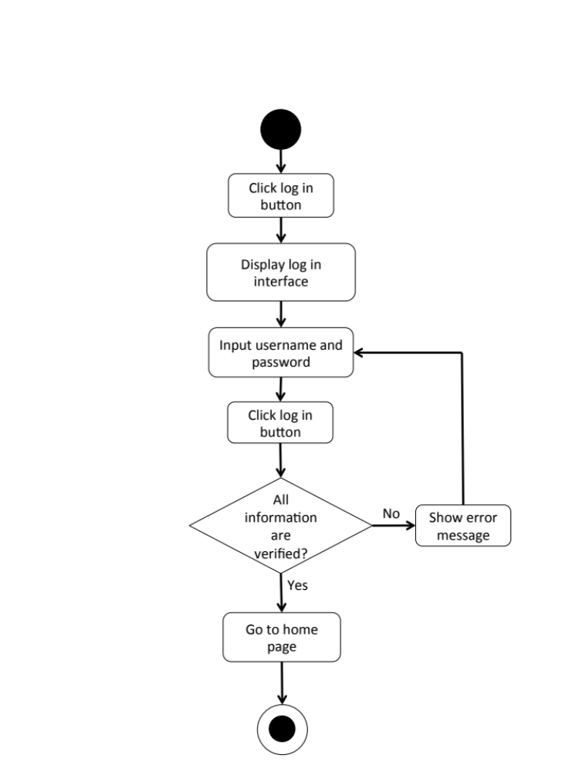
W-AD-02

W-URS-03: The user logouts from the system.
Input and Output
- Input: The user selects log out link to exit from the system.
- Output: The user log out from the system.

Description
URS ID | W-URS-03
URS Name | The user logouts from the system.
Actor | Blogger
Description | This function allows user to log out from the system.
Trigger | The user selects “Log out” to log out from the system.
Pre-condition | - User has logged in to the system.
Post-condition | - User has no longer logged in.
Normal flow | 1) User goes to blogger home page.  2) System provides blogger home page interface.  3) User clicks log out button.  4) System goes to visitor home page.
Alternative flow | -
Exception | - In all steps of normal flow, in case there is no internet connection.
Include | W-URS-02

W-AD-03
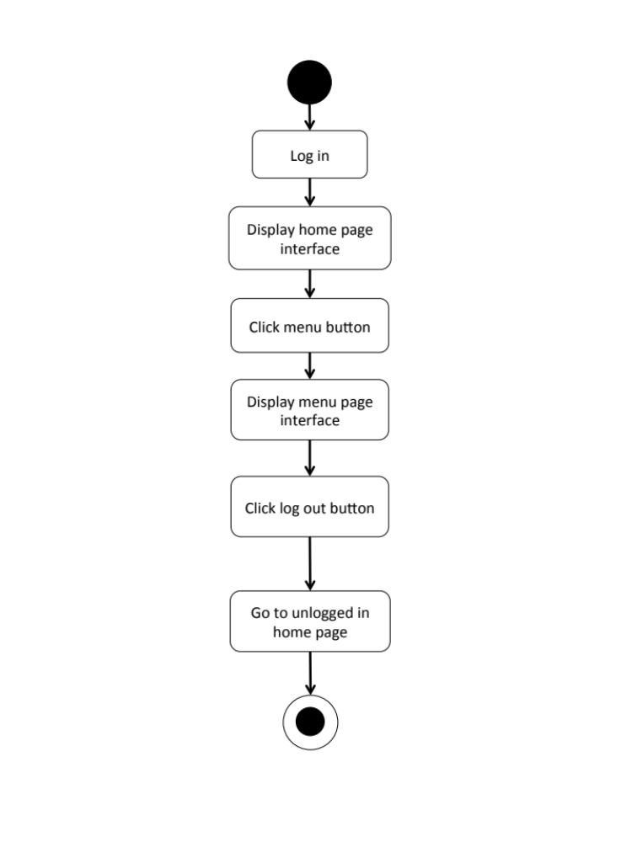

W-URS-04: The user sees his/her profile.
Input and Output
- Input: The user selects profile link to go to profile page.
- Output: The system shows user’s profile.

Description
URS ID | W-URS-04
URS Name | The user sees his/her profile.
Actor | Blogger
Description | This function allows user to see his/her own profile and information, which includes tutorials/shops that the user has created.
Trigger | The user selects “Profile” to go to his/her profile.
Pre-condition | - User has logged in to the system.
Post-condition | - System displays user’s profile.
Normal flow | - User goes to profile page.  - System gets user’s information from database.  - System displays interface and user’s information, which are profile picture, username, password, follower number, following number, and tutorials that he/she has created.
Alternative flow | -
Exception | In all steps of normal flow, in case there is no internet connection.
Include | W-URS-02

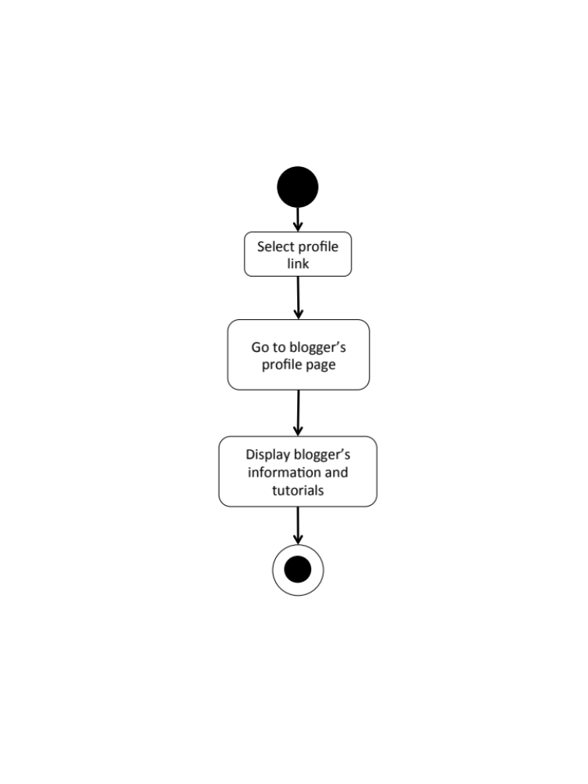
W-AD-04

W-URS-05: The user edits his/her email.

Input and Output
No | Input Name | Description | Example | Remarks | Output
1 | Email | Email must be the one that the user is currently using. | “kanom@msn.com” | The word should be in Email format | The system shows “kanom@msn.com” on the screen

Description
URS ID | W-URS-05
URS Name | The user edits his/her email.
Actor | Blogger
Description | This function allows user to edit his/her own email.
Trigger | The user selects “Edit” on user’s profile page.
Pre-condition | - User has logged in to the system.
Post-condition | - System updates the new information of user’s profile.
Normal flow | 1) User goes to edit profile page  2) System provides the editable interface of the profile.  3) User input new information.  4) User clicks save.  5) System validates email format.  6) System saves the new information into the database.  7) System goes back to profile page.
Alternative flow | - In step 1, the user clicks back button to go to the previous page in case he/she wants to cancel the edit profile process.  - In step 5, the system shows an error message if the user has input wrong information.
Exception | - In all steps of normal flow, in case there is no internet connection.
Include | W-URS-02

W-AD-05
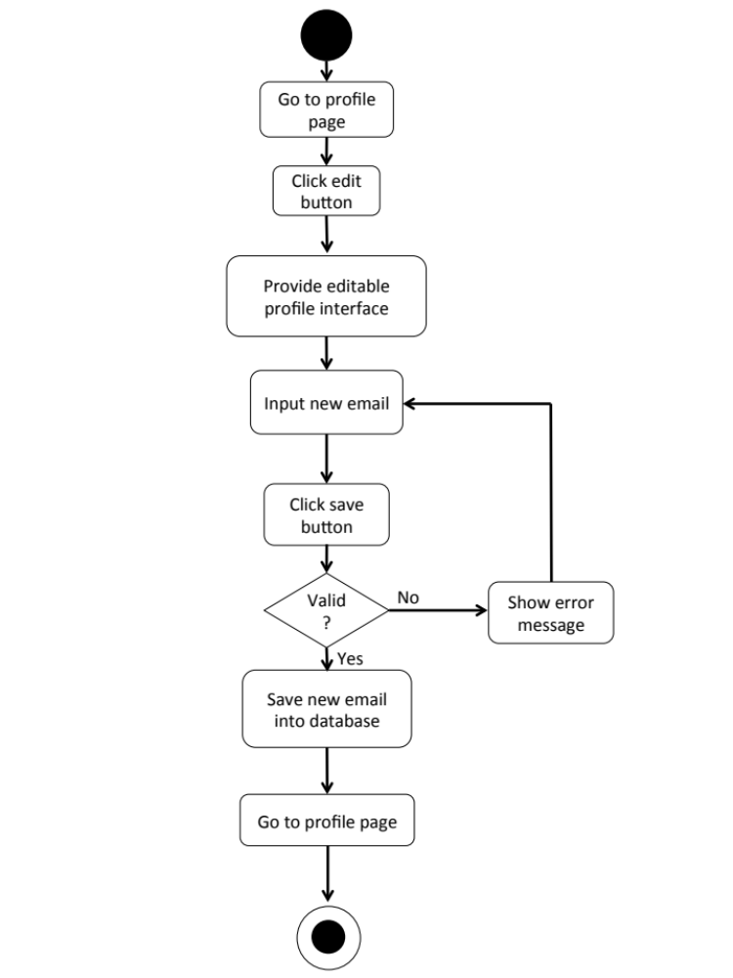

W-URS-06: The user adds profile picture.

Input and Output
No | Input Name | Description | Example | Remarks | Output
1 | Picture | The file type must be .jpg or .png | “IMG_ProfilePic.jpg” | - | The system shows “IMG_ProfilePic.jpg” on the screen

Description
URS ID | W-URS-06
URS Name | The user adds profile picture.
Actor | Blogger
Description | This function allows user to add his/her picture as a profile picture.
Trigger | The user selects “Profile picture” to add a picture.
Pre-condition | - User has logged in to the system.  - User goes to edit profile page.
Post-condition | - Picture appears on the profile page as the user’s profile picture.
Normal flow | 1) User selects browse picture link.  2) System shows pictures in user’s computer.  3) User selects a picture.  4) User clicks save.  5) System validates picture format.  6) System saves the added picture into the database.  7) System goes back to user’s profile page.
Alternative flow | - In step 1, the user clicks cancel button to go to the previous page in case he/she wants to cancel the picture adding process.  - In step 5, the system shows an error message if the user has input wrong information.
Exception | In all steps of normal flow, in case there is no internet connection.
Include | W-URS-02

W-URS-07: The user changes profile picture.

Input and Output
No | Input Name | Description | Example | Remarks | Output
1 | Picture | The file type must be .jpg or .png | “IMG_ProfilePic2.jpg” | - | The system shows “IMG_ProfilePic2.jpg” on the screen

Description
URS ID | W-URS-07
URS Name | The user changes profile picture.
Actor | Blogger
Description | This function allows user to change his/her profile picture.
Trigger | The user selects “Profile picture” to change the picture.
Pre-condition | - User has logged in to the system.  - User goes to edit profile page.
Post-condition | - System saves new user’s profile picture into database.
Normal flow | 1) User selects browse picture link.  2) System shows pictures in user’s computer.  3) User selects a picture.  4) User clicks save.  5) System validates picture format.  6) System saves the new picture into the database.  7) System goes back to user’s profile page.
Alternative flow | - In step 1-4, the user clicks cancel button to go to the previous page in case he/she wants to cancel the picture changing process.
Exception | - In step 5, system displays error message in case the format is wrong.  - In all steps of normal flow, in case there is no internet connection.
Include | W-URS-02

W-AD-06
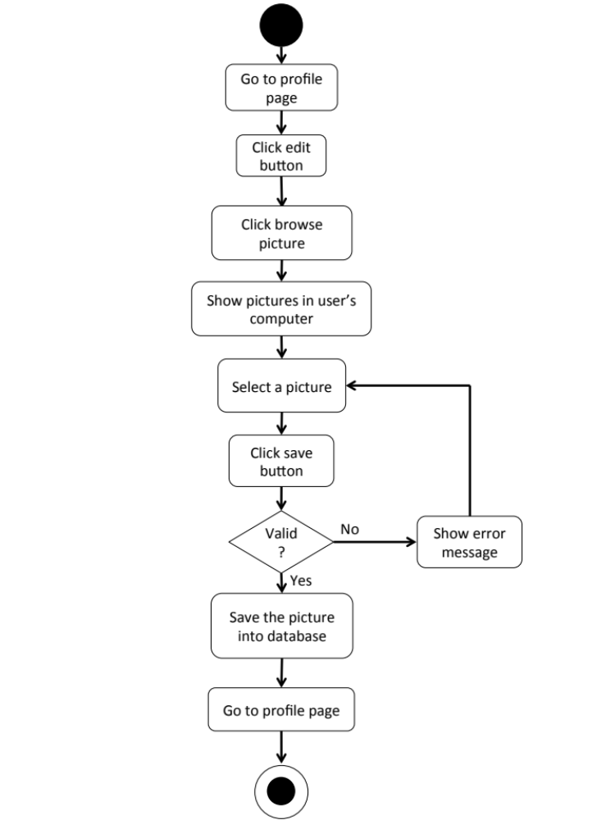

W-URS-08: The user changes his/her password.

Input and Output
No | Input Name | Description | Example | Remarks | Output
1 | Current Password | Current Password should be the password that the user is currently using. | “12345” | The word should not contain any symbol. | The system shows “●●●●●” on the screen
2 | New Password | The length of New Password must be between 1-20 characters | “00000” | The word should not contain any symbol. | The system shows “●●●●●” on the screen
3 | Re-New Password | Re-New Password must match with the New Password. | “00000” | The word should not contain any symbol. | The system shows “●●●●●” on the screen

Description
URS ID | W-URS-08
URS Name | The user changes his/her password.
Actor | Blogger
Description | This function allows user to change password for his/her account.
Trigger | The user selects “Change password” to change the password for user’s account.
Pre-condition | - User has logged in to the system.  - User goes to edit profile page.
Post-condition | - The password for the user’s account is updated.
Normal flow | 1) User clicks change password link.  2) System provide change password interface for user to fill information, which are current password and new password and re-new password.  3) User input information.  4) User clicks save button.  5) System validates current password, new password and re-new password.  6) System saves the new password into the database.  7) System goes back to user’s profile page.
Alternative flow | - In step 1, the user clicks back button to go to the previous page in case he/she wants to cancel the password changing process.  - In step 5, the system shows an error message if the user has input wrong information.
Exception | - In all steps of normal flow, in case there is no internet connection.
Include | W-URS-02

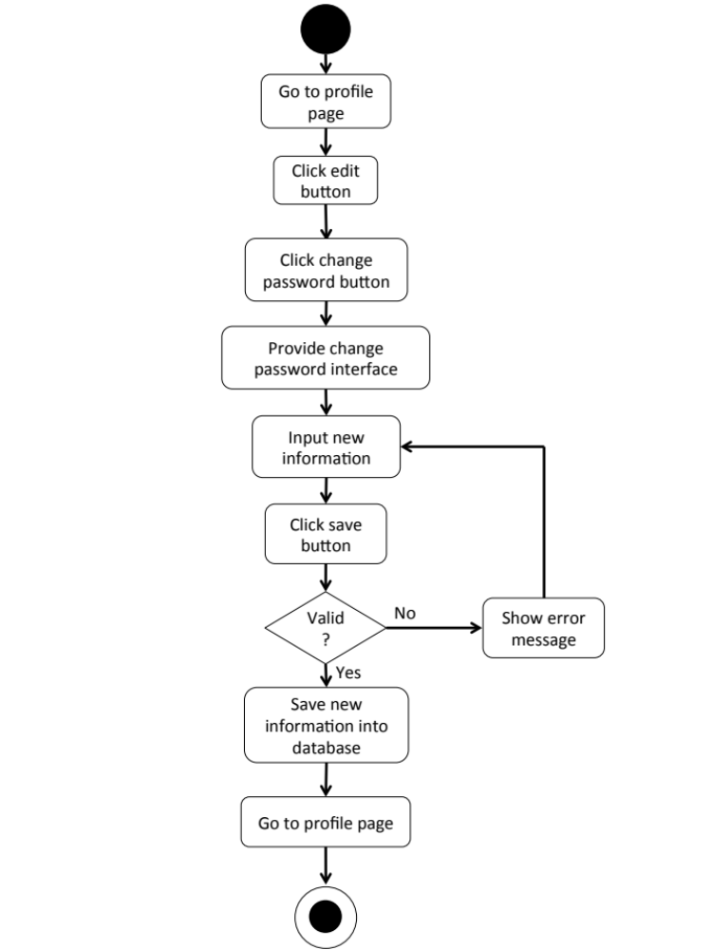
W-AD-07

W-URS-09: The user deletes his/her account.
Input and Output
- Input: The user selects delete account link to delete user’s account.
- Output: The system goes to home page for unlogged in user.

Description
URS ID | W-URS-09
URS Name | The user deletes his/her account.
Actor | Blogger
Description | This function allows user to delete his/her account, which the user will not be able to access the system as a blogger, unless the user register a new account.
Trigger | The user selects “Delete account” to delete the user’s account.
Pre-condition | - User has logged in to the system.  - User goes to edit profile page.
Post-condition | - User’s account is no longer available.
Normal flow | 1) User clicks delete account button.  2) System shows confirmation message with yes/no button.  3) User clicks yes button.  4) System removes the user’s information from the database.  5) System goes to visitor home page.
Alternative flow | - In step 3, the user clicks no button to cancel the account deletion process.
Exception | In all steps of normal flow, in case there is no internet connection.
Include | W-URS-02

W-AD-08

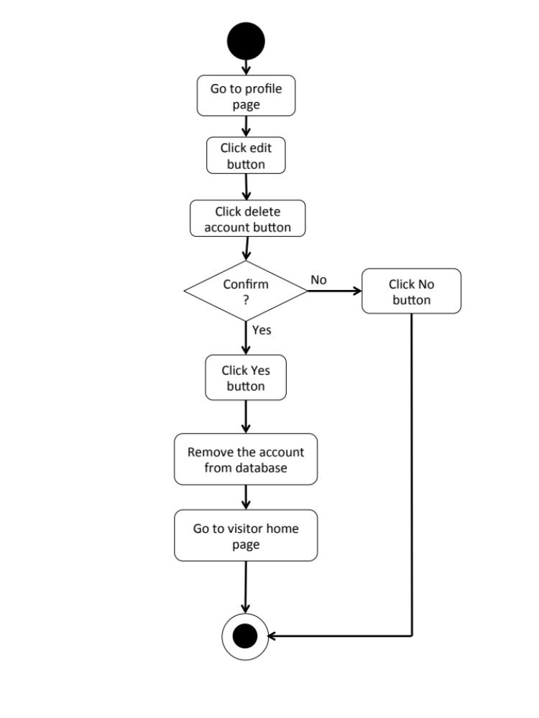

Feature 2: Tutorial Management
W-URS-10: The user randomly sees tutorials that exist in database.
Input and Output
- Input: The user selects random link to see random tutorials.
- Output: The system shows list of all tutorials with tutorial picture, title, owner username, and number of likes that exist in the database randomly.

Description
URS ID | W-URS-10
URS Name | The user randomly sees tutorials that exist in database.
Actor | Visitor, Blogger
Description | This function allows user to explore tutorials by randomly go through list of various tutorials that exist in database.
Trigger | The user selects “Random” to see random tutorials.
Pre-condition | - User stays on Home page.
Post-condition | - System displays list of all tutorials that exist in the database randomly.
Normal flow | 1) User selects “Random” on the Home page.  2) System gets tutorials information from database.  3) System displays list of all tutorials with tutorial picture, title, owner username, and number of likes that exist in the database randomly.
Alternative flow | -
Exception | In all steps of normal flow, in case there is no internet connection.
Include | W-URS-02

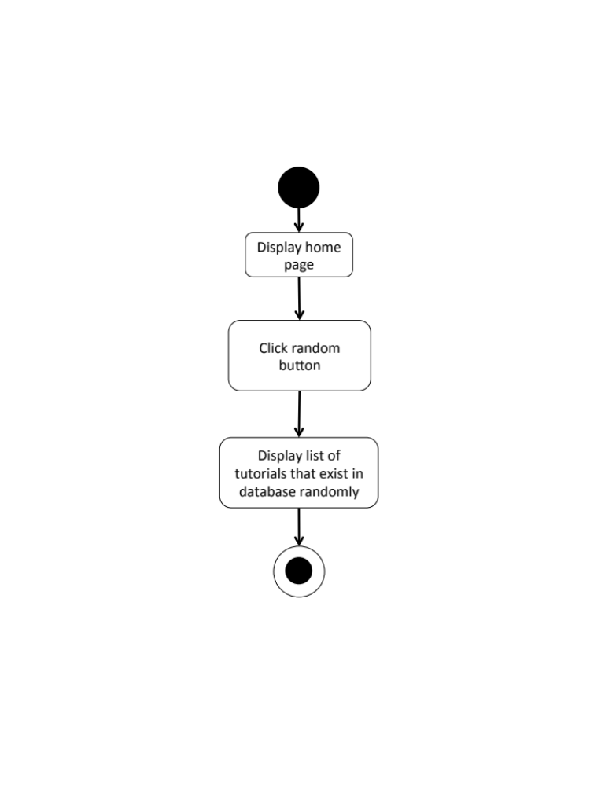
W-AD-09

W-URS-11: The user sees tutorials that exist in database by popularity according to number of likes.
Input and Output
- Input: The user selects popular link to see popular tutorials.
- Output: The system shows list of all tutorials with tutorial picture, title, owner username, and number of likes that exist in the database from the most liked to the less.

Description
URS ID | W-URS-11
URS Name | The user sees tutorials that exist in database by popularity according to number of likes.
Actor | Visitor, Blogger
Description | This function allows user to explore tutorials that has mostly liked within the current month and go through list of various tutorials that exist in database.
Trigger | The user selects “Popular” to see popular tutorials.
Pre-condition | - User stays on Home page.
Post-condition | - System displays list of all tutorials that exist in the database from the most liked to the less.
Normal flow | 1) User selects “Popular” on the Home page.  2) System gets tutorials information from database.  3) System displays list of all tutorials with tutorial picture, title, owner username, and number of likes that exist in the database from the most liked to the less of the current month.
Alternative flow | -
Exception | In all steps of normal flow, in case there is no internet connection.
Include | W-URS-02

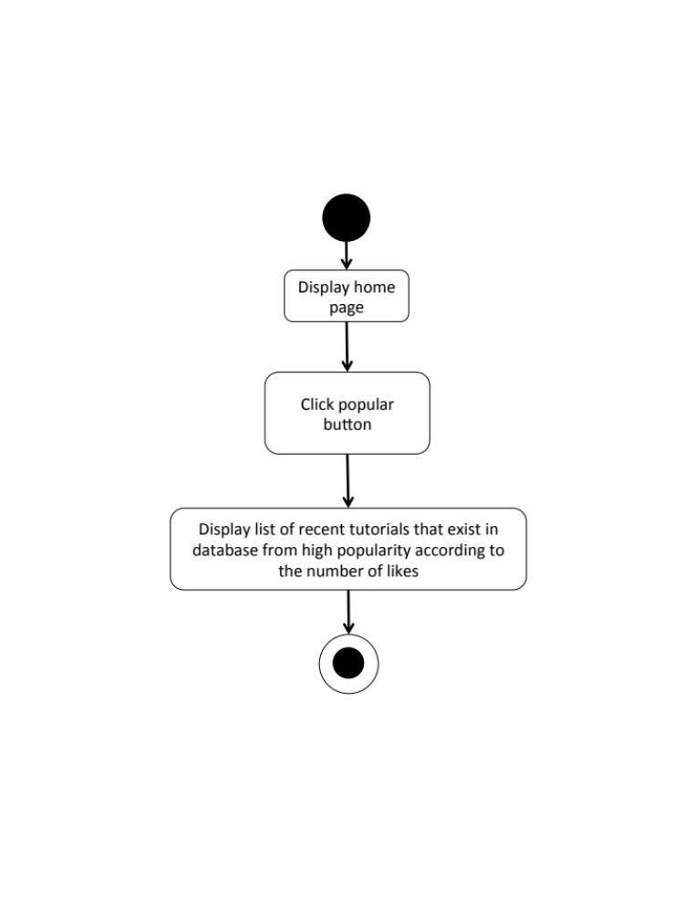
W-AD-10

W-URS-12: The user sees tutorials that exist in database by choosing a category.

Input and Output
- Input: The user selects a category link to see tutorials by category.
- Output: The system shows list of tutorials with tutorial picture, title, owner username, and number of likes of the selected category that exist in the database.

Description
URS ID | W-URS-12
URS Name | The user sees tutorials that exist in database by choosing a category.
Actor | Visitor, Blogger
Description | This function allows user to explore tutorials according to the category that the user selects and go through list of various tutorials that exist in database.
Trigger | The user selects a category on Home page.
Pre-condition | User stays on Home page
Post-condition | - System displays list of tutorials of the category.
Normal flow | 1) System displays categories, which are outfit, accessory, gift, kid, garden, home décor, pet, and other.  2) User selects a category.  3) System gets tutorials information from database.  4) System displays list of tutorials with tutorial picture, title, owner username, and number of likes of the selected category that exist in the database.
Alternative flow | -
Exception | In all steps of normal flow, in case there is no internet connection.
Include | W-URS-02

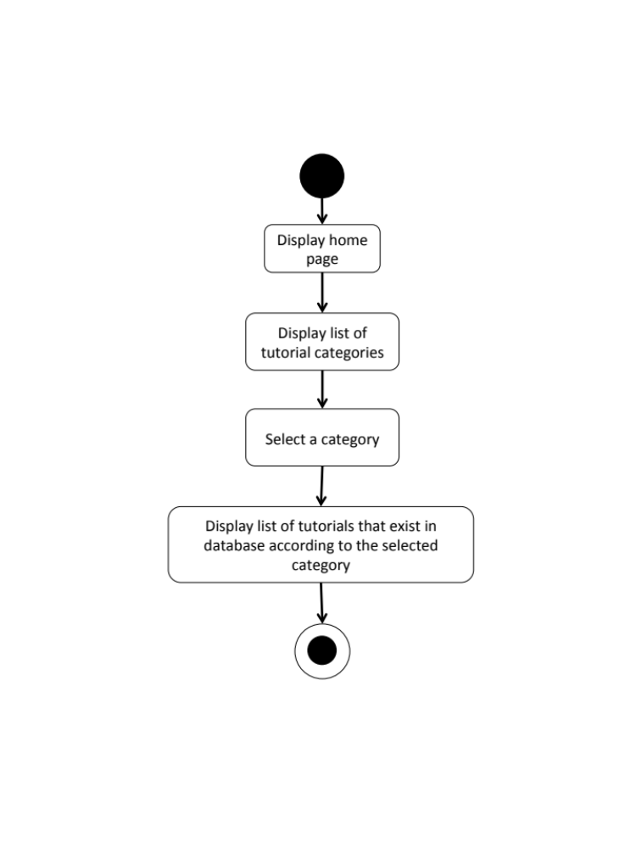
W-AD-11

W-URS-13: The user search tutorials’ title that exist in database by inputting a keyword.

Input and Output
No | Input Name | Description | Example | Remarks | Output
1 | Keyword | The length of Keyword must be between 1-20 characters | “Bracelet” | The word should not contain any symbol. | The system shows tutorials that have the word “Bracelet” as a tutorial name.

Description
URS ID | W-URS-13
URS Name | The user search tutorials’ title that exist in database by inputting a keyword.
Actor | Visitor, Blogger
Description | This function allows user to search certain kind of tutorials by inputting a keyword and go through list of various tutorials that exist in database.
Trigger | The user clicks on the search box.
Pre-condition | - User stays on Home page.
Post-condition | - System displays list of all tutorials that relate to the keyword.
Normal flow | 1) User input a keyword in the search box.  2) System gets tutorials information from database.  3) System displays list of all tutorials with tutorial picture, title, owner username, and number of likes that relate to the keyword.
Alternative flow | -
Exception | In all steps of normal flow, in case there is no internet connection.
Include | W-URS-02

W-AD-12
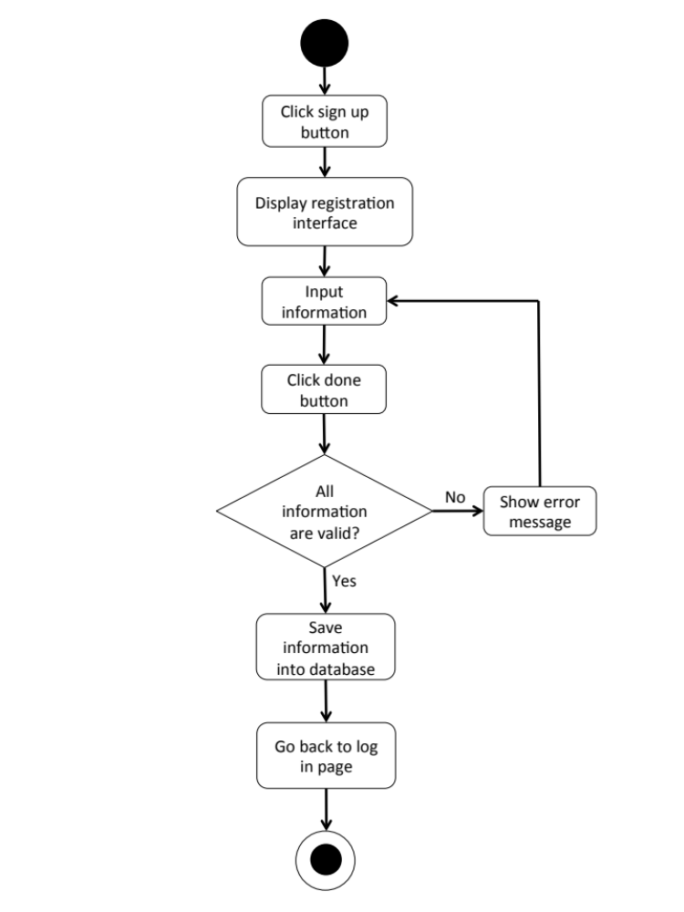

W-URS-14: The user sees tutorials that exist in database from following bloggers.

Input and Output
- Input: The user selects following link to see following tutorials.
- Output: The system shows list of tutorials with tutorial picture, title, owner username, and number of likes from the following bloggers.

Description
URS ID | W-URS-14
URS Name | The user sees tutorials that exist in database from following bloggers.
Actor | Blogger
Description | This function allows user to explore tutorials of bloggers that the user has followed and go through list of various tutorials that exist in database.
Trigger | The user selects “Following” to see tutorials from the bloggers that the user is following.
Pre-condition | - User has logged in to the system.  - User stays on Home page.
Post-condition | - System displays list of tutorials from the following bloggers.
Normal flow | 1) User tab “Following” on the Home page.  2) System gets tutorials of following bloggers from database.  3) System displays list of tutorials with tutorial picture, title, owner username, and number of likes from the following bloggers.
Alternative flow | - In step 1, the user cannot use this function if the user has not logged in as a blogger yet.
Exception | In all steps of normal flow, in case there is no internet connection.
Include | W-URS-02

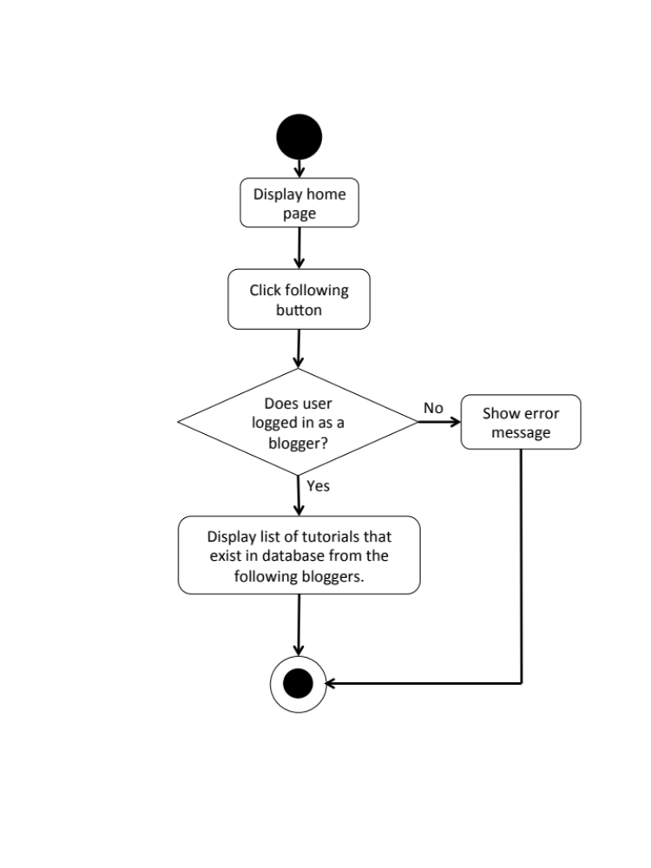
W-AD-13

W-URS-15: The user sees selected tutorial information.
Input and Output
- Input: The user selects tutorial link to see tutorial’s detail.
- Output: The system shows information of the tutorial, which are title, owner username, number of likes, category, material picture, material description, step description, step picture, video, and comments.

Description
URS ID | W-URS-15
URS Name | The user sees selected tutorial information.
Actor | Visitor, Blogger
Description | This function allows user to see information, which are title, owner username, number of likes, category, material picture, material description, step description, step picture, video, and comments of the selected tutorial.
Trigger | The user selects a tutorial to see the information.
Pre-condition | - User selects a tutorial.
Post-condition | - System displays all information of the tutorial.
Normal flow | 1) User selects a tutorial.  2) System gets the tutorial’s information from database.  3) System displays all information of the tutorial, which are title, owner username, number of likes, category, material picture, material description, step description, step picture, video, and comments.
Alternative flow | -
Exception | In all steps of normal flow, in case there is no internet connection.
Include | W-URS-02

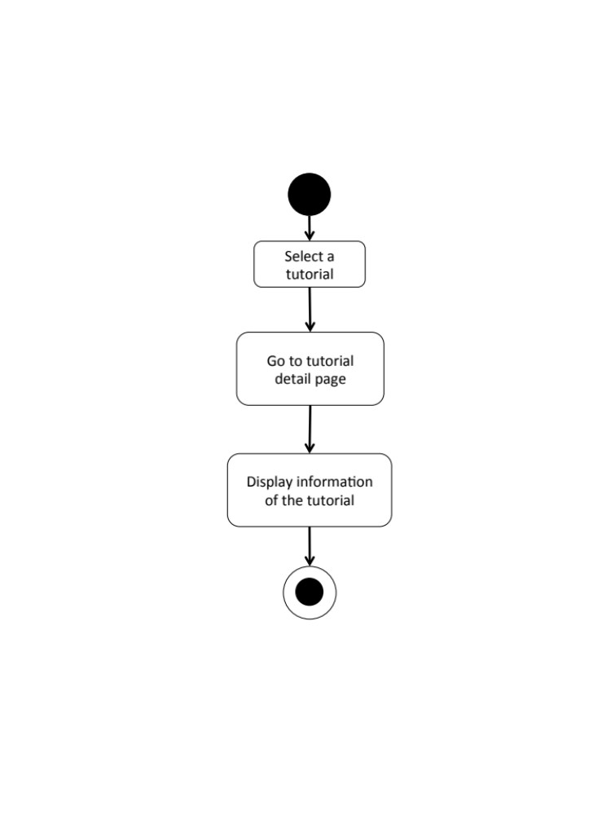
W-AD-14

W-URS-16: The user creates his/her own tutorial, which includes tutorial detail.

Input and Output
No | Input Name | Description | Example | Remarks | Output
1 | Tutorial Picture | The file type must be .jpg or .png | “IMG_tutorial.jpg” | - | The system shows “IMG_tutorial.jpg” on the screen
2 | Title | The length of Title must be between 1-20 characters | “Handmade Bracelet” | The word should not contain any symbol. | The system shows “Handmade Bracelet” on the screen
3 | Category | The categories are provided by the system. | “Accessory” | - | The system shows “Accessory” on the screen
4 | Material Picture | The file type must be .jpg or .png | “IMG_material.jpg” | - | The system shows “IMG_material.jpg” on the screen
5 | Material Description | The length of Material Description must be between 1-500 characters | “1.Rope 2.Glue 3.Scissor 4.Glitter 5.Pin” | - | The system shows “1.Rope 2.Glue 3.Scissor 4.Glitter 5.Pin”on the screen
6 | Step Number | The number of step should be between 1-10 | “1” | No symbol or character is allowed. | The system shows “1” on the screen
7 | Step Picture | The file type must be .jpg or .png | “IMG_step1.jpg” | - | The system shows “IMG_step1.jpg” on the screen
8 | Step Description | The length of Step Description must be between 1-500 characters | “Cut the rope to have the length as long as it can be out around your wrist.” | - | The system shows “Cut the rope to have the length as long as it can be out around your wrist.” On the screen
9 | Video | The file type must be .mov | “VDO_tutorial.mov” | - | The system shows “VDO_tutorial.mov” on the screen

Description
URS ID | W-URS-16
URS Name | The user creates his/her own tutorial, which includes tutorial detail.
Actor | Blogger
Description | This function allows user to create his/her own tutorial by inputting information, which are tutorial picture, title, category, material, material picture, step description, step picture, and video for a tutorial.
Trigger | The user selects “Create” to create a new tutorial.
Pre-condition | - User has logged in to the system.
Post-condition | - System stores the created tutorial into database.
Normal flow | 1) User clicks create button.  2) System provides create tutorial interface for user to fill information, which are tutorial picture, title, category, material, material picture, step description, step picture, and video.  3) User inputs the information.  4) User input the information step by step.  5) User clicks done button.  6) System validates tutorial picture, title, category, material picture, material description, step number, step picture, step description, and video format.  7) System saves the tutorial into the database.  8) System shows successful message.
Alternative flow | - In step 1-5, the user clicks back button to go to the previous page in case he/she wants to cancel the tutorial creating process.
Exception | - In step 6, system displays error message in case the format is wrong.  - In all steps of normal flow, in case there is no internet connection.
Include | W-URS-02

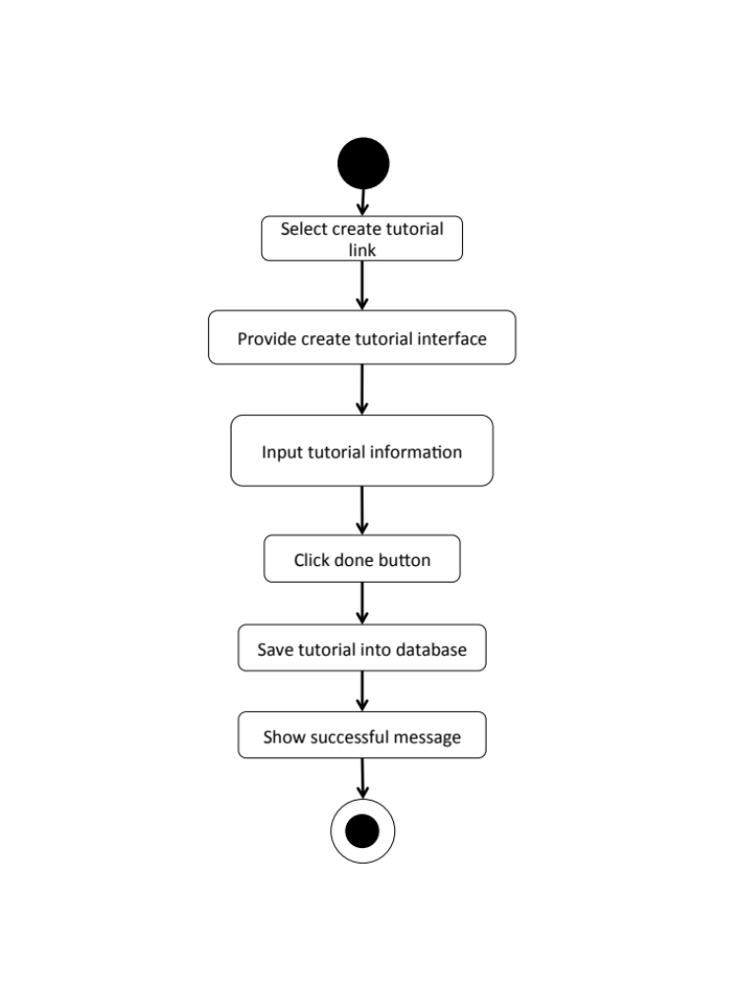
W-AD-15

W-URS-17: The user sees detail of his/her own tutorial.
Input and Output
- Input: The user selects profile link to go to profile page.
- Output: The system shows user’s profile including list of his/her tutorials.

Description
URS ID | W-URS-17
URS Name | The user sees detail of his/her own tutorial.
Actor | Blogger
Description | This function allows user to see his/her own tutorial and information, which are tutorial picture, title, category, material, material picture, step description, step picture, and video of the tutorial.
Trigger | The user selects “Profile” to see his/her information including his/her own tutorials.
Pre-condition | - User has logged in to the system.  - User goes to his/her profile page
Post-condition | - System shows tutorials that the user has created.
Normal flow | - User goes to profile page.  - System gets user’s information from database.  3) System displays interface and user’s information, which are profile picture, username, password, follower number, following number, and list of tutorials that he/she has created.
Alternative flow | -
Exception | In all steps of normal flow, in case there is no internet connection.
Include | W-URS-02

W-AD-16
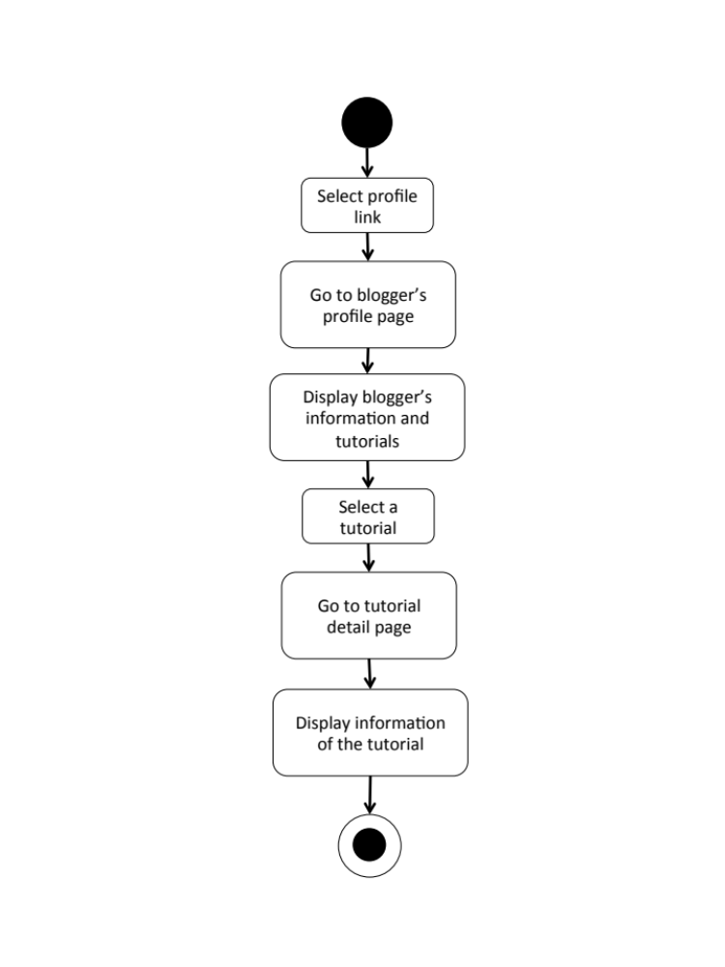

W-URS-18: The user edits detail of his/her own tutorial.

Input and Output
No | Input Name | Description | Example | Remarks | Output
1 | Tutorial Picture | The file type must be .jpg or .png | “IMG_tutorial2.jpg” | - | The system shows “IMG_tutorial2.jpg” on the screen
2 | Title | The length of Title must be between 1-20 characters | “DIY Bracelet” | The word should not contain any symbol. | The system shows “How to make a Handmade Bracelet by yourself” on the screen
3 | Category | The categories are provided by the system. | “Outfit” | - | The system shows “Accessory” on the screen
4 | Material Picture | The file type must be .jpg or .png | “IMG_material2.jpg” | - | The system shows “IMG_material2.jpg” on the screen
5 | Material Description | The length of Material Description must be between 1-500 characters | “1.Rope 2.Glue 3.Scissor 4.Glitter 5.Pin 6.Color” | - | The system shows “1.Rope 2.Glue 3.Scissor 4.Glitter 5.Pin  6.Color” on the screen
6 | Step | The number of step should be between 1-10 | “2” | No symbol or character is allowed. | The system shows “2” on the screen
7 | Step 1 Picture | The file type must be .jpg or .png | “IMG_step1.jpg” | - | The system shows “IMG_step1.jpg” on the screen
8 | Step 1 Description | The length of Step Description must be between 1-500 characters | “Cut the rope to have the length as long as it can be out around your wrist.  Be careful when you cut it!” | - | The system shows “Cut the rope to have the length as long as it can be out around your wrist. Be careful when you cut it!” on the screen
9 | Step 2 Picture | The file type must be .jpg or .png | “IMG_step2.jpg” | - | The system shows “IMG_step2.jpg” on the screen
10 | Step 2 Description | The length of Step Description must be between 1-500 characters | “Now it’s time to decorate!” | - | The system shows “Now it’s time to decorate!” on the screen
11 | Video | The file type must be .mov | “VDO_tutorial2.mov” | - | The system shows “VDO_tutorial2.mov” on the screen

Description
URS ID | W-URS-18
URS Name | The user edits detail of his/her own tutorial.
Actor | Blogger
Description | This function allows user to make some changes on his/her own tutorial and information, which are tutorial picture, title, category, material, material picture, step description, step picture, and video of the tutorial.
Trigger | The user selects “Edit” to edit the selected tutorial.
Pre-condition | - User has logged in to the system.
Post-condition | - System updates new information of the tutorial.
Normal flow | 1) User selects a tutorial that wants to be edited.  2) User clicks edit button.  3) System provides the editable interface for user to edit tutorial picture, title, category, material picture, material description, step number, step picture, step description, and video.  4) User clicks save.  5) System validates tutorial picture, title, category, material picture, material description, step number, step picture, step description, and video format.  6) System saves the edited tutorial into the database.  7) System shows successful message.
Alternative flow | - In step 1, the user clicks back button to cancel the process.  - In step 5, the system shows an error message if the user has input wrong information.
Exception | - In all steps of normal flow, in case there is no internet connection.
Include | W-URS-02

W-AD-17
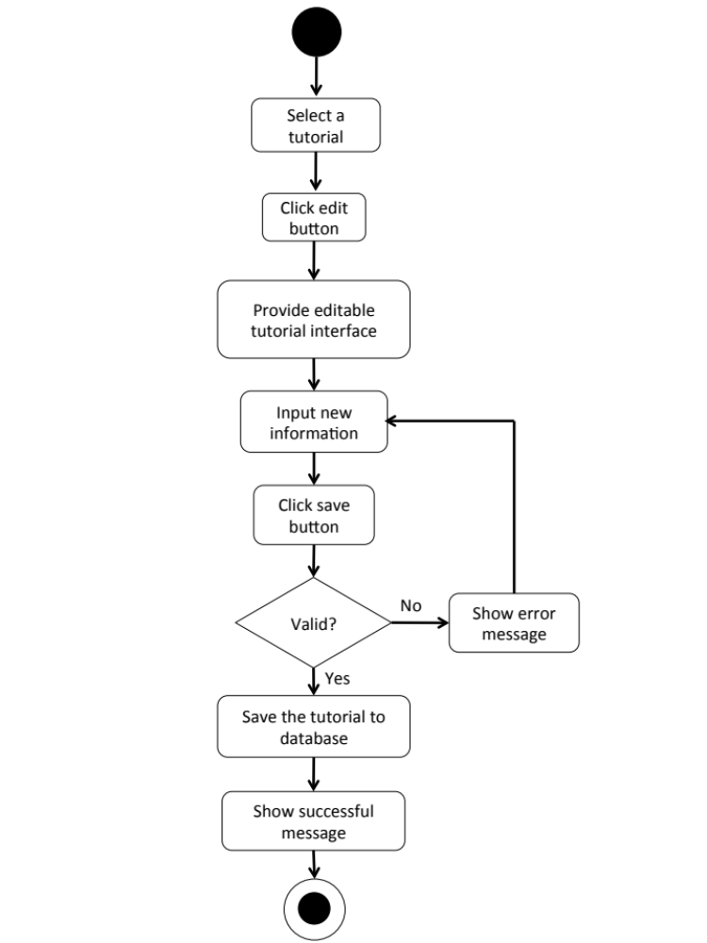

W-URS-19: The user deletes his/her own tutorial.

Input and Output
- Input: The user selects delete tutorial link to delete his/her tutorial.
- Output: The tutorial disappears from the tutorial list.

Description
URS ID | W-URS-19
URS Name | The user deletes his/her own tutorial.
Actor | Blogger
Description | This function allows user to remove his/her own tutorial from the database.
Trigger | The user selects “Delete tutorial” to remove tutorial from the database.
Pre-condition | - User has logged in to the system.  - User selects the tutorial that wants delete.
Post-condition | - System removes the tutorial from the database.
Normal flow | 1) User clicks delete button.  2) System shows confirmation message with yes/no button.  3) User clicks yes button.  4) System removes the tutorial from the database.  5) System shows successful message.
Alternative flow | - In step 3, the user clicks no button to cancel the tutorial deletion process.
Exception | In all steps of normal flow, in case there is no internet connection.
Include | W-URS-02

W-AD-18
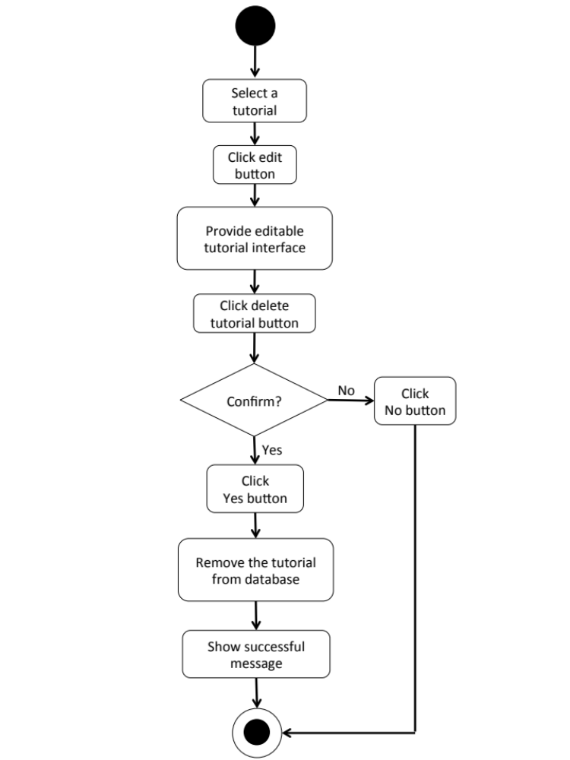

Feature 3: Shop Management
W-URS-20: The user randomly sees shops that exist in database.
Input and Output
- Input: The user selects random link to see random shops.
- Output: The system shows list of all shops with shop picture, shop name, and shopkeeper username that exist in the database randomly.

Description
URS ID | W-URS-20
URS Name | The user randomly sees shops that exist in database.
Actor | Blogger
Description | This function allows user to explore shops by randomly go through list of various shops that exist in database.
Trigger | The user selects “Shop” menu to see random shops.
Pre-condition | - User stays on Shop page.
Post-condition | - System displays list of all shops that exist in the database randomly.
Normal flow | 1) User selects “Shop” menu.  2) System gets shops information from database.  3) System displays list of all shops with shop picture, shop name, and shopkeeper username that exist in the database randomly.
Alternative flow | -
Exception | In all steps of normal flow, in case there is no internet connection.
Include | W-URS-02

W-AD-19

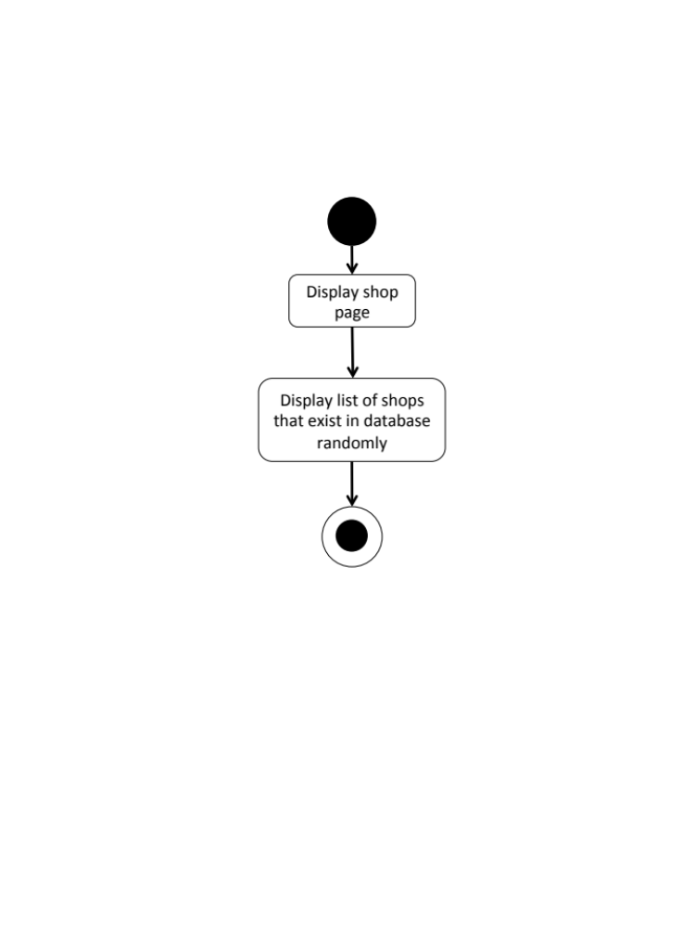

W-URS-21: The user sees shops that exist in database by choosing a category.

Input and Output
- Input: The user selects a category link to see shops by category.
- Output: The system shows list of shops with shop picture, shop name, and shopkeeper username of the selected category that exist in the database.

Description
URS ID | W-URS-21
URS Name | The user sees shops that exist in database by choosing a category.
Actor | Blogger
Description | This function allows user to explore shops according to the category that the user selects and go through list of various shops that exist in database.
Trigger | The user selects a category to see shops according to the selected category.
Pre-condition | - User goes to Shop page.
Post-condition | - System displays list of shops of the category.
Normal flow | 1) System displays categories, which are fabric, accessory, wood, stationary, container and other.  2) User selects a category.  3) System gets shops information from database.  4) System displays list of shops with shop picture, shop name, and shopkeeper username of the selected category that exist in the database.
Alternative flow | -
Exception | In all steps of normal flow, in case there is no internet connection.
Include | W-URS-02

W-AD-20
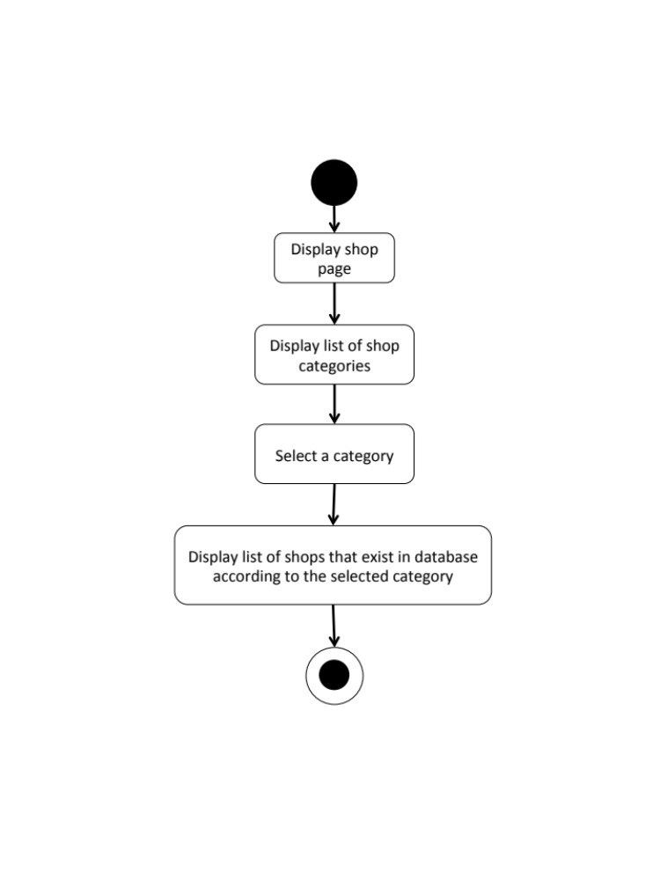

W-URS-22: The user search shop’s name that exist in database by inputting a keyword.

Input and Output
No | Input Name | Description | Example | Remarks | Output
1 | Keyword | The length of Keyword must be between 1-20 characters | “Pin” | The word should not contain any symbol. | The system shows shops that have the word “Pin” as a shop name.

Description
URS ID | W-URS-22
URS Name | The user search shop’s name that exist in database by inputting a keyword.
Actor | Blogger
Description | This function allows user to search certain kind of shops by inputting a keyword and go through list of various shops that exist in database.
Trigger | The user clicks on the search box.
Pre-condition | - User stays on Shop page.
Post-condition | - System displays list of all shops that relate to the keyword.
Normal flow | 1) User input a keyword in the search box.  2) System gets shops information from database.  3) System displays list of all shops with shop picture, shop name, and shopkeeper username that relate to the keyword.
Alternative flow | -
Exception | In all steps of normal flow, in case there is no internet connection.
Include | W-URS-02

W-AD-21
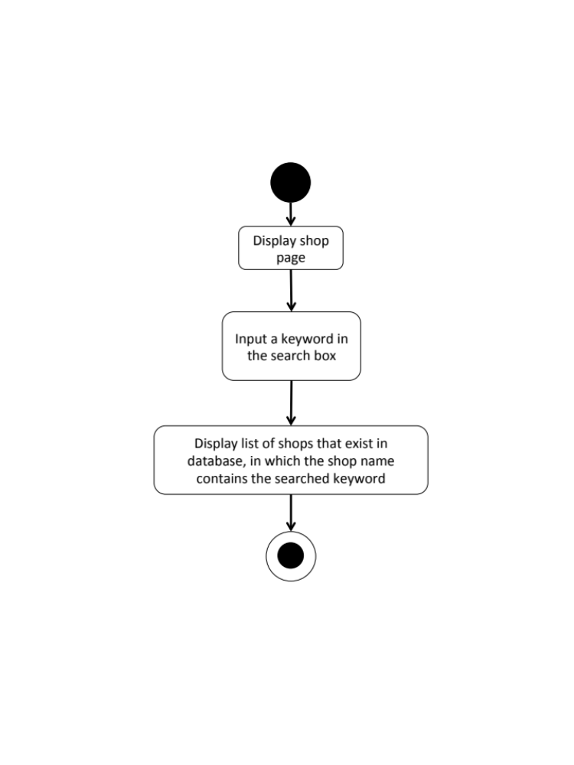

W-URS-23: The user sees selected shop information.
Input and Output
- Input: The user selects shop link to see shop’s detail.
- Output: The system shows information of the shop, which are shop name, shopkeeper username, branch, telephone number, information, pictures, and shop’s location.

Description
URS ID | W-URS-23
URS Name | The user sees selected shop information.
Actor | Blogger
Description | This function allows user to see information, which are shop name, shopkeeper username, branch, telephone number, information, pictures, and shop’s location of the selected tutorial.
Trigger | The user selects a shop to see the information.
Pre-condition | - User selects a shop.
Post-condition | - System displays all information of the shop.
Normal flow | 1) User selects a shop.  2) System gets the shop’s information from database.  3) System displays all information of the shop, which are shop name, shopkeeper username, branch, telephone number, information, pictures, and shop’s location.
Alternative flow | -
Exception | In all steps of normal flow, in case there is no internet connection.
Include | W-URS-02

W-AD-22
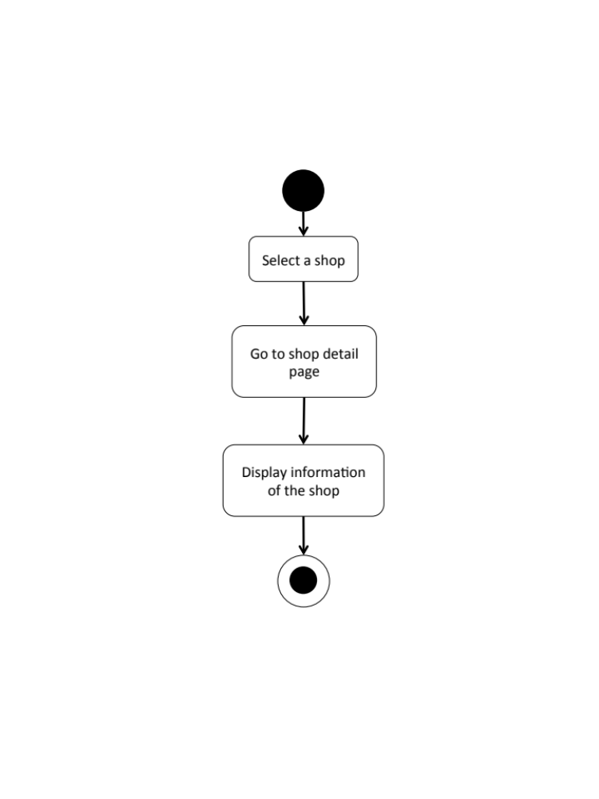

Feature 4: Map Management
W-URS-24: The user sees shop’s location on Google Map.
Input and Output
- Input: The user selects shop location link to see the location on Google Map.
- Output: The system shows the exact shop’s location on Google Map.

Description
URS ID | W-URS-24
URS Name | The user sees shop’s location on Google Map.
Actor | Blogger, Shopkeeper
Description | This function allows user to see the exact location of the selected shop on Google Map.
Trigger | The user selects shop location link to see the location on Google Map.
Pre-condition | - User selected a shop.
Post-condition | - System shows shop’s location on Google Map.
Normal flow | 1) User selects a shop.  2) System gets the shop’s information from database.  3) System displays all information of the shop, which are shop name, shopkeeper username, branch, telephone number, information, pictures, and shop’s location.  4) User selects shop location link.  5) System connects with Google Map.  6) System retrieves the location from database.  7) System shows the exact shop’s position on Google Map.
Alternative flow | -
Exception | In all steps of normal flow, in case there is no internet connection.
Include | W-URS-02

W-AD-23
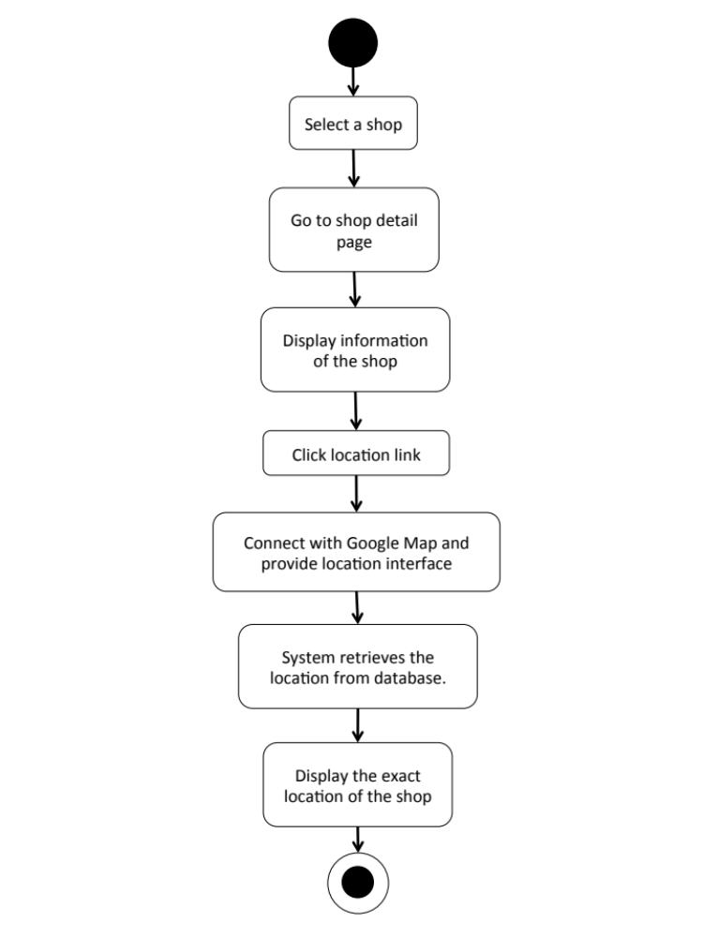

Feature 5: Communication Management
W-URS-25: The user sees comments on tutorial.
Input and Output
- Input: The user selects tutorial link to see tutorial’s detail.
- Output: The system shows information of the tutorial including comments.

Description
URS ID | W-URS-25
URS Name | The user sees comments on tutorial.
Actor | User, Blogger
Description | This function allows user to see comments that exist in database on a tutorial.
Trigger | -
Pre-condition | - User has logged in to the system.  - User stays on tutorial detail page.
Post-condition | - System displays all comments of the tutorial.
Normal flow | - User selects a tutorial.  - System gets the tutorial’s information from database.  - System displays all information of the tutorial, which are title, owner username, number of likes, category, material picture, material description, step description, step picture, video, and comments.  - System gets comment information, which are profile picture and username of the blogger that commented, and comment detail from database.  - System displays all comments of the tutorial.
Alternative flow | -
Exception | In all steps of normal flow, in case there is no internet connection.
Include | -

W-AD-24

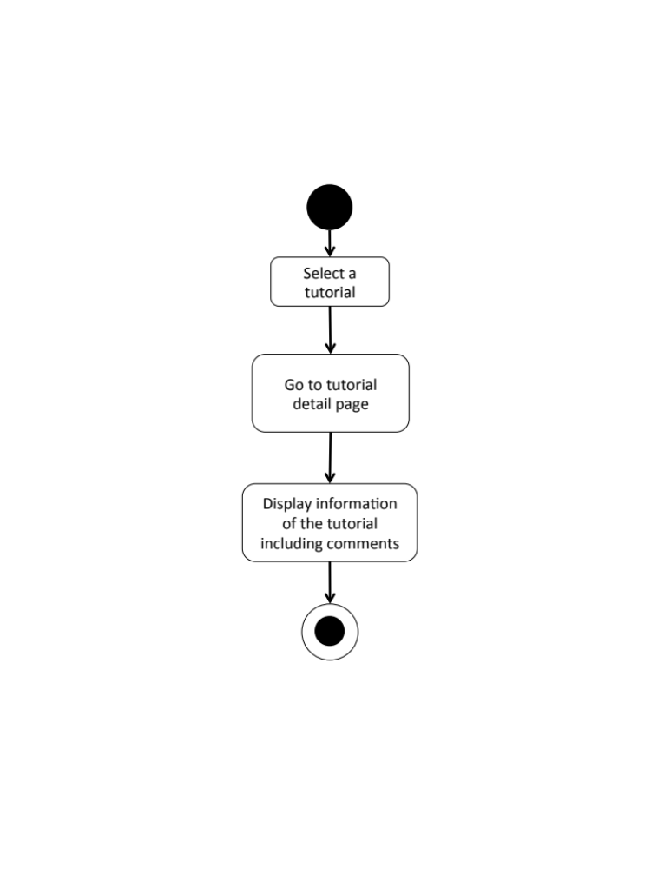

W-URS-26: The user adds comments on tutorial.
Input and Output
No | Input Name | Description | Example | Remarks | Output
1 | Comment | The length of Comment must be between 1-500 characters | “Awesome tutorial!” | - | The system shows “Awesome tutorial!” on the screen.

Description
URS ID | W-URS-26
URS Name | The user adds comments on tutorial.
Actor | Blogger
Description | This function allows user and other bloggers to communicate to each other by commenting on a certain tutorial.
Trigger | The user selects “Comment” to post comment on tutorial.
Pre-condition | - User has logged in to the system.  - User stays on tutorial detail page.
Post-condition | - System displays the comment on the tutorial detail page.
Normal flow | 1) System provides a comment box.  2) User types a comment within 500 characters.  3) User clicks comment button.  4) System validates the comment format.  5) System saves the comment into database.  6) System displays the comment on the tutorial detail page.
Alternative flow | In step 4, if the comment is not in the right format, the system displays an error message.
Exception | In all steps of normal flow, in case there is no internet connection.
Include | W-URS-02

W-AD-25
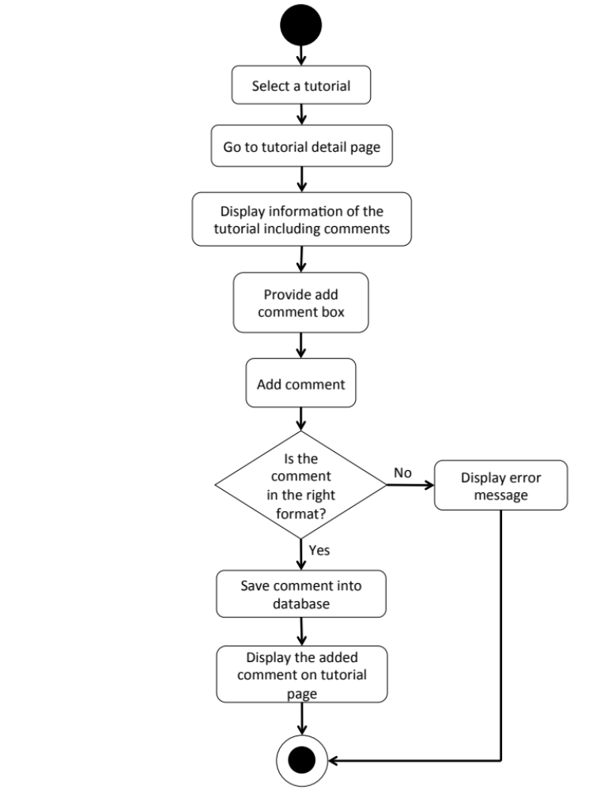

W-URS-27: The user likes a tutorial.
Input and Output
- Input: The user selects like on tutorial.
- Output: The system shows the liked sign on tutorial.

Description
URS ID | W-URS-27
URS Name | The user likes a tutorial.
Actor | Blogger
Description | This function allows user to give a like on his/her favorite tutorial.
Trigger | The user selects “Like” to like the tutorial.
Pre-condition | - User has logged in to the system.  - User stays on tutorial detail page.
Post-condition | - System increase like number of the tutorial.
Normal flow | 1) User clicks like button.  2) System checks whether the user has liked this tutorial or not.  3) System adds information, which are likeID, tutorialID, and userID in like table in database.  4) System checks whether the tutorial id already exist in popular table or not.  5) System increases like_number in popular table by one.  6) System shows updated number of likes of the tutorial.
Alternative flow | In step 3, the system goes to W-URS-28  In step 4, the system adds information, which are popularID, tutorialID, and like_number in popular table by one.
Exception | In all steps of normal flow, in case there is no internet connection.
Include | W-URS-02, W-URS-15

W-URS-28: The user undo likes from the liked tutorial.
Input and Output
- Input: The user selects like on the liked tutorial.
- Output: The system shows the like sign on tutorial.

Description
URS ID | W-URS-28
URS Name | The user undo likes from the liked tutorial.
Actor | Blogger
Description | This function allows user to remove the like that the user gave for a tutorial.
Trigger | The user selects “Liked” to undo like the tutorial.
Pre-condition | - User has logged in to the system.  - User stays on tutorial detail page.  - User liked the tutorial.
Post-condition | - System decrease like number of the tutorial.
Normal flow | 1) User clicks liked button.  2) System checks whether the user has liked this tutorial or not.  3) System deletes information, which are likeID, tutorialID, and userID in like table in database.  4) System checks whether the tutorial id already exist in popular table or not.  5) System decreses like_number in popular table by one.  6) System shows updated number of likes of the tutorial.
Alternative flow | In step 3, the system goes to W-URS-27  In step 4, the system deletes information, which are popularID, tutorialID, and like_number in popular table by one.
Exception | In all steps of normal flow, in case there is no internet connection.
Include | W-URS-02, W-URS-15, W-URS-27

W-AD-26

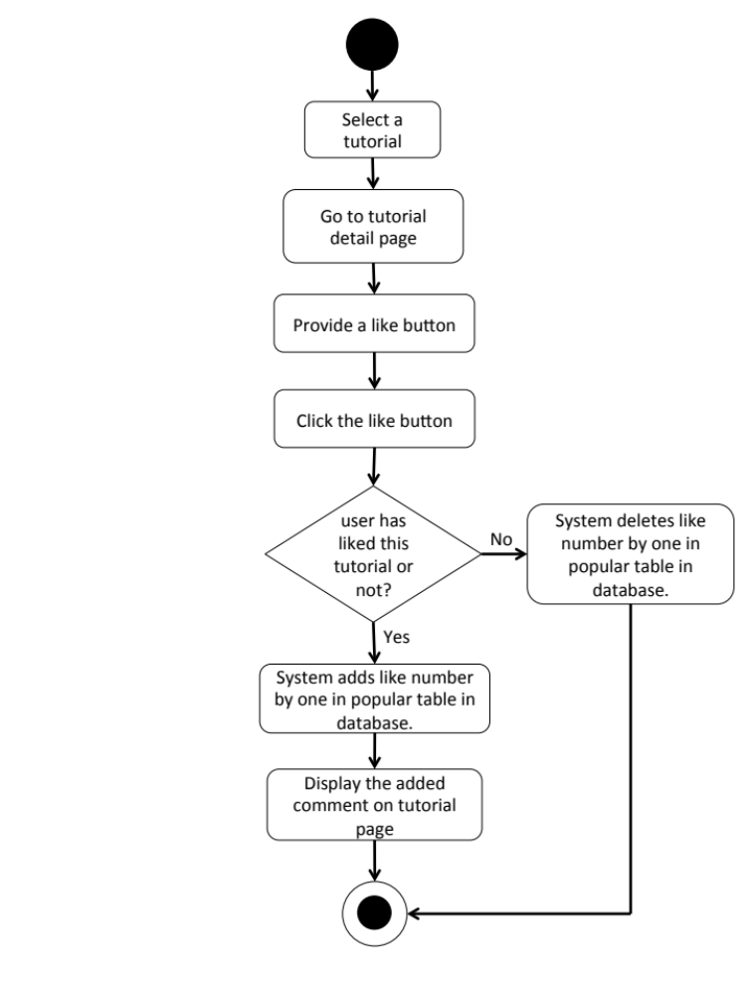

W-URS-29: The user follows other bloggers.
Input and Output
- Input: The user select follow on other blogger profile.
- Output: The system shows the followed sign on the blogger profile.

Description
URS ID | W-URS-29
URS Name | The user follows other bloggers.
Actor | Blogger
Description | This function allows user to follow other bloggers in order to catch up their new tutorials.
Trigger | The user selects “Follow” to follow the blogger.
Pre-condition | - User has logged in to the system.  - User stays on other blogger’s profile page.
Post-condition | - The system starts getting new information from the following blogger.
Normal flow | - System provides blogger’s profile interface.  - User clicks follow button.  - System checks whether the user has followed this user or not.  - System adds information, followID, following, and follower in follow table in database.  - System changes the sign on the button from follow to followed.
Alternative flow | W-URS-30
Exception | In all steps of normal flow, in case there is no internet connection.
Include | W-URS-02

W-URS-30: The user undo follows from the followed bloggers.
Input and Output
- Input: The user select followed on the followed blogger.
- Output: The system shows the follow sign on unfollowed blogger profile.

Description
URS ID | W-URS-30
URS Name | The user undo follows from the followed bloggers.
Actor | Blogger
Description | This function allows user to undo the follow process from the blogger that he/she is following.
Trigger | The user selects “Following” to undo follow the blogger.
Pre-condition | - User has logged in to the system.  - User stays on other blogger’s profile page.  - User followed the blogger.
Post-condition | - The system stops getting new information from the unfollow blogger.
Normal flow | - System provides blogger’s profile interface.  - User clicks follow button.  - System checks whether the user has followed this user or not.  - System deletes information, followID, following, and follower in follow table in database.  - System changes the sign on the button from followed to follow.
Alternative flow | W-URS-29
Exception | In all steps of normal flow, in case there is no internet connection.
Include | W-URS-02, W-URS-24

W-AD-27

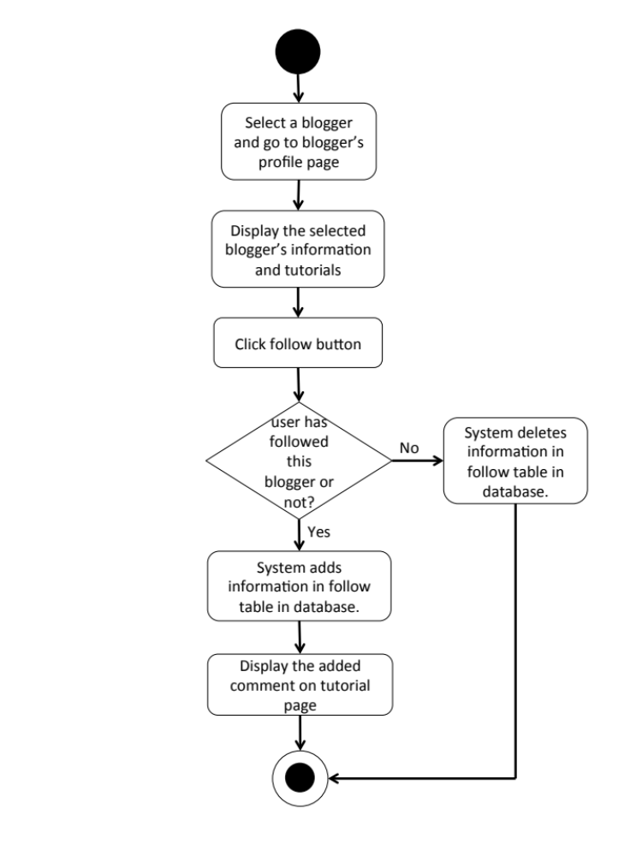

W-URS-31: The user sees list of bloggers whom the user is following.
Input and Output
- Input: The user select following link on other user’s profile page.
- Output: The system shows list of bloggers whom the user is following.

Description
URS ID | W-URS-31
URS Name | The user sees list of bloggers whom the user is following.
Actor | Blogger
Description | This function allows user to see list of the bloggers with their profile pictures and usernames that the user has been following.
Trigger | The user selects “Following” to undo follow the blogger.
Pre-condition | - User has logged in to the system.  - User stays on other blogger’s profile page.
Post-condition | - The system stops getting new information from the unfollowed blogger.
Normal flow | - User goes to profile page.  - System gets user’s information from database.  - System displays interface and user’s information, which are profile picture, username, password, follower number, following number, and list of tutorials that he/she has created.  - User clicks on see following link.  - System goes to following page.  - System get list of bloggers whom the user is following from database.  - System displays list of bloggers whom the user is following.
Alternative flow | -
Exception | In all steps of normal flow, in case there is no internet connection.
Include | W-URS-02, W-URS-24

W-AD-28
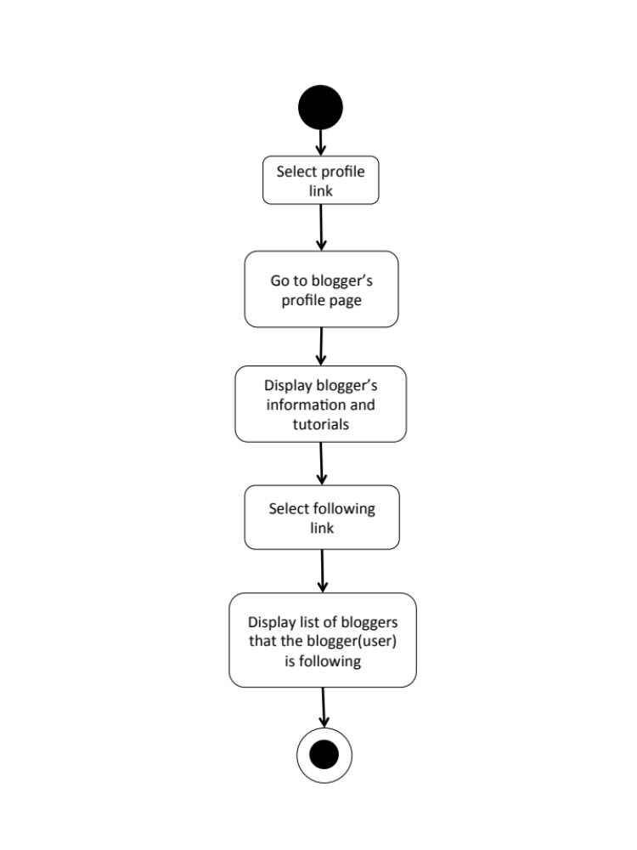

W-URS-32: The user sees list of bloggers who follows the user.
Input and Output
- Input: The user select follower link on other user’s profile page.
- Output: The system shows list of bloggers who follows the user.

Description
URS ID | W-URS-32
URS Name | The user sees list of bloggers who follows the user.
Actor | Blogger
Description | This function allows user to see list of the bloggers with their profile pictures and usernames that has been following the user.
Trigger | The user selects “Following” to undo follow the blogger.
Pre-condition | - User has logged in to the system.  - User stays on other blogger’s profile page.
Post-condition | - The system stops getting new information from the unfollowed blogger.
Normal flow | - User goes to profile page.  - System gets user’s information from database.  - System displays interface and user’s information, which are profile picture, username, password, follower number, following number, and list of tutorials that he/she has created.  - User clicks on see follower link.  - System goes to follower page.  - System get list of bloggers who follows the user from database.  - System displays list of bloggers who follows the user.
Alternative flow | -
Exception | In all steps of normal flow, in case there is no internet connection.
Include | W-URS-02

W-AD-29
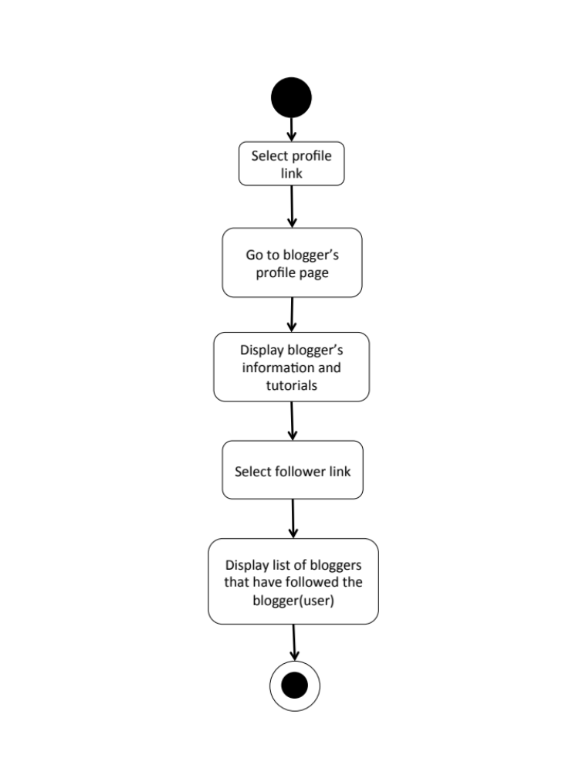

W-URS-33: The user sends private message.
Input and Output
No | Input Name | Description | Example | Remarks | Output
1 | Message | The length of Message must be between 1-500 characters | “Hello, I want to ask you something.” | - | The system shows “Hello, I want to ask you something.” on the screen.

Description
URS ID | W-URS-33
URS Name | The user sends private message.
Actor | Blogger
Description | This function allows user to start a private conversation with shopkeepers via messages.
Trigger | The user selects the conversation link between the user and the shopkeeper.
Pre-condition | - User has logged in to the system.  - User selects a shop that he/she wants to send message to.
Post-condition | - System sends message to the shopkeeper.
Normal flow | 1) User clicks message button.  2) System provides message interface.  3) User types a message in the message box.  4) User clicks send button.  5) System validates the message format.  6) System checks whether the first user, who sends a message and the second user, whom will receive the message have ever had a conversation between each other before or not.  7) System gets conversationID from conversation table in database  8) System saves the information, which are messageID, conversationID, userID, message_detail, and time into message table in database.  9) System displays the sent message on the private message page.
Alternative flow | In step 5, system adds information, which are conversationID, userID_1, and userID_2 in conversation table in database before proceed to step 6.
Exception | In all steps of normal flow, in case there is no internet connection.
Include | W-URS-02

W-AD-30
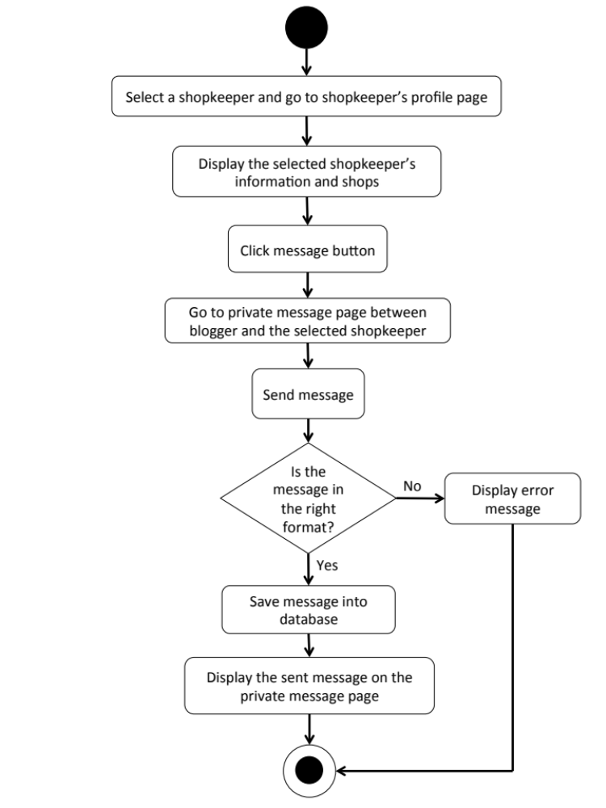

W-URS-34: The user receives private message.
- Input: The user selects message link to see messages.
- Output: The system shows messages that the user gets from a shopkeeper.

Description
URS ID | W-URS-34
URS Name | The user receives private message.
Actor | Blogger
Description | This function allows user to receive messages from the shopkeeper whom the user is talking with.
Trigger | The user selects the conversation link between the user and the shopkeeper.
Pre-condition | - User has logged in to the system.  - User stays on Message page.
Post-condition | - System displays received messages.
Normal flow | - User selects a conversation  - System gets conversationID from the selected conversation.  - System retrieves message information, which are user’s profile picture and username from registered user table by using userID, and message_detail and time from message table in database by using the conversationID.  - System displays message information according to time, the latest message will be in the bottom.
Alternative flow | -
Exception | In all steps of normal flow, in case there is no internet connection.
Include | W-URS-02

W-AD-31
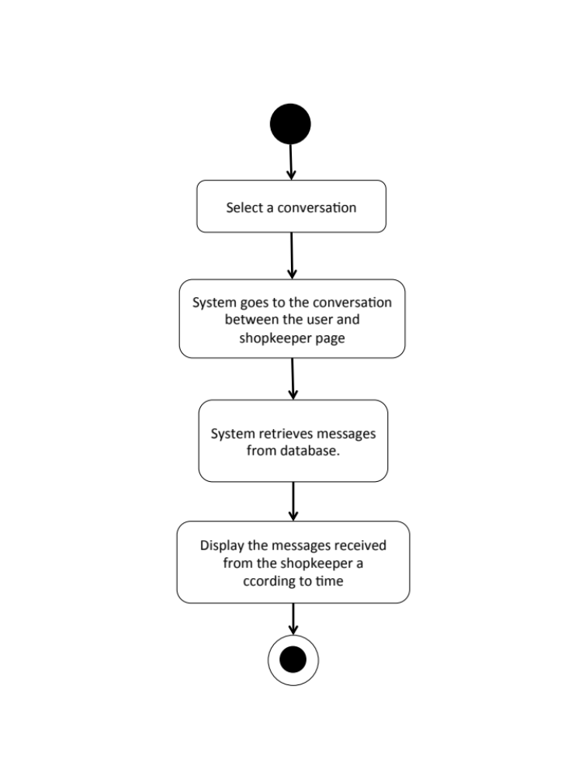

W-URS-35: The user sees list of shopkeepers that has been communicated with.
- Input: The user selects message link to see messages.
- Output: The system shows list of messages that the user gets.

Description
URS ID | W-URS-35
URS Name | The user sees list of shopkeepers that has been communicated with.
Actor | Blogger
Description | This function allows user to see the list of conversations with shopkeepers that the user has been communicated with.
Trigger | The user selects “Message” to go to message page.
Pre-condition | - User has logged in to the system.
Post-condition | - System displays list of conversations.
Normal flow | - User goes to message page.  - System provides user interface of message page.  - System takes the user’s username to find the people who have already had a conversation with the user in conversation table in database.  - System shows list of conversations including the date and time, shop/blogger picture, and shop name/ blogger username, and time.
Alternative flow | -
Exception | In all steps of normal flow, in case there is no internet connection.
Include | W-URS-02, W-URS-28, W-URS-29

W-AD-32
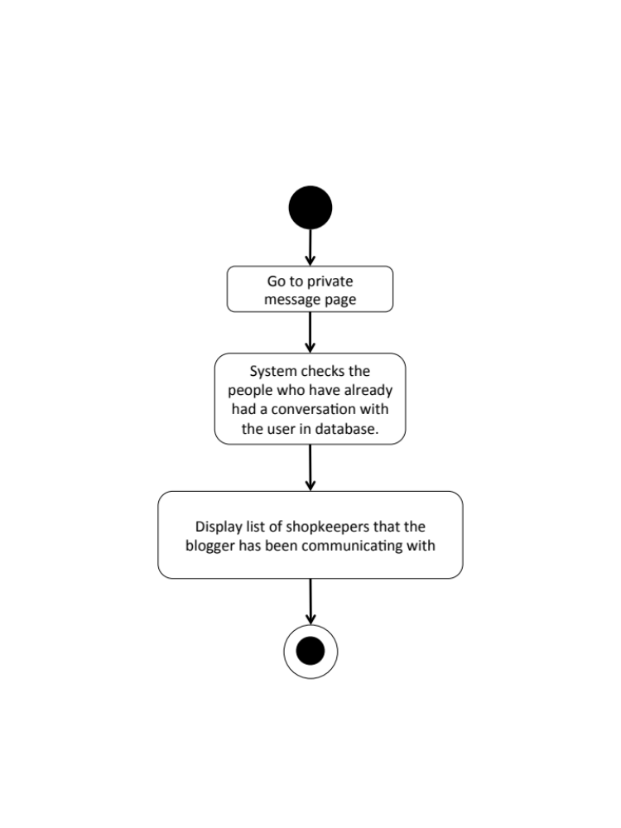

W-URS-36: The user shares tutorial to Facebook.
Input and Output
- Input: The user selects share link to share the tutorial to Facebook.
- Output: The system posts the tutorial on user’s Facebook wall.

Description
URS ID | W-URS-36
URS Name | The user shares tutorial to Facebook.
Actor | Visitor, Blogger
Description | This function allows user to share a tutorial on his/her Facebook wall, and also able to write something about the tutorial.
Trigger | The user selects “Share” to share the tutorial on user’s Facebook wall.
Pre-condition | - User stays on tutorial detail page.
Post-condition | - The tutorial is posted in user’s Facebook wall
Normal flow | - User clicks share to Facebook button.  - System access to the user’s Facebook account from the user’s web browser.  3) System displays confirmation post of the tutorial.  4) User writes some message about the tutorial.  5) User clicks post button.  6) System posts the tutorial on user’s Facebook wall.
Alternative flow | - In step 3, the user leaves the field blank in case he/she does not want to write anything about the tutorial.  - In step 4, the user clicks cancel button to cancel the tutorial sharing process.
Exception | In all steps of normal flow, in case there is no internet connection.
Include | W-URS-15

W-AD-33

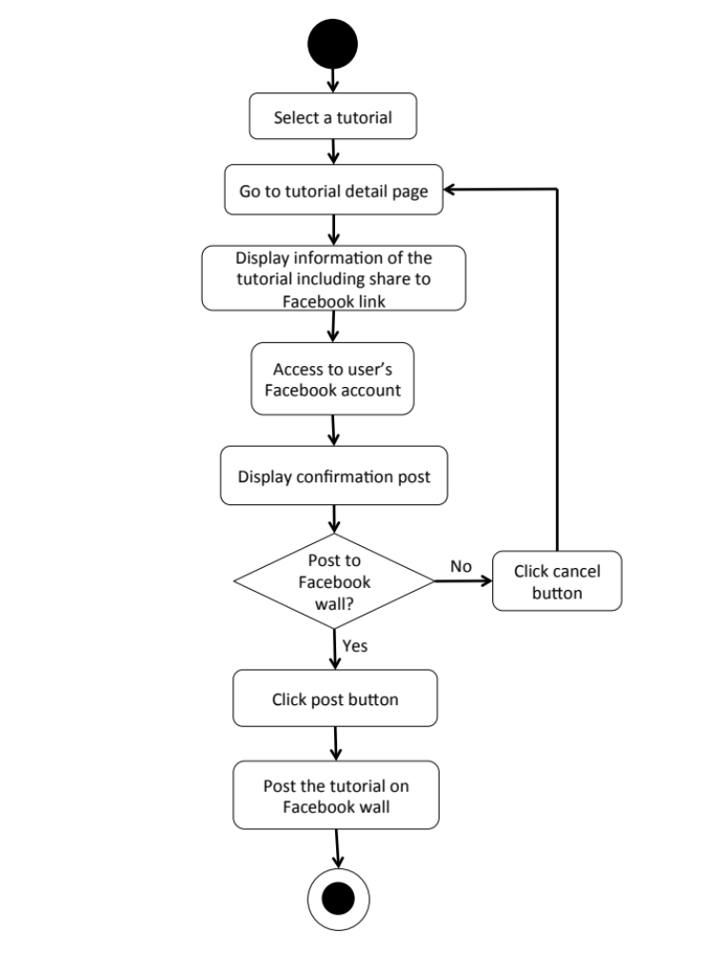

W-URS-37: The user sees list of notifications when there is new like, comment or follower.
Input and Output
- Input: The user selects notification link to see list of new activities that has happened to the user.
- Output: The system shows list of new activities that has happened to the user.

Description
URS ID | W-URS-37
URS Name | The user sees list of notifications when there is new like, comment or follower.
Actor | Blogger
Description | This function will notify the user when there is any new activity, such as new like, comment, or blogger follow. Moreover, it also allows the user to see list of the activities happened with the user.
Trigger | The user selects notification sign to go to notification page and see lists of new activities.
Pre-condition | - User stays on home page.
Post-condition | - The system shows list of new activities that has happened to the user.
Normal flow | - User goes to notification page.  - System provides user interface of notification page.  - System checks new activity of the user in database.  - System shows list of new activities including the type of activities and username of the blogger that has created the interaction.
Alternative flow | -
Exception | In all steps of normal flow, in case there is no internet connection.
Include | W-URS-02, W-URS-27, W-URS-25, W-URS-29

W-AD-34

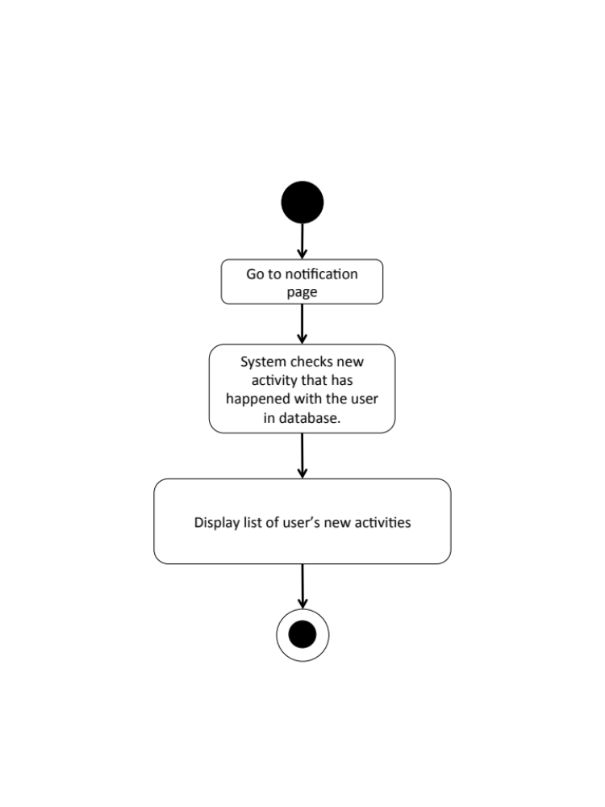

W-URS-38: The user goes to the activity that has been notified.
Input and Output
- Input: The user selects an activity link in the notification page.
- Output: The system goes to the page that the selected activity has happened.

Description
URS ID | W-URS-38
URS Name | The user goes to the activity that has been notified.
Actor | Blogger
Description | This function allows the user to select a new activity to see the detail where the activity has happened.
Trigger | The user selects an activity link to go to the page that the selected activity has happened.
Pre-condition | - User stays on activity page.
Post-condition | - The system goes to the page that the selected activity has happened.
Normal flow | - User goes to notification page.  - System shows list of new activities including the type of activities and username of the blogger that has created the interaction.  - User selects an activity link.  - System checks type of the selected activity, whether it is like, comment, or follow.  - System goes to tutorial detail page if the activity type are like or comment, and goes to user’s profile page if the type is follow.
Alternative flow | -
Exception | In all steps of normal flow, in case there is no internet connection.
Include | W-URS-02, W-URS-27, W-URS-25, W-URS-29, W-URS-37

W-AD-35

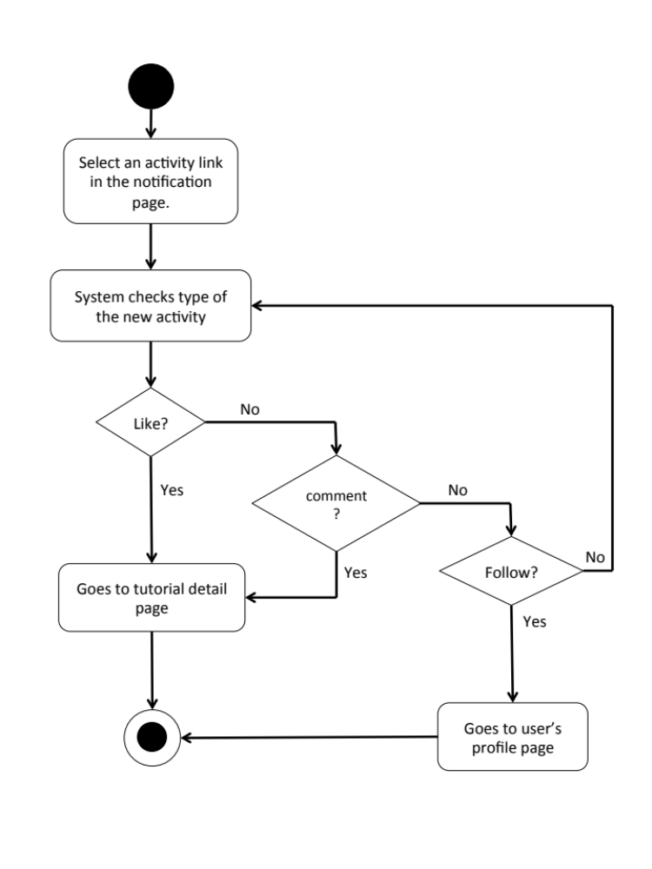

    - User Requirement Description for Mobile Application

Feature 1: User’s Profile and Authorization Management

M-URS-01: The user registers as a blogger/shopkeeper.

Input and Output
No | Input Name | Description | Example | Remarks | Output
1 | Username | The length of Username must be between 1-20 characters | “hideandseek05” | The word should not contain any symbol. | The system shows “HideandSeek05” on the screen
2 | Password | The length of Password must be between 1-20 characters | “12345” | The word should not contain any symbol. | The system shows “●●●●●” on the screen
3 | Re-Password | Re-password must match with the password. | “12345” | The word should not contain any symbol. | The system shows “●●●●●” on the screen
4 | Email | Email must be the one that the user is currently using. | “hello@gmail.com” | The word should be in Email format | The system shows “hello@gmail.com” on the screen
5 | Role | The choices, blogger and shopkeeper, will be provided for the user to choose. | “Blogger” | - | The system shows selected sign on the role that user selects.
6 | Picture | The file type must be .jpg or .png | “IMG_ProfilePic.jpg” | - | The system shows “IMG_ProfilePic.jpg” on the screen

Description
URS ID | M-URS-01
URS Name | The user registers as a blogger/shopkeeper.
Actor | User
Description | This function allows user who does not have his/her own account to register in order to use more functions of the application.
Trigger | The user selects “Sign Up” to register to be a member of the system.
Pre-condition | - Open the application
Post-condition | - The system saves user’s information into database.
Normal flow | 1) System provides registration interface for user to fill information, which are username, password, re-password, e-mail, role, and profile picture.  2) User input his/her information.  3) User clicks done to finish the registration.  4) System validates the information.  5) System saves the user’s information into the database.  6) System goes back to log in page.
Alternative flow | - In step 1, the user clicks back button to go to the previous page in case he/she wants to cancel the registration.  - In step 4, the system shows an error message if the user has input wrong information.
Exception | - In all steps of normal flow, in case there is no internet connection.
Include | -

M-AD-01

M-URS-02: The user logins to the system by username and password.
Input and Output
No | Input Name | Description | Example | Remarks | Output
1 | Username | The length of Username must be between 1-20 characters | “hideandseek05” | The word should not contain any symbol. | The system shows “HideandSeek05” on the screen
2 | Password | The length of Password must be between 1-20 characters | “12345” | The word should not contain any symbol. | The system shows “●●●●●” on the screen

Description
URS ID | M-URS-02
URS Name | The user logins to the system by username and password.
Actor | Blogger, Shopkeeper
Description | This function allows user, who has registered, logs in to the system either as a blogger or shopkeeper in order to use the system as a specific role.
Trigger | The user selects “Log in” to log in to the system.
Pre-condition | - User has registered to the system.
Post-condition | - User goes to home page for blogger.
Normal flow | 1) User clicks log in button.  2) System provides log in interface for user to fill information, which are username and password.  3) User input his/her username and password.  4) Users click log in button.  5) System validates username, and password format.  6) System verifies username and password from the database.  7) System goes to home page.
Alternative flow | - In step 2, the user clicks back button to go to the previous page in case he/she wants to cancel the log in process.  - In step 4, the system shows an error message if the user has input wrong information.
Exception | - In all steps of normal flow, in case there is no internet connection.

M-AD-02

M-URS-03: The user logouts from the system.
Input and Output
- Input: The user selects log out link to exit from the system.
- Output: The user log out from the system.

Description
URS ID | M-URS-03
URS Name | The user logouts from the system.
Actor | Blogger, Shopkeeper
Description | This function allows user to log out from the system.
Trigger | The user selects “Log out” to log out from the system.
Pre-condition | - User has logged in to the system.
Post-condition | - User has no longer logged in.
Normal flow | 1) User goes to Menu page.  2) System provides Menu page interface, which provides Categories, Shops, Around me, and Log out buttons.  3) User clicks Log out button.  4) System goes to visitor home page.
Alternative flow | -
Exception | - In all steps of normal flow, in case there is no internet connection.
Include | M-URS-02

M-AD-03

M-URS-04: The user sees his/her profile.
Input and Output
- Input: The user selects profile link to go to profile page.
- Output: The system shows user’s profile.

Description
URS ID | M-URS-04
URS Name | The user sees his/her profile.
Actor | Blogger, Shopkeeper
Description | This function allows user to see his/her own profile and information, which includes tutorials/shops that the user has created.
Trigger | The user selects “Profile” to go to his/her profile.
Pre-condition | - User has logged in to the system.
Post-condition | - System displays user’s profile.
Normal flow | - User goes to profile page.  - System gets user’s information from database.  - System displays interface and user’s information, which are profile picture, username, email, and list of tutorials/shops that the user has created.
Alternative flow | In step 3, the system would also display follower number and following number in case the user is blogger.
Exception | In all steps of normal flow, in case there is no internet connection.
Include | M-URS-02

M-AD-04

M-URS-05: The user edits his/her email.
Input and Output
No | Input Name | Description | Example | Remarks | Output
1 | Email | Email must be the one that the user is currently using. | “kanom@msn.com” | The word should be in Email format | The system shows “kanom@msn.com” on the screen

Description
URS ID | M-URS-05
URS Name | The user edits his/her email.
Actor | Blogger, Shopkeeper
Description | This function allows user to edit his/her own email.
Trigger | The user selects “Edit” on user’s profile page.
Pre-condition | - User has logged in to the system.
Post-condition | - System updates the new information of user’s profile.
Normal flow | 1) User goes to edit profile page  2) System provides the editable interface of the profile.  3) User input new email.  4) User clicks save.  5) System validates the input.  6) System saves the edited profile into the database.  7) System goes back to user’s profile page.
Alternative flow | - In step 2, the user clicks back button to go to the previous page in case he/she wants to cancel the edit profile process.  - In step 5, the system shows an error message if the user has input wrong information.
Exception | - In all steps of normal flow, in case there is no internet connection.
Include | M-URS-02

M-AD-05

M-URS-06: The user changes profile picture.
Input and Output
No | Input Name | Description | Example | Remarks | Output
1 | Picture | The file type must be .jpg or .png | “IMG_ProfilePic2.jpg” | - | The system shows “IMG_ProfilePic2.jpg” on the screen

Description
URS ID | M-URS-06
URS Name | The user changes profile picture.
Actor | Blogger, Shopkeeper
Description | This function allows user to change his/her profile picture.
Trigger | The user selects “Profile picture” to change the picture.
Pre-condition | - User has logged in to the system.  - User goes to edit profile page.
Post-condition | - System saves new user’s profile picture into database.
Normal flow | 1) User selects profile picture link.  2) System shows pictures in phone gallery.  3) User selects a picture.  4) User clicks save.  5) System validates the input.  6) System saves the new picture into the database.  7) System goes back to user’s profile page.
Alternative flow | - In step 2, the user clicks cancel button to go to the previous page in case he/she wants to cancel the picture changing process.  - In step 5, the system shows an error message if the user has input wrong information.
Exception | In all steps of normal flow, in case there is no internet connection.
Include | M-URS-02

M-AD-06

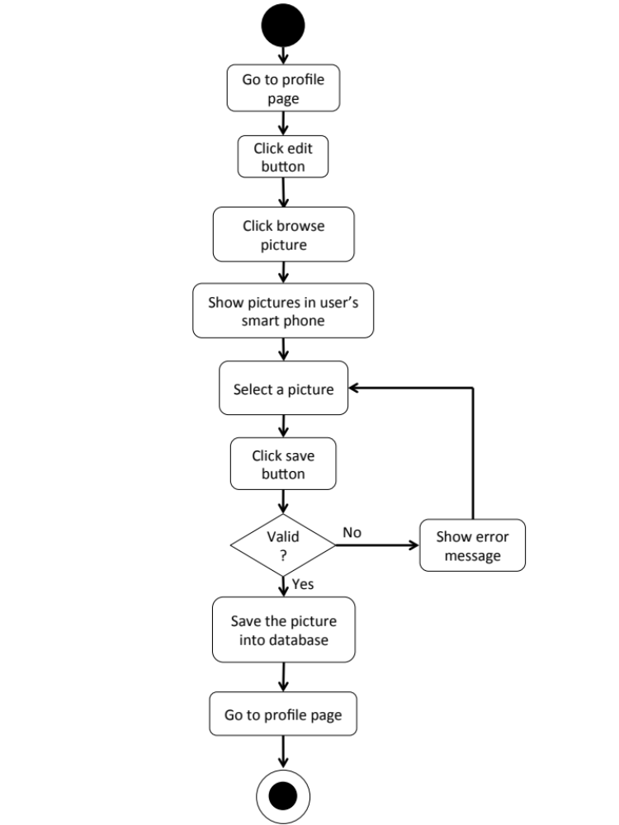

M-URS-07: The user changes his/her password.
Input and Output
No | Input Name | Description | Example | Remarks | Output
1 | Current Password | Current Password should be the password that the user is currently using. | “12345” | The word should not contain any symbol. | The system shows “●●●●●” on the screen
2 | New Password | The length of New Password must be between 1-20 characters | “00000” | The word should not contain any symbol. | The system shows “●●●●●” on the screen
3 | Re-New Password | Re-New Password must match with the New Password. | “00000” | The word should not contain any symbol. | The system shows “●●●●●” on the screen

Description
URS ID | M-URS-07
URS Name | The user changes his/her password.
Actor | Blogger, Shopkeeper
Description | This function allows user to change password for his/her account.
Trigger | The user selects “Change password” to change the password for user’s account.
Pre-condition | - User has logged in to the system.  - User goes to edit profile page.
Post-condition | - The password for the user’s account is updated.
Normal flow | - User clicks change password button.  - System provide change password interface for user to fill information, which are current password and new password.  - User input information.  - User clicks save button.  - System validates the input.  - System saves the new password into the database.  - System goes back to user’s profile page.
Alternative flow | - In step 2, the user clicks back button to go to the previous page in case he/she wants to cancel the password changing process.  - In step 5, the system shows an error message if the user has input wrong information.
Exception | In all steps of normal flow, in case there is no internet connection.
Include | M-URS-02

M-AD-07

M-URS-08: The user deletes his/her account.

Input and Output
- Input: The user selects delete account link to delete user’s account.
- Output: The system goes to home page for unlogged in user.

Description
URS ID | M-URS-08
URS Name | The user deletes his/her account.
Actor | Blogger, Shopkeeper
Description | This function allows user to delete his/her account, which the user will not be able to access the system as a blogger, unless the user register a new account.
Trigger | The user selects “Delete account” to delete the user’s account.
Pre-condition | - User has logged in to the system.  - User goes to edit profile page.
Post-condition | - User’s account is no longer available.
Normal flow | 1) User clicks delete account button.  2) System shows confirmation message.  3) User clicks yes button.  4) System removes the user’s account from the database.  5) System goes to unlogged in home page.
Alternative flow | - In step 3, the user clicks no button to cancel the account deletion process.
Exception | In all steps of normal flow, in case there is no internet connection.
Include | M-URS-02

M-AD-08

Feature 2: Tutorial Management
M-URS-09: The user randomly sees tutorials that exist in database.
Input and Output
- Input: The user selects random link to see random tutorials.
- Output: The system shows list of all tutorials with tutorial picture, title, owner username, and number of likes that exist in the database randomly.

Description
URS ID | M-URS-09
URS Name | The user randomly sees tutorials that exist in database.
Actor | Visitor, Blogger
Description | This function allows user to explore tutorials by randomly go through list of various tutorials that exist in database.
Trigger | The user selects “Random” to see random tutorials.
Pre-condition | - User stays on Home page.
Post-condition | - System displays list of all tutorials that exist in the database randomly.
Normal flow | 1) User selects “Random” on the Home page.  2) System gets tutorials information from database.  3) System displays list of all tutorials with tutorial picture, title, owner username, and number of likes that exist in the database randomly.
Alternative flow | -
Exception | In all steps of normal flow, in case there is no internet connection.
Include | M-URS-02

M-AD-09

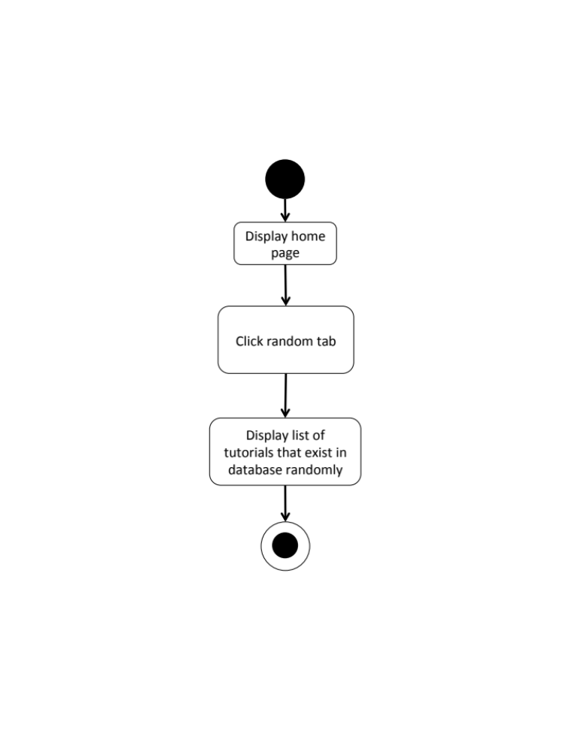

M-URS-10: The user sees tutorials that exist in database by popularity according to number of likes.
Input and Output
- Input: The user selects popular link to see popular tutorials.
- Output: The system shows list of all tutorials with tutorial picture, title, owner username, and number of likes that exist in the database from the most liked to the less.

Description
URS ID | M-URS-10
URS Name | The user sees tutorials that exist in database by popularity according to number of likes.
Actor | Visitor, Blogger
Description | This function allows user to explore tutorials that has mostly liked within the current month and go through list of various tutorials that exist in database.
Trigger | The user selects “Popular” to see popular tutorials.
Pre-condition | - User stays on Home page.
Post-condition | - System displays list of all tutorials that exist in the database from the most liked to the less.
Normal flow | 1) User selects “Popular” on the Home page.  2) System gets tutorials information from database.  3) System displays list of all tutorials with tutorial picture, title, owner username, and number of likes that exist in the database from the most liked to the less of the current month.
Alternative flow | -
Exception | In all steps of normal flow, in case there is no internet connection.
Include | M-URS-02

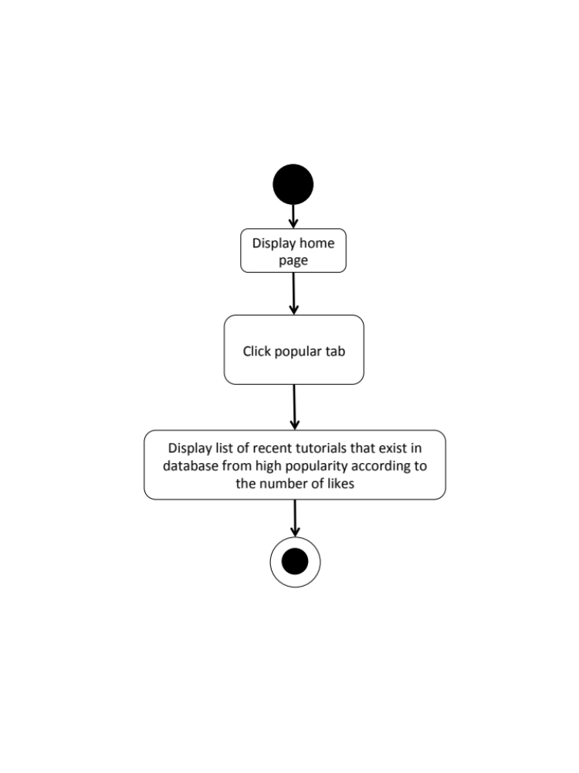
M-AD-10

M-URS-11: The user sees tutorials that exist in database by choosing a category.

Input and Output
- Input: The user selects a category link to see tutorials by category.
- Output: The system shows list of tutorials with tutorial picture, title, owner username, and number of likes of the category.

Description
URS ID | M-URS-11
URS Name | The user sees tutorials that exist in database by choosing a category.
Actor | Visitor, Blogger
Description | This function allows user to explore tutorials according to the category that the user selects and go through list of various tutorials that exist in database.
Trigger | The user selects “Categories” to see categories of tutorials.
Pre-condition | - User stays on Home page.
Post-condition | - System displays list of tutorials of the category.
Normal flow | - User goes to Menu page.  - System provides Menu page interface, which provides Categories, Shops, Around Me, and Log Out buttons.  3) User click categories button.  4) System displays categories, which are outfit, accessory, gift, kid, garden, home décor, pet, and other.  5) User selects a category.  6) System gets tutorials information from database.  7) System displays list of tutorials with tutorial picture, title, owner username, and number of likes of the category.
Alternative flow | -
Exception | In all steps of normal flow, in case there is no internet connection.
Include | M-URS-02

M-AD-11
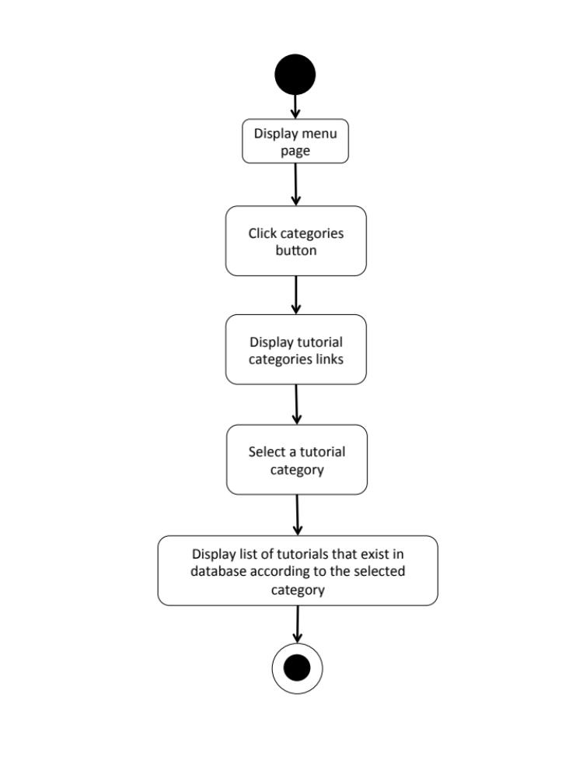

M-URS-12: The user search tutorials’ title that exist in database by inputting a keyword.

Input and Output
No | Input Name | Description | Example | Remarks | Output
1 | Keyword | The length of Keyword must be between 1-20 characters | “Bracelet” | The word should not contain any symbol. | The system shows tutorials that have the word “Bracelet” as a tutorial name.

Description
URS ID | M-URS-12
URS Name | The user search tutorials’ title that exist in database by inputting a keyword.
Actor | Visitor, Blogger
Description | This function allows user to search certain kind of tutorials by inputting a keyword and go through list of various tutorials that exist in database.
Trigger | The user clicks on the search box.
Pre-condition | - User stays on Home page.
Post-condition | - System displays list of all tutorials that relate to the keyword.
Normal flow | 1) User input a keyword in the search box.  2) System gets tutorials information from database.  3) System displays list of all tutorials with tutorial picture, title, owner username, and number of likes that relate to the keyword.
Alternative flow | -
Exception | In all steps of normal flow, in case there is no internet connection.
Include | M-URS-02

M-AD-12
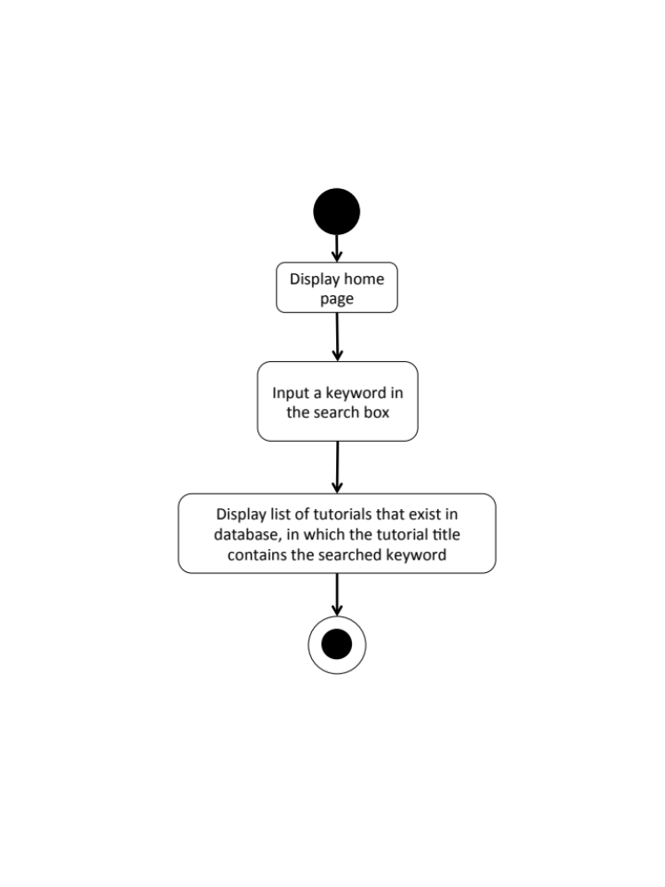

M-URS-13: The user sees tutorials that exist in database from following bloggers.

Input and Output
- Input: The user selects following link to see following tutorials.
- Output: The system shows list of tutorials with tutorial picture and title from the following bloggers.

Description
URS ID | M-URS-13
URS Name | The user sees tutorials that exist in database from following bloggers.
Actor | Blogger
Description | This function allows user to explore tutorials of bloggers that the user has followed and go through list of various tutorials that exist in database.
Trigger | The user selects “Following” to see tutorials from the bloggers that the user is following.
Pre-condition | - User has logged in to the system.  - User stays on Home page.
Post-condition | - System displays list of tutorials from the following bloggers.
Normal flow | 1) User tab “Following” on the Home page.  2) System gets tutorials information from database.  3) System displays list of tutorials with tutorial picture, title, owner username, and number of likes from the following bloggers.
Alternative flow | In step 1, the system shows an error message if the user has not logged in as a blogger yet.
Exception | In all steps of normal flow, in case there is no internet connection.
Include | M-URS-02

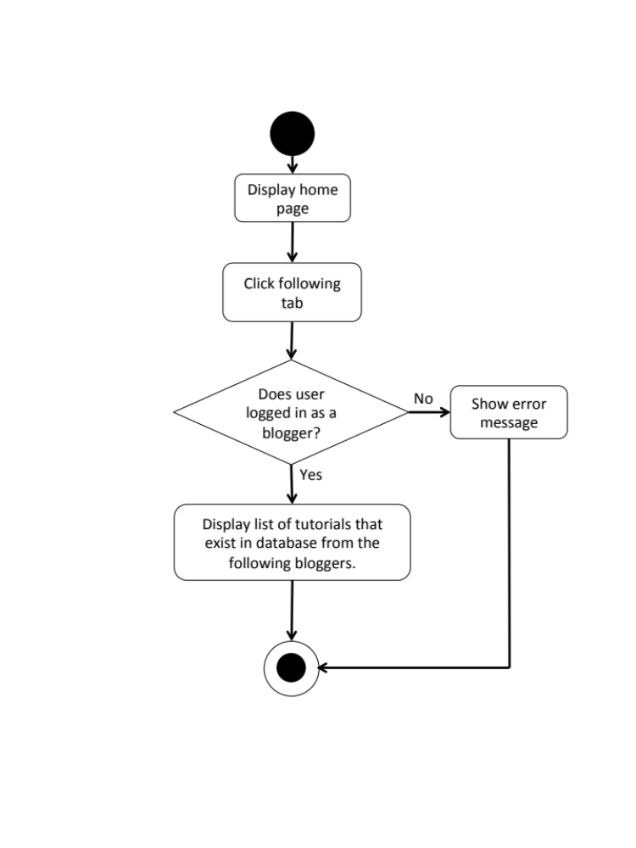
M-AD-13

M-URS-14: The user sees selected tutorial information.
Input and Output
- Input: The user selects tutorial link to see tutorial’s detail.
- Output: The system shows information of the tutorial, which are title, owner username, number of likes, category, material picture, material description, step description, step picture, video, and comments.

Description
URS ID | M-URS-14
URS Name | The user sees selected tutorial information.
Actor | Visitor, Blogger
Description | This function allows user to see information, which are title, owner username, number of likes, category, material picture, material description, step description, step picture, video, and comments of the selected tutorial.
Trigger | The user selects a tutorial to see the information.
Pre-condition | - User selects a tutorial
Post-condition | - System displays all information of the tutorial.
Normal flow | 1) User selects a tutorial.  2) System gets the tutorial’s information from database.  3) System displays all information of the tutorial, which are title, owner username, number of likes, category, material picture, material description, step description, step picture, video, and comments.
Alternative flow | -
Exception | In all steps of normal flow, in case there is no internet connection.
Include | M-URS-02

M-AD-14

M-URS-15: The user creates his/her own tutorial, which includes tutorial detail.

Input and Output
No | Input Name | Description | Example | Remarks | Output
1 | Tutorial Picture | The file type must be .jpg or .png | “IMG_tutorial.jpg” | - | The system shows “IMG_tutorial.jpg” on the screen
2 | Title | The length of Title must be between 1-20 characters between 1-20 characters | “Handmade Bracelet” | The word should not contain any symbol. | The system shows “Handmade Bracelet” on the screen
3 | Category | The categories are provided by the system. | “Accessory” | - | The system shows “Accessory” on the screen
4 | Material Picture | The file type must be .jpg or .png | “IMG_material.jpg” | - | The system shows “IMG_material.jpg” on the screen
5 | Material Description | The length of Material Description must be between 1-500 characters | “1.Rope 2.Glue 3.Scissor 4.Glitter 5.Pin” | - | The system shows “1.Rope 2.Glue 3.Scissor 4.Glitter 5.Pin”on the screen
6 | Step | The number of step should be between 1-10 | “1” | No symbol or character is allowed. | The system shows “1” on the screen
7 | Step Picture | The file type must be .jpg or .png | “IMG_step1.jpg” | - | The system shows “IMG_step1.jpg” on the screen
8 | Step Description | The length of Step Description must be between 1-500 characters | “Cut the rope to have the length as long as it can be out around your wrist.” | - | The system shows “Cut the rope to have the length as long as it can be out around your wrist.” on the screen
9 | Video | The file type must be .mov | “VDO_tutorial.mov” | - | The system shows “VDO_tutorial.mov” on the screen

Description
URS ID | M-URS-15
URS Name | The user creates his/her own tutorial, which includes tutorial detail.
Actor | Blogger
Description | This function allows user to create his/her own tutorial by inputting information, which are tutorial picture, title, category, material, material picture, step description, step picture, and video for a tutorial.
Trigger | The user selects “Create” to create a new tutorial.
Pre-condition | - User has logged in to the system.
Post-condition | - System saves the created tutorial into database.
Normal flow | 1) User clicks create button.  2) System provides create tutorial interface for user to fill information, which are tutorial picture, title, and category.  3) User inputs the information.  4) System validates tutorial picture, title, and category format.  5) User clicks next link.  6) System provides create tutorial interface for user to fill information, which are material, material picture, step description, step picture, and video.  7) User input the information step by step.  8) User clicks done button.  9) System validates material picture, material description, step number, step picture, step description, and video format.  10) System saves the tutorial into the database.  11) System shows successful message.
Alternative flow | - In step 1-8, the user clicks back button to go to the previous page in case he/she wants to cancel the tutorial creating process.
Exception | - In step 4 and 9, system displays error message in case the format is wrong.  - In all steps of normal flow, in case there is no internet connection.
Include | M-URS-02

M-AD-15

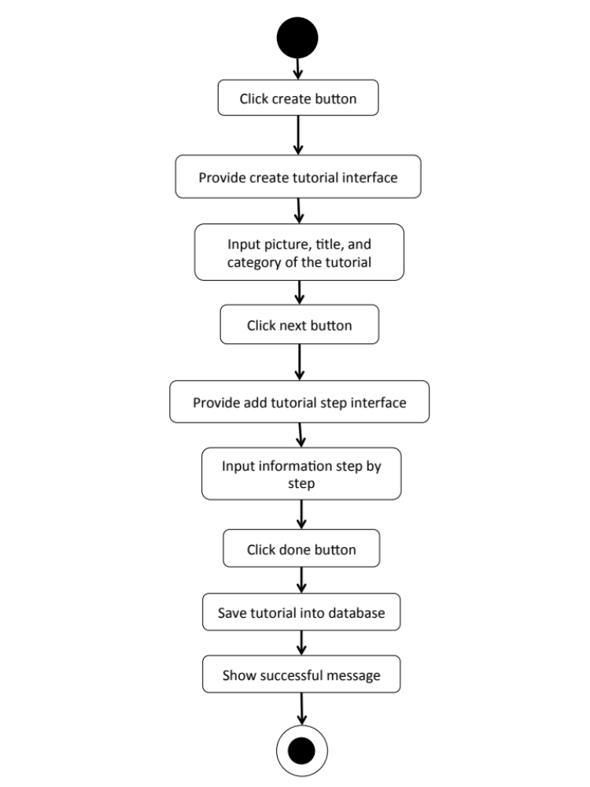

M-URS-16: The user sees detail of his/her own tutorial.
Input and Output
- Input: The user selects profile link to go to profile page.
- Output: The system shows user’s profile including list of his/her tutorials.

Description
URS ID | M-URS-16
URS Name | The user sees detail of his/her own tutorial.
Actor | Blogger
Description | This function allows user to see his/her own tutorial and information, which are tutorial picture, title, category, material, material picture, step description, step picture, and video of the tutorial.
Trigger | The user selects “Profile” to see his/her information including his/her own tutorials.
Pre-condition | - User has logged in to the system.  - User goes to his/her profile page
Post-condition | - System shows tutorials that the user has created.
Normal flow | - User goes to profile page.  - System gets user’s information from database.  - System displays interface and user’s information, which are profile picture, username, password, follower number, following number, and tutorials that he/she has created.  - User selects a tutorial.  - System gets selected tutorial’s information from database.  - System displays interface and tutorial’s information, which are title, owner username, number of likes, category, material picture, material description, step description, step picture, video, and comments of the tutorial.
Alternative flow | -
Exception | In all steps of normal flow, in case there is no internet connection.
Include | M-URS-02, M-URS-15

M-AD-16

M-URS-17: The user edits detail of his/her own tutorial.
Input and Output
No | Input Name | Description | Example | Remarks | Output
1 | Tutorial Picture | The file type must be .jpg or .png | “IMG_tutorial2.jpg” | - | The system shows “IMG_tutorial2.jpg” on the screen
2 | Title | The length of Title must be between 1-20 characters between 1-20 characters | “How to make a Handmade Bracelet by yourself” | The word should not contain any symbol. | The system shows “How to make a Handmade Bracelet by yourself” on the screen
3 | Category | The categories are provided by the system. | “Outfit” | - | The system shows “Accessory” on the screen
4 | Material Picture | The file type must be .jpg or .png | “IMG_material2.jpg” | - | The system shows “IMG_material2.jpg” on the screen
5 | Material Description | The length of Material Description must be between 1-500 characters | “1.Rope 2.Glue 3.Scissor 4.Glitter 5.Pin 6.Color” | - | The system shows “1.Rope 2.Glue 3.Scissor 4.Glitter 5.Pin  6.Color” on the screen
6 | Step | The number of step should be between 1-10 | “2” | No symbol or character is allowed. | The system shows “2” on the screen
7 | Step 1 Picture | The file type must be .jpg or .png | “IMG_step1.jpg” | - | The system shows “IMG_step1.jpg” on the screen
8 | Step 1 Description | The length of Step Description must be between 1-500 characters | “Cut the rope to have the length as long as it can be out around your wrist.  Be careful when you cut it!” | - | The system shows “Cut the rope to have the length as long as it can be out around your wrist. Be careful when you cut it!” on the screen
9 | Step 2 Picture | The file type must be .jpg or .png | “IMG_step2.jpg” | - | The system shows “IMG_step2.jpg” on the screen
10 | Step 2 Description | The length of Step Description must be between 1-500 characters | “Now it’s time to decorate!” | - | The system shows “Now it’s time to decorate!” on the screen
11 | Video | The file type must be .mov | “VDO_tutorial2.mov” | - | The system shows “VDO_tutorial2.mov” on the screen

Description
URS ID | M-URS-17
URS Name | The user edits detail of his/her own tutorial.
Actor | Blogger
Description | This function allows user to make some changes on his/her own tutorial and information, which are tutorial picture, title, category, material, material picture, step description, step picture, and video of the tutorial.
Trigger | The user selects “Edit” to edit the selected tutorial.
Pre-condition | - User has logged in to the system.
Post-condition | - System updates new information of the tutorial.
Normal flow | 1) User selects a tutorial that wants to be edited.  2) User clicks edit button.  3) System provides the editable interface for user to edit tutorial picture, title, category, material picture, material description, step number, step picture, step description, and video.  4) User clicks save.  5) System validates tutorial picture, title, category, material picture, material description, step number, step picture, step description, and video format.  6) System saves the edited tutorial into the database.  7) System shows successful message.
Alternative flow | - In step 3, the user clicks back button to cancel the process.  - In step 5, the system shows an error message if the user has input wrong information.
Exception | - In all steps of normal flow, in case there is no internet connection.
Include | M-URS-02, M-URS-15

M-AD-17

M-URS-18: The user deletes his/her own tutorial.

Input and Output
- Input: The user selects delete tutorial link to delete his/her tutorial.
- Output: The tutorial disappears from the tutorial list.

Description
URS ID | M-URS-18
URS Name | The user deletes his/her own tutorial.
Actor | Blogger
Description | This function allows user to remove his/her own tutorial from the database.
Trigger | The user selects “Delete tutorial” to remove tutorial from the database.
Pre-condition | - User has logged in to the system.  - User selects the tutorial that wants delete.
Post-condition | - System removes the tutorial from the database.
Normal flow | 1) User clicks delete button.  2) System shows confirmation message with yes/no button.  3) User clicks yes button.  4) System removes the tutorial from the database.  5) System shows successful message.
Alternative flow | - In step 3, the user clicks no button to cancel the tutorial deletion process.
Exception | In all steps of normal flow, in case there is no internet connection.
Include | M-URS-02, M-URS-15

M-AD-18

Feature 3: Shop Management
M-URS-19: The user randomly sees shops that exist in database.
Input and Output
- Input: The user selects random link to see random shops.
- Output: The system shows list of all shops with shop picture, shop name, and shopkeeper username that exist in the database randomly.

Description
URS ID | M-URS-19
URS Name | The user randomly sees shops that exist in database.
Actor | Blogger
Description | This function allows user to explore shops by randomly go through list of various shops that exist in database.
Trigger | The user selects “Shop” to see random shops.
Pre-condition | - User has logged in to the system as a blogger.  - User stays on Menu page.
Post-condition | - System displays list of all shops that exist in the database randomly.
Normal flow | 1) User selects “Shop” on menu page.  2) System gets shops information from database.  3) System displays list of all shops with shop picture, shop name, and shopkeeper username that exist in the database randomly.
Alternative flow | -
Exception | In all steps of normal flow, in case there is no internet connection.
Include | M-URS-02

M-AD-19

M-URS-20: The user sees shops that exist in database by choosing a category.

Input and Output
- Input: The user selects a category link to see shops by category.
- Output: The system shows list of shops with shop picture, shop name, and shopkeeper username of the selected category that exist in the database.

Description
URS ID | M-URS-20
URS Name | The user sees shops that exist in database by choosing a category.
Actor | Blogger
Description | This function allows user to explore shops according to the category that the user selects and go through list of various shops that exist in database.
Trigger | The user selects “Categories” to see categories of shops.
Pre-condition | - User has logged in to the system as a blogger.  - User stays on Shop page.
Post-condition | - System displays list of shops of the category.
Normal flow | 1) User clicks categories button.  2) System displays categories, which are fabric, accessory, wood, stationary, container and other.  3) User selects a category.  4) System gets shops information from database.  5) System displays list of shops with shop picture, shop name, and shopkeeper username of the selected category that exist in the database.
Alternative flow | -
Exception | In all steps of normal flow, in case there is no internet connection.
Include | M-URS-02

M-AD-20
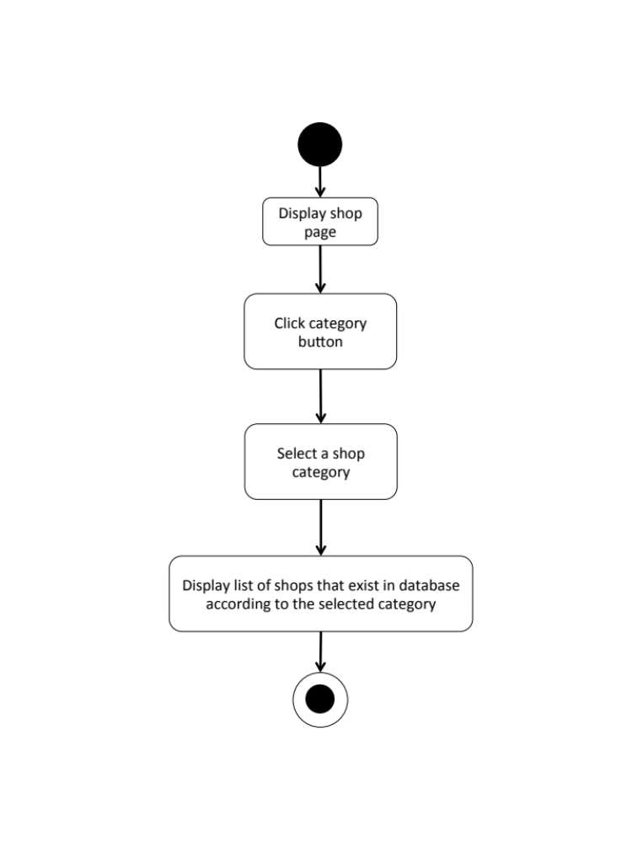

M-URS-21: The user search shop’s name that exist in database by inputting a keyword.

Input and Output
No | Input Name | Description | Example | Remarks | Output
1 | Keyword | The length of Keyword must be between 1-20 characters | “Pin” | The word should not contain any symbol. | The system shows shops that have the word “Pin” as a shop name.

Description
URS ID | M-URS-21
URS Name | The user search shop’s name that exist in database by inputting a keyword.
Actor | Blogger
Description | This function allows user to search certain kind of shops by inputting a keyword and go through list of various shops that exist in database.
Trigger | The user clicks on the search box.
Pre-condition | - User has logged in to the system as a blogger.  - User stays on Shop page.
Post-condition | - System displays list of all shops that relate to the keyword.
Normal flow | 1) User input a keyword in the search box.  2) System gets shops information from database.  3) System displays list of all shops with shop picture, shop name, and shopkeeper username that relate to the keyword.
Alternative flow | -
Exception | In all steps of normal flow, in case there is no internet connection.
Include | M-URS-02

M-AD-21

M-URS-22: The user sees selected shop information.
Input and Output
- Input: The user selects shop link to see shop’s detail.
- Output: The system shows information of the shop, which are shop name, shopkeeper username, branch, telephone number, information, pictures, and shop’s location.

Description
URS ID | M-URS-22
URS Name | The user sees selected tutorial information.
Actor | Blogger
Description | This function allows user to see information, which are shop name, shopkeeper username, branch, telephone number, information, pictures, and shop’s location of the selected tutorial.
Trigger | The user selects a shop to see the information.
Pre-condition | - User has logged in to the system as a blogger.  - User selects a shop.
Post-condition | - System displays all information of the shop.
Normal flow | 1) User selects a shop.  2) System gets the shop’s information from database.  3) System displays all information of the shop, which are shop name, shopkeeper username, branch, telephone number, information, pictures, and shop’s location.
Alternative flow | -
Exception | In all steps of normal flow, in case there is no internet connection.
Include | M-URS-02

M-AD-22

M-URS-23: The user creates his/her own shop, which includes shop detail.

Input and Output
No | Input Name | Description | Example | Remarks | Output
1 | Shop Picture | The file type must be .jpg or .png | “IMG_shop.jpg” | - | The system shows “IMG_shop.jpg” on the screen
2 | Shop name | The length of Shop name must be between 1-20 characters | “ABC shop” | The word should not contain any symbol. | The system shows “ABC shop” on the screen
3 | Category | The categories are provided by the system. | “Stationary” | - | The system shows “Stationary” on the screen
4 | Branch | The length of Branch must be between 1-20 characters | “Chiang mai” | The word should not contain any symbol. | The system shows “Chiang mai” on the screen
5 | Telephone Number | The telephone number should be in 10 digits. | “053111222” | No symbol or character is allowed. | The system shows “053111222” on the screen
6 | Information | The length of Information must be between 1-500 characters | “Welcome to ABC shop! We sale stationaries.” | - | The system shows “Welcome to ABC shop! We sale stationaries.” on the screen
7 | Pictures1 | The file type must be .jpg or .png | “IMG_ABCshop1.jpg” | - | The system shows “IMG_ABCshop1.jpg” on the screen
8 | Location | The length of Step Description must be between 1-500 characters | “ ” | -

Description
URS ID | M-URS-23
URS Name | The user creates his/her own shop, which includes shop detail.
Actor | Shopkeeper
Description | This function allows user to create his/her own shop by inputting information, which are shop picture, shop name, category, branch, telephone number, information, pictures, and location for a shop.
Trigger | The user selects “Create” to create a new shop.
Pre-condition | - User has logged in to the system as a shopkeeper.
Post-condition | - System saves the created shop into database.
Normal flow | 1) User clicks create button.  2) System provides create shop interface for user to fill information, which are shop picture, shop name, and category.  3) User inputs the information.  4) System validates shop picture, shop name, and category format.  5) User clicks next link.  6) System provides create shop interface for user to fill information, which are branch, telephone number, information, pictures, and location.  7) User input the information.  8) User clicks done button.  9) System validates branch, telephone number, information, pictures, and location format.  10) System saves the tutorial into the database.  11) System shows successful message.
Alternative flow | - In step 1-8, the user clicks back button to go to the previous page in case he/she wants to cancel the shop creating process.
Exception | - In step 4 and 9, system displays error message in case the format is wrong.  - In all steps of normal flow, in case there is no internet connection.
Include | M-URS-02

M-AD-23
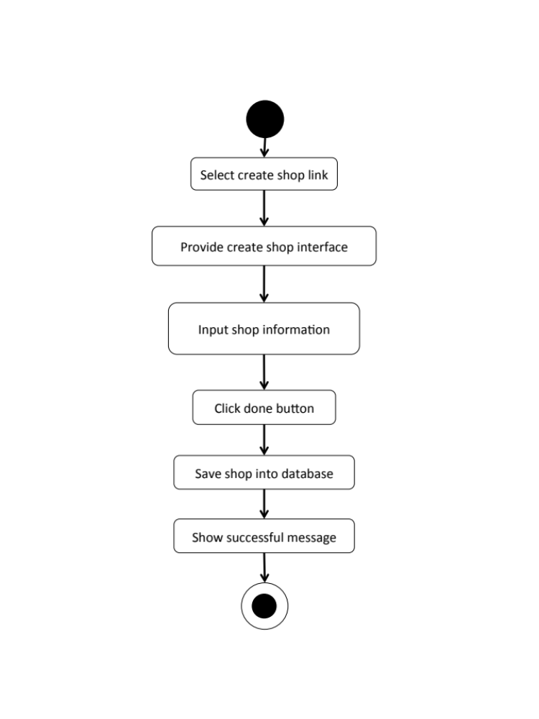

M-URS-24: The user sees detail of his/her own shop.
Input and Output
- Input: The user selects profile link to go to profile page.
- Output: The system shows user’s profile including list of his/her shop.

Description
URS ID | M-URS-24
URS Name | The user sees detail of his/her own shop.
Actor | Shopkeeper
Description | This function allows user to see his/her own shop and information, which are shop picture, shop name, category, branch, telephone number, information, pictures, and location for a shop.
Trigger | The user selects “Profile” to see his/her information including his/her own shops.
Pre-condition | - User has logged in to the system as a shopkeeper.  - User goes to his/her profile page
Post-condition | - System shows shops that the user has created.
Normal flow | - User goes to profile page.  - System gets user’s information from database.  - System displays interface and user’s information, which are profile picture, username, email, and shops that he/she has created.  - User selects a shop.  - System gets selected shop’s information from database.  - System displays interface and shop’s information, which are shop picture, shop name, owner, category, branch, telephone number, information, pictures, and location of the shop
Alternative flow | -
Exception | In all steps of normal flow, in case there is no internet connection.
Include | M-URS-02, M-URS-23

M-AD-24
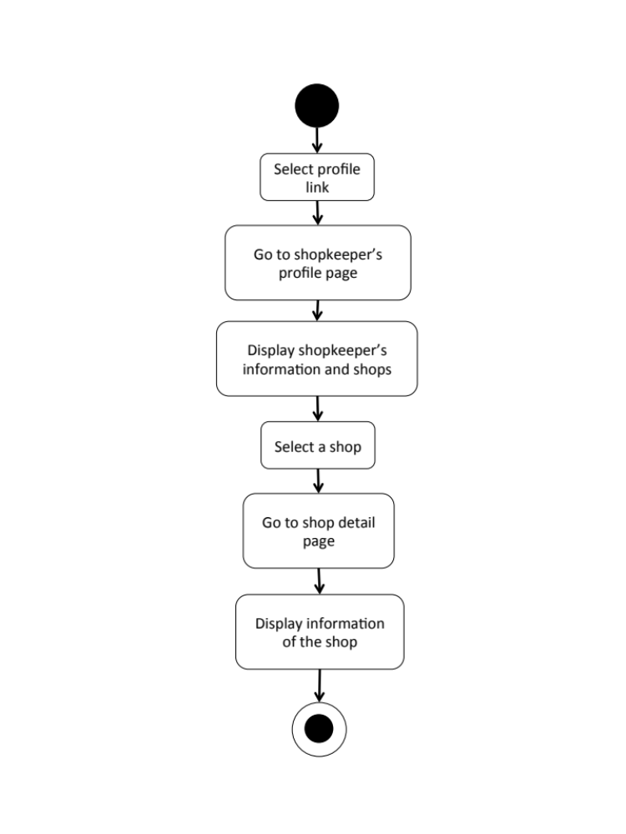

M-URS-25: The user edits detail of his/her own shop.
Input and Output
No | Input Name | Description | Example | Remarks | Output
1 | Shop Picture | The file type must be .jpg or .png | “IMG_shop2.jpg” | - | The system shows “IMG_shop2.jpg” on the screen
2 | Shop name | The length of Shop name must be between 1-20 characters | “ABC shop 555” | The word should not contain any symbol. | The system shows “ABC shop 555” on the screen
3 | Category | The categories are provided by the system. | “Fabric” | - | The system shows “Fabric” on the screen
4 | Branch | The length of Branch must be between 1-20 characters | “Bangkok” | The word should not contain any symbol. | The system shows “Bangkok” on the screen
5 | Telephone Number | The telephone number of step should be in 10 digits. | “0815556677” | No symbol or character is allowed. | The system shows “0815556677” on the screen
6 | Information | The length of Information must be between 1-500 characters | “Welcome to ABC shop 555! We sale fabrics.” | - | The system shows “Welcome to ABC shop 555! We sale fabrics.”on the screen
7 | Pictures1 | The file type must be .jpg or .png | “IMG_ABCshop1.jpg” | - | The system shows “IMG_ABCshop1.jpg” on the screen
8 | Pictures2 | The file type must be .jpg or .png | “IMG_ABCshop2.jpg” | - | The system shows “IMG_ABCshop2.jpg” on the screen
9 | Location | The length of Step Description must be between 1-500 characters | “ ” | -

Description
URS ID | M-URS-25
URS Name | The user edits detail of his/her own shop.
Actor | Shopkeeper
Description | This function allows user to make changes his/her own shop by inputting information, which are shop picture, shop name, category, branch, telephone number, information, pictures, and location of the shop.
Trigger | The user selects “Edit” to edit the selected shop.
Pre-condition | - User has logged in to the system as a shopkeeper.
Post-condition | - System updates new information of the shop.
Normal flow | 1) User selects a shop that wants to be edited.  2) User clicks edit button.  3) System provides create shop interface for user to fill information, which are shop picture, shop name, category, branch, telephone number, information, pictures, and location.  4) User clicks save.  5) System validates shop picture, shop name, category, branch, telephone number, information, pictures, and location format.  6) System saves the edited shop into the database.  7) System shows successful message.
Alternative flow | In step 1-4, the user clicks back button to cancel the process.
Exception | - In step 6, system displays error message in case the format is wrong.  - In all steps of normal flow, in case there is no internet connection.
Include | M-URS-02, M-URS-23

M-AD-25
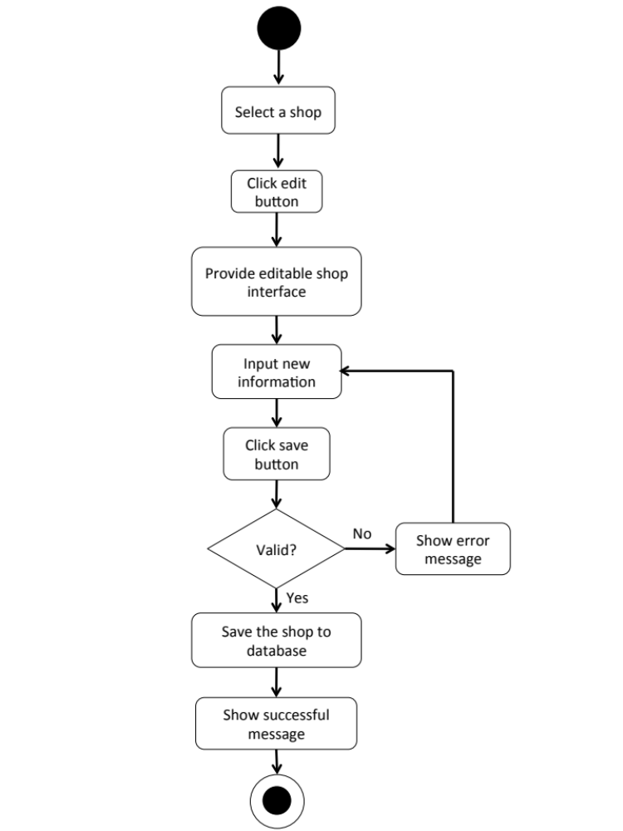

M-URS-26: The user deletes his/her own shop.

Input and Output
- Input: The user selects delete tutorial link to delete his/her shop.
- Output: The shop disappears from the shop list.

Description
URS ID | M-URS-26
URS Name | The user deletes his/her own shop.
Actor | Shopkeeper
Description | This function allows user to remove his/her own shop from the database.
Trigger | The user selects “Delete shop” to remove shop from the database.
Pre-condition | - User has logged in to the system as a shopkeeper.  - User selects the shop that wants delete.
Post-condition | - System removes the shop from the database.
Normal flow | 1) User clicks delete button.  2) System shows confirmation message with yes/no button.  3) User clicks yes button.  4) System removes the shop from the database.  5) System shows successful message.
Alternative flow | - In step 1-3, the user clicks no button to cancel the shop deletion process.
Exception | In all steps of normal flow, in case there is no internet connection.
Include | M-URS-02, M-URS-23

M-AD-26
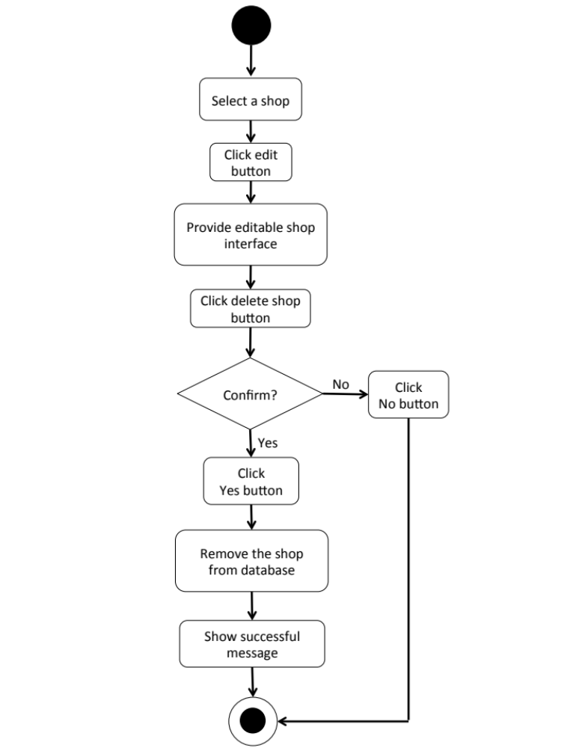

Feature 4: Map Management
M-URS-27: The user sees near by shops’ location on Google Map.
Input and Output
- Input: The user selects around me link to see shops near by on Google Map.
- Output: The system shows the exact shops’ location around that area on Google Map.

Description
URS ID | M-URS-27
URS Name | The user sees near by shops’ location on Google Map.
Actor | Blogger
Description | This function allows user to see shops that are located around the area that the user is currently in via Google Map.
Trigger | The user selects around me link to see near by shops’ location on Google Map.
Pre-condition | - User has logged in to the system as a blogger.  - User clicks around me button.
Post-condition | - System shows near by shops’ location on Google Map.
Normal flow | 1) User clicks around me button.  2) System connects with Google Map.  3) System retrieves the location from database.  4) System shows the exact shops’ position on Google Map.
Alternative flow | -
Exception | In all steps of normal flow, in case there is no internet connection.
Include | M-URS-02

M-AD-27
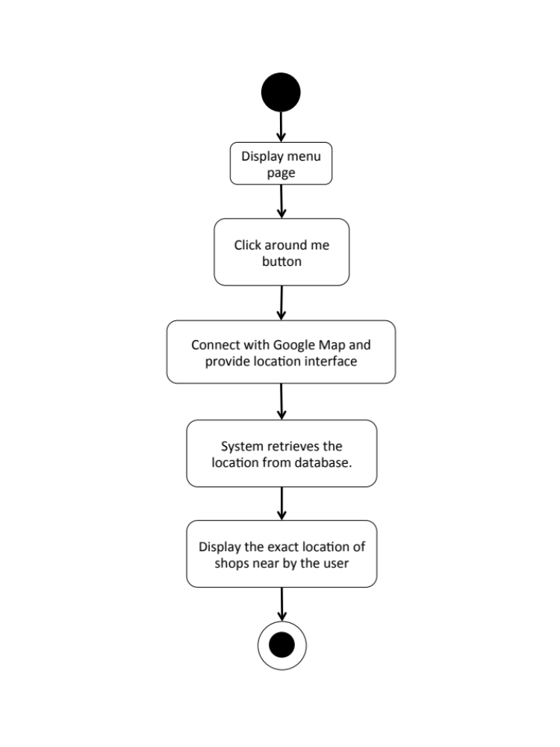

M-URS-28: The user sees shop’s location on Google Map.
Input and Output
- Input: The user selects shop location link to see the location on Google Map.
- Output: The system shows the exact shop’s location on Google Map.

Description
URS ID | M-URS-28
URS Name | The user sees shop’s location on Google Map.
Actor | Blogger, Shopkeeper
Description | This function allows user to see the exact location of the selected shop on Google Map.
Trigger | The user selects shop location link to see the location on Google Map.
Pre-condition | - User has logged in to the system as a blogger.  - User selected a shop.
Post-condition | - System shows shop’s location on Google Map.
Normal flow | 1) User selects a shop.  2) System gets the shop’s information from database.  3) System displays all information of the shop, which are shop name, shopkeeper username, branch, telephone number, information, pictures, and shop’s location.  4) User selects shop location link.  5) System connects with Google Map.  6) System retrieves the location from database.  7) System shows the exact shop’s position on Google Map.
Alternative flow | -
Exception | In all steps of normal flow, in case there is no internet connection.
Include | M-URS-02

M-AD-28

M-URS-29: The user identifies his/her shop’s location on Google Map.
Input and Output
No | Input Name | Description | Example | Remarks | Output
1 | Latitude | The latitude number must be in number with six decimal places | “13.234567” | No symbol or character is allowed. | The system shows shop’s position from the latitude and longitude on Google Map
2 | Longitude | The longitude number must be in number with six decimal places | “100.765432” | No symbol or character is allowed.

Description
URS ID | M-URS-29
URS Name | The user identifies his/her shop’s location on Google Map.
Actor | Shopkeeper
Description | This function allows user identify where his/her shop exactly is by pinning the shop’s location on Google Map.
Trigger | The user selects location link to access to Google Map and identify the exact shop’s location.
Pre-condition | - User has logged in to the system as a shopkeeper.  - User creates a shop.  - User edits a shop.
Post-condition | - System shows shop’s location on Google Map.  - System saves shop’s location into database.
Normal flow | 1) User crates a shop.  2) User selects location link.  3) System accesses to Google Map.  4) System shows Google Map user interface.  5) User identifies shop’s location on Google Maps  6) User clicks done  7) System validates the input.  8) System saves the location into database.  9) System goes back to shop creation page.
Alternative flow | In step 7, the system shows an error message if the user has input wrong information.
Exception | In all steps of normal flow, in case there is no internet connection.
Include | M-URS-02

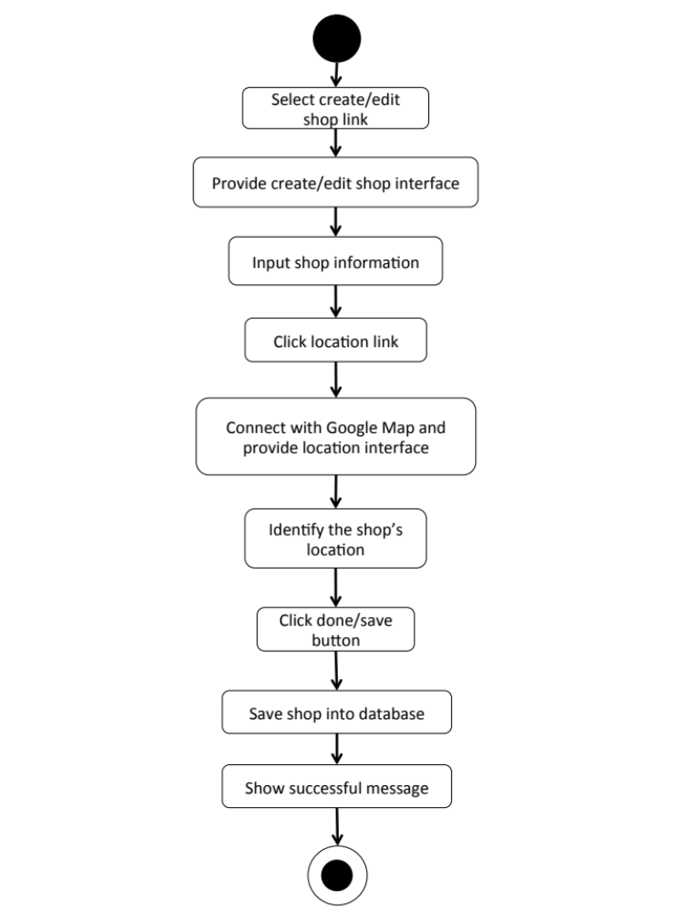
M-AD-29

Feature 5: Communication Management
M-URS-30: The user sees comments on tutorial.
Input and Output
- Input: The user selects tutorial link to see tutorial’s detail.
- Output: The system shows information of the tutorial including comments.

Description
URS ID | M-URS-30
URS Name | The user sees comments on tutorial.
Actor | User, Blogger
Description | This function allows user to see comments that exist in database on a tutorial.
Trigger | Select a tutorial
Pre-condition | - User has logged in to the system.  - User stays on tutorial detail page.
Post-condition | - System displays all comments that exist in database of the tutorial.
Normal flow | - User selects a tutorial.  - System gets the tutorial’s information from database.  - System displays all information of the tutorial, which are title, owner username, number of likes, category, material picture, material description, step description, step picture, video, and comments.  - System gets comment information, which are profile picture and username of the blogger that commented, and comment detail from database.  - System displays all comments of the tutorial.
Alternative flow | -
Exception | In all steps of normal flow, in case there is no internet connection.
Include | M-URS-14

M-AD-30

M-URS-31: The user adds comments on tutorial.
Input and Output
No | Input Name | Description | Example | Remarks | Output
1 | Comment | The length of Comment must be between 1-500 characters | “Awesome tutorial!” | - | The system shows “Awesome tutorial!” on the screen.

Description
URS ID | M-URS-31
URS Name | The user adds comments on tutorial.
Actor | Blogger
Description | This function allows user and other bloggers to communicate to each other by commenting on a certain tutorial.
Trigger | The user selects “Comment” to post comment on tutorial.
Pre-condition | - User has logged in to the system as a blogger.  - User stays on tutorial detail page.
Post-condition | - System displays the comment on the tutorial detail page.
Normal flow | 1) System provides a comment box.  2) User types a comment within 500 characters.  3) User clicks comment button.  4) System validates the comment format.  5) System saves the comment into database.  6) System displays the comment on the tutorial detail page.
Alternative flow | In step 4, if the comment is not in the right format, the system displays an error message.
Exception | In all steps of normal flow, in case there is no internet connection.
Include | M-URS-02, M-URS-14

M-AD-31

M-URS-32: The user likes a tutorial.
Input and Output
- Input: The user selects like on tutorial.
- Output: The system shows the liked sign on tutorial.

Description
URS ID | M-URS-32
URS Name | The user likes a tutorial.
Actor | Blogger
Description | This function allows user to give a like on his/her favorite tutorial.
Trigger | The user selects “Like” to like the tutorial.
Pre-condition | - User has logged in to the system as a blogger.  - User stays on tutorial detail page.
Post-condition | - System increase like number of the tutorial.
Normal flow | 1) User clicks like button.  2) System checks whether the user has liked this tutorial or not.  3) System adds information, which are likeID, tutorialID, and userID in like table in database.  4) System checks whether the tutorial id already exist in popular table or not.  5) System increases like_number in popular table by one.  6) System shows updated number of likes of the tutorial.
Alternative flow | In step 3, the system performs M-URS-33  In step 4, the system adds information, which are popularID, tutorialID, and like_number in popular table by one.
Exception | In all steps of normal flow, in case there is no internet connection.
Include | M-URS-02, M-URS-14

M-URS-33: The user undo likes from the liked tutorial.
Input and Output
- Input: The user selects like on the liked tutorial.
- Output: The system shows the like sign on tutorial.

Description
URS ID | M-URS-33
URS Name | The user undo likes from the liked tutorial.
Actor | Blogger
Description | This function allows user to remove the like that the user gave for a tutorial.
Trigger | The user selects “Liked” to undo like the tutorial.
Pre-condition | - User has logged in to the system as a blogger.  - User stays on tutorial detail page.  - User liked the tutorial.
Post-condition | - System decrease like number of the tutorial.
Normal flow | 1) User clicks liked button.  2) System checks whether the user has liked this tutorial or not.  3) System deletes information, which are likeID, tutorialID, and userID in like table in database.  4) System checks whether the tutorial id already exist in popular table or not.  5) System decreses like_number in popular table by one.  6) System shows updated number of likes of the tutorial.
Alternative flow | In step 3, the system performs M-URS-32  In step 4, the system deletes information, which are popularID, tutorialID, and like_number in popular table by one.
Exception | In all steps of normal flow, in case there is no internet connection.
Include | M-URS-02, M-URS-14, M-URS-32

M-AD-32

M-URS-34: The user follows other bloggers.
Input and Output
- Input: The user select follow on other blogger profile.
- Output: The system shows the following sign on the blogger profile.

Description
URS ID | M-URS-34
URS Name | The user follows other bloggers.
Actor | Blogger
Description | This function allows user to follow other bloggers in order to catch up their new tutorials.
Trigger | The user selects “Follow” to follow the blogger as a blogger.
Pre-condition | - User has logged in to the system.  - User stays on other blogger’s profile page.
Post-condition | - The system starts getting new information from the following blogger.
Normal flow | - System provides blogger’s profile interface.  - User clicks follow button.  - System checks whether the user has followed this user or not.  - System adds information, followID, following, and follower in follow table in database.  - System changes the sign on the button from follow to followed.
Alternative flow | M-URS-35
Exception | In all steps of normal flow, in case there is no internet connection.
Include | M-URS-02

M-URS-35: The user undo follows from the followed bloggers.
Input and Output
- Input: The user select unfollow on the followed blogger.
- Output: The system shows the follow sign on unfollowed blogger profile.

Description
URS ID | M-URS-35
URS Name | The user undo follows from the followed bloggers.
Actor | Blogger
Description | This function allows user to undo the follow process from the blogger that he/she is following.
Trigger | The user selects “Followed” to undo follow the blogger.
Pre-condition | - User has logged in to the system as a blogger.  - User stays on other blogger’s profile page.  - User followed the blogger.
Post-condition | - The system stops getting new information from the unfollowed blogger.
Normal flow | - System provides blogger’s profile interface.  - User clicks follow button.  - System checks whether the user has followed this user or not.  - System deletes information, followID, following, and follower in follow table in database.  - System changes the sign on the button from followed to follow.
Alternative flow | M-URS-34
Exception | In all steps of normal flow, in case there is no internet connection.
Include | M-URS-02, M-URS-34

M-AD-33

M-URS-36: The user sees list of bloggers whom the user is following.
Input and Output
- Input: The user select following link on other user’s profile page.
- Output: The system shows list of bloggers whom the user is following.

Description
URS ID | M-URS-36
URS Name | The user sees list of bloggers whom the user is following.
Actor | Blogger
Description | This function allows user to see list of the bloggers with their profile pictures and usernames that the user has been following.
Trigger | The user selects “Following” to undo follow the blogger.
Pre-condition | - User has logged in to the system as a blogger.  - User stays on other blogger’s profile page.
Post-condition | - The system stops getting new information from the unfollowed blogger.
Normal flow | 1) User goes to profile page.  - System gets user’s information from database.  - System displays interface and user’s information, which are profile picture, username, password, follower number, following number, and list of tutorials that he/she has created.  - User clicks on see following link.  - System goes to following page.  - System get list of bloggers whom the user is following from database.  - System displays list of bloggers whom the user is following.
Alternative flow | -
Exception | In all steps of normal flow, in case there is no internet connection.
Include | M-URS-34

M-AD-34

M-URS-37: The user sees list of bloggers who follows the user.
Input and Output
- Input: The user select follower link on other user’s profile page.
- Output: The system shows list of bloggers who follows the user.

Description
URS ID | M-URS-37
URS Name | The user sees list of bloggers who follows the user.
Actor | Blogger
Description | This function allows user to see list of the bloggers with their profile pictures and usernames that has been following the user.
Trigger | The user selects “Following” to undo follow the blogger.
Pre-condition | - User has logged in to the system as a blogger.  - User stays on other blogger’s profile page.
Post-condition | - The system stops getting new information from the unfollowed blogger.
Normal flow | - User goes to profile page.  - System gets user’s information from database.  - System displays interface and user’s information, which are profile picture, username, password, follower number, following number, and list of tutorials that he/she has created.  - User clicks on see follower link.  - System goes to follower page.  - System get list of bloggers who follows the user from database.  - System displays list of bloggers who follows the user.
Alternative flow | -
Exception | In all steps of normal flow, in case there is no internet connection.
Include | M-URS-34

M-AD-35

M-URS-38: The user sends private message.
Input and Output
No | Input Name | Description | Example | Remarks | Output
1 | Message | The length of Message must be between 1-500 characters | “Hello, I want to ask you something.” | - | The system shows “Hello, I want to ask you something.” on the screen.

Description
URS ID | M-URS-38
URS Name | The user sends private message.
Actor | Blogger, Shopkeeper
Description | This function allows user to start a private conversation with shopkeepers/bloggers via messages.
Trigger | The user selects the conversation link between the user and the shopkeeper/blogger.
Pre-condition | - User has logged in to the system.  - User selects a shop/blogger that he/she wants to send message to.
Post-condition | - System sends message to the shopkeeper/blogger.
Normal flow | 1) User clicks message button.  2) System provides message interface.  3) User types a message in the message box.  4) User clicks send button.  5) System validates the message format.  6) System checks whether the first user, who sends a message and the second user, whom will receive the message have ever had a conversation between each other before or not.  7) System gets conversationID from conversation table in database  8) System saves the information, which are messageID, conversationID, userID, message_detail, and time into message table in database.  9) System displays the sent message on the private message page.
Alternative flow | In step 5, system adds information, which are conversationID, userID_1, and userID_2 in conversation table in database before proceed to step 6.
Exception | In all steps of normal flow, in case there is no internet connection.
Include | M-URS-02

M-AD-36

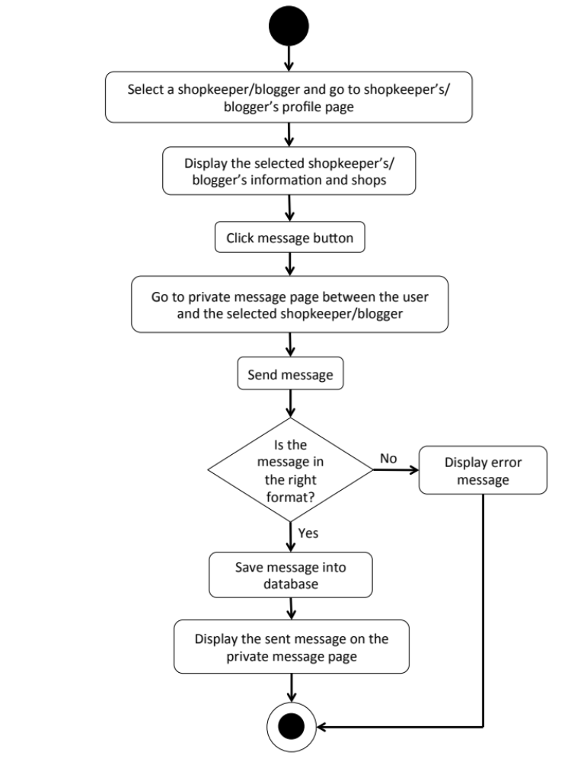

M-URS-39: The user receives private message.
- Input: The user selects message link to see messages.
- Output: The system shows messages that the user gets from a shopkeeper.

Description
URS ID | M-URS-39
URS Name | The user receives private message.
Actor | Blogger, Shopkeeper
Description | This function allows user to receive messages from the people whom the user is talking with.
Trigger | The user selects the conversation link between the user and the shopkeeper/blogger.
Pre-condition | - User has logged in to the system.  - User stays on Message page.
Post-condition | - System displays received messages.
Normal flow | - User selects a conversation  - System gets conversationID from the selected conversation.  - System retrieves message information, which are user’s profile picture and username from registered user table by using userID, and message_detail and time from message table in database by using the conversationID.  - System displays message information according to time, the latest message will be in the bottom.
Alternative flow | -
Exception | In all steps of normal flow, in case there is no internet connection.
Include | M-URS-02

M-AD-37
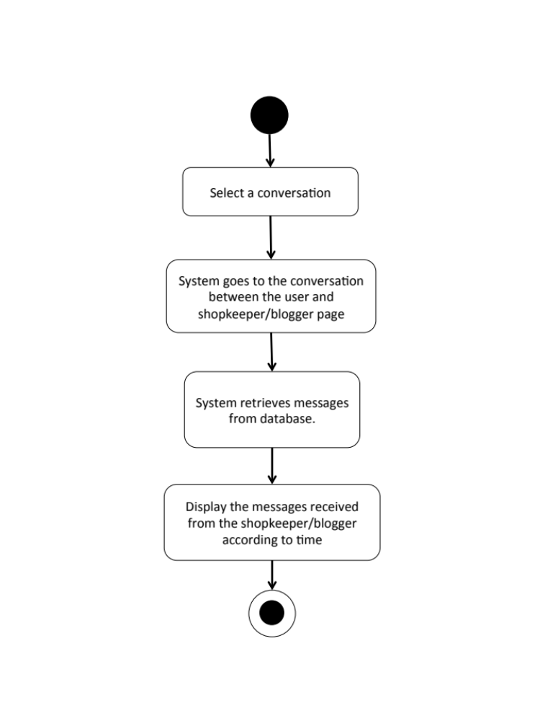

M-URS-40: The user sees list of people that has been communicated with.
- Input: The user selects message link to see messages.
- Output: The system shows list of messages that the user gets.

Description
URS ID | M-URS-40
URS Name | The user sees list of people that has been communicated with.
Actor | Blogger, Shopkeeper
Description | This function allows user to see the list of conversations with people that the user has been communicated with.
Trigger | The user selects “Message” to go to message page.
Pre-condition | - User has logged in to the system.
Post-condition | - System displays list of conversations.
Normal flow | - User goes to message page.  - System provides user interface of message page.  - System takes the user’s username to find the people who have already had a conversation with the user in conversation table in database.  - System shows list of conversations including the date and time, shop/blogger picture, and shop name/ blogger username, and time.
Alternative flow | -
Exception | In all steps of normal flow, in case there is no internet connection.
Include | M-URS-02, M-URS-38, M-URS-39

M-AD-38
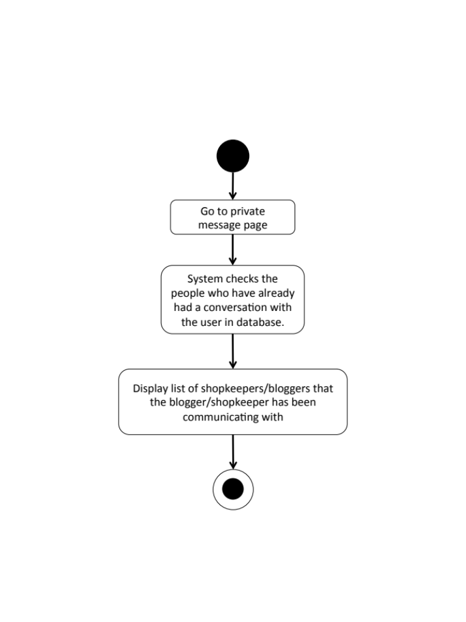

M-URS-41: The user shares tutorial to Facebook.
Input and Output
- Input: The user selects share link to share the tutorial to Facebook.
- Output: The system posts the tutorial on user’s Facebook wall.

Description
URS ID | M-URS-41
URS Name | The user shares tutorial to Facebook.
Actor | User, Blogger, Shopkeeper
Description | This function allows user to share a tutorial on his/her Facebook wall, and also able to write something about the tutorial.
Trigger | The user selects “Share” to share the tutorial on user’s Facebook wall.
Pre-condition | - User stays on tutorial detail page.
Post-condition | - The tutorial is posted in user’s Facebook wall
Normal flow | - User clicks share to Facebook button.  - System access to the user’s Facebook account from the user’s smart phone.  3) System displays confirmation post of the tutorial.  4) User writes some message about the tutorial.  5) User clicks post button.  6) System posts the tutorial on user’s Facebook wall.
Alternative flow | - In step 3, the user leaves the field blank in case he/she does not want to write anything about the tutorial.  - In step 4, the user clicks cancel button to cancel the tutorial sharing process.
Exception | In all steps of normal flow, in case there is no internet connection.
Include | M-URS-14

M-AD-39

M-URS-42: The user sees bloggers that exist in database by searching.

Input and Output
No | Input Name | Description | Example | Remarks | Output
1 | Keyword | The length of Keyword must be between 1-20 characters | “A” | The word should not contain any symbol. | The system shows bloggers that have the word “A” as a username.

Description
URS ID | M-URS-42
URS Name | The user sees bloggers that exist in database by searching.
Actor | Shopkeeper
Description | This function allows user to search certain bloggers by inputting a keyword or even a just character.
Trigger | The user clicks on the search box.
Pre-condition | - User has logged in to the system as a shopkeeper.  - User stays on search blogger page.
Post-condition | - System displays list of all bloggers that relate to the keyword or character.
Normal flow | 1) User input a keyword or character in the search box.  2) System gets bloggers information from database.  3) System displays list of all bloggers with bloggers’ pictures and usernames that relate to the keyword.
Alternative flow | -
Exception | In all steps of normal flow, in case there is no internet connection.
Include | M-URS-02

M-URS-43: The user sees list of searched bloggers.

Input and Output
No | Input Name | Description | Example | Remarks | Output
1 | Keyword | The length of Keyword must be between 1-20 characters | “A” | The word should not contain any symbol. | The system shows bloggers that have the word “A” as a username.

Description
URS ID | M-URS-43
URS Name | The user sees list of searched bloggers.
Actor | Shopkeeper
Description | This function allows user to see the list of bloggers that contain the searched keyword or character in their username
Trigger | The user clicks search button
Pre-condition | - User has logged in to the system as a shopkeeper.  - User stays on search blogger page.
Post-condition | - System displays list of all bloggers that relate to the keyword or character.
Normal flow | 1) User input a keyword or character in the search box.  2) System gets bloggers information from database.  3) System displays list of all bloggers with bloggers’ pictures and usernames that relate to the keyword.
Alternative flow | -
Exception | In all steps of normal flow, in case there is no internet connection.
Include | M-URS-02, M-URS-42

M-AD-40
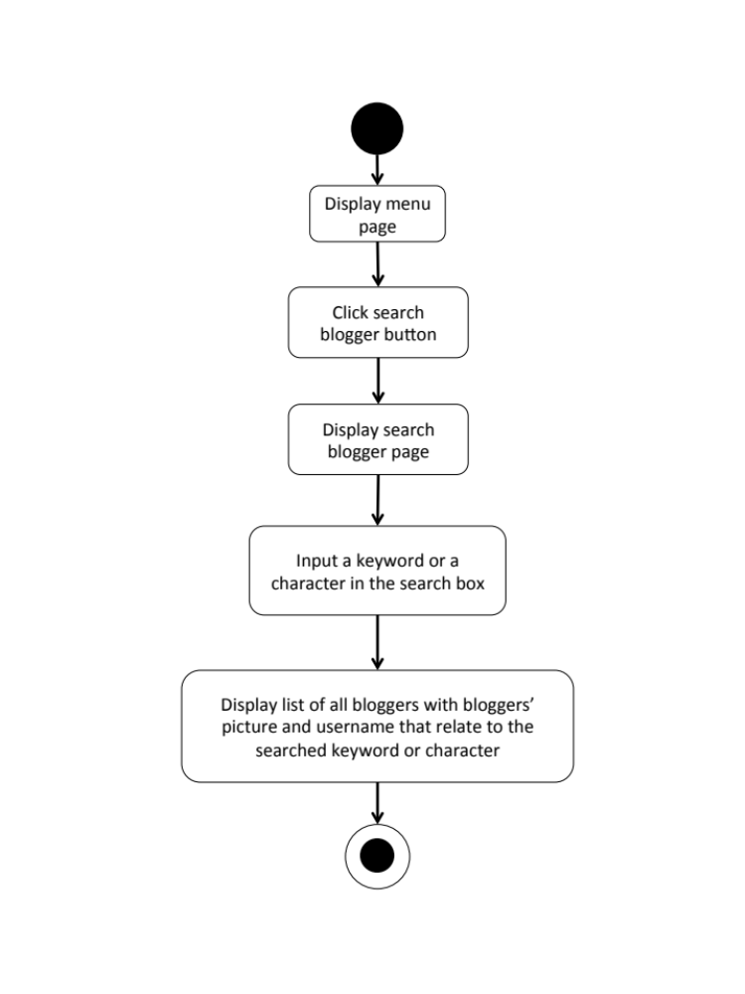

M-URS-44: The user sees blogger’s profile.
Input and Output
- Input: The user selects blogger link to go to the blogger’s profile page.
- Output: The system shows the selected blogger’s profile.

Description
URS ID | M-URS-44
URS Name | The user sees blogger’s profile.
Actor | Shopkeeper
Description | This function allows user to see selected blogger’s profile and information, which includes tutorials that the blogger has created.
Trigger | The user selects a blogger link to go to blogger’s profile page.
Pre-condition | - User has logged in to the system as a shopkeeper.  - User has searched and seen list of bloggers
Post-condition | - System displays the selected blogger’s profile.
Normal flow | - User goes to blogger’s profile page.  - System gets blogger’s information from database.  - System displays interface and blogger’s information, which are profile picture, username, follower number, following number, and list of tutorials that he/she has created.
Alternative flow | -
Exception | In all steps of normal flow, in case there is no internet connection.
Include | M-URS-02, M-URS-43

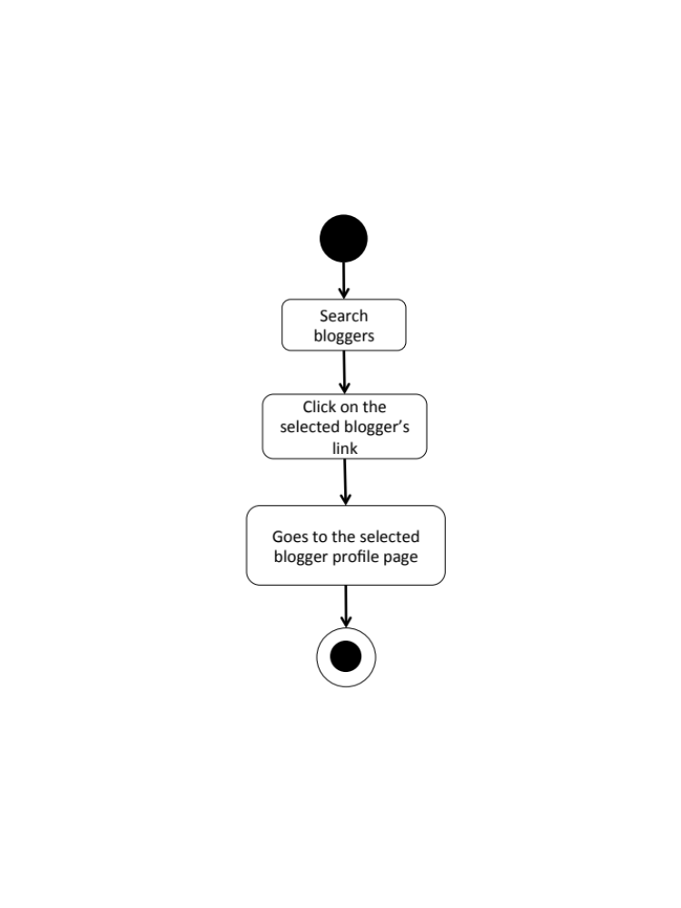
M-AD-41

M-URS-45: The user sees list of notifications when there is new like, comment or follower.
Input and Output
- Input: The user selects notification link to see list of new activities that has happened to the user.
- Output: The system shows list of new activities that has happened to the user.

Description
URS ID | M-URS-45
URS Name | The user sees list of notifications when there is new like, comment or follower.
Actor | Blogger
Description | This function will notify the user when there is any new activity, such as new like, comment, or blogger follow. Moreover, it also allows the user to see list of the activities happened with the user.
Trigger | The user selects notification sign to go to notification page and see lists of new activities.
Pre-condition | - User stays on home page.
Post-condition | - The system shows list of new activities that has happened to the user.
Normal flow | - User goes to notification page.  - System provides user interface of notification page.  - System checks new activity of the user in database.  - System shows list of new activities including the type of activities and username of the blogger that has created the interaction.
Alternative flow | -
Exception | In all steps of normal flow, in case there is no internet connection.
Include | M-URS-02, M-URS-32, M-URS-30, M-URS-34

M-AD-42

M-URS-46: The user goes to the activity that has been notified.
Input and Output
- Input: The user selects an activity link in the notification page.
- Output: The system goes to the page that the selected activity has happened.

Description
URS ID | M-URS-46
URS Name | The user goes to the activity that has been notified.
Actor | Blogger
Description | This function allows the user to select a new activity to see the detail where the activity has happened.
Trigger | The user selects an activity link to go to the page that the selected activity has happened.
Pre-condition | - User stays on activity page.
Post-condition | - The system goes to the page that the selected activity has happened.
Normal flow | - User goes to notification page.  - System shows list of new activities including the type of activities and username of the blogger that has created the interaction.  - User selects an activity link.  - System checks type of the selected activity, whether it is like, comment, or follow.  - System goes to tutorial detail page if the activity type are like or comment, and goes to user’s profile page if the type is follow.
Alternative flow | -
Exception | In all steps of normal flow, in case there is no internet connection.
Include | M-URS-02, M-URS-32, M-URS-30, M-URS-34, M-URS-45

M-AD-43

Chapter Four | System Features

  - Software Requirement Specification
    - Software Requirement Specification for Web Application

W-URS-01: The user registers as a blogger.
SRS No. | SRS Name
W-SRS-01 | The system shall provide sign up button on log in interface.
W-SRS-02 | The system shall provide service for user registration.
W-SRS-03 | The system shall provide text fields on sign up interface for user to input information.
W-SRS-04 | The system shall provide a confirmation button on sign up interface to confirm the registration.
W-SRS-05 | The system shall provide service for user information validation.
W-SRS-06 | The system shall provide service for existing user account validation.

W-URS-02: The user logins to the system.
SRS No. | SRS Name
W-SRS-07 | The system shall provide text fields on log in interface for user to input username and password.
W-SRS-08 | The system shall provide service for user account authorization validation.
W-SRS-09 | The system shall provide service for displaying Blogger/Shopkeeper home page.

W-URS-03: The user logouts from the system.
SRS No. | SRS Name
W-SRS-10 | The system shall provide service for displaying Blogger home page.
W-SRS-11 | The system shall provide log out button on Blogger home page interface.

W-URS-04: The user sees his/her profile.
SRS No. | SRS Name
W-SRS-12 | The system shall provide service for displaying Blogger profile page.

W-URS-05: The user edits his/her profile.
SRS No. | SRS Name
W-SRS-13 | The system shall provide edit button on Blogger profile page interface.
W-SRS-14 | The system shall provide service for profile editing.
W-SRS-15 | The system shall provide text fields on edit profile interface for user to input information.
W-SRS-16 | The system shall provide a confirmation button on edit profile interface to confirm the profile editing.
W-SRS-05 | The system shall provide service for user information validation.

W-URS-06: The user adds profile picture.
SRS No. | SRS Name
W-SRS-13 | The system shall provide edit button on Blogger profile page interface.
W-SRS-14 | The system shall provide service for profile editing.
W-SRS-17 | The system shall provide add picture button on Blogger profile page interface.
W-SRS-16 | The system shall provide a confirmation button on edit profile interface to confirm the profile editing.
W-SRS-05 | The system shall provide service for user information validation.

W-URS-07: The user changes profile picture.
SRS No. | SRS Name
W-SRS-13 | The system shall provide edit button on Blogger profile page interface.
W-SRS-14 | The system shall provide service for profile editing.
W-SRS-17 | The system shall provide add picture button on Blogger profile page interface.
W-SRS-16 | The system shall provide a confirmation button on edit profile interface to confirm the profile editing.
W-SRS-05 | The system shall provide service for user information validation.

W-URS-08: The user changes his/her password.
SRS No. | SRS Name
W-SRS-18 | The system shall provide change password button on Blogger edit profile page interface.
W-SRS-19 | The system shall provide service for password changing.
W-SRS-20 | The system shall provide text fields on change password interface for user to input information.
W-SRS-21 | The system shall provide a confirmation button on change password interface to confirm the profile editing.
W-SRS-05 | The system shall provide service for user information validation.

W-URS-09: The user deletes his/her account.
SRS No. | SRS Name
W-SRS-22 | The system shall provide delete account button on Blogger edit profile page interface.
W-SRS-23 | The system shall provide service for account deleting.
W-SRS-24 | The system shall display a confirm dialog box.

W-URS-10: The user sees tutorials by random.
SRS No. | SRS Name
W-SRS-25 | The system shall provide service for displaying Visitor/Blogger home page.
W-SRS-26 | The system shall provide service for tutorial exploration by random.

W-URS-11: The user sees tutorials by popular.
SRS No. | SRS Name
W-SRS-25 | The system shall provide service for displaying Visitor/Blogger home page.
W-SRS-27 | The system shall provide service for tutorial exploration by popularity.

W-URS-12: The user sees tutorials by categories.
SRS No. | SRS Name
W-SRS-25 | The system shall provide service for displaying Visitor/Blogger menu page.
W-SRS-28 | The system shall provide service for tutorial exploration by categories, which are outfit, accessory, gift, kid, garden, home décor, pet, and other.

W-URS-13: The user sees tutorials by searching.
SRS No. | SRS Name
W-SRS-25 | The system shall provide service for displaying Visitor/Blogger home page.
W-SRS-29 | The system shall provide service for tutorial exploration by searching a keyword.

W-URS-14: The user sees tutorials by following.
SRS No. | SRS Name
W-SRS-25 | The system shall provide service for displaying Blogger home page.
W-SRS-30 | The system shall provide service for tutorial exploration by following bloggers.

W-URS-15: The user sees tutorial information.
SRS No. | SRS Name
W-SRS-31 | The system shall provide service for displaying tutorial detail page.

W-URS-16: The user creates his/her own tutorial.
SRS No. | SRS Name
W-SRS-32 | The system shall provide create button on Blogger home page interface.
W-SRS-33 | The system shall provide service for tutorial creation.
W-SRS-34 | The system shall provide text fields on create tutorial interface for user to input information.
W-SRS-35 | The system shall provide a confirmation button on create tutorial interface to confirm the tutorial creation.
W-SRS-36 | The system shall provide service for tutorial information validation.

W-URS-17: The user sees his/her own tutorial.
SRS No. | SRS Name
W-SRS-12 | The system shall provide service for displaying Blogger profile page.

W-URS-18: The user edits his/her own tutorial.
SRS No. | SRS Name
W-SRS-37 | The system shall provide edit button on Blogger’s tutorial detail page interface.
W-SRS-38 | The system shall provide service for tutorial editing.
W-SRS-39 | The system shall provide text fields on edit tutorial interface for user to input information.
W-SRS-40 | The system shall provide a confirmation button on edit tutorial interface to confirm the tutorial editing.
W-SRS-36 | The system shall provide service for tutorial information validation.

W-URS-19: The user deletes his/her own tutorial.
SRS No. | SRS Name
W-SRS-41 | The system shall provide delete tutorial button on Blogger’s tutorial detail page interface.
W-SRS-42 | The system shall provide service for tutorial deleting.
W-SRS-24 | The system shall display a confirm dialog box.

W-URS-20: The user randomly sees list of shops that exist in database.
SRS No. | SRS Name
W-SRS-43 | The system shall provide service for displaying Shop page/ Shopkeeper home page.
W-SRS-44 | The system shall provide service for shop exploration by random.

W-URS-21: The user sees shops that exist in database by choosing a category.
SRS No. | SRS Name
W-SRS-43 | The system shall provide service for displaying Shop page/ Shopkeeper home page.
W-SRS-45 | The system shall provide service for shop exploration by categories, which are fabric, accessory, wood, stationary, container, and other.

W-URS-22: The user search shops’ name that exist in database by inputting a keyword.
SRS No. | SRS Name
W-SRS-43 | The system shall provide service for displaying Shop page/ Shopkeeper home page.
W-SRS-46 | The system shall provide service for shop exploration by searching a keyword.

W-URS-23: The user sees selected shop information.
SRS No. | SRS Name
W-SRS-47 | The system shall provide service for displaying shop detail page.

W-URS-24: The user sees shop’s location on Google Map.
SRS No. | SRS Name
W-SRS-47 | The system shall provide service for displaying shop detail page.

W-URS-25: The user sees comments on tutorial.
SRS No. | SRS Name
W-SRS-31 | The system shall provide service for displaying tutorial detail page.
W-URS-26: The user adds comment on tutorial.
SRS No. | SRS Name
W-SRS-31 | The system shall provide service for displaying tutorial detail page.
W-SRS-48 | The system shall provide comment box on tutorial detail interface for user to input comment.
W-SRS-49 | The system shall provide a submit button on tutorial detail interface to confirm to submit the comment.
W-SRS-50 | The system shall provide service for comment information validation.

W-URS-27: The user likes a tutorial.
SRS No. | SRS Name
W-SRS-31 | The system shall provide service for displaying tutorial detail page.
W-SRS-51 | The system shall provide like button on tutorial detail page interface.
W-SRS-52 | The system shall provide service for tutorial liking.

W-URS-28: The user undo likes from the liked tutorial.
SRS No. | SRS Name
W-SRS-31 | The system shall provide service for displaying tutorial detail page.
W-SRS-53 | The system shall provide liked button on tutorial detail page interface.
W-SRS-54 | The system shall provide service for undo tutorial liking.

W-URS-29: The user follows other bloggers.
SRS No. | SRS Name
W-SRS-12 | The system shall provide service for displaying Blogger profile page.
W-SRS-55 | The system shall provide follow button on Blogger profile page interface.
W-SRS-56 | The system shall provide service for blogger following.

W-URS-30: The user undo follows from the followed bloggers.
SRS No. | SRS Name
W-SRS-12 | The system shall provide service for displaying Blogger profile page.
W-SRS-57 | The system shall provide followed button on Blogger profile page interface.
W-SRS-58 | The system shall provide service for undo blogger following.

W-URS-31: The user sees list of bloggers whom the user is following.
SRS No. | SRS Name
W-SRS-12 | The system shall provide service for displaying Blogger profile page.
W-SRS-59 | The system shall provide following link on Blogger profile page interface.
W-SRS-60 | The system shall provide service for displaying list of bloggers that the user is following.

W-URS-32: The user sees list of bloggers who follows the user.
SRS No. | SRS Name
W-SRS-12 | The system shall provide service for displaying Blogger profile page.
W-SRS-61 | The system shall provide follower link on Blogger profile page interface.
W-SRS-62 | The system shall provide service for displaying list of bloggers who has followed the user.

W-URS-33: The user sends private message.
SRS No. | SRS Name
W-SRS-63 | The system shall provide message button on Shopkeeper profile page interface.
W-SRS-64 | The system shall provide service for displaying conversation page.
W-SRS-65 | The system shall provide service for message sending.

W-URS-34: The user receives private message.
SRS No. | SRS Name
W-SRS-66 | The system shall provide message button on home page interface.
W-SRS-67 | The system shall provide service for displaying message page.
W-SRS-68 | The system shall provide conversation link on message page interface.
W-SRS-64 | The system shall provide service for displaying conversation page.
W-SRS-69 | The system shall provide service for message receiving by displaying the received message on the conversation page.

W-URS-35: The user sees list of shopkeepers that has been communicate with.
SRS No. | SRS Name
W-SRS-67 | The system shall provide service for displaying message page.
W-SRS-70 | The system shall provide service for displaying list of people the user has communicated with.

W-URS-36: The user shares tutorial to Facebook.
SRS No. | SRS Name
W-SRS-31 | The system shall provide service for displaying tutorial detail page.
W-SRS-71 | The system shall provide Facebook share button on tutorial detail page interface.
W-SRS-72 | The system shall provide service for tutorial Facebook sharing.

W-URS-37: The user sees list of notifications when there is new like, comment or follower.
SRS No. | SRS Name
W-SRS-73 | The system shall provide service for displaying notification page.

W-URS-38: The user goes to the activity that has been notified.
SRS No. | SRS Name
W-SRS-73 | The system shall provide service for displaying notification page.
W-SRS-74 | The system shall provide activity link on tutorial notification page interface.
W-SRS-32 | The system shall provide service for displaying tutorial detail page.
W-SRS-12 | The system shall provide service for displaying Blogger profile page.

    - Software Requirement Specification for Mobile Application
M-URS-01: The user registers as a blogger.
SRS No. | SRS Name
M-SRS-01 | The system shall provide sign up button on log in interface.
M-SRS-02 | The system shall provide service for user registration.
M-SRS-03 | The system shall provide text fields on sign up interface for user to input information.
M-SRS-04 | The system shall provide a confirmation button on sign up interface to confirm the registration.
M-SRS-05 | The system shall provide service for user information validation.
M-SRS-06 | The system shall provide service for existing user account validation.

M-URS-02: The user logins to the system.
SRS No. | SRS Name
M-SRS-07 | The system shall provide text fields on log in interface for user to input username and password.
M-SRS-08 | The system shall provide service for user account authorization validation.
M-SRS-09 | The system shall provide service for displaying Blogger/Shopkeeper home page.

M-URS-03: The user logouts from the system.
SRS No. | SRS Name
M-SRS-10 | The system shall provide service for displaying Blogger/Shopkeeper menu page.
M-SRS-11 | The system shall provide log out button on Blogger/Shopkeeper menu page interface.

M-URS-04: The user sees his/her profile.
SRS No. | SRS Name
M-SRS-12 | The system shall provide service for displaying Blogger profile page.
M-SRS-13 | The system shall provide service for displaying Shopkeeper profile page.

M-URS-05: The user edits his/her profile.
SRS No. | SRS Name
M-SRS-14 | The system shall provide edit button on Blogger/Shopkeeper profile page interface.
M-SRS-15 | The system shall provide service for profile editing.
M-SRS-16 | The system shall provide text fields on edit profile interface for user to input information.
M-SRS-17 | The system shall provide a confirmation button on edit profile interface to confirm the profile editing.
M-SRS-05 | The system shall provide service for user information validation.

M-URS-06: The user changes profile picture.
SRS No. | SRS Name
M-SRS-14 | The system shall provide edit button on Blogger/Shopkeeper profile page interface.
M-SRS-15 | The system shall provide service for profile editing.
M-SRS-18 | The system shall provide add picture button on Blogger/Shopkeeper profile page interface.
M-SRS-17 | The system shall provide a confirmation button on edit profile interface to confirm the profile editing.
M-SRS-05 | The system shall provide service for user information validation.

M-URS-07: The user changes his/her password.
SRS No. | SRS Name
M-SRS-19 | The system shall provide change password button on Blogger/Shopkeeper edit profile page interface.
M-SRS-20 | The system shall provide service for password changing.
M-SRS-21 | The system shall provide text fields on change password interface for user to input information.
M-SRS-22 | The system shall provide a confirmation button on change password interface to confirm the profile editing.
M-SRS-05 | The system shall provide service for user information validation.

M-URS-08: The user deletes his/her account.
SRS No. | SRS Name
M-SRS-23 | The system shall provide delete account button on Blogger/Shopkeeper edit profile page interface.
M-SRS-24 | The system shall provide service for account deleting.
M-SRS-25 | The system shall display a confirm dialog box.

M-URS-09: The user sees tutorials by random.
SRS No. | SRS Name
M-SRS-26 | The system shall provide service for displaying Visitor/Blogger home page.
M-SRS-27 | The system shall provide service for tutorial exploration by random.

M-URS-10: The user sees tutorials by popular.
SRS No. | SRS Name
M-SRS-26 | The system shall provide service for displaying Visitor/Blogger home page.
M-SRS-28 | The system shall provide service for tutorial exploration by popularity.

M-URS-11: The user sees tutorials by categories.
SRS No. | SRS Name
M-SRS-26 | The system shall provide service for displaying Visitor/Blogger menu page.
M-SRS-29 | The system shall provide service for tutorial exploration by categories, which are outfit, accessory, gift, kid, garden, home décor, pet, and other.

M-URS-12: The user sees tutorials by searching.
SRS No. | SRS Name
M-SRS-26 | The system shall provide service for displaying Visitor/Blogger home page.
M-SRS-30 | The system shall provide service for tutorial exploration by searching a keyword.

M-URS-13: The user sees tutorials by following.
SRS No. | SRS Name
M-SRS-26 | The system shall provide service for displaying Blogger home page.
M-SRS-31 | The system shall provide service for tutorial exploration by following bloggers.

M-URS-14: The user sees tutorial information.
SRS No. | SRS Name
M-SRS-32 | The system shall provide service for displaying tutorial detail page.

M-URS-15: The user creates his/her own tutorial.
SRS No. | SRS Name
M-SRS-33 | The system shall provide create button on Blogger home page interface.
M-SRS-34 | The system shall provide service for tutorial creation.
M-SRS-35 | The system shall provide text fields on create tutorial interface for user to input information.
M-SRS-36 | The system shall provide a confirmation button on create tutorial interface to confirm the tutorial creation.
M-SRS-37 | The system shall provide service for tutorial information validation.

M-URS-16: The user sees his/her own tutorial.
SRS No. | SRS Name
M-SRS-12 | The system shall provide service for displaying Blogger profile page.

M-URS-17: The user edits his/her own tutorial.
SRS No. | SRS Name
M-SRS-38 | The system shall provide edit button on Blogger’s tutorial detail page interface.
M-SRS-39 | The system shall provide service for tutorial editing.
M-SRS-40 | The system shall provide text fields on edit tutorial interface for user to input information.
M-SRS-41 | The system shall provide a confirmation button on edit tutorial interface to confirm the tutorial editing.
M-SRS-37 | The system shall provide service for tutorial information validation.

M-URS-18: The user deletes his/her own tutorial.
SRS No. | SRS Name
M-SRS-42 | The system shall provide delete tutorial button on Blogger’s tutorial detail page interface.
M-SRS-43 | The system shall provide service for tutorial deleting.
M-SRS-25 | The system shall display a confirm dialog box.

M-URS-19: The user randomly sees list of shops that exist in database.
SRS No. | SRS Name
M-SRS-44 | The system shall provide service for displaying Shop page/ Shopkeeper home page.
M-SRS-45 | The system shall provide service for shop exploration by random.

M-URS-20: The user sees shops that exist in database by choosing a category.
SRS No. | SRS Name
M-SRS-44 | The system shall provide service for displaying Shop page/ Shopkeeper home page.
M-SRS-46 | The system shall provide service for tutorial exploration by categories, which are outfit, accessory, gift, kid, garden, home décor, pet, and other.

M-URS-21: The user search shops’ name that exist in database by inputting a keyword.
SRS No. | SRS Name
M-SRS-44 | The system shall provide service for displaying Shop page/ Shopkeeper home page.
M-SRS-47 | The system shall provide service for shop exploration by searching a keyword.

M-URS-22: The user sees selected shop information.
SRS No. | SRS Name
M-SRS-48 | The system shall provide service for displaying shop detail page.

M-URS-23: The user creates his/her own shop, which includes shop detail.
SRS No. | SRS Name
M-SRS-49 | The system shall provide create button on Shopkeeper home page interface.
M-SRS-50 | The system shall provide service for shop creation.
M-SRS-51 | The system shall provide text fields on create shop interface for user to input information.
M-SRS-52 | The system shall provide a confirmation button on create shop interface to confirm the shop creation.
M-SRS-53 | The system shall provide service for shop information validation.

M-URS-24: The user sees detail of his/her own shop.
SRS No. | SRS Name
M-SRS-13 | The system shall provide service for displaying Shopkeeper profile page.

M-URS-25: The user edits detail of his/her own shop.
SRS No. | SRS Name
M-SRS-54 | The system shall provide edit button on Shopkeeper’s shop detail page interface.
M-SRS-55 | The system shall provide service for shop editing.
M-SRS-56 | The system shall provide text fields on edit shop interface for user to input information.
M-SRS-57 | The system shall provide a confirmation button on edit shop interface to confirm the shop editing.
M-SRS-53 | The system shall provide service for shop information validation.

M-URS-26: The user deletes his/her own shop.
SRS No. | SRS Name
M-SRS-58 | The system shall provide delete shop button on Shopkeeper’s shop detail page interface.
M-SRS-59 | The system shall provide service for shop deleting.
M-SRS-25 | The system shall display a confirm dialog box.

M-URS-27: The user sees near by shops’ location on Google Map.
SRS No. | SRS Name
M-SRS-60 | The system shall provide service for displaying Blogger menu page.
M-SRS-61 | The system shall provide around me button on Blogger menu page interface.
M-SRS-62 | The system shall provide service for near by shop exploration.

M-URS-28: The user sees shop’s location on Google Map.
SRS No. | SRS Name
M-SRS-48 | The system shall provide service for displaying shop detail page.

M-URS-29: The user identifies his/her shop’s location on Google Map.
SRS No. | SRS Name
M-SRS-49 | The system shall provide create button on Shopkeeper home page interface.
M-SRS-50 | The system shall provide service for shop creation.
M-SRS-51 | The system shall provide text fields on create shop interface for user to input information.
M-SRS-52 | The system shall provide a confirmation button on create shop interface to confirm the shop creation.
M-SRS-53 | The system shall provide service for shop information validation.

M-URS-30: The user sees comment on tutorial.
SRS No. | SRS Name
M-SRS-32 | The system shall provide service for displaying tutorial detail page.

M-URS-31: The user adds comment on tutorial.
SRS No. | SRS Name
M-SRS-32 | The system shall provide service for displaying tutorial detail page.
M-SRS-63 | The system shall provide comment box on tutorial detail interface for user to input comment.
M-SRS-64 | The system shall provide a submit button on tutorial detail interface to confirm to submit the comment.
M-SRS-65 | The system shall provide service for comment information validation.

M-URS-32: The user likes a tutorial.
SRS No. | SRS Name
M-SRS-32 | The system shall provide service for displaying tutorial detail page.
M-SRS-66 | The system shall provide like button on tutorial detail page interface.
M-SRS-67 | The system shall provide service for tutorial liking.

M-URS-33: The user undo likes from the liked tutorial.
SRS No. | SRS Name
M-SRS-32 | The system shall provide service for displaying tutorial detail page.
M-SRS-68 | The system shall provide liked button on tutorial detail page interface.
M-SRS-69 | The system shall provide service for undo tutorial liking.

M-URS-34: The user follows other bloggers.
SRS No. | SRS Name
M-SRS-12 | The system shall provide service for displaying Blogger profile page.
M-SRS-70 | The system shall provide follow button on Blogger profile page interface.
M-SRS-71 | The system shall provide service for blogger following.

M-URS-35: The user undo follows from the followed bloggers.
SRS No. | SRS Name
M-SRS-12 | The system shall provide service for displaying Blogger profile page.
M-SRS-72 | The system shall provide followed button on Blogger profile page interface.
M-SRS-73 | The system shall provide service for undo blogger following.

M-URS-36: The user sees list of bloggers whom the user is following.
SRS No. | SRS Name
M-SRS-12 | The system shall provide service for displaying Blogger profile page.
M-SRS-74 | The system shall provide following link on Blogger profile page interface.
M-SRS-75 | The system shall provide service for displaying list of bloggers that the user is following.

M-URS-37: The user sees list of bloggers who follows the user.
SRS No. | SRS Name
M-SRS-12 | The system shall provide service for displaying Blogger profile page.
M-SRS-76 | The system shall provide follower link on Blogger profile page interface.
M-SRS-77 | The system shall provide service for displaying list of bloggers who has followed the user.

M-URS-38: The user sends private message.
SRS No. | SRS Name
M-SRS-78 | The system shall provide message button on Blogger/Shopkeeper profile page interface.
M-SRS-79 | The system shall provide service for displaying conversation page.
M-SRS-80 | The system shall provide service for message sending.

M-URS-39: The user receives private message.
SRS No. | SRS Name
M-SRS-81 | The system shall provide message button on home page interface.
M-SRS-82 | The system shall provide service for displaying message page.
M-SRS-83 | The system shall provide conversation link on message page interface.
M-SRS-79 | The system shall provide service for displaying conversation page.
M-SRS-84 | The system shall provide service for message receiving by displaying the received message on the conversation page.

M-URS-40: The user sees list of people that has been communicate with.
SRS No. | SRS Name
M-SRS-82 | The system shall provide service for displaying message page.
M-SRS-85 | The system shall provide service for displaying list of people the user has communicated with.

M-URS-41: The user shares tutorial to Facebook.
SRS No. | SRS Name
M-SRS-32 | The system shall provide service for displaying tutorial detail page.
M-SRS-86 | The system shall provide Facebook share button on tutorial detail page interface.
M-SRS-87 | The system shall provide service for tutorial Facebook sharing.

M-URS-42: The user sees bloggers that exist in database by searching.
SRS No. | SRS Name
M-SRS-88 | The system shall provide service for displaying search blogger page.
M-SRS-89 | The system shall provide service for blogger exploration by searching a keyword.

M-URS-43: The user sees list of searched bloggers.
SRS No. | SRS Name
M-SRS-90 | The system shall provide service for displaying bloggers searched page.

M-URS-44: The user sees blogger’s profile.
SRS No. | SRS Name
M-SRS-12 | The system shall provide service for displaying Blogger profile page.

M-URS-45: The user sees list of notifications when there is new like, comment or follower.
SRS No. | SRS Name
M-SRS-91 | The system shall provide service for displaying notification page.

M-URS-46: The user goes to the activity that has been notified.
SRS No. | SRS Name
M-SRS-91 | The system shall provide service for displaying notification page.
M-SRS-92 | The system shall provide activity link on tutorial notification page interface.
M-SRS-32 | The system shall provide service for displaying tutorial detail page.
M-SRS-12 | The system shall provide service for displaying Blogger profile page.

  - Quality Requirement

HanDIYcraft software should meet these quality factors according to the McCall’s Model.

    - Product Operation Factors

Correctness
The software should provide more than 80% of data as the user requested correctly.

Usability
The software should provide understandable and easy-to-use GUI and language.

Reliability
The software should perform with more than 80% of usual activities, and with less than 10% of failure.

Integrity
The software should be able to identify between authorized and unauthorized users, and also between each type of users.

    - Product Revision Factors

Maintainability
The software should contain 20-30% of comments from the total LOC, in order to support further more maintenance.

Testability

The software should be 100% tested.

    - Product Transition Factors

Reusability
More than 50% of the complete software should be able to be reused in the future.

