Document History
Document Name | Detail | Status | Date | Viewable | Reviewer& Responsible
HanDIYcraft-SRS-0.1.docx | -Introduction | Draft | 15/4/14 | Advisor | NK, PS
HanDIYcraft -SRS-0.2.docx | -Update Introduction  -Overall Description | Draft | 16/4/14 | Advisor | NK, PS
HanDIYcraft -SRS-0.3.docx | -Update Overall Description  -User Requirements | Draft | 17/4/14 | Advisor | NK, PS
HanDIYcraft -SRS-0.4.docx | -Update User Requirements | Draft | 18/4/14 | Advisor | NK, PS
HanDIYcraft -SRS-0.5.docx | -Update User Requirements | Draft | 19/4/14 | Advisor | NK, PS
HanDIYcraft -SRS-0.6.docx | -Update User Requirements | Draft | 20/4/14 | Advisor | NK, PS
HanDIYcraft -SRS-0.7.docx | -Update User Requirements  - System Features | Draft | 21/4/14 | Advisor | NK, PS
HanDIYcraft -SRS-0.8.docx | -Update System Features | Draft | 5/7/14 | Advisor | NK, PS
HanDIYcraft -SRS-1.0.docx | -Update System Features | Release | 7/7/14 | Advisor | NK, PS
HanDIYcraft -SRS-1.1.docx | -Update Overall Description  -Update User Requirements | Draft | 21/7/14 | Advisor | NK, PS
HanDIYcraft -SRS-1.2.docx | -Update User Requirements | Release | 24/7/14 | Advisor | NK, PS
HanDIYcraft -SRS-1.3.docx | -Update User Requirements | Draft | 23/9/14 | Advisor | NK, PS
HanDIYcraft -SRS-1.4.docx | -Update User Requirements | Draft | 24/9/14 | Advisor | NK, PS
HanDIYcraft -SRS-1.5.docx | -Update System Features | Draft | 25/9/14 | Advisor | NK, PS
HanDIYcraft -SRS-1.6.docx | -Update User Requirements | Draft | 11/10/14 | Advisor | NK, PS
HanDIYcraft -SRS-1.7.docx | -Update User Requirements | Draft | 12/10/14 | Advisor | NK, PS

NK : Nahathai Kaewtatib

PS : Pimchanok Sripraphan

…………………………

Ms. Nahathai Kaewtatib

Project SRS Writer

…………………………

Ms. Pimchanok Sripraphan

Project SRS Writer

22nd October 2014

Table of Contents
Chapter One| Introduction 4
1.1 Objective 4
1.2 Intended Audience and Reading Suggestions 4
1.3 Project Scope 5
1.4 Acronyms and Definitions 5
Chapter Two | Overall Description 6
2.1 Product Perspective 6
2.2 Product Features 6
2.3 User Classes and Characteristics 7
2.3.1 Users 7
2.3.2 Bloggers 7
2.3.3 Shopkeepers 7
2.4 Operation Environment 7
2.5 Design and Implementation Constraints 8
Chapter Three | User Requirements 9
3.1 Use Cases 9
3.1.1 HanDIYcraft Use Case for Web Application 9
3.1.2 HanDIYcraft Use Case for Mobile Application 10
3.2 User Requirement Specification 11
3.2.1 User Requirement Specification for Web Application 11
3.2.2 User Requirement Specification for Mobile Application 13
3.3 User Requirement Description and Activity Diagram 15
3.3.1 User Requirement Description for Web Application 15
3.3.2 User Requirement Description for Mobile Application 56
Chapter Four | System Features 94
4.1 Software Requirement Specification 94
4.1.1 Software Requirement Specification for Web Application 94
4.1.2 Software Requirement Specification for Mobile Application 104
4.2 Quality Requirement 113

Chapter One | Introduction

1.1 Objective
HanDIYcraft is a web application, and mobile application for smartphone that supports Android operating system. It is an application that guide users the method how to recycle things by themselves. This application provides several tutorials for users to learn. Moreover, in case the users do not have the needed materials and have no idea where to buy, this application provides a feature to let the users check out the shops that sell related materials for making their DIY artworks and find the location of the shop via Google Maps. Apart from just exploring, the bloggers can directly communicate with the shopkeepers by sending private messages, and among each other by the comment. They can also share their favorite DIY tutorial to the social network like Facebook too.
This Software Requirement Specification document defines more about the abilities and features of the system in details. It includes the scope and limitations of the project, product function, user characteristics, functional requirements, non-functional requirements, use cases and activity diagrams to explain how the system works.

  - Intended Audience an Reading Suggestions

This Software Requirement Specification is designed for the people who are involved and related with the HanDIYcraft project. It may benefit to these people as followed:

Development Team
- Specifies the abilities and actions, including the scope of the system. From this point, it helps everyone to have the same understanding towards the project.
- Verifies and validates the working of software whether it works as it is defined in the document or not.
- Helps in achieving the quality of the product as much as possible.
- Used for the discussion among the related people about the project.

Customer
- Ensure that the development team understands and interprets in the same thing, in order to satisfy the customer needs.
- Helps customer to understand the technical things such as the quality, scope and limitations.

  - Project Scope

- Available only in English.
- Provide understandable symbols and language.
- Provide member system
- Able to work with Google Maps to pin and see shops’ location.
- Able to work with Facebook in order to share tutorials.
- Provide communication system to make an interaction among bloggers, and also with the shopkeepers.
- Provide the tutorial management system on mobile application, and web application for bloggers to manage their tutorials easier.
- Provide tutorials for users and bloggers to explore.
- Let shopkeepers manage their shops in order to advertise them.

  - Acronyms and Definitions
- Acronyms
PMP = Project Management Plan
SDD = Software Design Document
SRS = Software Requirement Specification
URS = User Requirement Specification
UC = Use Case
AD = Activity Diagram
SW = Siraprapa Wattanakul
NK = Nahathai Kaewtatib
PS = Pimchanok Sripraphan

Chapter Two | Overall Description

  - Product Perspective

HanDIYcraft is a software system that able to operate as web and Android mobile application. It helps the users to obtain ideas to build DIY artworks. Plus, it also helps user to save their time to find the right place via Google Maps in order to get the material the want. More than that, it also helps the shopkeepers who sell DIY materials to advertise their shops too.

  - Product Features

Main features of HanDIYcraft are listed as follows:

Feature 1: User's Profile and Authorization Management
- Develop register, log in, and log out system for bloggers. (On both web and mobile)
- Develop register, log in, and log out system for shopkeepers. (On mobile)
- Display blogger's profile which contain profile picture, username, email, number of following and follower people, and created tutorials, and let the him/her edit their information.
- Display shopkeeper's profile, which contain profile picture, username, email, and created shops, and let him/her edit their information.

Feature 2: Tutorial Management (On both web and mobile)
- Add a tutorial, which contain pictures, descriptions, and a video by blogger.
- Manage (edit/delete) tutorials by blogger.
- Search tutorials title by keyword.
- Display tutorials that exist in the database by random, popular, and following.
- Display tutorial's detail, which contain tutorial owner username, number of likes, tutorial title, pictures, material, descriptions, a video, and comments.

Feature 3: Shop Management (On mobile)
- Add a shop, which contain pictures, descriptions, and a video by shopkeeper.
- Manage (edit/delete) shops by shopkeeper.
- Search shop name by keyword.
- Display shops that exist in the database randomly.
- Display shop's detail, which contain shop name, shop owner username, branch, telephone number, information, shop's pictures, and location.

Feature 4: Map Management
- See the shop's location via Google Maps. (On both web and mobile)
- Pin shop's location via Google Maps by shopkeeper. (On mobile)

Feature 5: Communication Management
- See and add comments on tutorials by blogger (On both web and mobile)
- Communicate via private messages (On both web and mobile)
- Search bloggers by username by shopkeeper. (On mobile)
- Giving and undo likes on tutorials by blogger. (On both web and mobile)
- Follow and unfollow bloggers by blogger. (On both web and mobile)
- See list of follower and following bloggers. (On both web and mobile)
- Share tutorials to Facebook (On both web and mobile)

Feature 6: The system provides notifications. (On both web and mobile)
- Display list of news when there is new tutorial comment, tutorial like, or follower.
- Display a sign when there is a new message.

  - User Classes and Characteristics

There are three types of users for our system. Information and characteristics are listed below:

    - Visitors
These are the general users that did not register to the system. What the can do the most is just exploring the DIY tutorials that exist in the system.

    - Bloggers
These are the people who have registered as a blogger. Apart from just exploring, they are able to create their own tutorials and manage it. Besides, they can do the communication through comments and private messages too.

    - Shopkeepers
These are the people who have registered as a shopkeeper. They can literally advertise their own shops via the application. Apart from that, they can communicate with the bloggers through private message.

  - Operation Environment
HanDIYcraft operates on both web and mobile application. Whenever the user requests any information to perform some tasks, the information will be requested from web application and response back to the mobile application.

Server Environment
Windows server platform is supported for this system. It is capable for web-server, database-server, and internet connection.

Client Environment
The system supports only Android OS, which has version 4.2 or later in order to run the system properly and be able to connect to the internet. It also requires GPS to identify location from Google Maps.

  - Design and Implementation Constraints

- The mobile application of the system is able to operate only on Android platform, version 4.2 or above.
- The system always requires internet connection.
- The system still has no security for inappropriate information.
- The users that did not log in can visit only some part of the system.

Chapter Three | User Requirements

  - Use Cases
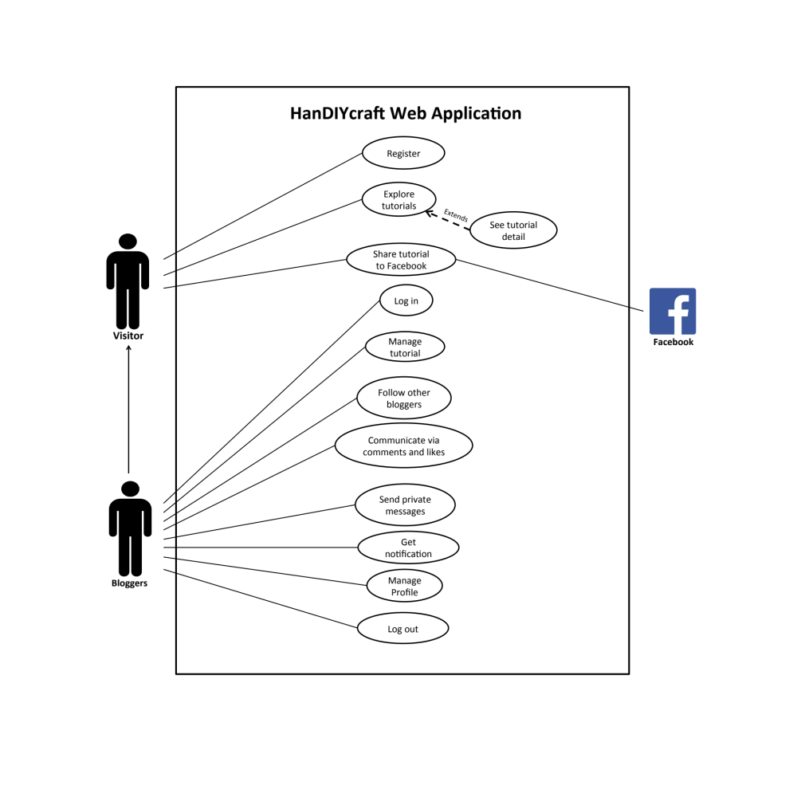
    - HanDIYcraft Use Case Web Application

    - HanDIYcraft Use Case for Mobile Application
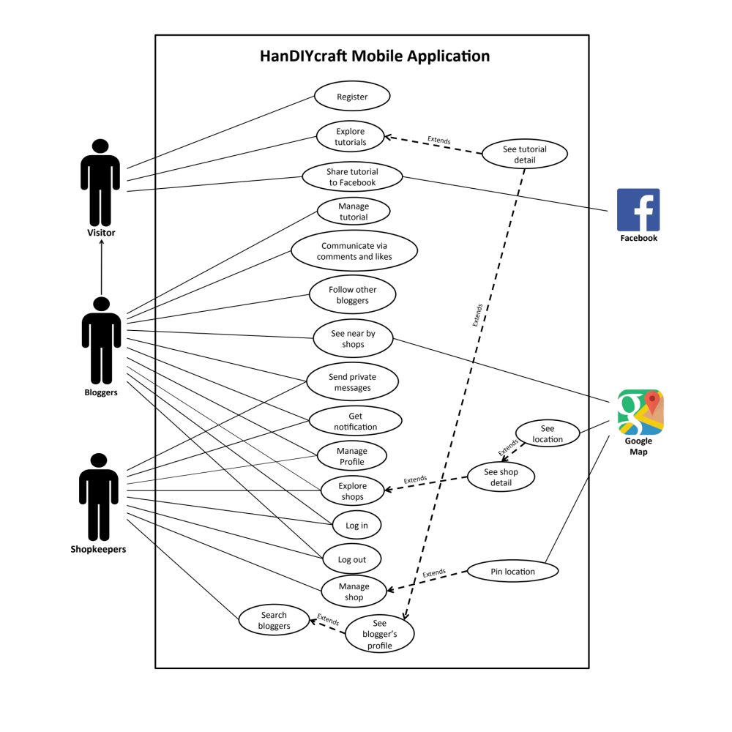

  - User Requirement Specification (URS)

    - User Requirement Specification for Web Application
No. | Feature Name | URS No. | URS Name | Actor
1 | User’s Profile and Authorization Management | W-URS-01 | The user registers as a blogger. | Visitor
1 | User’s Profile and Authorization Management | W-URS-02 | The user logins to the system by username and password. | Blogger
1 | User’s Profile and Authorization Management | W-URS-03 | The user logouts from the system. | Blogger
1 | User’s Profile and Authorization Management | W-URS-04 | The user sees his/her profile. | Blogger
1 | User’s Profile and Authorization Management | W-URS-05 | The user edits his/her email. | Blogger
1 | User’s Profile and Authorization Management | W-URS-06 | The user adds profile picture. | Blogger
1 | User’s Profile and Authorization Management | W-URS-07 | The user changes profile picture. | Blogger
1 | User’s Profile and Authorization Management | W-URS-08 | The user changes his/her password. | Blogger
1 | User’s Profile and Authorization Management | W-URS-09 | The user deletes his/her account. | Blogger
2 | Tutorial Management | W-URS-10 | The user randomly sees tutorials that exist in database. | Visitor, Blogger
2 | Tutorial Management | W-URS-11 | The user sees tutorials that exist in database by popularity according to number of likes. | Visitor, Blogger
2 | Tutorial Management | W-URS-12 | The user sees tutorials that exist in database by choosing a category. | Visitor, Blogger
2 | Tutorial Management | W-URS-13 | The user search tutorials’ title that exist in database by inputting a keyword. | Visitor, Blogger
2 | Tutorial Management | W-URS-14 | The user sees tutorials that exist in database from following bloggers. | Blogger
2 | Tutorial Management | W-URS-15 | The user sees selected tutorial information. | Visitor, Blogger
2 | Tutorial Management | W-URS-16 | The user creates his/her own tutorial, which includes tutorial detail. | Blogger
2 | Tutorial Management | W-URS-17 | The user sees detail of his/her own tutorial. | Blogger
2 | Tutorial Management | W-URS-18 | The user edits detail of his/her own tutorial. | Blogger
2 | Tutorial Management | W-URS-19 | The user deletes his/her own tutorial. | Blogger
3 | Communication Management | W-URS-20 | The user sees comments on tutorial. | Visitor, Blogger
3 | Communication Management | W-URS-21 | The user adds comment on tutorial. | Blogger
3 | Communication Management | W-URS-22 | The user likes a tutorial. | Blogger
3 | Communication Management | W-URS-23 | The user undo likes from the liked tutorial. | Blogger
3 | Communication Management | W-URS-24 | The user follows other bloggers. | Blogger
3 | Communication Management | W-URS-25 | The user undo follows from the followed bloggers. | Blogger
3 | Communication Management | W-URS-26 | The user sees list of bloggers whom the user is following. | Blogger
3 | Communication Management | W-URS-27 | The user sees list of bloggers who follows the user. | Blogger
3 | Communication Management | W-URS-28 | The user sends private message. | Blogger
3 | Communication Management | W-URS-29 | The user receives private message. | Blogger
3 | Communication Management | W-URS-30 | The user sees list of shopkeepers that has been communicate with. | Blogger
3 | Communication Management | W-URS-31 | The user shares tutorial to Facebook. | Visitor, Blogger
4 | Notification Management | W-URS-32 | The user sees list of notifications when there is new like, comment, or follower. | Blogger
4 | Notification Management | W-URS-33 | The user goes to the activity that has been notified. | Blogger

    - User Requirement Specification for Mobile Application
No. | Feature Name |  | URS No. | URS Name | Actor
1 | User’s Profile and Authorization Management |  | M-URS-01 | The user registers as a blogger or shopkeeper. | Visitor
1 |  |  | M-URS-02 | The user logins to the system by username and password. | Blogger, Shopkeeper
1 |  |  | M-URS-03 | The user logouts from the system. | Blogger, Shopkeeper
1 |  |  | M-URS-04 | The user sees his/her profile. | Blogger, Shopkeeper
1 |  |  | M-URS-05 | The user edits his/her email. | Blogger, Shopkeeper
1 |  |  | M-URS-06 | The user changes profile picture. | Blogger, Shopkeeper
1 |  |  | M-URS-07 | The user changes his/her password. | Blogger, Shopkeeper
1 |  |  | M-URS-08 | The user deletes his/her account. | Blogger, Shopkeeper
2 | Tutorial Management |  | M-URS-09 | The user randomly sees tutorials that exist in database. | Visitor, Blogger, Shopkeeper
2 |  |  | M-URS-10 | The user sees tutorials that exist in database by popularity according to number of likes. | Visitor, Blogger, Shopkeeper
2 |  |  | M-URS-11 | The user sees tutorials that exist in database by choosing a category. | Visitor, Blogger, Shopkeeper
2 |  |  | M-URS-12 | The user search tutorials’ title that exist in database by inputting a keyword. | Visitor, Blogger, Shopkeeper
2 |  |  | M-URS-13 | The user sees tutorials that exist in database from following bloggers. | Blogger
2 |  |  | M-URS-14 | The user sees selected tutorial information. | Visitor, Blogger, Shopkeeper
2 |  |  | M-URS-15 | The user creates his/her own tutorial, which includes tutorial detail. | Blogger
2 |  |  | M-URS-16 | The user sees detail of his/her own tutorial. | Blogger
2 |  |  | M-URS-17 | The user edits detail of his/her own tutorial. | Blogger
2 |  |  | M-URS-18 | The user deletes his/her own tutorial. | Blogger
3 | Shop Management |  | M-URS-19 | The user randomly sees list of shops that exist in database. | Blogger, Shopkeeper
3 |  |  | M-URS-20 | The user sees shops that exist in database by choosing a category. | Blogger, Shopkeeper
3 |  |  | M-URS-21 | The user search shops’ name that exist in database by inputting a keyword. | Blogger, Shopkeeper
3 |  |  | M-URS-22 | The user sees selected shop information. | Blogger, Shopkeeper
3 |  |  | M-URS-23 | The user creates his/her own shop, which includes shop detail. | Shopkeeper
3 |  |  | M-URS-24 | The user sees detail of his/her own shop. | Shopkeeper
3 |  |  | M-URS-25 | The user edits detail of his/her own shop. | Shopkeeper
3 |  |  | M-URS-26 | The user deletes his/her own shop. | Shopkeeper
4 | Map Management |  | M-URS-27 | The user sees near by shops’ location on Google Map. | Blogger
4 |  |  | M-URS-28 | The user sees shop’s location on Google Map. | Blogger, Shopkeeper
4 |  |  | M-URS-29 | The user identifies his/her shop’s location on Google Map. | Shopkeeper
5 | Communication Management |  | M-URS-30 | The user sees comment on tutorial. | Visitor, Blogger
5 |  |  | M-URS-31 | The user adds comment on tutorial. | Blogger
5 |  |  | M-URS-32 | The user likes a tutorial. | Blogger
5 |  |  | M-URS-33 | The user undo likes from the liked tutorial. | Blogger
5 |  |  | M-URS-34 | The user follows other bloggers. | Blogger
5 |  |  | M-URS-35 | The user undo follows from the followed bloggers. | Blogger
5 |  |  | M-URS-36 | The user sees list of bloggers whom the user is following. | Blogger
5 |  |  | M-URS-37 | The user sees list of bloggers who follows the user. | Blogger
5 |  |  | M-URS-38 | The user sends private message. | Blogger, Shopkeeper
5 |  |  | M-URS-39 | The user receives private message. | Blogger, Shopkeeper
5 |  |  | M-URS-40 | The user sees list of people that has been communicate with. | Blogger, Shopkeeper
5 |  |  | M-URS-41 | The user shares tutorial to Facebook. | Visitor, Blogger, Shopkeeper
5 |  |  | M-URS-42 | The user sees bloggers that exist in database by searching. | Shopkeeper
5 |  |  | M-URS-43 | The user sees list of searched bloggers. | Shopkeeper
5 |  |  | M-URS-44 | The user sees blogger’s profile. | Visitor, Blogger, Shopkeeper
6 |  | Notification Management | M-URS-45 | The user sees list of notifications when there is new like, comment, or follower. | Blogger, Shopkeeper
 |  | Notification Management | M-URS-46 | The user goes to the activity that has been notified. | Blogger, Shopkeeper

  - User Requirement Description and Activity Diagram

    - User Requirement Description for Web Application

Feature 1: User’s Profile and Authorization Management
W-URS-01: The user registers as a blogger.

Input and Output
No | Input Name | Description | Example | Remarks | Output
1 | Username | The length of Username must be between 1-20 characters | “hideandseek05” | The word should not contain any symbol. | The system shows “HideandSeek05” on the screen
2 | Password | The length of Password must be between 1-20 characters | “12345” | The word should not contain any symbol. | The system shows “●●●●●” on the screen
3 | Re-Password | Re-password must match with the password. | “12345” | The word should not contain any symbol. | The system shows “●●●●●” on the screen
4 | Email | Email must be the one that the user is currently using. | “hello@gmail.com” | The word should be in Email format | The system shows “hello@gmail.com” on the screen

Description
URS ID | W-URS-01
URS Name | The user registers as a blogger.
Actor | Visitor
Description | This function allows user who does not have his/her own account to register in order to use more functions of the application.
Trigger | The user selects “Sign Up” to register to be a member of the system.
Pre-condition | - Open the application
Post-condition | - The system saves user’s information into database.
Normal flow | 1) System provides registration interface for user to fill information, which are username, password, re-password, and e-mail.  3) User input his/her information.  4) User clicks done to finish the registration.  5) System validates username, password, re-password, and email format.  6) System saves the user’s information into the database.  7) System goes back to log in page.
Alternative flow | - In step 1-4, the user clicks back button to go to the previous page in case he/she wants to cancel the registration.
Exception | - In step 5, system displays error message in case the format is wrong.  - In all steps of normal flow, in case there is no internet connection.
Include | -

W-AD-01
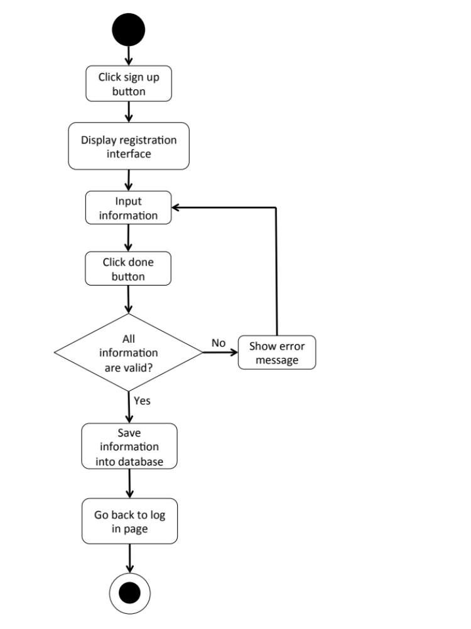

W-URS-02: The user logins to the system by username and password.

Input and Output
No | Input Name | Description | Example | Remarks | Output
1 | Username | The length of Username must be between 1-20 characters | “hideandseek05” | The word should not contain any symbol. | The system shows “HideandSeek05” on the screen
2 | Password | The length of Password must be between 1-20 characters | “12345” | The word should not contain any symbol. | The system shows “●●●●●” on the screen

Description
URS ID | W-URS-02
URS Name | The user logins to the system by username and password.
Actor | Blogger
Description | This function allows user, who has registered, logs in to the system.
Trigger | The user selects “Log in” to log in to the system.
Pre-condition | - User has registered to the system.
Post-condition | - User goes to home page for blogger.
Normal flow | 1) User goes to log in page.  2) System provides log in interface for user to fill information, which are username and password.  3) User input his/her username and password.  4) Users clicks log in button.  5) System validates username, and password format.  6) System verifies username and password from the database.  7) System goes to blogger home page.
Alternative flow | -In step 1-4, the user clicks back button to go to the previous page in case he/she wants to cancel the process.
Exception | - In step 5, in case user input invalid username or password, system will show an alert message.  - In all steps of normal flow, in case there is no internet connection.
Include | W-URS-01

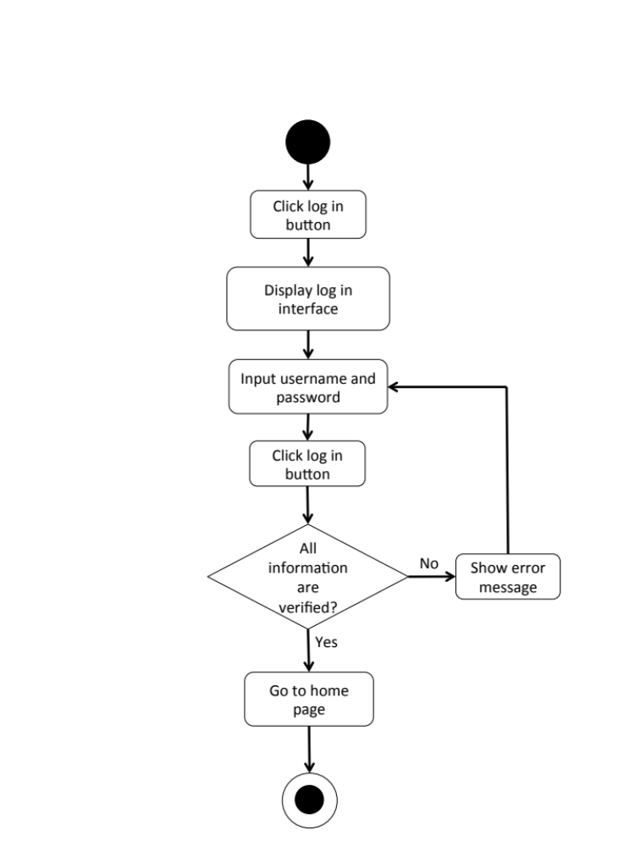
W-AD-02

W-URS-03: The user logouts from the system.
Input and Output
- Input: The user selects log out link to exit from the system.
- Output: The user log out from the system.

Description
URS ID | W-URS-03
URS Name | The user logouts from the system.
Actor | Blogger
Description | This function allows user to log out from the system.
Trigger | The user selects “Log out” to log out from the system.
Pre-condition | - User has logged in to the system.
Post-condition | - User has no longer logged in.
Normal flow | 1) User goes to blogger home page.  2) System provides blogger home page interface.  3) User clicks log out button.  4) System goes to visitor home page.
Alternative flow | -
Exception | - In all steps of normal flow, in case there is no internet connection.
Include | W-URS-02

W-AD-03
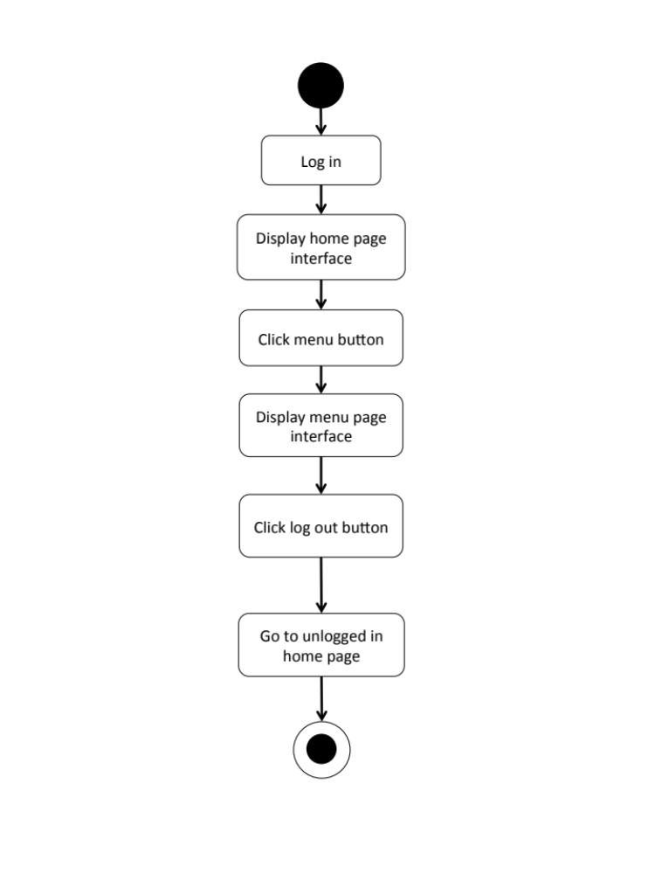

W-URS-04: The user sees his/her profile.
Input and Output
- Input: The user selects profile link to go to profile page.
- Output: The system shows user’s profile.

Description
URS ID | W-URS-04
URS Name | The user sees his/her profile.
Actor | Blogger
Description | This function allows user to see his/her own profile and information.
Trigger | The user selects “Profile” to go to his/her profile.
Pre-condition | - User has logged in to the system.
Post-condition | - System displays user’s profile.
Normal flow | - User goes to profile page.  - System gets user’s information from database.  - System displays interface and user’s information, which are profile picture, username, password, follower number, following number, and tutorials that he/she has created.
Alternative flow | -
Exception | In all steps of normal flow, in case there is no internet connection.
Include | W-URS-02

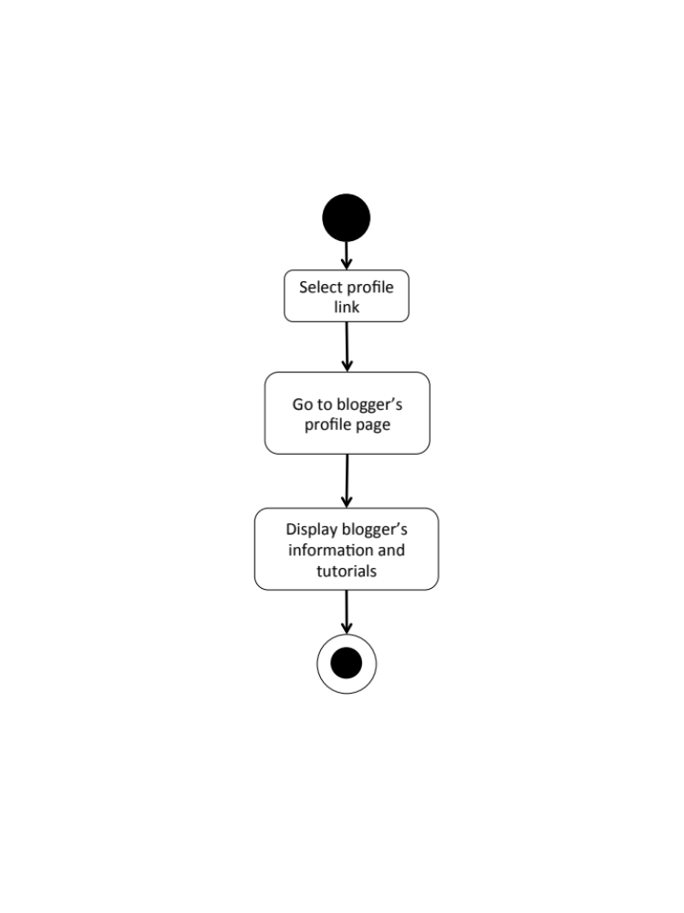
W-AD-04

W-URS-05: The user edits his/her email.

Input and Output
No | Input Name | Description | Example | Remarks | Output
1 | Email | Email must be the one that the user is currently using. | “kanom@msn.com” | The word should be in Email format | The system shows “kanom@msn.com” on the screen

Description
URS ID | W-URS-05
URS Name | The user edits his/her email.
Actor | Blogger
Description | This function allows user to edit his/her own email.
Trigger | The user selects “Edit” on user’s profile page.
Pre-condition | - User has logged in to the system.
Post-condition | - System updates the new information of user’s profile.
Normal flow | 1) User goes to edit profile page  2) System provides the editable interface of the profile.  3) User input new information.  4) User clicks save.  5) System validates email format.  6) System saves the new information into the database.  7) System goes back to profile page.
Alternative flow | - In step 1-4, the user clicks back button to go to the previous page in case he/she wants to cancel the edit profile process.
Exception | - In step 5, system displays error message in case the format is wrong.  - In all steps of normal flow, in case there is no internet connection.
Include | W-URS-02

W-AD-05
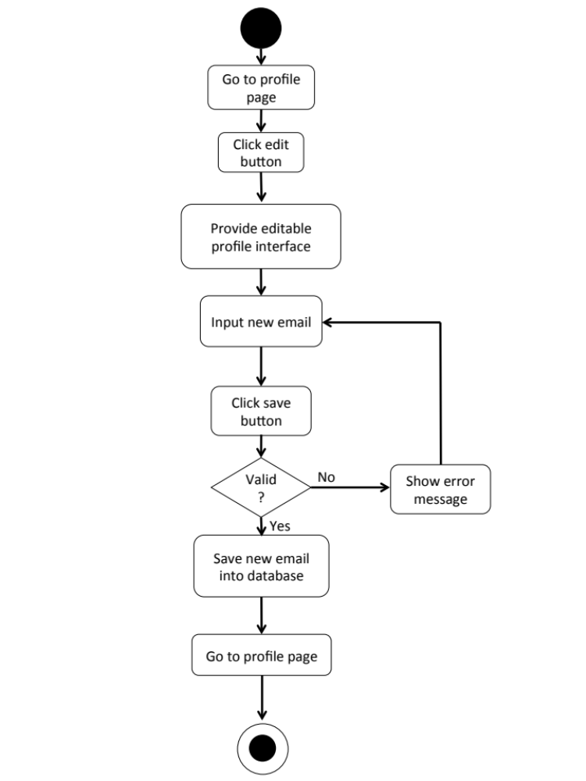

W-URS-06: The user adds profile picture.

Input and Output
No | Input Name | Description | Example | Remarks | Output
1 | Picture | The file type must be .jpg or .png | “IMG_ProfilePic.jpg” | - | The system shows “IMG_ProfilePic.jpg” on the screen

Description
URS ID | W-URS-06
URS Name | The user adds profile picture.
Actor | Blogger
Description | This function allows user to add his/her picture as a profile picture.
Trigger | The user selects “Profile picture” to add a picture.
Pre-condition | - User has logged in to the system.  - User goes to edit profile page.
Post-condition | - Picture appears on the profile page as the user’s profile picture.
Normal flow | 1) User selects browse picture link.  2) System shows pictures in user’s computer.  3) User selects a picture.  4) User clicks save.  5) System validates picture format.  6) System saves the added picture into the database.  7) System goes back to user’s profile page.
Alternative flow | - In step 1-4, the user clicks cancel button to go to the previous page in case he/she wants to cancel the picture adding process.
Exception | - In step 5, system displays error message in case the format is wrong.  In all steps of normal flow, in case there is no internet connection.
Include | W-URS-02

W-URS-07: The user changes profile picture.

Input and Output
No | Input Name | Description | Example | Remarks | Output
1 | Picture | The file type must be .jpg or .png | “IMG_ProfilePic2.jpg” | - | The system shows “IMG_ProfilePic2.jpg” on the screen

Description
URS ID | W-URS-07
URS Name | The user changes profile picture.
Actor | Blogger
Description | This function allows user to change his/her profile picture.
Trigger | The user selects “Profile picture” to change the picture.
Pre-condition | - User has logged in to the system.  - User goes to edit profile page.
Post-condition | - System saves new user’s profile picture into database.
Normal flow | 1) User selects browse picture link.  2) System shows pictures in user’s computer.  3) User selects a picture.  4) User clicks save.  5) System validates picture format.  6) System saves the new picture into the database.  7) System goes back to user’s profile page.
Alternative flow | - In step 1-4, the user clicks cancel button to go to the previous page in case he/she wants to cancel the picture changing process.
Exception | - In step 5, system displays error message in case the format is wrong.  - In all steps of normal flow, in case there is no internet connection.
Include | W-URS-02

W-AD-06
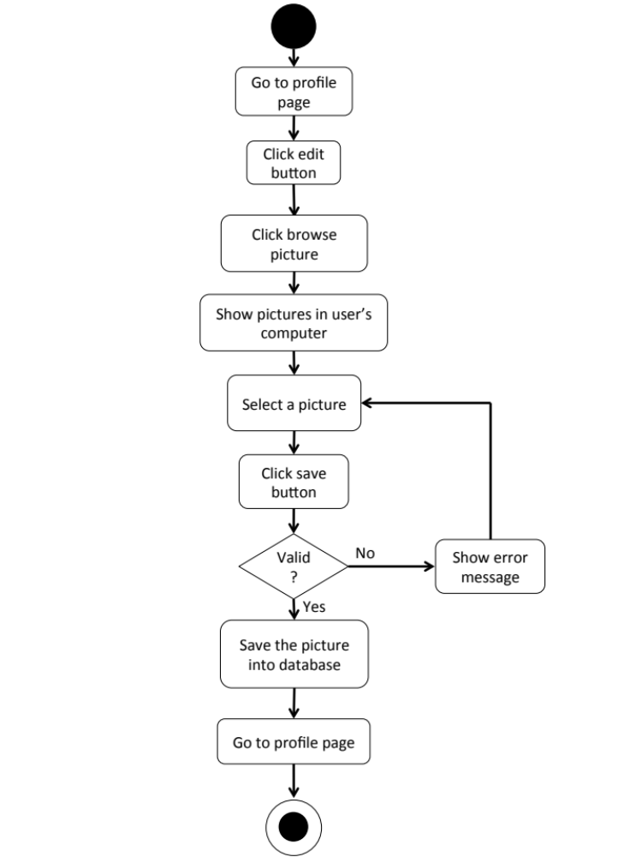

W-URS-08: The user changes his/her password.

Input and Output
No | Input Name | Description | Example | Remarks | Output
1 | Current Password | Current Password should be the password that the user is currently using. | “12345” | The word should not contain any symbol. | The system shows “●●●●●” on the screen
2 | New Password | The length of New Password must be between 1-20 characters | “00000” | The word should not contain any symbol. | The system shows “●●●●●” on the screen
3 | Re-New Password | Re-New Password must match with the New Password. | “00000” | The word should not contain any symbol. | The system shows “●●●●●” on the screen

Description
URS ID | W-URS-08
URS Name | The user changes his/her password.
Actor | Blogger
Description | This function allows user to change password for his/her account.
Trigger | The user selects “Change password” to change the password for user’s account.
Pre-condition | - User has logged in to the system.  - User goes to edit profile page.
Post-condition | - The password for the user’s account is updated.
Normal flow | 1) User clicks change password link.  2) System provide change password interface for user to fill information, which are current password and new password and re-new password.  3) User input information.  4) User clicks save button.  5) System validates current password, new password and re-new password.  6) System saves the new password into the database.  7) System goes back to user’s profile page.
Alternative flow | - In step 1-4, the user clicks back button to go to the previous page in case he/she wants to cancel the password changing process.
Exception | - In step 5, system displays error message in case the format is wrong.  - In all steps of normal flow, in case there is no internet connection.
Include | W-URS-02

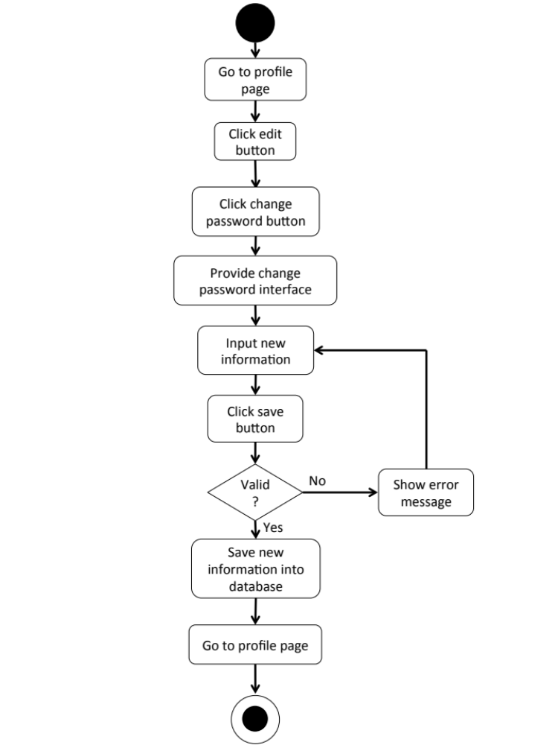
W-AD-07

W-URS-09: The user deletes his/her account.
Input and Output
- Input: The user selects delete account link to delete user’s account.
- Output: The system goes to home page for unlogged in user.

Description
URS ID | W-URS-09
URS Name | The user deletes his/her account.
Actor | Blogger
Description | This function allows user to delete his/her account, which the user will not be able to access the system as a blogger, unless the user register a new account.
Trigger | The user selects “Delete account” to delete the user’s account.
Pre-condition | - User has logged in to the system.  - User goes to edit profile page.
Post-condition | - User’s account is no longer available.
Normal flow | 1) User clicks delete account button.  2) System shows confirmation message with yes/no button.  3) User clicks yes button.  4) System removes the user’s information from the database.  5) System goes to visitor home page.
Alternative flow | - In step 1-3, the user clicks no button to cancel the account deletion process.
Exception | In all steps of normal flow, in case there is no internet connection.
Include | W-URS-02

W-AD-08

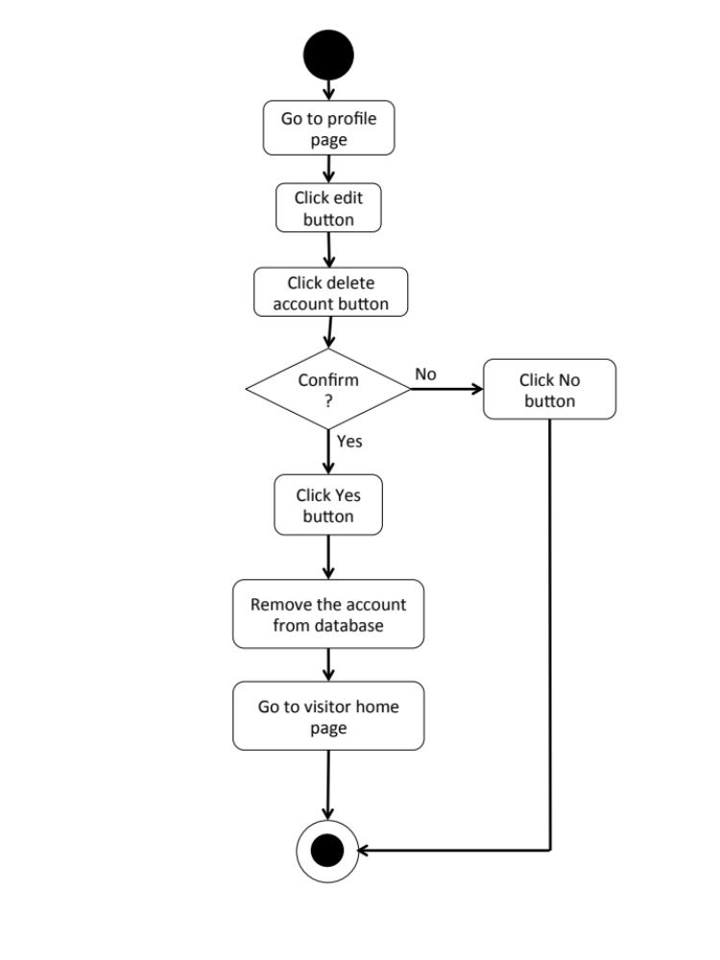

Feature 2: Tutorial Management
W-URS-10: The user randomly sees tutorials that exist in database.
Input and Output
- Input: The user selects random link to see random tutorials.
- Output: The system shows list of all tutorials with tutorial picture, title, owner username, and number of likes that exist in the database randomly.

Description
URS ID | W-URS-10
URS Name | The user randomly sees tutorials that exist in database.
Actor | Visitor, Blogger
Description | This function allows user to see list of tutorials that exist in database randomly.
Trigger | The user selects “Random” to see random tutorials.
Pre-condition | - User stays on Home page.
Post-condition | - System displays list of all tutorials that exist in the database randomly.
Normal flow | 1) User selects “Random” on the Home page.  2) System gets tutorials information from database.  3) System displays list of all tutorials with tutorial picture, title, owner username, and number of likes that exist in the database randomly.
Alternative flow | -
Exception | In all steps of normal flow, in case there is no internet connection.
Include | W-URS-02

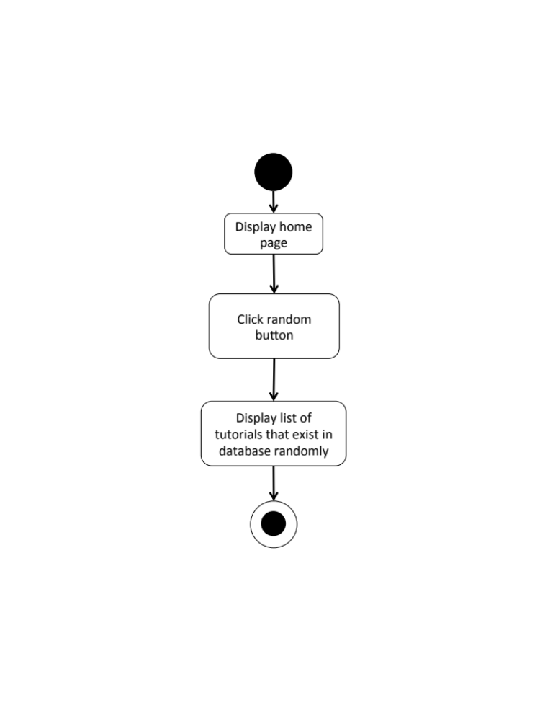
W-AD-09

W-URS-11: The user sees tutorials that exist in database by popularity according to number of likes.
Input and Output
- Input: The user selects popular link to see popular tutorials.
- Output: The system shows list of all tutorials with tutorial picture, title, owner username, and number of likes that exist in the database from the most liked to the less.

Description
URS ID | W-URS-11
URS Name | The user sees tutorials that exist in database by popularity according to number of likes.
Actor | Visitor, Blogger
Description | This function allows user to see list of tutorials that has most likes.
Trigger | The user selects “Popular” to see popular tutorials.
Pre-condition | - User stays on Home page.
Post-condition | - System displays list of all tutorials that exist in the database from the most liked to the less.
Normal flow | 1) User selects “Popular” on the Home page.  2) System gets tutorials information from database.  3) System displays list of all tutorials with tutorial picture, title, owner username, and number of likes that exist in the database from the most liked to the less.
Alternative flow | -
Exception | In all steps of normal flow, in case there is no internet connection.
Include | W-URS-02

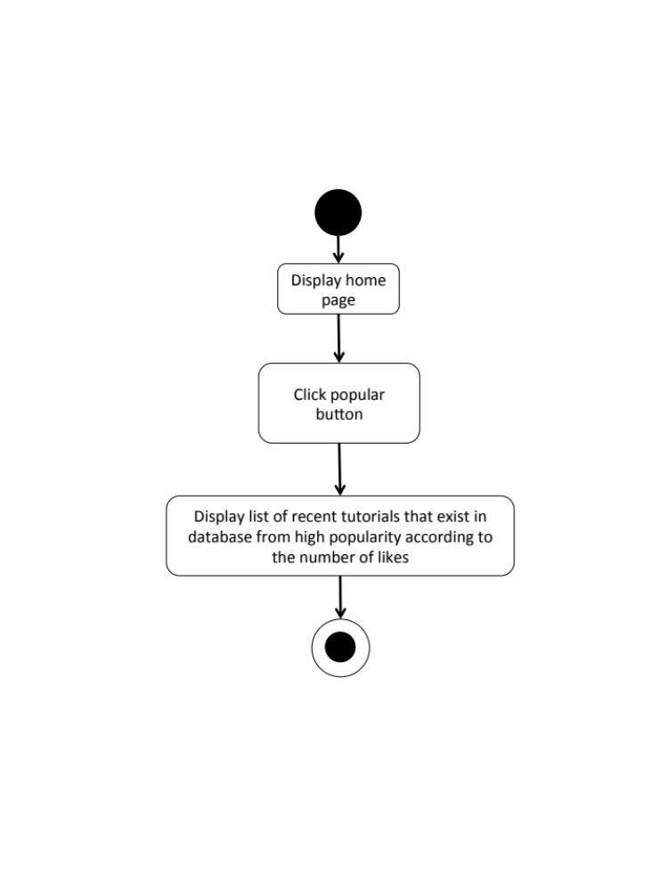
W-AD-10

W-URS-12: The user sees tutorials that exist in database by choosing a category.

Input and Output
- Input: The user selects a category link to see tutorials by category.
- Output: The system shows list of tutorials with tutorial picture, title, owner username, and number of likes of the selected category that exist in the database.

Description
URS ID | W-URS-12
URS Name | The user sees tutorials that exist in database by choosing a category.
Actor | Visitor, Blogger
Description | This function allows user to see list of tutorials according to each category.
Trigger | The user selects “Categories” to see categories of tutorials.
Pre-condition | - User goes to Menu page.
Post-condition | - System displays list of tutorials of the category.
Normal flow | 1) User clicks categories button.  2) System displays categories, which are outfit, accessory, gift, kid, garden, home décor, pet, and other.  3) User selects a category.  4) System gets tutorials information from database.  5) System displays list of tutorials with tutorial picture, title, owner username, and number of likes of the selected category that exist in the database.
Alternative flow | -
Exception | In all steps of normal flow, in case there is no internet connection.
Include | W-URS-02

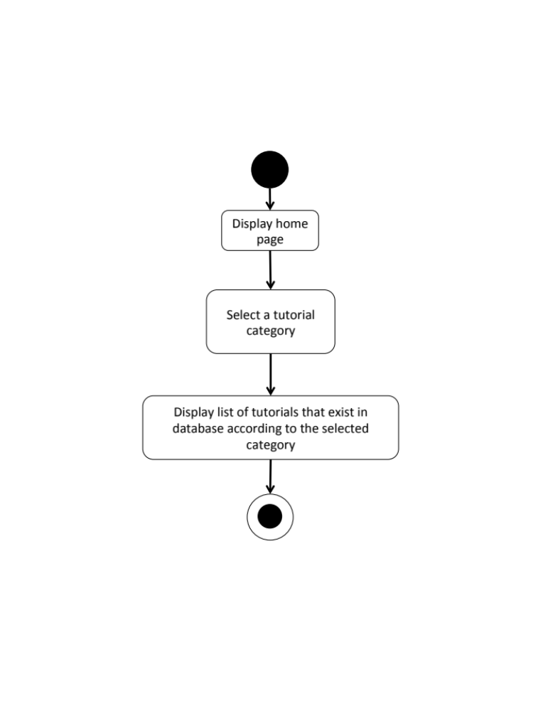
W-AD-11

W-URS-13: The user search tutorials’ title that exist in database by inputting a keyword.

Input and Output
No | Input Name | Description | Example | Remarks | Output
1 | Keyword | The length of Keyword must be between 1-20 characters | “Bracelet” | The word should not contain any symbol. | The system shows tutorials that have the word “Bracelet” as a tutorial name.

Description
URS ID | W-URS-13
URS Name | The user search tutorials’ title that exist in database by inputting a keyword.
Actor | Visitor, Blogger
Description | This function allows user to see list of tutorials by inputting keyword.
Trigger | The user clicks on the search box.
Pre-condition | - User stays on Home page.
Post-condition | - System displays list of all tutorials that relate to the keyword.
Normal flow | 1) User input a keyword in the search box.  2) System gets tutorials information from database.  3) System displays list of all tutorials with tutorial picture, title, owner username, and number of likes that relate to the keyword.
Alternative flow | -
Exception | In all steps of normal flow, in case there is no internet connection.
Include | W-URS-02

W-AD-12
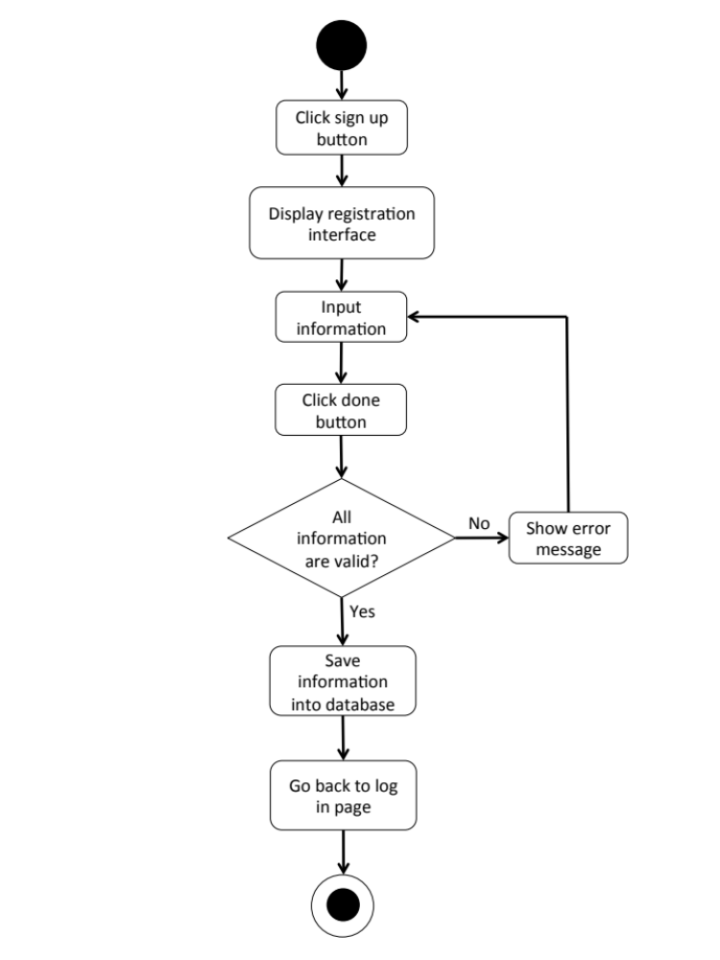

W-URS-14: The user sees tutorials that exist in database from following bloggers.

Input and Output
- Input: The user selects following link to see following tutorials.
- Output: The system shows list of tutorials with tutorial picture, title, owner username, and number of likes from the following bloggers.

Description
URS ID | W-URS-14
URS Name | The user sees tutorials that exist in database from following bloggers.
Actor | Blogger
Description | This function allows user to see list of tutorials from the bloggers that the user is following.
Trigger | The user selects “Following” to see tutorials from the bloggers that the user is following.
Pre-condition | - User has logged in to the system.  - User stays on Home page.
Post-condition | - System displays list of tutorials from the following bloggers.
Normal flow | 1) User tab “Following” on the Home page.  2) System gets tutorials of following bloggers from database.  3) System displays list of tutorials with tutorial picture, title, owner username, and number of likes from the following bloggers.
Alternative flow | - In step 1, the user cannot use this function if he/she has not logged in yet.
Exception | In all steps of normal flow, in case there is no internet connection.
Include | W-URS-02

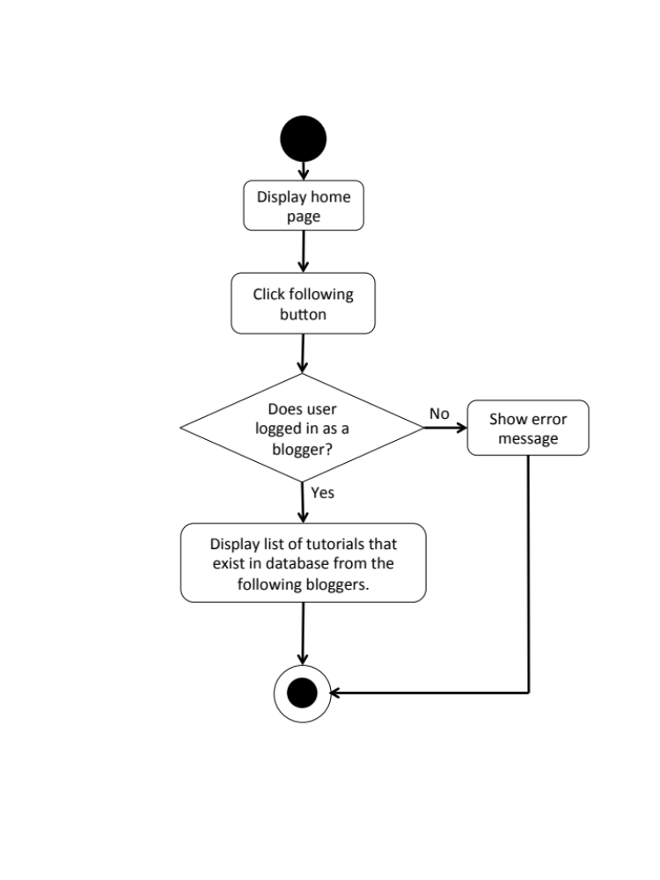
W-AD-13

W-URS-15: The user sees selected tutorial information.
Input and Output
- Input: The user selects tutorial link to see tutorial’s detail.
- Output: The system shows information of the tutorial, which are title, owner username, number of likes, category, material picture, material description, step description, step picture, video, and comments.

Description
URS ID | W-URS-15
URS Name | The user sees selected tutorial information.
Actor | Visitor, Blogger
Description | This function allows user to see information of each tutorial.
Trigger | The user selects a tutorial to see the information.
Pre-condition | - User selects a tutorial.
Post-condition | - System displays all information of the tutorial.
Normal flow | 1) User selects a tutorial.  2) System gets the tutorial’s information from database.  3) System displays all information of the tutorial, which are title, owner username, number of likes, category, material picture, material description, step description, step picture, video, and comments.
Alternative flow | -
Exception | In all steps of normal flow, in case there is no internet connection.
Include | W-URS-02

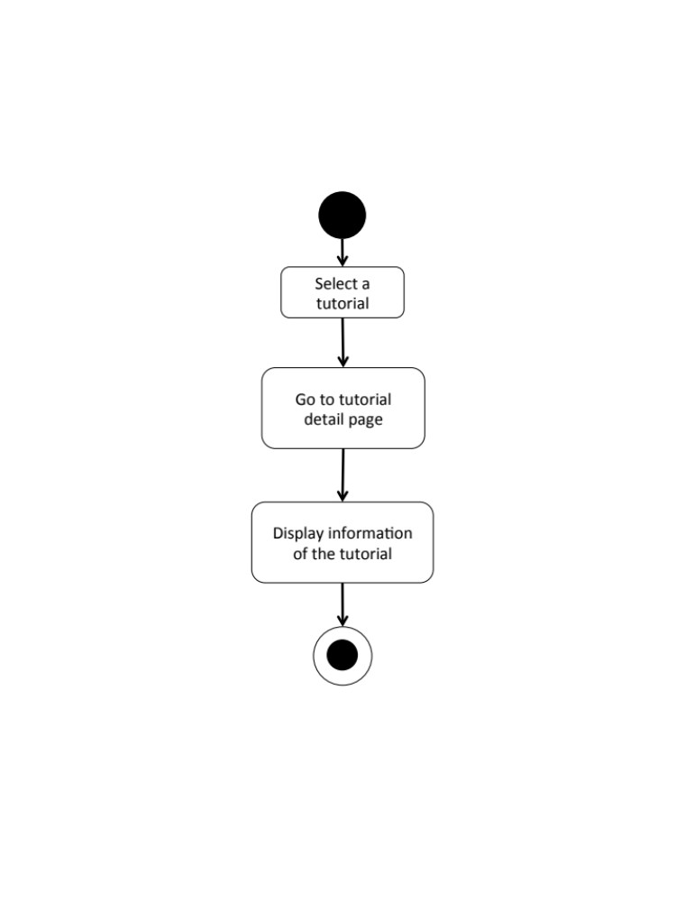
W-AD-14

W-URS-16: The user creates his/her own tutorial, which includes tutorial detail.

Input and Output
No | Input Name | Description | Example | Remarks | Output
1 | Tutorial Picture | The file type must be .jpg or .png | “IMG_tutorial.jpg” | - | The system shows “IMG_tutorial.jpg” on the screen
2 | Title | The length of Title must be between 1-20 characters | “Handmade Bracelet” | The word should not contain any symbol. | The system shows “Handmade Bracelet” on the screen
3 | Category | The categories are provided by the system. | “Accessory” | - | The system shows “Accessory” on the screen
4 | Material Picture | The file type must be .jpg or .png | “IMG_material.jpg” | - | The system shows “IMG_material.jpg” on the screen
5 | Material Description | The length of Material Description must be between 1-500 characters | “1.Rope 2.Glue 3.Scissor 4.Glitter 5.Pin” | - | The system shows “1.Rope 2.Glue 3.Scissor 4.Glitter 5.Pin”on the screen
6 | Step Number | The number of step should be between 1-6 | “1” | No symbol or character is allowed. | The system shows “1” on the screen
7 | Step Picture | The file type must be .jpg or .png | “IMG_step1.jpg” | - | The system shows “IMG_step1.jpg” on the screen
8 | Step Description | The length of Step Description must be between 1-500 characters | “Cut the rope to have the length as long as it can be out around your wrist.” | - | The system shows “Cut the rope to have the length as long as it can be out around your wrist.” On the screen
9 | Video | The file type must be .mov | “VDO_tutorial.mov” | - | The system shows “VDO_tutorial.mov” on the screen

Description
URS ID | W-URS-16
URS Name | The user creates his/her own tutorial, which includes tutorial detail.
Actor | Blogger
Description | This function allows user to create his/her own tutorial.
Trigger | The user selects “Create” to create a new tutorial.
Pre-condition | - User has logged in to the system.
Post-condition | - System stores the created tutorial into database.
Normal flow | 1) User clicks create button.  2) System provides create tutorial interface for user to fill information, which are tutorial picture, title, category, material, material picture, step description, step picture, and video.  3) User inputs the information.  4) User input the information step by step.  5) User clicks done button.  6) System validates tutorial picture, title, category, material picture, material description, step number, step picture, step description, and video format.  7) System saves the tutorial into the database.  8) System shows successful message.
Alternative flow | - In step 1-5, the user clicks back button to go to the previous page in case he/she wants to cancel the tutorial creating process.
Exception | - In step 6, system displays error message in case the format is wrong.  - In all steps of normal flow, in case there is no internet connection.
Include | W-URS-02

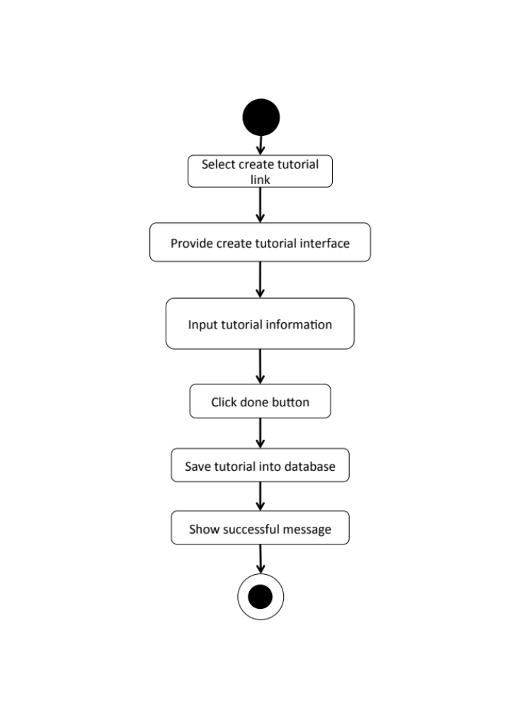
W-AD-15

W-URS-17: The user sees detail of his/her own tutorial.
Input and Output
- Input: The user selects profile link to go to profile page.
- Output: The system shows user’s profile including list of his/her tutorials.

Description
URS ID | W-URS-17
URS Name | The user sees detail of his/her own tutorial.
Actor | Blogger
Description | This function allows user to see tutorials that the user has created.
Trigger | The user selects “Profile” to see his/her information including his/her own tutorials.
Pre-condition | - User has logged in to the system.  - User goes to his/her profile page
Post-condition | - System shows tutorials that the user has created.
Normal flow | - User goes to profile page.  - System gets user’s information from database.  3) System displays interface and user’s information, which are profile picture, username, password, follower number, following number, and list of tutorials that he/she has created.
Alternative flow | -
Exception | In all steps of normal flow, in case there is no internet connection.
Include | W-URS-02

W-AD-16
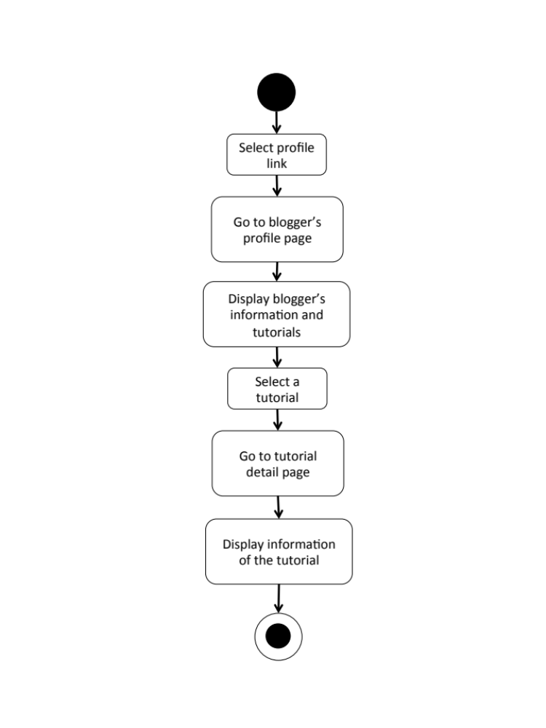

W-URS-18: The user edits detail of his/her own tutorial.

Input and Output
No | Input Name | Description | Example | Remarks | Output
1 | Tutorial Picture | The file type must be .jpg or .png | “IMG_tutorial2.jpg” | - | The system shows “IMG_tutorial2.jpg” on the screen
2 | Title | The length of Title must be between 1-20 characters | “DIY Bracelet” | The word should not contain any symbol. | The system shows “How to make a Handmade Bracelet by yourself” on the screen
3 | Category | The categories are provided by the system. | “Outfit” | - | The system shows “Accessory” on the screen
4 | Material Picture | The file type must be .jpg or .png | “IMG_material2.jpg” | - | The system shows “IMG_material2.jpg” on the screen
5 | Material Description | The length of Material Description must be between 1-500 characters | “1.Rope 2.Glue 3.Scissor 4.Glitter 5.Pin 6.Color” | - | The system shows “1.Rope 2.Glue 3.Scissor 4.Glitter 5.Pin  6.Color” on the screen
6 | Step | The number of step should be between 1-6 | “2” | No symbol or character is allowed. | The system shows “2” on the screen
7 | Step 1 Picture | The file type must be .jpg or .png | “IMG_step1.jpg” | - | The system shows “IMG_step1.jpg” on the screen
8 | Step 1 Description | The length of Step Description must be between 1-500 characters | “Cut the rope to have the length as long as it can be out around your wrist.  Be careful when you cut it!” | - | The system shows “Cut the rope to have the length as long as it can be out around your wrist. Be careful when you cut it!” on the screen
9 | Step 2 Picture | The file type must be .jpg or .png | “IMG_step2.jpg” | - | The system shows “IMG_step2.jpg” on the screen
10 | Step 2 Description | The length of Step Description must be between 1-500 characters | “Now it’s time to decorate!” | - | The system shows “Now it’s time to decorate!” on the screen
11 | Video | The file type must be .mov | “VDO_tutorial2.mov” | - | The system shows “VDO_tutorial2.mov” on the screen

Description
URS ID | W-URS-18
URS Name | The user edits detail of his/her own tutorial.
Actor | Blogger
Description | This function allows user to make some changes on his/her own tutorial.
Trigger | The user selects “Edit” to edit the selected tutorial.
Pre-condition | - User has logged in to the system.
Post-condition | - System updates new information of the tutorial.
Normal flow | 1) User selects a tutorial that wants to be edited.  2) User clicks edit button.  3) System provides the editable interface for user to edit tutorial picture, title, category, material picture, material description, step number, step picture, step description, and video.  4) User clicks save.  5) System validates tutorial picture, title, category, material picture, material description, step number, step picture, step description, and video format.  6) System saves the edited tutorial into the database.  7) System shows successful message.
Alternative flow | In step 1-4, the user clicks back button to cancel the process.
Exception | - In step 6, system displays error message in case the format is wrong.  - In all steps of normal flow, in case there is no internet connection.
Include | W-URS-02

W-AD-17
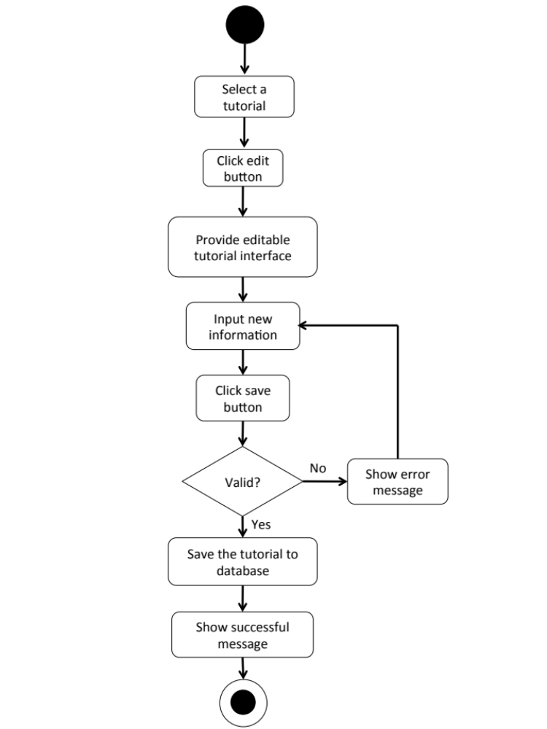

W-URS-19: The user deletes his/her own tutorial.

Input and Output
- Input: The user selects delete tutorial link to delete his/her tutorial.
- Output: The tutorial disappears from the tutorial list.

Description
URS ID | W-URS-19
URS Name | The user deletes his/her own tutorial.
Actor | Blogger
Description | This function allows user to remove his/her own tutorial from the database.
Trigger | The user selects “Delete tutorial” to remove tutorial from the database.
Pre-condition | - User has logged in to the system.  - User selects the tutorial that wants delete.
Post-condition | - System removes the tutorial from the database.
Normal flow | 1) User clicks delete button.  2) System shows confirmation message with yes/no button.  3) User clicks yes button.  4) System removes the tutorial from the database.  5) System shows successful message.
Alternative flow | - In step 1-3, the user clicks no button to cancel the tutorial deletion process.
Exception | In all steps of normal flow, in case there is no internet connection.
Include | W-URS-02

W-AD-18
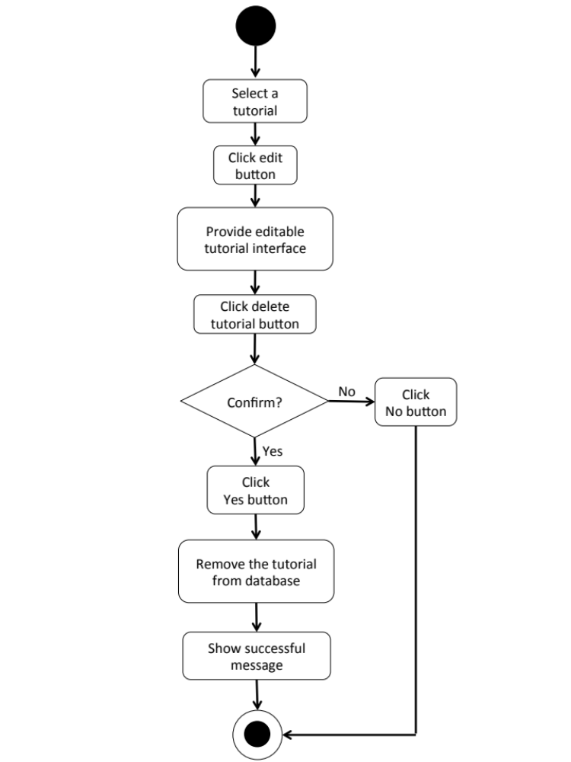

Feature 5: Communication Management
W-URS-20: The user sees comments on tutorial.
Input and Output
- Input: The user selects tutorial link to see tutorial’s detail.
- Output: The system shows information of the tutorial including comments.

Description
URS ID | W-URS-20
URS Name | The user sees comments on tutorial.
Actor | User, Blogger
Description | This function allows user to see comments on each tutorial.
Trigger | -
Pre-condition | - User has logged in to the system.  - User stays on tutorial detail page.
Post-condition | - System displays all comments of the tutorial.
Normal flow | - User selects a tutorial.  - System gets the tutorial’s information from database.  - System displays all information of the tutorial, which are title, owner username, number of likes, category, material picture, material description, step description, step picture, video, and comments.  - System gets comment information, which are profile picture and username of the blogger that commented, and comment detail from database.  - System displays all comments of the tutorial.
Alternative flow | -
Exception | In all steps of normal flow, in case there is no internet connection.
Include | -

W-AD-19

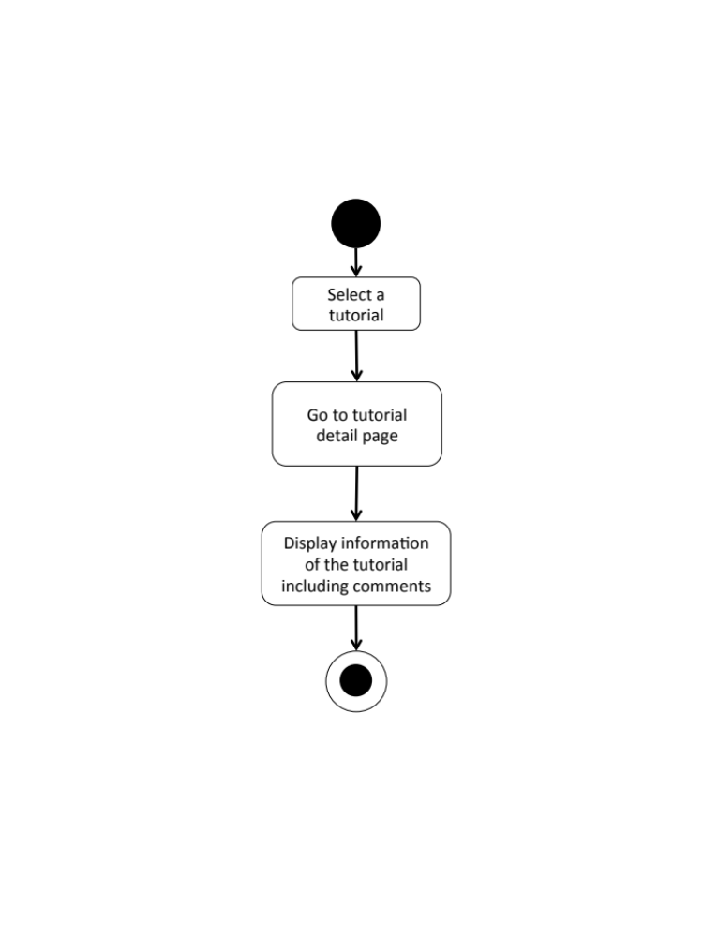

W-URS-21: The user adds comments on tutorial.
Input and Output
No | Input Name | Description | Example | Remarks | Output
1 | Comment | The length of Comment must be between 1-500 characters | “Awesome tutorial!” | - | The system shows “Awesome tutorial!” on the screen.

Description
URS ID | W-URS-21
URS Name | The user adds comments on tutorial.
Actor | Blogger
Description | This function allows user to give comments on tutorial.
Trigger | The user selects “Comment” to post comment on tutorial.
Pre-condition | - User has logged in to the system.  - User stays on tutorial detail page.
Post-condition | - System displays the comment on the tutorial detail page.
Normal flow | 1) System provides a comment box.  2) User types a comment within 500 characters.  3) User clicks comment button.  4) System validates the comment format.  5) System saves the comment into database.  6) System displays the comment on the tutorial detail page.
Alternative flow | -
Exception | In all steps of normal flow, in case there is no internet connection.
Include | W-URS-02

W-AD-20
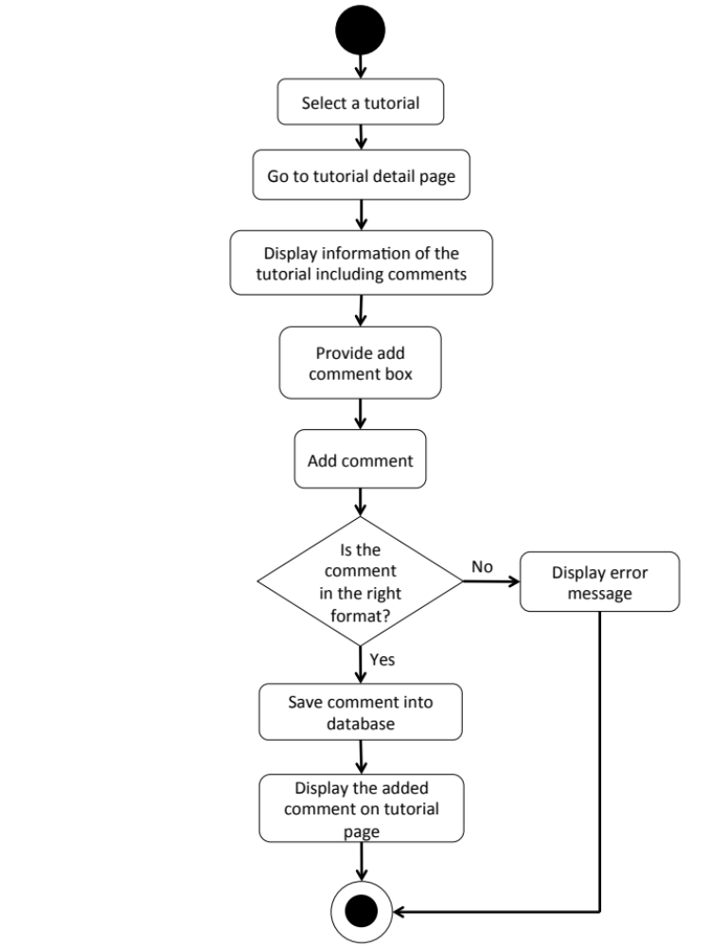

W-URS-22: The user likes a tutorial.
Input and Output
- Input: The user selects like on tutorial.
- Output: The system shows the liked sign on tutorial.

Description
URS ID | W-URS-22
URS Name | The user likes a tutorial.
Actor | Blogger
Description | This function allows user to give a like on his/her favorite tutorial.
Trigger | The user selects “Like” to like the tutorial.
Pre-condition | - User has logged in to the system.  - User stays on tutorial detail page.  - User stays on explore tutorial page.
Post-condition | - System increase like number of the tutorial.
Normal flow | 1) User clicks like button.  2) System increase like number for the tutorial in database.  3) System shows updated number of likes of the tutorial.
Alternative flow | -
Exception | In all steps of normal flow, in case there is no internet connection.
Include | W-URS-02

W-AD-21

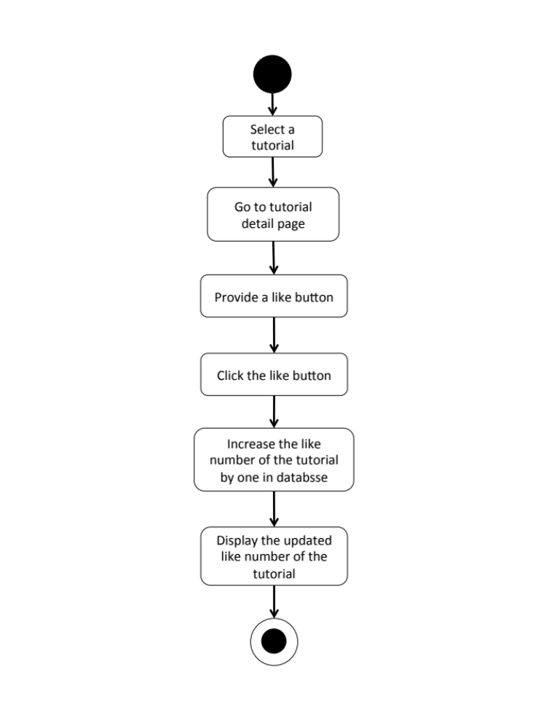

W-URS-23: The user undo likes from the liked tutorial.
Input and Output
- Input: The user selects like on the liked tutorial.
- Output: The system shows the like sign on tutorial.

Description
URS ID | W-URS-23
URS Name | The user undo likes from the liked tutorial.
Actor | Blogger
Description | This function allows user to remove the like that the user gave for a tutorial.
Trigger | The user selects “Liked” to undo like the tutorial.
Pre-condition | - User has logged in to the system.  - User stays on tutorial detail page.  - User stays on explore tutorial page.
Post-condition | - System decrease like number of the tutorial.
Normal flow | 1) User clicks liked button.  2) System decrease like number for the tutorial in database.  3) System shows updated number of likes of the tutorial.
Alternative flow | -
Exception | In all steps of normal flow, in case there is no internet connection.
Include | W-URS-02, W-URS-22

W-AD-22

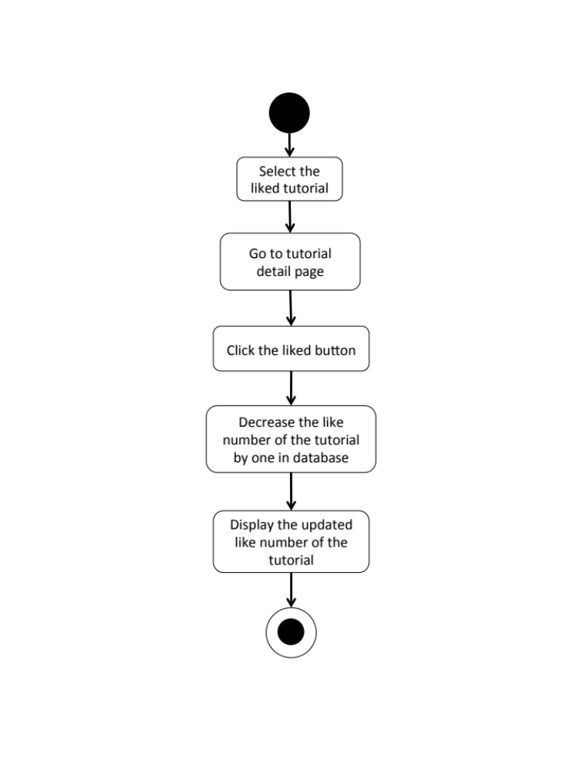

W-URS-24: The user follows other bloggers.
Input and Output
- Input: The user select follow on other blogger profile.
- Output: The system shows the followed sign on the blogger profile.

Description
URS ID | W-URS-24
URS Name | The user follows other bloggers.
Actor | Blogger
Description | This function allows user to follow other bloggers in order to catch up their new tutorials.
Trigger | The user selects “Follow” to follow the blogger.
Pre-condition | - User has logged in to the system.  - User stays on other blogger’s profile page.
Post-condition | - The system starts getting new information from the following blogger.
Normal flow | - System provides blogger’s profile interface.  - User clicks follow button.  3) System saves the blogger into database.  4) System changes the sign on the button from follow to followed.
Alternative flow | -
Exception | In all steps of normal flow, in case there is no internet connection.
Include | W-URS-02

W-AD-23
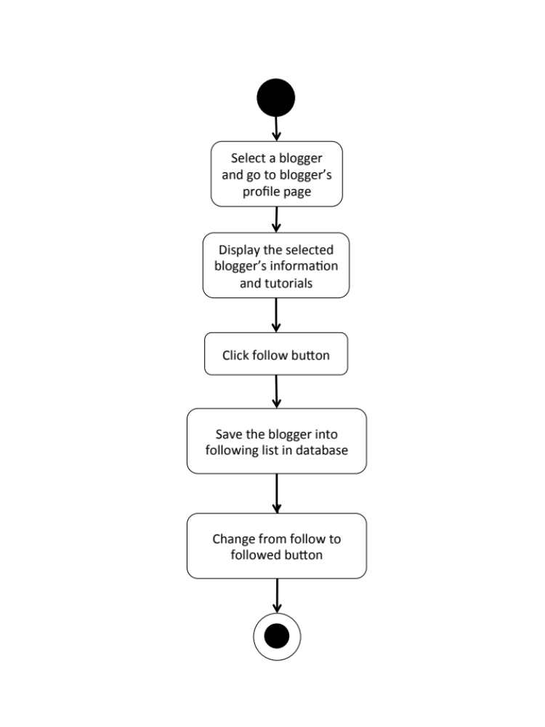

W-URS-25: The user undo follows from the followed bloggers.
Input and Output
- Input: The user select followed on the followed blogger.
- Output: The system shows the follow sign on unfollowed blogger profile.

Description
URS ID | W-URS-25
URS Name | The user undo follows from the followed bloggers.
Actor | Blogger
Description | This function allows user to undo the follow process from the blogger that he/she is following.
Trigger | The user selects “Following” to undo follow the blogger.
Pre-condition | - User has logged in to the system.  - User stays on other blogger’s profile page.
Post-condition | - The system stops getting new information from the unfollow blogger.
Normal flow | - System provides blogger’s profile interface.  2) User clicks followed button.  3) System removes the blogger from database.  4) System changes the sign on the button from followed to follow.
Alternative flow | -
Exception | In all steps of normal flow, in case there is no internet connection.
Include | W-URS-02, W-URS-24

W-AD-24

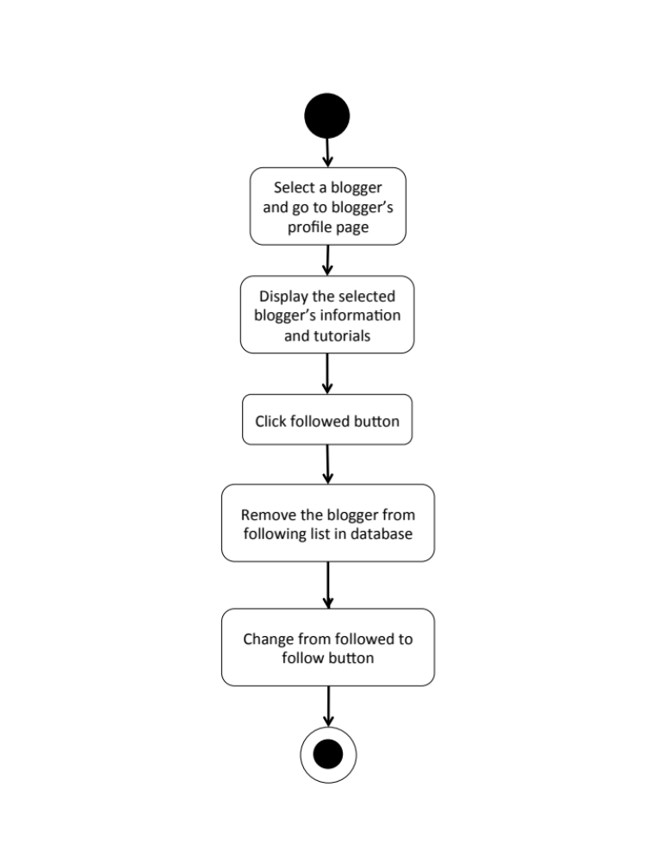

W-URS-26: The user sees list of bloggers whom the user is following.
Input and Output
- Input: The user select following link on other user’s profile page.
- Output: The system shows list of bloggers whom the user is following.

Description
URS ID | W-URS-26
URS Name | The user sees list of bloggers whom the user is following.
Actor | Blogger
Description | This function allows user to undo the follow process from the blogger that he/she is following.
Trigger | The user selects “Following” to undo follow the blogger.
Pre-condition | - User has logged in to the system.  - User stays on other blogger’s profile page.
Post-condition | - The system stops getting new information from the unfollowed blogger.
Normal flow | - User goes to profile page.  - System gets user’s information from database.  - System displays interface and user’s information, which are profile picture, username, password, follower number, following number, and list of tutorials that he/she has created.  - User clicks on see following link.  - System goes to following page.  - System get list of bloggers whom the user is following from database.  - System displays list of bloggers whom the user is following.
Alternative flow
Exception | In all steps of normal flow, in case there is no internet connection.
Include | W-URS-02, W-URS-24

W-AD-25
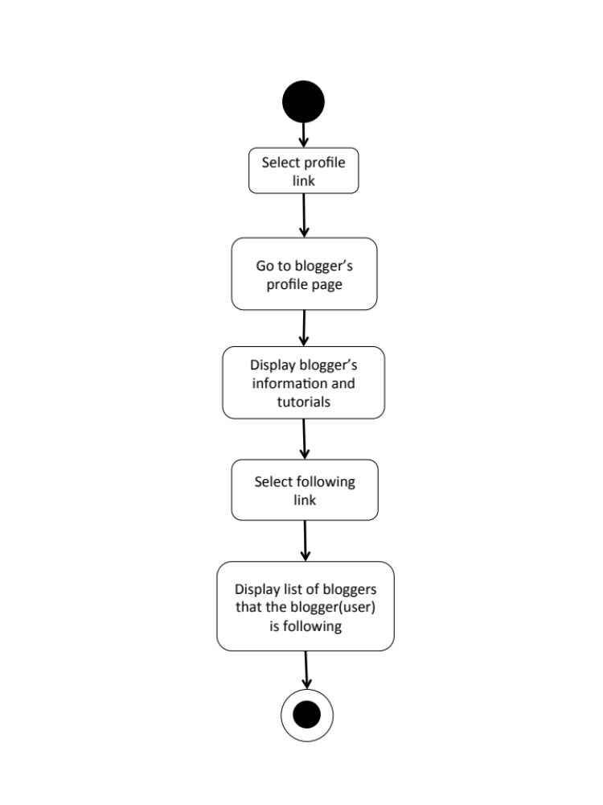

W-URS-27: The user sees list of bloggers who follows the user.
Input and Output
- Input: The user select follower link on other user’s profile page.
- Output: The system shows list of bloggers who follows the user.

Description
URS ID | W-URS-27
URS Name | The user sees list of bloggers who follows the user.
Actor | Blogger
Description | This function allows user to undo the follow process from the blogger that he/she is following.
Trigger | The user selects “Following” to undo follow the blogger.
Pre-condition | - User has logged in to the system.  - User stays on other blogger’s profile page.
Post-condition | - The system stops getting new information from the unfollowed blogger.
Normal flow | - User goes to profile page.  - System gets user’s information from database.  - System displays interface and user’s information, which are profile picture, username, password, follower number, following number, and list of tutorials that he/she has created.  - User clicks on see follower link.  - System goes to follower page.  - System get list of bloggers who follows the user from database.  - System displays list of bloggers who follows the user.
Alternative flow
Exception | In all steps of normal flow, in case there is no internet connection.
Include | W-URS-02

W-AD-26
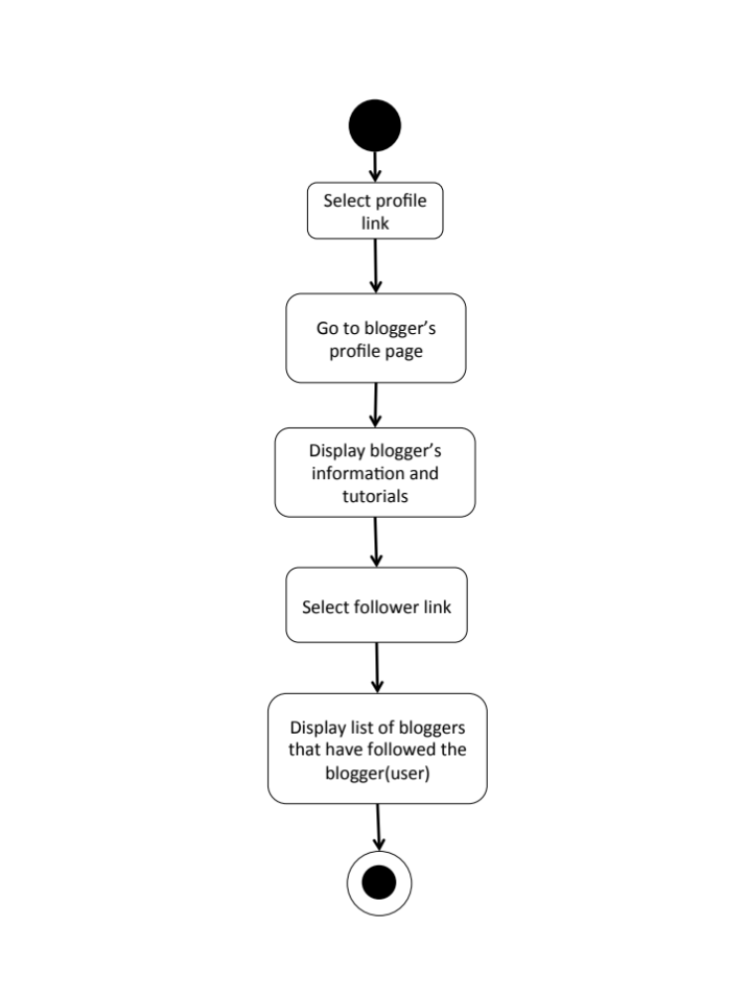

W-URS-28: The user sends private message.
Input and Output
No | Input Name | Description | Example | Remarks | Output
1 | Message | The length of Message must be between 1-500 characters | “Hello, I want to ask you something.” | - | The system shows “Hello, I want to ask you something.” on the screen.

Description
URS ID | W-URS-28
URS Name | The user sends private message.
Actor | Blogger
Description | This function allows user to start a private communication with shopkeepers via messages.
Trigger | The user selects the conversation link between the user and the shopkeeper.
Pre-condition | - User has logged in to the system.  - User selects a shop that he/she wants to send message to.
Post-condition | - System sends message to the shopkeeper.
Normal flow | 1) User clicks message button.  2) System provides message interface.  3) User types a message in the message box.  4) User clicks send button.  5) System sends the message to shopkeeper of the shop.  6) System saves the message into database.
Alternative flow | -
Exception | In all steps of normal flow, in case there is no internet connection.
Include | W-URS-02

W-AD-27
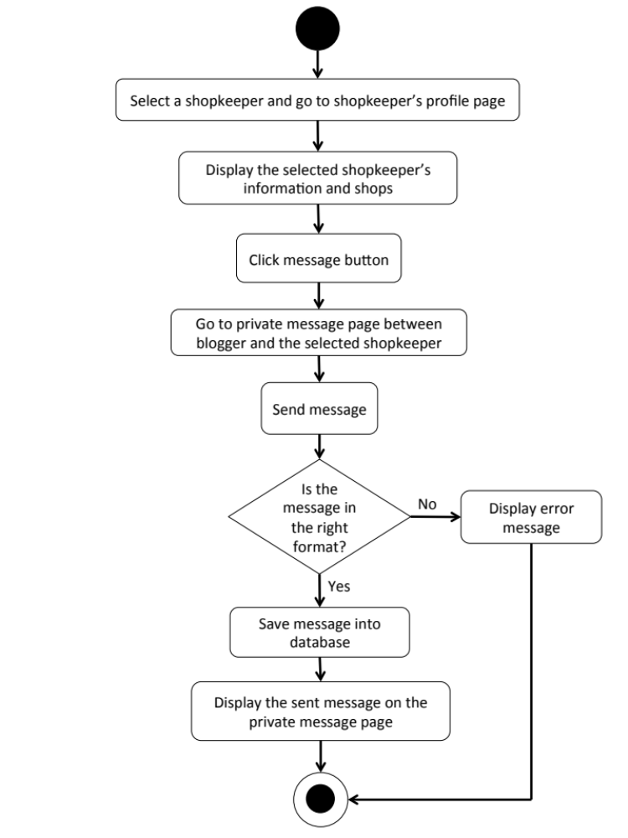

W-URS-29: The user receives private message.
- Input: The user selects message link to see messages.
- Output: The system shows messages that the user gets from a shopkeeper.

Description
URS ID | W-URS-29
URS Name | The user receives private message.
Actor | Blogger
Description | This function allows user to receive messages from the shopkeeper whom the user is talking with.
Trigger | The user selects the conversation link between the user and the shopkeeper.
Pre-condition | - User has logged in to the system.
Post-condition | - System displays received messages.
Normal flow | 1) User goes to the conversation between the user and the shopkeeper.  2) System shows messages received from the shopkeeper.
Alternative flow | -
Exception | In all steps of normal flow, in case there is no internet connection.
Include | W-URS-02

W-AD-28

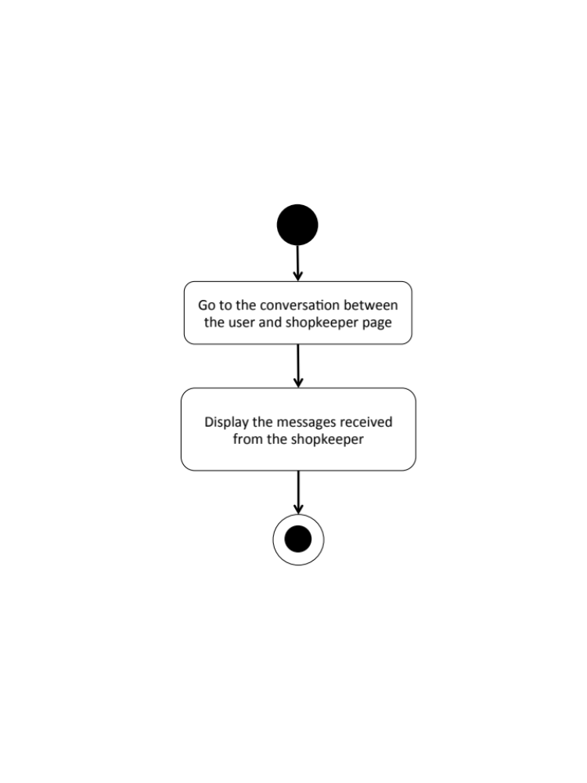

W-URS-30: The user sees list of shopkeepers that has been communicated with.
- Input: The user selects message link to see messages.
- Output: The system shows list of messages that the user gets.

Description
URS ID | W-URS-30
URS Name | The user sees list of shopkeepers that has been communicated with.
Actor | Blogger
Description | This function allows user to see the list of conversations with shopkeepers that the user has been communicated with.
Trigger | The user selects “Message” to go to message page.
Pre-condition | - User has logged in to the system.
Post-condition | - System displays list of conversations.
Normal flow | 1) User goes to message page.  2) System provides user interface of message page.  3) System shows list of conversations including the date and time, shop picture, and shop name.
Alternative flow | -
Exception | In all steps of normal flow, in case there is no internet connection.
Include | W-URS-02, W-URS-28, W-URS-29

W-AD-29
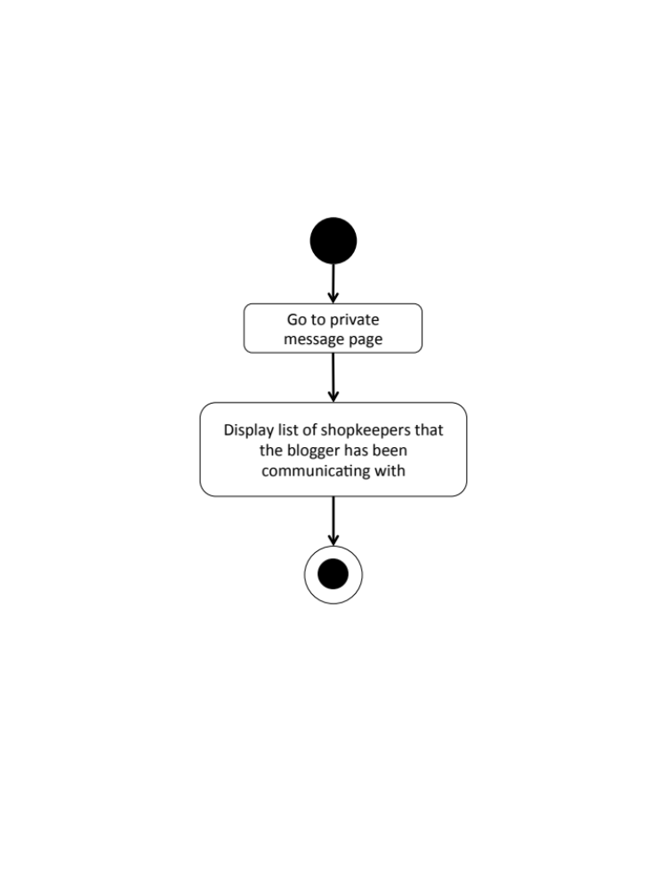

W-URS-31: The user shares tutorial to Facebook.
Input and Output
- Input: The user selects share link to share the tutorial to Facebook.
- Output: The system posts the tutorial on user’s Facebook wall.

Description
URS ID | W-URS-31
URS Name | The user shares tutorial to Facebook.
Actor | Visitor, Blogger
Description | This function allows user to share tutorial on his/her Facebook wall.
Trigger | The user selects “Share” to share the tutorial on user’s Facebook wall.
Pre-condition | - User stays on tutorial detail page.
Post-condition | - The tutorial is posted in user’s Facebook wall
Normal flow | - User clicks share to Facebook button.  - System access to the user’s Facebook account from the user’s web browser.  3) System displays confirmation post of the tutorial.  4) User writes some message about the tutorial.  5) User clicks post button.  6) System posts the tutorial on user’s Facebook wall.
Alternative flow | - In step 3, the user leaves the field blank in case he/she does not want to write anything about the tutorial.  - In step 4, the user clicks cancel button to cancel the tutorial sharing process.
Exception | In all steps of normal flow, in case there is no internet connection.
Include | W-URS-15

W-AD-30

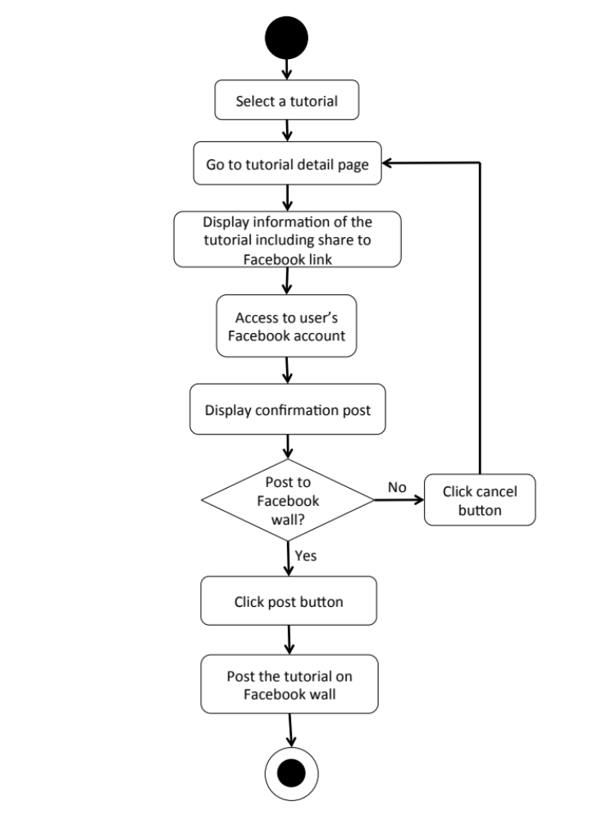

    - User Requirement Description for Mobile Application

Feature 1: User’s Profile and Authorization Management

M-URS-01: The user registers as a blogger/shopkeeper.

Input and Output
No | Input Name | Description | Example | Remarks | Output
1 | Username | The length of Username must be between 1-20 characters | “hideandseek05” | The word should not contain any symbol. | The system shows “HideandSeek05” on the screen
2 | Password | The length of Password must be between 1-20 characters | “12345” | The word should not contain any symbol. | The system shows “●●●●●” on the screen
3 | Re-Password | Re-password must match with the password. | “12345” | The word should not contain any symbol. | The system shows “●●●●●” on the screen
4 | Email | Email must be the one that the user is currently using. | “hello@gmail.com” | The word should be in Email format | The system shows “hello@gmail.com” on the screen
5 | Role | The choices, blogger and shopkeeper, will be provided for the user to choose. | “Blogger” | - | The system shows selected sign on the role that user selects.
6 | Picture | The file type must be .jpg or .png | “IMG_ProfilePic.jpg” | - | The system shows “IMG_ProfilePic.jpg” on the screen

Description
URS ID | M-URS-01
URS Name | The user registers as a blogger/shopkeeper.
Actor | User
Description | This function allows user who does not have his/her own account to register in order to use more functions of the application.
Trigger | The user selects “Sign Up” to register to be a member of the system.
Pre-condition | - Open the application
Post-condition | - The system saves user’s information into database.
Normal flow | 1) System provides registration interface for user to fill information, which are username, password, re-password, e-mail, role, and profile picture.  3) User input his/her information.  4) User clicks done to finish the registration.  5) System validates the information.  6) System saves the user’s information into the database.  7) System goes back to log in page.
Alternative flow | - In step 1-4, the user clicks back button to go to the previous page in case he/she wants to cancel the registration.
Exception | - In step 5, in case user has input incorrect information, system will display an alert message in order to notify user to input correct information.  - In all steps of normal flow, in case there is no internet connection.
Include | -

M-AD-01

M-URS-02: The user logins to the system by username and password.
Input and Output
No | Input Name | Description | Example | Remarks | Output
1 | Username | The length of Username must be between 1-20 characters | “hideandseek05” | The word should not contain any symbol. | The system shows “HideandSeek05” on the screen
2 | Password | The length of Password must be between 1-20 characters | “12345” | The word should not contain any symbol. | The system shows “●●●●●” on the screen

Description
URS ID | M-URS-02
URS Name | The user logins to the system by username and password.
Actor | Blogger, Shopkeeper
Description | This function allows user, who has registered, logs in to the system.
Trigger | The user selects “Log in” to log in to the system.
Pre-condition | - User has registered to the system.
Post-condition | - User goes to home page for blogger.
Normal flow | 1) User clicks log in button.  2) System provides log in interface for user to fill information, which are username and password.  3) User input his/her username and password.  4) Users click log in button.  5) System validates username, and password format.  6) System verifies username and password from the database.  7) System goes to home page.
Alternative flow | - In step 4, the user clicks back button to go to the previous page in case he/she wants to cancel the log in process.
Exception | - In step 5, in case user input invalid username or password, system will show an alert message.  - In all steps of normal flow, in case there is no internet connection.
Include | -

M-AD-02

M-URS-03: The user logouts from the system.
Input and Output
- Input: The user selects log out link to exit from the system.
- Output: The user log out from the system.

Description
URS ID | M-URS-03
URS Name | The user logouts from the system.
Actor | Blogger, Shopkeeper
Description | This function allows user to log out from the system.
Trigger | The user selects “Log out” to log out from the system.
Pre-condition | - User has logged in to the system.
Post-condition | - User has no longer logged in.
Normal flow | 1) User goes to Menu page.  2) System provides Menu page interface, which provides Categories, Shops, Around me, and Log out buttons.  3) User clicks Log out button.  4) System goes to visitor home page.
Alternative flow | -
Exception | - In all steps of normal flow, in case there is no internet connection.
Include | M-URS-02

M-AD-03

M-URS-04: The user sees his/her profile.
Input and Output
- Input: The user selects profile link to go to profile page.
- Output: The system shows user’s profile.

Description
URS ID | M-URS-04
URS Name | The user sees his/her profile.
Actor | Blogger
Description | This function allows user to see his/her own profile and information.
Trigger | The user selects “Profile” to go to his/her profile.
Pre-condition | - User has logged in to the system.
Post-condition | - System displays user’s profile.
Normal flow | - User goes to profile page.  - System gets user’s information from database.  - System displays interface and user’s information, which are profile picture, username, password, follower number, following number, and list of tutorials that he/she has created.
Alternative flow | -
Exception | In all steps of normal flow, in case there is no internet connection.
Include | M-URS-02

M-AD-04

M-URS-05: The user edits his/her email.
Input and Output
No | Input Name | Description | Example | Remarks | Output
1 | Email | Email must be the one that the user is currently using. | “kanom@msn.com” | The word should be in Email format | The system shows “kanom@msn.com” on the screen

Description
URS ID | M-URS-05
URS Name | The user edits his/her email.
Actor | Blogger
Description | This function allows user to edit his/her own email.
Trigger | The user selects “Edit” on user’s profile page.
Pre-condition | - User has logged in to the system.
Post-condition | - System updates the new information of user’s profile.
Normal flow | 1) User goes to edit profile page  2) System provides the editable interface of the profile.  3) User input new information.  4) User clicks save.  5) System saves the edited profile into the database.  6) System goes back to user’s profile page.
Alternative flow | - In step 1-4, the user clicks back button to go to the previous page in case he/she wants to cancel the edit profile process.
Exception | - In all steps of normal flow, in case there is no internet connection.
Include | M-URS-02

M-AD-05

M-URS-06: The user changes profile picture.
Input and Output
No | Input Name | Description | Example | Remarks | Output
1 | Picture | The file type must be .jpg or .png | “IMG_ProfilePic2.jpg” | - | The system shows “IMG_ProfilePic2.jpg” on the screen

Description
URS ID | M-URS-06
URS Name | The user changes profile picture.
Actor | Blogger
Description | This function allows user to change his/her profile picture.
Trigger | The user selects “Profile picture” to change the picture.
Pre-condition | - User has logged in to the system.  - User goes to edit profile page.
Post-condition | - System saves new user’s profile picture into database.
Normal flow | 1) User selects profile picture link.  2) System shows pictures in phone gallery.  3) User selects a picture.  4) User clicks save.  5) System saves the new picture into the database.  6) System goes back to user’s profile page.
Alternative flow | - In step 1-4, the user clicks cancel button to go to the previous page in case he/she wants to cancel the picture changing process.
Exception | In all steps of normal flow, in case there is no internet connection.
Include | M-URS-02

M-AD-06

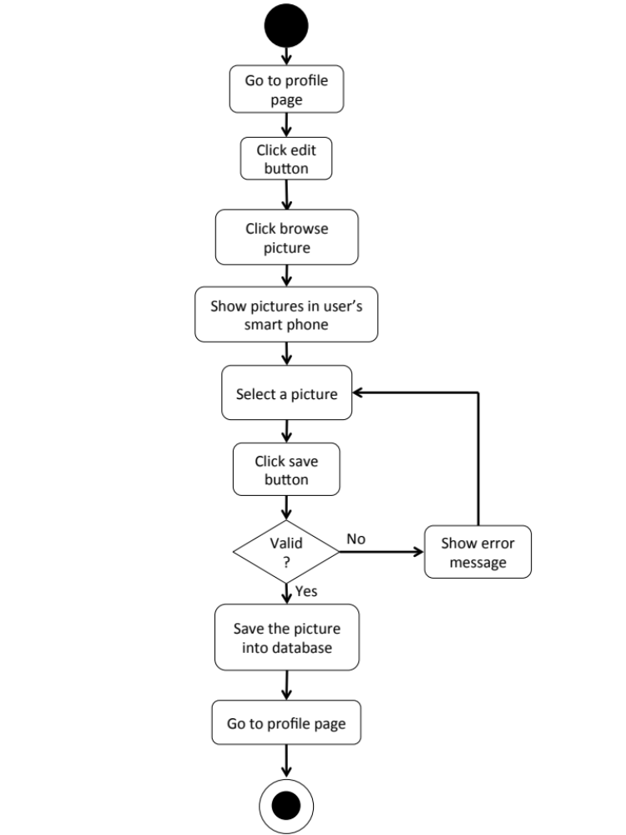

M-URS-07: The user changes his/her password.
Input and Output
No | Input Name | Description | Example | Remarks | Output
1 | Current Password | Current Password should be the password that the user is currently using. | “12345” | The word should not contain any symbol. | The system shows “●●●●●” on the screen
2 | New Password | The length of New Password must be between 1-20 characters | “00000” | The word should not contain any symbol. | The system shows “●●●●●” on the screen
3 | Re-New Password | Re-New Password must match with the New Password. | “00000” | The word should not contain any symbol. | The system shows “●●●●●” on the screen

Description
URS ID | M-URS-07
URS Name | The user changes his/her password.
Actor | Blogger
Description | This function allows user to change password for his/her account.
Trigger | The user selects “Change password” to change the password for user’s account.
Pre-condition | - User has logged in to the system.  - User goes to edit profile page.
Post-condition | - The password for the user’s account is updated.
Normal flow | 1) User clicks change password button.  2) System provide change password interface for user to fill information, which are current password and new password.  3) User input information.  4) User clicks save button.  5) System saves the new password into the database.  6) System goes back to user’s profile page.
Alternative flow | - In step 4, the user clicks back button to go to the previous page in case he/she wants to cancel the password changing process.
Exception | In all steps of normal flow, in case there is no internet connection.
Include | M-URS-02

M-AD-07

M-URS-08: The user deletes his/her account.

Input and Output
- Input: The user selects delete account link to delete user’s account.
- Output: The system goes to home page for unlogged in user.

Description
URS ID | M-URS-08
URS Name | The user deletes his/her account.
Actor | Blogger
Description | This function allows user to delete his/her account, which the user will not be able to access the system as a blogger, unless the user register a new account.
Trigger | The user selects “Delete account” to delete the user’s account.
Pre-condition | - User has logged in to the system.  - User goes to edit profile page.
Post-condition | - User’s account is no longer available.
Normal flow | 1) User clicks delete account button.  2) System shows confirmation message.  3) User clicks yes button.  4) System removes the user’s account from the database.  5) System goes to unlogged in home page.
Alternative flow | - In step 3, the user clicks no button to cancel the account deletion process.
Exception | In all steps of normal flow, in case there is no internet connection.
Include | M-URS-02

M-AD-08

Feature 2: Tutorial Management
M-URS-09: The user randomly sees tutorials that exist in database.
Input and Output
- Input: The user selects random link to see random tutorials.
- Output: The system shows list of all tutorials with tutorial picture, title, owner username, and number of likes that exist in the database randomly.

Description
URS ID | M-URS-09
URS Name | The user randomly sees tutorials that exist in database.
Actor | Visitor, Blogger
Description | This function allows user to see list of tutorials randomly.
Trigger | The user selects “Random” to see random tutorials.
Pre-condition | - User stays on Home page.
Post-condition | - System displays list of all tutorials that exist in the database randomly.
Normal flow | 1) User selects “Random” on the Home page.  2) System gets tutorials information from database.  3) System displays list of all tutorials with tutorial picture, title, owner username, and number of likes that exist in the database randomly.
Alternative flow | -
Exception | In all steps of normal flow, in case there is no internet connection.
Include | M-URS-02

M-AD-09

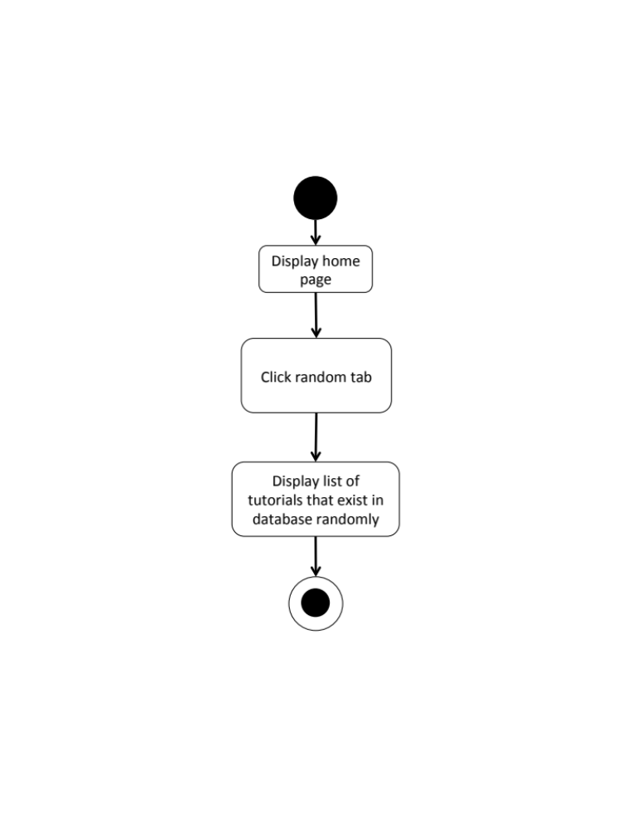

M-URS-10: The user sees tutorials that exist in database by popularity according to number of likes.
Input and Output
- Input: The user selects popular link to see popular tutorials.
- Output: The system shows list of all tutorials with tutorial picture, title, owner username, and number of likes that exist in the database from the most liked to the less.

Description
URS ID | M-URS-10
URS Name | The user sees tutorials that exist in database by popularity according to number of likes.
Actor | Visitor, Blogger
Description | This function allows user to see list of tutorials that has most likes.
Trigger | The user selects “Popular” to see popular tutorials.
Pre-condition | - User stays on Home page.
Post-condition | - System displays list of all tutorials that exist in the database from the most liked to the less.
Normal flow | 1) User selects “Popular” on the Home page.  2) System gets tutorials information from database.  3) System displays list of all tutorials with tutorial picture, title, owner username, and number of likes that exist in the database from the most liked to the less.
Alternative flow | -
Exception | In all steps of normal flow, in case there is no internet connection.
Include | M-URS-02

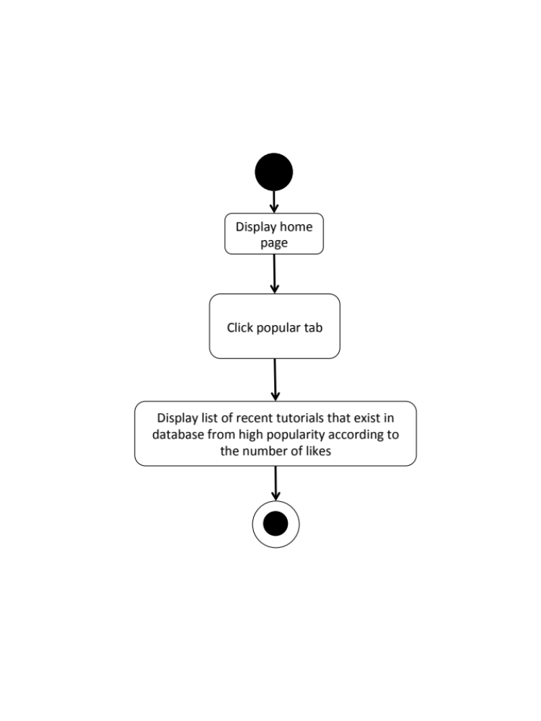
M-AD-10

M-URS-11: The user sees tutorials that exist in database by choosing a category.

Input and Output
- Input: The user selects a category link to see tutorials by category.
- Output: The system shows list of tutorials with tutorial picture, title, owner username, and number of likes of the category.

Description
URS ID | M-URS-11
URS Name | The user sees tutorials that exist in database by choosing a category.
Actor | Visitor, Blogger
Description | This function allows user to see list of tutorials according to each category.
Trigger | The user selects “Categories” to see categories of tutorials.
Pre-condition | - User stays on Home page.
Post-condition | - System displays list of tutorials of the category.
Normal flow | - User goes to Menu page.  - System provides Menu page interface, which provides Categories, Shops, Around Me, and Log Out buttons.  3) User click categories button.  4) System displays categories, which are outfit, accessory, gift, kid, garden, home décor, pet, and other.  5) User selects a category.  6) System gets tutorials information from database.  7) System displays list of tutorials with tutorial picture, title, owner username, and number of likes of the category.
Alternative flow | -
Exception | In all steps of normal flow, in case there is no internet connection.
Include | M-URS-02

M-AD-11
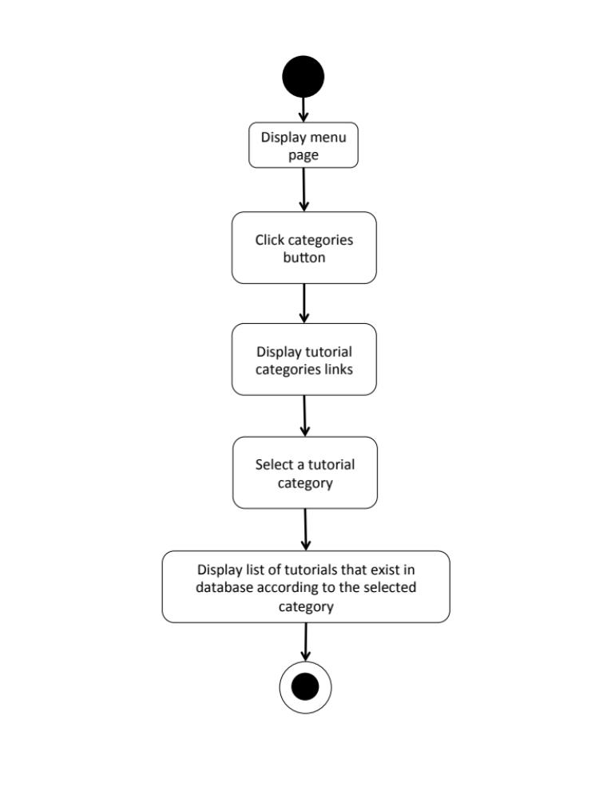

M-URS-12: The user search tutorials’ title that exist in database by inputting a keyword.

Input and Output
No | Input Name | Description | Example | Remarks | Output
1 | Keyword | The length of Keyword must be between 1-20 characters | “Bracelet” | The word should not contain any symbol. | The system shows tutorials that have the word “Bracelet” as a tutorial name.

Description
URS ID | M-URS-12
URS Name | The user search tutorials’ title that exist in database by inputting a keyword.
Actor | Visitor, Blogger
Description | This function allows user to see list of tutorials by inputting keyword.
Trigger | The user clicks on the search box.
Pre-condition | - User stays on Home page.
Post-condition | - System displays list of all tutorials that relate to the keyword.
Normal flow | 1) User input a keyword in the search box.  2) System gets tutorials information from database.  3) System displays list of all tutorials with tutorial picture, title, owner username, and number of likes that relate to the keyword.
Alternative flow | -
Exception | In all steps of normal flow, in case there is no internet connection.
Include | M-URS-02

M-AD-12
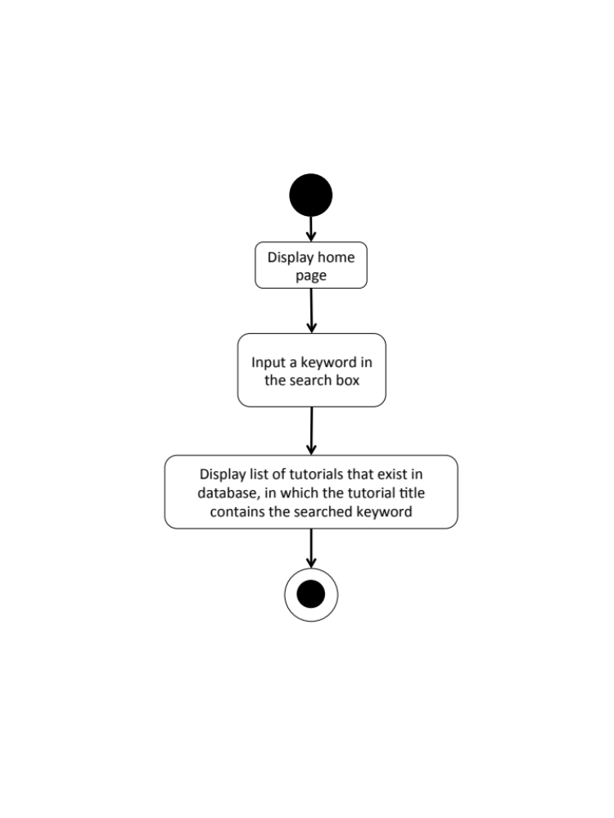

M-URS-13: The user sees tutorials that exist in database from following bloggers.

Input and Output
- Input: The user selects following link to see following tutorials.
- Output: The system shows list of tutorials with tutorial picture and title from the following bloggers.

Description
URS ID | M-URS-13
URS Name | The user sees tutorials that exist in database from following bloggers.
Actor | Blogger
Description | This function allows user to see list of tutorials from the bloggers that the user is following.
Trigger | The user selects “Following” to see tutorials from the bloggers that the user is following.
Pre-condition | - User has logged in to the system.  - User stays on Home page.
Post-condition | - System displays list of tutorials from the following bloggers.
Normal flow | 1) User tab “Following” on the Home page.  2) System gets tutorials information from database.  3) System displays list of tutorials with tutorial picture, title, owner username, and number of likes from the following bloggers.
Alternative flow | -
Exception | In all steps of normal flow, in case there is no internet connection.
Include | M-URS-02

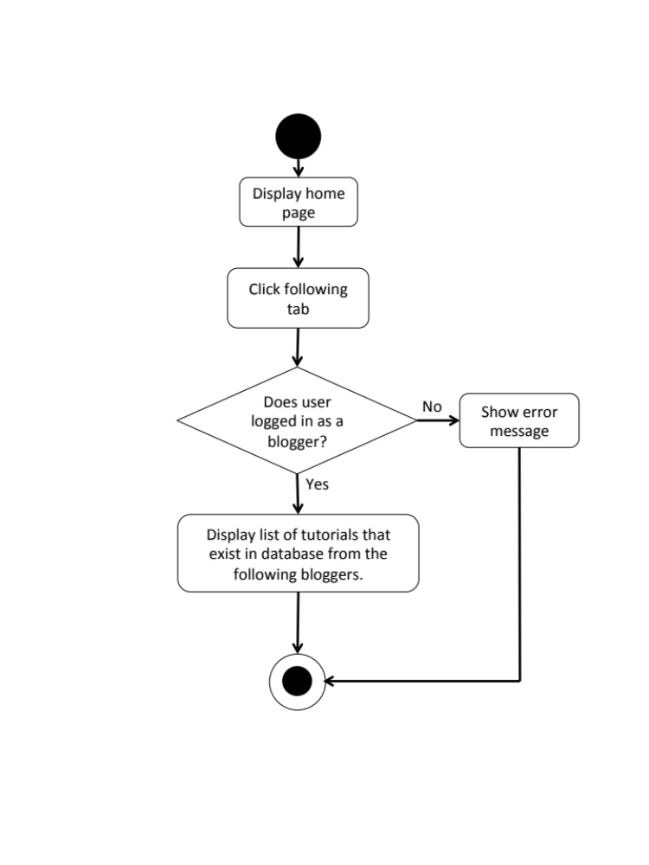
M-AD-13

M-URS-14: The user sees selected tutorial information.
Input and Output
- Input: The user selects tutorial link to see tutorial’s detail.
- Output: The system shows information of the tutorial, which are title, owner username, number of likes, category, material picture, material description, step description, step picture, video, and comments.

Description
URS ID | M-URS-14
URS Name | The user sees selected tutorial information.
Actor | Visitor, Blogger
Description | This function allows user to information of each tutorial.
Trigger | The user selects a tutorial to see the information.
Pre-condition | - User selects a tutorial
Post-condition | - System displays all information of the tutorial.
Normal flow | 1) User selects a tutorial.  2) System gets the tutorial’s information from database.  3) System displays all information of the tutorial, which are title, owner username, number of likes, category, material picture, material description, step description, step picture, video, and comments.
Alternative flow | -
Exception | In all steps of normal flow, in case there is no internet connection.
Include | M-URS-02

M-AD-14

M-URS-15: The user creates his/her own tutorial, which includes tutorial detail.

Input and Output
No | Input Name | Description | Example | Remarks | Output
1 | Tutorial Picture | The file type must be .jpg or .png | “IMG_tutorial.jpg” | - | The system shows “IMG_tutorial.jpg” on the screen
2 | Title | The length of Title must be between 1-20 characters between 1-20 characters | “Handmade Bracelet” | The word should not contain any symbol. | The system shows “Handmade Bracelet” on the screen
3 | Category | The categories are provided by the system. | “Accessory” | - | The system shows “Accessory” on the screen
4 | Material Picture | The file type must be .jpg or .png | “IMG_material.jpg” | - | The system shows “IMG_material.jpg” on the screen
5 | Material Description | The length of Material Description must be between 1-500 characters | “1.Rope 2.Glue 3.Scissor 4.Glitter 5.Pin” | - | The system shows “1.Rope 2.Glue 3.Scissor 4.Glitter 5.Pin”on the screen
6 | Step | The number of step should be between 1-6 | “1” | No symbol or character is allowed. | The system shows “1” on the screen
7 | Step Picture | The file type must be .jpg or .png | “IMG_step1.jpg” | - | The system shows “IMG_step1.jpg” on the screen
8 | Step Description | The length of Step Description must be between 1-500 characters | “Cut the rope to have the length as long as it can be out around your wrist.” | - | The system shows “Cut the rope to have the length as long as it can be out around your wrist.” on the screen
9 | Video | The file type must be .mov | “VDO_tutorial.mov” | - | The system shows “VDO_tutorial.mov” on the screen

Description
URS ID | M-URS-15
URS Name | The user creates his/her own tutorial, which includes tutorial detail.
Actor | Blogger
Description | This function allows user to create his/her own tutorial.
Trigger | The user selects “Create” to create a new tutorial.
Pre-condition | - User has logged in to the system.
Post-condition | - System saves the created tutorial into database.
Normal flow | 1) User clicks create button.  2) System provides create tutorial interface for user to fill information, which are tutorial picture, title, and category.  3) User inputs the information.  4) System validates tutorial picture, title, and category format.  5) User clicks next link.  6) System provides create tutorial interface for user to fill information, which are material, material picture, step description, step picture, and video.  7) User input the information step by step.  8) User clicks done button.  9) System validates material picture, material description, step number, step picture, step description, and video format.  10) System saves the tutorial into the database.  11) System shows successful message.
Alternative flow | - In step 1-8, the user clicks back button to go to the previous page in case he/she wants to cancel the tutorial creating process.
Exception | - In step 4 and 9, system displays error message in case the format is wrong.  - In all steps of normal flow, in case there is no internet connection.
Include | M-URS-02

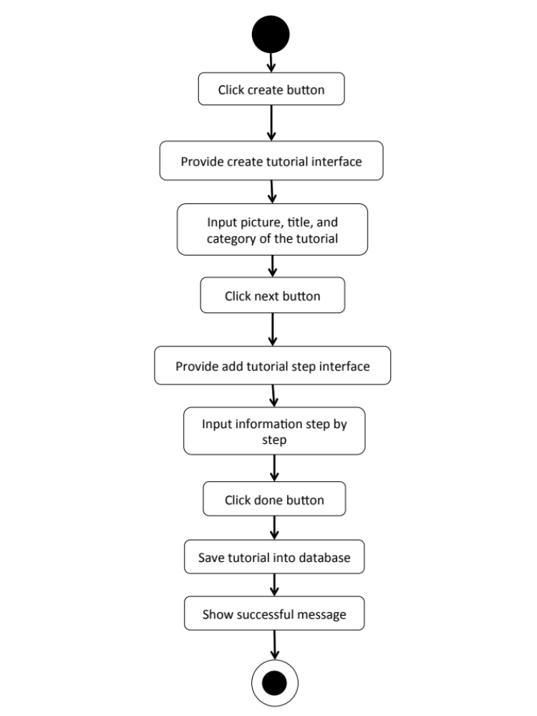

M-AD-15

M-URS-16: The user sees detail of his/her own tutorial.
Input and Output
- Input: The user selects profile link to go to profile page.
- Output: The system shows user’s profile including list of his/her tutorials.

Description
URS ID | M-URS-16
URS Name | The user sees detail of his/her own tutorial.
Actor | Blogger
Description | This function allows user to see tutorials that the user has created.
Trigger | The user selects “Profile” to see his/her information including his/her own tutorials.
Pre-condition | - User has logged in to the system.  - User goes to his/her profile page
Post-condition | - System shows tutorials that the user has created.
Normal flow | - User goes to profile page.  - System gets user’s information from database.  3) System displays interface and user’s information, which are profile picture, username, password, follower number, following number, and tutorials that he/she has created.
Alternative flow | -
Exception | In all steps of normal flow, in case there is no internet connection.
Include | M-URS-02, M-URS-15

M-AD-16

M-URS-17: The user edits detail of his/her own tutorial.
Input and Output
No | Input Name | Description | Example | Remarks | Output
1 | Tutorial Picture | The file type must be .jpg or .png | “IMG_tutorial2.jpg” | - | The system shows “IMG_tutorial2.jpg” on the screen
2 | Title | The length of Title must be between 1-20 characters between 1-20 characters | “How to make a Handmade Bracelet by yourself” | The word should not contain any symbol. | The system shows “How to make a Handmade Bracelet by yourself” on the screen
3 | Category | The categories are provided by the system. | “Outfit” | - | The system shows “Accessory” on the screen
4 | Material Picture | The file type must be .jpg or .png | “IMG_material2.jpg” | - | The system shows “IMG_material2.jpg” on the screen
5 | Material Description | The length of Material Description must be between 1-500 characters | “1.Rope 2.Glue 3.Scissor 4.Glitter 5.Pin 6.Color” | - | The system shows “1.Rope 2.Glue 3.Scissor 4.Glitter 5.Pin  6.Color” on the screen
6 | Step | The number of step should be between 1-6 | “2” | No symbol or character is allowed. | The system shows “2” on the screen
7 | Step 1 Picture | The file type must be .jpg or .png | “IMG_step1.jpg” | - | The system shows “IMG_step1.jpg” on the screen
8 | Step 1 Description | The length of Step Description must be between 1-500 characters | “Cut the rope to have the length as long as it can be out around your wrist.  Be careful when you cut it!” | - | The system shows “Cut the rope to have the length as long as it can be out around your wrist. Be careful when you cut it!” on the screen
9 | Step 2 Picture | The file type must be .jpg or .png | “IMG_step2.jpg” | - | The system shows “IMG_step2.jpg” on the screen
10 | Step 2 Description | The length of Step Description must be between 1-500 characters | “Now it’s time to decorate!” | - | The system shows “Now it’s time to decorate!” on the screen
11 | Video | The file type must be .mov | “VDO_tutorial2.mov” | - | The system shows “VDO_tutorial2.mov” on the screen

Description
URS ID | M-URS-17
URS Name | The user edits detail of his/her own tutorial.
Actor | Blogger
Description | This function allows user to make some changes on his/her own tutorial.
Trigger | The user selects “Edit” to edit the selected tutorial.
Pre-condition | - User has logged in to the system.
Post-condition | - System updates new information of the tutorial.
Normal flow | 1) User selects a tutorial that wants to be edited.  2) User clicks edit button.  3) System provides the editable interface for user to edit tutorial picture, title, category, material picture, material description, step number, step picture, step description, and video.  4) User clicks save.  5) System validates tutorial picture, title, category, material picture, material description, step number, step picture, step description, and video format.  6) System saves the edited tutorial into the database.  7) System shows successful message.
Alternative flow | In step 1-4, the user clicks back button to cancel the process.
Exception | - In step 6, system displays error message in case the format is wrong.  - In all steps of normal flow, in case there is no internet connection.
Include | M-URS-02, M-URS-15

M-AD-17

M-URS-18: The user deletes his/her own tutorial.

Input and Output
- Input: The user selects delete tutorial link to delete his/her tutorial.
- Output: The tutorial disappears from the tutorial list.

Description
URS ID | M-URS-18
URS Name | The user deletes his/her own tutorial.
Actor | Blogger
Description | This function allows user to remove his/her own tutorial from the database.
Trigger | The user selects “Delete tutorial” to remove tutorial from the database.
Pre-condition | - User has logged in to the system.  - User selects the tutorial that wants delete.
Post-condition | - System removes the tutorial from the database.
Normal flow | 1) User clicks delete button.  2) System shows confirmation message with yes/no button.  3) User clicks yes button.  4) System removes the tutorial from the database.  5) System shows successful message.
Alternative flow | - In step 1-3, the user clicks no button to cancel the tutorial deletion process.
Exception | In all steps of normal flow, in case there is no internet connection.
Include | M-URS-02, M-URS-15

M-AD-18

Feature 3: Shop Management
M-URS-19: The user randomly sees shops that exist in database.
Input and Output
- Input: The user selects random link to see random shops.
- Output: The system shows list of all shops with shop picture, shop name, and shopkeeper username that exist in the database randomly.

Description
URS ID | M-URS-19
URS Name | The user randomly sees shops that exist in database.
Actor | Blogger
Description | This function allows user to see list of shops that exist in database randomly.
Trigger | The user selects “Random” to see random shops.
Pre-condition | - User stays on Shop page.
Post-condition | - System displays list of all shops that exist in the database randomly.
Normal flow | 1) User selects “Random” on the Shop page.  2) System gets shops information from database.  3) System displays list of all shops with shop picture, shop name, and shopkeeper username that exist in the database randomly.
Alternative flow | -
Exception | In all steps of normal flow, in case there is no internet connection.
Include | M-URS-02

M-AD-19

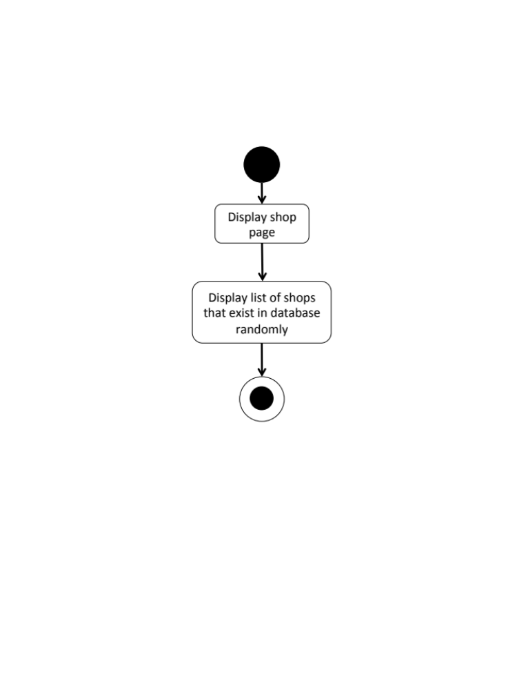

M-URS-20: The user sees shops that exist in database by choosing a category.

Input and Output
- Input: The user selects a category link to see shops by category.
- Output: The system shows list of shops with shop picture, shop name, and shopkeeper username of the selected category that exist in the database.

Description
URS ID | M-URS-20
URS Name | The user sees shops that exist in database by choosing a category.
Actor | Blogger
Description | This function allows user to see list of shops according to each category.
Trigger | The user selects “Categories” to see categories of shops.
Pre-condition | - User goes to Shop page.
Post-condition | - System displays list of shops of the category.
Normal flow | 1) User clicks categories button.  2) System displays categories, which are fabric, accessory, wood, stationary, container and other.  3) User selects a category.  4) System gets shops information from database.  5) System displays list of shops with shop picture, shop name, and shopkeeper username of the selected category that exist in the database.
Alternative flow | -
Exception | In all steps of normal flow, in case there is no internet connection.
Include | M-URS-02

M-AD-20
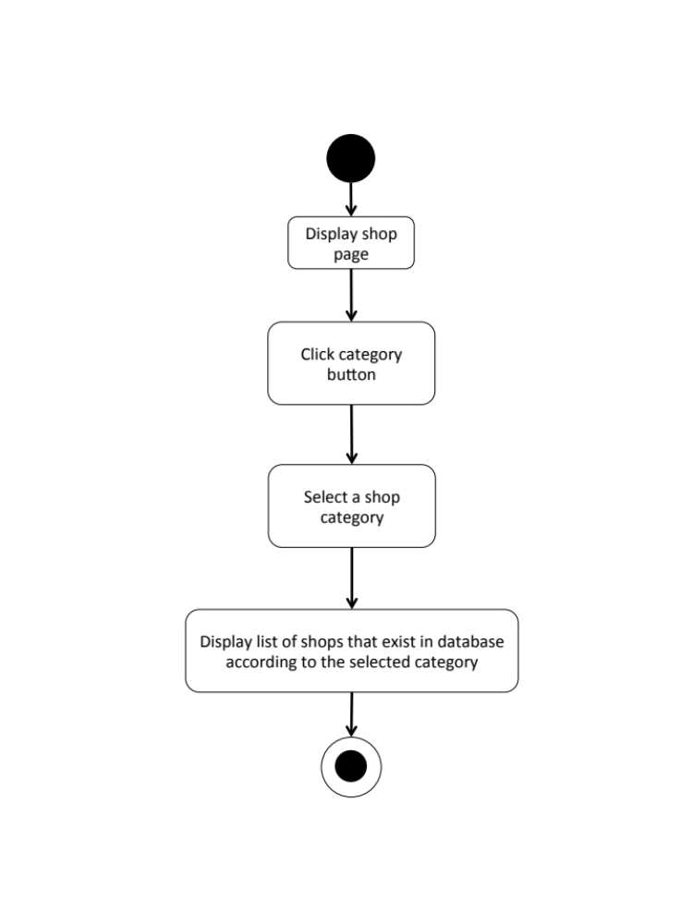

M-URS-21: The user search shop’s name that exist in database by inputting a keyword.

Input and Output
No | Input Name | Description | Example | Remarks | Output
1 | Keyword | The length of Keyword must be between 1-20 characters | “Pin” | The word should not contain any symbol. | The system shows shops that have the word “Pin” as a shop name.

Description
URS ID | M-URS-21
URS Name | The user search shop’s name that exist in database by inputting a keyword.
Actor | Blogger
Description | This function allows user to see list of shops by inputting keyword.
Trigger | The user clicks on the search box.
Pre-condition | - User stays on Shop page.
Post-condition | - System displays list of all shops that relate to the keyword.
Normal flow | 1) User input a keyword in the search box.  2) System gets shops information from database.  3) System displays list of all shops with shop picture, shop name, and shopkeeper username that relate to the keyword.
Alternative flow | -
Exception | In all steps of normal flow, in case there is no internet connection.
Include | M-URS-02

M-AD-21
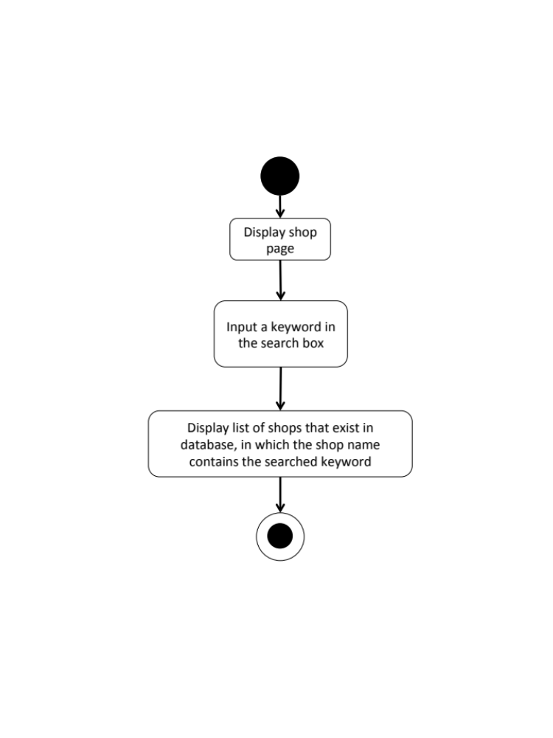

M-URS-22: The user sees selected shop information.
Input and Output
- Input: The user selects shop link to see shop’s detail.
- Output: The system shows information of the shop, which are shop name, shopkeeper username, branch, telephone number, information, pictures, and shop’s location.

Description
URS ID | M-URS-22
URS Name | The user sees selected tutorial information.
Actor | Blogger
Description | This function allows user to see information of each shop.
Trigger | The user selects a shop to see the information.
Pre-condition | - User selects a shop.
Post-condition | - System displays all information of the shop.
Normal flow | 1) User selects a shop.  2) System gets the shop’s information from database.  3) System displays all information of the shop, which are shop name, shopkeeper username, branch, telephone number, information, pictures, and shop’s location.
Alternative flow | -
Exception | In all steps of normal flow, in case there is no internet connection.
Include | M-URS-02

M-AD-22
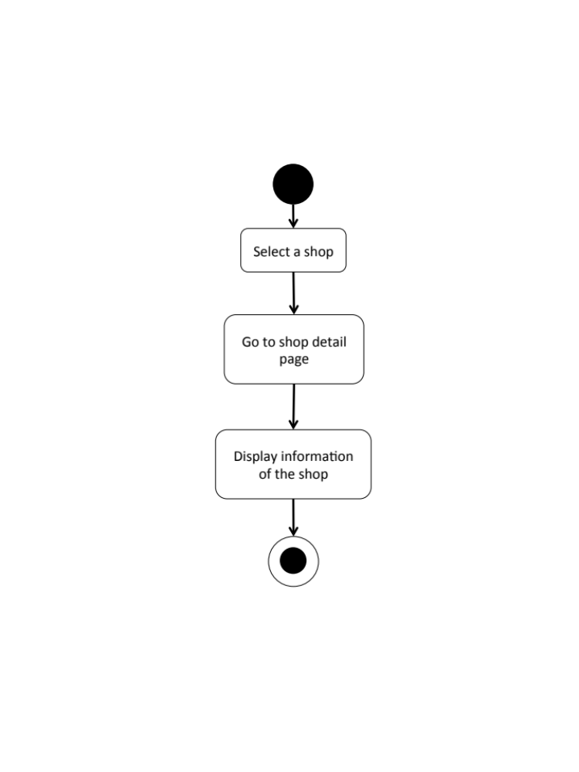

M-URS-23: The user creates his/her own shop, which includes shop detail.

Input and Output
No | Input Name | Description | Example | Remarks | Output
1 | Shop Picture | The file type must be .jpg or .png | “IMG_shop.jpg” | - | The system shows “IMG_shop.jpg” on the screen
2 | Shop name | The length of Shop name must be between 1-20 characters | “ABC shop” | The word should not contain any symbol. | The system shows “ABC shop” on the screen
3 | Category | The categories are provided by the system. | “Stationary” | - | The system shows “Stationary” on the screen
4 | Branch | The length of Branch must be between 1-20 characters | “Chiang mai” | The word should not contain any symbol. | The system shows “Chiang mai” on the screen
5 | Telephone Number | The telephone number should be in 10 digits. | “053111222” | No symbol or character is allowed. | The system shows “053111222” on the screen
6 | Information | The length of Information must be between 1-500 characters | “Welcome to ABC shop! We sale stationaries.” | - | The system shows “Welcome to ABC shop! We sale stationaries.” on the screen
7 | Pictures1 | The file type must be .jpg or .png | “IMG_ABCshop1.jpg” | - | The system shows “IMG_ABCshop1.jpg” on the screen
8 | Location | The length of Step Description must be between 1-500 characters | “ ” | -

Description
URS ID | M-URS-23
URS Name | The user creates his/her own shop, which includes shop detail.
Actor | Shopkeeper
Description | This function allows user to create his/her own shop.
Trigger | The user selects “Create” to create a new shop.
Pre-condition | - User has logged in to the system.
Post-condition | - System saves the created shop into database.
Normal flow | 1) User clicks create button.  2) System provides create shop interface for user to fill information, which are shop picture, shop name, and category.  3) User inputs the information.  4) System validates shop picture, shop name, and category format.  5) User clicks next link.  6) System provides create shop interface for user to fill information, which are branch, telephone number, information, pictures, and location.  7) User input the information.  8) User clicks done button.  9) System validates branch, telephone number, information, pictures, and location format.  10) System saves the tutorial into the database.  11) System shows successful message.
Alternative flow | - In step 1-8, the user clicks back button to go to the previous page in case he/she wants to cancel the shop creating process.
Exception | - In step 4 and 9, system displays error message in case the format is wrong.  - In all steps of normal flow, in case there is no internet connection.
Include | M-URS-02

M-AD-23
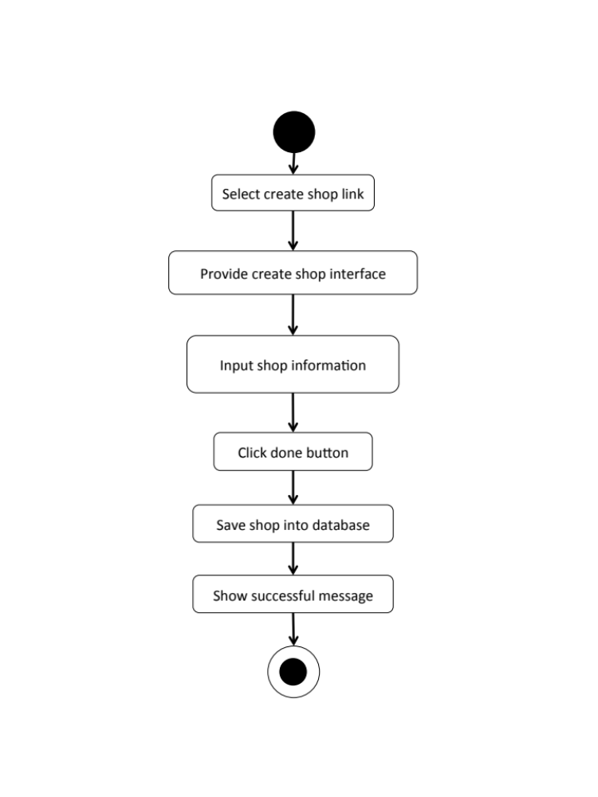

M-URS-24: The user sees detail of his/her own shop.
Input and Output
- Input: The user selects profile link to go to profile page.
- Output: The system shows user’s profile including list of his/her shop.

Description
URS ID | M-URS-24
URS Name | The user sees detail of his/her own shop.
Actor | Shopkeeper
Description | This function allows user to see shop s that the user has created.
Trigger | The user selects “Profile” to see his/her information including his/her own shops.
Pre-condition | - User has logged in to the system.  - User goes to his/her profile page
Post-condition | - System shows shops that the user has created.
Normal flow | - User goes to profile page.  - System gets user’s information from database.  3) System displays interface and user’s information, which are profile picture, username, email, and shops that he/she has created.
Alternative flow | -
Exception | In all steps of normal flow, in case there is no internet connection.
Include | M-URS-02, M-URS-23

M-AD-24
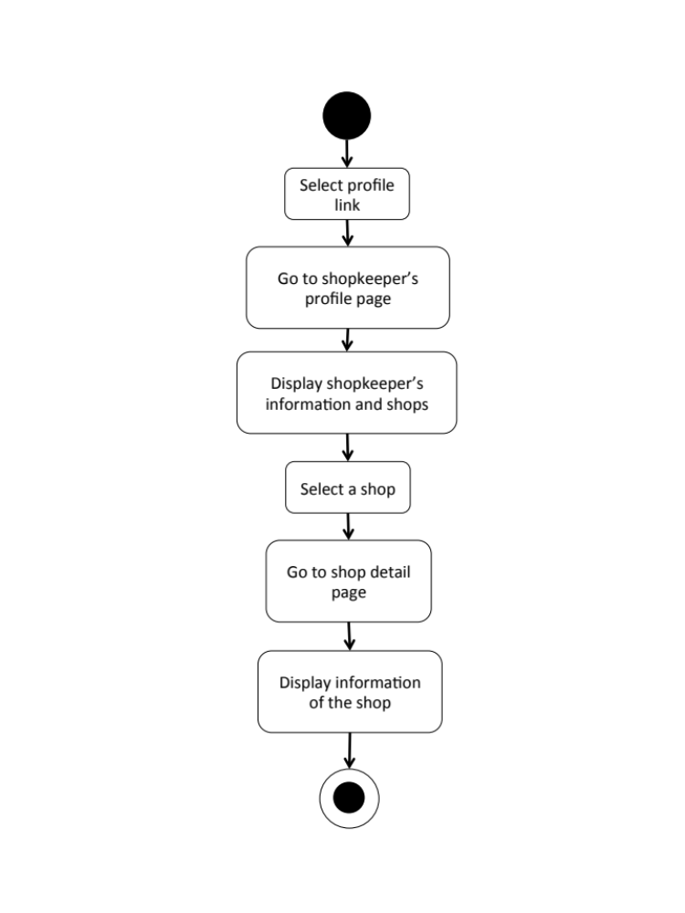

M-URS-25: The user edits detail of his/her own shop.
Input and Output
No | Input Name | Description | Example | Remarks | Output
1 | Shop Picture | The file type must be .jpg or .png | “IMG_shop2.jpg” | - | The system shows “IMG_shop2.jpg” on the screen
2 | Shop name | The length of Shop name must be between 1-20 characters | “ABC shop 555” | The word should not contain any symbol. | The system shows “ABC shop 555” on the screen
3 | Category | The categories are provided by the system. | “Fabric” | - | The system shows “Fabric” on the screen
4 | Branch | The length of Branch must be between 1-20 characters | “Bangkok” | The word should not contain any symbol. | The system shows “Bangkok” on the screen
5 | Telephone Number | The telephone number of step should be in 10 digits. | “0815556677” | No symbol or character is allowed. | The system shows “0815556677” on the screen
6 | Information | The length of Information must be between 1-500 characters | “Welcome to ABC shop 555! We sale fabrics.” | - | The system shows “Welcome to ABC shop 555! We sale fabrics.”on the screen
7 | Pictures1 | The file type must be .jpg or .png | “IMG_ABCshop1.jpg” | - | The system shows “IMG_ABCshop1.jpg” on the screen
8 | Pictures2 | The file type must be .jpg or .png | “IMG_ABCshop2.jpg” | - | The system shows “IMG_ABCshop2.jpg” on the screen
9 | Location | The length of Step Description must be between 1-500 characters | “ ” | -

Description
URS ID | M-URS-25
URS Name | The user edits detail of his/her own shop.
Actor | Shopkeeper
Description | This function allows user to make some changes on his/her own shop.
Trigger | The user selects “Edit” to edit the selected shop.
Pre-condition | - User has logged in to the system.
Post-condition | - System updates new information of the shop.
Normal flow | 1) User selects a shop that wants to be edited.  2) User clicks edit button.  3) System provides create shop interface for user to fill information, which are shop picture, shop name, category, branch, telephone number, information, pictures, and location.  4) User clicks save.  5) System validates shop picture, shop name, category, branch, telephone number, information, pictures, and location format.  6) System saves the edited shop into the database.  7) System shows successful message.
Alternative flow | In step 1-4, the user clicks back button to cancel the process.
Exception | - In step 6, system displays error message in case the format is wrong.  - In all steps of normal flow, in case there is no internet connection.
Include | M-URS-02, M-URS-23

M-AD-25
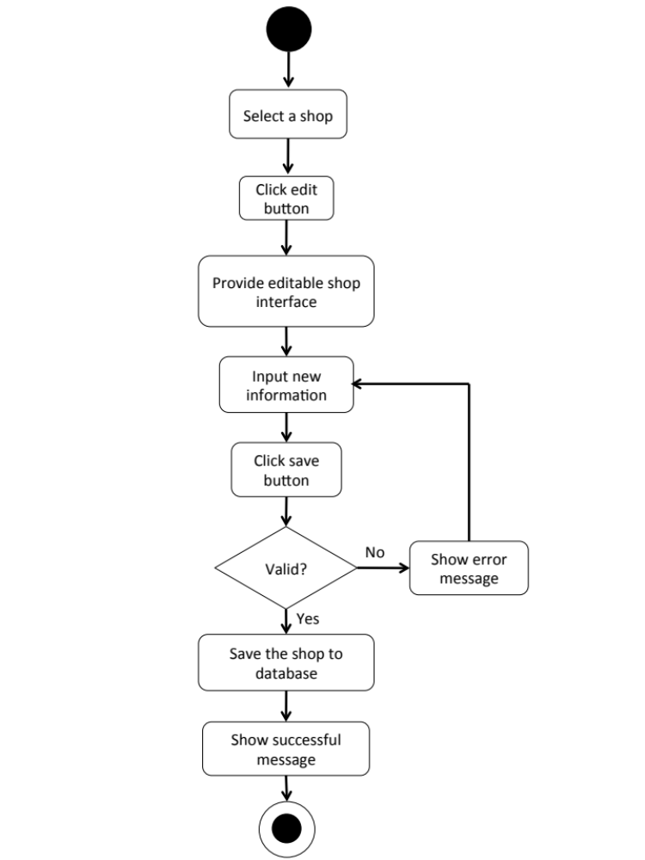

M-URS-26: The user deletes his/her own shop.

Input and Output
- Input: The user selects delete tutorial link to delete his/her shop.
- Output: The shop disappears from the shop list.

Description
URS ID | M-URS-26
URS Name | The user deletes his/her own shop.
Actor | Shopkeeper
Description | This function allows user to remove his/her own shop from the database.
Trigger | The user selects “Delete shop” to remove shop from the database.
Pre-condition | - User has logged in to the system.  - User selects the shop that wants delete.
Post-condition | - System removes the shop from the database.
Normal flow | 1) User clicks delete button.  2) System shows confirmation message with yes/no button.  3) User clicks yes button.  4) System removes the shop from the database.  5) System shows successful message.
Alternative flow | - In step 1-3, the user clicks no button to cancel the shop deletion process.
Exception | In all steps of normal flow, in case there is no internet connection.
Include | M-URS-02, M-URS-23

M-AD-26
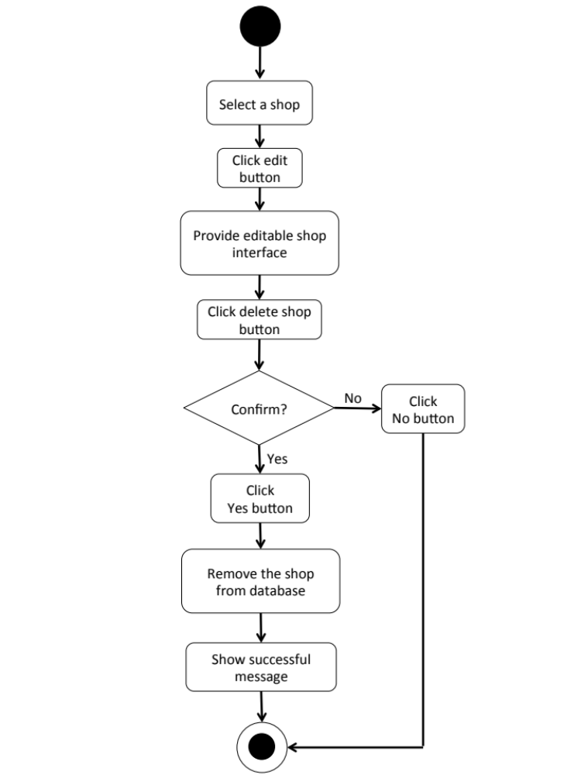

M-URS-27: The user sees near by shops’ location on Google Map.
Input and Output
- Input: The user selects around me link to see shops near by on Google Map.
- Output: The system shows the exact shops’ location around that area on Google Map.

Description
URS ID | M-URS-27
URS Name | The user sees near by shops’ location on Google Map.
Actor | Blogger
Description | This function allows user to see the near by or around him/her shops’ location that exist in database on Google Map.
Trigger | The user selects around me link to see near by shops’ location on Google Map.
Pre-condition | - User clicks around me button.
Post-condition | - System shows near by shops’ location on Google Map.
Normal flow | 1) User clicks around me button.  2) System gets the shops’ location information from database.  3) System retrieves the locations from Google Map.  4) System shows the exact shops’ position on Google Map.
Alternative flow | -
Exception | In all steps of normal flow, in case there is no internet connection.
Include | M-URS-02

M-AD-27
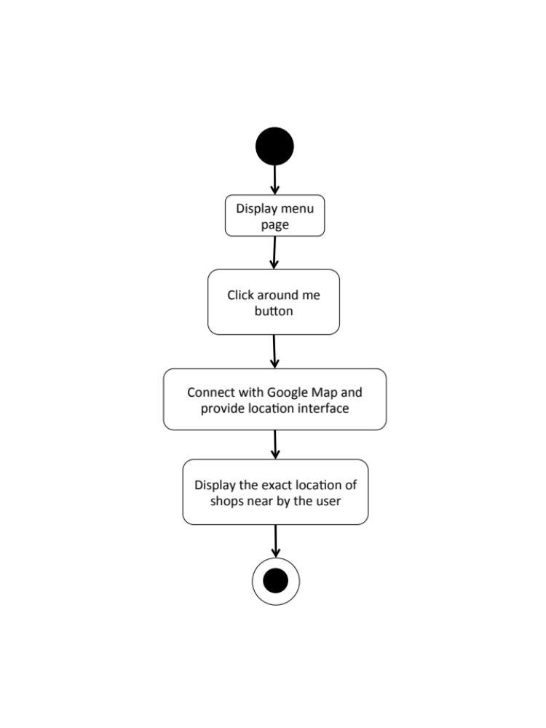

M-URS-28: The user sees shop’s location on Google Map.
Input and Output
- Input: The user selects shop location link to see the location on Google Map.
- Output: The system shows the exact shop’s location on Google Map.

Description
URS ID | M-URS-28
URS Name | The user sees shop’s location on Google Map.
Actor | Blogger, Shopkeeper
Description | This function allows user to see the exact location of the selected shop on Google Map.
Trigger | The user selects shop location link to see the location on Google Map.
Pre-condition | - User selected a shop.
Post-condition | - System shows shop’s location on Google Map.
Normal flow | 1) User selects a shop.  2) System gets the shop’s information from database.  3) System displays all information of the shop, which are shop name, shopkeeper username, branch, telephone number, information, pictures, and shop’s location.  4) User selects shop location link.  5) System retrieves the location from Google Map.  6) System shows the exact shop’s position on Google Map.
Alternative flow | -
Exception | In all steps of normal flow, in case there is no internet connection.
Include | M-URS-02

M-AD-28
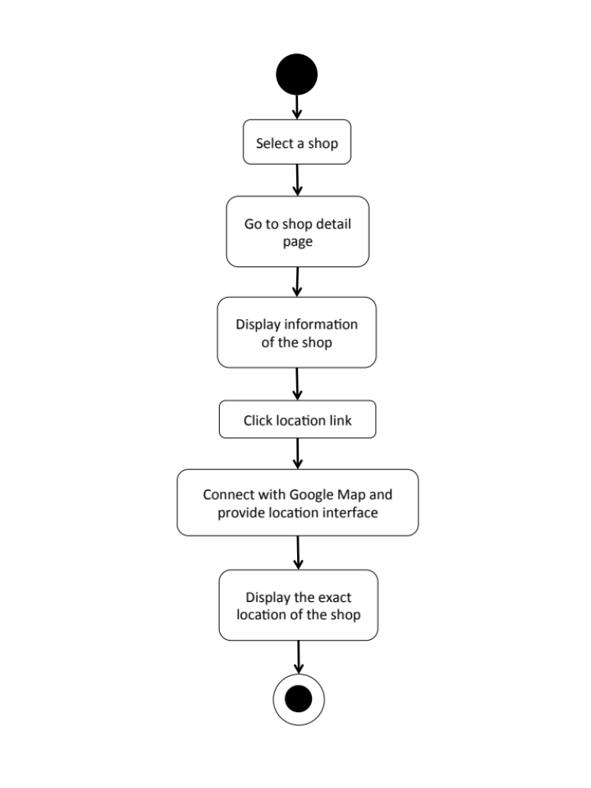

M-URS-29: The user identifies his/her shop’s location on Google Map.
Input and Output
- Input: The user identifies the shop’s location on Google Map.
- Output: The system shows the exact shop’s location on Google Map.

Description
URS ID | M-URS-29
URS Name | The user identifies his/her shop’s location on Google Map.
Actor | Shopkeeper
Description
Trigger | The user selects location link to access to Google Map and identify the exact shop’s location.
Pre-condition | - User creates a shop.  - User edits a shop.
Post-condition | - System shows shop’s location on Google Map.  - System saves shop’s location into database.
Normal flow | 1) User crates a shop.  2) User selects location link.  3) System accesses to Google Map.  4) System shows Google Map user interface.  5) User identifies shop’s location on Google Maps  6) User clicks done  7) System saves the location into database.  8) System goes back to shop creation page.
Alternative flow | -
Exception | In all steps of normal flow, in case there is no internet connection.
Include | M-URS-02

M-AD-29

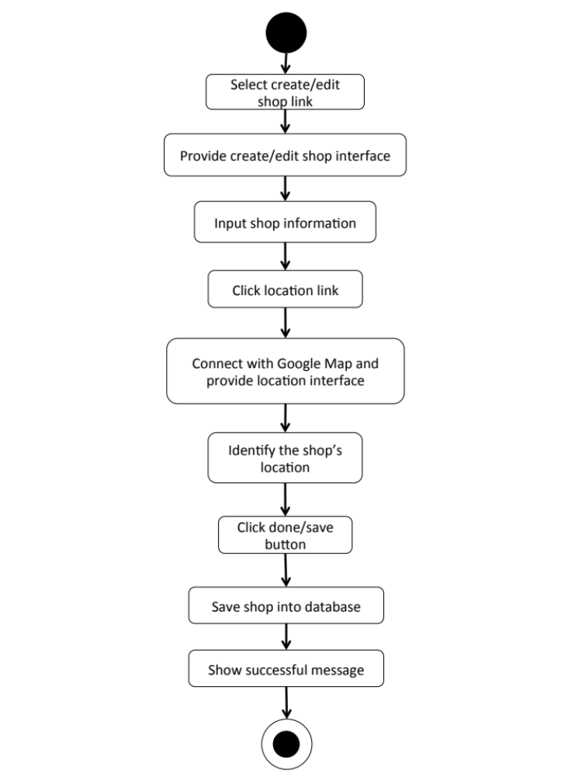

Feature 5: Communication Management
M-URS-30: The user sees comments on tutorial.
Input and Output
- Input: The user selects tutorial link to see tutorial’s detail.
- Output: The system shows information of the tutorial including comments.

Description
URS ID | M-URS-30
URS Name | The user sees comments on tutorial.
Actor | User, Blogger
Description | This function allows user to see comments on each tutorial.
Trigger | -
Pre-condition | - User has logged in to the system.  - User stays on tutorial detail page.
Post-condition | - System displays all comments of the tutorial.
Normal flow | - User selects a tutorial.  - System gets the tutorial’s information from database.  - System displays all information of the tutorial, which are title, owner username, number of likes, category, material picture, material description, step description, step picture, video, and comments.  - System gets comment information, which are profile picture and username of the blogger that commented, and comment detail from database.  - System displays all comments of the tutorial.
Alternative flow | -
Exception | In all steps of normal flow, in case there is no internet connection.
Include | M-URS-14

M-AD-30

M-URS-31: The user adds comments on tutorial.
Input and Output
No | Input Name | Description | Example | Remarks | Output
1 | Comment | The length of Comment must be between 1-500 characters | “Awesome tutorial!” | - | The system shows “Awesome tutorial!” on the screen.

Description
URS ID | M-URS-31
URS Name | The user adds comments on tutorial.
Actor | Blogger
Description | This function allows user to give comments on tutorial.
Trigger | The user selects “Comment” to post comment on tutorial.
Pre-condition | - User has logged in to the system.  - User stays on tutorial detail page.
Post-condition | - System displays the comment on the tutorial detail page.
Normal flow | 1) System provides a comment box.  2) User types a comment within 500 characters.  3) User clicks comment button.  4) System validates the comment format.  5) System saves the comment into database.  6) System displays the comment on the tutorial detail page.
Alternative flow | -
Exception | In all steps of normal flow, in case there is no internet connection.
Include | M-URS-02, M-URS-14

M-AD-31

M-URS-32: The user likes a tutorial.
Input and Output
- Input: The user selects like on tutorial.
- Output: The system shows the liked sign on tutorial.

Description
URS ID | M-URS-32
URS Name | The user likes a tutorial.
Actor | Blogger
Description | This function allows user to give a like on his/her favorite tutorial.
Trigger | The user selects “Like” to like the tutorial.
Pre-condition | - User has logged in to the system.  - User stays on tutorial detail page.  - User stays on explore tutorial page.
Post-condition | - System increase like number of the tutorial.
Normal flow | 1) User clicks like button.  2) System increase like number for the tutorial in database.  3) System shows updated number of likes of the tutorial.
Alternative flow | -
Exception | In all steps of normal flow, in case there is no internet connection.
Include | M-URS-02, M-URS-14

M-AD-32
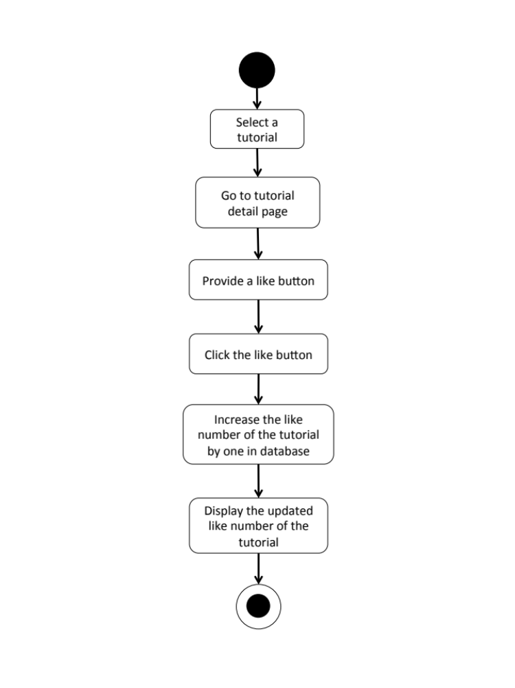

M-URS-33: The user undo likes from the liked tutorial.
Input and Output
- Input: The user selects like on the liked tutorial.
- Output: The system shows the like sign on tutorial.

Description
URS ID | M-URS-33
URS Name | The user undo likes from the liked tutorial.
Actor | Blogger
Description | This function allows user to remove the like that the user gave for a tutorial.
Trigger | The user selects “Liked” to undo like the tutorial.
Pre-condition | - User has logged in to the system.  - User stays on tutorial detail page.  - User stays on explore tutorial page.
Post-condition | - System decrease like number of the tutorial.
Normal flow | 1) User clicks liked button.  2) System decrease like number for the tutorial in database.  3) System shows updated number of likes of the tutorial.
Alternative flow | -
Exception | In all steps of normal flow, in case there is no internet connection.
Include | M-URS-02, M-URS-14, M-URS-32

M-AD-33

M-URS-34: The user follows other bloggers.
Input and Output
- Input: The user select follow on other blogger profile.
- Output: The system shows the following sign on the blogger profile.

Description
URS ID | M-URS-34
URS Name | The user follows other bloggers.
Actor | Blogger
Description | This function allows user to follow other bloggers in order to catch up their new tutorials.
Trigger | The user selects “Follow” to follow the blogger.
Pre-condition | - User has logged in to the system.  - User stays on other blogger’s profile page.
Post-condition | - The system starts getting new information from the following blogger.
Normal flow | - System provides blogger’s profile interface.  - User clicks follow button.  3) System saves the blogger into database.  4) System changes the sign on the button from follow to followed.
Alternative flow | -
Exception | In all steps of normal flow, in case there is no internet connection.
Include | M-URS-02

M-AD-34

M-URS-35: The user undo follows from the followed bloggers.
Input and Output
- Input: The user select unfollow on the followed blogger.
- Output: The system shows the follow sign on unfollowed blogger profile.

Description
URS ID | M-URS-35
URS Name | The user undo follows from the followed bloggers.
Actor | Blogger
Description | This function allows user to undo the follow process from the blogger that he/she is following.
Trigger | The user selects “Followed” to undo follow the blogger.
Pre-condition | - User has logged in to the system.  - User stays on other blogger’s profile page.
Post-condition | - The system stops getting new information from the unfollowed blogger.
Normal flow | - System provides blogger’s profile interface.  2) User clicks followed button.  3) System removes the blogger from database.  4) System changes the sign on the button from followed to follow.
Alternative flow | -
Exception | In all steps of normal flow, in case there is no internet connection.
Include | M-URS-02, M-URS-34

M-AD-35

M-URS-36: The user sees list of bloggers whom the user is following.
Input and Output
- Input: The user select following link on other user’s profile page.
- Output: The system shows list of bloggers whom the user is following.

Description
URS ID | M-URS-36
URS Name | The user sees list of bloggers whom the user is following.
Actor | Blogger
Description | This function allows user to undo the follow process from the blogger that he/she is following.
Trigger | The user selects “Following” to undo follow the blogger.
Pre-condition | - User has logged in to the system.  - User stays on other blogger’s profile page.
Post-condition | - The system stops getting new information from the unfollowed blogger.
Normal flow | 1) User goes to profile page.  - System gets user’s information from database.  - System displays interface and user’s information, which are profile picture, username, password, follower number, following number, and list of tutorials that he/she has created.  - User clicks on see following link.  - System goes to following page.  - System get list of bloggers whom the user is following from database.  - System displays list of bloggers whom the user is following.
Alternative flow | -
Exception | In all steps of normal flow, in case there is no internet connection.
Include | M-URS-34

M-AD-36

M-URS-37: The user sees list of bloggers who follows the user.
Input and Output
- Input: The user select follower link on other user’s profile page.
- Output: The system shows list of bloggers who follows the user.

Description
URS ID | M-URS-37
URS Name | The user sees list of bloggers who follows the user.
Actor | Blogger
Description | This function allows user to undo the follow process from the blogger that he/she is following.
Trigger | The user selects “Following” to undo follow the blogger.
Pre-condition | - User has logged in to the system.  - User stays on other blogger’s profile page.
Post-condition | - The system stops getting new information from the unfollowed blogger.
Normal flow | - User goes to profile page.  - System gets user’s information from database.  - System displays interface and user’s information, which are profile picture, username, password, follower number, following number, and list of tutorials that he/she has created.  - User clicks on see follower link.  - System goes to follower page.  - System get list of bloggers who follows the user from database.  - System displays list of bloggers who follows the user.
Alternative flow
Exception | In all steps of normal flow, in case there is no internet connection.
Include | M-URS-34

M-AD-37

M-URS-38: The user sends private message.
Input and Output
No | Input Name | Description | Example | Remarks | Output
1 | Message | The length of Message must be between 1-500 characters | “Hello, I want to ask you something.” | - | The system shows “Hello, I want to ask you something.” on the screen.

Description
URS ID | M-URS-38
URS Name | The user sends private message.
Actor | Blogger, Shopkeeper
Description | This function allows user to start a private communication with shopkeepers/bloggers via messages.
Trigger | The user selects the conversation link between the user and the shopkeeper/blogger.
Pre-condition | - User has logged in to the system.  - User selects a shop/blogger that he/she wants to send message to.
Post-condition | - System sends message to the shopkeeper/blogger.
Normal flow | 1) User clicks message button.  2) System provides message interface.  3) User types a message in the message box.  4) User clicks send button.  5) System sends the message to shopkeeper of the shop/blogger.  6) System saves the message into database.
Alternative flow | -
Exception | In all steps of normal flow, in case there is no internet connection.
Include | M-URS-02

M-AD-38

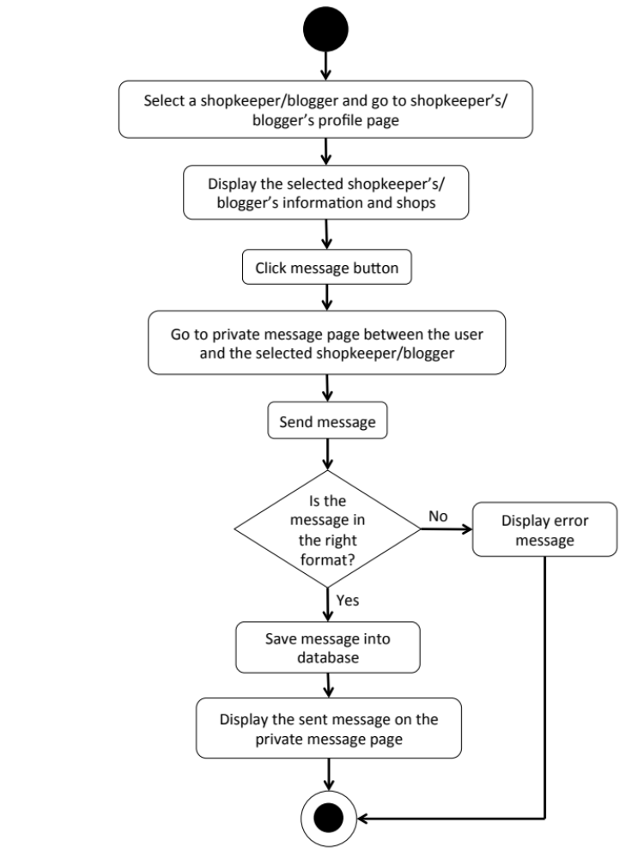

M-URS-39: The user receives private message.
- Input: The user selects message link to see messages.
- Output: The system shows messages that the user gets from a shopkeeper.

Description
URS ID | M-URS-39
URS Name | The user receives private message.
Actor | Blogger, Shopkeeper
Description | This function allows user to receive messages from the people whom the user is talking with.
Trigger | The user selects the conversation link between the user and the shopkeeper/blogger.
Pre-condition | - User has logged in to the system.
Post-condition | - System displays received messages.
Normal flow | 1) User goes to the conversation between the user and the shopkeeper/blogger.  2) System shows messages received from the shopkeeper/blogger.
Alternative flow | -
Exception | In all steps of normal flow, in case there is no internet connection.
Include | M-URS-02

M-AD-39
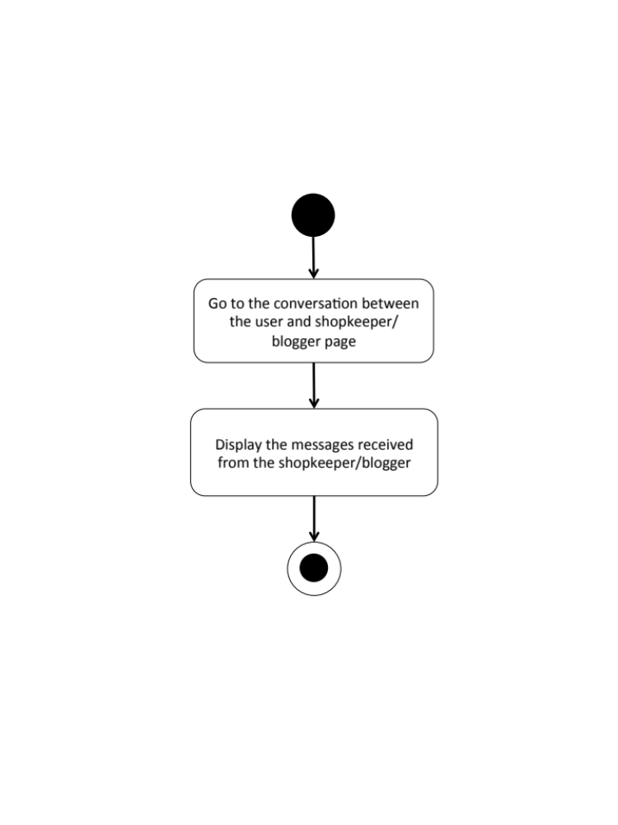

M-URS-40: The user sees list of people that has been communicated with.
- Input: The user selects message link to see messages.
- Output: The system shows list of messages that the user gets.

Description
URS ID | M-URS-40
URS Name | The user sees list of people that has been communicated with.
Actor | Blogger, Shopkeeper
Description | This function allows user to see the list of conversations with people that the user has been communicated with.
Trigger | The user selects “Message” to go to message page.
Pre-condition | - User has logged in to the system.
Post-condition | - System displays list of conversations.
Normal flow | 1) User goes to message page.  2) System provides user interface of message page.  3) System shows list of conversations including the date and time, shop/blogger picture, and shop name/ blogger username.
Alternative flow | -
Exception | In all steps of normal flow, in case there is no internet connection.
Include | M-URS-02, M-URS-38, M-URS-39

M-AD-40
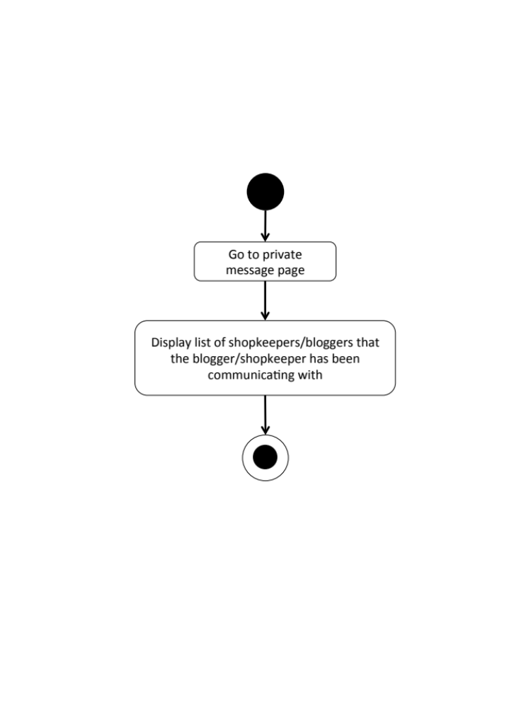

M-URS-41: The user shares tutorial to Facebook.
Input and Output
- Input: The user selects share link to share the tutorial to Facebook.
- Output: The system posts the tutorial on user’s Facebook wall.

Description
URS ID | M-URS-41
URS Name | The user shares tutorial to Facebook.
Actor | User, Blogger, Shopkeeper
Description | This function allows user to share tutorial on his/her Facebook wall.
Trigger | The user selects “Share” to share the tutorial on user’s Facebook wall.
Pre-condition | - User stays on tutorial detail page.
Post-condition | - The tutorial is posted in user’s Facebook wall
Normal flow | - User clicks share to Facebook button.  - System access to the user’s Facebook account from the user’s smart phone.  3) System displays confirmation post of the tutorial.  4) User writes some message about the tutorial.  5) User clicks post button.  6) System posts the tutorial on user’s Facebook wall.
Alternative flow | - In step 3, the user leaves the field blank in case he/she does not want to write anything about the tutorial.  - In step 4, the user clicks cancel button to cancel the tutorial sharing process.
Exception | In all steps of normal flow, in case there is no internet connection.
Include | M-URS-14

M-AD-41

M-URS-42: The user sees bloggers that exist in database by searching.

Input and Output
No | Input Name | Description | Example | Remarks | Output
1 | Keyword | The length of Keyword must be between 1-20 characters | “A” | The word should not contain any symbol. | The system shows bloggers that have the word “A” as a username.

Description
URS ID | M-URS-42
URS Name | The user sees bloggers that exist in database by searching.
Actor | Shopkeeper
Description | This function allows user to see list of bloggers by inputting keyword.
Trigger | The user clicks on the search box.
Pre-condition | - User has logged in to the system.  - User stays on search blogger page.
Post-condition | - System displays list of all bloggers that relate to the keyword or character.
Normal flow | 1) User input a keyword or character in the search box.  2) System gets bloggers information from database.  3) System displays list of all bloggers with bloggers’ pictures and usernames that relate to the keyword.
Alternative flow | -
Exception | In all steps of normal flow, in case there is no internet connection.
Include | M-URS-02

M-URS-43: The user sees list of searched bloggers.

Input and Output
No | Input Name | Description | Example | Remarks | Output
1 | Keyword | The length of Keyword must be between 1-20 characters | “A” | The word should not contain any symbol. | The system shows bloggers that have the word “A” as a username.

Description
URS ID | M-URS-43
URS Name | The user sees list of searched bloggers.
Actor | Shopkeeper
Description | This function allows user to see the list of bloggers that contain the searched keyword or character in their username
Trigger | The user clicks search button
Pre-condition | - User has logged in to the system.  - User stays on search blogger page.
Post-condition | - System displays list of all bloggers that relate to the keyword or character.
Normal flow | 1) User input a keyword or character in the search box.  2) System gets bloggers information from database.  3) System displays list of all bloggers with bloggers’ pictures and usernames that relate to the keyword.
Alternative flow | -
Exception | In all steps of normal flow, in case there is no internet connection.
Include | M-URS-02, M-URS-42

M-AD-42
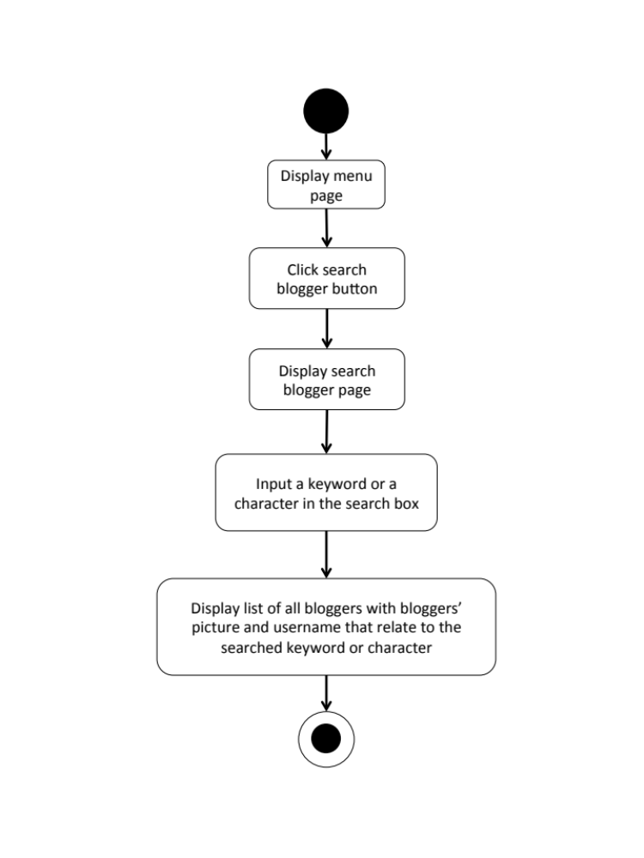

M-URS-44: The user sees blogger’s profile.
Input and Output
- Input: The user selects blogger link to go to the blogger’s profile page.
- Output: The system shows the selected blogger’s profile.

Description
URS ID | M-URS-44
URS Name | The user sees blogger’s profile.
Actor | Shopkeeper
Description | This function allows user to see searched blogger’s profile and information.
Trigger | The user selects a blogger link to go to blogger’s profile page.
Pre-condition | - User has logged in to the system.  - User has searched and seen list of bloggers
Post-condition | - System displays the selected blogger’s profile.
Normal flow | - User goes to blogger’s profile page.  - System gets blogger’s information from database.  - System displays interface and blogger’s information, which are profile picture, username, follower number, following number, and list of tutorials that he/she has created.
Alternative flow | -
Exception | In all steps of normal flow, in case there is no internet connection.
Include | M-URS-02, M-URS-43

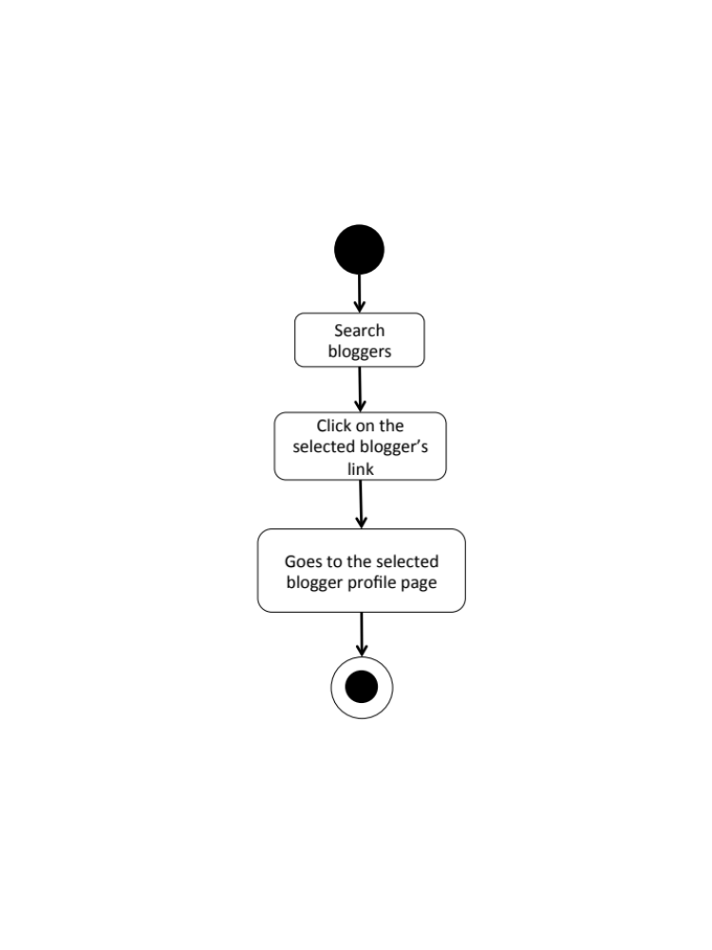
M-AD-43

Chapter Four | System Features

  - Software Requirement Specification
    - Software Requirement Specification for Web Application

W-URS-01: The user registers as a blogger.
SRS No. | SRS Name
W-SRS-01 | The system shall provide graphic user interface, which receive username, password, re-password, and e-mail.
W-SRS-02 | The system shall check the username format. The username must be 1-20 characters and must not contain any symbol.
W-SRS-03 | The system shall check the password format. The password must be 1-20 characters and must not contain any symbol.
W-SRS-04 | The system shall check whether the re-password is match to the password or not.
W-SRS-05 | The system shall check email format. The email must be in email format.
W-SRS-06 | The system shall check in database whether the username is already in use or not.
W-SRS-07 | The system shall show successful message “You are now a blogger, please log in.”
W-SRS-08 | The system shall show error message “The username should be between 1-20 characters.”
W-SRS-09 | The system shall show error message “The username should not contain any symbols”
W-SRS-10 | The system shall show error message “This username is already in use.”
W-SRS-11 | The system shall show error message “The password should be between 1-20 characters.”
W-SRS-12 | The system shall show error message “The password should not contain any symbols.”
W-SRS-13 | The system shall show error message “Re-password is not matching with your password.”
W-SRS-14 | The system shall show error message “The email should be in email format.”
W-SRS-15 | The system shall show error message “Sorry, you are not connected to the internet”
W-SRS-16 | The system shall save information into database.
W-SRS-22 | The system shall show error message “Please fill all information, don’t leave blank.”

W-URS-02: The user logins to the system.
SRS No. | SRS Name
W-SRS-17 | The system shall provide graphic user interface, which receive username and password.
W-SRS-02 | The system shall check the username format. The username must be 1-20 characters and must not contain any symbol.
W-SRS-03 | The system shall check the password format. The password must be 1-20 characters and must not contain any symbol.
W-SRS-18 | The system shall retrieve the username and password
W-SRS-19 | The system shall verify the username and password
W-SRS-20 | The system shall show the home page for blogger.
W-SRS-08 | The system shall show error message “The username should be between 1-20 characters.”
W-SRS-09 | The system shall show error message “The username should not contain any symbols”
W-SRS-10 | The system shall show error message “This username is already in use.”
W-SRS-11 | The system shall show error message “The password should be between 1-20 characters.”
W-SRS-12 | The system shall show error message “The password should not contain any symbols.”
W-SRS-21 | The system shall show error message “Invalid username or password.”
W-SRS-15 | The system shall show error message “Sorry, you are not connected to the internet”
W-SRS-22 | The system shall show error message “Please fill all information, don’t leave blank.”

W-URS-03: The user logouts from the system.
SRS No. | SRS Name
W-SRS-23 | The system shall provide home page interface for blogger, which provides notification symbol, create tutorial symbol, message symbol, profile symbol, log out symbol, random button, popular button, following button, categories tab, search box, and list of tutorials with tutorial picture, title, owner username, and number of likes.
W-SRS-24 | The system shall show the home page for visitor.
W-SRS-15 | The system shall show error message “Sorry, you are not connected to the internet”

W-URS-04: The user sees his/her profile.
SRS No. | SRS Name
W-SRS-23 | The system shall provide home page interface for blogger, which provides notification symbol, create tutorial symbol, message symbol, profile symbol, log out symbol, random button, popular button, following button, categories tab, search box, and list of tutorials with tutorial picture, title, owner username, and number of likes.
W-SRS-25 | The system shall provide profile page interface, which shows the blogger’s username, email, following, follower, profile picture, created tutorials with tutorial picture, title, number of likes, and edit button.
W-SRS-15 | The system shall show error message “Sorry, you are not connected to the internet”

W-URS-05: The user edits his/her profile.
SRS No. | SRS Name
W-SRS-26 | The system shall provide edit profile page interface, which provides editable fields for username, email, profile picture, change password, and delete account button.
W-SRS-16 | The system shall save information into database.
W-SRS-15 | The system shall show error message “Sorry, you are not connected to the internet”
W-SRS-22 | The system shall show error message “Please fill all information, don’t leave blank.”

W-URS-06: The user adds profile picture.
SRS No. | SRS Name
W-SRS-26 | The system shall provide edit profile page interface, which provides editable fields for username, email, profile picture, change password, and delete account button.
W-SRS-27 | The system shall check the picture format. The picture must be in .png or .jpg file.
W-SRS-28 | The system shall show the name of selected picture file.
W-SRS-16 | The system shall save information into database.
W-SRS-15 | The system shall show error message “Sorry, you are not connected to the internet”
W-SRS-29 | The system shall show error message “The picture must be .png/.jpg file.”

W-URS-07: The user changes profile picture.
SRS No. | SRS Name
W-SRS-26 | The system shall provide edit profile page interface, which provides editable fields for username, email, profile picture, change password, and delete account button.
W-SRS-27 | The system shall check the picture format. The picture must be in .png or .jpg file.
W-SRS-28 | The system shall show the name of selected picture file.
W-SRS-16 | The system shall save information into database.
W-SRS-29 | The system shall show error message “The picture must be .png/.jpg file.”
W-SRS-15 | The system shall show error message “Sorry, you are not connected to the internet”

W-URS-08: The user changes his/her password.
SRS No. | SRS Name
W-SRS-26 | The system shall provide edit profile page interface, which provides editable fields for username, email, profile picture, change password, and delete account button.
W-SRS-30 | The system shall provide graphic user interface, which receive current password, new password, and re-new password.
W-SRS-31 | The system shall check whether current password is match with the password in database or not.
W-SRS-16 | The system shall save information into database.
W-SRS-15 | The system shall show error message “Sorry, you are not connected to the internet”
W-SRS-32 | The system shall show error message “Your current password is wrong, please try again.”
W-SRS-11 | The system shall show error message “The password should be between 1-20 characters.”
W-SRS-12 | The system shall show error message “The password should not contain any symbols.”
W-SRS-33 | The system shall show error message “Re-new password is not matching with your new password.”
W-SRS-22 | The system shall show error message “Please fill all information, don’t leave blank.”

W-URS-09: The user deletes his/her account.
SRS No. | SRS Name
W-SRS-26 | The system shall provide edit profile page interface, which provides editable fields for username, email, profile picture, change password, and delete account button.
W-SRS-34 | The system shall show confirmation message “Are you sure to delete your account?”
W-SRS-35 | The system shall provide graphic user interface, which provides yes and no buttons.
W-SRS-36 | The system shall remove blogger’s information from database.
W-SRS-15 | The system shall show error message “Sorry, you are not connected to the internet”

W-URS-10: The user sees tutorials by random.
SRS No. | SRS Name
W-SRS-23 | The system shall provide home page interface for blogger, which provides notification symbol, create tutorial symbol, message symbol, profile symbol, log out symbol, random button, popular button, following button, categories tab, search box, and list of tutorials with tutorial picture, title, owner username, and number of likes.
W-SRS-37 | The system shall get tutorials from database.
W-SRS-38 | The system shall provide graphic user interface, which provides list of random tutorials.
W-SRS-15 | The system shall show error message “Sorry, you are not connected to the internet”

W-URS-11: The user sees tutorials by popular.
SRS No. | SRS Name
W-SRS-23 | The system shall provide home page interface for blogger, which provides notification symbol, create tutorial symbol, message symbol, profile symbol, log out symbol, random button, popular button, following button, categories tab, search box, and list of tutorials with tutorial picture, title, owner username, and number of likes.
W-SRS-37 | The system shall get tutorials from database.
W-SRS-39 | The system provides graphic user interface, which provides list of most liked tutorials.
W-SRS-15 | The system shall show error message “Sorry, you are not connected to the internet”

W-URS-12: The user sees tutorials by categories.
SRS No. | SRS Name
W-SRS-23 | The system shall provide home page interface for blogger, which provides notification symbol, create tutorial symbol, message symbol, profile symbol, log out symbol, random button, popular button, following button, categories tab, search box, and list of tutorials with tutorial picture, title, owner username, and number of likes.
W-SRS-40 | The system shall show the list of tutorial categories, which are outfit, accessory, gift, kid, garden, home décor, pet, and other.
W-SRS-37 | The system shall get tutorials from database.
W-SRS-41 | The system shall provide graphic user interface, which provides list of tutorials with tutorial picture, title, and number of likes according to each category.
W-SRS-15 | The system shall show error message “Sorry, you are not connected to the internet”

W-URS-13: The user sees tutorials by searching.
SRS No. | SRS Name
W-SRS-23 | The system shall provide home page interface for blogger, which provides notification symbol, create tutorial symbol, message symbol, profile symbol, log out symbol, random button, popular button, following button, categories tab, search box, and list of tutorials with tutorial picture, title, owner username, and number of likes.
W-SRS-42 | The system shall receive keyword and match with the tutorials in database.
W-SRS-37 | The system shall get tutorials from database.
W-SRS-43 | The system shall provide graphic user interface, which provides list of tutorials that match with the keyword.
W-SRS-44 | The system shall show error message “No result”
W-SRS-15 | The system shall show error message “Sorry, you are not connected to the internet”

W-URS-14: The user sees tutorials by following.
SRS No. | SRS Name
W-SRS-23 | The system shall provide home page interface for blogger, which provides notification symbol, create tutorial symbol, message symbol, profile symbol, log out symbol, random button, popular button, following button, categories tab, search box, and list of tutorials with tutorial picture, title, owner username, and number of likes.
W-SRS-37 | The system shall get tutorials from database.
W-SRS-45 | The system shall provide graphic user interface, which provides list of following people’s tutorials.
W-SRS-46 | The system shall show error message “You have not followed anyone yet.”
W-SRS-15 | The system shall show error message “Sorry, you are not connected to the internet”

W-URS-15: The user sees tutorial information.
SRS No. | SRS Name
W-SRS-47 | The system shall provide graphic user interface, which shows title, owner username, number of likes, material picture, material description, picture and description of each step, video, and comments.
W-SRS-48 | The system shall get tutorial’s information from database.
W-SRS-15 | The system shall show error message “Sorry, you are not connected to the internet”

W-URS-16: The user creates his/her own tutorial.
SRS No. | SRS Name
W-SRS-49 | The system shall provide graphic user interface, which receives tutorial picture, title, category, material picture, material description, number of step, picture and description of each step, video and video description.
W-SRS-50 | The system can check the tutorial picture format. The tutorial picture must be in .png or .jpg file.
W-SRS-51 | The system shall check the title format. The title must be 1-20 characters.
W-SRS-40 | The system shall show the list of tutorial categories, which are outfit, accessory, gift, kid, garden, home décor, pet, and other.
W-SRS-52 | The system shall check the material picture format. The material picture must be in .png or .jpg file.
W-SRS-53 | The system can check the material description format. The material description must be 1-500 characters.
W-SRS-54 | The system shall check the number of step format. The number of step must be 1-6.
W-SRS-55 | The system shall check the step picture format. The step picture must be in .png or .jpg file.
W-SRS-56 | The system shall check the step description format. The step description must be 1-500 characters.
W-SRS-57 | The system shall check the video format. The video must be in .mov file.
W-SRS-16 | The system shall save information into database.
W-SRS-15 | The system shall show error message “Sorry, you are not connected to the internet”
W-SRS-29 | The system shall show error message “The picture must be .png/.jpg file.”
W-SRS-58 | The system shall show error message “The title should be between 1-20 characters.”
W-SRS-59 | The system shall show error message “Please select a category”
W-SRS-60 | The system shall show error message “The description should be between 1-500 characters.”
W-SRS-61 | The system shall show error message “Please input number of step.”
W-SRS-62 | The system shall show error message “The step number should be between 1-6.”
W-SRS-63 | The system shall show error message “The video must be .mov file.”
W-SRS-22 | The system shall show error message “Please fill all information, don’t leave blank.”

W-URS-17: The user sees his/her own tutorial.
SRS No. | SRS Name
W-SRS-24 | The system shall provide graphic user interface, which shows the blogger’s username, email, following, follower, profile picture, and created tutorials.
W-SRS-39 | The system shall get tutorials from database.
W-SRS-47 | The system shall provide graphic user interface, which shows title, owner username, number of likes, material picture, material description, picture and description of each step, video, and comments.
W-SRS-48 | The system shall get tutorial’s information from database.
W-SRS-15 | The system shall show error message “Sorry, you are not connected to the internet”

W-URS-18: The user edits his/her own tutorial.
SRS No. | SRS Name
W-SRS-64 | The system shall provide edit tutorial interface, which provides editable fields of tutorial picture, title, material picture, material description, picture and description of each step, video, and delete tutorial button.
W-SRS-50 | The system shall check the tutorial picture format. The tutorial picture must be in .png or .jpg file.
W-SRS-51 | The system shall check the title format. The title must be 1-20 characters.
W-SRS-40 | The system shall show the list of tutorial categories, which are outfit, accessory, gift, kid, garden, home décor, pet, and other.
W-SRS-52 | The system shall check the material picture format. The material picture must be in .png or .jpg file.
W-SRS-53 | The system shall check the material description format. The material description must be 1-500 characters.
W-SRS-54 | The system shall check the number of step format. The number of step must be 1-6.
W-SRS-55 | The system shall check the step picture format. The step picture must be in .png or .jpg file.
W-SRS-56 | The system shall check the step description format. The step description must be 1-500 characters.
W-SRS-57 | The system shall check the video format. The video must be in .mov file.
W-SRS-16 | The system shall save information into database.
W-SRS-15 | The system shall show error message “Sorry, you are not connected to the internet”
W-SRS-29 | The system shall show error message “The picture must be .png/.jpg file.”
W-SRS-58 | The system shall show error message “The title should be between 1-20 characters.”
W-SRS-59 | The system shall show error message “Please select a category”
W-SRS-60 | The system shall show error message “The description should be between 1-500 characters.”
W-SRS-61 | The system shall show error message “Please input number of step.”
W-SRS-62 | The system shall show error message “The step number should be between 1-6.”
W-SRS-63 | The system shall show error message “The video must be .mov file.”
W-SRS-65 | The system shall show successful message “Your tutorial has been saved.”
W-SRS-22 | The system shall show error message “Please fill all information, don’t leave blank.”

W-URS-19: The user deletes his/her own tutorial.
SRS No. | SRS Name
W-SRS-64 | The system shall provide edit tutorial interface, which provides editable fields of tutorial picture, title, material picture, material description, picture and description of each step, video, and delete tutorial button.
W-SRS-66 | The system shall show confirmation message “Are you sure to delete your tutorial?”
W-SRS-35 | The system shall provide graphic user interface, which provides yes and no buttons.
W-SRS-67 | The system shall remove blogger’s tutorial from database.
W-SRS-15 | The system shall show error message “Sorry, you are not connected to the internet”
W-SRS-68 | The system shall show successful message “Your tutorial has been deleted.”

W-URS-20: The user sees comments on tutorial.
SRS No. | SRS Name
W-SRS-15 | The system shall show error message “Sorry, you are not connected to the internet”
W-SRS-47 | The system shall provide graphic user interface, which shows title, owner username, number of likes, material picture, material description, picture and description of each step, video, and comments.
W-SRS-48 | The system shall get tutorial’s information from database.

W-URS-21: The user adds comment on tutorial.
SRS No. | SRS Name
W-SRS-15 | The system shall show error message “Sorry, you are not connected to the internet”
W-SRS-47 | The system shall provide graphic user interface, which shows title, owner username, number of likes, material picture, material description, picture and description of each step, video, and comments.
W-SRS-48 | The system shall get tutorial’s information from database.
W-SRS-69 | The system shall provide a comment box to receive new comment from the user.
W-SRS-70 | The system shall check the comment format. The comment must be 1-500 characters.
W-SRS-71 | The system shall show error message “The comment should be between 1-500 characters.”
W-SRS-72 | The system shall provide a comment button to let the user submit the comment.
W-SRS-16 | The system shall save information into database.
W-SRS-73 | The system shall display the added comment as a part of the tutorial’s comment.

W-URS-22: The user likes a tutorial.
SRS No. | SRS Name
W-SRS-15 | The system shall show error message “Sorry, you are not connected to the internet”
W-SRS-47 | The system shall provide graphic user interface, which shows title, owner username, number of likes, material picture, material description, picture and description of each step, video, and comments.
W-SRS-48 | The system shall get tutorial’s information from database.
W-SRS-74 | The system shall provide a like button to let the user like the tutorial.
W-SRS-16 | The system shall save information into database.
W-SRS-75 | The system shall change the like button into a liked button.

W-URS-23: The user undo likes from the liked tutorial.
SRS No. | SRS Name
W-SRS-15 | The system shall show error message “Sorry, you are not connected to the internet”
W-SRS-47 | The system shall provide graphic user interface, which shows title, owner username, number of likes, material picture, material description, picture and description of each step, video, and comments.
W-SRS-48 | The system shall get tutorial’s information from database.
W-SRS-76 | The system shall provide a liked button to let the user undo liking from the tutorial.
W-SRS-16 | The system shall save information into database.
W-SRS-77 | The system shall change the liked button into a like button.

W-URS-24: The user follows other bloggers.
SRS No. | SRS Name
W-SRS-15 | The system shall show error message “Sorry, you are not connected to the internet”
W-SRS-78 | The system shall provide blogger’s profile page interface, which shows the blogger’s username, email, following number, follower number, profile picture, created tutorials with tutorial picture, title, number of likes, and follow button.
W-SRS-16 | The system shall save information into database.
W-SRS-79 | The system shall change the follow button into a followed button.

W-URS-25: The user undo follows from the followed bloggers.
SRS No. | SRS Name
W-SRS-15 | The system shall show error message “Sorry, you are not connected to the internet”
W-SRS-80 | The system shall provide blogger’s profile page interface, which shows the blogger’s username, email, following number, follower number, profile picture, created tutorials with tutorial picture, title, number of likes, and followed button.
W-SRS-16 | The system shall save information into database.
W-SRS-81 | The system shall change the followed button into a follow button.

W-URS-26: The user sees list of bloggers whom the user is following.
SRS No. | SRS Name
W-SRS-15 | The system shall show error message “Sorry, you are not connected to the internet”
W-SRS-25 | The system shall provide profile page interface, which shows the blogger’s username, email, following, follower, profile picture, created tutorials with tutorial picture, title, number of likes, and edit button.
W-SRS-82 | The system shall show list of bloggers, which consists of bloggers’ profile picture and username, who the user is following.

W-URS-27: The user sees list of bloggers who follows the user.
SRS No. | SRS Name
W-SRS-15 | The system shall show error message “Sorry, you are not connected to the internet”
W-SRS-25 | The system shall provide profile page interface, which shows the blogger’s username, email, following, follower, profile picture, created tutorials with tutorial picture, title, number of likes, and edit button.
W-SRS-83 | The system shall show list of bloggers, which consists of bloggers’ profile picture and username, who has followed the user.

W-URS-28: The user sends private message.
SRS No. | SRS Name
W-SRS-15 | The system shall show error message “Sorry, you are not connected to the internet”
W-SRS-23 | The system shall provide home page interface for blogger, which provides notification symbol, create tutorial symbol, message symbol, profile symbol, log out symbol, random button, popular button, following button, categories tab, search box, and list of tutorials with tutorial picture, title, owner username, and number of likes.
W-SRS-84 | The system shall provide shopkeeper’s profile page interface, which shows the shopkeeper’s username, email, profile picture, created shops with shop picture and shop name, and message button.
W-SRS-85 | The system shall provide message page interface between the user and shopkeeper, which shows the shopkeeper’s username and profile picture, message box to let the user input message, and send message button.
W-SRS-86 | The system shall check the message format. The message must be 1-500 characters.
W-SRS-87 | The system shall show error message “The message should be between 1-500 characters.”
W-SRS-16 | The system shall save information into database.
W-SRS-88 | The system shall display the sent message on the message page.

W-URS-29: The user receives private message.
SRS No. | SRS Name
W-SRS-15 | The system shall show error message “Sorry, you are not connected to the internet”
W-SRS-23 | The system shall provide home page interface for blogger, which provides notification symbol, create tutorial symbol, message symbol, profile symbol, log out symbol, random button, popular button, following button, categories tab, search box, and list of tutorials with tutorial picture, title, owner username, and number of likes.
W-SRS-85 | The system shall provide message page interface between the user and shopkeeper, which shows the shopkeeper’s username and profile picture, message box to let the user input message, and send message button.
W-SRS-16 | The system shall save information into database.
W-SRS-89 | The system shall display the received message on the message page.

W-URS-30: The user sees list of shopkeepers that has been communicate with.
SRS No. | SRS Name
W-SRS-15 | The system shall show error message “Sorry, you are not connected to the internet”
W-SRS-23 | The system shall provide home page interface for blogger, which provides notification symbol, create tutorial symbol, message symbol, profile symbol, log out symbol, random button, popular button, following button, categories tab, search box, and list of tutorials with tutorial picture, title, owner username, and number of likes.
W-SRS-90 | The system shall show list of shopkeepers, which consists of shopkeepers’ profile picture and username, who has been communicating with via private messages.

W-URS-31: The user shares tutorial to Facebook.
SRS No. | SRS Name
W-SRS-15 | The system shall show error message “Sorry, you are not connected to the internet”
W-SRS-47 | The system shall provide graphic user interface, which shows title, owner username, number of likes, material picture, material description, picture and description of each step, video, and comments.
W-SRS-91 | The system shall provide a Facebook share button to let the user share the tutorial on his/her Facebook wall.
W-SRS-92 | The system shall access to the user’s Facebook account from web browser.
W-SRS-93 | The system shall display the confirmation box in order to let the user write something about the tutorial and confirm the Facebook posting process.
W-SRS-94 | The system shall post the tutorial on the user’s Facebook wall.

    - Software Requirement Specification for Mobile Application
M-URS-01: The user registers as a blogger.
SRS No. | SRS Name
M-SRS-01 | The system shall provide register page interface, which receives username, password, re-password, e-mail and profile picture.
M-SRS-02 | The system shall check the username format. The username must be 1-20 characters and must not contain any symbol.
M-SRS-03 | The system shall check the password format. The password must be 1-20 characters and must not contain any symbol.
M-SRS-04 | The system shall check whether the re-password is match to the password or not.
M-SRS-05 | The system shall check email format. The email must be in email format.
M-SRS-06 | The system shall check in database whether the username is already in use or not.
M-SRS-07 | The system shall check the picture format. The picture must be in .png or .jpg file.
M-SRS-08 | The system shall show the name of selected picture file.
M-SRS-09 | The system shall show successful message “You are now a blogger, please log in.”
M-SRS-10 | The system shall show successful message “You are now a shopkeeper, please log in.”
M-SRS-11 | The system shall show error message “The username should be between 1-20 characters.”
M-SRS-12 | The system shall show error message “The username should not contain any symbols”
M-SRS-13 | The system shall show error message “This username is already in use.”
M-SRS-14 | The system shall show error message “The password should be between 1-20 characters.”
M-SRS-15 | The system shall show error message “The password should not contain any symbols.”
M-SRS-16 | The system shall show error message “Re-password is not matching with your password.”
M-SRS-17 | The system shall show error message “The email should be in email format.”
M-SRS-18 | The system shall show error message “The picture must be .png/.jpg file.”
M-SRS-19 | The system shall show error message “Sorry, you are not connected to the internet”
M-SRS-20 | The system shall save information into database.
M-SRS-21 | The system shall show error message “Please fill all information, don’t leave blank.”

M-URS-02: The user logins to the system.
SRS No. | SRS Name
M-SRS-22 | The system shall provide graphic user interface, which receive username and password.
M-SRS-02 | The system shall check the username format. The username must be 1-20 characters and must not contain any symbol.
M-SRS-03 | The system shall check the password format. The password must be 1-20 characters and must not contain any symbol.
M-SRS-23 | The system shall retrieve the username and password
M-SRS-24 | The system shall verify the username and password
M-SRS-25 | The system shall show the home page for blogger.
M-SRS-11 | The system shall show error message “The username should be between 1-20 characters.”
M-SRS-12 | The system shall show error message “The username should not contain any symbols”
M-SRS-13 | The system shall show error message “This username is already in use.”
M-SRS-14 | The system shall show error message “The password should be between 1-20 characters.”
M-SRS-15 | The system shall show error message “The password should not contain any symbols.”
M-SRS-26 | The system shall show error message “Invalid username or password.”
M-SRS-19 | The system shall show error message “Sorry, you are not connected to the internet”
M-SRS-21 | The system shall show error message “Please fill all information, don’t leave blank.”

M-URS-03: The user logouts from the system.
SRS No. | SRS Name
M-SRS-27 | The system shall provide menu page interface, which provides categories, shops, around me, and log out button.
M-SRS-28 | The system shall show the home page for visitor.
M-SRS-19 | The system shall show error message “Sorry, you are not connected to the internet”

M-URS-04: The user sees his/her profile.
SRS No. | SRS Name
M-SRS-29 | The system shall provide profile page interface, which shows the blogger’s username, email, following, follower, profile picture, and created tutorials with tutorial picture, title, and number of likes, or created shops with shop picture and shop name, and edit button.
M-SRS-19 | The system shall show error message “Sorry, you are not connected to the internet”

M-URS-05: The user edits his/her profile.
SRS No. | SRS Name
M-SRS-30 | The system shall provide edit profile page interface, which provides editable fields for email, profile picture, change password, and delete account button.
M-SRS-20 | The system saves information into database.
M-SRS-19 | The system shall show error message “Sorry, you are not connected to the internet”
M-SRS-21 | The system shall show error message “Please fill all information, don’t leave blank.”

M-URS-06: The user changes profile picture.
SRS No. | SRS Name
M-SRS-30 | The system shall provide edit profile page interface, which provides editable fields for email, profile picture, change password, and delete account button.
M-SRS-31 | The system shall check the picture format. The picture must be in .png or .jpg file.
M-SRS-32 | The system shall show the name of selected picture file.
M-SRS-20 | The system shall save information into database.
M-SRS-33 | The system shall show error message “The picture must be .png/.jpg file.”
M-SRS-19 | The system shall show error message “Sorry, you are not connected to the internet”

M-URS-07: The user changes his/her password.
SRS No. | SRS Name
M-SRS-30 | The system shall provide edit profile page interface, which provides editable fields for email, profile picture, change password, and delete account button.
M-SRS-34 | The system shall provide graphic user interface, which receive current password, new password, and re-new password.
M-SRS-35 | The system shall check whether current password is match with the password in database or not.
M-SRS-20 | The system shall save information into database.
M-SRS-19 | The system shall show error message “Sorry, you are not connected to the internet”
M-SRS-36 | The system shall show error message “Your current password is wrong, please try again.”
M-SRS-14 | The system shall show error message “The password should be between 1-20 characters.”
M-SRS-15 | The system shall show error message “The password should not contain any symbols.”
M-SRS-37 | The system shall show error message “Re-new password is not matching with your new password.”
M-SRS-21 | The system shall show error message “Please fill all information, don’t leave blank.”

M-URS-08: The user deletes his/her account.
SRS No. | SRS Name
M-SRS-30 | The system shall provide edit profile page interface, which provides editable fields for email, profile picture, change password, and delete account button.
M-SRS-38 | The system shall show confirmation message “Are you sure to delete your account?”
M-SRS-39 | The system shall provide graphic user interface, which provides yes and no buttons.
M-SRS-40 | The system shall remove blogger’s information from database.
M-SRS-19 | The system shall show error message “Sorry, you are not connected to the internet”

M-URS-09: The user sees tutorials by random.
SRS No. | SRS Name
M-SRS-41 | The system shall provide home page interface, which provides random, popular, following tabs, search box, list of tutorials with tutorial picture, title, owner username, and number of likes.
M-SRS-42 | The system shall get tutorials from database.
M-SRS-43 | The system shall provide graphic user interface, which provides list of random tutorials.
M-SRS-19 | The system shall show error message “Sorry, you are not connected to the internet”

M-URS-10: The user sees tutorials by popular.
SRS No. | SRS Name
M-SRS-41 | The system shall provide home page interface, which provides random, popular, following tabs, search box, list of tutorials with tutorial picture, title, owner username, and number of likes.
M-SRS-42 | The system shall get tutorials from database.
M-SRS-44 | The system shall provide graphic user interface, which provides list of most liked tutorials.
M-SRS-19 | The system shall show error message “Sorry, you are not connected to the internet”

M-URS-11: The user sees tutorials by categories.
SRS No. | SRS Name
M-SRS-26 | The system shall provide menu page interface, which provides categories, shops, around me, and log out button.
M-SRS-45 | The system shall show the list of tutorial categories, which are outfit, accessory, gift, kid, garden, home décor, pet, and other.
M-SRS-42 | The system shall get tutorials from database.
M-SRS-46 | The system shall provide graphic user interface, which provides list of tutorials with tutorial picture, title, and number of likes according to each category.
M-SRS-19 | The system shall show error message “Sorry, you are not connected to the internet”

M-URS-12: The user sees tutorials by searching.
SRS No. | SRS Name
M-SRS-41 | The system shall provide home page interface, which provides random, popular, following tabs, search box, list of tutorials with tutorial picture, title, owner username, and number of likes.
M-SRS-47 | The system shall receive keyword and match with the tutorials in database.
M-SRS-42 | The system shall get tutorials from database.
M-SRS-48 | The system shall provide graphic user interface, which provides list of tutorials that match with the keyword.
M-SRS-49 | The system shall show error message “No result”
M-SRS-19 | The system shall show error message “Sorry, you are not connected to the internet”

M-URS-13: The user sees tutorials by following.
SRS No. | SRS Name
M-SRS-41 | The system shall provide home page interface, which provides random, popular, following tabs, search box, list of tutorials with tutorial picture, title, owner username, and number of likes.
M-SRS-42 | The system shall get tutorials from database.
M-SRS-50 | The system shall provide graphic user interface, which provides list of following people’s tutorials.
M-SRS-51 | The system shall show error message “You have not followed anyone yet.”
M-SRS-19 | The system shall show error message “Sorry, you are not connected to the internet”

M-URS-14: The user sees tutorial information.
SRS No. | SRS Name
M-SRS-52 | The system shall provide graphic user interface, which shows title, owner’s username, number of likes, material picture, material description, picture and description of each step, video, and comments.
M-SRS-53 | The system shall get tutorial’s information from database.
M-SRS-19 | The system shall show error message “Sorry, you are not connected to the internet”

M-URS-15: The user creates his/her own tutorial.
SRS No. | SRS Name
M-SRS-54 | The system shall provide graphic user interface, which receives tutorial picture, title, category, material picture, material description, number of step, picture and description of each step, video and video description.
M-SRS-55 | The system shall check the tutorial picture format. The tutorial picture must be in .png or .jpg file.
M-SRS-56 | The system shall check the title format. The title must be 1-20 characters.
M-SRS-45 | The system shall show the list of tutorial categories, which are outfit, accessory, gift, kid, garden, home décor, pet, and other.
M-SRS-57 | The system shall check the material picture format. The material picture must be in .png or .jpg file.
M-SRS-58 | The system shall check the material description format. The material description must be 1-500 characters.
M-SRS-59 | The system shall check the number of step format. The number of step must be 1-6.
M-SRS-60 | The system shall check the step picture format. The step picture must be in .png or .jpg file.
M-SRS-61 | The system shall check the step description format. The step description must be 1-500 characters.
M-SRS-62 | The system shall check the video format. The video must be in .mov file.
M-SRS-20 | The system shall save information into database.
M-SRS-19 | The system shall show error message “Sorry, you are not connected to the internet”
M-SRS-63 | The system shall show error message “The picture must be .png/.jpg file.”
M-SRS-64 | The system shall show error message “The title should be between 1-20 characters.”
M-SRS-65 | The system shall show error message “Please select a category”
M-SRS-66 | The system shall show error message “The description should be between 1-500 characters.”
M-SRS-67 | The system shall show error message “Please input number of step.”
M-SRS-68 | The system shall show error message “The step number should be between 1-6.”
M-SRS-69 | The system shall show error message “The video must be .mov file.”
M-SRS-21 | The system shall show error message “Please fill all information, don’t leave blank.”

M-URS-16: The user sees his/her own tutorial.
SRS No. | SRS Name
M-SRS-29 | The system shall provide profile page interface, which shows the blogger’s username, email, following, follower, profile picture, and created tutorials with tutorial picture, title, and number of likes, or created shops with shop picture and shop name, and edit button.
M-SRS-42 | The system shall get tutorials from database.
M-SRS-70 | The system shall provide graphic user interface, which shows title, owner’s username, number of likes, material picture, material description, picture and description of each step, video, comments, and edit button.
M-SRS-53 | The system shall get tutorial’s information from database.
M-SRS-19 | The system shall show error message “Sorry, you are not connected to the internet”

M-URS-17: The user edits his/her own tutorial.
SRS No. | SRS Name
M-SRS-71 | The system shall provide edit tutorial interface, which provides editable fields of tutorial picture, title, material picture, material description, picture and description of each step, video, and delete tutorial button.
M-SRS-72 | The system shall provide graphic user interface, which provide editable fields for tutorial picture, title, category, material picture, material description, number of step, picture and description of each step, video and video description.
M-SRS-55 | The system shall check the tutorial picture format. The tutorial picture must be in .png or .jpg file.
M-SRS-56 | The system shall check the title format. The title must be 1-20 characters.
M-SRS-45 | The system shall show the list of tutorial categories, which are outfit, accessory, gift, kid, garden, home décor, pet, and other.
M-SRS-57 | The system shall check the material picture format. The material picture must be in .png or .jpg file.
M-SRS-58 | The system shall check the material description format. The material description must be 1-500 characters.
M-SRS-59 | The system shall check the number of step format. The number of step must be 1-6.
M-SRS-60 | The system shall check the step picture format. The step picture must be in .png or .jpg file.
M-SRS-61 | The system shall check the step description format. The step description must be 1-500 characters.
M-SRS-62 | The system shall check the video format. The video must be in .mov file.
M-SRS-20 | The system shall save information into database.
M-SRS-19 | The system shall show error message “Sorry, you are not connected to the internet”
M-SRS-63 | The system shall show error message “The picture must be .png/.jpg file.”
M-SRS-64 | The system shall show error message “The title should be between 1-20 characters.”
M-SRS-65 | The system shall show error message “Please select a category”
M-SRS-66 | The system shall show error message “The description should be between 1-500 characters.”
M-SRS-67 | The system shall show error message “Please input number of step.”
M-SRS-68 | The system shall show error message “The step number should be between 1-6.”
M-SRS-69 | The system shall show error message “The video must be .mov file.”
M-SRS-73 | The system shall show successful message “Your tutorial has been saved.”
M-SRS-21 | The system shall show error message “Please fill all information, don’t leave blank.”

M-URS-18: The user deletes his/her own tutorial.
SRS No. | SRS Name
M-SRS-71 | The system shall provide edit tutorial interface, which provides editable fields of tutorial picture, title, material picture, material description, picture and description of each step, video, and delete tutorial button.
M-SRS-74 | The system shall show confirmation message “Are you sure to delete your tutorial?”
M-SRS-39 | The system shall provide graphic user interface, which provides yes and no buttons.
M-SRS-75 | The system shall remove blogger’s tutorial from database.
M-SRS-19 | The system shall show error message “Sorry, you are not connected to the internet”
M-SRS-76 | The system shall show successful message “Your tutorial has been deleted.”

M-URS-19: The user randomly sees list of shops that exist in database.
SRS No. | SRS Name
M-SRS-19 | The system shall show error message “Sorry, you are not connected to the internet”
M-SRS-77 | The system shall provide shop page interface, which provides search box, categories button, and list of shops with shop picture and shop name.
M-SRS-78 | The system shall get shops from database.
M-SRS-79 | The system shall provide graphic user interface, which provides list of random shops.

M-URS-20: The user sees shops that exist in database by choosing a category.
SRS No. | SRS Name
M-SRS-19 | The system shall show error message “Sorry, you are not connected to the internet”
M-SRS-80 | The system shall show the list of shop categories, which are fabric, accessory, wood, stationary, container, and other.
M-SRS-78 | The system shall get shops from database.
M-SRS-81 | The system shall provide graphic user interface, which provides list of shops with shop picture and shop name according to each category.

M-URS-21: The user search shops’ name that exist in database by inputting a keyword.
SRS No. | SRS Name
M-SRS-19 | The system shall show error message “Sorry, you are not connected to the internet”
M-SRS-77 | The system shall provide shop page interface, which provides search box, categories button, and list of shops with shop picture and shop name.
M-SRS-82 | The system shall receive keyword and match with the tutorials in database.
M-SRS-78 | The system shall get shops from database.
M-SRS-79 | The system shall provide graphic user interface, which provides list of shops that match with the keyword.

M-URS-22: The user sees selected shop information.
SRS No. | SRS Name
M-SRS-19 | The system shall show error message “Sorry, you are not connected to the internet”
M-SRS-83 | The system shall provide graphic user interface, which shows shop name, shopkeeper’s username, category, branch, telephone number, information, pictures, and location.
M-SRS-84 | The system shall get shop’s information from database.

M-URS-23: The user creates his/her own shop, which includes shop detail.
SRS No. | SRS Name
M-SRS-19 | The system shall show error message “Sorry, you are not connected to the internet”
M-SRS-85 | The system shall provide graphic user interface, which receives shop picture, shop name, shop category, branch, telephone number, information, pictures, and location.
M-SRS-86 | The system shall check the shop picture format. The shop picture must be in .png or .jpg file.
M-SRS-87 | The system shall check the shop name format. The shop name must be 1-20 characters.
M-SRS-88 | The system shall show the list of tutorial categories, which are fabric, accessory, wood, stationary, container, and other.
M-SRS-89 | The system shall check the branch format. The branch must be 1-500 characters.
M-SRS-90 | The system shall check the telephone number format. The telephone number must only be in numbers.
M-SRS-91 | The system shall check the information format. The information must be 1-500 characters.
M-SRS-92 | The system shall check the picture format. The picture must be in .png or .jpg file.
M-SRS-20 | The system shall save information into database.
M-SRS-63 | The system shall show error message “The picture must be .png/.jpg file.”
M-SRS-93 | The system shall show error message “The shop name should be between 1-20 characters.”
M-SRS-65 | The system shall show error message “Please select a category”
M-SRS-94 | The system shall show error message “The branch should be between 1-500 characters.”
M-SRS-95 | The system shall show error message “The telephone number should be in 10 digit numbers”
M-SRS-96 | The system shall show error message “The information should be between 1-500 characters.”
M-SRS-21 | The system shall show error message “Please fill all information, don’t leave blank.”

M-URS-24: The user sees detail of his/her own shop.
SRS No. | SRS Name
M-SRS-19 | The system shall show error message “Sorry, you are not connected to the internet”
M-SRS-29 | The system shall provide profile page interface, which shows the blogger’s username, email, following, follower, profile picture, and created tutorials with tutorial picture, title, and number of likes, or created shops with shop picture and shop name, and edit button.
M-SRS-78 | The system shall get shops from database.
M-SRS-97 | The system shall provide graphic user interface, which shop name, shopkeeper’s username, category, branch, telephone number, information, pictures, location, and edit button.
M-SRS-84 | The system shall get shop’s information from database.

M-URS-25: The user edits detail of his/her own shop.
SRS No. | SRS Name
M-SRS-19 | The system shall show error message “Sorry, you are not connected to the internet”
M-SRS-97 | The system shall provide graphic user interface, which shop name, shopkeeper’s username, category, branch, telephone number, information, pictures, location, and edit button.
M-SRS-85 | The system shall provide graphic user interface, which receives shop picture, shop name, shop category, branch, telephone number, information, pictures, and location.
M-SRS-86 | The system shall check the shop picture format. The shop picture must be in .png or .jpg file.
M-SRS-87 | The system shall check the shop name format. The shop name must be 1-20 characters.
M-SRS-88 | The system shall show the list of tutorial categories, which are fabric, accessory, wood, stationary, container, and other.
M-SRS-89 | The system shall check the branch format. The branch must be 1-500 characters.
M-SRS-90 | The system shall check the telephone number format. The telephone number must only be in numbers.
M-SRS-91 | The system shall check the information format. The information must be 1-500 characters.
M-SRS-92 | The system shall check the picture format. The picture must be in .png or .jpg file.
M-SRS-20 | The system shall save information into database.
M-SRS-63 | The system shall show error message “The picture must be .png/.jpg file.”
M-SRS-93 | The system shall show error message “The shop name should be between 1-20 characters.”
M-SRS-65 | The system shall show error message “Please select a category”
M-SRS-94 | The system shall show error message “The branch should be between 1-500 characters.”
M-SRS-95 | The system shall show error message “The telephone number should be in 10 digit numbers”
M-SRS-96 | The system shall show error message “The information should be between 1-500 characters.”
M-SRS-21 | The system shall show error message “Please fill all information, don’t leave blank.”

M-URS-26: The user deletes his/her own shop.
SRS No. | SRS Name
M-SRS-19 | The system shall show error message “Sorry, you are not connected to the internet”
M-SRS-98 | The system shall show confirmation message “Are you sure to delete your shop?”
M-SRS-39 | The system shall provide graphic user interface, which provides yes and no buttons.
M-SRS-99 | The system shall remove shopkeeper’s shop from database.
M-SRS-100 | The system shall show successful message “Your shop has been deleted.”

M-URS-27: The user sees near by shops’ location on Google Map.
SRS No. | SRS Name
M-SRS-19 | The system shall show error message “Sorry, you are not connected to the internet”
M-SRS-26 | The system shall provide menu page interface, which provides categories, shops, around me, and log out button.
M-SRS-101 | The system shall get shop location from database.
M-SRS-102 | The system shall connect with Google Map.
M-SRS-103 | The system shall show existed shops’ location on Google Map.

M-URS-28: The user sees shop’s location on Google Map.
SRS No. | SRS Name
M-SRS-19 | The system shall show error message “Sorry, you are not connected to the internet”
M-SRS-83 | The system shall provide graphic user interface, which shows shop name, shopkeeper’s username, category, branch, telephone number, information, pictures, and location.
M-SRS-101 | The system shall get shop location from database.
M-SRS-102 | The system shall connect with Google Map.
M-SRS-104 | The system shall selected shop’s location on Google Map.

M-URS-29: The user identifies his/her shop’s location on Google Map.
SRS No. | SRS Name
M-SRS-19 | The system shall show error message “Sorry, you are not connected to the internet”
M-SRS-85 | The system shall provide graphic user interface, which receives shop picture, shop name, shop category, branch, telephone number, information, pictures, and location.
M-SRS-102 | The system shall connect with Google Map.
M-SRS-105 | The system shall provide Google Map user interface to let the user identify shop’s location.
M-SRS-20 | The system shall save information into database.
M-SRS-106 | The system shall show error message “You have not identify the location yet.”

M-URS-30: The user sees comment on tutorial.
SRS No. | SRS Name
M-SRS-19 | The system shall show error message “Sorry, you are not connected to the internet”
M-SRS-52 | The system shall provide graphic user interface, which shows title, owner username, number of likes, material picture, material description, picture and description of each step, video, and comments.
M-SRS-53 | The system shall get tutorial’s information from database.

M-URS-31: The user adds comment on tutorial.
SRS No. | SRS Name
M-SRS-19 | The system shall show error message “Sorry, you are not connected to the internet”
M-SRS-52 | The system shall provide graphic user interface, which shows title, owner username, number of likes, material picture, material description, picture and description of each step, video, and comments.
M-SRS-53 | The system shall get tutorial’s information from database.
M-SRS-107 | The system shall provide a comment box to receive new comment from the user.
M-SRS-108 | The system shall check the comment format. The comment must be 1-500 characters.
M-SRS-109 | The system shall provide a comment button to let the user submit the comment.
M-SRS-20 | The system shall save information into database.
M-SRS-110 | The system shall display the added comment as a part of the tutorial’s comment.

M-URS-32: The user likes a tutorial.
SRS No. | SRS Name
M-SRS-19 | The system shall show error message “Sorry, you are not connected to the internet”
M-SRS-52 | The system shall provide graphic user interface, which shows title, owner username, number of likes, material picture, material description, picture and description of each step, video, and comments.
M-SRS-53 | The system shall get tutorial’s information from database.
M-SRS-111 | The system shall provide a like button to let the user like the tutorial.
M-SRS-20 | The system shall save information into database.
M-SRS-112 | The system shall change the like button into a liked button.

M-URS-33: The user undo likes from the liked tutorial.
SRS No. | SRS Name
M-SRS-19 | The system shall show error message “Sorry, you are not connected to the internet”
M-SRS-52 | The system shall provide graphic user interface, which shows title, owner username, number of likes, material picture, material description, picture and description of each step, video, and comments.
M-SRS-53 | The system shall get tutorial’s information from database.
M-SRS-113 | The system shall provide a liked button to let the user undo liking from the tutorial.
M-SRS-114 | The system shall save information into database.
M-SRS-115 | The system shall change the liked button into a like button.

M-URS-34: The user follows other bloggers.
SRS No. | SRS Name
M-SRS-19 | The system shall show error message “Sorry, you are not connected to the internet”
M-SRS-116 | The system shall provide blogger’s profile page interface, which shows the blogger’s username, email, following number, follower number, profile picture, created tutorials with tutorial picture, title, number of likes, and follow button.
M-SRS-20 | The system shall save information into database.
M-SRS-117 | The system shall change the follow button into a followed button.

M-URS-35: The user undo follows from the followed bloggers.
SRS No. | SRS Name
M-SRS-19 | The system shall show error message “Sorry, you are not connected to the internet”
M-SRS-118 | The system shall provide blogger’s profile page interface, which shows the blogger’s username, email, following number, follower number, profile picture, created tutorials with tutorial picture, title, number of likes, and followed button.
M-SRS-20 | The system shall save information into database.
M-SRS-119 | The system shall change the followed button into a follow button.

M-URS-36: The user sees list of bloggers whom the user is following.
SRS No. | SRS Name
M-SRS-19 | The system shall show error message “Sorry, you are not connected to the internet”
M-SRS-29 | The system shall provide profile page interface, which shows the blogger’s username, email, following, follower, profile picture, created tutorials with tutorial picture, title, number of likes, and edit button.
M-SRS-120 | The system shall show list of bloggers, which consists of bloggers’ profile picture and username, who the user is following.

M-URS-37: The user sees list of bloggers who follows the user.
SRS No. | SRS Name
M-SRS-19 | The system shall show error message “Sorry, you are not connected to the internet”
M-SRS-29 | The system shall provide profile page interface, which shows the blogger’s username, email, following, follower, profile picture, created tutorials with tutorial picture, title, number of likes, and edit button.
M-SRS-121 | The system shall show list of bloggers, which consists of bloggers’ profile picture and username, who has followed the user.

M-URS-38: The user sends private message.
SRS No. | SRS Name
M-SRS-19 | The system shall show error message “Sorry, you are not connected to the internet”
M-SRS-122 | The system shall provide person’s profile page interface, which shows the blogger’s username, email, following number, follower number, profile picture, created tutorials with tutorial picture, title, number of likes, or shopkeeper’s username, email, profile picture, created shops with shop picture and shop name, and message button.
M-SRS-123 | The system shall provide message page interface between the user and the person, which shows the person’s username and profile picture, message box to let the user input message, and send message button.
M-SRS-124 | The system shall check the message format. The message must be 1-500 characters.
M-SRS-20 | The system shall save information into database.
M-SRS-125 | The system shall display the sent message on the message page.

M-URS-39: The user receives private message.
SRS No. | SRS Name
M-SRS-19 | The system shall show error message “Sorry, you are not connected to the internet”
M-SRS-123 | The system shall provide message page interface between the user and the person, which shows the person’s username and profile picture, message box to let the user input message, and send message button.
M-SRS-20 | The system shall save information into database.
M-SRS-126 | The system shall display the received message on the message page.

M-URS-40: The user sees list of people that has been communicate with.
SRS No. | SRS Name
M-SRS-19 | The system shall show error message “Sorry, you are not connected to the internet”
M-SRS-127 | The system shall show list of people, which consists of profile picture and username, who has been communicating with via private messages.

M-URS-41: The user shares tutorial to Facebook.
SRS No. | SRS Name
M-SRS-19 | The system shall show error message “Sorry, you are not connected to the internet”
M-SRS-52 | The system shall provide graphic user interface, which shows title, owner username, number of likes, material picture, material description, picture and description of each step, video, and comments.
M-SRS-128 | The system shall provide a Facebook share button to let the user share the tutorial on his/her Facebook wall.
M-SRS-129 | The system shall access to the user’s Facebook account from web browser.
M-SRS-130 | The system shall display the confirmation box in order to let the user write something about the tutorial and confirm the Facebook posting process.
M-SRS-131 | The system shall post the tutorial on the user’s Facebook wall.

M-URS-42: The user sees bloggers that exist in database by searching.
SRS No. | SRS Name
M-SRS-19 | The system shall show error message “Sorry, you are not connected to the internet”
M-SRS-132 | The system shall provide search blogger page interface, which provides search box to search bloggers.
M-SRS-133 | The system shall receive keyword and match with the bloggers’ username in database.
M-SRS-134 | The system shall get bloggers from database.
M-SRS-135 | The system shall provide graphic user interface, which provides list of bloggers that has username match with the keyword.

M-URS-43: The user sees list of searched bloggers.
SRS No. | SRS Name
M-SRS-19 | The system shall show error message “Sorry, you are not connected to the internet”
M-SRS-134 | The system shall get bloggers from database.
M-SRS-135 | The system shall provide graphic user interface, which provides list of bloggers that has username match with the keyword.

M-URS-44: The user sees blogger’s profile.
SRS No. | SRS Name
M-SRS-19 | The system shall show error message “Sorry, you are not connected to the internet”
M-SRS-136 | The system shall provide person’s profile page interface, which shows the blogger’s username, email, following number, follower number, profile picture, created tutorials with tutorial picture, title, number of likes, and message button.

  - Quality Requirement

HanDIYcraft software should meet these quality factors according to the McCall’s Model.

    - Product Operation Factors

Correctness
The software should provide more than 80% of data as the user requested correctly.

Usability
The software should provide understandable and easy-to-use GUI and language.

Reliability
The software should perform with more than 80% of usual activities, and with less than 10% of failure.

Integrity
The software should be able to identify between authorized and unauthorized users, and also between each type of users.

    - Product Revision Factors

Maintainability
The software should contain 20-30% of comments from the total LOC, in order to support further more maintenance.

Testability

The software should be 100% tested.

    - Product Transition Factors

Reusability
More than 50% of the complete software should be able to be reused in the future.

