Document History
Document Name | Detail | Status | Date | View able | Reviewer& Responsible
HanDIYcraft App -Project Proposal-0.1.docx | -Introduction and Background | Draft | 2/2/14 | Advisor | NK, PS
HanDIYcraft App -Project Proposal-0.2.docx | -Update Introduction and Background  - Business Review  - Technology Review  - Development Review | Draft | 8/2/14 | Advisor | NK, PS
HanDIYcraft App -Project Proposal-0.3.docx | -Update Business Review  - Quality Standard | Draft | 27/2/14 | Advisor | NK, PS
HanDIYcraft App -Project Proposal-0.4.docx | -Deliverables and Limit  -Future Work | Draft | 28/2/14 | Advisor | NK, PS
HanDIYcraft App -Project Proposal-0.5.docx | - Motivation  - Aim and Object  - Architecture Review  - Schedule and Milestone | Draft | 3/2/14 | Advisor | NK, PS
HanDIYcraft App -Project proposal-0.6.docx | -Update Aims and Object  - Abstract  - References | Draft | 4/2/14 | Advisor | NK, PS
HanDIYcraft App -Project proposal-1.0.docx | -Update Architecture  -Update Aims  -Update Features  -Update Milestone | Release | 26/3/14 | Advisor | NK, PS

NK : Nahathai Kaewtatib
PS : Pimchanok Sripraphan

…………………………
Ms. Nahathai Kaewtatib
Project Proposal Writer

…………………………
Ms. Pimchanok Sripraphan
Project Proposal Writer

26th March 2014

Abstract
Expenditure recently tends to keep getting higher than before, so people turns to find a way to reduce their unnecessary expenses. DIY (Do it yourself) is a method to recycle, renovate, and repair old things. Many people love to build creative DIY artworks and share their idea to others. However, another problem is they do not know where exactly they should buy certain materials to do their DIY artworks.

HanDIYcraft application provides several functions helping users to explore and share DIY ideas. Also, it allows users to communicate among each other by commenting, and with the shopkeeper by private messaging. It provides map function to solve the problem on finding shops to buy needed materials. On the other hand, shopkeepers are also able to provide information in order to advertise their shops to gain more customers. This application requires a smart phone on Android Operating System to serves portability to the users. In addition, it uses Google Maps API to identify the location of shops.

Table of Contents
Chapter One | Introduction and Background 5
Chapter Two | Literature Review 7
2.1 Business Review 7
2.2 Software Review 9
2.3 Architecture Review 13
2.4 Technology Review 14
2.5 Development Tools Review 16
Chapter Three | Quality Standard 18
3.1 ISO29110 for Very Small Entity (VSE) 18
3.1.1 Project Management Process 18
3.1.2 Software Implementation Process 19
Chapter Four | Project Plan 20
4.1 Motivation 20
4.2 Aims and Objectives 21
4.2.1 Aims 21
4.2.2 Objectives 21
4.3 Deliverables and Limits 22
4.3.1 Deliverables 22
4.3.2 Limits 23
4.4 Future Work 23
4.5 Software Process Model 24
4.5.1 Iterative Model 24
4.6 Schedule and Milestones 25
Chapter Five | References 30

Document Name |  | HanDIYcraft-Proposal-V.1.0.docx |  | Owner |  | NK, PS |  | Page |  | 4 / 30
Document Type |  | Proposal |  | Release Date |  | 26 March 2014 |  | Print Date |  | 26 March 2014

Chapter One |
Introduction and Background
Since the cost of livings has been getting higher and higher, expenditure seems to be more than earnings. People are now tends to figure out their way to manage their money and reduce their expenses as much as possible. One way to reduce their expenses is recycling items. The easiest and most interesting things to get recycled are the stuffs around them, from knickknacks to utensils. Not only saving money, but people also could get their happiness and pride on themselves.
DIY (Do It Yourself) is a method to build, renovate, modify or repair things without any professional skill. It has become very popular for people recently. There are many different medias, mostly websites that let people explore and share their DIY ideas. Those medias allow people to create their own tutorials and also be able to look at the others. In addition, they can communicate with each other by commenting. From this feature, the bloggers could have more friends and be able to create a small community sharing things they like. However, there is a problem that the blogger may not know where exactly should they get materials for their DIY artworks. Those websites did not provide any information on this point after all. For this reason, our application provides a feature to solve this problem. The bloggers can check out shops, which will provide information for each of them. The information will be consists of shop name, address, telephone number, details, pictures and location of the shop. Users who have registered as a shopkeeper would provide information about their shops and add their own location individually.

Document Name |  | HanDIYcraft-Proposal-V.1.0.docx |  | Owner |  | NK, PS |  | Page |  | 5 / 30
Document Type |  | Proposal |  | Release Date |  | 26 March 2014 |  | Print Date |  | 26 March 2014

On the other hand, technology has become very popular and has more priority for people, especially the technology like smart phones. In fact, smart phones have become another important factor of people’s life. Besides from giving and receiving calls, it also has various other abilities such as taking photos, playing music, access to the internet, and support many applications that would help users to live their life much easier. Therefore, we decided to develop an application on the Android operating system. Apart from that, this application also uses Google Map API to identify the location for the map feature. Therefore, the user can get the exact location and go without getting lost. Moreover, this application also allows shopkeepers to promote their shops by providing information including photos, which would help them to attract and gain more customers.
The goal of this application is to help users avoid from wasteful and make them realize that they can reduce their expenditure by recycling things by themselves, As well as helping them to know where to buy things they need. In addition, it would be handier for the user to do it on a portable device like a smart phone, which can access at anywhere and anytime.

Document Name |  | HanDIYcraft-Proposal-V.1.0.docx |  | Owner |  | NK, PS |  | Page |  | 6 / 30
Document Type |  | Proposal |  | Release Date |  | 26 March 2014 |  | Print Date |  | 26 March 2014

Chapter Two |
Literature Review
2.1 Business Review
2.1.1 Overview
HanDIYcraft is an android application for smartphone that supports Android operating system. It is an application that guide users the method how to turn their old things, from knickknacks to utensils, into a new one by themselves. This application provides several tutorials for users to learn. In addition, they also be able to make tutorials on their own. Moreover, in case the users do not have the needed materials and have no idea where to buy, this application provides a feature to let the users check out the shops that sell related materials for making their DIY works. There will be shops’ details including the location of them provided for the user. The location feature can be done via Google API. On the other hand, the users that register as a shop can create their own shops by themselves. They have to provide their information, such as name, address, telephone number, details, pictures and the shops’ location. Apart from just exploring the shops’ information, the users can also directly communicate with the shops by sending private messages.

2.1.2 Target
There are two main targets of this application. One is everyone who wants to explore and get some DIY ideas in order to renovating their old things. Another one is the related shops that want to advertise themselves to get more customers. However, the main factor for them is to have a smart phone to access the application.

Document Name |  | HanDIYcraft-Proposal-V.1.0.docx |  | Owner |  | NK, PS |  | Page |  | 7 / 30
Document Type |  | Proposal |  | Release Date |  | 26 March 2014 |  | Print Date |  | 26 March 2014

2.1.3 Benefit

2.1.3.1 Users
- Users can take a look at the application before decided to register.
- Users can explore all provided tutorials.
- Users can save more time to find needed materials by checking them out through provided shops.
- Users can get an idea of shops’ location and go there without getting lost.

2.1.3.2 Bloggers
- Bloggers can communicate with each other by posting comments on tutorials after they have logged in.
- Bloggers can save more time to find needed materials by checking them out through provided shops.
- Bloggers can get an idea of shops’ location and go there without getting lost.
- Bloggers can create their own tutorial as they wish.
- Bloggers can communicate among each other via comment.
- Bloggers and shopkeepers can communicate to each other through private message.

2.1.3.3 Shopkeepers
- Shopkeepers can promote their shops via the application.
- Shopkeepers can search the bloggers by their username to see their basic information.

Document Name |  | HanDIYcraft-Proposal-V.1.0.docx |  | Owner |  | NK, PS |  | Page |  | 8 / 30
Document Type |  | Proposal |  | Release Date |  | 26 March 2014 |  | Print Date |  | 26 March 2014

2.2 Software Review
2.2.1 Instructable
Instructable is a mobile application that provides various kinds of DIY tutorial. The users can explore all of the DIY artworks and create their own tutorials from this application. Moreover, it allows users to follow the others’ works too.
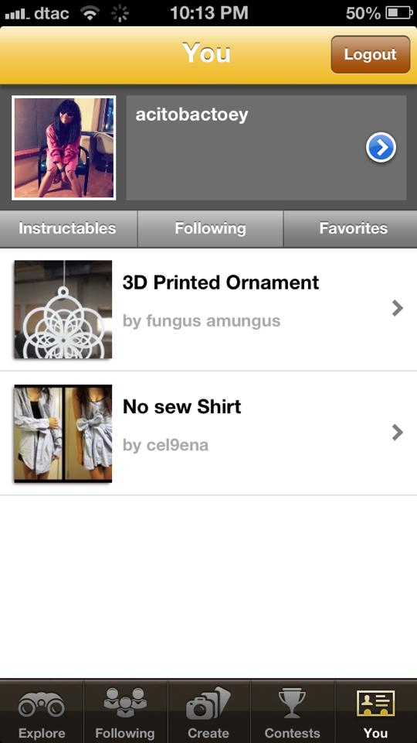
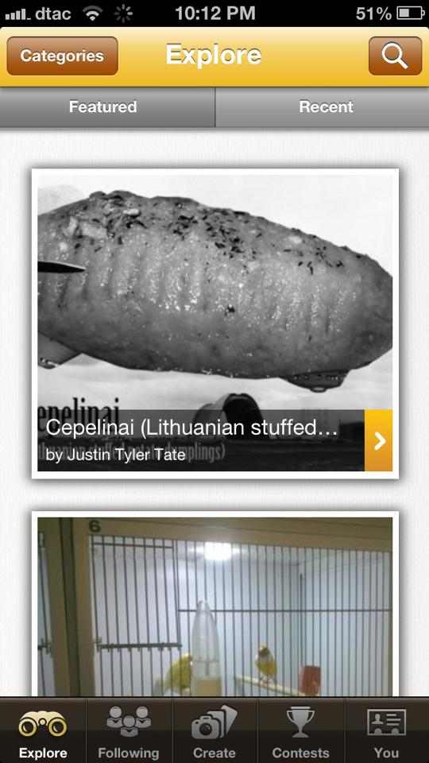
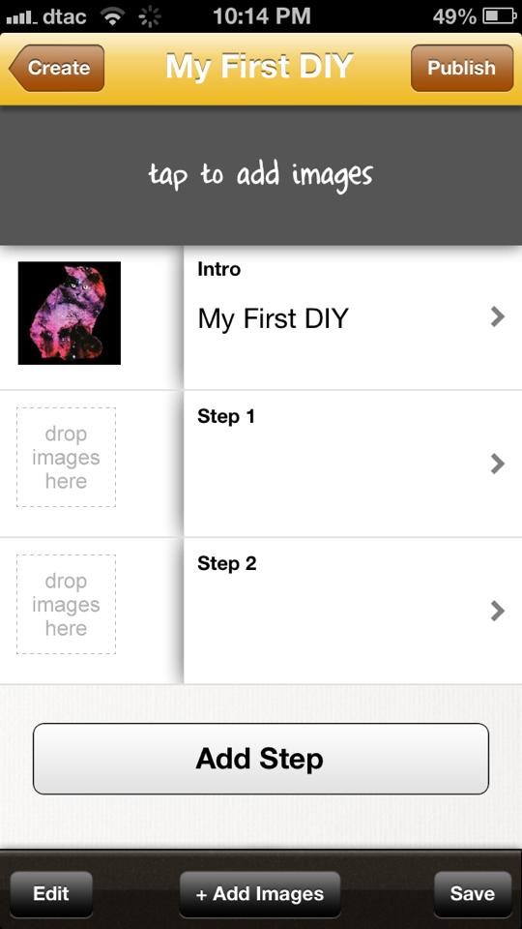

Figure 1.1: Instructable Graphic User Interface
Pros
- The system provides DIY artworks for users to explore.
- The system allows users to like, comment, and share the tutorial.
- The system provides various categories and subcategories.
- The system allows users to follow the others’ artworks.
- The system provides uncomplicated user interface.
- The system is easy to learn for the new users.
Cons
Document Name |  | HanDIYcraft-Proposal-V.1.0.docx |  | Owner |  | NK, PS |  | Page |  | 9 / 30
Document Type |  | Proposal |  | Release Date |  | 26 March 2014 |  | Print Date |  | 26 March 2014
- Unattractive user interface.
- Some feature requires users to log in to perform the task.
- No recommendation about needed materials for a certain tutorial.

2.2.2 Pinterest
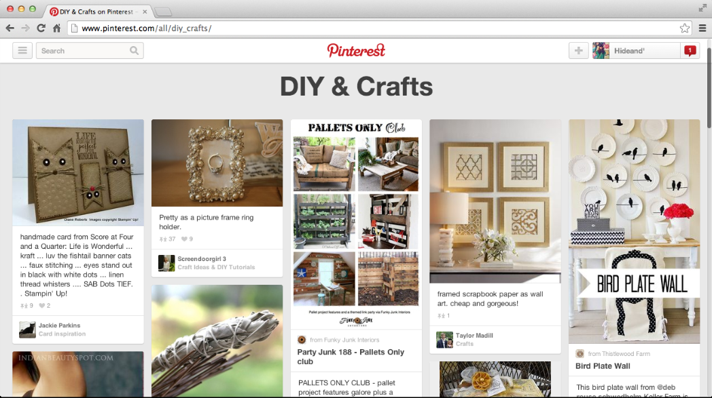
Pinterest is a web application full with several kinds of DIY artworks. The users can explore DIY artworks and pin the favorite one into their own profile page. On the other hand, the users also able to upload their own artworks and let the others pin it. Moreover, users can follow the other people to catch up their artworks

Figure 1.2: Pinterest Website Graphic User Interface
Pros
- The system provides a sign up with Facebook feature.
- The system provides alternative languages.
- The system provides many pictures to attract users.
- The system shows the related stuffs for that tutorial.
- The system allows users to create multi-boards for different kind of artworks.
- The system allows users to like tutorials.
- The system allows users to share tutorials to their Facebook, Twitter and web sites.
- The system is easy to learn for the new users.
Cons
Document Name |  | HanDIYcraft-Proposal-V.1.0.docx |  | Owner |  | NK, PS |  | Page |  | 10 / 30
Document Type |  | Proposal |  | Release Date |  | 26 March 2014 |  | Print Date |  | 26 March 2014
- No categories for DIY and crafts
- The user can upload only one picture for one tutorial.
2.2.3 Paper and Stitch
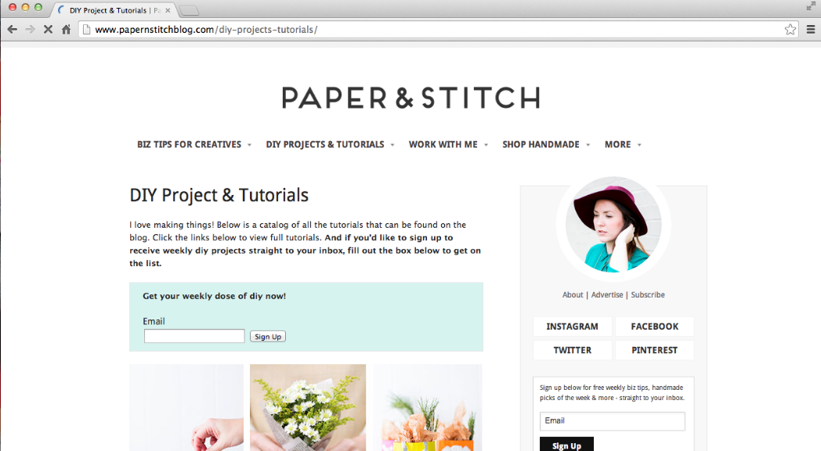
Paper and Stitch gives many DIY artworks for people to explore. It provides pictures and explanation exhaustively. However, it does not allow users to create their own tutorials and share their idea. So, this website is more like someone’s blog that let people come and take a look.

Figure 1.3: Paper and Stitch Website Graphic User Interface
Pros
- The system provides simple and attractive user interface.
- The system provides tutorials in pictures and texts.
- The system allows users to share tutorials on Facebook and Twitter.
- The system allows users to comment on tutorials.
Cons
- The system allows users to only look around.
- The system does not allow users to create their own tutorial.

Document Name |  | HanDIYcraft-Proposal-V.1.0.docx |  | Owner |  | NK, PS |  | Page |  | 11 / 30
Document Type |  | Proposal |  | Release Date |  | 26 March 2014 |  | Print Date |  | 26 March 2014

2.2.4 DIY and Craft Tutorials
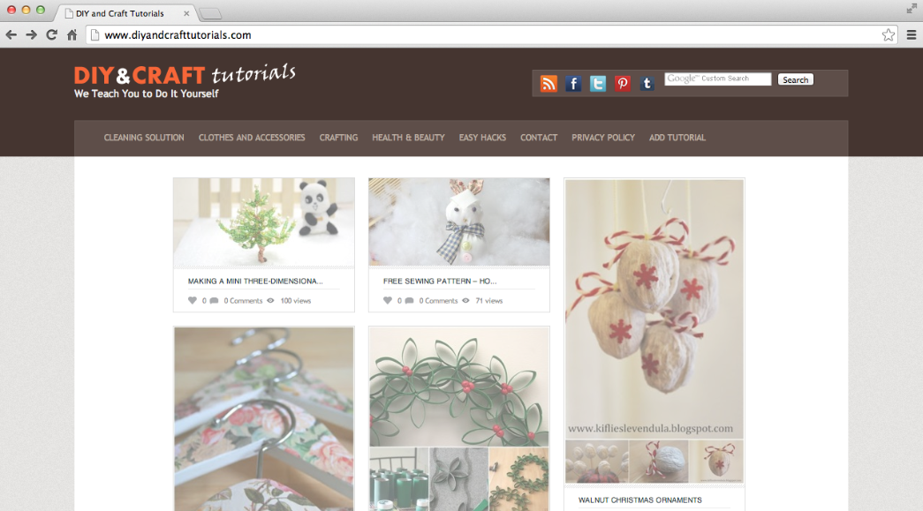
DIY and Craft Tutorials is an open web application for users to explore and share DIY artworks. The users can share their works by creating their own tutorials, and for this they do not need to be a member to done the task. Moreover, users can share their favorite artworks to their social medias like Facebook, Twitter, Google Plus, and Tumblr.

Figure 1.4: Paper and Stitch Website Graphic User Interface
Pros
- The users do not have to sign up to create tutorials.
- The system provides uncomplicated user interface.
- The system allows users to share tutorials on Facebook, Twitter, Pinterest, and Tumblr.
- Easy to learn for the new users.
Cons
Document Name |  | HanDIYcraft-Proposal-V.1.0.docx |  | Owner |  | NK, PS |  | Page |  | 12 / 30
Document Type |  | Proposal |  | Release Date |  | 26 March 2014 |  | Print Date |  | 26 March 2014
- The system provides too many advertisements.
- The system provides lack of attraction point.
- No log in system to identify the blogger who post the tutorial.
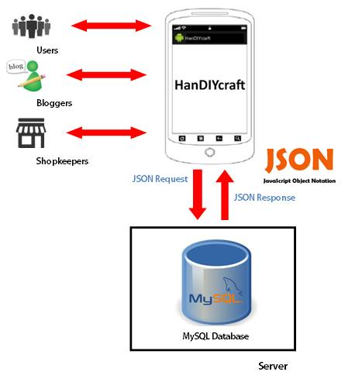
2.3 Architecture Review

Figure 1.5: Architecture Review
HanDIYcraft application is a social application on Android OS smart phones. Whenever the user interacts with the application, the system will query data through JSON from MySQL database system and response the result back to the user via the application’s user interface.

Users, bloggers and shopkeepers can access to the data differently.
- Users will be able to only explore tutorials and shops’ location that are provided in the application.
- Bloggers can manage (create/edit/delete) tutorials. They can communicate among each other via the comments, and to the shopkeepers via private messages. Also, be able to explore others’ tutorials and shops’ location just like the users.
- Shopkeepers can manage shops, and be able to communicate with the bloggers via private messages. They can search to a specific blogger by using the blogger’s username to reach the basic information.
Document Name |  | HanDIYcraft-Proposal-V.1.0.docx |  | Owner |  | NK, PS |  | Page |  | 13 / 30
Document Type |  | Proposal |  | Release Date |  | 26 March 2014 |  | Print Date |  | 26 March 2014

2.4 Technology Review

2.4.1 Android Operating System
Android is operating system that develops on a Linux-based for mobile devices such as smart phone and tablet. Android is open source, it is free for everyone who are interested to develop. Because Android has developed by Google, so it has a lot of Google services supported such as Gmail, Google Calendar, and Google Maps. ^{[1]}

Alternative Tools
- iOS
- Symbian
- Window Phone
- BlackBerry OS

The selection of this technology
Nowadays smart phones are very popular. For us we choose the Android OS because it is an open source operating system. It is free for developing and also support by many tools. It can directly be tested on the smart phones.

2.4.2 JSON
JSON (JavaScript Object Notation) is a lightweight data-interchange format. It is easy for humans to read and write. It is easy for machines to parse and generate. It is based on a subset of the JavaScript Programming Language, Standard ECMA-262 3rd Edition - December 1999. JSON is a text format that is completely language independent but uses conventions that are familiar to programmers of the C-family of languages, including C, C++, C#, Java, JavaScript, Perl, Python, and many others. These properties make JSON an ideal data-interchange language. ^{[2]}

Document Name |  | HanDIYcraft-Proposal-V.1.0.docx |  | Owner |  | NK, PS |  | Page |  | 14 / 30
Document Type |  | Proposal |  | Release Date |  | 26 March 2014 |  | Print Date |  | 26 March 2014

Alternative Tool
- Extensible Markup Language (XML)

The selection of this technology
JSON makes us be more easy to read and write. It is not extensible because it does not need to be. Moreover, it is not a document markup language, so it is not necessary to define new tags or attributes to represent data in it. We can use JSON to store and retrieve data between Web-Service and our application.

2.4.3 Google Maps API
Google Maps is a web mapping service application and technology provided by Google, that powers many map-based services, including the Google Maps website, Google Ride Finder, Google Transit, and maps embedded on third-party websites via the Google Maps API. It offers street maps and a route planner for traveling by foot, car, bike (beta), or with public transportation. It also includes a locator for urban businesses in numerous countries around the world. ^{[3]}

Alternative Tool
- Bing Map

The selection of this technology
There are a lot of information of Google Maps API provided, such as source code samples and tutorials on the internet. Also, there is a complete code of the Google Maps provided for us to apply for our projects. Therefore, we do not have to waste our time writing the whole source code for this part again.

Document Name |  | HanDIYcraft-Proposal-V.1.0.docx |  | Owner |  | NK, PS |  | Page |  | 15 / 30
Document Type |  | Proposal |  | Release Date |  | 26 March 2014 |  | Print Date |  | 26 March 2014

2.5 Development Tools Review

2.5.1 Eclipse
Eclipse is an IDE (Integrated Development Environment) or an editor that is popular in software development. It supports people in developing software in many languages, mostly Java. It provides a simple and understandable user interface. Moreover, the developers also be able to download many different plugins to work with Eclipse. For example, to develop an Android application, there will be plugins for Android development provided. Further than that, it is free. ^{[4]}

Alternative Tools
- Netbean
- IntelliJ IDEA

The selection of this technology
Not only because it’s free, but also because it is easy to set up and find various plugins to work with. In addition, it supports Android platform too. Therefore, we decided to use this software as a tool for our project.

2.5.2 MySQL
MySQL is an open source relational database management
system which used by many users around the world. It can create both
standalone and server database. It can integrate with other product such as MySQL Workbench, MySQL Notifier and MySQL Connector. It also supports many development tool for create application such as Eclipse, NetBeans.^{[5]}

Alternative Tools
- SQLite

Document Name |  | HanDIYcraft-Proposal-V.1.0.docx |  | Owner |  | NK, PS |  | Page |  | 16 / 30
Document Type |  | Proposal |  | Release Date |  | 26 March 2014 |  | Print Date |  | 26 March 2014

The selection of this technology
Due to our application needs to connect the database with the web server. From this point, MySQL does support our need for our application. Not only Android OS that it supports, but also in other different platforms. In addition, it’s free. Apart form that, there are many people has been using it, so there are many tutorial introducing us the software on the Internet. Therefore, if we have any problem, we can immediately figure it out.

2.5.3 Dropbox
Dropbox is a free service that let users keep their data and files. Once users install Dropbox in their own computer, any file they save will automatically be saved to all of their devices, and even on Dropbox website. So, the users do not have to worry about losing their files. Even if they accidently lost their Android somewhere, their stuff would always be safe on Dropbox. ^{[6]}

Alternative Tools
- GitHub
- Google Drive
- iCloud
- Sky Drive

The selection of this technology
Dropbox gives free 2GB storage for every user that has signed up. It has an ability to work on Windows, Mac, Linux, mobile application, and web application. No matter what the users have made changes to the files, Dropbox will update those changes in the other devices as well. Also, it let users do the file sharing, so that they can collaborate with other people much more easier and faster.
Document Name |  | HanDIYcraft-Proposal-V.1.0.docx |  | Owner |  | NK, PS |  | Page |  | 17 / 30
Document Type |  | Proposal |  | Release Date |  | 26 March 2014 |  | Print Date |  | 26 March 2014

Chapter Three |
Quality Standard
3.1 ISO29110 for Very Small Entity (VSE)

ISO29110 is a guide applies to a Very Small Entity (VSE), enterprise, organization, department or project up to 25 people, dedicated to software development. The Guide provides Project Management and Software Implementation processes which integrate practices based on the selection of ISO/IEC 12207- Systems and Software Engineering — Software Life Cycle Processes and ISO/IEC 15289Software Engineering – Software Life Cycle Process – guidelines for the content of software life cycle process information products (documentation) standards elements.

3.1.1 Project Management Process
The purpose of the Project Management process is to establish and carry out in a systematic way the tasks of the software implementation project, which allows complying with the project’s objectives in the expected quality, time and cost.
Selected process
- - Project Planning Process
- - Project Plan Execution Process
- - Project Assessment and Control Process
- - Project Closer Process
Document Name |  | HanDIYcraft-Proposal-V.1.0.docx |  | Owner |  | NK, PS |  | Page |  | 18 / 30
Document Type |  | Proposal |  | Release Date |  | 26 March 2014 |  | Print Date |  | 26 March 2014

- 3.1.2 Software Implementation Process
- The purpose of the Software Implementation process is the systematic performance of the analysis, design, construction, integration and tests activities for new or modified software products according to the specified requirements.
Selected process
- - Software Implementation Initiation Process
- - Software Requirements Analysis Process
- - Software Architectural Design Process
- - Software Construction Process
- - Software Integration and Test Process
- - Software Delivery Process

Document Name |  | HanDIYcraft-Proposal-V.1.0.docx |  | Owner |  | NK, PS |  | Page |  | 19 / 30
Document Type |  | Proposal |  | Release Date |  | 26 March 2014 |  | Print Date |  | 26 March 2014

Chapter Four |
Project Plan
4.1 Motivation
Nowadays, people give more interests on creating recycled artworks, or as known as DIY artworks by themselves. They tend to keep exploring ideas to do it. As a result, there are many applications and websites provided to let them explore and share their DIY artworks and give a tutorial how to do it. Although those medias seem to provide perfect and sufficient features for the users, there is one point that they did not concern. The problem is the users may not know where exactly they should buy the materials if they would like to do a DIY artwork. Therefore, HanDIYcraft application will help users to find out stores to buy needed stuffs. In addition, the users also be able to communicate with the stores via private message feature.
The reason we want to work on DIY is that it is becoming very popular for people to reduce their expenses. Apart from the money purpose, it also helps people in the way of relieving from tension and anxiety, increase more concentration, and more pride and happiness in their life.
Moreover, smart phones have become an essential item for people. There are several operating systems developed to support them. One of those operating systems that are well-known is Android OS. Due to it is an open source, there are many resources provided to develop, and it is easy to learn.
From this software project, we expect to get more knowledge and experiences in processing in order to develop new software. On the other hand, also to get the experience of working as a team and taking serious responsibilities, for the good of our working life in the future.

Document Name |  | HanDIYcraft-Proposal-V.1.0.docx |  | Owner |  | NK, PS |  | Page |  | 20 / 30
Document Type |  | Proposal |  | Release Date |  | 26 March 2014 |  | Print Date |  | 26 March 2014

4.2 Aims and Objectives
4.2.1 Aims
The aims of HanDIYcraft application are to allow users to explore, and bloggers to share DIY artworks. Shopkeepers can advertise their shops in order to get interests from the users and get more customers than before. The development of this application will be done under the ISO 29110 software quality standard.

4.2.2 Objectives
- Develop an Android application using open source technology and development tools to give portability to the user.
- Let the users learn the tutorials through explanations and pictures.
- Allow bloggers to create their own tutorials.
- Be able to seek for shops’ information and location.
- Communicate among bloggers, and between blogger and shopkeeper.
- Let the shopkeepers present their shops by providing information and pictures.

Document Name |  | HanDIYcraft-Proposal-V.1.0.docx |  | Owner |  | NK, PS |  | Page |  | 21/ 30
Document Type |  | Proposal |  | Release Date |  | 26 March 2014 |  | Print Date |  | 26 March 2014

4.3 Deliverables and Limits
4.3.1 Deliverables
Progress Report I
Feature 1: Authorization Management
    - Develop register system for both bloggers and shopkeepers.
    - Develop log in and log out system for both bloggers and shopkeepers.
    - The system can display user’s profile and let the user edit the information.
Feature 2: Tutorial Management
- Blogger can manage tutorials.
- Blogger can add details of the tutorial step by step.
- Blogger can add pictures for the tutorial.
- The system can display tutorials that exist in the database.

Progress Report II
Feature 3: Shop Management
- Shopkeepers can manage shops.
- Shopkeepers can add information of the shop.
- Shopkeepers can add pictures of the shop.
Feature 4: Map Management
- Develop Map using Google Maps API.
- Users can see the location of shops.
- Bloggers can see the location of shops.
- Shopkeepers can pin the location of the shop.
Feature 5: Communication Management
- Bloggers can communicate to each other via comment.
- Blogger and shopkeeper can communicate to each other via private message.
- Shopkeepers can search bloggers using their username.
Document Name |  | HanDIYcraft-Proposal-V.1.0.docx |  | Owner |  | NK, PS |  | Page |  | 22/ 30
Document Type |  | Proposal |  | Release Date |  | 26 March 2014 |  | Print Date |  | 26 March 2014

Progress Show Pro
Feature 6: The system provides notifications.

Final Progress
Ensure that the system and documents are complete.

Documents
- Proposal
- Project plan
- Software requirement specification
- Software design document
- Testing document
- Traceability record
- Software quality assurance document
- Demo of program
- Poster for presentation

4.3.2 Limits
- The application requires Android Operating System.
- Internet connection is required for the application to perform.
- Only the user that has registered as a blogger is able to create tutorials.
- Only the user that has registered as a shopkeeper is able to add shops.
- There is no security system to check the inappropriate information.

4.4 Future Work
- HanDIYcraft application should be able to operate in iOS.
- HanDIYcraft application should be able to let bloggers upload video in their tutorials.
- HanDIYcraft application should be able to connect with social networks.

Document Name |  | HanDIYcraft-Proposal-V.1.0.docx |  | Owner |  | NK, PS |  | Page |  | 23/ 30
Document Type |  | Proposal |  | Release Date |  | 26 March 2014 |  | Print Date |  | 26 March 2014
4.4 Software Process Model
4.4.1 Iterative Model
In Iterative model, iterative process starts with a simple implementation of a small set of the software requirements and iteratively enhances the evolving versions until the complete system is implemented and ready to be deployed.
An iterative life cycle model does not attempt to start with a full specification of requirements. Instead, development begins by specifying and implementing just part of the software, which is then reviewed in order to identify further requirements. This process is then repeated, producing a new version of the software at the end of each iteration of the model. ^{[7]}
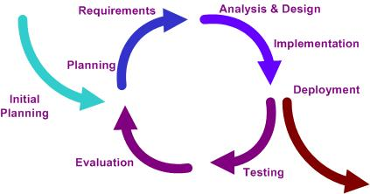

Figure 1.6: Iterative Model^{[8]}

Document Name |  | HanDIYcraft-Proposal-V.1.0.docx |  | Owner |  | NK, PS |  | Page |  | 24/ 30
Document Type |  | Proposal |  | Release Date |  | 26 March 2014 |  | Print Date |  | 26 March 2014

4.5 Schedule and Milestones

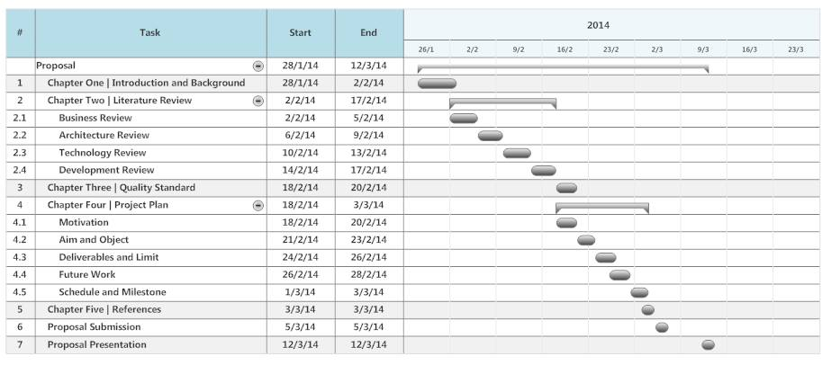

Document Name |  | HanDIYcraft-Proposal-V.1.0.docx |  | Owner |  | NK, PS |  | Page |  | 25 / 30
Document Type |  | Proposal |  | Release Date |  | 26 March 2014 |  | Print Date |  | 26 March 2014

Figure 1.6: The Milestone of Initial Project

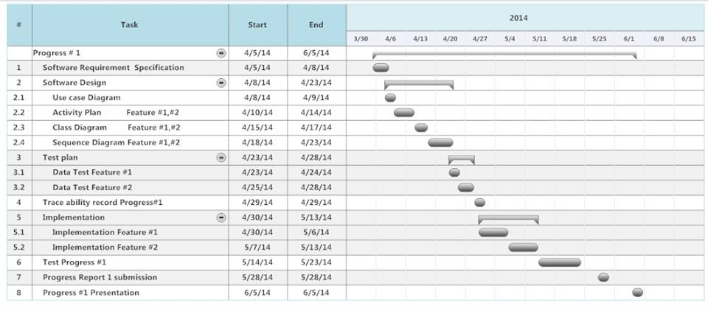

Figure 1.7: The Milestone of First Progress Report
Document Name |  | HanDIYcraft-Proposal-V.1.0.docx |  | Owner |  | NK, PS |  | Page |  | 26 / 30
Document Type |  | Proposal |  | Release Date |  | 26 March 2014 |  | Print Date |  | 26 March 2014

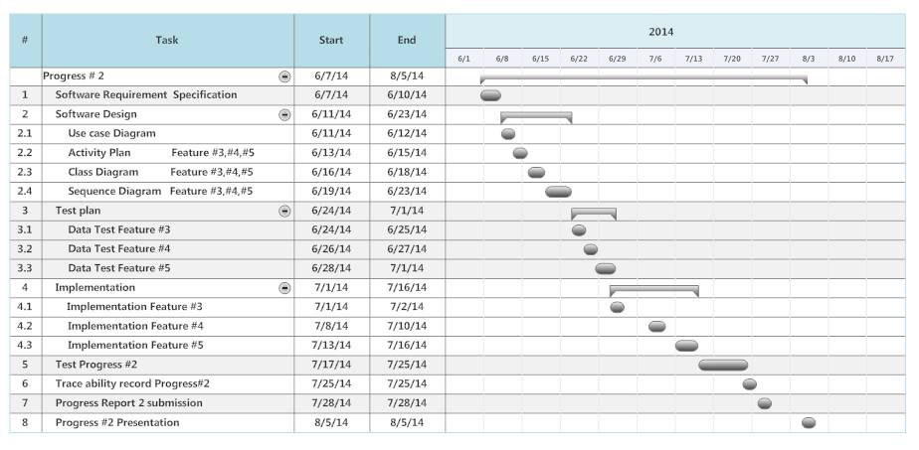

Document Name |  | HanDIYcraft-Proposal-V.1.0.docx |  | Owner |  | NK, PS |  | Page |  | 27 / 30
Document Type |  | Proposal |  | Release Date |  | 26 March 2014 |  | Print Date |  | 26 March 2014
Figure 1.8: The Milestone of Second Progress Report

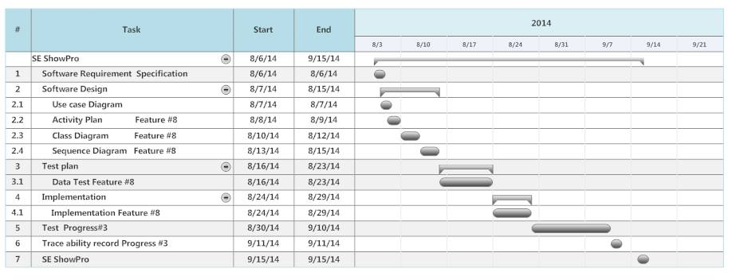

Document Name |  | HanDIYcraft-Proposal-V.1.0.docx |  | Owner |  | NK, PS |  | Page |  | 28 / 30
Document Type |  | Proposal |  | Release Date |  | 26 March 2014 |  | Print Date |  | 26 March 2014
Figure 1.9: The Milestone of Show Pro Progress Report

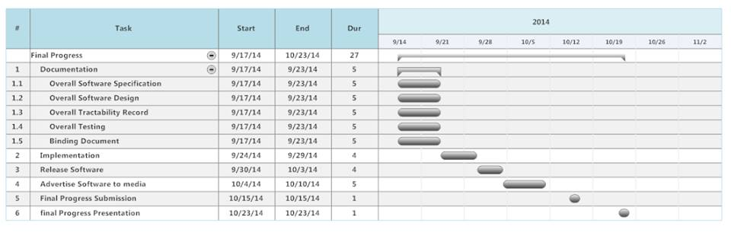

Figure 1.10: The Milestone of Final Progress Report
Document Name |  | HanDIYcraft-Proposal-V.1.0.docx |  | Owner |  | NK, PS |  | Page |  | 29 / 30
Document Type |  | Proposal |  | Release Date |  | 26 March 2014 |  | Print Date |  | 26 March 2014
Chapter Five |
References
[1] Topic: Android Operating System Information
Source: http://en.wikipedia.org/wiki/Android_(operating_system)

[2] Topic: JSON Information
Source: http://www.json.org/

[3] Topic: Google Maps Information
Source: http://en.wikipedia.org/wiki/Google_Maps

[4] Topic: Eclipse Information
Source: http://en.wikipedia.org/wiki/Eclipse_(software)

[5] Topic: My SQL Information
Source: http://www.ehow.com/info_8704041_mysql.html

[6] Topic: Dropbox Information
Source: http://www.appsapk.com/dropbox/

[7] Topic: Iterative Model Information
Source: http://www.tutorialspoint.com/sdlc/sdlc_iterative_model.htm

[8] Topic: Iterative Model Picture
Source: http://en.wikipedia.org/wiki/Iterative_and_incremental_development

Document Name |  | HanDIYcraft-Proposal-V.1.0.docx |  | Owner |  | NK, PS |  | Page |  | 30 / 30
Document Type |  | Proposal |  | Release Date |  | 26 March 2014 |  | Print Date |  | 26 March 2014

