Document History
Document Name | Detail | Status | Date | Viewable | Reviewer& Responsible
HanDIYcraft-SRS-0.1.docx | -Introduction | Draft | 15/4/14 | Advisor | NK, PS
HanDIYcraft -SRS-0.2.docx | -Update Introduction  -Overall Description | Draft | 16/4/14 | Advisor | NK, PS
HanDIYcraft -SRS-0.3.docx | -Update Overall Description  -User Requirements | Draft | 17/4/14 | Advisor | NK, PS
HanDIYcraft -SRS-0.4.docx | -Update User Requirements | Draft | 18/4/14 | Advisor | NK, PS
HanDIYcraft -SRS-0.5.docx | -Update User Requirements | Draft | 19/4/14 | Advisor | NK, PS
HanDIYcraft -SRS-0.6.docx | -Update User Requirements | Draft | 20/4/14 | Advisor | NK, PS
HanDIYcraft -SRS-0.7.docx | -Update User Requirements  - System Features | Draft | 21/4/14 | Advisor | NK, PS
HanDIYcraft -SRS-0.8.docx | -Update System Features | Draft | 5/7/14 | Advisor | NK, PS
HanDIYcraft -SRS-1.0.docx | -Update System Features | Release | 7/7/14 | Advisor | NK, PS

NK : Nahathai Kaewtatib

PS : Pimchanok Sripraphan

…………………………

Ms. Nahathai Kaewtatib

Project SRS Writer

…………………………

Ms. Pimchanok Sripraphan

Project SRS Writer

7th July 2014

Table of Contents
Chapter One| Introduction 4
1.1 Objective 4
1.2 Intended Audience and Reading Suggestions 4
1.3 Project Scope 5
1.4 Acronyms and Definitions 5
Chapter Two | Overall Description 7
2.1 Product Perspective 7
2.2 Product Features 7
2.3 User Classes and Characteristics 7
2.3.1 Users 7
2.3.2 Bloggers 7
2.3.3 Shopkeepers 7
2.4 Operation Environment 8
2.5 Design and Implementation Constraints 8
Chapter Three | User Requirements 9
3.1 Use Cases 9
3.1.1 HanDIYcraft Use Case for Web Application 9
3.1.2 HanDIYcraft Use Case for Mobile Application 10
3.2 User Requirement Specification 11
3.2.1 User Requirement Specification for Web Application 11
3.2.2 User Requirement Specification for Mobile Application 13
3.3 User Requirement Description and Activity Diagram 16
3.3.1 User Requirement Description for Web Application 16
3.3.2 User Requirement Description for Mobile Application 49
Chapter Four | System Features 81
4.1 Software Requirement Specification 81
4.1.1 Software Requirement Specification for Web Application 81
4.1.2 Software Requirement Specification for Mobile Application 93
4.2 Quality Requirement 104

Chapter One | Introduction

1.1 Objective
HanDIYcraft is a web application, and mobile application for smartphone that supports Android operating system. It is an application that guide users the method how to recycle things by themselves. This application provides several tutorials for users to learn. Moreover, in case the users do not have the needed materials and have no idea where to buy, this application provides a feature to let the users check out the shops that sell related materials for making their DIY artworks and find the location of the shop via Google Maps. Apart from just exploring, the bloggers can directly communicate with the shopkeepers by sending private messages, and among each other by the comment. They can also share their favorite DIY tutorial to the social network like Facebook too.
This Software Requirement Specification document defines more about the abilities and features of the system in details. It includes the scope and limitations of the project, product function, user characteristics, functional requirements, non-functional requirements, use cases and activity diagrams to explain how the system works.

  - Intended Audience an Reading Suggestions

This Software Requirement Specification is designed for the people who are involved and related with the HanDIYcraft project. It may benefit to these people as followed:

Development Team
- Specifies the abilities and actions, including the scope of the system. From this point, it helps everyone to have the same understanding towards the project.
- Verifies and validates the working of software whether it works as it is defined in the document or not.
- Helps in achieving the quality of the product as much as possible.
- Used for the discussion among the related people about the project.

Customer
- Ensure that the development team understands and interprets in the same thing, in order to satisfy the customer needs.
- Helps customer to understand the technical things such as the quality, scope and limitations.

  - Project Scope

- Available only in English.
- Provide understandable symbols and language.
- Provide member system
- Able to work with Google Maps to pin and see shops’ location.
- Able to work with Facebook in order to share tutorials.
- Provide communication system to make an interaction among bloggers, and also with the shopkeepers.
- Provide the tutorial management system on mobile application, and web application for bloggers to manage their tutorials easier.
- Provide tutorials for users and bloggers to explore.
- Let shopkeepers manage their shops in order to advertise them.

  - Acronyms and Definitions
- Acronyms
PMP = Project Management Plan
SDD = Software Design Document
SRS = Software Requirement Specification
URS = User Requirement Specification
UC = Use Case
AD = Activity Diagram
SW = Siraprapa Wattanakul
NK = Nahathai Kaewtatib
PS = Pimchanok Sripraphan

Chapter Two | Overall Description

  - Product Perspective

HanDIYcraft is a software system that able to operate as web and Android mobile application. It helps the users to obtain ideas to build DIY artworks. Plus, it also helps user to save their time to find the right place via Google Maps in order to get the material the want. More than that, it also helps the shopkeepers who sell DIY materials to advertise their shops too.

  - Product Features

Main features of HanDIYcraft are listed as follows:

Feature 1: Authorization Management
- Develop register, log in, and log out system for bloggers. (On both web and mobile)
- Develop register, log in, and log out system for shopkeepers. (On mobile)
- The system can display user’s (blogger/shopkeeper) profile and let the users edit their information.

Feature 2: Tutorial Management (On both web and mobile)
- Bloggers can manage tutorials.
- Bloggers can add detail of the tutorial step by step.
- Bloggers can pictures for the tutorial.
- Bloggers can add a video for the tutorial.
- Bloggers and users can search tutorials by keyword.
- The system can display tutorials that exist in the database.

Feature 3: Shop Management (On mobile)
- Shopkeepers can manage shops.
- Shopkeepers can add information of the shop.
- Shopkeepers can add pictures of the shop.

Feature 4: Map Management
- Develop Map using Google Maps API. (On both web and mobile)
- Bloggers can see the location of shops. (On both web and mobile)
- Shopkeepers can pin the location of the shop. (On mobile)

Feature 5: Communication Management
- Bloggers can communicate to each other via comment. (On both web and mobile)
- Bloggers and shopkeepers can communicate to each other via private message. (On both web and mobile)
- Shopkeepers can search bloggers using their username. (On mobile)
- Bloggers can give likes on tutorials. (On both web and mobile)
- Bloggers can follow other bloggers. (On both web and mobile)
- Bloggers can share a tutorial on Facebook. (On both web and mobile)

Feature 6: The system provides notifications. (On both web and mobile.

  - User Classes and Characteristics

There are three types of users for our system. Information and characteristics are listed below:

    - Visitors
These are the general users that did not register to the system. What the can do the most is just exploring the DIY tutorials that exist in the system.

    - Bloggers
These are the people who have registered as a blogger. Apart from just exploring, they are able to create their own tutorials and manage it. Besides, they can do the communication through comments and private messages too.

    - Shopkeepers
These are the people who have registered as a shopkeeper. They can literally advertise their own shops via the application. Apart from that, they can communicate with the bloggers through private message.

  - Operation Environment
HanDIYcraft operates on both web and mobile application. Whenever the user requests any information to perform some tasks, the information will be requested from web application and response back to the mobile application.

Server Environment
Windows server platform is supported for this system. It is capable for web-server, database-server, and internet connection.

Client Environment
The system supports only Android OS, which has version 4.2 or later in order to run the system properly and be able to connect to the internet. It also requires GPS to identify location from Google Maps.

  - Design and Implementation Constraints

- The mobile application of the system is able to operate only on Android platform, version 4.2 or above.
- Require the internet connection.
- There is no security for inappropriate information.
- The users that did not log in can visit only some part of the system.

Chapter Three | User Requirements

  - Use Cases
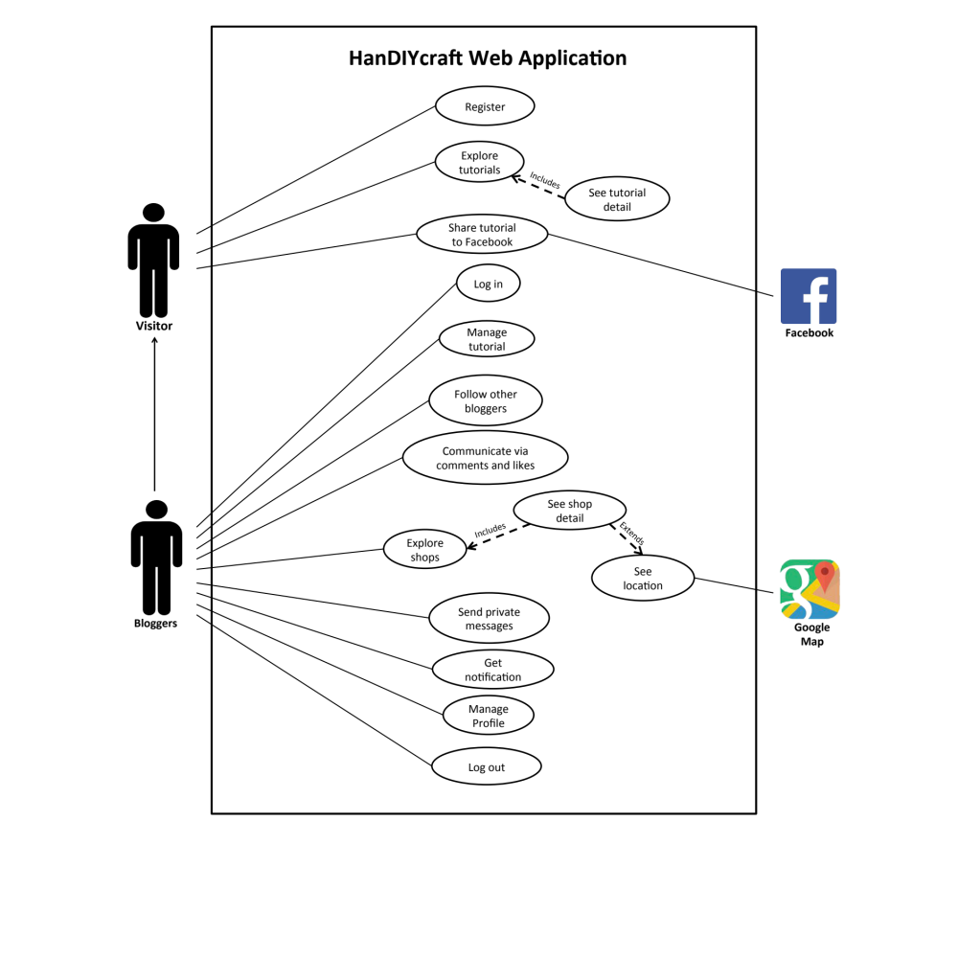
    - HanDIYcraft Use Case Web Application

    - HanDIYcraft Use Case for Mobile Application
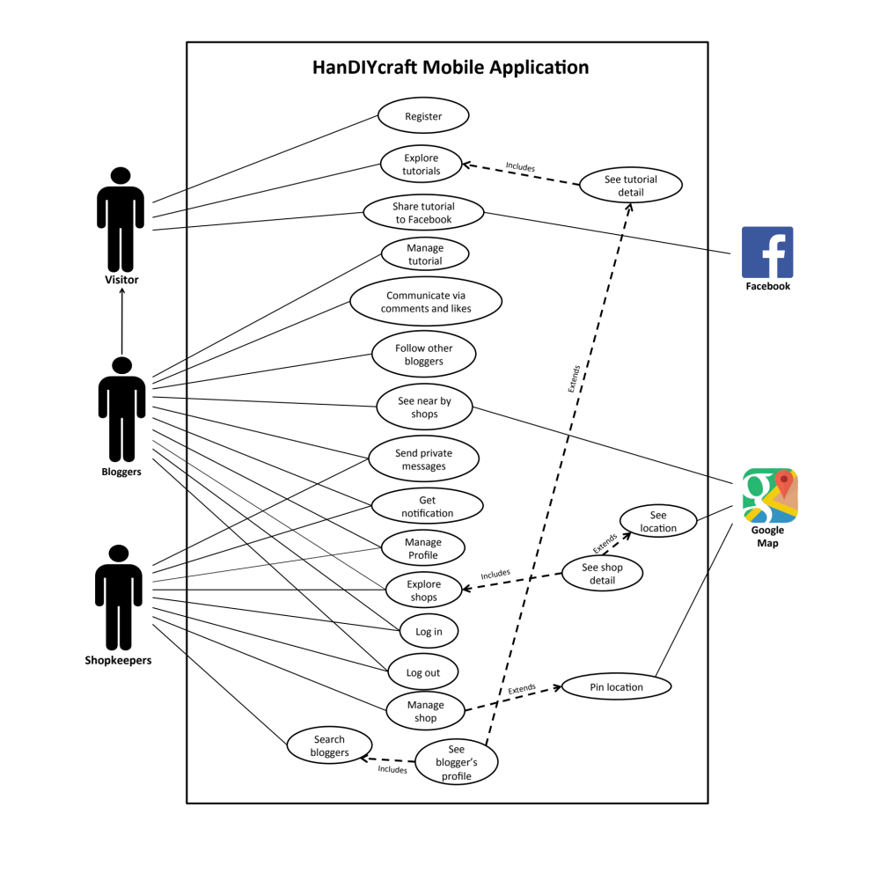

  - User Requirement Specification (URS)

    - User Requirement Specification for Web Application
No. | Feature Name | URS No. | URS Name | Actor
1 | Authorization Management | W-URS-01 | The user registers as a blogger. | Visitor
1 | Authorization Management | W-URS-02 | The user logins to the system. | Blogger
1 | Authorization Management | W-URS-03 | The user logouts from the system. | Blogger
1 | Authorization Management | W-URS-04 | The user sees his/her profile. | Blogger
1 | Authorization Management | W-URS-05 | The user edits his/her email. | Blogger
1 | Authorization Management | W-URS-06 | The user adds profile picture. | Blogger
1 | Authorization Management | W-URS-07 | The user changes profile picture. | Blogger
1 | Authorization Management | W-URS-08 | The user changes his/her password. | Blogger
1 | Authorization Management | W-URS-09 | The user deletes his/her account. | Blogger
2 | Tutorial Management | W-URS-10 | The user sees tutorials by random. | Visitor, Blogger
2 | Tutorial Management | W-URS-11 | The user sees tutorials by popular. | Visitor, Blogger
2 | Tutorial Management | W-URS-12 | The user sees tutorials by categories. | Visitor, Blogger
2 | Tutorial Management | W-URS-13 | The user sees tutorials by searching. | Visitor, Blogger
2 | Tutorial Management | W-URS-14 | The user sees tutorials by following. | Blogger
2 | Tutorial Management | W-URS-15 | The user sees tutorial information. | Visitor, Blogger
2 | Tutorial Management | W-URS-16 | The user creates his/her own tutorial. | Blogger
2 | Tutorial Management | W-URS-17 | The user sees his/her own tutorial. | Blogger
2 | Tutorial Management | W-URS-18 | The user edits his/her own tutorial. | Blogger
2 | Tutorial Management | W-URS-19 | The user deletes his/her own tutorial. | Blogger
3 | Shop Management | W-URS-20 | The user sees shops by random. | Blogger
3 | Shop Management | W-URS-21 | The user sees shops by categories. | Blogger
3 | Shop Management | W-URS-22 | The user sees shops by searching. | Blogger
3 | Shop Management | W-URS-23 | The user sees shop information. | Blogger
4 | Map Management | W-URS-24 | The user sees shop’s location on Google Map. | Blogger
5 | Communication Management | W-URS-25 | The user sees comments on tutorial. | Visitor, Blogger
5 | Communication Management | W-URS-26 | The user adds comment on tutorial. | Blogger
5 | Communication Management | W-URS-27 | The user likes a tutorial. | Blogger
5 | Communication Management | W-URS-28 | The user undo likes a tutorial. | Blogger
5 | Communication Management | W-URS-29 | The user follows other bloggers | Blogger
5 | Communication Management | W-URS-30 | The user undo follows other bloggers | Blogger
5 | Communication Management | W-URS-31 | The user sends private message. | Blogger
5 | Communication Management | W-URS-32 | The user receives private message. | Blogger
5 | Communication Management | W-URS-33 | The user shares tutorial to Facebook. | Visitor, Blogger
6 | Notification Management | W-URS-34 | The user sees notification. | Blogger
6 | Notification Management | W-URS-35 | The user goes to the activity that has been notified. | Blogger

    - User Requirement Specification for Mobile Application
No. | Feature Name |  | URS No. | URS Name | Actor
1 | Authorization Management |  | M-URS-01 | The user registers as a blogger or shopkeeper. | Visitor
1 |  |  | M-URS-02 | The user logins to the system. | Blogger, Shopkeeper
1 |  |  | M-URS-03 | The user logouts from the system. | Blogger, Shopkeeper
1 |  |  | M-URS-04 | The user sees his/her profile. | Blogger, Shopkeeper
1 |  |  | M-URS-05 | The user edits his/her email. | Blogger, Shopkeeper
1 |  |  | M-URS-06 | The user changes profile picture. | Blogger, Shopkeeper
1 |  |  | M-URS-07 | The user changes his/her password. | Blogger, Shopkeeper
1 |  |  | M-URS-08 | The user deletes his/her account. | Blogger, Shopkeeper
2 | Tutorial Management |  | M-URS-09 | The user sees tutorials by random. | Visitor, Blogger, Shopkeeper
2 |  |  | M-URS-10 | The user sees tutorials by popular. | Visitor, Blogger, Shopkeeper
2 |  |  | M-URS-11 | The user sees tutorials by categories. | Visitor, Blogger, Shopkeeper
2 |  |  | M-URS-12 | The user sees tutorials by searching. | Visitor, Blogger, Shopkeeper
2 |  |  | M-URS-13 | The user sees tutorials by following. | Blogger
2 |  |  | M-URS-14 | The user sees tutorial information. | Visitor, Blogger, Shopkeeper
2 |  |  | M-URS-15 | The user creates his/her own tutorial. | Blogger
2 |  |  | M-URS-16 | The user sees his/her own tutorial. | Blogger
2 |  |  | M-URS-17 | The user edits his/her own tutorial. | Blogger
2 |  |  | M-URS-18 | The user deletes his/her own tutorial. | Blogger
3 | Shop Management |  | M-URS-19 | The user sees shops by random. | Blogger, Shopkeeper
3 |  |  | M-URS-20 | The user sees shops by categories. | Blogger, Shopkeeper
3 |  |  | M-URS-21 | The user sees shops by searching. | Blogger, Shopkeeper
3 |  |  | M-URS-22 | The user sees shop information. | Blogger, Shopkeeper
3 |  |  | M-URS-23 | The user creates his/her own shop. | Shopkeeper
3 |  |  | M-URS-24 | The user sees his/her own shop. | Shopkeeper
3 |  |  | M-URS-25 | The user edits his/her own shop. | Shopkeeper
3 |  |  | M-URS-26 | The user deletes his/her own shop. | Shopkeeper
4 | Map Management |  | M-URS-27 | The user sees shop’s location on Google Map. | Blogger, Shopkeeper
4 |  |  | M-URS-28 | The user identifies his/her shop’s location on Google Map. | Shopkeeper
5 | Communication Management |  | M-URS-29 | The user sees comment on tutorial. | Visitor, Blogger
5 |  |  | M-URS-30 | The user adds comment on tutorial. | Blogger
5 |  |  | M-URS-31 | The user likes a tutorial. | Blogger
5 |  |  | M-URS-32 | The user undo likes a tutorial. | Blogger
5 |  |  | M-URS-33 | The user follows other bloggers | Blogger
5 |  |  | M-URS-34 | The user undo follows other bloggers | Blogger
5 |  |  | M-URS-35 | The user sends private message. | Blogger, Shopkeeper
5 |  |  | M-URS-36 | The user receives private message. | Blogger, Shopkeeper
5 |  |  | M-URS-37 | The user shares tutorial to Facebook. | Visitor, Blogger, Shopkeeper
5 |  |  | M-URS-38 | The user sees bloggers by searching. | Shopkeeper
5 |  |  | M-URS-39 | The user sees list of searched bloggers. | Shopkeeper
5 |  |  | M-URS-40 | The user sees blogger’s profile. | Visitor, Blogger, Shopkeeper
6 |  | Notification Management | M-URS-41 | The user sees notification. | Blogger, Shopkeeper
 |  | Notification Management | M-URS-42 | The user goes to the activity that has been notified. | Blogger, Shopkeeper

  - User Requirement Description and Activity Diagram

    - User Requirement Description for Web Application

Feature 1: Authorization Management
W-URS-01: The user registers as a blogger.

Input and Output
No | Input Name | Description | Example | Remarks | Output
1 | Username | The length of Username must be between 1-20 characters | “hideandseek05” | The word should not contain any symbol. | The system shows “HideandSeek05” on the screen
2 | Password | The length of Password must be between 1-20 characters | “12345” | The word should not contain any symbol. | The system shows “●●●●●” on the screen
3 | Re-Password | Re-password must match with the password. | “12345” | The word should not contain any symbol. | The system shows “●●●●●” on the screen
4 | Email | Email must be the one that the user is currently using. | “hello@gmail.com” | The word should be in Email format | The system shows “hello@gmail.com” on the screen

Description
URS ID | W-URS-01
URS Name | The user registers as a blogger.
Actor | Visitor
Description | This function allows user who does not have his/her own account to register in order to use more functions of the application.
Trigger | The user selects “Sign Up” to register to be a member of the system.
Pre-condition | - Open the application
Post-condition | - The system saves user’s information into database.
Normal flow | 1) System provides registration interface for user to fill information, which are username, password, re-password, and e-mail.  3) User input his/her information.  4) User clicks done to finish the registration.  5) System validates username, password, re-password, and email format.  6) System saves the user’s information into the database.  7) System goes back to log in page.
Alternative flow | - In step 1-4, the user clicks back button to go to the previous page in case he/she wants to cancel the registration.
Exception | - In step 5, system displays error message in case the format is wrong.  - In all steps of normal flow, in case there is no internet connection.
Include | -

W-AD-01
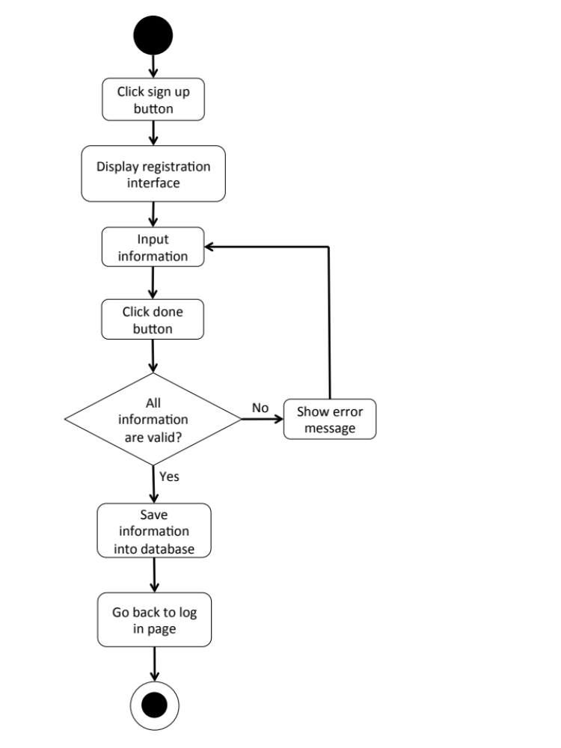

W-URS-02: The user logins to the system.

Input and Output
No | Input Name | Description | Example | Remarks | Output
1 | Username | The length of Username must be between 1-20 characters | “hideandseek05” | The word should not contain any symbol. | The system shows “HideandSeek05” on the screen
2 | Password | The length of Password must be between 1-20 characters | “12345” | The word should not contain any symbol. | The system shows “●●●●●” on the screen

Description
URS ID | W-URS-02
URS Name | The user logins to the system.
Actor | Blogger
Description | This function allows user, who has registered, logs in to the system.
Trigger | The user selects “Log in” to log in to the system.
Pre-condition | - User has registered to the system.
Post-condition | - User goes to home page for blogger.
Normal flow | 1) User goes to log in page.  2) System provides log in interface for user to fill information, which are username and password.  3) User input his/her username and password.  4) Users clicks log in button.  5) System validates username, and password format.  6) System verifies username and password from the database.  7) System goes to blogger home page.
Alternative flow | -In step 1-4, the user clicks back button to go to the previous page in case he/she wants to cancel the process.
Exception | - In step 5, in case user input invalid username or password, system will show an alert message.  - In all steps of normal flow, in case there is no internet connection.
Include | -
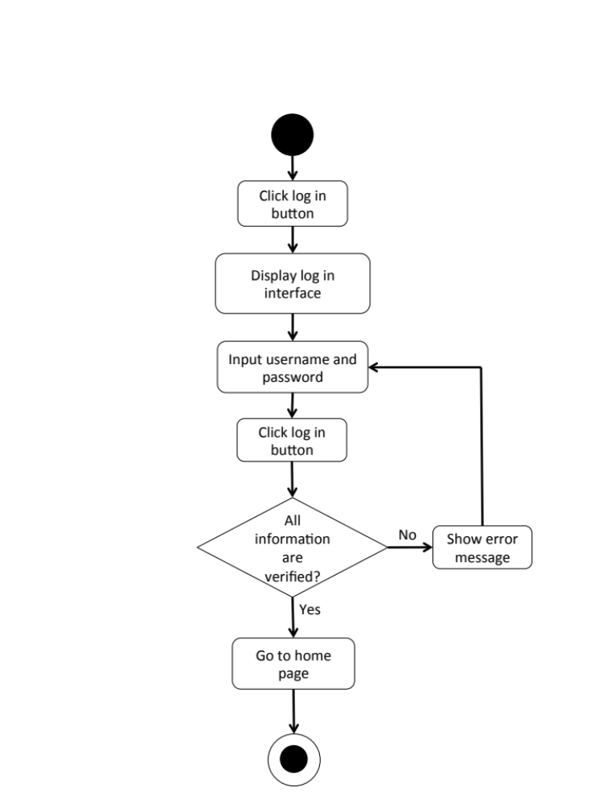

W-AD-02

W-URS-03: The user logouts from the system.
Input and Output
- Input: The user selects log out link to exit from the system.
- Output: The user log out from the system.

Description
URS ID | W-URS-03
URS Name | The user logouts from the system.
Actor | Blogger
Description | This function allows user to log out from the system.
Trigger | The user selects “Log out” to log out from the system.
Pre-condition | - User has logged in to the system.
Post-condition | - User has no longer logged in.
Normal flow | 1) User goes to blogger home page.  2) System provides blogger home page interface.  3) User clicks log out button.  4) System goes to visitor home page.
Alternative flow | -
Exception | - In all steps of normal flow, in case there is no internet connection.
Include | W-URS-02

W-AD-03
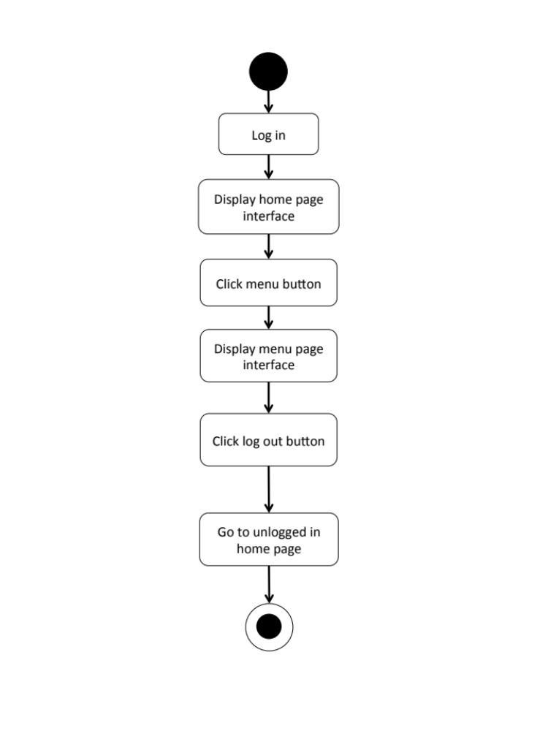

W-URS-04: The user sees his/her profile.
Input and Output
- Input: The user selects profile link to go to profile page.
- Output: The system shows user’s profile.

Description
URS ID | W-URS-04
URS Name | The user sees his/her profile.
Actor | Blogger
Description | This function allows user to see his/her own profile and information.
Trigger | The user selects “Profile” to go to his/her profile.
Pre-condition | - User has logged in to the system.
Post-condition | - System displays user’s profile.
Normal flow | - User goes to profile page.  - System gets user’s information from database.  - System displays interface and user’s information, which are profile picture, username, password, follower number, following number, and tutorials that he/she has created.
Alternative flow | -
Exception | In all steps of normal flow, in case there is no internet connection.
Include | W-URS-02

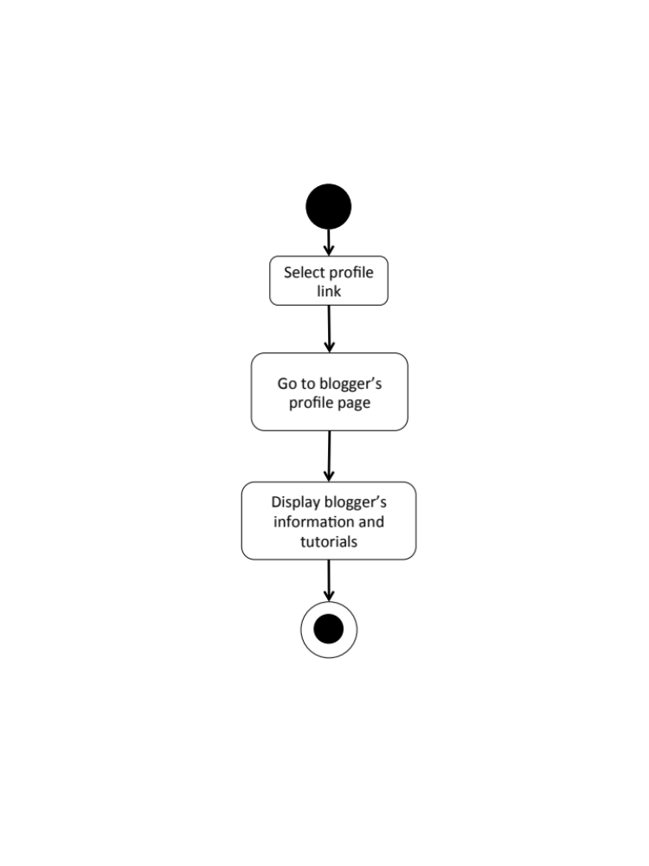
W-AD-04

W-URS-05: The user edits his/her information.

Input and Output
No | Input Name | Description | Example | Remarks | Output
1 | Email | Email must be the one that the user is currently using. | “kanom@msn.com” | The word should be in Email format | The system shows “kanom@msn.com” on the screen

Description
URS ID | W-URS-05
URS Name | The user edits his/her email.
Actor | Blogger
Description | This function allows user to edit his/her own email.
Trigger | The user selects “Edit” on user’s profile page.
Pre-condition | - User has logged in to the system.
Post-condition | - System updates the new information of user’s profile.
Normal flow | 1) User goes to edit profile page  2) System provides the editable interface of the profile.  3) User input new information.  4) User clicks save.  5) System validates email format.  6) System saves the new information into the database.  7) System goes back to profile page.
Alternative flow | - In step 1-4, the user clicks back button to go to the previous page in case he/she wants to cancel the edit profile process.
Exception | - In step 5, system displays error message in case the format is wrong.  - In all steps of normal flow, in case there is no internet connection.
Include | W-URS-02

W-URS-06: The user adds profile picture.

Input and Output
No | Input Name | Description | Example | Remarks | Output
1 | Picture | The file type must be .jpg or .png | “IMG_ProfilePic.jpg” | - | The system shows “IMG_ProfilePic.jpg” on the screen

Description
URS ID | W-URS-06
URS Name | The user adds profile picture.
Actor | Blogger
Description | This function allows user to add his/her picture as a profile picture.
Trigger | The user selects “Profile picture” to add a picture.
Pre-condition | - User has logged in to the system.  - User goes to edit profile page.
Post-condition | - Picture appears on the profile page as the user’s profile picture.
Normal flow | 1) User selects browse picture link.  2) System shows pictures in user’s computer.  3) User selects a picture.  4) User clicks save.  5) System validates picture format.  6) System saves the added picture into the database.  7) System goes back to user’s profile page.
Alternative flow | - In step 1-4, the user clicks cancel button to go to the previous page in case he/she wants to cancel the picture adding process.
Exception | - In step 5, system displays error message in case the format is wrong.  In all steps of normal flow, in case there is no internet connection.
Include | W-URS-02

W-URS-07: The user changes profile picture.

Input and Output
No | Input Name | Description | Example | Remarks | Output
1 | Picture | The file type must be .jpg or .png | “IMG_ProfilePic2.jpg” | - | The system shows “IMG_ProfilePic2.jpg” on the screen

Description
URS ID | W-URS-07
URS Name | The user changes profile picture.
Actor | Blogger
Description | This function allows user to change his/her profile picture.
Trigger | The user selects “Profile picture” to change the picture.
Pre-condition | - User has logged in to the system.  - User goes to edit profile page.
Post-condition | - System saves new user’s profile picture into database.
Normal flow | 1) User selects browse picture link.  2) System shows pictures in user’s computer.  3) User selects a picture.  4) User clicks save.  5) System validates picture format.  6) System saves the new picture into the database.  7) System goes back to user’s profile page.
Alternative flow | - In step 1-4, the user clicks cancel button to go to the previous page in case he/she wants to cancel the picture changing process.
Exception | - In step 5, system displays error message in case the format is wrong.  - In all steps of normal flow, in case there is no internet connection.
Include | W-URS-02

W-URS-08: The user changes his/her password.

Input and Output
No | Input Name | Description | Example | Remarks | Output
1 | Current Password | Current Password should be the password that the user is currently using. | “12345” | The word should not contain any symbol. | The system shows “●●●●●” on the screen
2 | New Password | The length of New Password must be between 1-20 characters | “00000” | The word should not contain any symbol. | The system shows “●●●●●” on the screen
3 | Re-New Password | Re-New Password must match with the New Password. | “00000” | The word should not contain any symbol. | The system shows “●●●●●” on the screen

Description
URS ID | W-URS-08
URS Name | The user changes his/her password.
Actor | Blogger
Description | This function allows user to change password for his/her account.
Trigger | The user selects “Change password” to change the password for user’s account.
Pre-condition | - User has logged in to the system.  - User goes to edit profile page.
Post-condition | - The password for the user’s account is updated.
Normal flow | 1) User clicks change password link.  2) System provide change password interface for user to fill information, which are current password and new password and re-new password.  3) User input information.  4) User clicks save button.  5) System validates current password, new password and re-new password.  6) System saves the new password into the database.  7) System goes back to user’s profile page.
Alternative flow | - In step 1-4, the user clicks back button to go to the previous page in case he/she wants to cancel the password changing process.
Exception | - In step 5, system displays error message in case the format is wrong.  - In all steps of normal flow, in case there is no internet connection.
Include | W-URS-02

W-URS-09: The user deletes his/her account.
Input and Output
- Input: The user selects delete account link to delete user’s account.
- Output: The system goes to home page for unlogged in user.

Description
URS ID | W-URS-09
URS Name | The user deletes his/her account.
Actor | Blogger
Description | This function allows user to delete his/her account, which the user will not be able to access the system as a blogger, unless the user register a new account.
Trigger | The user selects “Delete account” to delete the user’s account.
Pre-condition | - User has logged in to the system.  - User goes to edit profile page.
Post-condition | - User’s account is no longer available.
Normal flow | 1) User clicks delete account button.  2) System shows confirmation message with yes/no button.  3) User clicks yes button.  4) System removes the user’s information from the database.  5) System goes to visitor home page.
Alternative flow | - In step 1-3, the user clicks no button to cancel the account deletion process.
Exception | In all steps of normal flow, in case there is no internet connection.
Include | W-URS-02

W-AD-05
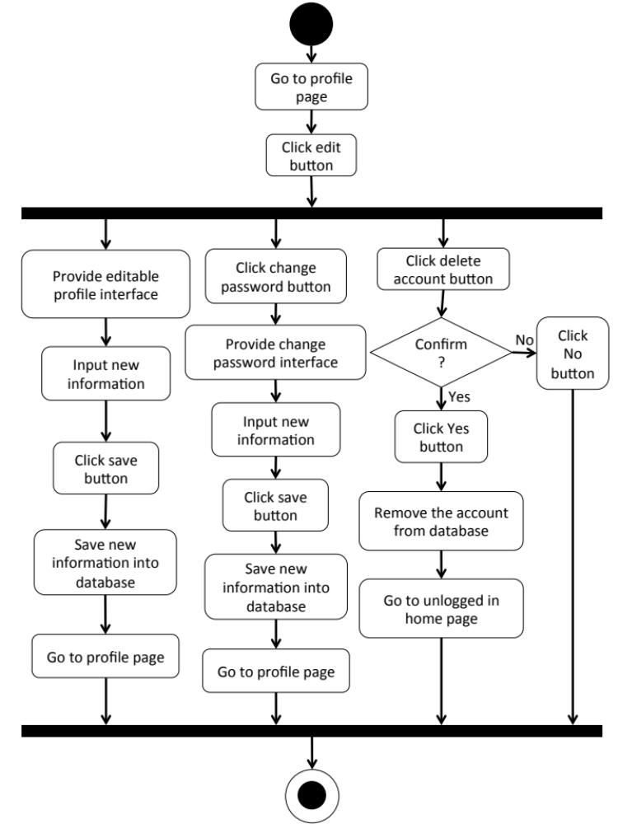

Feature 2: Tutorial Management
W-URS-10: The user sees tutorials by random.
Input and Output
- Input: The user selects random link to see random tutorials.
- Output: The system shows list of all tutorials with tutorial picture, title, owner username, and number of likes that exist in the database randomly.

Description
URS ID | W-URS-10
URS Name | The user sees tutorials by random.
Actor | Visitor, Blogger
Description | This function allows user to see list of tutorials that exist in database randomly.
Trigger | The user selects “Random” to see random tutorials.
Pre-condition | - User stays on Home page.
Post-condition | - System displays list of all tutorials that exist in the database randomly.
Normal flow | 1) User selects “Random” on the Home page.  2) System gets tutorials information from database.  3) System displays list of all tutorials with tutorial picture, title, owner username, and number of likes that exist in the database randomly.
Alternative flow | -
Exception | In all steps of normal flow, in case there is no internet connection.
Include | W-URS-02

W-URS-11: The user sees tutorials by popular.
Input and Output
- Input: The user selects popular link to see popular tutorials.
- Output: The system shows list of all tutorials with tutorial picture, title, owner username, and number of likes that exist in the database from the most liked to the less.

Description
URS ID | W-URS-11
URS Name | The user sees tutorials by popular.
Actor | Visitor, Blogger
Description | This function allows user to see list of tutorials that has most likes.
Trigger | The user selects “Popular” to see popular tutorials.
Pre-condition | - User stays on Home page.
Post-condition | - System displays list of all tutorials that exist in the database from the most liked to the less.
Normal flow | 1) User selects “Popular” on the Home page.  2) System gets tutorials information from database.  3) System displays list of all tutorials with tutorial picture, title, owner username, and number of likes that exist in the database from the most liked to the less.
Alternative flow | -
Exception | In all steps of normal flow, in case there is no internet connection.
Include | W-URS-02

W-URS-12: The user sees tutorials by categories.

Input and Output
- Input: The user selects a category link to see tutorials by category.
- Output: The system shows list of tutorials with tutorial picture, title, owner username, and number of likes of the selected category that exist in the database.

Description
URS ID | W-URS-12
URS Name | The user sees tutorials by categories.
Actor | Visitor, Blogger
Description | This function allows user to see list of tutorials according to each category.
Trigger | The user selects “Categories” to see categories of tutorials.
Pre-condition | - User goes to Menu page.
Post-condition | - System displays list of tutorials of the category.
Normal flow | 1) User clicks categories button.  2) System displays categories, which are outfit, accessory, gift, kid, garden, home décor, pet, and other.  3) User selects a category.  4) System gets tutorials information from database.  5) System displays list of tutorials with tutorial picture, title, owner username, and number of likes of the selected category that exist in the database.
Alternative flow | -
Exception | In all steps of normal flow, in case there is no internet connection.
Include | W-URS-02

W-URS-13: The user sees tutorials by searching.

Input and Output
No | Input Name | Description | Example | Remarks | Output
1 | Keyword | The length of Keyword must be between 1-20 characters | “Bracelet” | The word should not contain any symbol. | The system shows tutorials that have the word “Bracelet” as a tutorial name.

Description
URS ID | W-URS-13
URS Name | The user sees tutorials by searching.
Actor | Visitor, Blogger
Description | This function allows user to see list of tutorials by inputting keyword.
Trigger | The user clicks on the search box.
Pre-condition | - User stays on Home page.
Post-condition | - System displays list of all tutorials that relate to the keyword.
Normal flow | 1) User input a keyword in the search box.  2) System gets tutorials information from database.  3) System displays list of all tutorials with tutorial picture, title, owner username, and number of likes that relate to the keyword.
Alternative flow | -
Exception | In all steps of normal flow, in case there is no internet connection.
Include | W-URS-02

W-URS-14: The user sees tutorials by following.

Input and Output
- Input: The user selects following link to see following tutorials.
- Output: The system shows list of tutorials with tutorial picture, title, owner username, and number of likes from the following bloggers.

Description
URS ID | W-URS-14
URS Name | The user sees tutorials by following.
Actor | Blogger
Description | This function allows user to see list of tutorials from the bloggers that the user is following.
Trigger | The user selects “Following” to see tutorials from the bloggers that the user is following.
Pre-condition | - User has logged in to the system.  - User stays on Home page.
Post-condition | - System displays list of tutorials from the following bloggers.
Normal flow | 1) User tab “Following” on the Home page.  2) System gets tutorials of following bloggers from database.  3) System displays list of tutorials with tutorial picture, title, owner username, and number of likes from the following bloggers.
Alternative flow | - In step 1, the user cannot use this function if he/she has not logged in yet.
Exception | In all steps of normal flow, in case there is no internet connection.
Include | W-URS-02

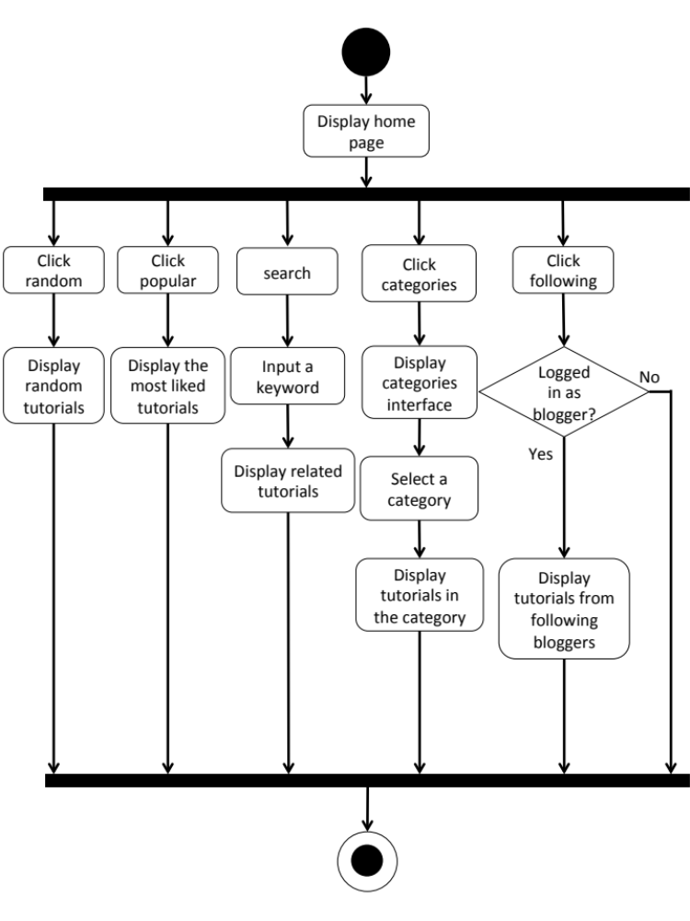
W-AD-06

W-URS-15: The user sees tutorial information.
Input and Output
- Input: The user selects tutorial link to see tutorial’s detail.
- Output: The system shows information of the tutorial, which are title, owner username, number of likes, category, material picture, material description, step description, step picture, video, and comments.

Description
URS ID | W-URS-15
URS Name | The user sees tutorial information.
Actor | Visitor, Blogger
Description | This function allows user to see information of each tutorial.
Trigger | The user selects a tutorial to see the information.
Pre-condition | - User selects a tutorial.
Post-condition | - System displays all information of the tutorial.
Normal flow | 1) User selects a tutorial.  2) System gets the tutorial’s information from database.  3) System displays all information of the tutorial, which are title, owner username, number of likes, category, material picture, material description, step description, step picture, video, and comments.
Alternative flow | -
Exception | In all steps of normal flow, in case there is no internet connection.
Include | W-URS-02

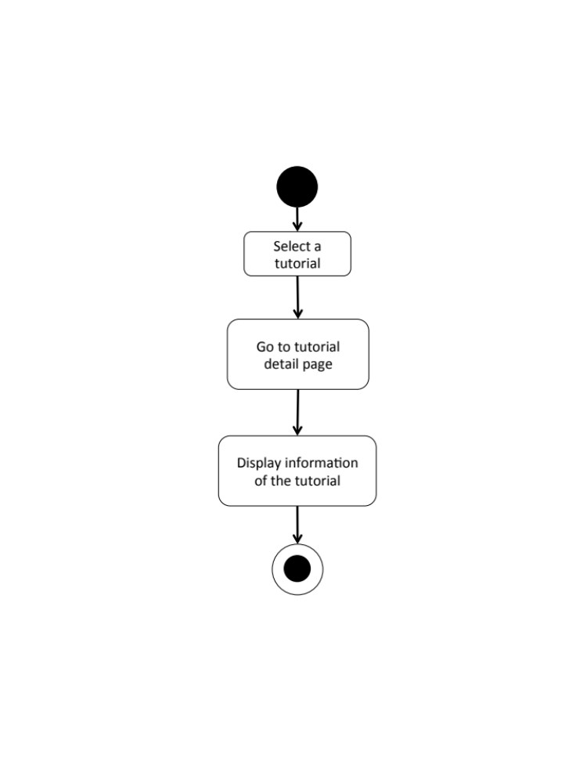
W-AD-07

W-URS-16: The user creates his/her own tutorial.

Input and Output
No | Input Name | Description | Example | Remarks | Output
1 | Tutorial Picture | The file type must be .jpg or .png | “IMG_tutorial.jpg” | - | The system shows “IMG_tutorial.jpg” on the screen
2 | Title | The length of Title must be between 1-20 characters | “Handmade Bracelet” | The word should not contain any symbol. | The system shows “Handmade Bracelet” on the screen
3 | Category | The categories are provided by the system. | “Accessory” | - | The system shows “Accessory” on the screen
4 | Material Picture | The file type must be .jpg or .png | “IMG_material.jpg” | - | The system shows “IMG_material.jpg” on the screen
5 | Material Description | The length of Material Description must be between 1-500 characters | “1.Rope 2.Glue 3.Scissor 4.Glitter 5.Pin” | - | The system shows “1.Rope 2.Glue 3.Scissor 4.Glitter 5.Pin”on the screen
6 | Step Number | The number of step should be between 1-6 | “1” | No symbol or character is allowed. | The system shows “1” on the screen
7 | Step Picture | The file type must be .jpg or .png | “IMG_step1.jpg” | - | The system shows “IMG_step1.jpg” on the screen
8 | Step Description | The length of Step Description must be between 1-500 characters | “Cut the rope to have the length as long as it can be out around your wrist.” | - | The system shows “Cut the rope to have the length as long as it can be out around your wrist.” On the screen
9 | Video | The file type must be .mov | “VDO_tutorial.mov” | - | The system shows “VDO_tutorial.mov” on the screen

Description
URS ID | W-URS-16
URS Name | The user creates his/her own tutorial.
Actor | Blogger
Description | This function allows user to create his/her own tutorial.
Trigger | The user selects “Create” to create a new tutorial.
Pre-condition | - User has logged in to the system.
Post-condition | - System stores the created tutorial into database.
Normal flow | 1) User clicks create button.  2) System provides create tutorial interface for user to fill information, which are tutorial picture, title, category, material, material picture, step description, step picture, and video.  3) User inputs the information.  4) User input the information step by step.  5) User clicks done button.  6) System validates tutorial picture, title, category, material picture, material description, step number, step picture, step description, and video format.  7) System saves the tutorial into the database.  8) System shows successful message.
Alternative flow | - In step 1-5, the user clicks back button to go to the previous page in case he/she wants to cancel the tutorial creating process.
Exception | - In step 6, system displays error message in case the format is wrong.  - In all steps of normal flow, in case there is no internet connection.
Include | W-URS-02

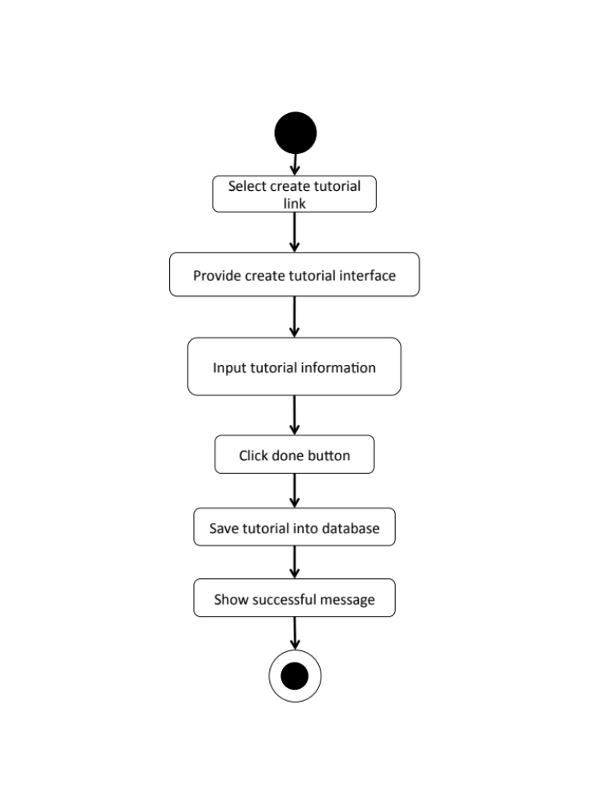
W-AD-08

W-URS-17: The user sees his/her own tutorial.
Input and Output
- Input: The user selects profile link to go to profile page.
- Output: The system shows user’s profile including list of his/her tutorials.

Description
URS ID | W-URS-17
URS Name | The user sees his/her own tutorial.
Actor | Blogger
Description | This function allows user to see tutorials that the user has created.
Trigger | The user selects “Profile” to see his/her information including his/her own tutorials.
Pre-condition | - User has logged in to the system.  - User goes to his/her profile page
Post-condition | - System shows tutorials that the user has created.
Normal flow | - User goes to profile page.  - System gets user’s information from database.  3) System displays interface and user’s information, which are profile picture, username, password, follower number, following number, and list of tutorials that he/she has created.
Alternative flow | -
Exception | In all steps of normal flow, in case there is no internet connection.
Include | W-URS-02

W-URS-18: The user edits his/her own tutorial.

Input and Output
No | Input Name | Description | Example | Remarks | Output
1 | Tutorial Picture | The file type must be .jpg or .png | “IMG_tutorial2.jpg” | - | The system shows “IMG_tutorial2.jpg” on the screen
2 | Title | The length of Title must be between 1-20 characters | “DIY Bracelet” | The word should not contain any symbol. | The system shows “How to make a Handmade Bracelet by yourself” on the screen
3 | Category | The categories are provided by the system. | “Outfit” | - | The system shows “Accessory” on the screen
4 | Material Picture | The file type must be .jpg or .png | “IMG_material2.jpg” | - | The system shows “IMG_material2.jpg” on the screen
5 | Material Description | The length of Material Description must be between 1-500 characters | “1.Rope 2.Glue 3.Scissor 4.Glitter 5.Pin 6.Color” | - | The system shows “1.Rope 2.Glue 3.Scissor 4.Glitter 5.Pin  6.Color” on the screen
6 | Step | The number of step should be between 1-6 | “2” | No symbol or character is allowed. | The system shows “2” on the screen
7 | Step 1 Picture | The file type must be .jpg or .png | “IMG_step1.jpg” | - | The system shows “IMG_step1.jpg” on the screen
8 | Step 1 Description | The length of Step Description must be between 1-500 characters | “Cut the rope to have the length as long as it can be out around your wrist.  Be careful when you cut it!” | - | The system shows “Cut the rope to have the length as long as it can be out around your wrist. Be careful when you cut it!” on the screen
9 | Step 2 Picture | The file type must be .jpg or .png | “IMG_step2.jpg” | - | The system shows “IMG_step2.jpg” on the screen
10 | Step 2 Description | The length of Step Description must be between 1-500 characters | “Now it’s time to decorate!” | - | The system shows “Now it’s time to decorate!” on the screen
11 | Video | The file type must be .mov | “VDO_tutorial2.mov” | - | The system shows “VDO_tutorial2.mov” on the screen

Description
URS ID | W-URS-18
URS Name | The user edits his/her own tutorial.
Actor | Blogger
Description | This function allows user to make some changes on his/her own tutorial.
Trigger | The user selects “Edit” to edit the selected tutorial.
Pre-condition | - User has logged in to the system.
Post-condition | - System updates new information of the tutorial.
Normal flow | 1) User selects a tutorial that wants to be edited.  2) User clicks edit button.  3) System provides the editable interface for user to edit tutorial picture, title, category, material picture, material description, step number, step picture, step description, and video.  4) User clicks save.  5) System validates tutorial picture, title, category, material picture, material description, step number, step picture, step description, and video format.  6) System saves the edited tutorial into the database.  7) System shows successful message.
Alternative flow | In step 1-4, the user clicks back button to cancel the process.
Exception | - In step 6, system displays error message in case the format is wrong.  - In all steps of normal flow, in case there is no internet connection.
Include | W-URS-02

W-URS-19: The user deletes his/her own tutorial.

Input and Output
- Input: The user selects delete tutorial link to delete his/her tutorial.
- Output: The tutorial disappears from the tutorial list.

Description
URS ID | W-URS-19
URS Name | The user deletes his/her own tutorial.
Actor | Blogger
Description | This function allows user to remove his/her own tutorial from the database.
Trigger | The user selects “Delete tutorial” to remove tutorial from the database.
Pre-condition | - User has logged in to the system.  - User selects the tutorial that wants delete.
Post-condition | - System removes the tutorial from the database.
Normal flow | 1) User clicks delete button.  2) System shows confirmation message with yes/no button.  3) User clicks yes button.  4) System removes the tutorial from the database.  5) System shows successful message.
Alternative flow | - In step 1-3, the user clicks no button to cancel the tutorial deletion process.
Exception | In all steps of normal flow, in case there is no internet connection.
Include | W-URS-02

W-AD-09
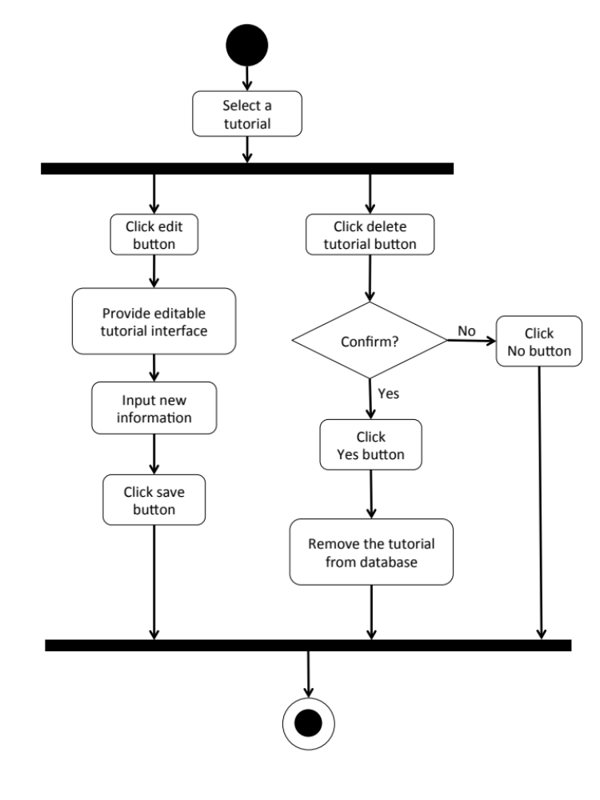

    - User Requirement Description for Mobile Application

Feature 1: Authorization Management

M-URS-01: The user registers as a blogger/shopkeeper.

Input and Output
No | Input Name | Description | Example | Remarks | Output
1 | Username | The length of Username must be between 1-20 characters | “hideandseek05” | The word should not contain any symbol. | The system shows “HideandSeek05” on the screen
2 | Password | The length of Password must be between 1-20 characters | “12345” | The word should not contain any symbol. | The system shows “●●●●●” on the screen
3 | Re-Password | Re-password must match with the password. | “12345” | The word should not contain any symbol. | The system shows “●●●●●” on the screen
4 | Email | Email must be the one that the user is currently using. | “hello@gmail.com” | The word should be in Email format | The system shows “hello@gmail.com” on the screen
5 | Role | The choices, blogger and shopkeeper, will be provided for the user to choose. | “Blogger” | - | The system shows selected sign on the role that user selects.
6 | Picture | The file type must be .jpg or .png | “IMG_ProfilePic.jpg” | - | The system shows “IMG_ProfilePic.jpg” on the screen

Description
URS ID | M-URS-01
URS Name | The user registers as a blogger/shopkeeper.
Actor | User
Description | This function allows user who does not have his/her own account to register in order to use more functions of the application.
Trigger | The user selects “Sign Up” to register to be a member of the system.
Pre-condition | - Open the application
Post-condition | - The system saves user’s information into database.
Normal flow | 1) System provides registration interface for user to fill information, which are username, password, re-password, e-mail, role, and profile picture.  3) User input his/her information.  4) User clicks done to finish the registration.  5) System validates the information.  6) System saves the user’s information into the database.  7) System goes back to log in page.
Alternative flow | - In step 1-4, the user clicks back button to go to the previous page in case he/she wants to cancel the registration.
Exception | - In step 5, in case user has input incorrect information, system will display an alert message in order to notify user to input correct information.  - In all steps of normal flow, in case there is no internet connection.
Include | -

M-AD-01

M-URS-02: The user logins to the system.
Input and Output
No | Input Name | Description | Example | Remarks | Output
1 | Username | The length of Username must be between 1-20 characters | “hideandseek05” | The word should not contain any symbol. | The system shows “HideandSeek05” on the screen
2 | Password | The length of Password must be between 1-20 characters | “12345” | The word should not contain any symbol. | The system shows “●●●●●” on the screen

Description
URS ID | M-URS-02
URS Name | The user logins to the system.
Actor | Blogger, Shopkeeper
Description | This function allows user, who has registered, logs in to the system.
Trigger | The user selects “Log in” to log in to the system.
Pre-condition | - User has registered to the system.
Post-condition | - User goes to home page for blogger.
Normal flow | 1) User clicks log in button.  2) System provides log in interface for user to fill information, which are username and password.  3) User input his/her username and password.  4) Users click log in button.  5) System validates username, and password format.  6) System verifies username and password from the database.  7) System goes to home page.
Alternative flow | - In step 4, the user clicks back button to go to the previous page in case he/she wants to cancel the log in process.
Exception | - In step 5, in case user input invalid username or password, system will show an alert message.  - In all steps of normal flow, in case there is no internet connection.
Include | -

M-AD-02

M-URS-03: The user logouts from the system.
Input and Output
- Input: The user selects log out link to exit from the system.
- Output: The user log out from the system.

Description
URS ID | M-URS-03
URS Name | The user logouts from the system.
Actor | Blogger, Shopkeeper
Description | This function allows user to log out from the system.
Trigger | The user selects “Log out” to log out from the system.
Pre-condition | - User has logged in to the system.
Post-condition | - User has no longer logged in.
Normal flow | 1) User goes to Menu page.  2) System provides Menu page interface, which provides Categories, Shops, Around me, and Log out buttons.  3) User clicks Log out button.  4) System goes to visitor home page.
Alternative flow | -
Exception | - In all steps of normal flow, in case there is no internet connection.
Include | M-URS-02

M-AD-03

M-URS-04: The user sees his/her profile.
Input and Output
- Input: The user selects profile link to go to profile page.
- Output: The system shows user’s profile.

Description
URS ID | M-URS-04
URS Name | The user sees his/her profile.
Actor | Blogger
Description | This function allows user to see his/her own profile and information.
Trigger | The user selects “Profile” to go to his/her profile.
Pre-condition | - User has logged in to the system.
Post-condition | - System displays user’s profile.
Normal flow | - User goes to profile page.  - System gets user’s information from database.  - System displays interface and user’s information, which are profile picture, username, password, follower number, following number, and list of tutorials that he/she has created.
Alternative flow | -
Exception | In all steps of normal flow, in case there is no internet connection.
Include | M-URS-02

M-AD-04

M-URS-05: The user edits his/her email.
Input and Output
No | Input Name | Description | Example | Remarks | Output
1 | Email | Email must be the one that the user is currently using. | “kanom@msn.com” | The word should be in Email format | The system shows “kanom@msn.com” on the screen

Description
URS ID | M-URS-05
URS Name | The user edits his/her email.
Actor | Blogger
Description | This function allows user to edit his/her own email.
Trigger | The user selects “Edit” on user’s profile page.
Pre-condition | - User has logged in to the system.
Post-condition | - System updates the new information of user’s profile.
Normal flow | 1) User goes to edit profile page  2) System provides the editable interface of the profile.  3) User input new information.  4) User clicks save.  5) System saves the edited profile into the database.  6) System goes back to user’s profile page.
Alternative flow | - In step 1-4, the user clicks back button to go to the previous page in case he/she wants to cancel the edit profile process.
Exception | - In all steps of normal flow, in case there is no internet connection.
Include | M-URS-02

M-URS-06: The user changes profile picture.
Input and Output
No | Input Name | Description | Example | Remarks | Output
1 | Picture | The file type must be .jpg or .png | “IMG_ProfilePic2.jpg” | - | The system shows “IMG_ProfilePic2.jpg” on the screen

Description
URS ID | M-URS-06
URS Name | The user changes profile picture.
Actor | Blogger
Description | This function allows user to change his/her profile picture.
Trigger | The user selects “Profile picture” to change the picture.
Pre-condition | - User has logged in to the system.  - User goes to edit profile page.
Post-condition | - System saves new user’s profile picture into database.
Normal flow | 1) User selects profile picture link.  2) System shows pictures in phone gallery.  3) User selects a picture.  4) User clicks save.  5) System saves the new picture into the database.  6) System goes back to user’s profile page.
Alternative flow | - In step 1-4, the user clicks cancel button to go to the previous page in case he/she wants to cancel the picture changing process.
Exception | In all steps of normal flow, in case there is no internet connection.
Include | M-URS-02

M-URS-07: The user changes his/her password.
Input and Output
No | Input Name | Description | Example | Remarks | Output
1 | Current Password | Current Password should be the password that the user is currently using. | “12345” | The word should not contain any symbol. | The system shows “●●●●●” on the screen
2 | New Password | The length of New Password must be between 1-20 characters | “00000” | The word should not contain any symbol. | The system shows “●●●●●” on the screen
3 | Re-New Password | Re-New Password must match with the New Password. | “00000” | The word should not contain any symbol. | The system shows “●●●●●” on the screen

Description
URS ID | M-URS-07
URS Name | The user changes his/her password.
Actor | Blogger
Description | This function allows user to change password for his/her account.
Trigger | The user selects “Change password” to change the password for user’s account.
Pre-condition | - User has logged in to the system.  - User goes to edit profile page.
Post-condition | - The password for the user’s account is updated.
Normal flow | 1) User clicks change password button.  2) System provide change password interface for user to fill information, which are current password and new password.  3) User input information.  4) User clicks save button.  5) System saves the new password into the database.  6) System goes back to user’s profile page.
Alternative flow | - In step 4, the user clicks back button to go to the previous page in case he/she wants to cancel the password changing process.
Exception | In all steps of normal flow, in case there is no internet connection.
Include | M-URS-02

M-URS-08: The user deletes his/her account.

Input and Output
- Input: The user selects delete account link to delete user’s account.
- Output: The system goes to home page for unlogged in user.

Description
URS ID | M-URS-08
URS Name | The user deletes his/her account.
Actor | Blogger
Description | This function allows user to delete his/her account, which the user will not be able to access the system as a blogger, unless the user register a new account.
Trigger | The user selects “Delete account” to delete the user’s account.
Pre-condition | - User has logged in to the system.  - User goes to edit profile page.
Post-condition | - User’s account is no longer available.
Normal flow | 1) User clicks delete account button.  2) System shows confirmation message.  3) User clicks yes button.  4) System removes the user’s account from the database.  5) System goes to unlogged in home page.
Alternative flow | - In step 3, the user clicks no button to cancel the account deletion process.
Exception | In all steps of normal flow, in case there is no internet connection.
Include | M-URS-02

M-AD-05

Feature 2: Tutorial Management
M-URS-09: The user sees tutorials by random.
Input and Output
- Input: The user selects random link to see random tutorials.
- Output: The system shows list of all tutorials with tutorial picture, title, owner username, and number of likes that exist in the database randomly.

Description
URS ID | M-URS-09
URS Name | The user sees tutorials by random.
Actor | Visitor, Blogger
Description | This function allows user to see list of tutorials randomly.
Trigger | The user selects “Random” to see random tutorials.
Pre-condition | - User stays on Home page.
Post-condition | - System displays list of all tutorials that exist in the database randomly.
Normal flow | 1) User selects “Random” on the Home page.  2) System gets tutorials information from database.  3) System displays list of all tutorials with tutorial picture, title, owner username, and number of likes that exist in the database randomly.
Alternative flow | -
Exception | In all steps of normal flow, in case there is no internet connection.
Include | M-URS-02

M-URS-10: The user sees tutorials by popular.
Input and Output
- Input: The user selects popular link to see popular tutorials.
- Output: The system shows list of all tutorials with tutorial picture, title, owner username, and number of likes that exist in the database from the most liked to the less.

Description
URS ID | M-URS-10
URS Name | The user sees tutorials by popular.
Actor | Visitor, Blogger
Description | This function allows user to see list of tutorials that has most likes.
Trigger | The user selects “Popular” to see popular tutorials.
Pre-condition | - User stays on Home page.
Post-condition | - System displays list of all tutorials that exist in the database from the most liked to the less.
Normal flow | 1) User selects “Popular” on the Home page.  2) System gets tutorials information from database.  3) System displays list of all tutorials with tutorial picture, title, owner username, and number of likes that exist in the database from the most liked to the less.
Alternative flow | -
Exception | In all steps of normal flow, in case there is no internet connection.
Include | M-URS-02

M-URS-11: The user sees tutorials by categories.

Input and Output
- Input: The user selects a category link to see tutorials by category.
- Output: The system shows list of tutorials with tutorial picture, title, owner username, and number of likes of the category.

Description
URS ID | M-URS-11
URS Name | The user sees tutorials by categories.
Actor | Visitor, Blogger
Description | This function allows user to see list of tutorials according to each category.
Trigger | The user selects “Categories” to see categories of tutorials.
Pre-condition | - User stays on Home page.
Post-condition | - System displays list of tutorials of the category.
Normal flow | - User goes to Menu page.  - System provides Menu page interface, which provides Categories, Shops, Around Me, and Log Out buttons.  3) User click categories button.  4) System displays categories, which are outfit, accessory, gift, kid, garden, home décor, pet, and other.  5) User selects a category.  6) System gets tutorials information from database.  7) System displays list of tutorials with tutorial picture, title, owner username, and number of likes of the category.
Alternative flow | -
Exception | In all steps of normal flow, in case there is no internet connection.
Include | M-URS-02

M-URS-12: The user sees tutorials by searching.

Input and Output
No | Input Name | Description | Example | Remarks | Output
1 | Keyword | The length of Keyword must be between 1-20 characters | “Bracelet” | The word should not contain any symbol. | The system shows tutorials that have the word “Bracelet” as a tutorial name.

Description
URS ID | M-URS-12
URS Name | The user sees tutorials by searching.
Actor | Visitor, Blogger
Description | This function allows user to see list of tutorials by inputting keyword.
Trigger | The user clicks on the search box.
Pre-condition | - User stays on Home page.
Post-condition | - System displays list of all tutorials that relate to the keyword.
Normal flow | 1) User input a keyword in the search box.  2) System gets tutorials information from database.  3) System displays list of all tutorials with tutorial picture, title, owner username, and number of likes that relate to the keyword.
Alternative flow | -
Exception | In all steps of normal flow, in case there is no internet connection.
Include | M-URS-02

M-URS-13: The user sees tutorials by following.

Input and Output
- Input: The user selects following link to see following tutorials.
- Output: The system shows list of tutorials with tutorial picture and title from the following bloggers.

Description
URS ID | M-URS-13
URS Name | The user sees tutorials by following.
Actor | Blogger
Description | This function allows user to see list of tutorials from the bloggers that the user is following.
Trigger | The user selects “Following” to see tutorials from the bloggers that the user is following.
Pre-condition | - User has logged in to the system.  - User stays on Home page.
Post-condition | - System displays list of tutorials from the following bloggers.
Normal flow | 1) User tab “Following” on the Home page.  2) System gets tutorials information from database.  3) System displays list of tutorials with tutorial picture, title, owner username, and number of likes from the following bloggers.
Alternative flow | -
Exception | In all steps of normal flow, in case there is no internet connection.
Include | M-URS-02

M-AD-06

M-URS-14: The user sees tutorial information.
Input and Output
- Input: The user selects tutorial link to see tutorial’s detail.
- Output: The system shows information of the tutorial, which are title, owner username, number of likes, category, material picture, material description, step description, step picture, video, and comments.

Description
URS ID | M-URS-14
URS Name | The user sees tutorial information.
Actor | Visitor, Blogger
Description | This function allows user to information of each tutorial.
Trigger | The user selects a tutorial to see the information.
Pre-condition | - User selects a tutorial
Post-condition | - System displays all information of the tutorial.
Normal flow | 1) User selects a tutorial.  2) System gets the tutorial’s information from database.  3) System displays all information of the tutorial, which are title, owner username, number of likes, category, material picture, material description, step description, step picture, video, and comments.
Alternative flow | -
Exception | In all steps of normal flow, in case there is no internet connection.
Include | M-URS-02

M-AD-07

M-URS-15: The user creates his/her own tutorial.

Input and Output
No | Input Name | Description | Example | Remarks | Output
1 | Tutorial Picture | The file type must be .jpg or .png | “IMG_tutorial.jpg” | - | The system shows “IMG_tutorial.jpg” on the screen
2 | Title | The length of Title must be between 1-20 characters between 1-20 characters | “Handmade Bracelet” | The word should not contain any symbol. | The system shows “Handmade Bracelet” on the screen
3 | Category | The categories are provided by the system. | “Accessory” | - | The system shows “Accessory” on the screen
4 | Material Picture | The file type must be .jpg or .png | “IMG_material.jpg” | - | The system shows “IMG_material.jpg” on the screen
5 | Material Description | The length of Material Description must be between 1-500 characters | “1.Rope 2.Glue 3.Scissor 4.Glitter 5.Pin” | - | The system shows “1.Rope 2.Glue 3.Scissor 4.Glitter 5.Pin”on the screen
6 | Step | The number of step should be between 1-6 | “1” | No symbol or character is allowed. | The system shows “1” on the screen
7 | Step Picture | The file type must be .jpg or .png | “IMG_step1.jpg” | - | The system shows “IMG_step1.jpg” on the screen
8 | Step Description | The length of Step Description must be between 1-500 characters | “Cut the rope to have the length as long as it can be out around your wrist.” | - | The system shows “Cut the rope to have the length as long as it can be out around your wrist.” on the screen
9 | Video | The file type must be .mov | “VDO_tutorial.mov” | - | The system shows “VDO_tutorial.mov” on the screen

Description
URS ID | M-URS-15
URS Name | The user creates his/her own tutorial.
Actor | Blogger
Description | This function allows user to create his/her own tutorial.
Trigger | The user selects “Create” to create a new tutorial.
Pre-condition | - User has logged in to the system.
Post-condition | - System saves the created tutorial into database.
Normal flow | 1) User clicks create button.  2) System provides create tutorial interface for user to fill information, which are tutorial picture, title, and category.  3) User inputs the information.  4) System validates tutorial picture, title, and category format.  5) User clicks next link.  6) System provides create tutorial interface for user to fill information, which are material, material picture, step description, step picture, and video.  7) User input the information step by step.  8) User clicks done button.  9) System validates material picture, material description, step number, step picture, step description, and video format.  10) System saves the tutorial into the database.  11) System shows successful message.
Alternative flow | - In step 1-8, the user clicks back button to go to the previous page in case he/she wants to cancel the tutorial creating process.
Exception | - In step 4 and 9, system displays error message in case the format is wrong.  - In all steps of normal flow, in case there is no internet connection.
Include | M-URS-02

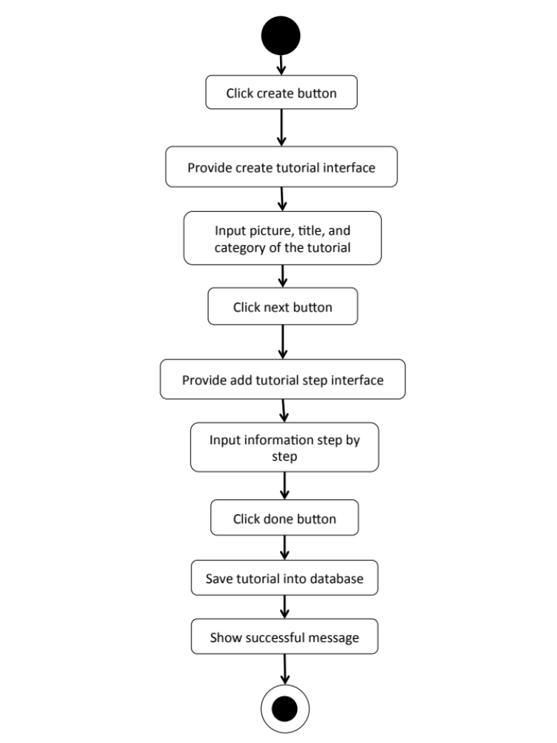

M-AD-08

M-URS-16: The user sees his/her own tutorial.
Input and Output
- Input: The user selects profile link to go to profile page.
- Output: The system shows user’s profile including list of his/her tutorials.

Description
URS ID | M-URS-16
URS Name | The user sees his/her own tutorial.
Actor | Blogger
Description | This function allows user to see tutorials that the user has created.
Trigger | The user selects “Profile” to see his/her information including his/her own tutorials.
Pre-condition | - User has logged in to the system.  - User goes to his/her profile page
Post-condition | - System shows tutorials that the user has created.
Normal flow | - User goes to profile page.  - System gets user’s information from database.  3) System displays interface and user’s information, which are profile picture, username, password, follower number, following number, and tutorials that he/she has created.
Alternative flow | -
Exception | In all steps of normal flow, in case there is no internet connection.
Include | M-URS-02

M-URS-17: The user edits his/her own tutorial.
Input and Output
No | Input Name | Description | Example | Remarks | Output
1 | Tutorial Picture | The file type must be .jpg or .png | “IMG_tutorial2.jpg” | - | The system shows “IMG_tutorial2.jpg” on the screen
2 | Title | The length of Title must be between 1-20 characters between 1-20 characters | “How to make a Handmade Bracelet by yourself” | The word should not contain any symbol. | The system shows “How to make a Handmade Bracelet by yourself” on the screen
3 | Category | The categories are provided by the system. | “Outfit” | - | The system shows “Accessory” on the screen
4 | Material Picture | The file type must be .jpg or .png | “IMG_material2.jpg” | - | The system shows “IMG_material2.jpg” on the screen
5 | Material Description | The length of Material Description must be between 1-500 characters | “1.Rope 2.Glue 3.Scissor 4.Glitter 5.Pin 6.Color” | - | The system shows “1.Rope 2.Glue 3.Scissor 4.Glitter 5.Pin  6.Color” on the screen
6 | Step | The number of step should be between 1-6 | “2” | No symbol or character is allowed. | The system shows “2” on the screen
7 | Step 1 Picture | The file type must be .jpg or .png | “IMG_step1.jpg” | - | The system shows “IMG_step1.jpg” on the screen
8 | Step 1 Description | The length of Step Description must be between 1-500 characters | “Cut the rope to have the length as long as it can be out around your wrist.  Be careful when you cut it!” | - | The system shows “Cut the rope to have the length as long as it can be out around your wrist. Be careful when you cut it!” on the screen
9 | Step 2 Picture | The file type must be .jpg or .png | “IMG_step2.jpg” | - | The system shows “IMG_step2.jpg” on the screen
10 | Step 2 Description | The length of Step Description must be between 1-500 characters | “Now it’s time to decorate!” | - | The system shows “Now it’s time to decorate!” on the screen
11 | Video | The file type must be .mov | “VDO_tutorial2.mov” | - | The system shows “VDO_tutorial2.mov” on the screen

Description
URS ID | M-URS-17
URS Name | The user edits his/her own tutorial.
Actor | Blogger
Description | This function allows user to make some changes on his/her own tutorial.
Trigger | The user selects “Edit” to edit the selected tutorial.
Pre-condition | - User has logged in to the system.
Post-condition | - System updates new information of the tutorial.
Normal flow | 1) User selects a tutorial that wants to be edited.  2) User clicks edit button.  3) System provides the editable interface for user to edit tutorial picture, title, category, material picture, material description, step number, step picture, step description, and video.  4) User clicks save.  5) System validates tutorial picture, title, category, material picture, material description, step number, step picture, step description, and video format.  6) System saves the edited tutorial into the database.  7) System shows successful message.
Alternative flow | In step 1-4, the user clicks back button to cancel the process.
Exception | - In step 6, system displays error message in case the format is wrong.  - In all steps of normal flow, in case there is no internet connection.
Include | M-URS-02

M-AD-09

Chapter Four | System Features

  - Software Requirement Specification
    - Software Requirement Specification for Web Application

W-URS-01: The user registers as a blogger.
SRS No. | SRS Name
W-SRS-01 | The system shall provide graphic user interface, which receive username, password, re-password, and e-mail.
W-SRS-02 | The system shall check the username format. The username must be 1-20 characters and must not contain any symbol.
W-SRS-03 | The system shall check the password format. The password must be 1-20 characters and must not contain any symbol.
W-SRS-04 | The system shall check whether the re-password is match to the password or not.
W-SRS-05 | The system shall check email format. The email must be in email format.
W-SRS-06 | The system shall check in database whether the username is already in use or not.
W-SRS-07 | The system shall show successful message “You are now a blogger, please log in.”
W-SRS-08 | The system shall show error message “The username should be between 1-20 characters.”
W-SRS-09 | The system shall show error message “The username should not contain any symbols”
W-SRS-10 | The system shall show error message “This username is already in use.”
W-SRS-11 | The system shall show error message “The password should be between 1-20 characters.”
W-SRS-12 | The system shall show error message “The password should not contain any symbols.”
W-SRS-13 | The system shall show error message “Re-password is not matching with your password.”
W-SRS-14 | The system shall show error message “The email should be in email format.”
W-SRS-15 | The system shall show error message “Sorry, you are not connected to the internet”
W-SRS-16 | The system shall save information into database.
W-SRS-22 | The system shall show error message “Please fill all information, don’t leave blank.”

W-URS-02: The user logins to the system.
SRS No. | SRS Name
W-SRS-17 | The system shall provide graphic user interface, which receive username and password.
W-SRS-02 | The system shall check the username format. The username must be 1-20 characters and must not contain any symbol.
W-SRS-03 | The system shall check the password format. The password must be 1-20 characters and must not contain any symbol.
W-SRS-18 | The system shall retrieve the username and password
W-SRS-19 | The system shall verify the username and password
W-SRS-20 | The system shall show the home page for blogger.
W-SRS-08 | The system shall show error message “The username should be between 1-20 characters.”
W-SRS-09 | The system shall show error message “The username should not contain any symbols”
W-SRS-10 | The system shall show error message “This username is already in use.”
W-SRS-11 | The system shall show error message “The password should be between 1-20 characters.”
W-SRS-12 | The system shall show error message “The password should not contain any symbols.”
W-SRS-21 | The system shall show error message “Invalid username or password.”
W-SRS-15 | The system shall show error message “Sorry, you are not connected to the internet”
W-SRS-22 | The system shall show error message “Please fill all information, don’t leave blank.”

W-URS-03: The user logouts from the system.
SRS No. | SRS Name
W-SRS-23 | The system shall provide home page interface for blogger, which provides notification symbol, create tutorial symbol, message symbol, profile symbol, log out symbol, random button, popular button, following button, categories tab, search box, and list of tutorials with tutorial picture, title, owner username, and number of likes.
W-SRS-24 | The system shall show the home page for visitor.
W-SRS-15 | The system shall show error message “Sorry, you are not connected to the internet”

W-URS-04: The user sees his/her profile.
SRS No. | SRS Name
W-SRS-23 | The system shall provide home page interface for blogger, which provides notification symbol, create tutorial symbol, message symbol, profile symbol, log out symbol, random button, popular button, following button, categories tab, search box, and list of tutorials with tutorial picture, title, owner username, and number of likes.
W-SRS-25 | The system shall provide profile page interface, which shows the blogger’s username, email, following, follower, profile picture, created tutorials with tutorial picture, title, number of likes, and edit button.
W-SRS-15 | The system shall show error message “Sorry, you are not connected to the internet”

W-URS-05: The user edits his/her profile.
SRS No. | SRS Name
W-SRS-26 | The system shall provide edit profile page interface, which provides editable fields for username, email, profile picture, change password, and delete account button.
W-SRS-16 | The system shall save information into database.
W-SRS-15 | The system shall show error message “Sorry, you are not connected to the internet”
W-SRS-22 | The system shall show error message “Please fill all information, don’t leave blank.”

W-URS-06: The user adds profile picture.
SRS No. | SRS Name
W-SRS-26 | The system shall provide edit profile page interface, which provides editable fields for username, email, profile picture, change password, and delete account button.
W-SRS-27 | The system shall check the picture format. The picture must be in .png or .jpg file.
W-SRS-28 | The system shall show the name of selected picture file.
W-SRS-16 | The system shall save information into database.
W-SRS-15 | The system shall show error message “Sorry, you are not connected to the internet”
W-SRS-29 | The system shall show error message “The picture must be .png/.jpg file.”

W-URS-07: The user changes profile picture.
SRS No. | SRS Name
W-SRS-26 | The system shall provide edit profile page interface, which provides editable fields for username, email, profile picture, change password, and delete account button.
W-SRS-27 | The system shall check the picture format. The picture must be in .png or .jpg file.
W-SRS-28 | The system shall show the name of selected picture file.
W-SRS-16 | The system shall save information into database.
W-SRS-29 | The system shall show error message “The picture must be .png/.jpg file.”
W-SRS-15 | The system shall show error message “Sorry, you are not connected to the internet”

W-URS-08: The user changes his/her password.
SRS No. | SRS Name
W-SRS-26 | The system shall provide edit profile page interface, which provides editable fields for username, email, profile picture, change password, and delete account button.
W-SRS-30 | The system shall provide graphic user interface, which receive current password, new password, and re-new password.
W-SRS-31 | The system shall check whether current password is match with the password in database or not.
W-SRS-16 | The system shall save information into database.
W-SRS-15 | The system shall show error message “Sorry, you are not connected to the internet”
W-SRS-32 | The system shall show error message “Your current password is wrong, please try again.”
W-SRS-11 | The system shall show error message “The password should be between 1-20 characters.”
W-SRS-12 | The system shall show error message “The password should not contain any symbols.”
W-SRS-33 | The system shall show error message “Re-new password is not matching with your new password.”
W-SRS-22 | The system shall show error message “Please fill all information, don’t leave blank.”

W-URS-09: The user deletes his/her account.
SRS No. | SRS Name
W-SRS-26 | The system shall provide edit profile page interface, which provides editable fields for username, email, profile picture, change password, and delete account button.
W-SRS-34 | The system shall show confirmation message “Are you sure to delete your account?”
W-SRS-35 | The system shall provide graphic user interface, which provides yes and no buttons.
W-SRS-36 | The system shall remove blogger’s information from database.
W-SRS-15 | The system shall show error message “Sorry, you are not connected to the internet”

W-URS-10: The user sees tutorials by random.
SRS No. | SRS Name
W-SRS-23 | The system shall provide home page interface for blogger, which provides notification symbol, create tutorial symbol, message symbol, profile symbol, log out symbol, random button, popular button, following button, categories tab, search box, and list of tutorials with tutorial picture, title, owner username, and number of likes.
W-SRS-37 | The system shall get tutorials from database.
W-SRS-38 | The system shall provide graphic user interface, which provides list of random tutorials.
W-SRS-15 | The system shall show error message “Sorry, you are not connected to the internet”

W-URS-11: The user sees tutorials by popular.
SRS No. | SRS Name
W-SRS-23 | The system shall provide home page interface for blogger, which provides notification symbol, create tutorial symbol, message symbol, profile symbol, log out symbol, random button, popular button, following button, categories tab, search box, and list of tutorials with tutorial picture, title, owner username, and number of likes.
W-SRS-37 | The system shall get tutorials from database.
W-SRS-39 | The system provides graphic user interface, which provides list of most liked tutorials.
W-SRS-15 | The system shall show error message “Sorry, you are not connected to the internet”

W-URS-12: The user sees tutorials by categories.
SRS No. | SRS Name
W-SRS-23 | The system shall provide home page interface for blogger, which provides notification symbol, create tutorial symbol, message symbol, profile symbol, log out symbol, random button, popular button, following button, categories tab, search box, and list of tutorials with tutorial picture, title, owner username, and number of likes.
W-SRS-40 | The system shall show the list of tutorial categories, which are outfit, accessory, gift, kid, garden, home décor, pet, and other.
W-SRS-37 | The system shall get tutorials from database.
W-SRS-41 | The system shall provide graphic user interface, which provides list of tutorials with tutorial picture, title, and number of likes according to each category.
W-SRS-15 | The system shall show error message “Sorry, you are not connected to the internet”

W-URS-13: The user sees tutorials by searching.
SRS No. | SRS Name
W-SRS-23 | The system shall provide home page interface for blogger, which provides notification symbol, create tutorial symbol, message symbol, profile symbol, log out symbol, random button, popular button, following button, categories tab, search box, and list of tutorials with tutorial picture, title, owner username, and number of likes.
W-SRS-42 | The system shall receive keyword and match with the tutorials in database.
W-SRS-37 | The system shall get tutorials from database.
W-SRS-43 | The system shall provide graphic user interface, which provides list of tutorials that match with the keyword.
W-SRS-44 | The system shall show error message “No result”
W-SRS-15 | The system shall show error message “Sorry, you are not connected to the internet”

W-URS-14: The user sees tutorials by following.
SRS No. | SRS Name
W-SRS-23 | The system shall provide home page interface for blogger, which provides notification symbol, create tutorial symbol, message symbol, profile symbol, log out symbol, random button, popular button, following button, categories tab, search box, and list of tutorials with tutorial picture, title, owner username, and number of likes.
W-SRS-37 | The system shall get tutorials from database.
W-SRS-45 | The system shall provide graphic user interface, which provides list of following people’s tutorials.
W-SRS-46 | The system shall show error message “You have not followed anyone yet.”
W-SRS-15 | The system shall show error message “Sorry, you are not connected to the internet”

W-URS-15: The user sees tutorial information.
SRS No. | SRS Name
W-SRS-47 | The system shall provide graphic user interface, which shows title, owner username, number of likes, material picture, material description, picture and description of each step, video, and comments.
W-SRS-48 | The system shall get tutorial’s information from database.
W-SRS-15 | The system shall show error message “Sorry, you are not connected to the internet”

W-URS-16: The user creates his/her own tutorial.
SRS No. | SRS Name
W-SRS-49 | The system shall provide graphic user interface, which receives tutorial picture, title, category, material picture, material description, number of step, picture and description of each step, video and video description.
W-SRS-50 | The system can check the tutorial picture format. The tutorial picture must be in .png or .jpg file.
W-SRS-51 | The system shall check the title format. The title must be 1-20 characters.
W-SRS-40 | The system shall show the list of tutorial categories, which are outfit, accessory, gift, kid, garden, home décor, pet, and other.
W-SRS-52 | The system shall check the material picture format. The material picture must be in .png or .jpg file.
W-SRS-53 | The system can check the material description format. The material description must be 1-500 characters.
W-SRS-54 | The system shall check the number of step format. The number of step must be 1-6.
W-SRS-55 | The system shall check the step picture format. The step picture must be in .png or .jpg file.
W-SRS-56 | The system shall check the step description format. The step description must be 1-500 characters.
W-SRS-57 | The system shall check the video format. The video must be in .mov file.
W-SRS-16 | The system shall save information into database.
W-SRS-15 | The system shall show error message “Sorry, you are not connected to the internet”
W-SRS-29 | The system shall show error message “The picture must be .png/.jpg file.”
W-SRS-58 | The system shall show error message “The title should be between 1-20 characters.”
W-SRS-59 | The system shall show error message “Please select a category”
W-SRS-60 | The system shall show error message “The description should be between 1-500 characters.”
W-SRS-61 | The system shall show error message “Please input number of step.”
W-SRS-62 | The system shall show error message “The step number should be between 1-6.”
W-SRS-63 | The system shall show error message “The video must be .mov file.”
W-SRS-22 | The system shall show error message “Please fill all information, don’t leave blank.”

W-URS-17: The user sees his/her own tutorial.
SRS No. | SRS Name
W-SRS-24 | The system shall provide graphic user interface, which shows the blogger’s username, email, following, follower, profile picture, and created tutorials.
W-SRS-39 | The system shall get tutorials from database.
W-SRS-47 | The system shall provide graphic user interface, which shows title, owner username, number of likes, material picture, material description, picture and description of each step, video, and comments.
W-SRS-48 | The system shall get tutorial’s information from database.
W-SRS-15 | The system shall show error message “Sorry, you are not connected to the internet”

W-URS-18: The user edits his/her own tutorial.
SRS No. | SRS Name
W-SRS-64 | The system shall provide edit tutorial interface, which provides editable fields of tutorial picture, title, material picture, material description, picture and description of each step, video, and delete tutorial button.
W-SRS-50 | The system shall check the tutorial picture format. The tutorial picture must be in .png or .jpg file.
W-SRS-51 | The system shall check the title format. The title must be 1-20 characters.
W-SRS-40 | The system shall show the list of tutorial categories, which are outfit, accessory, gift, kid, garden, home décor, pet, and other.
W-SRS-52 | The system shall check the material picture format. The material picture must be in .png or .jpg file.
W-SRS-53 | The system shall check the material description format. The material description must be 1-500 characters.
W-SRS-54 | The system shall check the number of step format. The number of step must be 1-6.
W-SRS-55 | The system shall check the step picture format. The step picture must be in .png or .jpg file.
W-SRS-56 | The system shall check the step description format. The step description must be 1-500 characters.
W-SRS-57 | The system shall check the video format. The video must be in .mov file.
W-SRS-16 | The system shall save information into database.
W-SRS-15 | The system shall show error message “Sorry, you are not connected to the internet”
W-SRS-29 | The system shall show error message “The picture must be .png/.jpg file.”
W-SRS-58 | The system shall show error message “The title should be between 1-20 characters.”
W-SRS-59 | The system shall show error message “Please select a category”
W-SRS-60 | The system shall show error message “The description should be between 1-500 characters.”
W-SRS-61 | The system shall show error message “Please input number of step.”
W-SRS-62 | The system shall show error message “The step number should be between 1-6.”
W-SRS-63 | The system shall show error message “The video must be .mov file.”
W-SRS-65 | The system shall show successful message “Your tutorial has been saved.”
W-SRS-22 | The system shall show error message “Please fill all information, don’t leave blank.”

W-URS-19: The user deletes his/her own tutorial.
SRS No. | SRS Name
W-SRS-64 | The system shall provide edit tutorial interface, which provides editable fields of tutorial picture, title, material picture, material description, picture and description of each step, video, and delete tutorial button.
W-SRS-66 | The system shall show confirmation message “Are you sure to delete your tutorial?”
W-SRS-35 | The system shall provide graphic user interface, which provides yes and no buttons.
W-SRS-67 | The system shall remove blogger’s tutorial from database.
W-SRS-15 | The system shall show error message “Sorry, you are not connected to the internet”
W-SRS-68 | The system shall show successful message “Your tutorial has been deleted.”

    - Software Requirement Specification for Mobile Application
M-URS-01: The user registers as a blogger.
SRS No. | SRS Name
M-SRS-01 | The system shall provide register page interface, which receives username, password, re-password, e-mail and profile picture.
M-SRS-02 | The system shall check the username format. The username must be 1-20 characters and must not contain any symbol.
M-SRS-03 | The system shall check the password format. The password must be 1-20 characters and must not contain any symbol.
M-SRS-04 | The system shall check whether the re-password is match to the password or not.
M-SRS-05 | The system shall check email format. The email must be in email format.
M-SRS-06 | The system shall check in database whether the username is already in use or not.
M-SRS-07 | The system shall check the picture format. The picture must be in .png or .jpg file.
M-SRS-08 | The system shall show the name of selected picture file.
M-SRS-09 | The system shall show successful message “You are now a blogger, please log in.”
M-SRS-10 | The system shall show successful message “You are now a shopkeeper, please log in.”
M-SRS-11 | The system shall show error message “The username should be between 1-20 characters.”
M-SRS-12 | The system shall show error message “The username should not contain any symbols”
M-SRS-13 | The system shall show error message “This username is already in use.”
M-SRS-14 | The system shall show error message “The password should be between 1-20 characters.”
M-SRS-15 | The system shall show error message “The password should not contain any symbols.”
M-SRS-16 | The system shall show error message “Re-password is not matching with your password.”
M-SRS-17 | The system shall show error message “The email should be in email format.”
M-SRS-18 | The system shall show error message “The picture must be .png/.jpg file.”
M-SRS-19 | The system shall show error message “Sorry, you are not connected to the internet”
M-SRS-20 | The system shall save information into database.
M-SRS-21 | The system shall show error message “Please fill all information, don’t leave blank.”

M-URS-02: The user logins to the system.
SRS No. | SRS Name
M-SRS-22 | The system shall provide graphic user interface, which receive username and password.
M-SRS-02 | The system shall check the username format. The username must be 1-20 characters and must not contain any symbol.
M-SRS-03 | The system shall check the password format. The password must be 1-20 characters and must not contain any symbol.
M-SRS-23 | The system shall retrieve the username and password
M-SRS-24 | The system shall verify the username and password
M-SRS-25 | The system shall show the home page for blogger.
M-SRS-11 | The system shall show error message “The username should be between 1-20 characters.”
M-SRS-12 | The system shall show error message “The username should not contain any symbols”
M-SRS-13 | The system shall show error message “This username is already in use.”
M-SRS-14 | The system shall show error message “The password should be between 1-20 characters.”
M-SRS-15 | The system shall show error message “The password should not contain any symbols.”
M-SRS-26 | The system shall show error message “Invalid username or password.”
M-SRS-19 | The system shall show error message “Sorry, you are not connected to the internet”
M-SRS-21 | The system shall show error message “Please fill all information, don’t leave blank.”

M-URS-03: The user logouts from the system.
SRS No. | SRS Name
M-SRS-27 | The system shall provide menu page interface, which provides categories, shops, around me, and log out button.
M-SRS-28 | The system shall show the home page for visitor.
M-SRS-19 | The system shall show error message “Sorry, you are not connected to the internet”

M-URS-04: The user sees his/her profile.
SRS No. | SRS Name
M-SRS-29 | The system shall provide profile page interface, which shows the blogger’s username, email, following, follower, profile picture, and created tutorials with tutorial picture, title, and number of likes.
M-SRS-19 | The system shall show error message “Sorry, you are not connected to the internet”

M-URS-05: The user edits his/her profile.
SRS No. | SRS Name
M-SRS-30 | The system shall provide edit profile page interface, which provides editable fields for email, profile picture, change password, and delete account button.
M-SRS-20 | The system saves information into database.
M-SRS-19 | The system shall show error message “Sorry, you are not connected to the internet”
M-SRS-21 | The system shall show error message “Please fill all information, don’t leave blank.”

M-URS-06: The user changes profile picture.
SRS No. | SRS Name
M-SRS-30 | The system shall provide edit profile page interface, which provides editable fields for email, profile picture, change password, and delete account button.
M-SRS-31 | The system shall check the picture format. The picture must be in .png or .jpg file.
M-SRS-32 | The system shall show the name of selected picture file.
M-SRS-20 | The system shall save information into database.
M-SRS-33 | The system shall show error message “The picture must be .png/.jpg file.”
M-SRS-19 | The system shall show error message “Sorry, you are not connected to the internet”

M-URS-07: The user changes his/her password.
SRS No. | SRS Name
M-SRS-30 | The system shall provide edit profile page interface, which provides editable fields for email, profile picture, change password, and delete account button.
M-SRS-34 | The system shall provide graphic user interface, which receive current password, new password, and re-new password.
M-SRS-35 | The system shall check whether current password is match with the password in database or not.
M-SRS-20 | The system shall save information into database.
M-SRS-19 | The system shall show error message “Sorry, you are not connected to the internet”
M-SRS-36 | The system shall show error message “Your current password is wrong, please try again.”
M-SRS-14 | The system shall show error message “The password should be between 1-20 characters.”
M-SRS-15 | The system shall show error message “The password should not contain any symbols.”
M-SRS-37 | The system shall show error message “Re-new password is not matching with your new password.”
M-SRS-21 | The system shall show error message “Please fill all information, don’t leave blank.”

M-URS-08: The user deletes his/her account.
SRS No. | SRS Name
M-SRS-30 | The system shall provide edit profile page interface, which provides editable fields for email, profile picture, change password, and delete account button.
M-SRS-38 | The system shall show confirmation message “Are you sure to delete your account?”
M-SRS-39 | The system shall provide graphic user interface, which provides yes and no buttons.
M-SRS-40 | The system shall remove blogger’s information from database.
M-SRS-19 | The system shall show error message “Sorry, you are not connected to the internet”

M-URS-09: The user sees tutorials by random.
SRS No. | SRS Name
M-SRS-41 | The system shall provide home page interface, which provides random, popular, following tabs, search box, list of tutorials with tutorial picture, title, owner username, and number of likes.
M-SRS-42 | The system shall get tutorials from database.
M-SRS-43 | The system shall provide graphic user interface, which provides list of random tutorials.
M-SRS-19 | The system shall show error message “Sorry, you are not connected to the internet”

M-URS-10: The user sees tutorials by popular.
SRS No. | SRS Name
M-SRS-41 | The system shall provide home page interface, which provides random, popular, following tabs, search box, list of tutorials with tutorial picture, title, owner username, and number of likes.
M-SRS-42 | The system shall get tutorials from database.
M-SRS-44 | The system shall provide graphic user interface, which provides list of most liked tutorials.
M-SRS-19 | The system shall show error message “Sorry, you are not connected to the internet”

M-URS-11: The user sees tutorials by categories.
SRS No. | SRS Name
M-SRS-26 | The system shall provide menu page interface, which provides categories, shops, around me, and log out button.
M-SRS-45 | The system shall show the list of tutorial categories, which are outfit, accessory, gift, kid, garden, home décor, pet, and other.
M-SRS-42 | The system shall get tutorials from database.
M-SRS-46 | The system shall provide graphic user interface, which provides list of tutorials with tutorial picture, title, and number of likes according to each category.
M-SRS-19 | The system shall show error message “Sorry, you are not connected to the internet”

M-URS-12: The user sees tutorials by searching.
SRS No. | SRS Name
M-SRS-41 | The system shall provide home page interface, which provides random, popular, following tabs, search box, list of tutorials with tutorial picture, title, owner username, and number of likes.
M-SRS-47 | The system shall receive keyword and match with the tutorials in database.
M-SRS-42 | The system shall get tutorials from database.
M-SRS-48 | The system shall provide graphic user interface, which provides list of tutorials that match with the keyword.
M-SRS-49 | The system shall show error message “No result”
M-SRS-19 | The system shall show error message “Sorry, you are not connected to the internet”

M-URS-13: The user sees tutorials by following.
SRS No. | SRS Name
M-SRS-41 | The system shall provide home page interface, which provides random, popular, following tabs, search box, list of tutorials with tutorial picture, title, owner username, and number of likes.
M-SRS-42 | The system shall get tutorials from database.
M-SRS-50 | The system shall provide graphic user interface, which provides list of following people’s tutorials.
M-SRS-51 | The system shall show error message “You have not followed anyone yet.”
M-SRS-19 | The system shall show error message “Sorry, you are not connected to the internet”

M-URS-14: The user sees tutorial information.
SRS No. | SRS Name
M-SRS-52 | The system shall provide graphic user interface, which shows title, owner’s username, number of likes, material picture, material description, picture and description of each step, video, and comments.
M-SRS-53 | The system shall get tutorial’s information from database.
M-SRS-19 | The system shall show error message “Sorry, you are not connected to the internet”

M-URS-15: The user creates his/her own tutorial.
SRS No. | SRS Name
M-SRS-54 | The system shall provide graphic user interface, which receives tutorial picture, title, category, material picture, material description, number of step, picture and description of each step, video and video description.
M-SRS-55 | The system shall check the tutorial picture format. The tutorial picture must be in .png or .jpg file.
M-SRS-56 | The system shall check the title format. The title must be 1-20 characters.
M-SRS-45 | The system shall show the list of tutorial categories, which are outfit, accessory, gift, kid, garden, home décor, pet, and other.
M-SRS-57 | The system shall check the material picture format. The material picture must be in .png or .jpg file.
M-SRS-58 | The system shall check the material description format. The material description must be 1-500 characters.
M-SRS-59 | The system shall check the number of step format. The number of step must be 1-6.
M-SRS-60 | The system shall check the step picture format. The step picture must be in .png or .jpg file.
M-SRS-61 | The system shall check the step description format. The step description must be 1-500 characters.
M-SRS-62 | The system shall check the video format. The video must be in .mov file.
M-SRS-20 | The system shall save information into database.
M-SRS-19 | The system shall show error message “Sorry, you are not connected to the internet”
M-SRS-63 | The system shall show error message “The picture must be .png/.jpg file.”
M-SRS-64 | The system shall show error message “The title should be between 1-20 characters.”
M-SRS-65 | The system shall show error message “Please select a category”
M-SRS-66 | The system shall show error message “The description should be between 1-500 characters.”
M-SRS-67 | The system shall show error message “Please input number of step.”
M-SRS-68 | The system shall show error message “The step number should be between 1-6.”
M-SRS-69 | The system shall show error message “The video must be .mov file.”
M-SRS-21 | The system shall show error message “Please fill all information, don’t leave blank.”

M-URS-16: The user sees his/her own tutorial.
SRS No. | SRS Name
M-SRS-28 | The system shall provide profile page interface, which shows the blogger’s username, email, following, follower, profile picture, and created tutorials with tutorial picture, title, and number of likes.
M-SRS-42 | The system shall get tutorials from database.
M-SRS-70 | The system shall provide graphic user interface, which shows title, owner’s username, number of likes, material picture, material description, picture and description of each step, video, comments, and edit button.
M-SRS-53 | The system shall get tutorial’s information from database.
M-SRS-19 | The system shall show error message “Sorry, you are not connected to the internet”

M-URS-17: The user edits his/her own tutorial.
SRS No. | SRS Name
M-SRS-71 | The system shall provide edit tutorial interface, which provides editable fields of tutorial picture, title, material picture, material description, picture and description of each step, video, and delete tutorial button.
M-SRS-72 | The system shall provide graphic user interface, which provide editable fields for tutorial picture, title, category, material picture, material description, number of step, picture and description of each step, video and video description.
M-SRS-55 | The system shall check the tutorial picture format. The tutorial picture must be in .png or .jpg file.
M-SRS-56 | The system shall check the title format. The title must be 1-20 characters.
M-SRS-45 | The system shall show the list of tutorial categories, which are outfit, accessory, gift, kid, garden, home décor, pet, and other.
M-SRS-57 | The system shall check the material picture format. The material picture must be in .png or .jpg file.
M-SRS-58 | The system shall check the material description format. The material description must be 1-500 characters.
M-SRS-59 | The system shall check the number of step format. The number of step must be 1-6.
M-SRS-60 | The system shall check the step picture format. The step picture must be in .png or .jpg file.
M-SRS-61 | The system shall check the step description format. The step description must be 1-500 characters.
M-SRS-62 | The system shall check the video format. The video must be in .mov file.
M-SRS-20 | The system shall save information into database.
M-SRS-19 | The system shall show error message “Sorry, you are not connected to the internet”
M-SRS-63 | The system shall show error message “The picture must be .png/.jpg file.”
M-SRS-64 | The system shall show error message “The title should be between 1-20 characters.”
M-SRS-65 | The system shall show error message “Please select a category”
M-SRS-66 | The system shall show error message “The description should be between 1-500 characters.”
M-SRS-67 | The system shall show error message “Please input number of step.”
M-SRS-68 | The system shall show error message “The step number should be between 1-6.”
M-SRS-69 | The system shall show error message “The video must be .mov file.”
M-SRS-73 | The system shall show successful message “Your tutorial has been saved.”
M-SRS-21 | The system shall show error message “Please fill all information, don’t leave blank.”

M-URS-18: The user deletes his/her own tutorial.
SRS No. | SRS Name
M-SRS-71 | The system shall provide edit tutorial interface, which provides editable fields of tutorial picture, title, material picture, material description, picture and description of each step, video, and delete tutorial button.
M-SRS-74 | The system shall show confirmation message “Are you sure to delete your tutorial?”
M-SRS-39 | The system shall provide graphic user interface, which provides yes and no buttons.
M-SRS-75 | The system shall remove blogger’s tutorial from database.
M-SRS-19 | The system shall show error message “Sorry, you are not connected to the internet”
M-SRS-76 | The system shall show successful message “Your tutorial has been deleted.”

  - Quality Requirement

HanDIYcraft software should meet these quality factors according to the McCall’s Model.

    - Product Operation Factors

Correctness
The software should provide more than 80% of data as the user requested correctly.

Usability
The software should provide understandable and easy-to-use GUI and language.

Reliability
The software should perform with more than 80% of usual activities, and with less than 10% of failure.

Integrity
The software should be able to identify between authorized and unauthorized users, and also between each type of users.

    - Product Revision Factors

Maintainability
The software should contain 20-30% of comments from the total LOC, in order to support further more maintenance.

Testability

The software should be 100% tested.

    - Product Transition Factors

Reusability
More than 50% of the complete software should be able to be reused in the future.

