“Dilema de los tres caminos
# O dilema dos três caminhos
# Crear los ensayos
ensaio = seq(1,31,1)
ensaio # Runs in console
## [1] 1 2 3 4 5 6 7 8 9 10 11 12 13 14 15 16 17 18 19 20 21 22 23 24 25
## [26] 26 27 28 29 30 31
tempo = c(18.3,18.9,10.9,20.7,11.4,22.9,12.1,12.8,13.3,
10.9,13.1,12.7,20.6,18.9,11.0,10.3,13.0,18.6,
13.0,10.6,10.4,21.5,10.9,10.9,11.0,19.1,16.1,
12.1,18.1,12.2,19.2)
tempo # Runs in console
## [1] 18.3 18.9 10.9 20.7 11.4 22.9 12.1 12.8 13.3 10.9 13.1 12.7 20.6 18.9 11.0
## [16] 10.3 13.0 18.6 13.0 10.6 10.4 21.5 10.9 10.9 11.0 19.1 16.1 12.1 18.1 12.2
## [31] 19.2
plot(ensaio, tempo, # Todos los tiempos
ylab="Tiempo (min)", # Etiqueta Y
xlab="Ensayo", # Etiqueta x
ylim=c(5,25)) # Limites, 5 a 25 m
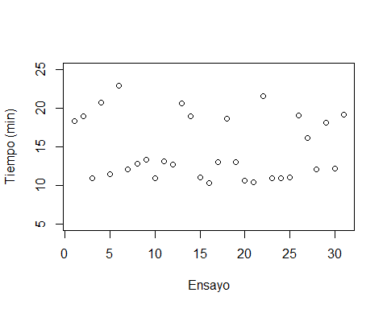
# -- route separation ----
# Route A
xA = seq(1,6,1) # Sol , lluvia, transitado, 1era parada
PERCURSOA = c(12.8,13.3,13.1,12.7,13.0,13.0)
# Route B
xB = seq(7,19,1) # Sombra, autopista, camino diagonal, 3era parada
PERCURSOB = c(10.9,11.4,12.1,10.9,11.0,10.3,10.6,10.4,10.9,10.9,11.0,12.1,12.2)
# Route C
xC = seq(20,31,1) # Sombra, seguro, agradable, 16 parada
PERCURSOC = c(18.3,18.9,20.7,22.9,20.6,18.9,18.6,21.5,19.1,16.1,18.1,19.2)
# --- Graphy by routes
plot(xA, PERCURSOA,
xlab = "Ensayo",
ylab = "Tiempo (min)",
main = "Datos del experimento estratificados",
xlim = c(0, 32),
ylim = c(5, 25),
col = "red") # Camino A → rojo
# Agregamos el camino B en NEGRO (por defecto)
lines(xB, PERCURSOB, type = "p")
# Agregamos el camino C en AZUL
lines(xC, PERCURSOC, type = "p", col = "blue")
legend("topleft",
legend=c("A","B","C"),
text.col =c("red", "black", "blue"),
inset=0.02,
pch=1) # plotting character
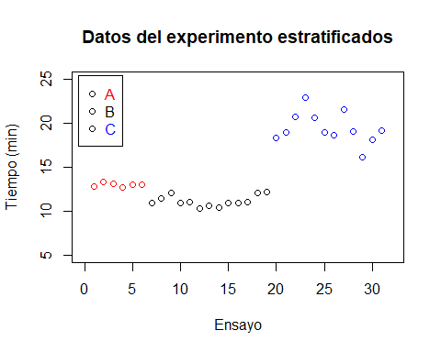
# --- Prueba t _ A vs B
t.test(PERCURSOA,PERCURSOB) # Runs in console
##
## Welch Two Sample t-test
##
## data: PERCURSOA and PERCURSOB
## t = 9.4188, df = 16.257, p-value = 5.465e-08
## alternative hypothesis: true difference in means is not equal to 0
## 95 percent confidence interval:
## 1.436141 2.268987
## sample estimates:
## mean of x mean of y
## 12.98333 11.13077
# --- Desviacion Estandar Conjunta-Combinada
# --- (17 grados de libertad)
VAR = ((6-1)*var(PERCURSOA) + (13-1)*var(PERCURSOB)) / ((6-1)+(13-1))
VAR # Runs in console
## [1] 0.2985897
desvio = sqrt(VAR)
desvio # Runs in console
## [1] 0.5464337
# --- as médias e os desvios para cada percurso/Route
MEDIA.A= mean(PERCURSOA)
MEDIA.A
## [1] 12.98333
## [1] 12.98333
SD.A= sd(PERCURSOA)
SD.A
## [1] 0.2136976
## [1] 0.2136976
MEDIA.B = mean(PERCURSOB)
MEDIA.B
## [1] 11.13077
## [1] 11.13077
SD.B= sd(PERCURSOB)
SD.B
## [1] 0.6355898
## [1] 0.6355898
MEDIA.C = mean(PERCURSOC)
MEDIA.C
## [1] 19.40833
## [1] 19.40833
SD.C= sd(PERCURSOC)
SD.C
## [1] 1.779917
## [1] 1.779917
# Construimos la tabla resumen como un data frame
resumen <- data.frame(
Camino = c("A", "B", "C"),
Ensayos = c(6, 13, 12),
Media_min = c(round(MEDIA.A, 2), round(MEDIA.B, 2), round(MEDIA.C, 2)),
Desv_Estandar = c(round(SD.A, 4), round(SD.B, 4), round(SD.C, 4))
)
resumen
## Camino Ensayos Media_min Desv_Estandar
## 1 A 6 12.98 0.2137
## 2 B 13 11.13 0.6356
## 3 C 12 19.41 1.7799

