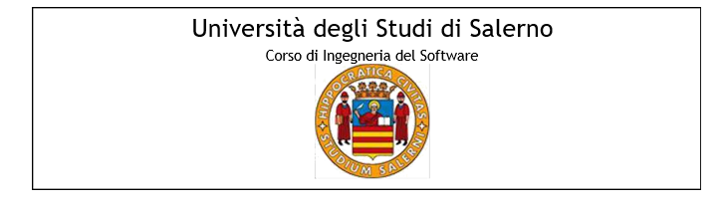

Nome progetto: EsteticaMente

Anno accademico 2018/2019



Indice

[1. Test Registrazione 5](#_Toc536354178)

[1.1. TC\_REG\_1 5](#_Toc536354179)

[1.2. TC\_REG\_2 6](#_Toc536354180)

[1.3. TC\_REG\_3 6](#_Toc536354181)

[1.4. TC\_REG\_4 7](#_Toc536354182)

[1.5. TC\_REG\_5 7](#_Toc536354183)

[1.6. TC\_REG\_6 8](#_Toc536354184)

[1.7. TC\_REG\_7 8](#_Toc536354185)

[1.8. TC\_REG\_8 9](#_Toc536354186)

[1.9. TC\_REG\_9 9](#_Toc536354187)

[1.10. TC\_REG\_10 10](#_Toc536354188)

[1.11. TC\_REG\_11 11](#_Toc536354189)

[1.12. TC\_REG\_12 11](#_Toc536354190)

[1.13. TC\_REG\_13 12](#_Toc536354191)

[1.14. TC\_REG\_14 13](#_Toc536354192)

[1.15. TC\_REG\_15 13](#_Toc536354193)

[1.16. TC\_REG\_16 14](#_Toc536354194)

[1.17. TC\_REG\_17 15](#_Toc536354195)

[1.18. TC\_REG\_18 16](#_Toc536354196)

[1.19. TC\_REG\_19 16](#_Toc536354197)

[1.20. TC\_REG\_20 17](#_Toc536354198)

[1.21. TC\_REG\_21 18](#_Toc536354199)

[1.22. TC\_REG\_22 19](#_Toc536354200)

[1.23. TC\_REG\_23 20](#_Toc536354201)

[1.24. TC\_REG\_24 21](#_Toc536354202)

[1.25. TC\_REG\_25 22](#_Toc536354203)

[1.26. TC\_REG\_26 23](#_Toc536354204)

[1.27. TC\_REG\_27 24](#_Toc536354205)

[2. Test login 25](#_Toc536354206)

[2.1. TC\_0.2\_1 25](#_Toc536354207)

[2.2. TC\_0.2\_2 25](#_Toc536354208)

[2.3. TC\_0.2\_3 26](#_Toc536354209)

[2.4. TC\_0.2\_4 27](#_Toc536354210)

[3. Modifica utente 27](#_Toc536354211)

[3.1. TC\_0.3\_1 27](#_Toc536354212)

[3.2. TC\_REG\_3 28](#_Toc536354213)

[3.3. TC\_REG\_4 29](#_Toc536354214)

[3.4. TC\_REG\_5 29](#_Toc536354215)

[3.5. TC\_REG\_6 30](#_Toc536354216)

[3.6. TC\_REG\_7 30](#_Toc536354217)

[3.7. TC\_REG\_8 31](#_Toc536354218)

[3.8. TC\_REG\_9 32](#_Toc536354219)

[3.9. TC\_REG\_10 32](#_Toc536354220)

[3.10. TC\_REG\_11 33](#_Toc536354221)

[3.11. TC\_REG\_12 34](#_Toc536354222)

[3.12. TC\_REG\_13 34](#_Toc536354223)

[3.13. TC\_REG\_14 35](#_Toc536354224)

[3.14. TC\_REG\_15 36](#_Toc536354225)

[3.15. TC\_REG\_16 36](#_Toc536354226)

[3.16. TC\_REG\_17 37](#_Toc536354227)

[3.17. TC\_REG\_18 38](#_Toc536354228)

[3.18. TC\_REG\_19 39](#_Toc536354229)

[3.19. TC\_REG\_20 40](#_Toc536354230)

[3.20. TC\_REG\_21 41](#_Toc536354231)

[3.21. TC\_REG\_22 42](#_Toc536354232)

[3.22. TC\_REG\_23 42](#_Toc536354233)

[3.23. TC\_REG\_24 43](#_Toc536354234)

[3.24. TC\_REG\_25 44](#_Toc536354235)

[3.25. TC\_REG\_26 45](#_Toc536354236)

[3.26. TC\_REG\_27 46](#_Toc536354237)

[4. Gestione prodotto 47](#_Toc536354238)

[4.1 TC\_0.4\_1 47](#_Toc536354239)

[4.2 TC\_0.3\_2 48](#_Toc536354240)

[4.3 TC\_0.3\_3 49](#_Toc536354241)

[4.4 TC\_0.3\_4 49](#_Toc536354242)

[4.5 TC\_0.3\_5 50](#_Toc536354243)

[4.6 TC\_0.3\_6 51](#_Toc536354244)

[4.7 TC\_0.3\_7 51](#_Toc536354245)

[5. Modifica Prodotto 52](#_Toc536354246)

[5.1 TC\_0.4\_1 52](#_Toc536354247)

[5.2. TC\_0.4\_2 52](#_Toc536354248)

[5.3 TC\_0.4\_3 53](#_Toc536354249)

[5.4. TC\_0.4\_4 54](#_Toc536354250)

[5.5 TC\_0.4\_5 54](#_Toc536354251)

[6. Elimina Prodotto 55](#_Toc536354252)

[7. Ricerca Prodotto 56](#_Toc536354253)

[7.1 TC\_0.5\_1 56](#_Toc536354254)

[7.2. TC\_0.5\_2 56](#_Toc536354255)

[8. Effettua Pagamento 57](#_Toc536354256)

[8.1. TC\_0.6\_1 57](#_Toc536354257)

[8.2. TC\_0.6\_2 58](#_Toc536354258)

# Test Registrazione

# TC\_REG\_1

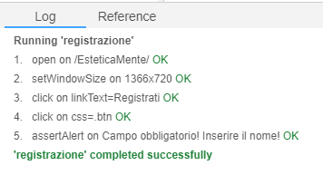

# TC\_REG\_2

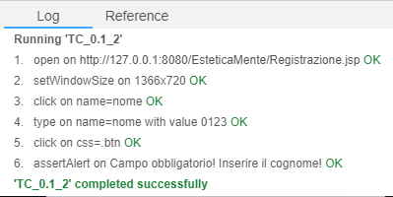

# TC\_REG\_3

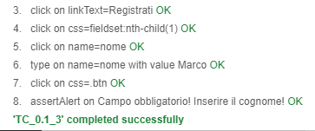

# TC\_REG\_4

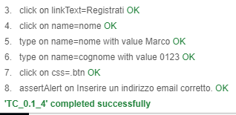

# TC\_REG\_5

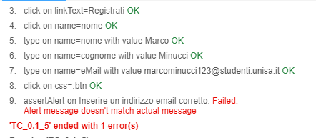

# TC\_REG\_6

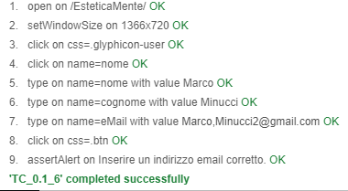

# TC\_REG\_7

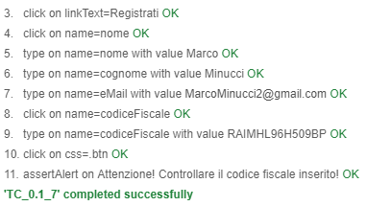

# TC\_REG\_8

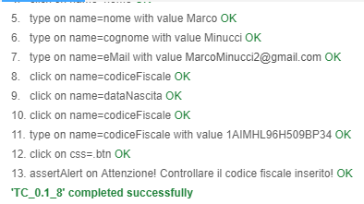

# TC\_REG\_9

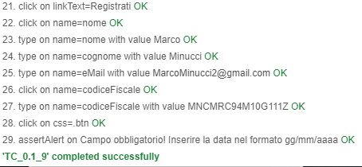

# TC\_REG\_10

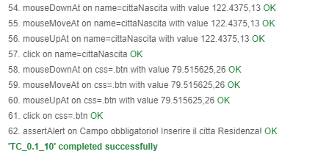

# TC\_REG\_11

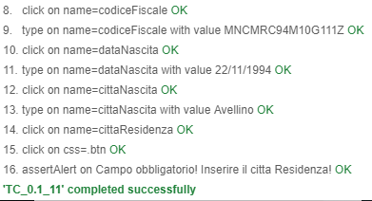

# TC\_REG\_12

# TC\_REG\_13

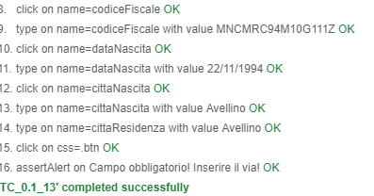

# TC\_REG\_14

# TC\_REG\_15

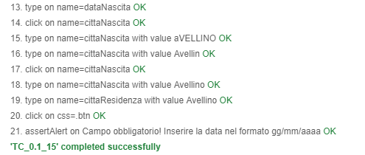

# TC\_REG\_16

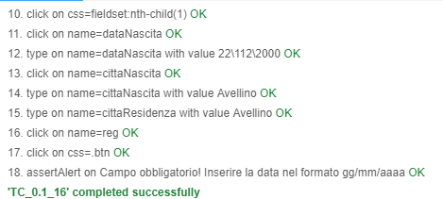

# TC\_REG\_17

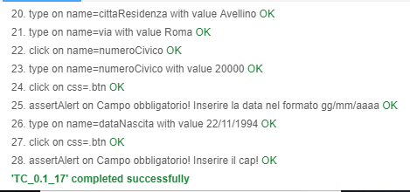

# TC\_REG\_18

# TC\_REG\_19

# TC\_REG\_20

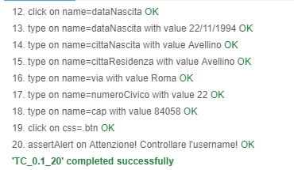

# TC\_REG\_21

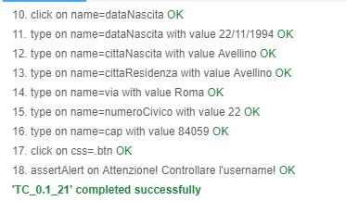

# TC\_REG\_22

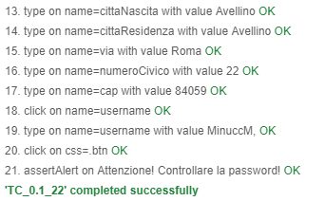

# TC\_REG\_23

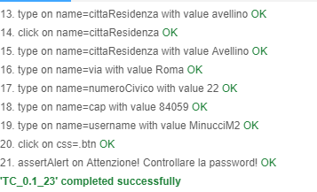

# TC\_REG\_24

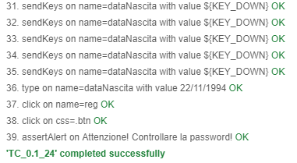

# TC\_REG\_25

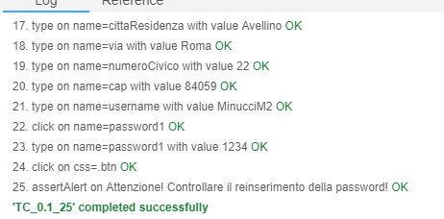

# TC\_REG\_26

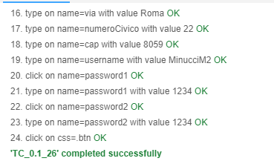

# TC\_REG\_27

# Test login

# 2.1. TC\_0.2\_1

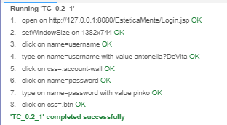

# 2.2. TC\_0.2\_2

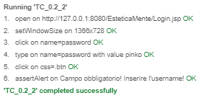

# 2.3. TC\_0.2\_3

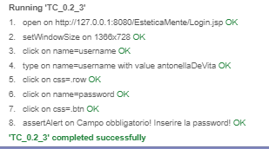

# 2.4. TC\_0.2\_4

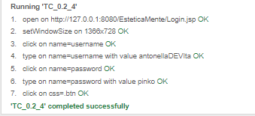

# Modifica utente

# TC\_REG\_1



# TC\_REG\_2



# TC\_REG\_3



# TC\_REG\_4



# TC\_REG\_5



# TC\_REG\_6



# TC\_REG\_7



# TC\_REG\_8



# TC\_REG\_9



# TC\_REG\_10



# TC\_REG\_11



# TC\_REG\_12

# TC\_REG\_13



# TC\_REG\_14

# TC\_REG\_15



# TC\_REG\_16



# TC\_REG\_17



# TC\_REG\_18

# TC\_REG\_19

# TC\_REG\_20



# TC\_REG\_21



# TC\_REG\_22



# TC\_REG\_23



# TC\_REG\_24



# TC\_REG\_25



# TC\_REG\_26



# TC\_REG\_27

# Gestione prodotto

- Inserisci Prodotto

# 4.1 TC\_0.4\_1

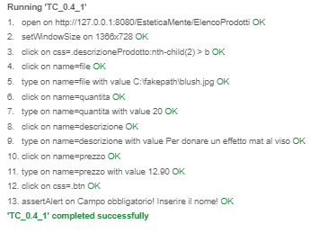

# 4.2 TC\_0.4\_2

# 4.3 TC\_0.4\_3

# 4.4 TC\_0.4\_4

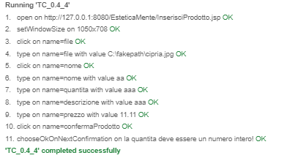

# 4.5 TC\_0.4\_5

# C:\Users\ASUS\Desktop\Test screen\Inserisci prodotto\TC_0.4_5.PNG

# 4.6 TC\_0.4\_6

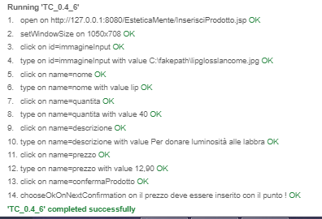

# 4.7 TC\_0.4\_7

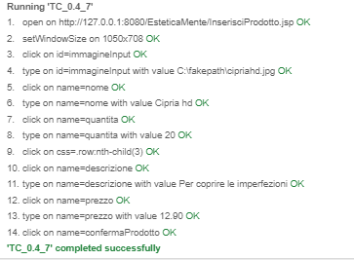

# 5. Modifica Prodotto

# 5.1 TC\_0.5\_1



# 5.2. TC\_0.5\_2



# 5.3 TC\_0.5\_3

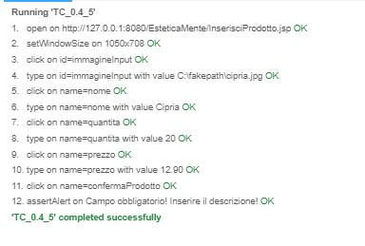

# 5.4. TC\_0.5\_4



# 5.5 TC\_0.5\_5

# C:\Users\ASUS\Desktop\Test screen\Inserisci prodotto\TC_0.4_7.PNG

# 6. Elimina Prodotto

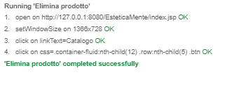

# 7. Ricerca Prodotto

# 7.1 TC\_0.6\_1

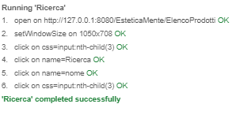

# 7.2. TC\_0.6\_2

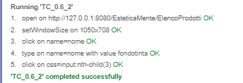

Gestione Ordini

# 8. Effettua Pagamento

# 8.1. TC\_0.7\_1

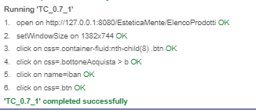

# 8.2. TC\_0.7\_2

