**Problem 1 ( 30 Points)**

**ACROSS**

3. In fluid dynamics, a **Karman** vortex street is a repeating pattern of swirling vortices caused by the unsteady separation of flow of a fluid around blunt bodies.

5. A **solar** cell is an electrical device that converts the energy of light directly into electricity by the photovoltaic effect,, which is a physical and chemical phenomenon.

7. **Friction** is the force resisting the relative motion of solid surfaces, fluid layers, and material elements sliding against each other.

10. A **pitot** tube is a pressure measurement instrument used to measure fluid flow velocity.

11. In fluid dynamics, a **vortex** is a region in a fluid in which the flow is rotating around an axis line, which may be straight or curved.

13. **Particulate** matter (PM) are microscopic solid or liquid matter suspended in the Earth's atmosphere.

14. In Stirling engine, the **displacer** can move up and down in the container. If the **displacer** is on the top of the container, the air will move down to the bottom of container and be heated by the heat source.

15. Heat **transfer** is a very important subject and has long been an essential part of mechanical engineering curricula all over the world.

DOWN

1. The law of heat conduction, also known as **Fourier**'s law, states that the time rate of heat transfer through a material is proportional to the negative gradient in the temperature and to the area, at right angles to that gradient, through which the heat flows.

2. **Pathline**s are the trajectories that individual fluid particles follow. These can be thought of as "recording" the path of a fluid element in the flow over a certain period.

4. Thermal **conductivity** (often denoted k, λ, or κ) is the property of a material to conduct heat.

6. **Streamline**s are a family of curves that are instantaneously tangent to the velocity vector of the flow.

8. A **fin** is a thin component or appendage attached to a larger body or structure for air cooling.

9. **Streakline**s are the Locus of points of all the fluid particles that have passed continuously through a particular spatial point in the past.

12. A **wind** tunnel is a tool used in aerodynamic research to study the effects of air moving past solid objects.

**Problem 2 ( 70 Points)**

1. What are the materials used in “LABORATORY 2: Heat Transfer Coefficient Measurement”? (4pts)

不鏽鋼、黃銅、鋁

2. What are the K and Q in Fourier’s Law of Heat Conduction? What are the units of them? (6pts)

熱傳導係數 單位：W/(m-K) ； 熱傳率 單位：W

3. Why the Reynolds number in Water Flow Visualization is huge, but we do not observe the vortex? (6pts)

因為水流持續供給，若流場沒有持續的能量供給，流場會因為黏滯阻力而消散所有動能，最後整個流場會停止流動。譬如邊界層流的動能即來自於自由流，而所有動能終將消散於邊界層流中大大小小的渦流中，若自由流停止流動，則所有渦流也會停止流動。

4. Which section (A~I) has the maximum flow velocity, and explain why? (5pts)

截面B有最大流速，因為管的截面積較小。

5. Please draw the streamlines of laminar flow(very low Raynolds number) and turbulence flow around the cylinder. (6pts)

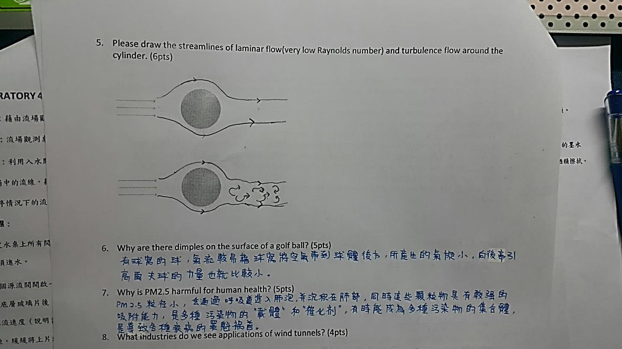

6. Why are there dimples on the surface of a golf ball? (5pts)

氣流較容易藉球窩將空氣帶到球體後方，所產生的氣旋小，向後牽引高爾夫球的力量也就比較小。

7. Why is PM2.5 harmful for human health? (5pts)

PM2.5粒徑小，會通過呼吸道進入肺泡並沉積於肺部，同時這些顆粒物具有較強的吸附能力，是多種汙染物的載體和催化劑，有時能成為多種汙染物的集合體，是導致疾病的罪魁禍首。

8. What industries do we see applications of wind tunnels? (4pts)

風洞是一種產生人造氣流的管道，用於研究空氣流經物體所產生的氣動效應。風洞主要應用於汽車、飛行器、導彈設計領域，也適用於建築物、高速列車、船艦的空氣阻力、耐熱與抗壓試驗等。

9. Which electrode should we connect first when we install a battery of the engine? (3pts)

因為整個引擎相當於一個龐大的負極，故先把正極接上可減少碰觸時產生短路的風險。

10. What are the functions of flywheel and crank shaft in a Stirling engine? (6pts)

曲柄機構(crank shaft)的功能是要讓移氣器可以上下移動，而飛輪(flywheel)具有旋轉慣性能達成連續的運轉。補充：移氣器(displacer)的功用主要在於移動氣體，使氣體在冷熱兩端之間來回流動。藉由動力活塞(piston)的膨脹及收縮運動，可以轉換為動力輸出來源。

11. What are N-type and P-type semiconductor? (6pts)

N-type：純半導體中摻入五價元素，由於價電子間會互相結合形成共價鍵，而五價的雜質與四價的矽每形成一共價鍵便多出一自由電子。P-type：當在純矽中摻入三價元素的雜質，使得每個矽原子與三價雜質結合產生共價鍵時，便缺少一電子，也就是多一個電洞。

12. Please describe sudden expansion and sudden contraction pressure between 1 and 2 in picture considering friction coefficient. (>, < or =) (6pts)

(a) 1 < 2



(b) 1 = 2



13. Please identify the components of refrigerator

cycle in the picture below.( 8pts)

※助教補充

* **水流場觀測**

停滯點：最大壓力發生於物體表面速度為零處，則此點即定義為滯點。

* **太陽能：**

1. 光電流強度與哪些參數有關 ?
   1. 光源與太陽能板的垂直距離
   2. 光源照射太陽能板的角度
2. 為何屋頂的太陽能板大都是擺放一個傾斜角度？

由於緯度關係，太陽並不會四季都直射擺放斜角能使屋頂的板長時間與太陽光方向垂直，以接受最多的照射並且可避開陰影提升發電效率。

1. 氫氧電池充與放的正極如何反應？負極的反應又是如何？

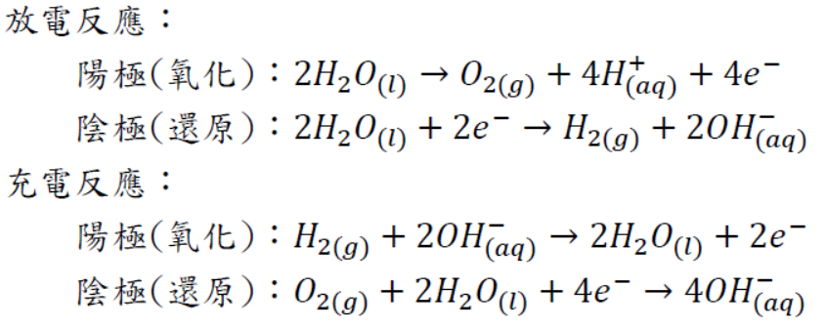

* **風洞實驗**：

壓力，體積流率Q = AV(m3/s)

熱對流實驗：LCM = Lumped capacity method

假設條件 (1) 試件在每一瞬間每個部位溫度皆一致。

(2) 試件內部阻力相對於試件與空氣之阻力來得小。

流線：只在流場中每一點速度方向向量切線相連的曲線，且兩條不同流線間不會相交。

徑線：不同時間點，某一特定流體質點的移動軌跡。

煙線：在某一瞬間，通過某一處，所有流體質點的連線

補充單字：Bernoulli's principle、Conductivity、Streamline(流線)，Pathline(徑線)，Streakline(煙線)、Kinematic Viscosity、octane number(辛烷值)、cetane number(十六烷值)、Stirling Engine、Refrigeration Cycle、stagnation point(停滯點)

