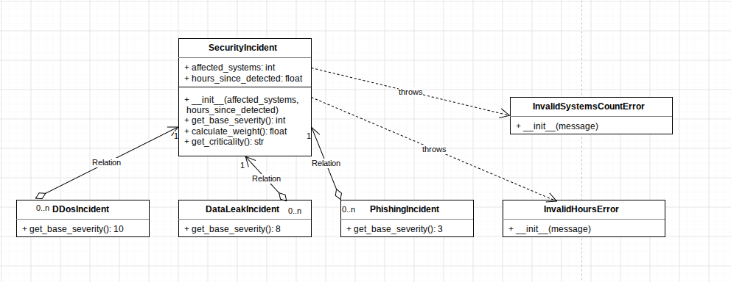

class InvalidSystemsCountError(ValueError):
pass
class InvalidHoursError(ValueError):
pass
class SecurityIncident:
def __init__(self, incident_id: str, affected_systems:int, hours_since_detected:float):
self.incident_id = incident_id
self.affected_systems = affected_systems
self.hours_since_detected = hours_since_detected
@property
def affected_systems(self):
return self._affected_systems
@affected_systems.setter
def affected_systems(self, value:int):
if not isinstance(value,int) and value < 0:
raise InvalidSystemsCountError("Введите числовое значение больше нуля!")
else:
self._affected_systems = value
@property
def hours_since_detected(self):
return self._hours_since_detected
@hours_since_detected.setter
def hours_since_detected(self, value:float):
if value < 0:
raise InvalidHoursError("Количество часов не может быть меньше нуля!")
else:
self._hours_since_detected = float(value)
def get_base_severity(self):
return 0
def calculate_weight(self):
time_factor = 1 + self.hours_since_detected / 24
weight = self.get_base_severity() * self.affected_systems * time_factor
return weight
def get_critical(self):
if self.calculate_weight() >=50:
return "CRITICAL"
if self.calculate_weight() >=20:
return "HIGH"
if self.calculate_weight() >=5:
return "MEDIUM"
else:
return "LOW"
def __str__(self) -> str:
return (
f"{type(self).__name__}\n"
f"Вес: {self.calculate_weight():.1f}\n"
f"Уровень риска: {self.get_critical()}\n"
)
def __repr__(self) -> str:
return (
f"{type(self).__name__}("
f"incident_id={self.incident_id!r}, "
f"affected_systems={self.affected_systems!r}, "
f"hours_since_detected={self.hours_since_detected!r})"
)
def __eq__(self, other):
if not isinstance(other,SecurityIncident):
return NotImplemented
else:
return self.incident_id == other.incident_id
def __hash__(self):
return hash(self.incident_id)
def __lt__(self, other):
if not isinstance(other, SecurityIncident):
return NotImplemented
else:
return self.calculate_weight() < other.calculate_weight()
def __gt__(self, other):
if not isinstance(other, SecurityIncident):
return NotImplemented
else:
return self.calculate_weight() > other.calculate_weight()
def __add__(self, other):
if not isinstance(other, SecurityIncident):
return NotImplemented
else:
return self.calculate_weight() + other.calculate_weight()
def __sub__(self, other):
if not isinstance(other, SecurityIncident):
return NotImplemented
else:
return self.calculate_weight() - other.calculate_weight()
class DDoSIncident(SecurityIncident):
def get_base_severity(self):
return 10
class DataLeakIncident(SecurityIncident):
def get_base_severity(self):
return 8
class PhishingIncident(SecurityIncident):
def get_base_severity(self):
return 3
if __name__ == "__main__":
ddos = DDoSIncident("1", affected_systems=3, hours_since_detected=12)
fish = PhishingIncident("2", affected_systems=1, hours_since_detected=0)
leak = DataLeakIncident("3", affected_systems=5, hours_since_detected=48)
print("=== Все инциденты ===")
print()
print(ddos)
print(leak)
print(fish)
print("\n=== Проверка __eq__ ===")
ddos_copy = DDoSIncident("1", affected_systems=2, hours_since_detected=1)
print(f"ddos == ddos_copy: {ddos == ddos_copy}")
print(f"ddos == fish: {ddos == fish}")
print("\n=== Проверка __add__ / __sub__ ===")
print(f"ddos + leak = {ddos + leak}")
print(f"leak - ddos = {leak - ddos}")
print("\n=== Проверка исключений ===")
try:
DDoSIncident("4", affected_systems=0, hours_since_detected=5)
except InvalidSystemsCountError as e:
print("Ошибка:", e)
try:
PhishingIncident("5", affected_systems=2, hours_since_detected=-3)
except InvalidHoursError as e:
print("Ошибка:", e)

