clear all;

close all;

K=0;

z = [];

p = [0 -5.6 -10];

k = [100];

sys1 = zpk( z,p,k);

sys2 = feedback(sys1,K,-1);

sys3 = series(sys2,10)

figure,step(sys3,0.1);

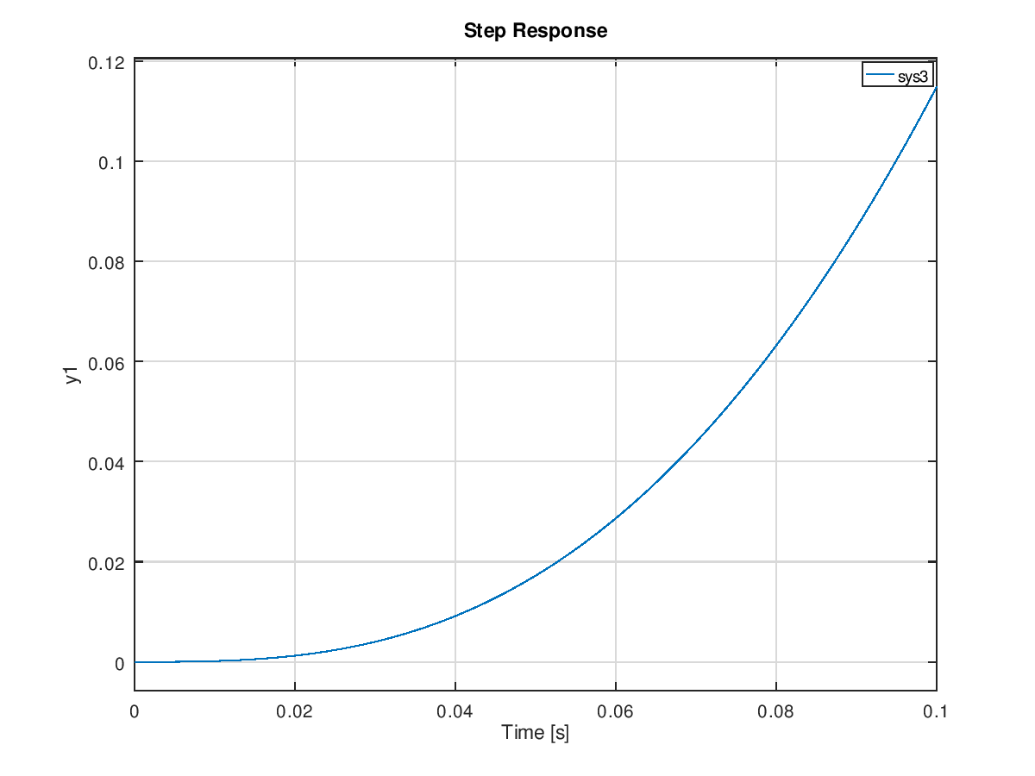

K=0.081;

z = [];

p = [0 -5.6 -10];

k = 100;

sys1 = zpk( z, p, k );

sys2 = feedback(sys1,K,-1);

sys3 = series(sys2,10)

figure,step(sys3,0.1);

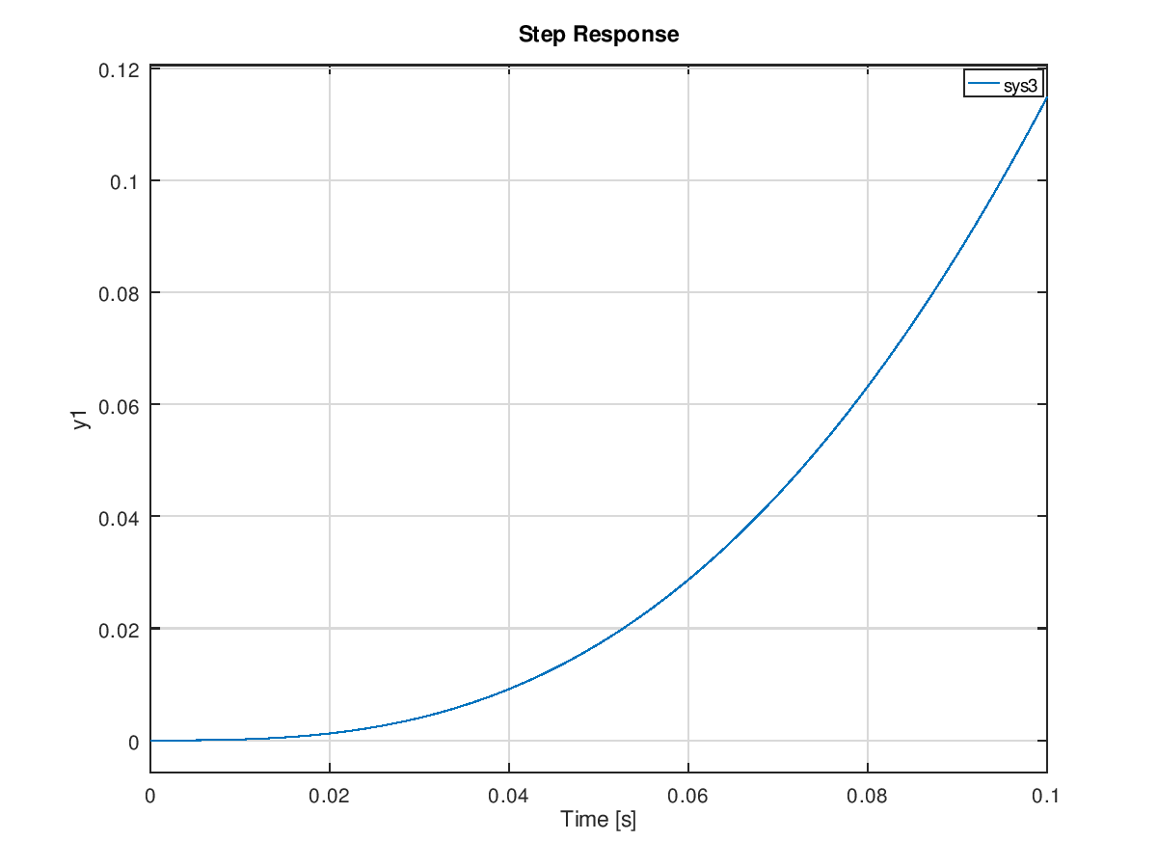

K=1;

z = [];

p = [0 -5.6 -10];

k = 100;

sys1 = zpk( z, p, k );

sys2 = feedback(sys1,K,-1);

sys3 = series(sys2,10)

figure,step(sys3,0.1);

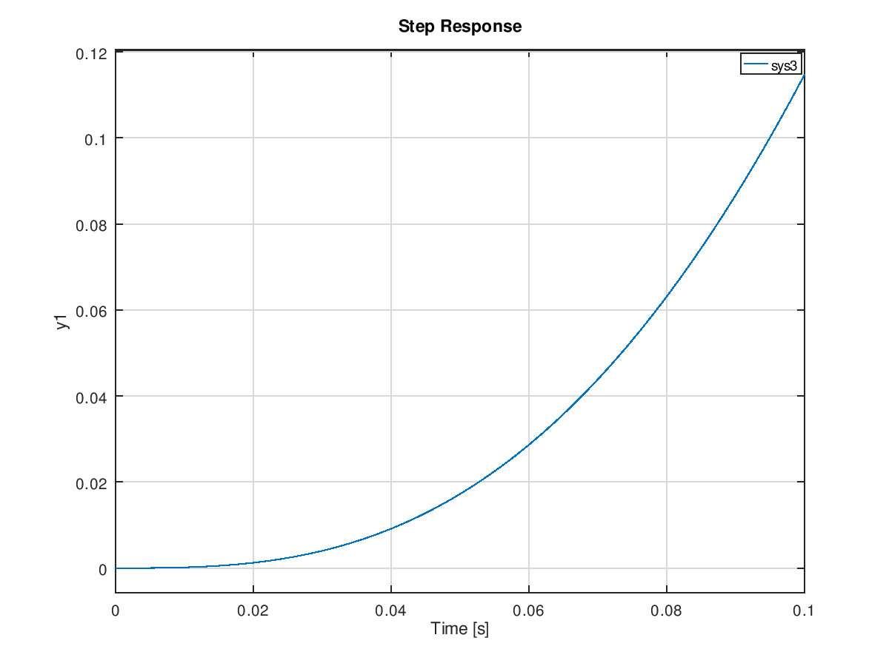

K=10;

z = [];

p = [0 -5.6 -10];

k = 100;

sys1 = zpk( z, p, k );

sys2 = feedback(sys1,K,-1);

sys3 = series(sys2,10)

figure,step(sys3,0.1);

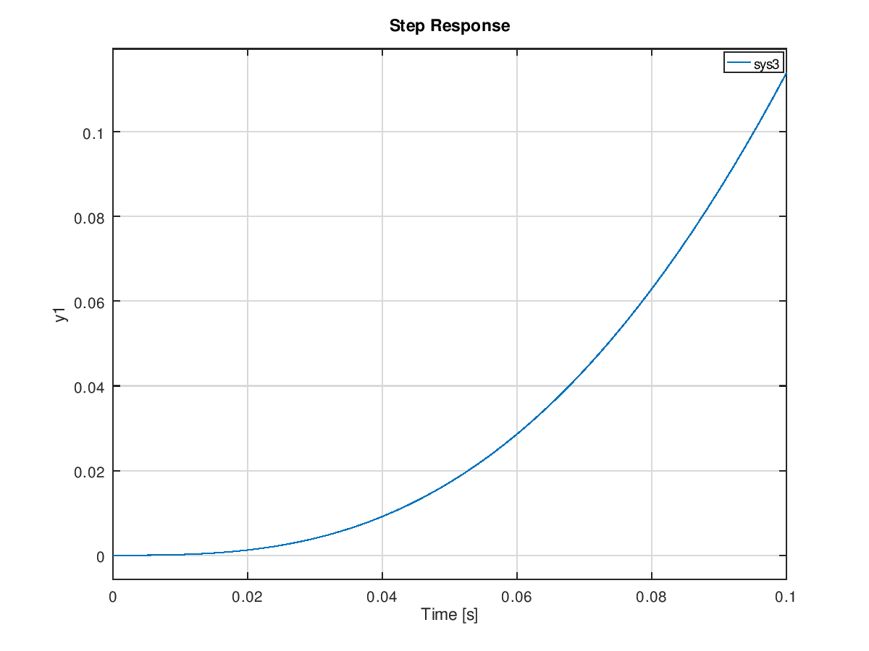

clear all;

close all;

a=1;

k=1;

num=[k 2\*k];

den=[1 0 -1];

sys1=tf(num,den);

num=[1 a];

den=[1 0];

sys2=tf(num,den);

sys3=series(sys1,sys2)

figure,step(sys3,0.1)

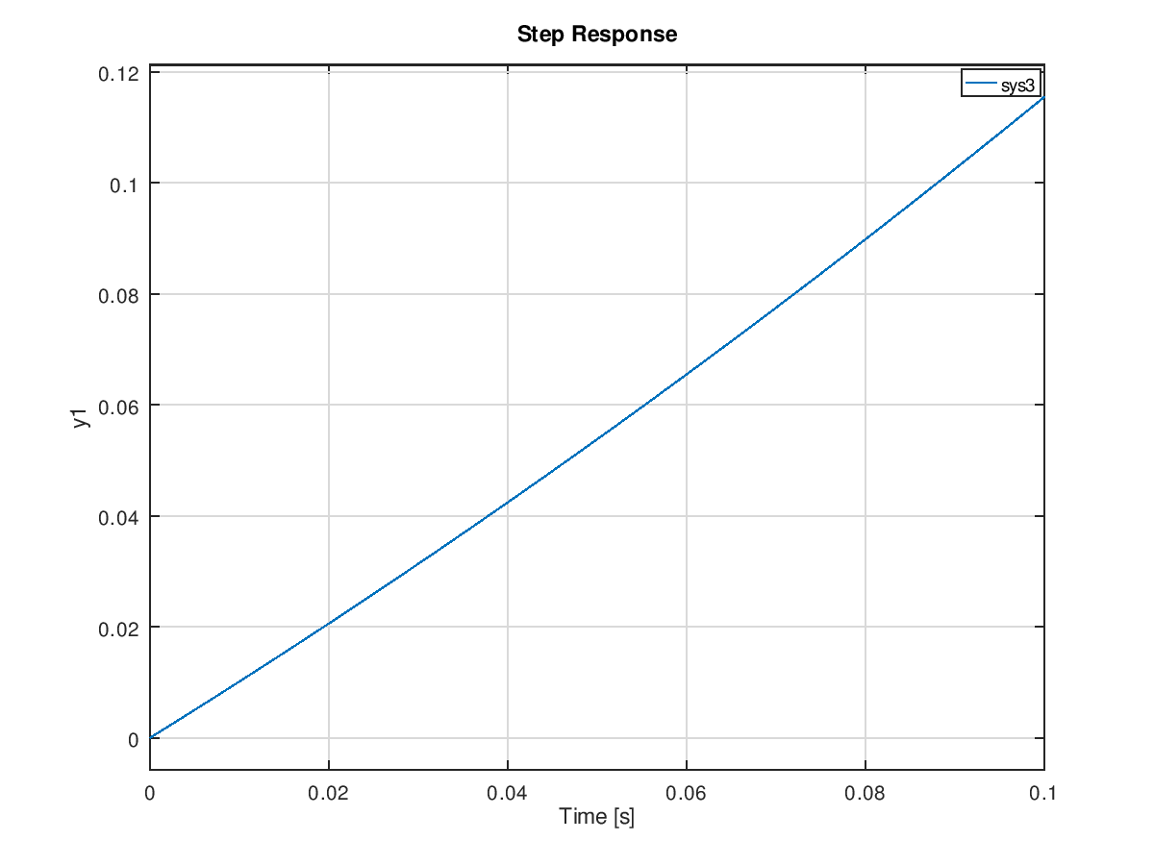

a=2;

k=2;

num=[k 2\*k];

den=[1 0 -1];

sys1=tf(num,den);

num=[1 a];

den=[1 0];

sys2=tf(num,den);

sys3=series(sys1,sys2)

figure,step(sys3,0.1)

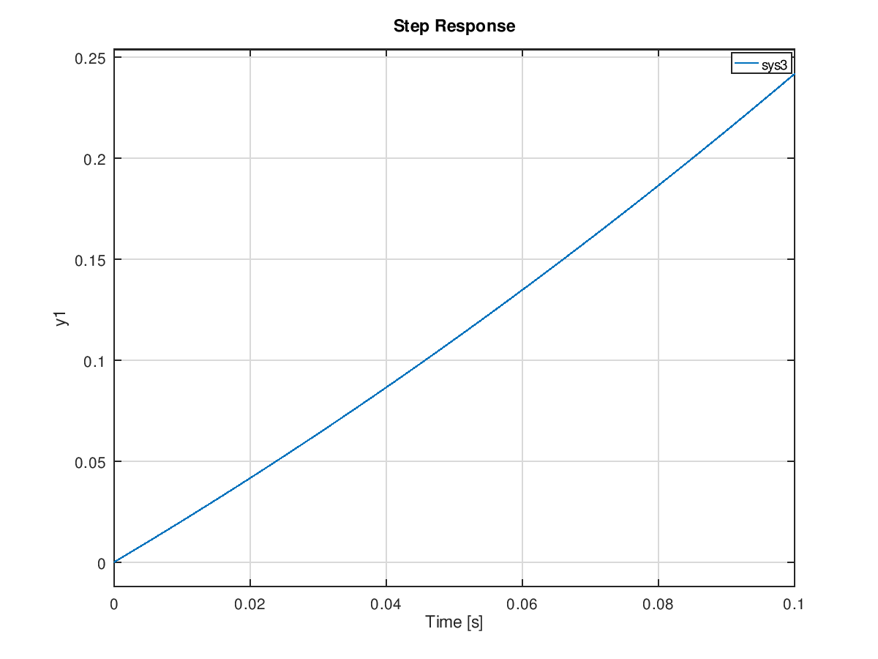

a=3;

k=3;

num=[k 2\*k];

den=[1 0 -1];

sys1=tf(num,den);

num=[1 a];

den=[1 0];

sys2=tf(num,den);

sys3=series(sys1,sys2)

figure,step(sys3,0.1)

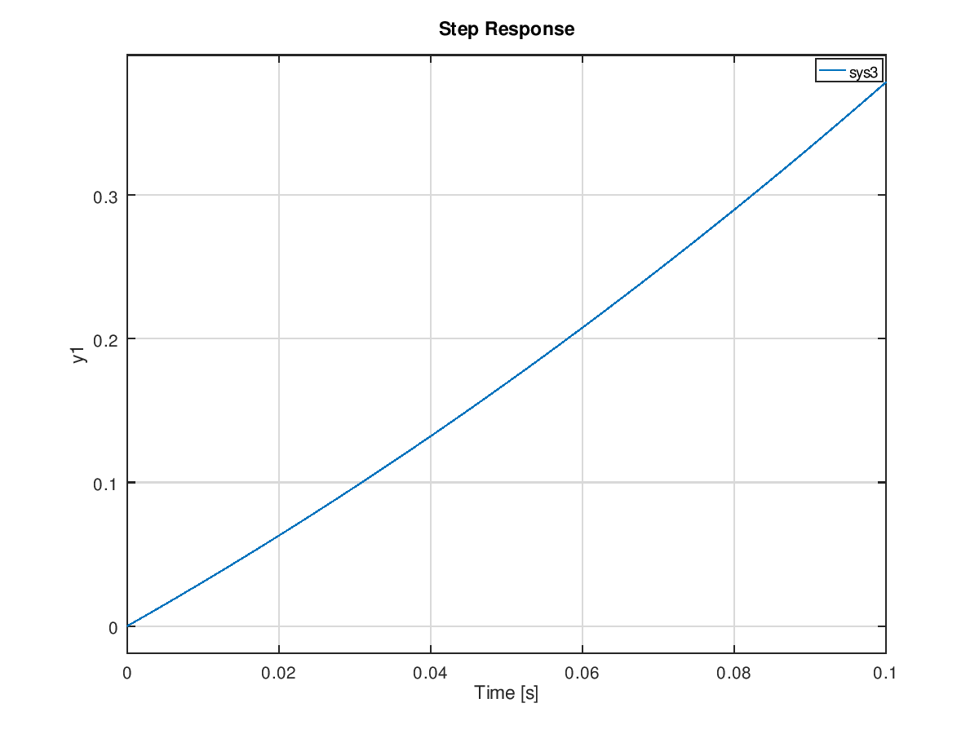

a=-1;

k=-1;

num=[k 2\*k];

den=[1 0 -1];

sys1=tf(num,den);

num=[1 a];

den=[1 0];

sys2=tf(num,den);

sys3=series(sys1,sys2)

figure,step(sys3,0.1)

