Digital Image Processing Quiz1 Student ID: 04242456 Name: 李仲朗
- How many bits are required to store a 64x64 gray image? 262，144
- Explain what is the “Histogram” (直方圖) of an image? 灰階影像的直方圖（histogram）是由其灰階值統計量所構成，也就是一張標示每個灰階值在影像中出現次數的圖表。
- Explain what is the “Indexed image”(索引影像)? What is the “Color map”(色譜) ing it? 索引影像是一种抽样显示的技术，将所有颜色搜集到一个色盘中。色谱是对应的位址的表
- Explain what is the “Point processing” (點處理) of an image. List three types of point processing..
点处理是对像素进行数学运算等处理。
轉換（transforms）
鄰域處理（neighborhood processing ）
點運算（point
- Get the indexed image “emu.tif”.
  - Transform it to a RGB color image and display it.
a=imread('emu.tif');
figure,imshow(a);
  - Transform the RGB color image to a grayscale image and display it.
a=imread('emu.tif');
figure,imshow(a)，pixval on；

  - Transform the grayscale image to a binary image and display it
a=imread('emu.tif');
cd=double(a);
figure,imshow(cd);
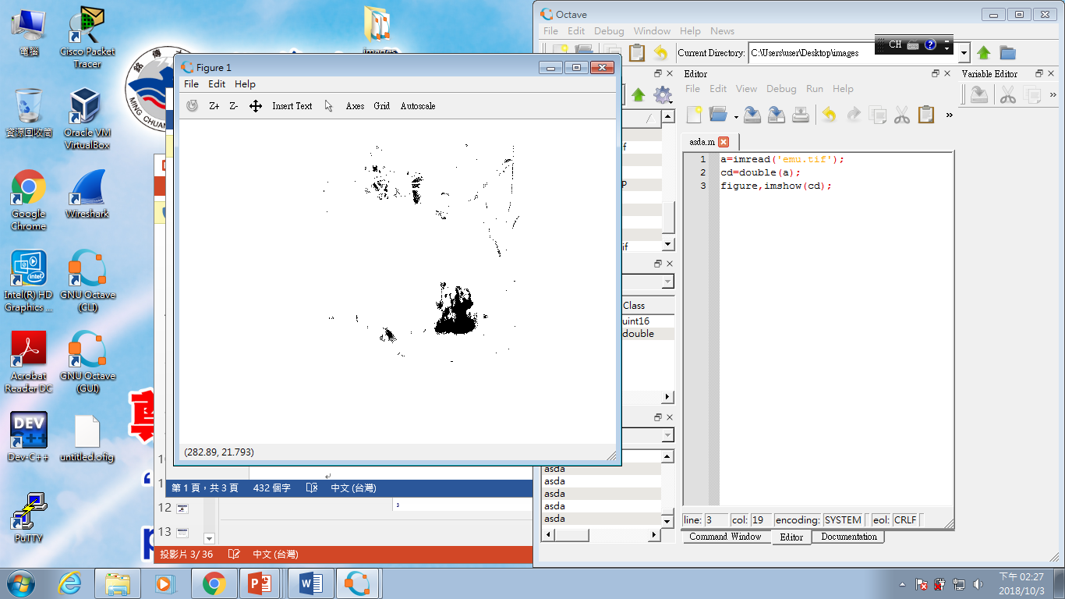

- Execute the following instructions:
>> c = imread(‘LENNA.bmp’);
  - Show the most significant bit plane c7 and bit plane c5.
a=imread('LENNA.bmp');
cd=double(a);
c7=mod(floor(cd/128),2);
imshow(c7);
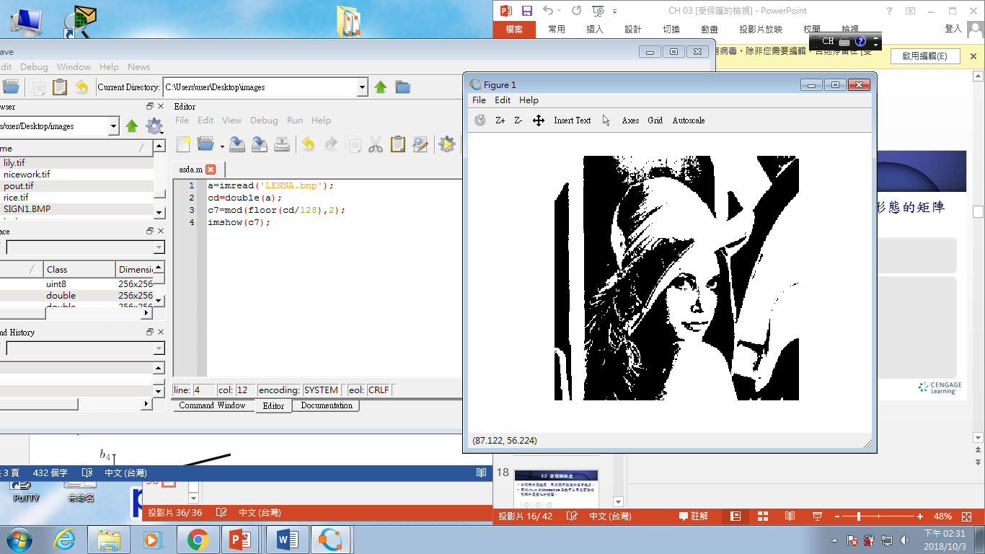
a=imread('LENNA.bmp');
cd=double(a);
c5=mod(floor(cd/32),2);
imshow(c5);
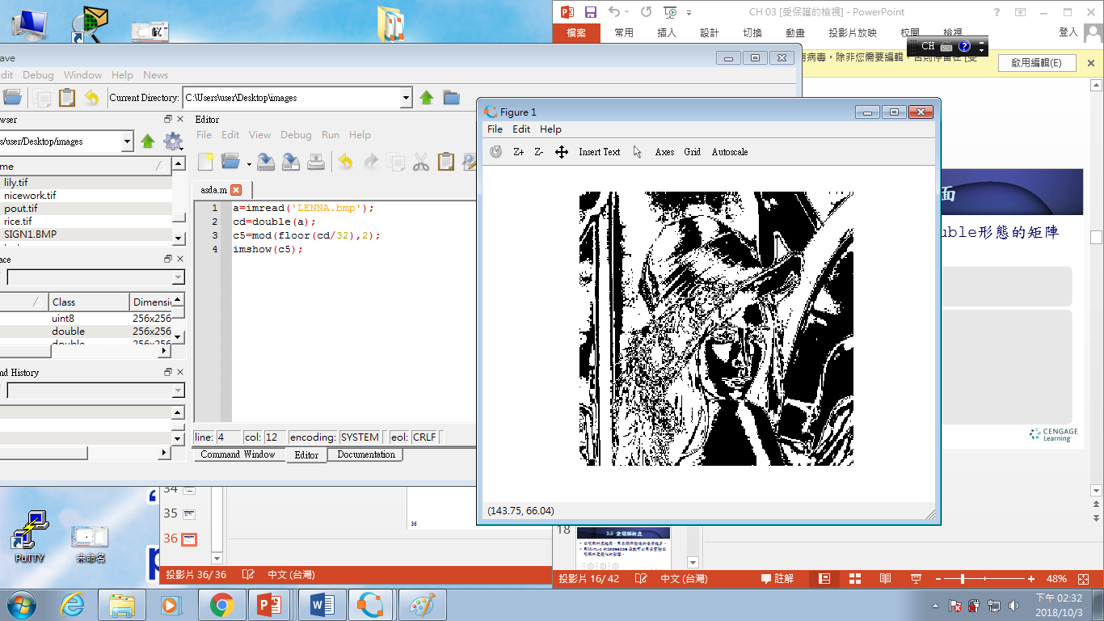
  - Recover the image by using only the bit planes c5 and c7 and show the resulting image.

- (a) Read the image ”, then display it. “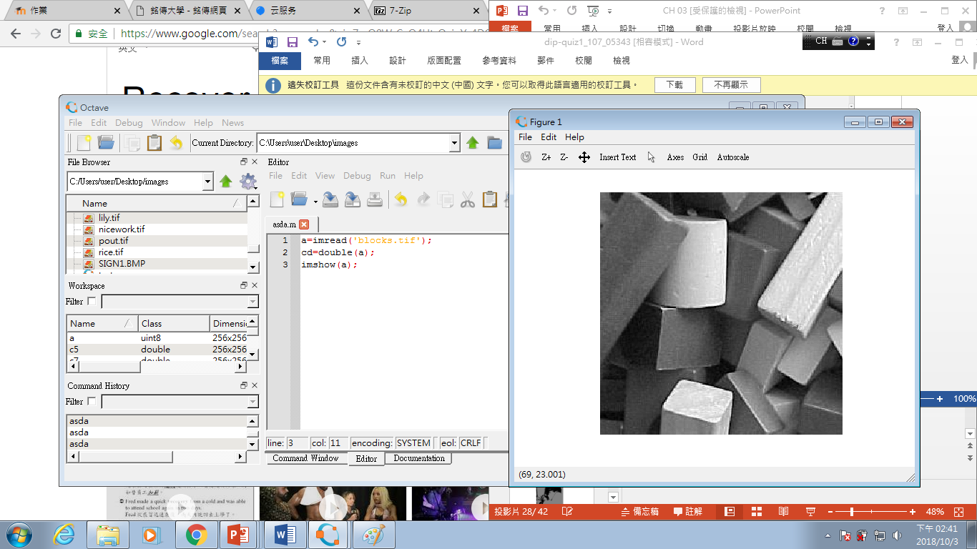

(b) Use the function histpwl() to perform piecewise linear-stretching on this image (let a1= 0/255, a2=75/255, a3=150/255, a4=255/255, b1= 30/255, b2=80/255, b3=200/255, b4=255/255), display the resulting image.

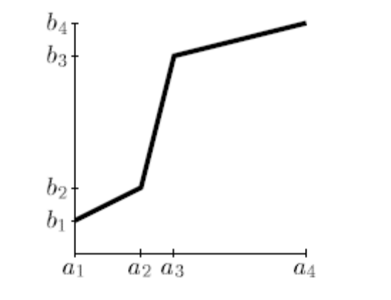
(c) Display the stretching function with the “plot” function

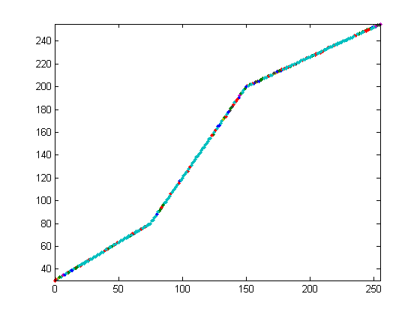
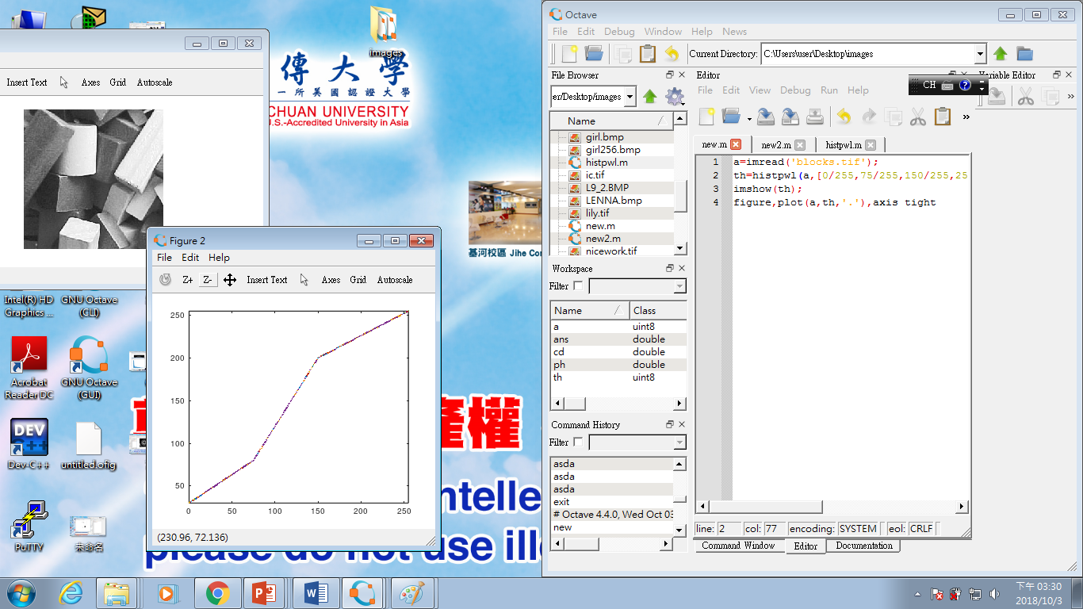
- (a) Read the image “tire.tif”, then display it.

(b) Obtain the grey level histogram of this image.
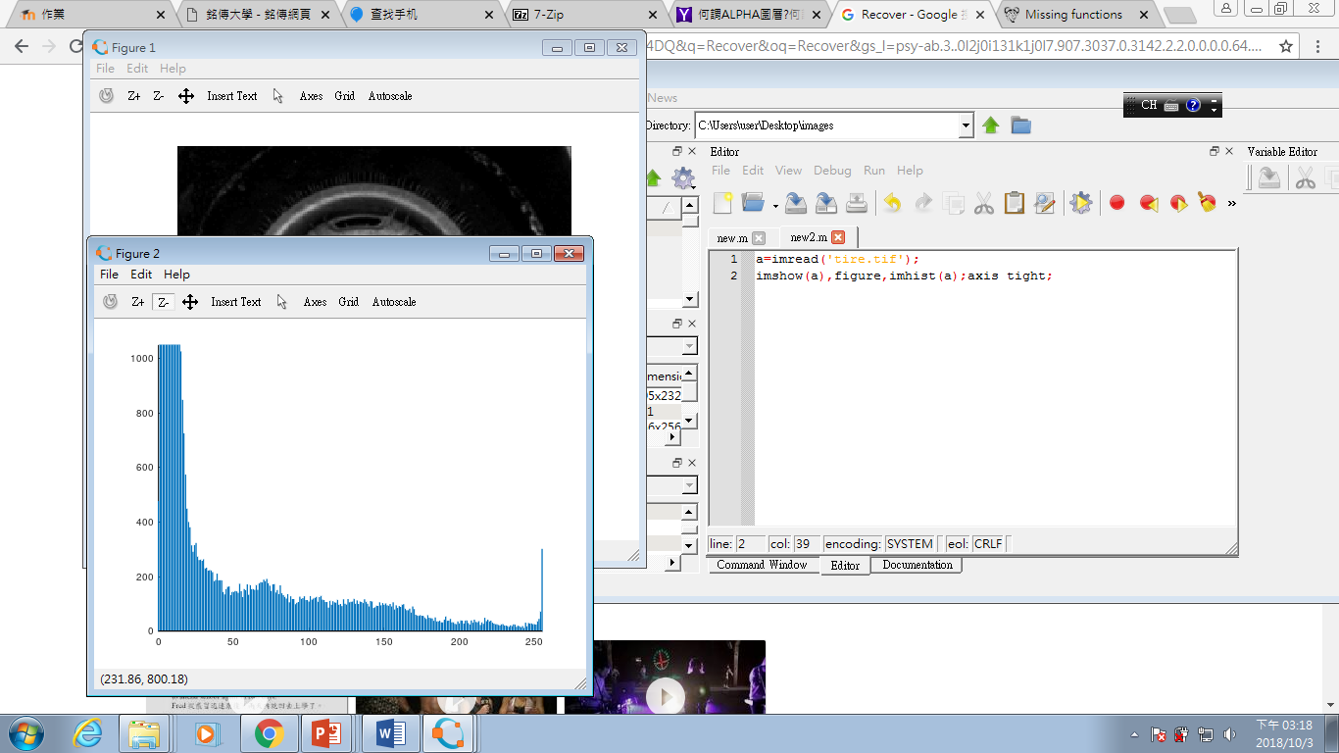
a=imread('tire.tif');
imshow(a),figure,imhist(a);axis tight;
(c) Obtain the histogram-equalized image.

(d) Obtain the grey level histogram of the histogram-equalized image.

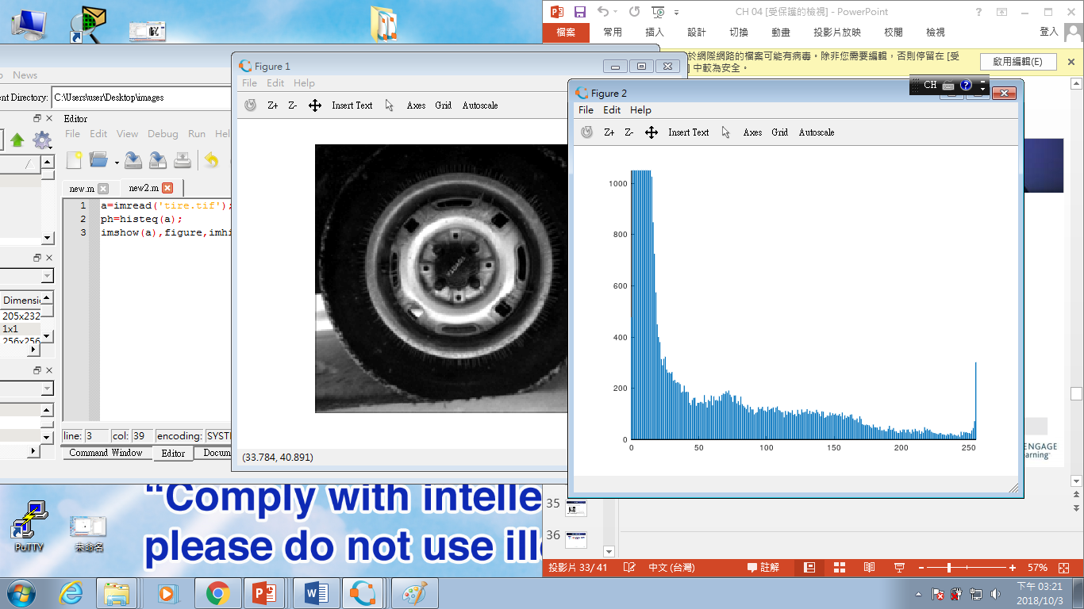
10.(a) Read and show the image “tire.tif.”
(b) Apply an LUT (lookup table) to implement the contrast-stretching function given by the following equations
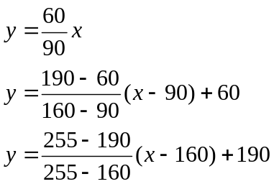
Show the first 10 components of the LUT (T(:,1:10))
(c) Using this LUT to perform contrast-stretching function on the image ‘tire.tif’. Show the resulting image
(d) Display the stretching function with the “plot” function.

