電通二乙微處理器實驗 實驗結報

實驗名稱 | Lab 10 Bluetooth low energy
組別 | 14 | 組員 | 05050910吳宇翔

- 實驗步驟
CHECK POINT 1. 由手機 App 看到自己的 7697 iBeacon
CHECK POINT 2. 由手機 App 看到自己的 7697 EddyStone URL Beacon
CHECK POINT 3. 由手機 App 控制 7697 LED
- 程式碼
Check point1
/*
This example configures LinkIt 7697 to send iBeacon-compatbile advertisement data.

You should be able to search this device with iOS or Android iBeacon tools.

created Mar 2017
*/
#include <LBLE.h>
#include <LBLEPeriphral.h>

void setup() {
//Initialize serial and wait for port to open:
Serial.begin(9600);

// Initialize BLE subsystem
Serial.println("BLE begin");
LBLE.begin();
while (!LBLE.ready()) {
delay(100);
}
Serial.println("BLE ready");

// configure our advertisement data as iBeacon.
LBLEAdvertisementData beaconData;

// This is a common AirLocate example UUID.
LBLEUuid uuid("E2C56DB5-DFFB-48D2-B060-D0F5A71096E0");
beaconData.configAsIBeacon(uuid, 04, 23, -40);

Serial.print("Start advertising iBeacon with uuid=");
Serial.println(uuid);

// start advertising it
LBLEPeripheral.advertise(beaconData);
}

void loop() {
// The underlying framework will advertise periodically.
// we simply wait here.
//
// You can use iBeacon apps such as
// "Locate Beacon" by Radius Networks on iOS devices
// to locate this beacon.
delay(3000);
}
Check point2
/*
This example configures LinkIt 7697 to send Eddyston-URL advertisement data.

You should be able to search this beacon with tools such as "Beacon Tools" on iOS or
"Physical Web" app on Android.

created April 2017
*/
#include <LBLE.h>
#include <LBLEPeriphral.h>

void setup() {
//Initialize serial and wait for port to open:
Serial.begin(115200);

// Initialize BLE subsystem
Serial.println("BLE begin");
LBLE.begin();
while (!LBLE.ready()) {
delay(100);
}
Serial.println("BLE ready");

// configure our advertisement data as iBeacon.
LBLEAdvertisementData beaconData;

// make an Eddystone-URL beacon that board casts
// https://labs.mediatek.com
// Note 1: You can obmit the suffix and tail part, e.g.
// https://goo.gl/Aq18zF
// can be constructed with
// configAsEddystoneURL(EDDY_HTTPS, "goo.gl/Aq18zF");
// Note 2: Note that total url length must not exceed 17 bytes.
//
// Please refer to https://github.com/google/eddystone/tree/master/eddystone-url#url-scheme-prefix
// to know how the prefix/suffix/tails are expanded.
beaconData.configAsEddystoneURL(EDDY_HTTPS, "05050910", EDDY_DOT_COM);

Serial.print("Start advertising Eddystone-URL");

// start advertising it
LBLEPeripheral.advertiseAsBeacon(beaconData);
}

void loop() {
// The underlying framework will advertise periodically.
// we simply wait here.
Check point3
/*
This example configures LinkIt 7697 to act as a simple GATT server with 1 characteristic.

To use it, open AppInventor project:

*

Build & install it on Android id

created Mar 2017
*/
#include <LBLE.h>
#include <LBLEPeriphral.h>

// Define a simple GATT service with only 1 characteristic
LBLEService ledService("05050910-E8F2-537E-4F6C-D104768A1214");
LBLECharacteristicInt switchCharacteristic("19B10011-E8F2-537E-4F6C-D104768A1214", LBLE_READ | LBLE_WRITE);

void setup() {

// Initialize LED pin
pinMode(LED_BUILTIN, OUTPUT);
digitalWrite(LED_BUILTIN, LOW);

//Initialize serial and wait for port to open:
Serial.begin(9600);

// to check if USR button is pressed
pinMode(6, INPUT);

// Initialize BLE subsystem
LBLE.begin();
while (!LBLE.ready()) {
delay(100);
}
Serial.println("BLE ready");

Serial.print("Device Address = [");
Serial.print(LBLE.getDeviceAddress());
Serial.println("]");

// configure our advertisement data.
// In this case, we simply create an advertisement that represents an
// connectable device with a device name
LBLEAdvertisementData advertisement;
advertisement.configAsConnectableDevice("Davidd");

// Configure our device's Generic Access Profile's device name
// Ususally this is the same as the name in the advertisement data.
LBLEPeripheral.setName("Davidd");

// Add characteristics into ledService
ledService.addAttribute(switchCharacteristic);

// Add service to GATT server (peripheral)
LBLEPeripheral.addService(ledService);

- 實驗結果及分析
Check point1
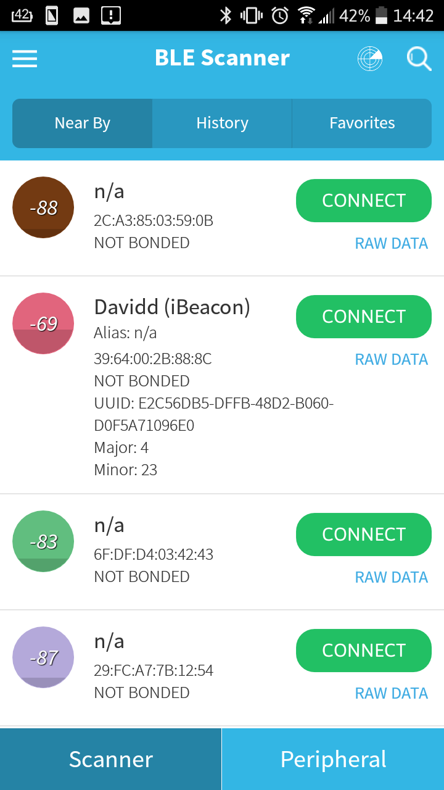
Check point2
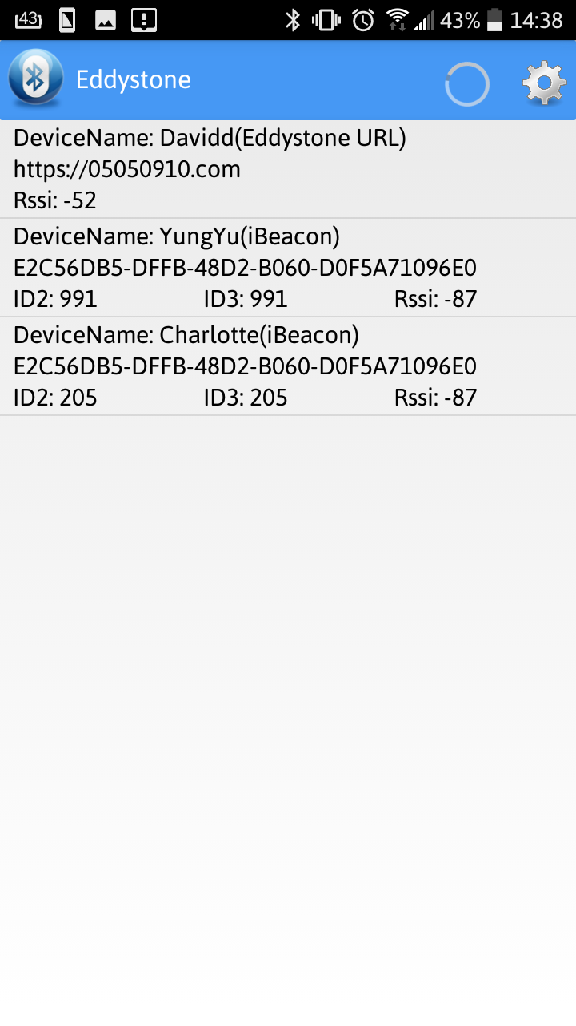
Check point3
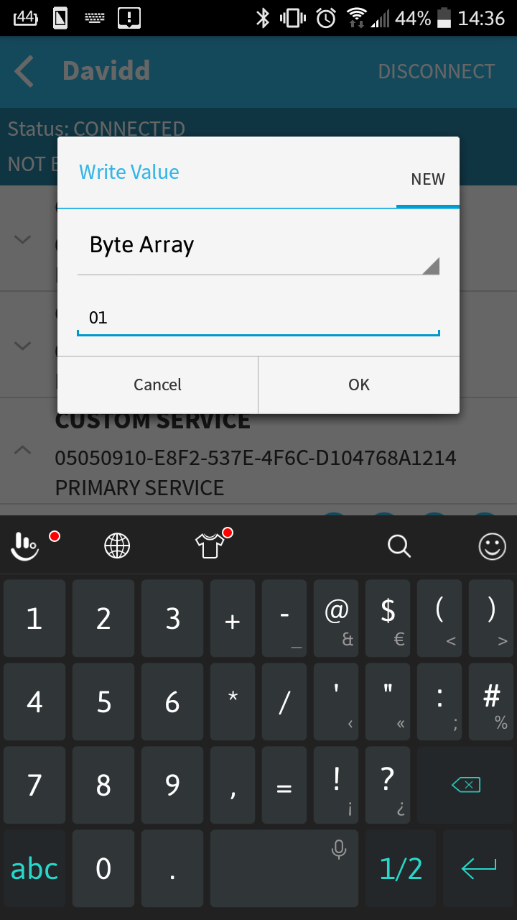

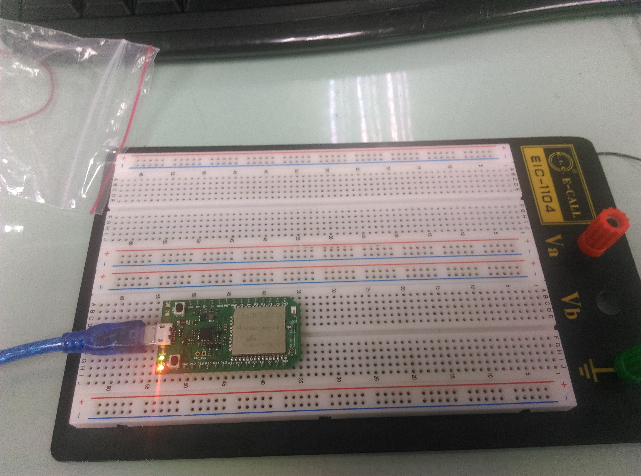
心得:這次的因為都用範例所以比較簡單,這也是我第一次用藍芽連接7697

