

Mati Heritage 3D: A Web-Based Interactive Cultural Heritage Preservation System with Gamification

STEVEN JOHN IV S. DAGSUAN
PRINCESS HIYAS A. MEJOS
ELBERT JOHN V. VALLES

A BSIT Capstone Project Proposal Presented to the Faculty of
Computing and Engineering of the Davao Oriental State University in Partial
Fulfillment of the Requirements for the Degree

BACHELOR OF SCIENCE IN INFORMATION TECHNOLOGY

APRIL 2026

Approval Sheet

TABLE OF CONTENTS
TITLE PAGE

Title Page i
Approval Sheet ii
Table of Contents iii
List of Tables v
List of Figures vi
CHAPTER I
1.1 Rationale 1
1.2 Purpose and Project Description 3
1.3 Objectives of the Study 4
1.4 Significance of the Study 5
1.5 Scope and Limitations 6
1.6 Conceptual Framework 10
1.7 Definition of Terms 12
CHAPTER II
2.1 Literature Map 15
2.2 Related Literature 16
2.3 Synthesis 22
2.4 Related System 23
CHAPTER III
3.1 Software Methodology 32
3.2 System Planning 36
3.3 System Analysis 46
3.4 System Design 56
LITERATURE CITED 69

LIST OF TABLES
TABLES PAGE

Table 1. Tabulated Comparison 30
Table 2. Cost/Benefit Analysis 38

LIST OF FIGURES

FIGURES PAGE
Figure 1. Conceptual Framework of the Study 10
Figure 2. Literature Map 15
Figure 3. Prayalane Gallery showing community-contributed photos and thematic categories 24
Figure 4. Google Arts & Culture – Heritage on the Edge Interface Showing Featured At-Risk Cultural Heritage Sites 25
Figure 5. Interface of CyArk’s Tapestry Platform Showing Interactive 3D Cultural Heritage Experiences 26
Figure 6. PHL Trails for UNESCO Interactive Heritage Map 28
Figure 7. Cultural Mapping of Panay and Guimaras (CMPG) website featuring its cultural heritage resources and mapping platform 29
Figure 8. Scrum Framework 32
Figure 9. Work Breakdown Structure 43
Figure 10. Gantt Chart 45
Figure 11. BPMN of the Current System 47
Figure 12. Landing Page 57
Figure 13. About Page 58
Figure 14. Games Page 59
Figure 15. Gallery Page 60
Figure 16. Explore Panel 60
Figure 17. 3D Site Details 61
Figure 18. Interactive 3D Viewer 62
Figure 19. Gallery Model Overlay 63
Figure 20. Admin Login Page 64
Figure 21. Admin Manage Site 65
Figure 22. Admin Add Sites 66
Figure 23. Media Vault Page 67
Figure 24. Admin Setting Page 68

CHAPTER I
INTRODUCTION

Rationale
Cultural heritage comprises both tangible and intangible assets inherited from past generations, representing the identity, history, and collective memory of communities (Logan, 2007). These cultural resources serve as essential foundations for social identity, economic value, and cultural continuity, reflecting the shared traditions and experiences that define a society (Campelo, 2018). As societies continue to evolve, the preservation of cultural heritage becomes increasingly important to ensure that knowledge, traditions, and historical narratives are sustained and transmitted across generations. Various preservation efforts, including documentation, community participation, and institutional initiatives, have been recognized as essential in maintaining cultural heritage, as they promote awareness and encourage intergenerational transfer of cultural practices (Jones, 2017; Brown, 2019). However, despite these efforts, many cultural resources remain vulnerable due to limitations in preservation systems and accessibility, highlighting the need for more effective and sustainable approaches to cultural heritage conservation. Across the world, cultural heritage is increasingly threatened by environmental, developmental, and socio-political factors, with deterioration viewed as a multidimensional process (Jokilehto, 2007). Heritage loss results from natural decay, urban development, political instability, and armed conflict, affecting both tangible and intangible assets. UNESCO (2003) further explains that environmental degradation, urban expansion, and climate hazards intensify these risks. In conflict settings, heritage is often deliberately targeted, as seen in the destruction of monuments like the Temple of Bel in Palmyra, Syria (Isakhan et al., 2018). In the Philippines, cultural heritage preservation faces challenges in documentation, digitization, and long-term conservation, leading to weakened cultural memory and awareness (Zerrudo, 2020; Cruz, 2024). Many heritage assets remain undocumented or inconsistently recorded, limiting accessibility and integration into formal preservation systems (Rabang, 2015; Besmonte, 2022). These issues are further intensified by environmental risks such as typhoons, earthquakes, and urbanization (Gumiran & Solano, 2022). A documented example, the 2013 Bohol earthquake caused significant damage to heritage structures like Baclayon Church (Asor et al., 2019). Although Republic Act No. 10066 provides a legal framework for protection, gaps in implementation persist at the local level due to limited resources and technical capacity (Zerrudo, 2020; National Commission for Culture and the Arts, 2017). At the local level, Mati City faces challenges in the preservation and documentation of its cultural heritage, with historical narratives and traditions remaining insufficiently recorded (Odoy, 2023). Limitations in technical capacity, inconsistent policy implementation, and the lack of comprehensive digital repository systems further hinder effective preservation and knowledge transfer (Zerrudo, 2020; Cruz, 2024). Furthermore, existing cultural mapping efforts remain inconsistent and lack digital integration, reducing their overall effectiveness (Rabang, 2015; Besmonte, 2022). Persistent issues such as limited funding, human resources, and technological infrastructure continue to affect heritage conservation, highlighting the need for an integrated and technology-driven approach in cultural resourcesity (National Commission for Culture and the Arts, 2017).
Several studies have emphasized the importance of digital technologies in supporting cultural heritage preservation; however, gaps remain in the development of interactive and engaging systems. Many existing digital heritage initiatives are limited to static documentation and basic visualization, lacking interactive features that enhance user understanding and participation (Ioannides et al., 2017). Furthermore, Ch’ng and Gaffney (2013) note that while digital technologies have been introduced in heritage preservation, most existing systems remain fragmented and focus primarily on basic documentation rather than integrated platforms that support interactive exploration, multimedia presentation, and user engagement. In addition, Champion (2021) emphasizes that despite advancements in digital heritage systems, the implementation of interactive 3D platforms and location map technologies remains limited and inconsistently applied across heritage applications. This indicates a persistent gap in the development of comprehensive digital heritage systems that integrate cultural heritage information, interactive visualization, location map exploration, and engaging technologies to improve accessibility and cultural awareness.
To address the identified research gap, the developers propose Mati Heritage 3D: A Web-Based Interactive Cultural Heritage Preservation System with Gamification. This system provides a centralized digital platform for the documentation and presentation of built heritage, intangible cultural heritage, and natural heritage in Mati City. It integrates 3D visualization models and photographs, videos, and audio recordings for other cultural assets to enhance user understanding and interaction. It also incorporates a location map feature to visualize built heritage and natural heritage sites within Mati City. Gamification features are included to promote cultural awareness and encourage user engagement in heritage learning and preservation.

1.2 Purpose and Project Description
The purpose of Mati Heritage 3D: A Web-Based Interactive Cultural Heritage Preservation System with Gamification is to provide a centralized web-based platform for preserving the cultural heritage of Mati City. The system is designed to organize and present built heritage, intangible cultural heritage, and natural heritage in a structured and accessible online environment, making cultural information and multimedia resources easier to manage, access, and retrieve.
The system allows users to explore cultural heritage through an interactive location map that displays the locations of built heritage and natural heritage sites within Mati City. It also incorporates a gallery feature that displays photographs and videos of intangible cultural heritage and natural heritage sites. The system presents built heritage through 3D visualization models and photographs, intangible cultural heritage through photographs, videos, and audio recordings, and natural heritage through photographs and videos. City Tourism Office administrators can add and update this information and the related digital materials, and can view graphical reports of heritage records, registered users, and leaderboard records, with the report data exportable in CSV format. In addition, the system includes cultural heritage-based 2D games with scoring and time-based mechanics, namely Mati Heritage Trivia Challenge, Memory Matching Pairs, Word Scramble, Slide Puzzle, and True or False Sprint, that allow users to learn about Mati City’s cultural heritage in an engaging and interactive manner, thereby providing an accessible and web-based interactive approach to preserving and experiencing the cultural identity of Mati City.

1.3 Objectives of the Study
The project’s main objective is to support the preservation of the cultural heritage of Mati City and to enhance user engagement with cultural heritage content.
Specific Objectives
In detail, the project aims to:
- Design and develop a web-based system in Mati City with the following features:
- Display photographs and videos of intangible cultural heritage and natural heritage sites.
- 3D visualization models of built heritage sites.
- User account registration.
- Location map of built and natural heritage sites.
- Add 2D games with scoring and time-based mechanics and randomized content per session.
- Enable City Tourism Office administrators to add, update, and manage the records of built heritage, intangible cultural heritage, and natural heritage sites, including their photographs, videos, audio recordings, and 3D visualization models.
- Generate reports of built heritage, intangible cultural heritage, and natural heritage records, registered users, and leaderboard records.

1.4 Significance of the Study
This study proposes a web-based interactive system for the preservation of Mati City’s cultural heritage in response to the limited accessibility and engagement of local cultural information. The system is expected to benefit the following stakeholders:
Local Residents. The system provides residents with accessible and organized cultural heritage content, helping them strengthen their awareness, understanding, and appreciation of Mati City’s history, traditions, and identity. It also promotes cultural continuity by making local heritage more engaging and interactive.
Visitors. The system allows visitors to explore and learn about Mati City’s cultural heritage through an interactive platform featuring a location map, multimedia content, 3D visualization models, and gamified learning activities. This enhances their understanding and appreciation of the city’s cultural and historical identity in an engaging and accessible manner.
City Tourism Office Administrators. The system provides the City Tourism Office with a centralized platform for managing cultural heritage information and digital assets. It allows authorized personnel to add, update, and maintain records of built heritage, intangible cultural heritage, and natural heritage, ensuring accurate and well-maintained cultural data for preservation and presentation purposes.
Local Government Units (LGUs). The system supports LGUs by providing an organized and accessible digital platform for cultural heritage records. It may assist in decision-making, cultural heritage planning, and long-term preservation initiatives through improved data accessibility and management.
Future Researchers. The study serves as a reference for the development of similar web-based systems focused on cultural heritage preservation, particularly those involving a location map, 3D visualization models, multimedia presentation, and gamification concepts. It also contributes to the body of knowledge on digital cultural heritage systems and may guide future improvements, enhancements, or related studies in the field of cultural heritage preservation and interactive web-based applications.

1.5 Scope and Limitations
The main focus of the project is to preserve the cultural heritage of Mati City through a web-based interactive system that promotes cultural awareness and engagement. The project specifically covered the following scope:
- The system provides a presentation of cultural heritage in Mati City, which includes the following:
- Built Heritage (3D Visualization Model and Photographs):
- Centennial Clock and Pathway of Leaders
- City Hall
- MFGR Park and Baywalk
- Gabaldon Structure of RRMCES-1
- Menzi Visitors Information Center
- Noventa Ancestral House
- OMPO sa Tampat sa Baguidan
- Provincial Capitol of Davao Oriental
- Provincial Capitol Old Mansion
- Pylon Monument
- Subangan Museum
- Intangible Cultural Heritage (Photographs, Videos, and Audio Recordings):
- Pujada Bay Festival
- Sambuokan Festival
- Works of Dioscoro Vicentino
- Natural Heritage (Photographs and Videos):
- Dahican Shoreline
- Guang-guang Mangrove Nature Reserve Park
- Mamacao Tree
- Oak Island
- Pujada Bay
- Pujada Island
- Taytay Daga (Sleeping Dinosaur)
- Waniban Island
- The target users of the system include local residents, visitors, and other users who seek to access, learn about, and interact with the cultural heritage of the city and gain awareness of its cultural and historical significance.
- The system includes a gallery feature that allows users to view photographs and play videos related to cultural heritage sites.
- The location map feature is used to display the locations of built and natural heritage sites through an interactive map.
- The system allows City Tourism Office administrators to view graphical reports summarizing the total records of built heritage, intangible cultural heritage, natural heritage, registered users, and leaderboard records, and export the generated report data in CSV format.
- The system allows users to register and log in using a username and password or through Google Sign-In, with accounts enabling player identification, score tracking, and participation in the global leaderboard.
- The system stores and manages account credentials and gameplay records within the database.
- The system includes gamified learning activities that allow users to interact with Mati City’s cultural heritage through various game-based features.
8.1 Mati Heritage Trivia Challenge
- Genre: Quiz Game
- Game Type: Multiple Choice Trivia
- Difficulty: Easy to Hard
8.2 Memory Matching Pairs
- Genre: Memory Game
- Game Type: Card Matching
- Difficulty: Easy to Hard
8.3 Word Scramble
- Genre: Word Puzzle Game
- Game Type: Word Scramble
- Difficulty: Easy to Hard
8.4 Slide Puzzle
- Genre: Puzzle Game
- Game Type: Tile Sliding Puzzle
- Difficulty: Easy to Hard
8.5 True or False Sprint
- Genre: Fast-Paced Educational Game
- Game Type: Timed True or False Challenge
- Difficulty: Easy to Hard
The following factors are limitations beyond the researcher’s control that may affect the system’s features and performance:
- The system primarily depends on cultural heritage information provided by the official Local Government Unit (LGU) of Mati City. However, photographs, videos, and audio recordings may come from secondary sources, depending on their availability and accessibility. The completeness and quality of these digital materials depend on the available sources.
- The platform is limited to web-based access and requires stable internet connectivity for optimal performance.
- The location map feature is limited to displaying the locations of built heritage and natural heritage sites within Mati City. It does not cover heritage sites outside the geographical boundaries of Mati City.
- The 3D built heritage models will be limited in detail and visual quality due to development time constraints.
- The gamification module is limited to single-player mode and does not support multiplayer gameplay or real-time player interaction features.

1.6 Conceptual Framework
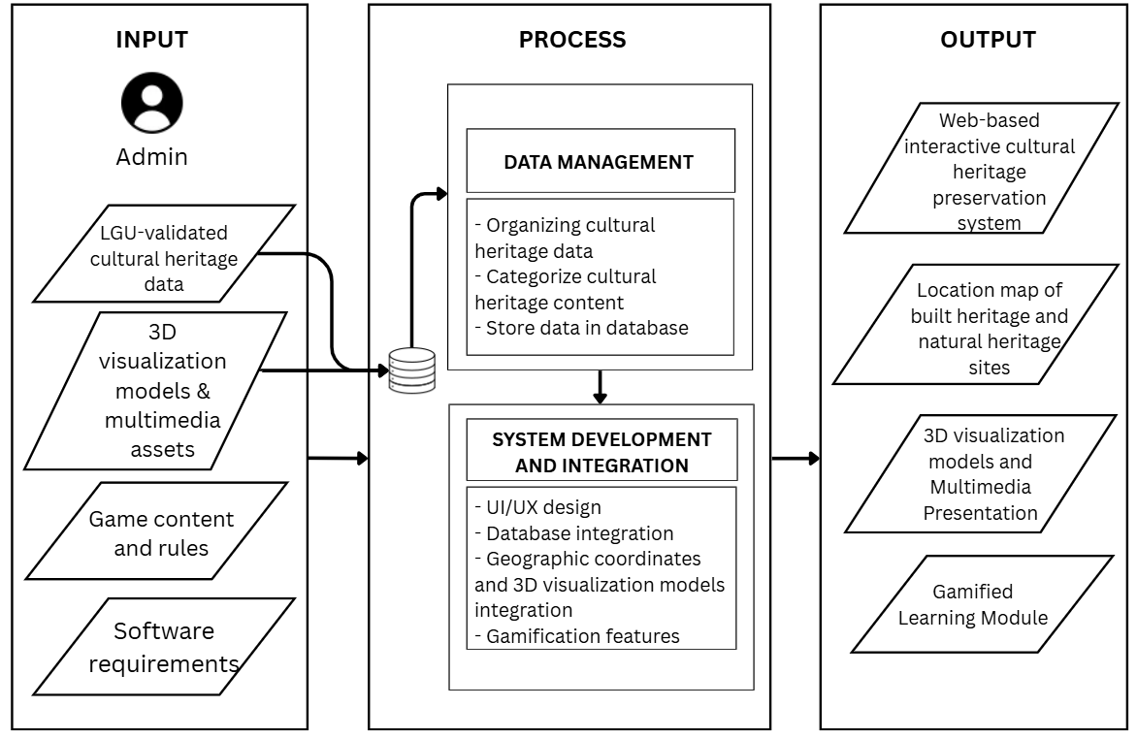
Figure 1. Conceptual Framework of the Study

The diagram illustrates the development framework of the system using the Input–Process–Output (IPO) model, which defines the structured flow of data, procedures, and system development activities involved in creating the web-based Mati Heritage 3D system. This framework serves as the foundation for understanding how cultural heritage information is transformed into an interactive digital platform that supports preservation, accessibility, and engagement.
In the input stage, the framework identifies four essential inputs managed by the administrator: LGU-validated cultural heritage data, 3D visualization models and multimedia assets, game content and rules, and software requirements. The LGU-validated cultural heritage data provides verified information for the system, supplemented by photographs, videos, and audio recordings from secondary sources where available, while the 3D visualization models and multimedia assets serve as the visual and digital resources used to present cultural heritage content. Game content and rules provide the basis for incorporating gamification features into the system, whereas the software requirements establish the technical specifications and functionalities needed for development. As illustrated in the diagram, the LGU-validated cultural heritage data, 3D visualization models, and multimedia assets are connected to the database, indicating that these resources are stored and managed for integration into the system.
In the process stage, the framework consists of two major components: data management and system development and integration. The data management phase focuses on organizing cultural heritage data, categorizing cultural heritage content, and storing the information in the database. This phase ensures that heritage-related information is systematically arranged and maintained for use within the platform. The database serves as the repository for the cultural heritage information and associated resources, supporting their retrieval and integration during system development.
The second component, system development and integration, focuses on developing and combining the system's main features. This includes UI/UX design, database integration, the integration of geographic coordinates and 3D visualization models, and the implementation of gamification features. These activities ensure that the stored cultural heritage data, location information, and 3D visualization model resources are incorporated into an accessible and interactive web-based platform. The integration of gamification features, guided by the game content and rules provided in the input stage, further supports interactive learning and user engagement.
In the output stage, the framework identifies four expected outputs. The first is the web-based interactive cultural heritage preservation system, which serves as the primary platform for accessing and exploring cultural heritage information. The second is the location map of built heritage and natural heritage sites, which allows users to view the locations of heritage sites based on their geographic coordinates. The third is the 3D visualization models and multimedia presentation, which allow users to explore and appreciate cultural heritage through 3D visualization models, photographs, videos, and audio recordings. The fourth is the gamified learning module, which incorporates game-based features to encourage user participation and support learning about cultural heritage. Collectively, these outputs create an integrated digital environment that supports the preservation, documentation, promotion, and appreciation of Mati City’s cultural heritage.

1.7 Definition of Terms
Technical Terms
For the purpose of this study, the following technical terms were used and defined to serve as reference to the readers.
3D Visualization Model This refers to the digital three-dimensional representations of Mati City’s built heritage sites within the web-based system. These models allow users to view and interact with the structures by rotating, zooming, panning, and examining their architectural features, enhancing their visual understanding and appreciation of built heritage.
Built Heritage This refers to physical historical structures and man-made sites, which are digitally preserved through 3D visualization models and interactive features that allow users to rotate, zoom, and view the models from different angles.
Cultural Heritage This refers to the built heritage sites, intangible cultural heritage, and natural heritage of Mati City validated by the Local Government Unit (LGU) and supplemented by secondary-source media where available. These are digitized, stored, and organized for presentation through interactive features including 3D visualization models and multimedia galleries, enabling users to explore and learn about the city’s cultural and historical identity.
Gallery A feature that presents visual and media content of Mati City’s cultural heritage. Built heritage is represented through photographs, and intangible heritage through photographs, videos, and audio recordings and natural heritage through photographs and videos.
Gamification This refers to a feature of the system that integrates educational game elements to make learning about Mati City’s cultural heritage more interactive and engaging. It is implemented through different game modules that allow users to test their knowledge, memory, and vocabulary skills while earning scores based on their performance and interaction with the content.
Intangible Cultural Heritage This refers to non-physical cultural assets presented through audio recordings, videos, and photographs, representing community traditions and cultural expressions.
Leaderboard A ranking system within the gamification module that displays the names and scores of users based on their performance in the 2D cultural heritage games.
Location Map A feature that utilizes geographic coordinates to identify, organize, and present built and natural heritage sites in Mati City through an interactive map. It enables users to access site-specific information based on spatial location data.
Natural Heritage This refers to naturally occurring physical landscapes and significant natural sites, presented through photographs and videos that allow users to view and understand their visual and environmental characteristics.

CHAPTER II
REVIEW OF RELATED LITERATURE

2.1 Literature Map
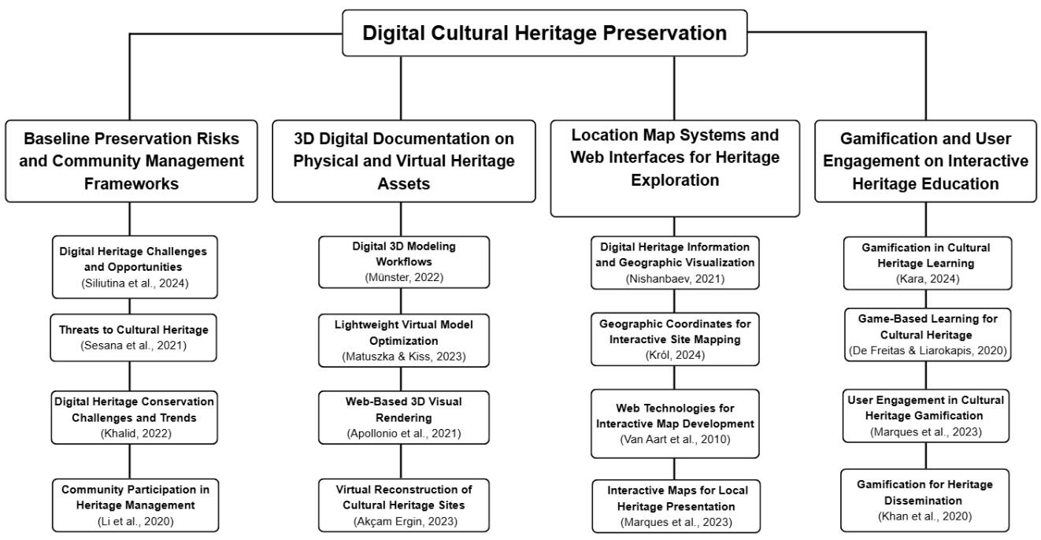
Figure 2. Literature Map
The research for the development of Mati Heritage 3D is structured around the literature map illustrated in Figure 2. The literature for the development of Mati Heritage 3D is organized around four interrelated thematic areas that establish the theoretical and technical foundation of the study. The first theme focuses on Baseline Preservation Risks and Community Management Frameworks, emphasizing the growing need for digital approaches to address threats to cultural heritage. The second theme focuses on 3D Digital and Documentation on Physical and Virtual Heritage Assets, which shows how 3D technologies improve the accuracy and accessibility of heritage records. The third theme discusses Location Map Systems and Web Interfaces for Heritage Exploration, which enable interactive access to heritage information through location map web platforms. The fourth theme examines Gamification and User Engagement on Interactive Heritage Education, which demonstrates how interactive and game-based approaches enhance cultural awareness and learning participation. Collectively, these themes provide a foundation for identifying gaps in integrated cultural heritage systems and support the development of a unified digital platform for cultural heritage preservation.

2.2 Related Literature
Baseline Preservation Risks and Community Management Frameworks
Cultural heritage is recognized as a fundamental component of community identity and a primary driver for sustainable development. According to Siliutina et al. (2024), the fusion of technology and preservation efforts not only addresses immediate threats to cultural landmarks but also ensures their long-term resilience and accessibility. This perspective is supported by Taqa (2025), who argues that heritage provides a community with a necessary sense of continuity and social cohesion. Furthermore, frameworks from UNESCO (2021) highlight that heritage-led strategies are essential for balanced urban growth and environmental stability, reinforcing the idea that protecting cultural landmarks is vital for the long-term well-being of society.
However, these cultural resources face unprecedented risks that necessitate immediate intervention. Sesana et al. (2020) conducted an assessment of the vulnerability of heritage sites to climate change, noting that many sites are increasingly exposed to environmental degradation. Supporting this, Shrestha et al. (2024) emphasize that structural deterioration in historical areas continues to threaten cultural assets. Additionally, UNESCO (2021) highlights that modernization, natural disasters, and rapid urbanization contribute to the irreversible loss of historical narratives.
To combat these threats, digital technologies have emerged as essential tools for modern documentation and preservation. According to Data and Information Management (2021), the role of data in cultural heritage has evolved into building sustainable infrastructures for preservation and digital scholarship. Similarly, Ćosović and Maksimović (2022) and Ababneh (2024) advocate for the application of digital solutions such as digital twin technologies to create virtual representations of heritage assets. These innovations enable better monitoring, preservation, and accessibility of cultural sites. Moreover, Lee et al. (2025) highlight the importance of integrating data, metadata, and paradata in creating collaborative digital heritage environments that enhance knowledge sharing and preservation.
The long-term viability of these preservation efforts depends heavily on the involvement of local communities. Li et al. (2020) argue that community participation is a critical factor in cultural heritage management, ensuring authenticity and the transmission of traditions across generations. Furthermore, Marques et al. (2023a) emphasize that engaging communities through digital platforms, such as gamification, enhances user interaction and promotes cultural awareness. In addition, Prasad et al. (2024) highlight that digital transformation in heritage preservation fosters greater public engagement and supports sustainable conservation practices.
3D Digital and Documentation on Physical and Virtual Heritage Assets
The transition from traditional two-dimensional records to three-dimensional (3D) digital recording has significantly transformed how cultural heritage sites are documented and managed. According to Münster (2022), 3D modeling workflows utilizing historical documents, physical blueprints, and local descriptive records allow for the creation of precise structural interpretations without needing advanced on-site field scanning equipment. This process enables an efficient way to generate and analyze architectural structures, especially for physical assets that are at risk of environmental or natural decay. Similarly, Matuszka and Kiss (2023) emphasize that building lightweight virtual models from standard digital design software enhances the web performance and public accessibility of heritage platforms. Furthermore, Palčák et al. (2022) highlight that 3D digital technologies improve the efficiency of heritage documentation and support long-term conservation efforts.
Standard computer-aided design and low-polygon mesh generation are among the primary methodologies used to build web-ready virtual platforms. Apollonio et al. (2021) describe how web-based rendering frameworks utilize optimized geometric shapes and custom textures to produce detailed 3D representations that run smoothly in standard web browsers. This method is highly effective for reconstructing the visual characteristics of physical landmarks using standard desktop software applications. Supporting this approach, Potenziani et al. (2015) explain that optimizing the polygon density of 3D structural designs allows for quick file transmission over basic internet connections while maintaining visual accuracy. These integrated design techniques enable the creation of responsive 3D assets for entire historical structures and natural environments. In addition, Akçam Ergin (2023) highlights the importance of 3D virtual reconstruction in conserving ancient cities by digitally recreating lost or damaged architectural elements.
Managing and utilizing the large datasets generated by 3D documentation is another key concern in current research. According to Bekele et al. (2018), advanced technologies such as virtual reality (VR), augmented reality (AR), and mixed reality (MR) provide effective platforms for visualizing and interacting with 3D cultural heritage data. These technologies allow users to explore heritage sites in immersive digital environments. Similarly, Champion (2016) discusses how interactive and game-based environments can enhance user engagement and education in virtual heritage. Earlier, Addison (2000) already identified virtual heritage as an emerging field that supports the preservation and dissemination of cultural knowledge through digital means. By integrating these technologies, cultural heritage projects can ensure that valuable historical information remains accessible even when physical sites are threatened or no longer exist.
Location Map Systems and Web Interfaces for Heritage Exploration
The use of location map web platforms provides a practical method for displaying historical data without requiring complex spatial software or expert mapping skills. Nishanbaev (2021) states that linking digital assets directly to specific coordinates on a public web map makes cultural records accessible to a wider audience. This approach allows users to discover history through intuitive location markers rather than complex spatial layers. Liberge and Gerlings (2008) argue that point-and-click interfaces enable a seamless connection between a multimedia database and map layouts. Furthermore, Stefanakis (2017) highlights that standard web mapping platforms offer scalable tools for public visualization, showing that connecting records to geographical points increases the educational value of public databases (Lai et al., 2012; Ziku et al., 2024).
Managing geographic data through simplified coordinate structures ensures that interactive map applications remain responsive. Król (2024) explores how storing plain latitude and longitude values inside a relational database bridges the gap between text records and map layouts. This method avoids the need for heavy spatial data engines or geoprocessing tasks. According to Horbiński and Lorek (2022), treating geographical locations as basic numeric parameters keeps web interfaces lightweight and fast. Similarly, Lu (2013) notes that avoiding heavy data layers ensures that users can select a point marker and immediately see corresponding asset details without experiencing performance lag (Sadeghi-Niaraki, 2023; Dziatkiewicz & Król, 2026).
Modern web cartography has increasingly shifted toward open-source libraries that simplify the deployment of interactive maps. Van Aart et al. (2010) describe how lightweight JavaScript frameworks allow developers to plot historical points of interest directly onto standard web layouts. These open-source technologies eliminate the barrier of expensive software and specialized engineering skills. According to the International Society for Photogrammetry and Remote Sensing (2025), responsive map tools provide a highly efficient architecture for municipal conservation projects. This perspective is supported by Lata et al. (2022), who demonstrate that web-based interfaces can successfully distribute public asset data without requiring an extensive geoinformatics background (Liu et al., 2024).
The inclusion of interactive web maps in regional projects directly enhances public discovery and community engagement. Marques et al. (2023b) argue that presenting local landmarks through familiar points on a map helps individuals build a stronger connection to their local environment. This is because interactive pins act as visual anchors for localized storytelling. According to Singh et al. (2024), simple map interfaces are highly effective for transferring cultural knowledge across generations. Additionally, Bozoğlu et al. (2024) state that map-based exploration fosters a sense of local ownership over historical narratives, transforming static listings into engaging virtual spaces (Higgins & Douglas, 2020).
Gamification and User Engagement on Interactive Heritage Education
The use of gamification has become a widely adopted strategy for making cultural heritage more accessible and engaging to the public. Gamification is defined as the application of game design elements in non-game contexts to increase user motivation (Deterding et al., 2011). According to Kara (2024), serious games are effective tools for heritage learning because they allow users to actively interact with historical content rather than passively consume information. This interactive approach enhances user engagement and improves knowledge retention. Supporting this, De Freitas and Liarokapis (2020) emphasize that well-designed serious games provide immersive learning environments that promote a deeper understanding of cultural heritage.
To maintain user interest, digital platforms must incorporate effective engagement strategies. Fotaris et al. (2022) highlight that gamification in cultural heritage environments enhances user engagement through interactive learning and game-based elements. Similarly, Marques et al. (2023a) found that interactivity plays a key role in preventing disengagement in digital heritage platforms by encouraging active participation. These interactive features allow users to explore, solve problems, and connect more meaningfully with cultural content. Furthermore, Skublewska-Paszkowska et al. (2022) emphasize that integrating 3D technologies with interactive systems supports the preservation and presentation of intangible cultural heritage, making it more engaging for diverse audiences.
The selection of appropriate game mechanics is also critical in effectively communicating cultural heritage information. According to Khan et al. (2020), gamification is one of the most effective strategies for disseminating cultural heritage, particularly to younger audiences. By incorporating game elements such as challenges, rewards, and storytelling, digital platforms can transform passive observation into active participation. Additionally, Xu et al. (2017) highlight that serious games and gamification enhance user experience by simulating real-world or historical scenarios, which improves engagement and learning outcomes. Moreover, studies such as Ibáñez et al. (2014) demonstrate that interactive technologies, including augmented reality, significantly enhance learning effectiveness by creating immersive educational experiences. Through these approaches, cultural heritage can be preserved and shared in ways that are both meaningful and engaging for modern audiences.

2.3 Synthesis
The reviewed literature shows that digital technologies can support the documentation, preservation, accessibility, and public engagement of cultural heritage. The first theme establishes that heritage is threatened by environmental degradation, urbanization, and disasters (Sesana et al., 2020; Shrestha et al., 2024; UNESCO, 2021) and that community participation is central to sustaining it (Li et al., 2020). The second theme shows that web-ready 3D models can be built with standard design software instead of costly on-site scanning (Münster, 2022; Matuszka & Kiss, 2023; Apollonio et al., 2021), which supports the use of Blender for the built heritage models of this study. The third theme shows that location maps linked to simple latitude and longitude records keep heritage information accessible and fast to load (Król, 2024; Horbiński & Lorek, 2022; Nishanbaev, 2021), which supports the use of Leaflet for the location map. The fourth theme shows that gamification and serious games increase engagement and cultural awareness, particularly among younger audiences (Khan et al., 2020; Kara, 2024; Marques et al., 2023a).
Despite these advances, existing digital heritage initiatives often remain limited to static documentation and basic visualization (Ioannides et al., 2017) and tend to be fragmented, focusing on documentation rather than integrated platforms that support interactive exploration, multimedia presentation, and user engagement (Ch’ng & Gaffney, 2013).
In response to this gap, the study proposes Mati Heritage 3D: A Web-Based Interactive Cultural Heritage Preservation System with Gamification. The system integrates 3D visualization models and photographs of built heritage; photographs, videos, and audio recordings of intangible cultural heritage; photographs and videos of natural heritage; a location map of built and natural heritage sites; user account registration and login with a game leaderboard; and an administrator module for managing heritage records and generating reports. By bringing these functions together in a single platform for a localized context, the study aims to support the preservation, appreciation, and understanding of Mati City’s cultural heritage and to encourage community engagement in heritage learning.

2.4 Related System
Prayalane
Prayalane is a community-driven digital heritage platform developed to preserve the cultural identity of the Kristang community in Malacca, Malaysia. It functions as a digital storytelling system that utilizes map-based narratives supported by multimedia content such as photographs, audio recordings, and community-contributed photographs to document intangible cultural heritage. The platform enables users to explore cultural content in a non-linear and context-based manner, aligning with digital heritage approaches that emphasize participatory documentation and narrative-driven representation (Prayalane, 2021).
The system provides key features such as map-based storytelling and multimedia integration, which can be applied to the proposed Mati Heritage 3D system. These features inform the design of linking cultural sites to narratives and media within a map-based interface, allowing users to access contextual information through interactive map elements. Additionally, its structured presentation of cultural content can guide data organization in the system. However, the proposed system enhances these functionalities by incorporating location map visualization, interactive 3D visualization models, and gamification, resulting in a more immersive and interactive platform for cultural heritage preservation.
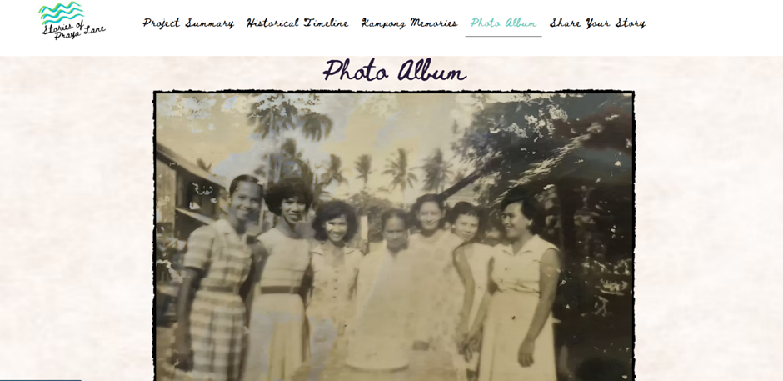
Figure 3. Prayalane Gallery showing community-contributed photos and thematic categories (Prayalane, 2021)
Google Arts & Culture
Heritage on the Edge is a global digital heritage preservation initiative on the Google Arts & Culture platform that documents cultural sites threatened by climate change. It employs advanced multimedia technologies such as high-resolution 3D guided tours, augmented reality experiences, aerial drone footage, virtual exhibitions, documentary videos, and expert interviews. The platform presents cultural heritage sites in a highly immersive visual format, allowing users to virtually explore and understand their historical, environmental, and cultural significance (Google Arts & Culture, 2020). The wider Google Arts & Culture platform also offers interactive games, showing how game-based activities can complement digital cultural content.
The 3D visualization and navigation interface of Heritage on the Edge serves as a reference for the 3D exploration of Mati City’s built heritage. The proposed system implements a similar interface in which users can zoom, rotate, and interact with the 3D visualization models of built heritage sites in a web browser. Furthermore, the web-based rendering approach used in this platform guides the optimization of the Mati Heritage 3D visualization models, ensuring they remain accessible across different web devices.
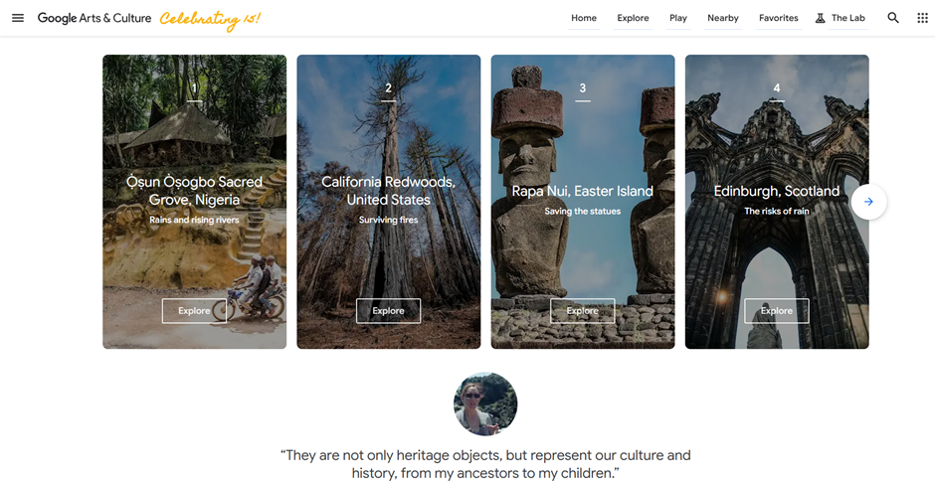
Figure 4. Google Arts & Culture – Heritage on the Edge Interface Showing Featured At-Risk Cultural Heritage Sites (Google Arts & Culture, 2020)
CyArk’s Tapestry
CyArk’s Tapestry is a web-based cultural heritage platform that utilizes LiDAR scanning and photogrammetry to generate highly detailed 3D reconstructions and immersive virtual tours of heritage sites. It presents these sites together with image galleries and location-based exploration. It focuses on producing accurate digital replicas of historical environments, often requiring advanced technical expertise, specialized equipment, and significant production resources (CyArk, 2021).
CyArk’s Tapestry serves as a reference for how 3D heritage content can be presented to the public through a web browser. Unlike Tapestry, which relies on LiDAR scanning and photogrammetry, Mati Heritage 3D builds its 3D visualization models in Blender and presents them through an interactive viewer with zoom, rotate, and navigation controls, as described in Chapter III. Tapestry therefore guides the presentation and web optimization of the models, while their level of detail remains limited by the development time constraints stated in the limitations of the study.
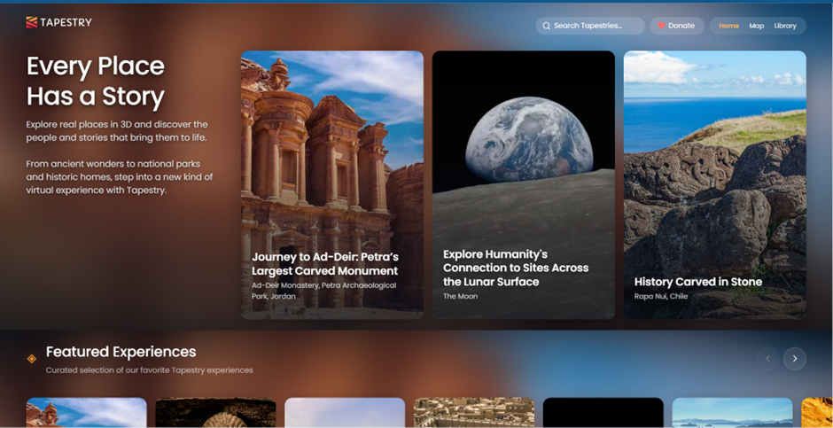
Figure 5. Interface of CyArk’s Tapestry Platform Showing Interactive 3D Cultural Heritage Experiences (CyArk, 2021)
PHL Trails for UNESCO
PHL Trails for UNESCO is a web-based platform that promotes the exploration of Philippine heritage sites and nature trails through interactive maps, informational content, and travel guides. The platform allows users to browse heritage locations across different regions of the Philippines, view information about specific sites, and explore routes connecting places of cultural and natural significance. It also features articles and stories that provide additional information about heritage conservation and related initiatives. These features support public awareness and accessibility by presenting heritage information through a centralized digital platform (PHL Trails for UNESCO, n.d.).
PHL Trails for UNESCO serves as a reference for the location map and presentation of cultural heritage information in Mati Heritage 3D. The proposed system adapts the use of interactive maps and organized site information to help users explore local heritage sites. However, Mati Heritage 3D focuses on the heritage of Mati City and integrates 3D visualization models, multimedia presentation, and gamified learning activities to enhance users’ learning and appreciation of local heritage.

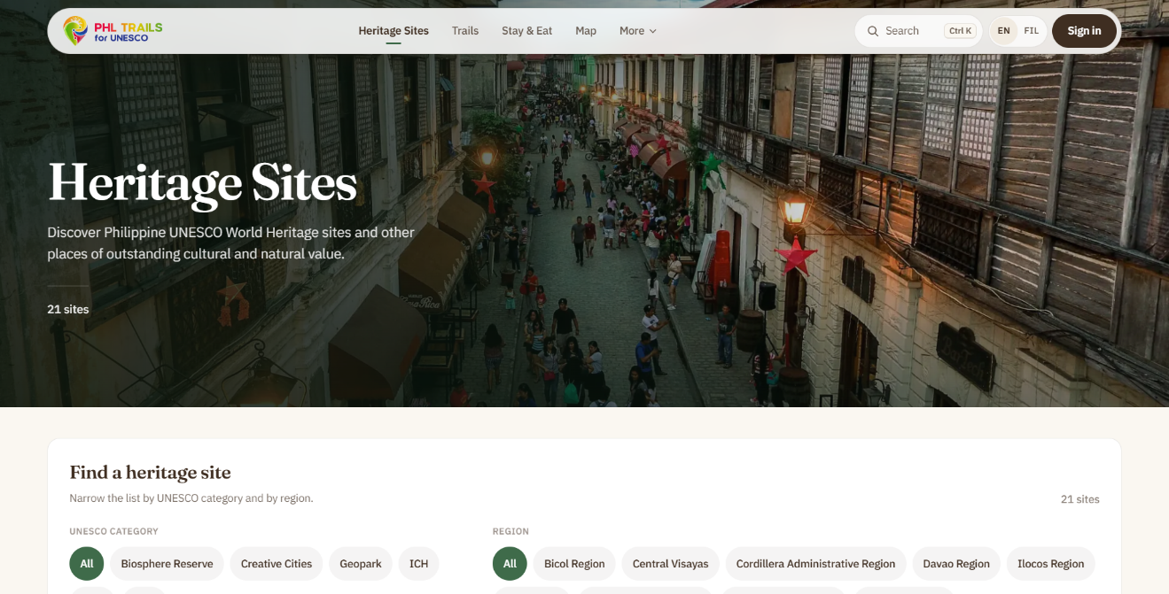
Figure 6. PHL Trails for UNESCO Interactive Heritage Map (n.d).
Cultural Mapping of Panay and Guimaras (CMPG)
The Cultural Mapping of Panay and Guimaras (CMPG) is a digital platform that documents and presents the cultural heritage of Panay and Guimaras in the Philippines. It features categorized heritage information, including intangible heritage, tangible immovable heritage, tangible movable heritage, and natural heritage. The platform also provides an intangible heritage gallery and an interactive map that help users explore cultural resources and learn about local traditions and heritage sites (Cultural Mapping of Panay and Guimaras, n.d.).
The CMPG platform serves as a reference for organizing and presenting cultural heritage information in the proposed Mati Heritage 3D system. Its categorization of heritage resources and use of an interactive map provide a basis for structuring information about Mati City's built heritage, intangible cultural heritage, and natural heritage sites. However, Mati Heritage 3D will extend this approach by integrating 3D visualization models of built heritage sites, photographs and videos of cultural traditions and natural heritage, user account registration, and gamified learning activities to promote interactive exploration and appreciation of Mati City's local heritage.
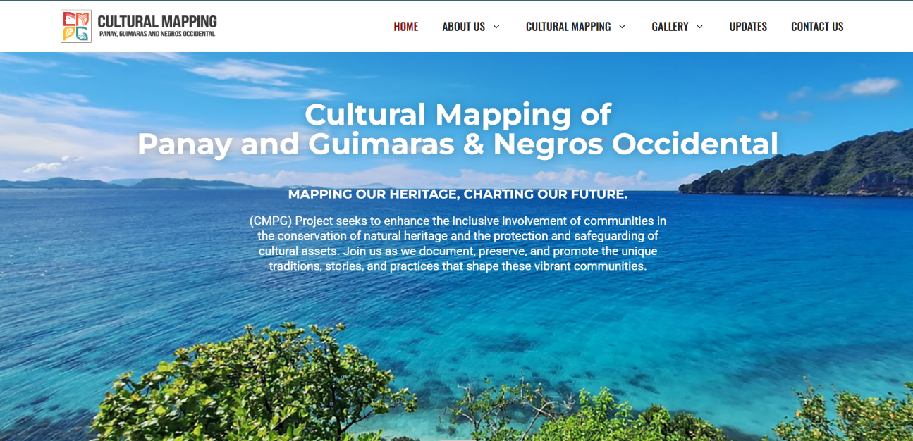
Figure 7. Cultural Mapping of Panay and Guimaras (CMPG) website featuring its cultural heritage resources and mapping platform. (Cultural Mapping of Panay and Guimaras, 2024)
Table 1. Tabulated Comparison
 | Proposed  System | Existing Related Systems
Key Features | Mati Heritage 3D: A Web-Based Interactive Cultural Heritage Preservation System with Gamification | Prayalane | Google Arts & Culture | CyArk’s Tapestry | PHL Trails for UNESCO | Cultural Mapping of Panay and Guimaras (CMPG)
Interactive Web-based | YES | YES | YES | YES | YES | YES
3D Visualization Models | YES | NO | YES | YES | NO | NO
Gamified Learning Module | YES | NO | YES | NO | NO | NO
Gallery | YES | YES | YES | YES | NO | YES
Location Map | YES | YES | NO | YES | YES | YES
User Account Registration | YES | NO | NO | NO | YES | NO

The systems compared demonstrate various applications of digital technology for cultural heritage preservation, documentation, and educational engagement. Prayalane focuses on presenting cultural heritage through map-based narratives and a digital collection of cultural materials. Google Arts & Culture provides access to digital cultural collections, online exhibitions, 3D models, and interactive games, demonstrating how digital technologies can support cultural exploration and gamified learning. Similarly, CyArk’s Tapestry emphasizes digital heritage documentation through 3D models, interactive experiences, and location-based exploration. PHL Trails for UNESCO provides information about heritage sites and trails through an interactive mapping platform, helping users discover and learn about cultural heritage locations. Meanwhile, the Cultural Mapping of Panay and Guimaras (CMPG) platform organizes cultural heritage information through categorized resources, an intangible heritage gallery, and an interactive map. Although these systems contribute to cultural documentation and public engagement, their available features differ in scope and implementation.
As presented in Table 1, Mati Heritage 3D is designed to integrate the identified functional components into a single web-based platform, including 3D visualization models of built heritage sites, a gallery of photographs and videos, a location map, user account registration, and gamified learning activities. None of the systems reviewed combines 3D visualization models, a gallery, a location map, user account registration, and gamified learning in a single platform, and none is focused on the cultural heritage of Mati City. Unlike systems that primarily emphasize particular aspects of digital heritage presentation, the proposed system focuses on combining these functions to support the exploration and appreciation of Mati City's built heritage, intangible cultural heritage, and natural heritage sites. This integrated approach aims to provide users with a more accessible and engaging way to discover local heritage while encouraging learning through interactive activities.

CHAPTER III
MATERIALS AND METHODS

3.1 Software Methodology
In this study, a structured software methodology serves as a guide for planning and managing the overall development process of the system. It provides a systematic framework for organizing development activities and addressing system complexity throughout the project lifecycle. This approach ensures that requirements are properly analyzed and translated into a functional solution in an organized and efficient manner (Sommerville, 2016).
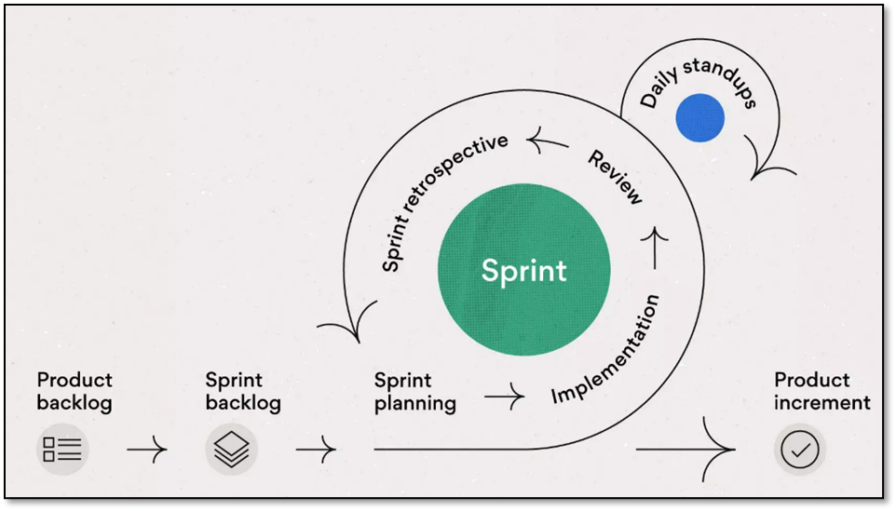
Figure 8. Scrum Framework (Martins, 2026)
This project adopts the Scrum framework. Scrum is a lightweight agile framework that emphasizes iterative development, collaboration, and continuous feedback. This structure allows development teams to quickly adapt to changing requirements while ensuring the steady delivery of functional outputs. As described by Schwaber and Sutherland (2020), Scrum enables effective team collaboration and incremental delivery of value in complex software projects. The following sections present the Scrum phases and describe how each phase is applied in the development of the proposed system.
Product Backlog. During the product backlog phase, the developers identify, gather, and organize all system requirements and features needed for the development of the Mati Heritage 3D web-based system. These requirements are derived from data gathering activities, including coordination with Local Government Units (LGUs), review of related literature, and analysis of existing systems. The backlog includes core system components, including the location map feature for built heritage and natural heritage, the gallery, the user account system, the gamification modules, and the administrator module. Built heritage is presented through 3D visualization models and photographs, intangible cultural heritage through photographs, videos, and audio recordings, and natural heritage through photographs and videos. Gamification includes interactive 2D games with scoring and time-based mechanics. User accounts support registration, login (including Google Sign-In), score tracking, and participation in a global leaderboard. The administrator module allows City Tourism Office administrators to manage heritage records and multimedia files and to view graphical reports with CSV export. Each feature is listed, described, and prioritized based on its importance and contribution to the overall objective of preserving and promoting the cultural heritage of Mati City. This phase serves as the foundation for planning and managing the development process.
Sprint Backlog. The developers organize the selected Product Backlog items into a Sprint Backlog, which lists the tasks and activities planned for a specific Sprint. For the Mati Heritage 3D system, these tasks include implementing the location map for built heritage and natural heritage sites, integrating cultural heritage records and multimedia content, designing user interface components, creating and integrating 3D visualization models of built heritage sites, developing gamified learning activities with scoring and time-based mechanics, implementing user account features such as registration, login, score tracking, and leaderboard participation, and developing the administrator module for heritage record management, multimedia management, graphical reports, and CSV export. The Sprint Backlog provides a working list of development tasks that the team can monitor and update throughout the Sprint.
Sprint Planning. During Sprint Planning, the developers determine the objectives of the upcoming Sprint and plan the work needed to achieve them. The team reviews the prioritized Product Backlog, establishes the Sprint goal, estimates the required time and effort, identifies dependencies, and organizes the development activities according to the system requirements. Planning activities may include location map integration for built heritage and natural heritage sites, cultural heritage content integration, 3D visualization model development for built heritage, gamification module development, user account implementation, and administrator module development. This process helps the developers establish a clear plan for the development activities to be carried out during the Sprint.
Implementation. Actual system development takes place during this phase, where the developers execute the tasks defined in the sprint backlog. The web-based system is developed, the location map feature for built heritage and natural heritage is implemented, cultural heritage content is integrated, and 3D visualization models of built heritage are created. Gamified learning modules with scoring and time-based mechanics are developed to allow users to interact with cultural heritage content in an engaging manner. User account functionalities including registration, login, score tracking, and leaderboard participation are also implemented. The administrator module for managing heritage records and multimedia files and generating reports is also developed. Continuous integration of features is conducted to ensure alignment with system requirements, resulting in functional outputs at the end of each sprint.
Daily Scrum. Throughout the implementation, the developers hold short daily coordination meetings to report progress, discuss obstacles, and align tasks for the day. These meetings help monitor sprint progress and ensure that development activities are completed within the intended timeline.
Review. At the end of each sprint, the completed features are evaluated to determine whether they meet the specified requirements. Functional demonstrations are conducted for the location map feature for built heritage and natural heritage, cultural heritage content integration, 3D visualization models of built heritage, gamification modules, user account functionalities, and the administrator module. Feedback is gathered to identify issues, improvements, or additional requirements. This evaluation ensures that each system increment remains aligned with the objective of supporting the preservation and promotion of cultural heritage in Mati City.
Sprint Retrospective. After the sprint review, the development team conducts a reflection on the completed sprint to assess the effectiveness of the development process. Strengths, challenges, and workflow issues are identified, including task management and technical difficulties encountered during implementation. Based on these observations, adjustments are planned to improve efficiency and performance in succeeding sprints.
Product Increment. Each completed sprint produces a working version of the web-based system known as a product increment. These increments include newly developed and functional features that gradually build the complete Mati Heritage 3D web-based system. The system evolves step by step, starting from the location map feature for built heritage and natural heritage, progressing toward cultural heritage content integration, 3D visualization models of built heritage, gamified learning activities with scoring and time-based mechanics, user account functionalities including registration, login, score tracking, and leaderboard participation, and the administrator module. Through continuous testing and validation, each increment ensures that the system consistently supports the preservation and promotion of cultural heritage information.

3.2 System Planning
The planning stage serves as the foundation for the development of the Mati Heritage 3D web-based system. The project is conceptualized in response to the need for an organized and accessible approach to preserving and presenting the cultural heritage of Mati City. This idea is developed after identifying gaps in the documentation and accessibility of local cultural assets, where information remains fragmented and not digitally centralized. Through initial observations, consultation with relevant stakeholders, and review of related literature, the researchers determine the need for a web-based system that supports the preservation of cultural heritage through structured digital presentation and interactive features.
To prepare for system development, the researchers conduct requirement gathering and analyze existing studies and related systems to identify appropriate features and design approaches. The system scope is defined to include a location map feature for built heritage and natural heritage, 3D visualization models and photographs for built heritage, and multimedia content for intangible cultural heritage consisting of photographs, videos, and audio recordings. The system also includes gamified learning activities with scoring and time-based mechanics, and user account functionalities that support registration, login, score tracking, and leaderboard participation, as well as an administrator module for managing heritage records and generating reports. This stage ensures that the project has a clear direction, structured scope, and well-defined requirements before proceeding to system design and implementation.
Feasibility Study
The Feasibility Study evaluates whether the proposed web-based system can be realistically developed, implemented, and maintained within given constraints of time, resources, and technology. The project focuses on the development of a system for the preservation of the cultural heritage of Mati City through a location map feature for built heritage and natural heritage, 3D visualization models of built heritage, multimedia presentation of intangible cultural heritage (photographs, videos, and audio recordings), and natural heritage (photographs and videos), and gamified learning activities. This section assesses the major dimensions of feasibility, including operational feasibility, technical feasibility, and economic feasibility.
Operational Feasibility
The proposed system is operationally feasible as it is designed to function effectively in support of cultural heritage preservation in Mati City. In terms of user acceptance, local residents, visitors, and future researchers are expected to readily adopt the system due to its specific features, including location map access to built heritage and natural heritage sites, 3D visualization models of built heritage, multimedia presentation of intangible cultural heritage (photographs, videos, and audio recordings), and natural heritage (photographs and videos), and gamified learning activities with scoring and time-based mechanics that provide an interactive approach to cultural learning. Regarding current pain points, the system addresses the difficulty of accessing fragmented and manually stored cultural heritage records by providing a centralized web-based system that organizes built heritage, intangible cultural heritage, and natural heritage, improving accessibility, retrieval, and consistency of information. For organizational support, the City Tourism Office, as the primary administrator of the system, is expected to support and utilize the system for managing and presenting cultural heritage information, while Local Government Units (LGUs) may also utilize the system as a reference for cultural heritage documentation and promotion.

Economic Feasibility
Shown in Table 2 is the cost-benefit analysis used to examine the project’s feasibility from an economic perspective.
Table 2. Cost/Benefit Analysis
COST
CATEGORY ESTIMATED BUDGET
1. Product Backlog
1.1 Requirements Gathering Php 1350.00
2. Sprint Planning
2.1 3D Built Heritage Models Php 300.00
2.2 Location Map and Gamification Planning Php 450.00
3. Sprint Backlog -
4. Implementation
4.1 Web Hosting and Domain Subscription Php 1,200.00
4.2 Supabase Monthly Subscription Php 1,540.00
5. Sprint Review
5.1 System Testing & Demo Php 700.00
Presentation
6. Sprint Retrospective
6.1 Evaluation & Process Improvement Php 450.00
7. Daily Scrum
7.1 Team Coordination Meetings Php 520.00
8. Product Increment -

Total Cost: Php 6,510.00

The economic feasibility of the proposed system is evaluated through the cost analysis presented in Table 2, which indicates a total estimated development cost of ₱6,510.00 distributed across Scrum-based development activities. This reflects an agile and iterative development approach in which planning, coordination, implementation, evaluation, and testing are conducted in incremental cycles to ensure the continuous refinement of the proposed system. The largest share of the budget is allocated to the Implementation phase (₱2,740.00), followed by the Product Backlog phase (₱1,350.00), which involves Requirements Gathering. This phase includes the identification of system requirements, coordination with the Local Government Unit (LGU) of Mati City as the primary source of cultural heritage data, and the collection of necessary information such as heritage site listings, descriptions, photographs, videos, audio recordings, and geographic locations for integration into the Mati Heritage 3D web-based system. This phase serves as the foundation of the development process by defining the project scope and reducing uncertainties during system development. Costs are also allocated to the Sprint Planning phase (₱750.00), which focuses on preparing and organizing development activities for core system features. This includes the development preparation for 3D built heritage models, as well as the location map and gamification features of the system. The phase involves organizing tasks, prioritizing system modules, estimating development activities, and establishing a structured workflow to support an organized and achievable implementation process. The Implementation phase (₱2,740.00) covers the operational and deployment requirements of the system. This includes the Web Hosting and Domain Subscription (₱1,200.00), which enables the platform to be deployed and accessed online through a registered domain and hosting service. It also includes the Supabase Monthly Subscription (₱1,540.00), which provides backend infrastructure services such as cloud database management, user authentication, storage of multimedia files, and management of cultural heritage records and gamification data. These resources are necessary to ensure stable system functionality, secure data storage, and accessibility of the web-based platform. The Sprint Review phase (₱700.00) covers system testing and demonstration activities conducted to evaluate the functionality, usability, and overall performance of the system. This phase ensures that the developed features meet the identified requirements and project objectives. The Sprint Retrospective phase (₱450.00) focuses on evaluating the development workflow, identifying technical challenges, and improving development practices for succeeding sprint cycles. Meanwhile, the Daily Scrum phase (₱520.00) supports regular communication and coordination among the developers to monitor sprint progress, align development activities, and ensure that project tasks are completed within the intended timeline. Other Scrum phases, such as Sprint Backlog and Product Increment, are not assigned separate monetary costs because their corresponding activities are already integrated within the planning, implementation, and review processes of the project.
On the other hand, the proposed system offers benefits in terms of cultural preservation, accessibility, and administrative efficiency. It provides a centralized digital platform for organizing and preserving cultural heritage information, reducing the risks of data loss and inconsistent documentation. The web-based system also improves accessibility by allowing users to access cultural heritage content, multimedia resources, and interactive features anytime and anywhere through internet-enabled devices. Furthermore, the integration of location map features, 3D visualization models, and gamified learning activities enhances user engagement and promotes awareness of Mati City’s cultural heritage. For the Local Government Unit (LGU) and the City Tourism Office, the system improves the management, updating, and retrieval of cultural heritage records while reducing the time and effort required for manual documentation processes. These projected benefits indicate that the proposed Mati Heritage 3D system is economically feasible for implementation.
Technical Feasibility
The proposed system is considered technically feasible as it is developed using established web technologies that support interactive and multimedia-based applications. The system is developed and tested using laptops and internet-enabled devices such as desktop computers, tablets, and smartphones, and it operates through standard web browsers without requiring additional software installation, ensuring accessibility across multiple devices.
The development uses Visual Studio Code as the primary code editor. HTML, CSS, and JavaScript are used to build the user interface and manage client-side functionality, while Tailwind CSS is used to support responsive and efficient interface design. Leaflet is utilized to implement the location map feature, displaying a web-based map of Mati City with markers for built heritage and natural heritage sites, allowing users to view and access cultural heritage information interactively. Supabase is used as the backend service and database management system to handle user authentication (including Google Sign-In), data storage, and management of cultural heritage content, including built heritage, intangible cultural heritage, natural heritage, and gamification records. Blender is used to create and optimize 3D visualization models of built heritage, which are displayed in the browser using Google’s model-viewer web component (version 3.5.0), allowing users to rotate, zoom, and pan the models without installing additional software. Overall, the technologies used are widely supported, accessible, and suitable for the development and implementation of the system.

Work Breakdown Structure (TO BE CHECK)

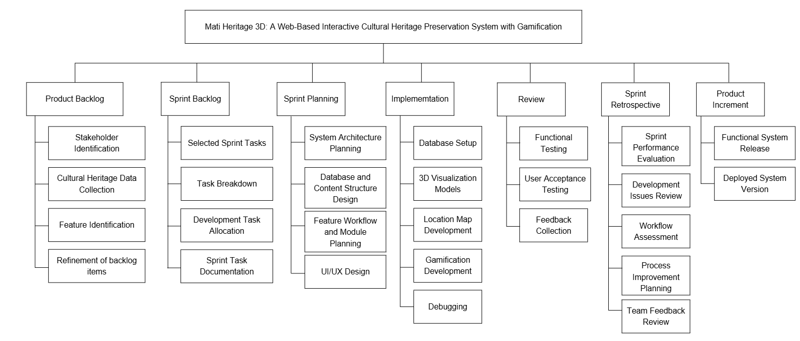

Figure 9. Work Breakdown Structure
Figure 9 illustrates the Work Breakdown Structure (WBS) for the Mati Heritage 3D project, showing the hierarchical organization of tasks based on the Scrum framework to support a structured and systematic development process. The Product Backlog focuses on stakeholder identification, cultural heritage data collection, feature identification, and refinement of backlog items to establish the project requirements and core system functionalities. The Sprint Backlog organizes the selected sprint tasks, task breakdown, development task allocation, and sprint task documentation to identify and organize the work required for each sprint. The Sprint Planning phase covers system architecture planning, database and content structure design, feature workflow and module planning, and UI/UX design to establish the technical structure and interface requirements of the system.

The Implementation phase covers the actual system development activities, including database setup, 3D visualization models, location map development, gamification development, and debugging. The Review phase evaluates the developed system through functional testing, user acceptance testing, and feedback collection to assess whether the system meets its intended requirements and functionalities. Meanwhile, the Sprint Retrospective phase focuses on sprint performance evaluation, development issues review, workflow assessment, process improvement planning, and team feedback review to identify challenges and improve the development process. Lastly, the Product Increment represents the functional system release and deployed system version resulting from the development activities. Overall, the WBS provides a structured breakdown of the tasks involved in developing the Mati Heritage 3D web-based system.

Gantt Chart (TO BE UPDATED SOON) DO NOT TOUCH
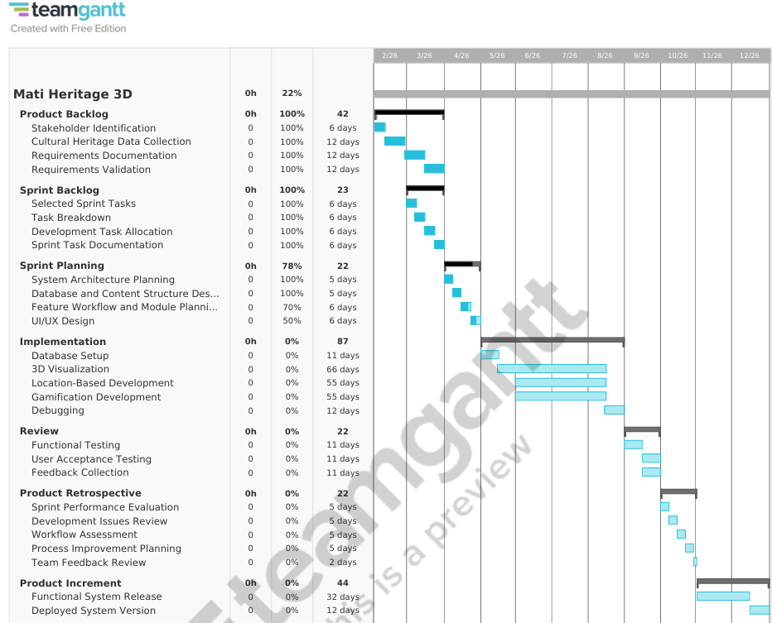
Figure 10. Gantt Chart
The Gantt chart’s horizontal bars represent the duration and percentage of each task, where black bars indicate the planned schedule and blue bars show the actual progress. This visual representation serves as an essential tool for both the developer and stakeholders, providing a clear means of monitoring project progress, allocating resources efficiently, and ensuring that development activities are completed within the intended timeline. Moreover, the transparency of the chart allows easy identification of tasks that are on track or delayed, thereby supporting effective supervision and informed decision-making during each Scrum sprint cycle.

3.3 System Analysis
The system analysis phase focused on evaluating the current cultural heritage documentation process to understand its operation and identify gaps for improvement.
Description of the Current System
The current approach to cultural heritage documentation and preservation in Mati City primarily relies on manual and non-centralized methods of storing and managing cultural heritage information. Data related to built heritage, intangible cultural heritage, and natural heritage are commonly collected through interviews, photographs, videos, audio recordings, and field documentation, then stored in physical records, individual files, or separate digital repositories managed by different offices or personnel. Because there is no centralized web-based system, cultural heritage information remains fragmented and difficult to organize, retrieve, and manage efficiently.
The existing process also presents several limitations in terms of accessibility, organization, and user engagement. Accessing cultural heritage records often requires manual searching and coordination between offices, which increases the time and effort needed to retrieve information. The absence of a centralized system may also result in inconsistent records, duplicated files, and difficulties in maintaining updated information. In addition, the current setup lacks interactive features that can improve user engagement and cultural awareness, including location map access to built heritage and natural heritage sites, 3D visualization models of built heritage, multimedia presentation of intangible cultural heritage and natural heritage, and gamified learning activities. These limitations reduce the effectiveness of cultural heritage preservation and limit opportunities for accessible and interactive cultural learning within Mati City.

Business Process Modelling Notations

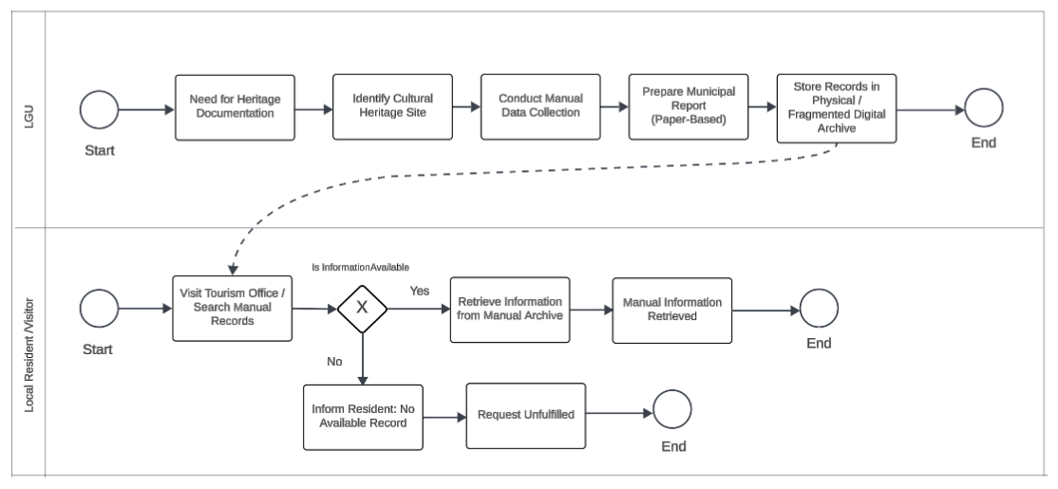

Figure 11. BPMN of the Current System
The BPMN diagram depicts the current workflow for cultural heritage documentation and information access within the local government unit (LGU) and the community, characterized by a predominantly manual and linear process. Initially, the LGU identifies the need for heritage documentation, followed by the selection of cultural heritage sites and the conduct of manual data collection, which is subsequently consolidated into paper-based municipal reports and stored in either physical repositories or fragmented digital archives. Such practices are commonly associated with inefficiencies in information management, including data redundancy, limited interoperability, and heightened vulnerability to data loss. From the perspective of local residents, access to cultural heritage information remains constrained by the necessity of physically visiting the tourism office or manually searching archival records. The process incorporates a decision point to determine information availability; when records exist, they are retrieved and disseminated in a static format, restricting user interaction and engagement, whereas the absence of records results in unfulfilled requests. This workflow underscores systemic limitations in accessibility, responsiveness, and data management, thereby indicating the need for a more integrated, digitized, and user-centered approach to cultural heritage preservation and dissemination.
Requirement Specification
The proposed system, Mati Heritage 3D, is designed to meet both functional and non-functional requirements to ensure a reliable, efficient, and interactive web-based system for cultural heritage preservation. These requirements define the functions, features, and standards needed to address the limitations of the current approach, particularly in terms of accessibility, fragmented cultural heritage information, and limited user interaction.
- Functional Requirements
The system is expected to perform the following core functions based on user needs and system objectives:
- The system shall allow users to access and navigate built heritage and natural heritage sites through a location map feature.
- The system shall allow users to interact 3D visualization models and view photographs of built heritage sites.
- The system shall allow users to interact with 3D visualization models through:
  - Zoom controls (scroll wheel and dedicated zoom in/out buttons)
  - Rotation controls (drag to rotate around the model)
  - Toggleable pan mode (hand button enables directional panning via drag)
  - Auto-rotate toggle (enables automatic model rotation)
  - Fullscreen mode (expands model to fullscreen viewing)
  - Double-click reset (returns camera to default position)
  - Help overlay (displays interactive control instructions)
- The system shall allow users to view photographs, videos, and audio recordings related to intangible cultural heritage.
- The system shall allow users to view photographs and videos related to natural heritage.
- The system shall allow users to view cultural heritage information and descriptions.
- The system shall allow users to register and log in using a username and password or through Google Sign-In.
- The system shall allow users to participate in gamified learning activities through:
  - Game selection (the Games page lets users choose from the Mati Heritage Trivia Challenge, Memory Matching Pairs, Word Scramble, Slide Puzzle, and True or False Sprint)
  - Difficulty levels (easy to hard)
  - On-screen instructions (users follow each game’s instructions to complete its activity)
  - Scoring and time-based mechanics (performance measured through points, completion time, moves, or correct answers)
  - Randomized content per session
- The system shall record and store gameplay scores, completed activities, and leaderboard rankings.
- The system shall display the global leaderboard of player scores.
- The system shall provide an administrative dashboard for the City Tourism Office to add, update, and manage cultural heritage information and multimedia files.
- The system shall store and manage user account information, cultural heritage content, and gamification records within the database.
- The system shall allow administrators to view graphical reports summarizing the total records of built heritage, intangible cultural heritage, natural heritage, registered users, and leaderboard records, and export the generated report data in CSV format.
- Non-Functional Requirements
The non-functional requirements define the quality attributes, constraints, and overall performance standards of the system. These requirements focus on how the system operates and are aligned with the ISO/IEC 25010 software quality standards.
- Performance Efficiency: The system shall provide responsive interaction and acceptable loading times for the location map feature, multimedia content, gamified learning activities, and 3D visualization models under normal internet connectivity.
- Usability: The system shall provide a user-friendly and responsive interface that allows users to easily navigate cultural heritage content, access built heritage and natural heritage locations, interact with 3D visualization models, and participate in gamified learning activities regardless of technical experience.
- Reliability: The system shall maintain stable operation and consistent access to cultural heritage information, user accounts, multimedia content, and gamification records during normal system usage.
- Security: The system shall implement secure authentication and role-based access control mechanisms to protect user and administrator accounts from unauthorized access or modification. User passwords shall be securely stored using the SHA-256 hashing algorithm.
- Scalability: The system shall support future expansion by allowing administrators to add, update, and manage additional cultural heritage locations, multimedia resources, 3D visualization models, and gamified learning content without significantly affecting system performance or usability.
- Compatibility: The system shall be accessible through commonly used web browsers and internet-enabled devices, including desktop computers, tablets, and smartphones, while maintaining consistent functionality across different platforms.
- Maintainability: The system shall be developed using a modular and organized structure to allow easier maintenance, updates, and management of cultural heritage information, multimedia files, user accounts, and gamification content by the City Tourism Office.
Proposed Solution
The proposed system addresses the limitations of the existing cultural heritage documentation process in Mati City by developing a web-based interactive platform that centralizes and digitizes cultural heritage information. The current system is characterized by fragmented and non-centralized storage of heritage data, resulting in limited accessibility and inefficient information management. To resolve these issues, the system provides a unified digital repository that organizes cultural heritage records in a structured format, allowing users to access comprehensive information, including site descriptions, historical background, photographs, videos, audio recordings, and three-dimensional (3D) visualizations. To enhance accessibility and user interaction, the system incorporates a location map feature that enables users to identify and explore built and natural heritage sites through an interactive interface. The system further supports built heritage documentation through 3D visualization models, allowing users to interact with digital models using zooming and rotation functions for improved visual understanding of heritage structures.
In addition, the system includes a multimedia gallery that consolidates cultural heritage photographs, videos, and audio recordings, providing organized and convenient access to heritage-related materials. It also integrates gamified learning activities designed to promote active user participation and encourage cultural learning through interactive engagement. Collectively, these components form an integrated platform that enhances the preservation, presentation, and accessibility of cultural heritage resources in Mati City. The system improves user engagement and cultural awareness while also providing the City Tourism Office with a centralized digital tool for efficient management, updating, and promotion of cultural heritage information. Ultimately, the system supports the digital preservation and dissemination of built heritage, intangible cultural heritage, and natural heritage of Mati City, based on information provided by the Local Government Unit (LGU) and supplemented by secondary sources.

Ethical Considerations
In the conduct of the study, the researchers will be guided by ethical standards to ensure the rights, privacy, and well-being of all participants are upheld throughout the research process.
Participant Activities and Evaluation Procedure
Participants will take part in one facilitated evaluation session of the Mati Heritage 3D web-based system using a laptop, desktop computer, tablet, or smartphone with a standard web browser and an internet connection. No software installation, virtual reality headset, or special equipment is required. During the session, participants will be asked to perform the following activities:
(a) Exploring heritage sites through the web-based platform. Participants will browse the Landing, About, Explore, Gallery, and Games pages and view the descriptions, photographs, videos, and audio recordings of the built, intangible, and natural heritage of Mati City.
(b) Interacting with the 3D cultural heritage models. Participants will open the 3D Site Details page of a built heritage site and use the Interactive 3D Viewer to rotate, zoom, and pan the model, turn auto-rotate on or off, switch to fullscreen mode, and reset the view using the on-screen controls and help overlay.
(c) Using the location map. Participants will use the Explore location map to view the markers of built heritage and natural heritage sites in Mati City and select a marker to open the name, description, and photographs of the site. The map is based on the fixed geographic coordinates of the heritage sites and not on the participant’s own location (see Location Data and Privacy Safeguards).
(d) Participating in gamified activities. Participants will play at least one of the five cultural heritage 2D games (Mati Heritage Trivia Challenge, Memory Matching Pairs, Word Scramble, Slide Puzzle, and True or False Sprint), which use scoring and time-based mechanics. Participants may register an account or use a test account provided by the researchers so that their scores can be recorded on the leaderboard.
(e) Evaluating the system. After using the system, participants will answer an evaluation questionnaire (printed or online) that asks them to rate the system’s functionality, usability, performance efficiency, reliability, security, compatibility, and maintainability based on the ISO/IEC 25010 software quality characteristics, followed by optional open-ended comments. Responses will be used only to assess and improve the system.
Duration of Participation
Participation is expected to take approximately 15 to 20 minutes in a single session: about 2 to 3 minutes for orientation and informed consent, about 8 to 12 minutes for using the system, and about 5 minutes for answering the questionnaire. Participants may take a rest break at any time, may pause or stop at any point, and are not required to join any follow-up session.
Selection of Participants
Participation in the study will be entirely voluntary. The respondents will be informed of the study’s objectives and procedures before their participation. They will be asked to sign an Informed Consent Form to confirm their willingness to participate after understanding the purpose of the study. Respondents will also be informed that they could withdraw at any time without any negative consequences or prejudice.
Inclusion criteria will include students from the Faculty of Computing, Engineering, and Technology (FaCET) and personnel from the City Tourism Office of Mati City who are willing to provide informed consent, are capable of understanding the research procedures, and can complete the questionnaire accurately. For participants who may be considered vulnerable, inclusion will be subject to their ability to safely participate, and with appropriate safeguards in place.
Exclusion criteria will include individuals under 18 years old, those unable to provide informed consent, and those whose condition or circumstances may place them at risk of discomfort or harm during participation. Participants whose prior involvement may introduce bias in the results will also be excluded. These criteria are established to ensure the validity of the data and to protect the well-being of all participants.
Participants will be assured of their right to withdraw from the study at any stage without providing any reason and without any negative consequences. In the event of withdrawal, the participant’s decision will be respected immediately. Any data collected before withdrawal will be securely deleted and excluded from the analysis upon the participant’s request. If the participant allows, previously collected data may be retained in anonymized form. No attempt will be made to persuade participants to continue once they have decided to withdraw. In cases where withdrawal is due to discomfort or distress, appropriate support or referral (e.g., guidance services) will be made available. All withdrawal cases will be documented without revealing the identity of the participant. Declining to participate, skipping any activity or question, or withdrawing at any stage will not affect the participant’s academic standing, employment, or relationship with Davao Oriental State University, the City Tourism Office of Mati City, or the researchers. Participation in the study does not constitute a waiver of any legal rights or remedies available to the participant.
Recruitment Procedures
Prospective participants will be invited through a formal letter and a face-to-face invitation coordinated with the FaCET office and the City Tourism Office of Mati City. The invitation will state the purpose of the study, the activities involved, the expected duration of participation, the voluntary nature of participation, and the data privacy safeguards. Interested individuals will be given a copy of the Informed Consent Form and sufficient time to read it and ask questions before deciding. Consent will be obtained in writing before any activity begins. No incentive, grade, or pressure will be used to persuade anyone to join, and the researchers will not disclose to instructors or supervisors who accepted or declined the invitation.
Benefits of the Participants
Participants will receive educational benefits through handouts or summaries of the study’s findings once the research is completed. These results aim to increase awareness and understanding of Mati City’s cultural heritage and digital heritage preservation, contributing to related academic and personal development. Participants may also gain increased awareness and understanding of the cultural heritage of Mati City through their interaction with the system. The study may benefit the community by providing an accessible digital platform that supports the preservation, presentation, and promotion of Mati City’s built, intangible, and natural cultural heritage.
Risk Assessment
The researchers acknowledged possible minimal risks, such as discomfort from answering evaluation questions, as well as potential breaches of confidentiality. To minimize these risks, the researchers will ensure that all data will be kept confidential, responses will be anonymized, and participants will be allowed to skip any question they are uncomfortable with. Support and clarification will be made available if needed. Participants may also be withdrawn by the researchers if signs of discomfort, distress, or inability to continue are observed, or if continuing participation may pose potential harm to the individual.
In addition, the researchers identified the following foreseeable risks associated with the use of the web-based platform, together with the measures that will be taken to minimize them:
(a) Disclosure of the participant’s location. Not applicable. The system does not collect, request, or use the participant’s location; the map displays only the fixed coordinates of heritage sites. Participants will still be advised not to write personal addresses in any open-ended comment.
(b) Online privacy concerns. Participants will not be required to provide their real names, home addresses, or personal social media information. Participants may use a researcher-provided test account or a username that does not reveal their identity instead of signing in with a personal Google account. Only the minimum data needed for the study will be collected, and the leaderboard will show only the chosen username and score. Participants will be advised to use the system on a trusted device and to log out and close the browser after the session.
(c) Discomfort or fatigue from prolonged screen use. Because the session involves screen use for up to about 20 minutes, participants may experience eye strain, headache, or tiredness. The researchers will schedule rest breaks, remind participants to look away from the screen periodically, and allow participants to pause, skip an activity, or stop at any time. A participant who shows signs of discomfort will be asked whether they wish to rest or stop.
The study involves no physical procedures and no monetary compensation. Should a participant experience distress during the session, the researchers will stop the activity immediately and refer the participant to the appropriate guidance or health services.
Location Data and Privacy Safeguards
The Explore location map displays the fixed geographic coordinates (latitude and longitude) of the built heritage and natural heritage sites of Mati City, which are part of the heritage records and are not personal data. Mati Heritage 3D has no location-based feature that detects or uses the user’s own position: it does not use GPS or device location, does not request browser location permission, and does not record the user’s location or movement. Because no participant location data is collected, location-data safeguards beyond this statement are not applicable to this study.
Data Storage and Confidentiality
All collected research data will be treated with strict confidentiality. Hard copies of completed questionnaires will be stored in a locked cabinet accessible only to the researchers. Research records will be retained and securely disposed of in accordance with the approved research protocol and applicable university policies.
The study will comply with Republic Act No. 10173, otherwise known as the Data Privacy Act of 2012, and its Implementing Rules and Regulations. Personal information will be collected only for the stated academic purpose (transparency and legitimate purpose) and will be limited to what is necessary for the study (proportionality), namely the participant’s role (student or City Tourism Office personnel), questionnaire responses, and, where applicable, an optional username used for game score tracking. Each participant will be assigned a code, and consent forms will be stored separately from questionnaire responses to protect participants’ identities. Only the researchers and their adviser will have access to the research data. The data will not be sold, shared with unauthorized third parties, or used for any purpose other than this study, and results will be reported only in aggregated or de-identified form. Participants have the right to be informed about the processing of their personal data and, subject to applicable legal conditions, to access and correct their data, object to its processing, and request deletion.
Conflict of Interest
The researchers declared no conflict of interest. The study will be conducted solely for academic purposes, with no financial or personal gain involved.
Feedback and Dissemination
Upon completion, the results of the study will be shared with stakeholders and participants through a clear and concise summary report. Interested parties will also be allowed to discuss or request more information about the findings.

3.4 System Design

Landing page
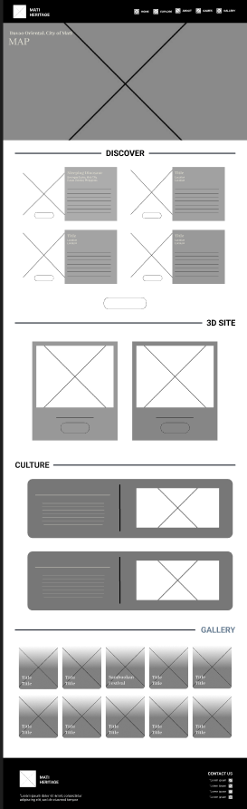

Figure 12. Landing Page
The Landing Page (Figure 12) serves as the starting point of the Mati Heritage 3D platform. Since the system is web-based, users can access it through any browser without installing additional software. Once users open the system link, they are directed to the homepage, where they can view an introduction about the platform and use the navigation menu to access the About, Explore, Gallery, and Games sections.
About Page
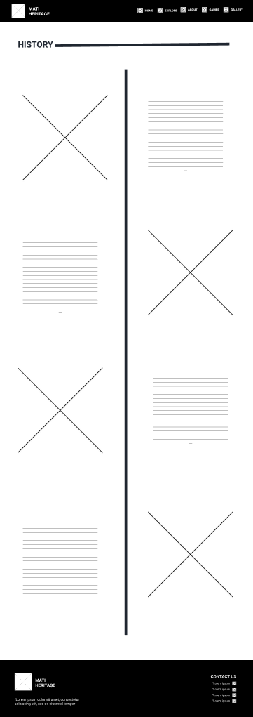

Figure 13. About Page
After selecting the About section from the navigation menu, users may access the About Page (Figure 13), where they can read background information about the history and development of Mati City. The page presents important events and cultural milestones in an organized timeline format with corresponding videos, photographs, and descriptions. This allows users to better understand the city’s heritage before exploring the other features of the system.
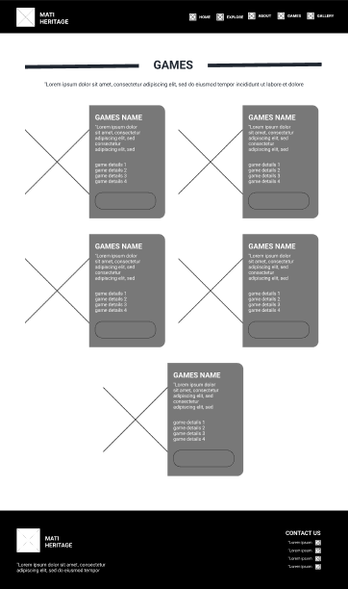
Games Page

Figure 14. Games Page

When users open the Games section, they may access the Games Page (Figure 14), which contains interactive activities designed to promote learning about the cultural heritage of Mati City. The page includes several game options such as the Mati Heritage Trivia Challenge, a multiple-choice quiz game with difficulty levels from easy to hard; Memory Matching Pairs, a card matching game that tests memory skills; Word Scramble, a word puzzle game with difficulty levels from easy to hard; Slide Puzzle, a tile sliding puzzle based on cultural photographs; and True or False Sprint, a timed challenge where users answer statements from easy to hard levels. Through these features, users are able to learn about local history and culture in a more enjoyable and engaging way.
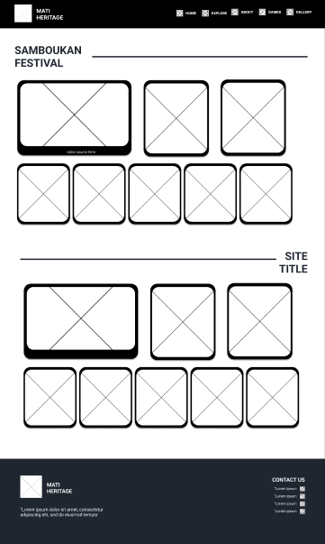
Gallery Page

Figure 15. Gallery Page
By selecting the Gallery section, users are brought to the Gallery Page (Figure 15), where photos and videos related to Mati City’s heritage, festivals, and landmarks are stored and displayed. The page organizes media files in a structured layout so users can browse them easily. This section serves as a digital repository that allows users to view important cultural events and historical visuals in one place.
Explore Panel
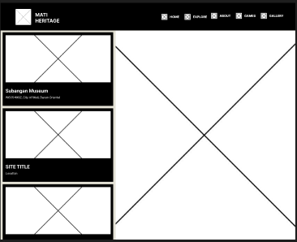

Figure 16. Explore Panel
When users access the Explore section, they may open the Explore Panel (Figure 16), where they can view cultural heritage sites through the location map. The page displays site markers that represent built heritage and natural heritage sites. Once a heritage site marker is clicked, the name, description, photographs, and other related information of the selected location will appear on the page. This feature helps users identify where heritage sites are located and supports easier navigation for visitors, students, and researchers.
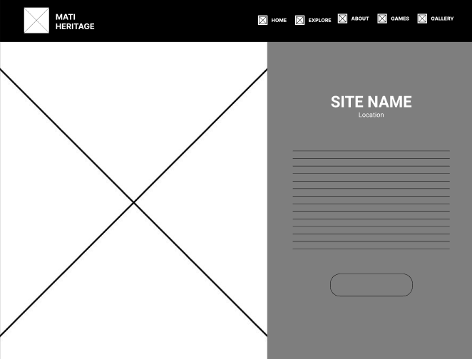
3D Site Details

Figure 17. 3D Site Details
After selecting a built heritage site from the Explore Panel, users are taken to the 3D Site Details page (Figure 17). This page displays a preview of the selected site’s 3D visualization model together with its name, location, and historical background. It provides users with more detailed information about the site before entering the full 3D viewing mode. Natural heritage sites are presented through their photographs and videos instead.

Interactive 3D Viewer
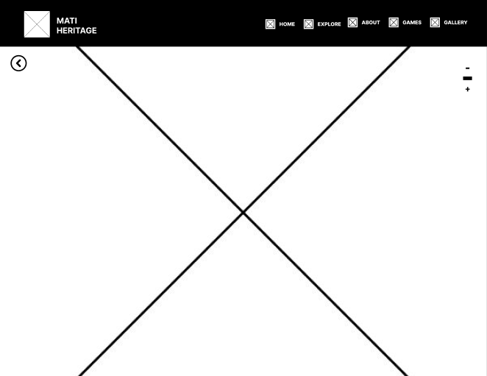

Figure 18. Interactive 3D Viewer
When users click the view button from the site details page, they are redirected to the Interactive 3D Viewer (Figure 18). In this page, users can inspect the 3D visualization model of the selected heritage structure using zoom, rotate, and navigation controls provided by the model-viewer component. This feature gives users a closer look at the structure and allows them to explore the site virtually.

Gallery Model Overlay
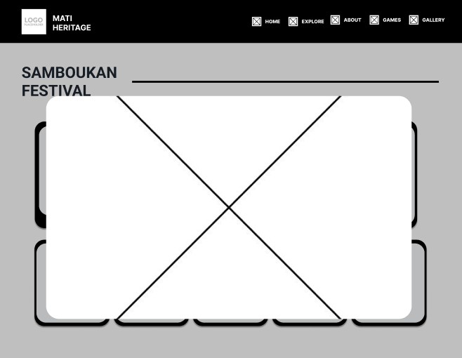

Figure 19. Gallery Model Overlay
Once users select a photo or video from the gallery, the system opens the Gallery Model Overlay (Figure 19). This feature enlarges the selected media in a centered pop-up window while keeping the user on the same gallery page. It allows users to clearly view photographs and videos without leaving their current location in the system.

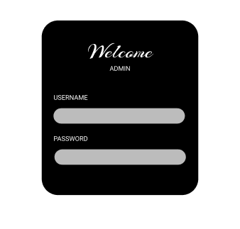
Admin Login Page

Figure 20. Admin Login Page
The Admin Login Page (Figure 20) is intended for authorized administrators who manage the contents of the system. Administrators are required to enter their username and password before gaining access to the dashboard. This process helps secure the system and prevents unauthorized users from modifying records and files.

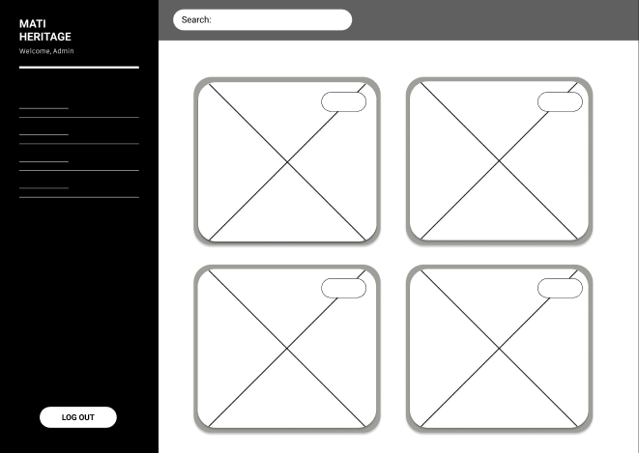
Admin Manage Site

Figure 21. Admin Manage Site
After logging in successfully, administrators are directed to the Admin Manage Site page (Figure 21), where they can view and manage existing heritage site records. The page provides options to search, edit, and update site information. This allows administrators to maintain accurate and updated content within the system.

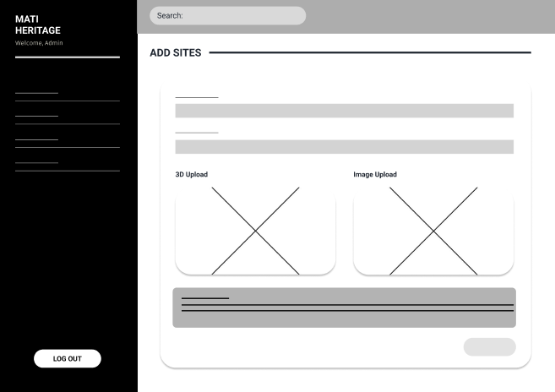
Admin Add Sites

Figure 22. Admin Add Sites
When administrators need to add new cultural sites, they may use the Admin Add Sites page (Figure 22). This page contains input fields for site name, description, and other necessary details, together with file upload options for photographs, videos, audio recordings, and 3D visualization models. Once submitted, the new record becomes part of the public system database.

Media Vault Page
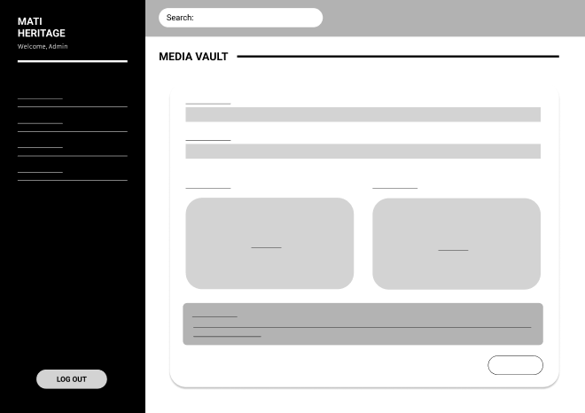

Figure 23. Media Vault Page
The Media Vault Page (Figure 23) is used for managing photographs and videos displayed in the gallery section of the platform. Administrators can upload, organize, and remove media files through this page. This helps keep the gallery updated and ensures that multimedia content is properly stored.

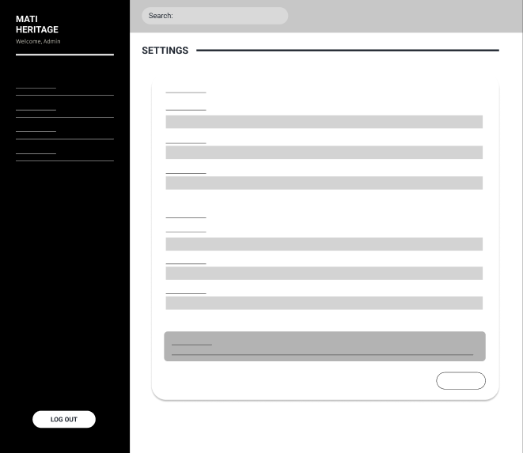
Admin Setting Page

Figure 24. Admin Setting Page
The Admin Setting Page (Figure 24) allows administrators to update account credentials and basic website information. Through this page, they can change usernames, passwords, system titles, and other settings when necessary. This feature supports easier maintenance and management of the platform.

LITERATURE CITED
Ababneh, A. (2024). Digital solutions for cultural heritage: Preservation, interpretation, and engagement in line with the Venice Charter principles. CEUR Workshop Proceedings. https://ceur-ws.org/Vol-3838/paper1.pdf
Addison, A. C. (2000). Emerging trends in virtual heritage. IEEE Multimedia, 7(2), 22–25. https://doi.org/10.1109/93.848425
Akçam Ergin, İ. D. (2023). Digital approach in conservation of heritage: 3D virtual reconstruction applications in ancient cities. Mimarlık Bilimleri ve Uygulamaları Dergisi (MBUD), 969–987. https://doi.org/10.30785/mbud.1312738
Apollonio, F. I., Basilici, C., Callieri, M., D'Orazi, M., Gaiani, M., Ponchio, F., & Rizzo, F. (2021). A 3D web visualization architecture for cultural heritage artifacts. ISPRS International Journal of Geo-Information, 10(3), 138. https://www.mdpi.com/2220-9964/10/3/138
Asor, A. N., Jr., Asor, B. B. N., & Cayme, J.-M. C. (2019). The Baclayon Church (Bohol) debris of mortar: A geomaterial dimension of Philippine cultural-historical church [Paper presentation]. De La Salle University Research Congress, Manila, Philippines. https://www.researchgate.net/publication/335419342
Bekele, M. K., Pierdicca, R., Frontoni, E., Malinverni, E. S., & Gain, J. (2018). A survey of augmented, virtual, and mixed reality for cultural heritage. Journal on Computing and Cultural Heritage, 11(2), 1–36. https://doi.org/10.1145/3145534
Besmonte, E. L. (2022). Identification and safeguarding of intangible cultural heritage (ICH) of Tabaco City, Philippines through cultural mapping. Journal of Education, Management, and Development Studies, 4(1), 47–58. https://systems.bicol-u.edu.ph/journal/assets/journal_pdf/5%20Besmonte_47-58.pdf
Bozoğlu, C., Campbell, G., & Smith, L. (2024). Local identity and community ownership in heritage management. International Journal of Heritage Studies, 30(2), 145–160. https://doi.org/10.1080/13527258.2023.2291045
Brown, S. (2019). The role of cultural relevance in heritage preservation. Global Heritage Journal, 52(1), 45–59.
Campelo, A. (2018). Cultural heritage. Routledge.
Ch’ng, E., & Gaffney, V. (2013). Seeing things: Heritage and visualisation. Bloomsbury Academic.
Champion, E. (2016). Critical gaming: Interactive history and virtual heritage. Routledge.
Ćosović, M., & Maksimović, M. (2022). Application of the digital twin concept in cultural heritage. CEUR Workshop Proceedings. http://ceur-ws.org
Cruz, G. (2024). Cultural governance: A participatory approach towards sustainable heritage management. Journal of Heritage Management, 9, 103–115. https://doi.org/10.1177/24559296241237364
CyArk. (2021). Tapestry: Digital storytelling for cultural heritage. https://tapestry.cyark.org/
Data and Information Management. (2021). Towards a sustainable infrastructure for the preservation of cultural heritage and digital scholarship. Data and Information Management, 5(2), 253–261. https://doi.org/10.2478/dim-2020-0052
De Freitas, S., & Liarokapis, F. (2020). Serious games for cultural heritage: A review of design and learning approaches. International Journal of Game-Based Learning, 10(1), 1–17. https://doi.org/10.4018/IJGBL.2020010101
Deterding, S., Dixon, D., Khaled, R., & Nacke, L. (2011). From game design elements to gamefulness: Defining “gamification.” In Proceedings of the 15th International Academic MindTrek Conference (pp. 9–15). https://doi.org/10.1145/2181037.2181040
Dziatkiewicz, M., & Król, K. (2026). Generating a web map of digital cultural heritage using large language models. Geomatics, Landmanagement and Landscape, 1(1), 55–72. https://gll.urk.edu.pl/pdf-218109-138222
Fotaris, P., Mastoras, T., & Mavrommati, I. (2022). Gamification in cultural heritage: Enhancing engagement through serious games and interactive learning environments. Heritage, 5(3), 2150–2168. https://doi.org/10.3390/heritage5030113
Google Arts & Culture. (2020). Heritage on the edge. https://artsandculture.google.com/project/heritage-on-the-edge
Gumiran, I. C., & Solano, N. (2022). The conservation of cultural heritage in Northeastern Philippines. Asian Journal of Social Science and Management Technology. https://www.ajssmt.com/Papers/449599.pdf
Higgins, S., & Douglas, J. (2020). Discovering the local in national cultural heritage collections. Information, Communication & Society, 23(9), 1210–1226. https://doi.org/10.1080/1369118X.2022.2113819
Horbiński, T., & Lorek, D. (2022). JavaScript libraries in modern web cartography: Performance and usability. Polish Cartographical Review, 54(1), 33–45. https://doi.org/10.2478/pcr-2022-0004
Ibáñez, M.-B., Di Serio, Á., Villarán, D., & Delgado Kloos, C. (2014). Experimenting with electromagnetism using augmented reality: Impact on flow, student experience, and educational effectiveness. Computers & Education, 71, 1–13. https://doi.org/10.1016/j.compedu.2013.09.004
International Society for Photogrammetry and Remote Sensing. (2025). Community participation and web mapping with open source technologies: An approach to the identification and dissemination of intangible cultural heritage. The International Archives of the Photogrammetry, Remote Sensing and Spatial Information Sciences, XLVIII-M-9-2025, 1327–1334. https://isprs-archives.copernicus.org/articles/XLVIII-M-9-2025/1327/2025/isprs-archives-XLVIII-M-9-2025-1327-2025.pdf
Ioannides, M., Magnenat-Thalmann, N., & Papagiannakis, G. (Eds.). (2017). Mixed reality and gamification for cultural heritage. Springer. https://doi.org/10.1007/978-3-319-49607-8
Jokilehto, J. (2007). International charters on conservation and restoration. ICCROM.
Jones, M. (2017). Fostering community responsibility in heritage preservation. Community Development Journal, 43(3), 269–283.
Kara, N. (2024). A mixed-methods study of cultural heritage learning through playing a serious game. International Journal of Human–Computer Interaction, 40(6), 1397–1408. https://doi.org/10.1080/10447318.2022.2125627
Khan, I., Melro, A., Amaro, A. C., & Oliveira, L. (2020). Systematic review on gamification and cultural heritage dissemination. Journal of Digital Media & Interaction, 3(8), 19–41. https://doi.org/10.34624/jdmi.v3i8.21934
Król, K. (2024). Web cartography and storytelling tools for historical conservation projects. Journal of Cultural Heritage Management, 14(3), 201–215. https://doi.org/10.1108/JCHMS-10-2023-0112
Lai, Y., Li, J., & Zhang, Q. (2012). Web-based informational mapping architectures for cultural repositories. Computers & Geosciences, 44, 88–97. https://doi.org/10.1016/j.cageo.2012.03.011
Lata, R., Sharma, M., & Kumar, P. (2022). Web mapping dashboard systems using open-source technologies for public access assets. Geo-spatial Information Science, 25(2), 210–222. https://doi.org/10.1080/10095020.2021.2014563
Lee, Y., Seol, S., Oh, J., & Lee, J. (2025). Semantic collaborative environment for extended digital natural heritage: Integrating data, metadata, and paradata. Heritage, 8(12), 507. https://doi.org/10.3390/heritage8120507
Li, J., Krishnamurthy, S., Pereira Roders, A., & van Wesemael, P. (2020). Community participation in cultural heritage management: A systematic literature review comparing Chinese and international practices. Cities, 96, 102476. https://doi.org/10.1016/j.cities.2019.102476
Liberge, L., & Gerlings, J. (2008). Mapping cultural history: A web interface for localized digital assets. Archives and Museum Informatics. https://www.archimuse.com/mw2008/papers/liberge/liberge.html
Liu, Y., Wang, X., & Zhang, J. (2024). Web-based mapping systems and database architecture for regional cultural heritage conservation. Journal of Cultural Heritage, 65, 45–56. https://doi.org/10.1016/j.culher.2023.11.009
Logan, W. S. (2007). Closing Pandora’s box: Human rights conundrums in cultural heritage protection. In H. Silverman & D. F. Ruggles (Eds.), Cultural heritage and human rights (pp. 33–52). Springer.
Lu, M. (2013). Spatial coordinates and web visualization tools for localized historical records. Cartographica, 48(2), 112–125. https://doi.org/10.3138/carto.48.2.1835
Marques, C. G., Pedro, J. P., & Araújo, I. (2023a). A systematic literature review of gamification in/for cultural heritage: Leveling up, going beyond. Heritage, 6(8), 5935–5951. https://doi.org/10.3390/heritage6080312
Marques, L., Santos, M., & Martins, R. (2023b). Connecting communities to places: Map-based narrative platforms for urban preservation. Sustainability, 15(8), 6412. https://doi.org/10.3390/su15086412
Matuszka, T., & Kiss, A. (2023). Interactive 3D web environments for cultural heritage presentation using lightweight models. Technologies, 11(4), 95. https://www.mdpi.com/2227-7080/11/4/95
Münster, S. (2022). Digital 3D modelling in the humanities: A systematic literature review. Digital Scholarship in the Humanities, 37(Supplement_1), i59-i73. https://academic.oup.com/dsh/article/37/Supplement_1/i59/6561501
Nishanbaev, S. (2021). A web-based interactive 3D cultural heritage repository using open-source Web content management system. Digital, 1(3), 167–181. https://doi.org/10.3390/digital1030013
Odoy, A. (2023). Unveiling the past: Delving into the local history of Mati City, Davao Oriental, Philippines. International Journal of Social Sciences: Current and Future Research Trends, 20(1), 172–189.
Palčák, M., Kudela, P., Fandáková, M., & Kordek, J. (2022). Utilization of 3D digital technologies in the documentation of cultural heritage: A case study of the Kunerad Mansion (Slovakia). Applied Sciences, 12(9), 4376. https://doi.org/10.3390/app12094376
Prasad, T., Sehgal, A., & Ghiya, S. (2024). A study on cultural heritage preservation in the digital era. International Journal of Scientific Research in Engineering and Management, 8, 1–13. https://doi.org/10.55041/IJSREM28803
Prayalane. (2021). Home. https://www.prayalane.com/
Potenziani, M., Callieri, M., Dellepiane, M., Corsini, M., Ponchio, F., & Scopigno, R. (2015). 3DHOP: 3D Heritage Online Presenter. Computers & Graphics, 52, 129-141. https://doi.org/10.1016/j.cag.2015.07.001
Rabang, M. R. Q. (2015). Cultural mapping as a tool in heritage conservation in Vigan City. Journal Sampurasun: Interdisciplinary Studies for Cultural Heritage.
Sadeghi-Niaraki, A. (2023). Ubiquitous geospatial cloud-based systems for cultural heritage management and preservation. Sustainability, 15(4), 3120. https://doi.org/10.3390/su15043120
Schwaber, K., & Sutherland, J. (2020). The Scrum guide: The definitive guide to Scrum: The rules of the game. https://scrumguides.org/scrum-guide.html
Sesana, E., Gagnon, A. S., Bonazza, A., & Hughes, J. J. (2020). An integrated approach for assessing the vulnerability of World Heritage Sites to climate change impacts. Journal of Cultural Heritage, 41, 211–224. https://doi.org/10.1016/j.culher.2019.06.013
Shrestha, R., Shen, Z., & Bhatta, K. D. (2024). Cultural heritage deterioration in the historical town “Thimi.” Buildings, 14(1), 244. https://doi.org/10.3390/buildings14010244
Siliutina, I., Tytar, O., Barbash, M., Petrenko, N., & Yepyk, L. (2024). Cultural preservation and digital heritage: Challenges and opportunities. Revista Amazonia Investiga, 14(75), 262–273. https://doi.org/10.34069/ai/2024.75.03.22
Singh, S., Kumar, A., & Bannerjee, P. (2024). Interactive web maps as tools for intergenerational knowledge transfer. Journal of Heritage Education, 11(1), 78–94. https://doi.org/10.1016/j.jheded.2024.01.005
Skublewska-Paszkowska, M., Milosz, M., Powroznik, P., & Lukasik, E. (2022). 3D technologies for intangible cultural heritage preservation—Literature review for selected databases. Heritage Science, 10(1). https://doi.org/10.1186/s40494-021-00633-x
Sommerville, I. (2016). Software engineering (10th ed.). Pearson.
Stefanakis, E. (2017). Web mapping architectures and developer tools in the Web Mercator era. International Journal of Cartography, 3(1), 89–104. https://doi.org/10.1080/23729333.2017.1301223
Taqa, A. (2025). The role of cultural heritage in sustainable development. ResearchGate. https://www.researchgate.net/publication/388869475_The_Role_of_Cultural_Heritage_in_Sustainable_Development
UNESCO. (2021). Climate change and World Heritage. https://whc.unesco.org/en/climatechange/
Van Aart, C., Wielinga, B., & Van Hage, W. R. (2010). Mobile cultural heritage guide: Location-aware semantic search. Proceedings of Knowledge Engineering and Knowledge Management by the Masses, 133–142. http://www.few.vu.nl/~wrvhage/papers/Mobile_cultural_heritage_guide_ekaw2010.pdf
Xu, F., Buhalis, D., & Weber, J. (2017). Serious games and the gamification of tourism. Tourism Management, 60, 244–256. https://doi.org/10.1016/j.tourman.2016.11.020
Zerrudo, E. (2020). Heritage-driven development and cultural governance in Philippine LGUs. National Commission for Culture and the Arts.
Ziku, M., Papadopoulou, E., & Gain, A. (2024). Linking crowdsourced community databases with digital maps for heritage protection. Heritage Science, 12(1), 102–118. https://doi.org/10.1186/s40494-024-01205-x

