BOQ BUI 1 Assessment Report – Draft V3
Aaron Dain
2025-12-22
Table of Contents
1 Introduction 3
1.1 Brief history of BUI in AOC and previous actions 3
1.2 Actions since previous report 3
1.3 Delisting criteria change 3
1.4 3
(PART*) Tiered Assessment Approach for Criterion 1.1 3
2 Methods 3
2.1 Generic criteria 3
2.2 Tiered assessment framework 4
2.2.1 Tier 1: Comparison of AOC Fish Consumption Advisories to Desired Consumption Rates 6
2.2.2 Tier 2: Comparison of AOC Advisories to Reference Sites 7
2.2.3 Tier 3: Weight of Evidence Approach 8
2.2.4 Tier 4: Legacy Sources of Priority Contaminants in the AOC 12
2.3 Community fish consumption survey 12
2.3.1 NOTE: This section is copied from the SLR version of the report, and may serve as a template for LTCA and MBQ to fill in their version. 12
2.4 Data Sources 14
3 Results: Species of Interest and Desired Consumption Rate 15
3.1 Species of Interest and Desired Consumption Rate 15
4 Results: Measure 1 16
4.1 Tier 1 Assessment for the Bay of Quinte AOC 16
4.2 Tier 2 Assessment for the Bay of Quinte AOC 19
4.3 Tier 3 Assessment for the Bay of Quinte AOC 24
4.3.1 PCBs 24
4.3.2 Dioxins and Furans 37
5 Results: Measure 2 43
5.1 Tier 1 Results (Measure 2) 43
5.1.1 Tier 1: Belleville Nearshore 43
5.1.2 Tier 1: Trenton Nearshore 45
5.2 Tier 2 Results (Measure 2, Yellow Perch and Brown Bullhead) 47
5.3 Tier 3 (Measure 2, Brown Bullhead) 48
5.3.1 PCBs 48
5.3.2 Dioxins/Furans 52
5.4 Measure 2 Summary 57
6 Discussion and Recommendations 58
Appendix 58
7 Tier 3 Supplementary Figures for Bay of Quinte AOC 58
7.0.1 Walleye 58
7.0.2 Lake Whitefish 61
7.0.3 Northern Pike 64
7.0.4 Smallmouth Bass 67

1 Introduction

1.1 Brief history of BUI in AOC and previous actions

1.2 Actions since previous report

1.3 Delisting criteria change

1.4

(PART*) Tiered Assessment Approach for Criterion 1.1

2 Methods

2.1 Generic criteria
In 1991, the IJC recommended the Fish and Wildlife Consumption BUI delisting guideline:
“When contaminant levels in fish and wildlife populations do not exceed current standards, objectives or guidelines, and no public health advisories are in effect for human consumption of fish or wildlife. Contaminant levels in fish and wildlife must not be due to contaminant input from the watershed.” (IJC, 1991)
In the following decades, the original delisting guideline from 1991 proved inadequate for assessing this BUI. Though contaminant concentrations in fish have improved in AOCs since these delisting guidelines were proposed (Bhavsar et al. 2018), advisories remain in place throughout the Great Lakes because the contaminants of concern are more toxic and persistent than previously thought (Bhavsar et al. 2018). To rectify the inconsistencies among AOCs in addressing this BUI, Bhavsar (2016) utilized the following delisting statement in the Toronto and Region AOC’s BUI 1 Assessment Report:
“Consumption advisories for fish of interest in the AOC are unrestricted or no more restrictive than the advisories for suitable reference site(s) due to contaminants from locally-controllable sources.”
In 2018, Bhavsar recommended the delisting criterion be used as a generic delisting criterion for BUI 1 among Canadian AOCs (Bhavsar et al. 2018). In 2021, following a series of workshops attended by RAP leaders and stakeholders, the shared generic delisting criterion and assessment framework were adopted by several Canadian AOCs. The intent was to draw from the experiences of the Toronto and Region, Niagara River, and Detroit River AOCs in using a tiered framework for assessing BUI 1. Through these workshops, a standardized operating procedure, common data sources, and data interpretation guidelines were developed to be applied in the tiered framework.
In 2025, the Restoration Advisory Council for the Bay of Quinte AOC adopted a modified version of delisting criterion and its associated tiered assessment framework:
“The BUI is to be redesignated when it can be demonstrated that consumption advisories for fishes of interest in the Bay of Quinte are non-restrictive, declining or comparable to the advisories for suitable Lake Ontario reference site(s) due to contaminants (PCBs, dioxin-like PCBs, TCDDs (dioxins) and TCDFs (furans)) from locally-controllable sources specific to the AOC.”
The following measures of success were added to the delisting criterion:
- “Fish consumption advisories for fishes of interest in the Bay of Quinte are non-restrictive, declining or are comparable to suitable reference area(s);” and
- “Fish consumption advisories for Brown Bullhead and Yellow Perch (or similar sentinel species) collected in the areas of the Trenton Nearshore Area and the Belleville Nearshore Area, near legacy sources of contamination, are non-restrictive, declining or comparable to advisories for these fish in the rest of the Bay of Quinte.”
The two measures of success are evaluated similarly, with the difference being that Measure 2 compares only a subset of species (yellow perch and brown bullhead) from the Trenton and Belleville Nearshore areas with those from the rest of the Bay of Quinte, rather than the full suite of reference sites (see Section 2.2.2).

2.2 Tiered assessment framework
The tiered assessment framework, as adapted for use in the St. Lawrence River AOC, comprises 4 tiers, each compiling different evidence lines to determine if delisting criterion 1.1 is met (Figure 2.1):
Tier 1: Are monthly meal allowances for fish of interest in the AOC considered unrestrictive relative to the desired fish consumption rates?
Tier 2: Are fish consumption restrictions in the AOC similar or less restrictive than suitable reference sites?
Tier 3: Do lines of evidence indicate that the beneficial use is not impaired due to priority contaminants (PCBs, dioxin-like PCBs, dioxins, and furans)?
Tier 4: Have all feasible remedial actions to address local legacy contamination in the AOC been implemented?
The framework is designed such that if all fish of interest in the AOC pass a particular tier, the delisting criterion can be said to be met. Otherwise, analysis moves to the next tier. If all tiers are failed, then the delisting criterion cannot be said to be met. It should be noted that, in the Bay of Quinte AOC, the primary contaminants of concern are PCBs, dioxin-like PCBs, dioxins, and furans. Thus, analyses of contaminants are limited strictly to the sources and concentrations of these contaminants in AOC fish.
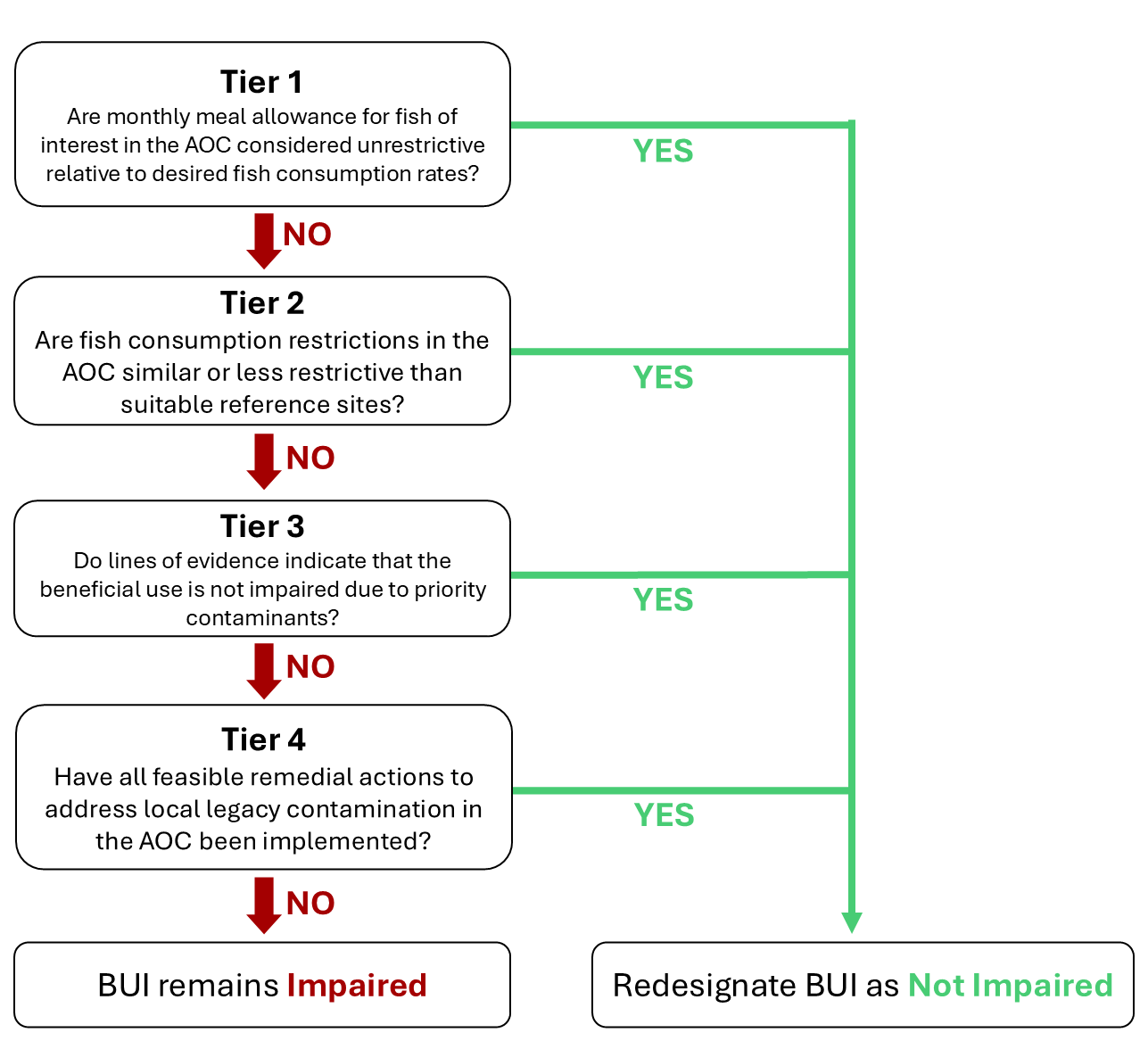
Figure 2.1: Modified tiered assessment framework applied in the 2025 BUI 1 Assessment for the Bay of Quinte AOC. Adapted from Drouillard 2022.
Since the previous Bay of Quinte BUI 1 Assessment Report in (year) (reference), the Guide to Eating Ontario Fish has been updated with new fish contaminant data (which was collected on an annual basis, excluding 2020 due to the Covid-19 pandemic [could use citation]) where available, including collections of targeted species (such as walleye and yellow perch) following recommendations from the report. Furthermore, a combination of angler surveys and scientific publications were used to assess the BUI in terms of community desired consumption rates of fish of interest, rather than using MECP definitions of restrictive consumption advice (MECP, 2025). These new data were used to make up-do-date comparisons of fish consumption advisories within the AOC and reference areas in the Upper St. Lawrence River and Lake Ontario. Below is a summary of each tier, and the methods for which they are evaluated.

2.2.1 Tier 1: Comparison of AOC Fish Consumption Advisories to Desired Consumption Rates
The first step of the tiered framework provides a coarse screening of whether fish consumption advisories in the AOC are restrictive in relation to locally desired consumption rates. Given that virtually all fishing zones in Ontario have some fish consumption restrictions in place, there is a need to define a benchmark for the degree of restrictiveness that is considered non-restrictive relative to the normal consumption patterns of fish in a given waterbody by the local community. Advisory values, expressed as the number of meals per month recommended for the general and sensitive population groups, were compiled from the Guide to Eating Ontario Fish, published by the Ontario Ministry of the Environment, Conservation and Parks (MECP; see Section 2.4.0.1). These advisories are based on contaminant concentrations measured in fish flesh and translated into species- and size-specific consumption categories using contaminant thresholds (Table 2.1).
Table 2.1: MECP fish consumption advisory contaminant benchmarks (adapted from Bhavsar 2016). Contaminant concentration values correspond to advised maximum monthly fish meals. Mercury consumption advisories are issued separately for the general population and sensitive population (children under 15 years old and anyone who is pregnant or may become pregnant).
 | Hg (µg/g) |  | PCB (ng/g) | Dioxin/Furan/  dlPCB TEQ (pg/g) | Mirex (ng/g) | Photomirex (ng/g) | Toxaphene (ng/g)
Meals/  month | Sensitive | General
0 | >0.5 | >1.8 | >844 | >21.6 | >657 | >122 | >1877
1 |  |  | 422-844 | 10.8-21.6 | 329-657 | 61-122 | 939-1877
2 |  |  | 211-422 | 5.4-10.8 | 164-329 | 31-61 | 469-939
4 | 0.25-0.5 | 0.6-1.2 | 105-211 | 2.7-5.4 | 82-164 | 15-31 | 235-469
8 | 0.16-0.25 | 0.4-0.6 | 70-105 | 1.8-2.7 | 55-82 | 10-15 | 156-235
12 | 0.12-0.16 | 0.3-0.4 | 53-70 | 1.3-1.8 | 41-55 | 8-10 | 111-156
16 | 0.06-0.12 | 0.15-0.3 | 26-53 | 0.7-1.3 | 21-41 | 4-8 | 59-117
32 | <0.06 | <0.15 | <26 | <0.7 | <21 | <4 | <59

Advisory values for each fish of interest in the AOC were then compared against a benchmark representing acceptable levels of consumption, determined by the results of the community survey (see Section 2.3). Any advisory below this benchmark was considered restrictive, while those at or above the benchmark were considered non-restrictive. This step provides a baseline indication of potential impairment and allows the RAP team to identify species or size classes where consumption guidance is most restrictive, independent of regional comparisons. Additionally, Tier 1 excludes unrestricted fish from further analysis, since these species meet the delisting criteria at its most basic level. If all species pass Tier 1, delisting criterion 1.1 can be said to be met. Tier 1 uses a strict passing benchmark, where any number of restrictive size categories in either population type (General or Sensitive) will cause a species to fail and move to Tier 2.

2.2.2 Tier 2: Comparison of AOC Advisories to Reference Sites
Tier 2 assesses whether the fish consumption advisories for fish of interest in the AOC are comparable to those at suitable reference sites. If all the restrictive advisories for a given species in the AOC are less restrictive or equivalent to those in reference sites, the species passes Tier 2. Otherwise, the assessment of failing species moves to Tier 3. Similarly to Tier 1, Tier 2 uses official consumption advice provided by MECP. Species that passed Tier 1 assessment were excluded from Tier 2 analysis. Furthermore, size classes that pass Tier 1 within a species were excluded from Tier 2 analysis.
The advisory values for each species of interest in the AOC are compared to the median value of advisories for reference sites. In Tier 2, reference sites are selected as those representative of a broad measure of background intensity of advisories across a comparable geographic region. That is, selection of reference sites for Tier 2 does not consider similarity of ecology, environmental conditions, or history; nor does it select for pristine, undisturbed water bodies. Rather, reference sites are characterized as a broad geographical representation of the region that are removed from AOC sources of legacy contamination. Furthermore, reference sites need to have fish consumption advisories available for the selected species of interest as well as overlapping size ranges of each species with that of the AOC. For this analysis, measures 1 and 2 are evaluated separately: measure 1 compares fish consumption advice within the AOC, excluding the nearshore sites, to sites outside the AOC, whereas measure 2 compares fish consumption advice between Belleville and Trenton Nearshore sites, respectively, with Lake Ontario (Eastern Basin), in which the rest of the Bay of Quinte is included. For measure 1, we selected all non-AOC fishing zones in the Upper St. Lawrence River and Lake Ontario for which consumption advice is issued for the same species of interest in the AOC. The AOC fishing zones excluded were Hamilton Harbour and the Niagara River (Upper and Lower). The Toronto Waterfront zone, despite being an AOC, was included as a reference site as their most recent BUI assessment report indicated that consumption advisories were no longer restrictive due to legacy contamination (Drouillard, unpublished). Furthermore, tributaries and harbours were excluded, as they generally do not encapsulate background conditions of the geographical region.
To compare the intensity of advisories, we compared the advisory value for each species and size class, each for the General and Sensitive populations, for available species of interest in the AOC (below the Tier 1 benchmark) to the median of reference advisories for which similar advisories were issued. Because meal/month consumption advisories are issued in discrete categories (see Section 2.4.0.1), reference median values were rounded up to the next advisory value when there were an even number of reference sites. For example, a median advisory value of 10 meals/month would be rounded up to 12 meals/month. This is because the median of an even number of sites would fall between two advisory categories (e.g., the median between 8 and 12 is 10). While this does not change the outcome of the analysis, it is a clearer representation of official consumption advice. AOC advisory values below the desired consumption benchmark (e.g., 8 meals/month) are compared to their respective reference medians, and those size categories equal to or above the reference median pass Tier 2 assessment, while those below the reference median fail Tier 2. Similarly to Tier 1, Tier 2 adopts a strict benchmark, where any number of size categories for either population type will cause a species to fail and move to Tier 3.

2.2.3 Tier 3: Weight of Evidence Approach
Tier 3 evaluates the status of the BUI using a weight of evidence approach, which considers multiple lines of evidence pertaining to fish contaminant concentrations in the AOC and reference areas. As with previous tiers, species are evaluated independently. However, the nuanced nature of the weighted evidence approach means that a single pass/fail metric for each species is inappropriate at this tier. The outcome of the weight of evidence available will be used to support or not support redesignation of the BUI. Tier 3 evidence lines are determined in aggregate, meaning that unlike the decision tree between tiers, all sub-categories of Tier 3 are considered jointly regardless if a species passes or fails one or more evidence lines. Because measures 1 and 2 (Section 2.1) are evaluated separately, all tier 3 assessments for measure 1 exclude the Trenton and Belleville Nearshore sites. We considered the following lines of evidence for Tier 3:

2.2.3.1 Tier 3A: Virtual advisory
Tier 3A seeks to address the relationship between priority contaminants in the AOC and fish consumption advice. Because fish consumption advisories consider multiple fish contaminants, and are issued based on the strictest restriction from any contaminant (cite), it is important to isolate the effect of priority AOC contaminants on driving local fish consumption advisories. Additionally, official advisories may be based on data that dates as far back as the 1970s. Thus, it is important that restrictions on fish consumption are considered using more recent data to account for restorative effects in the AOC associated with previous remedial actions. To achieve this, “virtual advisories” are created using the same fish contaminant data and methods used by MECP to generate official consumption advice. Fish contaminant data (obtained from MECP, see Section 2.4) is filtered to the contaminant of concern (total PCBs and dioxin/furan TEQs, respectively) and the previous 10 years of data (2014 and more recent), and this data is used to calculate virtual advisories using the MECP method.
Virtual advisory values were generated by modelling the relationship between fish length and contaminant concentration. For each region (AOC and reference), the function fits a log-log linear model (lm(log(Value) ~ log(Length)) to evaluate whether a significant relationship exists (p ≤ 0.05). If so, predicted concentrations are generated across a continuous length range, and then averaged within fixed 5 cm fish length bins. Advisory levels are assigned using MECP-defined contaminant- and population-specific (General/Sensitive population) thresholds to the mean predicted concentrations. If no significant relationship is detected, advisory levels are based on the mean concentration of all observations within each fish length interval. If any size categories of the virtual advisory are restrictive compared to the desired consumption rate and to reference values, Tier 3A assessment is unsupportive of delisting for this species. Virtual advisories are not to be used as a replacement for official consumption advice and are limited strictly to the evaluation of this BUI.
The virtual advisories in this tier are evaluated similarly to Tiers 1 and 2; i.e. first it is determined if virtual advice for any size categories is restrictive compared to the community desired consumption rate (see Section 2.2.1), then if virtual advice for any size category are more restrictive than suitable reference sites. Similarly to Tiers 1 and 2, any number of restrictive size categories are considered a failure for Tier 3A.

2.2.3.2 Tier 3B: Comparisons of fish contaminants in the AOC vs Reference
To determine the degree of contamination in fish in the AOC by priority contaminants, the concentrations of priority contaminants in fish tissue were compared between the AOC and suitable reference sites.
Reference sites for Tier 3B differ from those used in Tier 2 in that the MECP fish collection zones do not correlate directly with the zones used in the official advisories. For example, one official advisory zone (as is used in Tier 2) may comprise several collection areas. For Tier 3B, reference zones are similarly limited to non-AOC collections zones in the upper St. Lawrence River (upstream of the Moses-Saunders Dam) and Lake Ontario for which collections of the evaluated species have occurred within the most recent 10 years of study (2014-2024). The number and locations of reference sites may differ between species depending on the availability of data.
To assess differences in fish contamination between the AOC and reference sites, contaminant–length relationships were modeled using Generalized Additive Models (GAMs), allowing for non-linear associations. For this model, length was first log-transformed to control for skewed data distributions (contaminant-length relationships are often exponential), which was used as a fixed smooth effect along with region (AOC or reference), with collection area as a random effect to control for site-specific confounding variables. For each species of interest, we first tested whether the shape of the concentration–length relationship differed significantly between AOC and reference fish by comparing the full model to a null model with reduced terms using ANOVA. Where models supported statistically similar trends (non-significant interaction), we compared size-adjusted contaminant levels using estimated marginal means. Where shapes differed significantly, contaminant concentration values were compared by GAM-predicted values across the range of lengths of each fish species at 5 cm intervals. A threshold of α = 0.05 was used to evaluate statistical significance throughout.
Where contaminant-length relationships differed between AOC and reference, Tier 3B can be considered supportive of redesignation when the majority of size classes do not significantly differ in predicted contaminant concentration between AOC and reference. Where the contaminant-length relationship does not significantly differ, Tier 3B can be considered supportive of redesignation when the marginal mean of contaminant concentration does not significantly differ between AOC in reference. Otherwise, Tier 3B is considered not supportive of redesignation.

2.2.3.3 Tier 3C: Temporal trends of contaminants in fish
In Tier 3C, we evaluated the direction of trends in contaminants through time, and make predict how these trends will continue into the future. Temporal trends in mercury concentrations in AOC fish of interest were assessed using generalized additive mixed models (GAMMs) across all years of data. Log-contaminant concentration was modeled with a log-linear fixed effect for sample year to assess the temporal trends on an exponential scale, a smooth fixed effect for log-length to account for differences in contaminant concentration across fish length, and a site smooth random effect to account for regional differences in sampling and other confounding variables. The slope (on log scale) represents the annual rate of change in mercury concentration, defined as k = -slope (such that k > 0 indicates a decline, and k < 0 indicates an increase in contaminant concentration). Standard errors are obtained via the delta method. This model allows us to determine if contaminant trends are stable, increasing, or decreasing over time. If contaminant concentrations are stable or increasing, Tier 3C is unsupportive of delisting. If contaminant concentrations are decreasing, we use the model to predict future trends in contaminants.
Using this decay model, we estimated the time required to reach a nonrestrictive monthly meal allowance for sensitive populations for the median, upper quartile, and lower quartile fish lengths (rounded to the nearest 5 cm). Generally, community survey and MNR creel survey results indicated that the lower, median, and upper quartiles of fish lengths approximately correspond to the range of fish lengths consumed by most anglers in the AOC. The half-life of contamination in each species was derived from the fitted yearly slope of log-transformed concentrations in the GAMM. If concentrations are increasing, a doubling time is reported instead. To estimate time to unrestrictive advisory threshold, predictions were anchored at the most recent observed year and a representative length (upper quartile rounded to the nearest 5 cm), and the model assumed a continuous rate of change using the half-life estimate. The model projects the expected time required for contaminant concentrations of upper-quartile-length fish to fall below the restrictive benchmark established in Tier 1 for the sensitive population. For instance, if the desired consumption rate of a species is 8 meals per month, the threshold for the sensitive population would be 0.16 µg/g mercury (Table 2.1). A timeline of 10 years or fewer is considered supportive of delisting, whereas a timeline of 10 or more years is unsupportive of delisting for this species. This estimate supports the temporal assessment of Tier 3C by forecasting how long the BUI will remain impaired in the absence of additional remedial actions.

2.2.4 Tier 4: Legacy Sources of Priority Contaminants in the AOC
Tier 4 assessment, like Tier 3, uses several evidence lines to determine support for delisting the BUI. Tier 4 expands the scope from fish to the environment, assessing the history and impact of past remedial actions on environmental recovery and fish contamination, as well as identifying potential future actions. Using a combination of literature review, monitoring data, and ecological metrics, available data is weighed in relation the restoration actions identified in the Stage 2 and draft (unpublished) Stage 3 RAP reports, as well as the degree of completion of these actions. Data may include contaminant concentration and track-down studies in the water, sediments, young of year (YOY) forage fish, and benthic invertebrates within the AOC and tributaries. Tier 4 may also include modelling approaches to relate environmental conditions to fish contaminants, including contaminant isotopic tracer studies to determine the sources and movement of priority contaminants into the food web.
(This section to be expanded in future)

2.3 Community fish consumption survey

2.3.1 NOTE: This section is copied from the SLR version of the report, and may serve as a template for LTCA and MBQ to fill in their version.
To properly address the needs of the community surrounding the AOC through this BUI assessment, it is important to understand the the impact of the BUI on the consumption habits of the community. By asking the community about consumption habits, we can identify a list of species of interest in the AOC, how often these species are being consumed, and the desired rate of consumption if there were no issues related to priority contaminants.
A survey was conducted in Cornwall and surrounding regions from January to November of 2025. The survey asked respondents about where community members fished, their fishing methods, whether they eat fish, which fish from the AOC they consume (or feed to others), how often they eat each kind of fish, their normal portion size for each fish, their methods of cooking, and how often they would eat each fish species if there were no issues related to contamination in the AOC. The survey asked respondents the same questions about fish consumed from outside of the AOC. Additionally, the survey asked respondents if they had heard of the Guide to Eating Ontario Fish and the RAP program, and whether either of these resources have modified their consumption habits.
Responses from this survey were used to establish the community desired consumption rates for each species using the following methods: First, species of interest are defined as those consumed by at least 5% of anglers who eat fish. Second, a weighted average for meal frequency was calculated by multiplying the number of respondents by their desired monthly meal rate (converted from survey response options to monthly meal equivalents, see Table 2.2), then dividing by the total number of respondents. Since the BUI assessment aims to address the level of impairment to fish consumption in the AOC, the desired consumption rate is set based on the amount of fish the community would eat if the BUI was not impaired, rather than the current consumption rate. Third, a weighted average meal size was calculated similarly to frequency, with survey response options converted to monthly meal equivalents as per Table 2.3. Finally, the weighted average frequency was multiplied by the weighted average portion size to get an average desired consumption rate, which was rounded up to the next advisory category for the Sensitive population (0, 4, 8, 12, 16, or 32 meals per month).
Table 2.2: Survey response conversion table for desired consumption frequency
Consumption Rate (Survey) | Conversion
A few times per year | 1
A few times per month | 8
A few times per week | 16
Daily | 32

Table 2.3: Survey response conversion table for desired portion size
Portion Size (Survey) | Conversion
Less than 4 oz | 0.25
4 oz | 0.50
4-8 oz | 0.75
8 oz | 1.00
Greater than 8 oz | 2.00

2.4 Data Sources

2.4.0.1 MECP Advisory Data
Tier 1 and Tier 2 of the BUI 1 assessment framework are based on the official fish consumption advisories issued by the Ontario Ministry of Environment, Conservation and Parks (MECP) for the AOC and suitable reference sites. For this assessment report, the most recent advisories were pulled from the 2024 Guide to Eating Ontario Fish (at the time of writing, available here). The Guide provides monthly meal recommendations based on the size and species of fish available from collections in each area assessed. Recommendations are based on contaminant testing of fish within each zone, which are modeled and compared against concentration thresholds associated with a recommended monthly meal allowance. In the Bay of Quinte AOC, the monthly meal recommendations correspond to advisory tables issued for the “Lake Ontario (Eastern Basin)”, “Belleville Nearshore”, and “Trenton Nearshore” zones. Advisory information was collected for all available species for which advice is issued, at all size classes and for the two populations identified: General and Sensitive Populations. For reference sites, information was collected only for species that are also monitored in the AOC. Fish consumption advisories are provided for General and Sensitive Populations. Advisories for Sensitive Populations are intended to be used by women of childbearing age and children under the age of 15. Generally, advisories tend to be stricter for the Sensitive Populations, with lower contaminant concentration benchmarks for some contaminants such as mercury, due to the greater sensitivity of this population to negative health effects from some contaminants. Maximum monthly meal recommendation categories for the Sensitive Population include 32, 16, 12, 8, 4 and 0 meals/month. Maximum monthly meal recommendation categories for the General Population include 32, 16, 12, 8, 4, 2, 1 and 0 meals per month. For the purposes of this assessment, advisories for both populations will be considered for Tiers 1 and 2.

2.4.0.2 MECP Contaminant Data
Tier 3 assessment is primarily based on contaminant data compiled by MECP, which is used to generate official consumption advice. This data is collected across the waters of Ontario by MECP and partner organizations, and comprises fish measurements such as sample site, length, sample year, weight, sex, and contaminant concentration for a number of fish of interest within each waterbody. These data were used to calculate virtual advisories, compare contaminant concentrations between AOC and reference sites, and make predictions of temporal trends of contaminants within the AOC.

2.4.0.3 MNR Survey Data
To support the identification of fishes of interest and desired consumption rates, we used angler surveys and fish population data collected by MNR. These data were used to confirm reasonable sizes for desired consumption and fish consumption habitats. For instance, fish size data was used to support the selection of representative fish lengths used in the temporal assessment of contaminants (Section 2.2.3). (Sarah et al please fill in for accuracy and completeness).

2.4.0.4 Tier 4 data sources
(to be expanded)

3 Results: Species of Interest and Desired Consumption Rate

3.1 Species of Interest and Desired Consumption Rate
The following species were identified as species of interest, with the respective desired consumption rates:
Table 3.1: Fish species of interest and desired consumption rate within the Bay of Quinte AOC.
Species | Desired Consumption Rate
Black Crappie | 8
Bluegill | 8
Brown Bullhead | 8
Channel Catfish | 8
Pumpkinseed | 8
Freshwater Drum | 8
Largemouth Bass | 8
Northern Pike | 4
Rock Bass | 8
Smallmouth Bass | 8
Walleye | 32
White Bass | 8
White Sucker | 8
Yellow Perch | 8
White Perch | 8
Chinook Salmon | 8
Lake Whitefish | 8
Rainbow Smelt | 8

4 Results: Measure 1

4.1 Tier 1 Assessment for the Bay of Quinte AOC
Tier 1 assessment compares the official MECP consumption advisory information for each fish of interest to the desired consumption rate (in meals per month) as indicated by community survey. Table 4.1 summarizes the MECP advisory values for fish of interest in the Bay of Quinte AOC for both General and Sensitive, compared to each species’ community desired consumption rate. Measure 1 assessment is limited to the Lake Ontario (Eastern Basin) advisory zone, which includes the Bay of Quinte.

Table 4.1: Results of Tier 1 assessment for Lake Ontario (Eastern Basin). The consumption advisory for each species is compared to its desired consumption rate, as determined by community survey. Numbers in cells indicate advisory levels for a species, size class, and population type (General/Sensitive) in the AOC. Red cells indicate an advisory below the "Restrictive" meals/month threshold (indicated by community survey), and green cells indicate advisory levels equal to or above this threshold. The contaminants driving the advisories ("Adv cause") are displayed below each cell. Advisory causes: 1 = Dioxins/Furans; 2 = Mercury; 3 = PCB; 4 = PFAS.
Species | Desired Consumption Rate (Meals/Month) | Population | 15-20cm | 20-25cm | 25-30cm | 30-35cm | 35-40cm | 40-45cm | 45-50cm | 50-55cm | 55-60cm | 60-65cm | 65-70cm | 70-75cm | >75cm
Black Crappie | 8 | General | 32 | 32 | 32 | 16 | 16
 |  | Adv cause |  |  |  | 2 | 2
 |  | Sensitive | 32 | 16 | 16 | 12 | 8
 |  | Adv cause |  | 2 | 2 | 2 | 2
Bluegill | 8 | General | 32 | 16
 |  | Adv cause |  | 2
 |  | Sensitive | 16 | 8
 |  | Adv cause | 2 | 2
Brown Bullhead | 8 | General | 8 | 8 | 8 | 8 | 8
 |  | Adv cause | 1 | 1 | 1 | 1 | 1
 |  | Sensitive | 8 | 8 | 8 | 4 | 0
 |  | Adv cause | 1 | 1 | 1 | 2 | 2
Channel Catfish | 8 | General | 32 | 32 | 32 | 32 | 32 | 16 | 16 | 12 | 8 | 4 | 4 | 4 | 0
 |  | Adv cause |  |  |  |  |  | 3 | 3 | 3 | 3 | 3 | 3 | 2 | 3, 2
 |  | Sensitive | 16 | 16 | 16 | 16 | 16 | 16 | 16 | 12 | 8 | 4 | 4 | 0 | 0
 |  | Adv cause | 2 | 2 | 2 | 2 | 2 | 2 | 2 | 2 | 2 | 2 | 2 | 2 | 2
Chinook Salmon | 8 | General | 32 | 32 | 16 | 16 | 12 | 8 | 8 | 4 | 1 | 1 | 1 | 1 | 1
 |  | Adv cause |  |  | 3 | 3 | 3 | 3 | 3 | 3 | 3 | 3 | 3 | 3 | 3
 |  | Sensitive | 32 | 32 | 16 | 16 | 12 | 8 | 8 | 4 | 0 | 0 | 0 | 0 | 0
 |  | Adv cause |  |  | 3 | 3 | 3 | 3 | 3 | 3 | 3 | 3 | 3 | 3 | 3
Freshwater Drum | 8 | General | 32 | 32 | 16 | 16 | 16 | 12 | 12 | 8 | 8 | 4 | 4
 |  | Adv cause |  |  | 3 | 3 | 3 | 3 | 3 | 3 | 3 | 3 | 3
 |  | Sensitive | 32 | 32 | 16 | 16 | 16 | 12 | 8 | 8 | 4 | 0 | 0
 |  | Adv cause |  |  | 2 | 2, 3 | 2 | 3 | 2 | 2 | 2 | 2 | 2
Lake Whitefish | 8 | General | 32 | 32 | 16 | 16 | 12 | 8 | 8 | 4 | 4 | 4 | 2
 |  | Adv cause |  |  | 3 | 3 | 3 | 3 | 3 | 3 | 3 | 3 | 3
 |  | Sensitive | 32 | 32 | 16 | 16 | 12 | 8 | 8 | 4 | 4 | 4 | 0
 |  | Adv cause |  |  | 3 | 3 | 3 | 3 | 3 | 3 | 3 | 3 | 3
Largemouth Bass | 8 | General | 32 | 32 | 16 | 16 | 16 | 16 | 8 | 0 | 0
 |  | Adv cause |  |  | 2 | 2 | 2 | 2 | 2 | 3 | 3
 |  | Sensitive | 16 | 12 | 8 | 8 | 8 | 4 | 4 | 0 | 0
 |  | Adv cause | 2 | 2 | 2 | 2 | 2 | 2 | 2 | 2 | 2
Northern Pike | 4 | General |  |  |  |  | 16 | 16 | 16 | 16 | 8 | 4 | 4 | 4 | 4
 |  | Adv cause |  |  |  |  | 2 | 2 | 2 | 2 | 1 | 1 | 1 | 1 | 1
 |  | Sensitive |  |  |  |  | 12 | 8 | 8 | 8 | 4 | 4 | 4 | 4 | 0
 |  | Adv cause |  |  |  |  | 2 | 2 | 2 | 2 | 2 | 2 | 2 | 2 | 2
Pumpkinseed | 8 | General | 16 | 16
 |  | Adv cause | 3 | 2
 |  | Sensitive | 12 | 8
 |  | Adv cause | 2 | 2
Rainbow Smelt | 8 | General | 4
 |  | Adv cause | 4, 3
 |  | Sensitive | 4
 |  | Adv cause | 4, 3
Rock Bass | 8 | General | 16 | 16 | 12
 |  | Adv cause | 2 | 2 | 2
 |  | Sensitive | 8 | 4 | 4
 |  | Adv cause | 2 | 2 | 2
Smallmouth Bass | 8 | General | 32 | 16 | 16 | 12 | 8 | 8 | 8 | 8
 |  | Adv cause |  | 3 | 3, 2 | 3 | 3 | 2 | 3, 2 | 2
 |  | Sensitive | 16 | 12 | 8 | 4 | 4 | 4 | 0 | 0
 |  | Adv cause | 2 | 2 | 2 | 2 | 2 | 2 | 2 | 2
Walleye | 32 | General | 32 | 32 | 16 | 16 | 16 | 16 | 16 | 12 | 8 | 4 | 4 | 2 | 0
 |  | Adv cause |  |  | 3 | 3 | 2, 3 | 2 | 2 | 2 | 2 | 2 | 2 | 2 | 2
 |  | Sensitive | 32 | 32 | 16 | 16 | 16 | 8 | 4 | 4 | 0 | 0 | 0 | 0 | 0
 |  | Adv cause |  |  | 2, 3 | 2 | 2 | 2 | 2 | 2 | 2 | 2 | 2 | 2 | 2
White Bass | 8 | General |  |  | 16 | 16 | 12 | 8
 |  | Adv cause |  |  | 4, 3 | 2, 4 | 2 | 2
 |  | Sensitive |  |  | 16 | 8 | 4 | 4
 |  | Adv cause |  |  | 2, 4, 3 | 2 | 2 | 2
White Perch | 8 | General | 32 | 32 | 16 | 8
 |  | Adv cause |  |  | 2 | 3
 |  | Sensitive | 16 | 12 | 8 | 4
 |  | Adv cause | 2 | 2 | 2 | 2
White Sucker | 8 | General | 8 | 8 | 8 | 8 | 8 | 8 | 8 | 8 | 8
 |  | Adv cause | 1 | 1 | 1 | 1 | 1 | 1 | 1 | 1 | 1
 |  | Sensitive | 8 | 8 | 8 | 8 | 8 | 8 | 8 | 8 | 8
 |  | Adv cause | 1 | 1 | 1 | 1 | 1 | 1 | 1 | 1 | 1
Yellow Perch | 8 | General | 16 | 16 | 16
 |  | Adv cause | 3 | 2 | 2, 3
 |  | Sensitive | 16 | 8 | 8
 |  | Adv cause | 2, 3 | 2 | 2

Table 4.2: Results by species of Tier 1 assessment for Lake Ontario (Eastern Basin). The consumption advisory for each species is compared to its desired consumption rate, as determined by community survey. Species for which the consumption advisory is equal to or above the desired consumption rate pass Tier 1 and are excluded from further analysis; otherwise the species fails and moves forward to Tier 2.
Species | Tier 1
Black Crappie | ✔️
Bluegill | ✔️
Brown Bullhead | ❌
Channel Catfish | ❌
Chinook Salmon | ❌
Freshwater Drum | ❌
Lake Whitefish | ❌
Largemouth Bass | ❌
Northern Pike | ❌
Pumpkinseed | ✔️
Rainbow Smelt | ❌
Rock Bass | ❌
Smallmouth Bass | ❌
Walleye | ❌
White Bass | ❌
White Perch | ❌
White Sucker | ✔️
Yellow Perch | ✔️

4.2 Tier 2 Assessment for the Bay of Quinte AOC
Tier 2 assessment compares the intensity of fish consumption advisories in the AOC to suitable reference sites. Measure 1 and measure 2 of the delisting criterion are evaluated separately (Methods Section 2.1). Reference sites for Tier 2 assessment of measure 1 should reflect background levels of intensity of advisories, i.e., they should represent geographically similar locations that are not AOCs. For the Bay of Quinte AOC, reference sites were non-AOC fishing zones in the upper St. Lawrence River (upstream of the Moses-Saunders Dam) and Lake Ontario for which advisories for species located in the AOC were available. The following reference sites were used for measure 1 of the Tier 2 analysis of the BOQ AOC:
- Jordan Harbour (Lake Ontario)
- Lake Ontario (Western Basin)
- Frenchman Bay (Lake Ontario)
- McLaughlin Bay (Lake Ontario)
- Oshawa Harbour (Lake Ontario)
- Whitby Harbour (Lake Ontario)
- East Lake
- West Lake
- Consecon Lake
- St. Lawrence River (Lake Ontario to Cornwall)
The consumption advisories for each fish of interest that failed Tier 1 in the AOC were compared to the median advisory (rounded to the nearest advisory level issued, see methods Section 2.2.2) level (in meals per month) of available reference sites for which advisories are issued for that species and size class. The results are summarized below in Table 4.3. Species where all size classes are equal to or above the median advisory level of the reference sites pass Tier 2 and are excluded from further analysis, otherwise the species fails Tier 2 and is carried forward to Tier 3 (Table 4.4). Only size classes that failed the Tier 1 criteria were assessed at Tier 2. Species and size classes with fewer than three reference sites are considered data-deficient and automatically fail Tier 2. For the purposes of this assessment, data-deficient species fail Tier 2 automatically.

Table 4.3: Results of Tier 2 assessment for Bay of Quinte. Numbers in cells indicate advisory levels for a species, size class, and population type (General/Sensitive) in the AOC, alongside the median advisory level of suitable reference sites. n values indicate the number of reference sites with advisories for this species, size class, and population type. Red cells indicate an advisory in the AOC lower than the median of reference sites, and solid green cells indicate advisories levels equal to or above the reference median. Transparent green cells indicate size classes that passed Tier 1 (i.e., the advisory value meets the desired consumption rate). Grey cells are advisories in the AOC with an insufficient number (fewer than 3) of suitable reference sites. The drop-down menus display the advisory levels in each reference site for that species and population type.
Species | Population | Site | 15-20cm | 20-25cm | 25-30cm | 30-35cm | 35-40cm | 40-45cm | 45-50cm | 50-55cm | 55-60cm | 60-65cm | 65-70cm | 70-75cm | >75cm
Brown Bullhead | General | AOC | 8 | 8 | 8 | 8 | 8
 |  | Reference Median | 16 | 12 | 16 | 8 | 4
 |  | n | 6 | 9 | 9 | 7 | 6
 | Sensitive | AOC | 8 | 8 | 8 | 4 | 0
 |  | Reference Median | 16 | 12 | 16 | 8 | 4
 |  | n | 6 | 9 | 9 | 7 | 6
Channel Catfish | General | AOC | 32 | 32 | 32 | 32 | 32 | 16 | 16 | 12 | 8 | 4 | 4 | 4 | 0
 |  | Reference Median |  |  | 4 | 2 | 2 | 2 | 2 | 1 | 1 | 0 | 0 | 0 | 0
 |  | n |  |  | 2 | 2 | 2 | 2 | 2 | 2 | 2 | 2 | 2 | 2 | 2
 | Sensitive | AOC | 16 | 16 | 16 | 16 | 16 | 16 | 16 | 12 | 8 | 4 | 4 | 0 | 0
 |  | Reference Median |  |  | 4 | 0 | 0 | 0 | 0 | 0 | 0 | 0 | 0 | 0 | 0
 |  | n |  |  | 2 | 2 | 2 | 2 | 2 | 2 | 2 | 2 | 2 | 2 | 2
Chinook Salmon | General | AOC | 32 | 32 | 16 | 16 | 12 | 8 | 8 | 4 | 1 | 1 | 1 | 1 | 1
 |  | Reference Median |  |  |  |  | 8 | 8 | 4 | 4 | 1 | 0 | 0 | 0 | 0
 |  | n |  |  |  |  | 1 | 1 | 1 | 1 | 2 | 2 | 2 | 2 | 2
 | Sensitive | AOC | 32 | 32 | 16 | 16 | 12 | 8 | 8 | 4 | 0 | 0 | 0 | 0 | 0
 |  | Reference Median |  |  |  |  | 8 | 8 | 4 | 4 | 0 | 0 | 0 | 0 | 0
 |  | n |  |  |  |  | 1 | 1 | 1 | 1 | 2 | 2 | 2 | 2 | 2
Freshwater Drum | General | AOC | 32 | 32 | 16 | 16 | 16 | 12 | 12 | 8 | 8 | 4 | 4
 |  | Reference Median | 4 | 4 | 4 | 4 | 4 | 2 | 4 | 2 | 2 | 1 | 4
 |  | n | 1 | 1 | 2 | 2 | 2 | 2 | 3 | 4 | 3 | 2 | 1
 | Sensitive | AOC | 32 | 32 | 16 | 16 | 16 | 12 | 8 | 8 | 4 | 0 | 0
 |  | Reference Median | 4 | 4 | 4 | 4 | 4 | 0 | 0 | 0 | 0 | 0 | 0
 |  | n | 1 | 1 | 2 | 2 | 2 | 2 | 3 | 4 | 3 | 2 | 1
Lake Whitefish | General | AOC | 32 | 32 | 16 | 16 | 12 | 8 | 8 | 4 | 4 | 4 | 2
 | Sensitive | AOC | 32 | 32 | 16 | 16 | 12 | 8 | 8 | 4 | 4 | 4 | 0
Largemouth Bass | General | AOC | 32 | 32 | 16 | 16 | 16 | 16 | 8 | 0 | 0
 |  | Reference Median | 16 | 16 | 16 | 12 | 8 | 8 | 4
 |  | n | 6 | 8 | 8 | 8 | 8 | 4 | 2
 | Sensitive | AOC | 16 | 12 | 8 | 8 | 8 | 4 | 4 | 0 | 0
 |  | Reference Median | 8 | 8 | 8 | 4 | 4 | 4 | 0
 |  | n | 6 | 8 | 8 | 8 | 8 | 4 | 2
Northern Pike | General | AOC |  |  |  |  | 16 | 16 | 16 | 16 | 8 | 4 | 4 | 4 | 4
 |  | Reference Median |  |  |  |  | 16 | 12 | 8 | 8 | 8 | 8 | 8 | 8 | 4
 |  | n |  |  |  |  | 7 | 8 | 8 | 9 | 9 | 9 | 8 | 8 | 7
 | Sensitive | AOC |  |  |  |  | 12 | 8 | 8 | 8 | 4 | 4 | 4 | 4 | 0
 |  | Reference Median |  |  |  |  | 8 | 8 | 4 | 8 | 4 | 4 | 4 | 4 | 0
 |  | n |  |  |  |  | 7 | 8 | 8 | 9 | 9 | 9 | 8 | 8 | 7
Rainbow Smelt | General | AOC | 4
 |  | Reference Median | 8
 |  | n | 1
 | Sensitive | AOC | 4
 |  | Reference Median | 8
 |  | n | 1
Rock Bass | General | AOC | 16 | 16 | 12
 |  | Reference Median | 16 | 8 | 4
 |  | n | 7 | 5 | 4
 | Sensitive | AOC | 8 | 4 | 4
 |  | Reference Median | 8 | 4 | 0
 |  | n | 7 | 5 | 4
Smallmouth Bass | General | AOC | 32 | 16 | 16 | 12 | 8 | 8 | 8 | 8
 |  | Reference Median | 16 | 16 | 12 | 16 | 8 | 2 | 2 | 8
 |  | n | 3 | 4 | 4 | 6 | 5 | 4 | 3 | 1
 | Sensitive | AOC | 16 | 12 | 8 | 4 | 4 | 4 | 0 | 0
 |  | Reference Median | 12 | 12 | 8 | 8 | 4 | 0 | 0 | 4
 |  | n | 3 | 4 | 4 | 6 | 5 | 4 | 3 | 1
Walleye | General | AOC | 32 | 32 | 16 | 16 | 16 | 16 | 16 | 12 | 8 | 4 | 4 | 2 | 0
 |  | Reference Median | 12 | 12 | 12 | 16 | 16 | 12 | 8 | 12 | 8 | 8 | 4 | 4 | 0
 |  | n | 1 | 3 | 4 | 7 | 7 | 7 | 6 | 5 | 5 | 5 | 3 | 3 | 3
 | Sensitive | AOC | 32 | 32 | 16 | 16 | 16 | 8 | 4 | 4 | 0 | 0 | 0 | 0 | 0
 |  | Reference Median | 12 | 12 | 8 | 12 | 8 | 8 | 4 | 4 | 4 | 0 | 0 | 0 | 0
 |  | n | 1 | 3 | 4 | 7 | 7 | 7 | 6 | 5 | 5 | 5 | 3 | 3 | 3
White Bass | General | AOC |  |  | 16 | 16 | 12 | 8
 |  | Reference Median |  |  | 2 | 0 | 1
 |  | n |  |  | 2 | 2 | 1
 | Sensitive | AOC |  |  | 16 | 8 | 4 | 4
 |  | Reference Median |  |  | 0 | 0 | 0
 |  | n |  |  | 2 | 2 | 1
White Perch | General | AOC | 32 | 32 | 16 | 8
 |  | Reference Median | 8 | 8 | 4 | 2
 |  | n | 4 | 4 | 4 | 3
 | Sensitive | AOC | 16 | 12 | 8 | 4
 |  | Reference Median | 8 | 8 | 4 | 0
 |  | n | 4 | 4 | 4 | 3

Table 4.4: Results by species of Tier 2 assessment for Lake Ontario (Eastern Basin). The consumption advisory for each species is compared to its desired consumption rate, as determined by community survey. Species for which the consumption advisory is equal to or above the desired consumption rate pass Tier 1 and are excluded from further analysis; otherwise the species fails and moves forward to Tier 2.
Species | Tier 2
Brown Bullhead | ❌
Channel Catfish | ✔️ ⚠️
Chinook Salmon | ❌ ⚠️
Freshwater Drum | ✔️ ⚠️
Lake Whitefish | — ⚠️
Largemouth Bass | ✔️
Northern Pike | ✔️
Rainbow Smelt | ❌ ⚠️
Rock Bass | ✔️
Smallmouth Bass | ❌
Walleye | ❌
White Bass | ✔️ ⚠️
White Perch | ✔️
⚠️ - Species has low reference site count (<3) at more than 50% of size classes.

4.3 Tier 3 Assessment for the Bay of Quinte AOC
Tier 3 comprises multiple lines of evidence (virtual advisory, contaminant concentration comparisons, and temporal contaminant trends in fish of interest) to determine if redesignating the BUI is supported by contaminant trends in each species of interest. Below, the full Tier 3 analysis is demonstrated for brown bullhead. All other species of interest that passed Tier 2 are evaluated independently, and the results for which are presented in-text (with further details in Appendices). A full summary of Tier 3 results are summarized in Table 4.5.

4.3.1 PCBs

4.3.1.1 Tier 3 Summary
Table 4.5 summarizes the results of tier 3 assessment for each species. Lines of evidence are evaluated independently, and the overall decision for each species is based on whether or not the majority of evidence lines are supportive of redesignating.
Table 4.5. Summary of tier 3 results for each species of interest that failed Tiers 1 and 2 within the Bay of Quinte Area of Concern. For each species, the analytical metric is presented along with the outcome for each line of evidence, as described in the methods. The overall Tier 3 decision is based on whether or not the majority of evidence lines are supportive of redesignating for each species.
Species | Tier 3A | Tier 3B | Tier 3C | Tier 3 Overall
Brown Bullhead | Supportive | Supportive | Supportive | Supportive
 | General: 0/6 size bins restrictive or more restrictive than reference | No significant difference in smooth terms (p = NA); AOC marginal mean not higher than reference | 0/3 representative size groups (lower quartile, median, upper quartile) are restrictive based on time-to-threshold results.
Chinook Salmon | Insufficient Data | Insufficient Data | Insufficient Data | Insufficient Data
 | Available years: 5; observations: 26 (require ≥5 years and ≥30 observations in the AOC) | Available years: 5; observations: 26 (require ≥5 years and ≥30 observations in the AOC) | Available years: 5; observations: 26 (require ≥5 years and ≥30 observations in the AOC)
Lake Whitefish | Supportive | Supportive | Supportive | Supportive
 | General: 0/11 size bins restrictive or more restrictive than reference | No significant difference in smooth terms (p = NA); AOC marginal mean not higher than reference | 0/3 representative size groups (lower quartile, median, upper quartile) are restrictive based on time-to-threshold results.
Northern Pike | Supportive | Supportive | Supportive | Supportive
 | General: 0/9 size bins restrictive or more restrictive than reference | No significant difference in smooth terms (p = 0.159); AOC marginal mean not higher than reference | 0/3 representative size groups (lower quartile, median, upper quartile) are restrictive based on time-to-threshold results.
Rainbow Smelt | Insufficient Data | Insufficient Data | Insufficient Data | Insufficient Data
 | Available years: 5; observations: 18 (require ≥5 years and ≥30 observations in the AOC) | Available years: 5; observations: 18 (require ≥5 years and ≥30 observations in the AOC) | Available years: 5; observations: 18 (require ≥5 years and ≥30 observations in the AOC)
Smallmouth Bass | Supportive | Supportive | Supportive | Supportive
 | General: 0/9 size bins restrictive or more restrictive than reference | No significant difference in smooth terms (p = NA); AOC marginal mean not higher than reference | 0/3 representative size groups (lower quartile, median, upper quartile) are restrictive based on time-to-threshold results.
Walleye | Unsupportive | Supportive | Supportive | Supportive
 | General: 1/13 size bins restrictive or more restrictive than reference | No significant difference in smooth terms (p = 0.128); AOC marginal mean not higher than reference | 0/3 representative size groups (lower quartile, median, upper quartile) are restrictive based on time-to-threshold results.

4.3.1.2 Brown Bullhead
The following AOC and reference sites were used in the tier 3 analysis of brown bullhead in the Bay of Quinte AOC:

AOC
- Lake Ontario 10 - Middle Bay of Quinte
- Lake Ontario 11 - Lower Bay of Quinte/Eastern Lake Ontario
- Lake Ontario 9 - Upper Bay of Quinte

Reference
- Lake Ontario - Cataraqui Bay
- Lake Ontario 4 - Colonel Sams Bay
- Lake Ontario 4a - Humber Bay
- Lake Ontario 4a - Mimico Bay
- Lake Ontario 4a - Toronto Islands
- Lake Ontario 4a - Toronto Waterfront
- Lake Ontario 6 - Carruthers Creek Marsh
- Lake Ontario 6a - Frenchman Bay
- Lake Ontario 8
- St. Lawrence River 12 - Lower Thousand Island

4.3.1.2.1 Tier 3A: Virtual Advisory
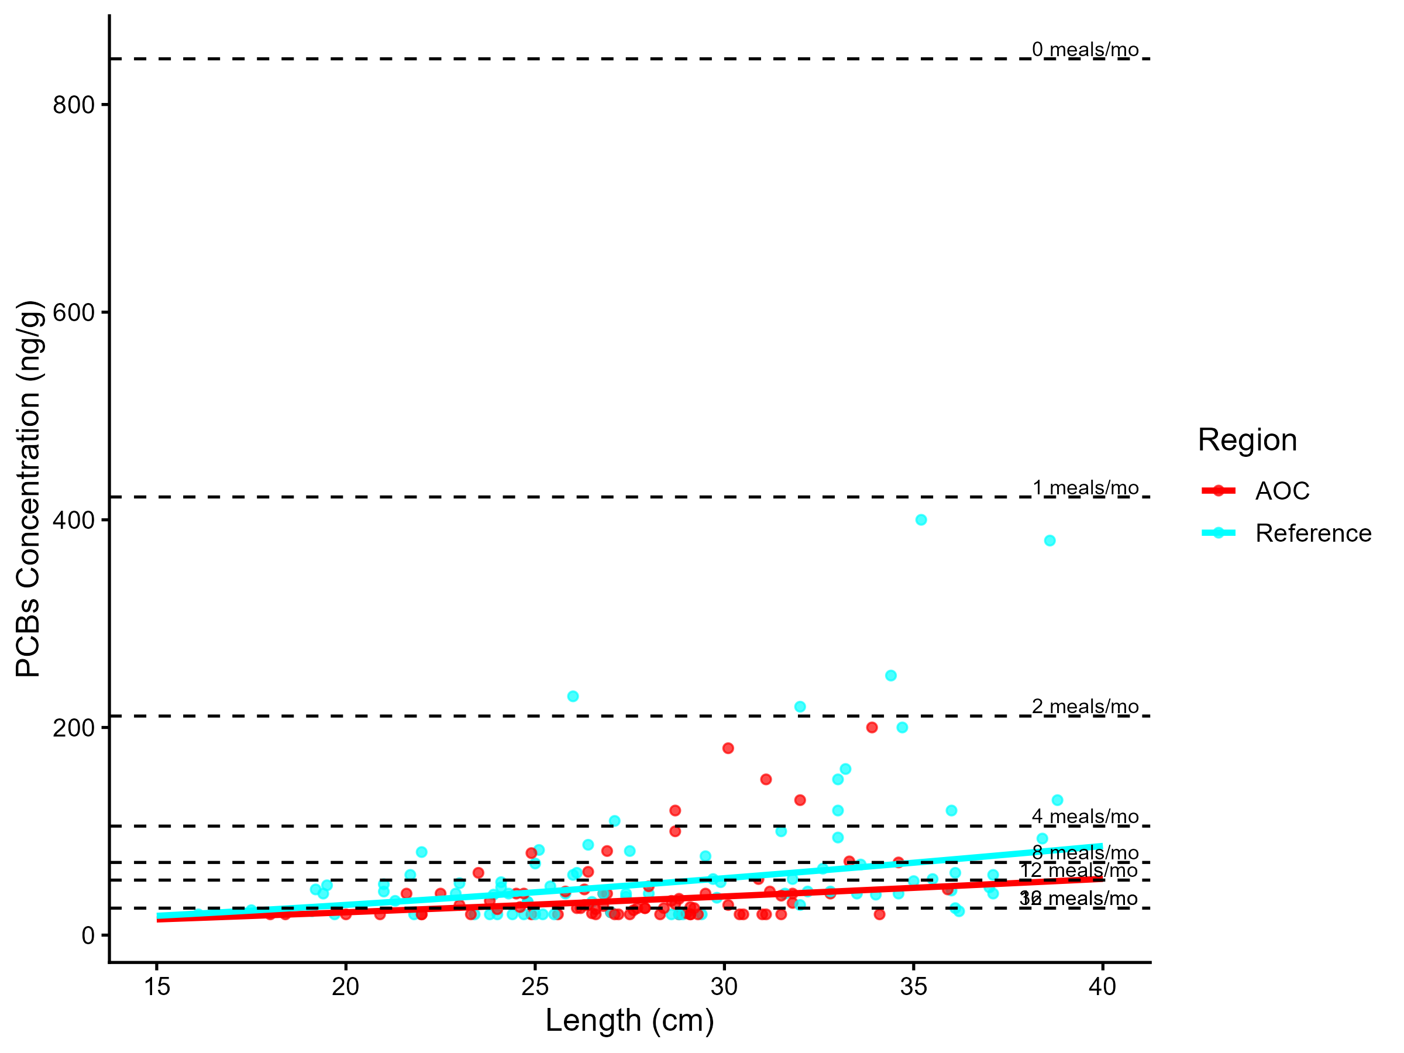
Figure 4.1: Virtual PCB advisories in brown bullhead. Predicted concentrations (curve) and observed values (points) by region using power regression model, compared to MECP advisory limits for PCB for the sensitive population (dashed lines).

Model Summary by Region
AOC: There is a statistically significant relationship between fish length and contaminant concentration. The power model used was: concentration = 0.446 × Length1.301 (R² = 0.098, p = 5.50e-03).
Reference: There is a statistically significant relationship between fish length and contaminant concentration. The power model used was: concentration = 0.273 × Length1.56 (R² = 0.201, p = < 0.001).
Table 4.5: (ref:t3a-brown bullhead-table-pcb)
Population | Region | 15-20 | 20-25 | 25-30 | 30-35 | 35-40 | 40-45
General | AOC | 32 | 32 | 16 | 16 | 16 | 12
General | Reference | 32 | 16 | 16 | 12 | 8 | 8
General population: Of 6 size bins, 0 were below the desired consumption rate of 8 meals/month. Of these, 0 were more restrictive than reference. Overall, Tier 3A assessment for brown bullhead is supportive.
Tier 3A Overall Decision: Supportive

4.3.1.2.2 Tier 3B: Contaminant Concentration vs Reference

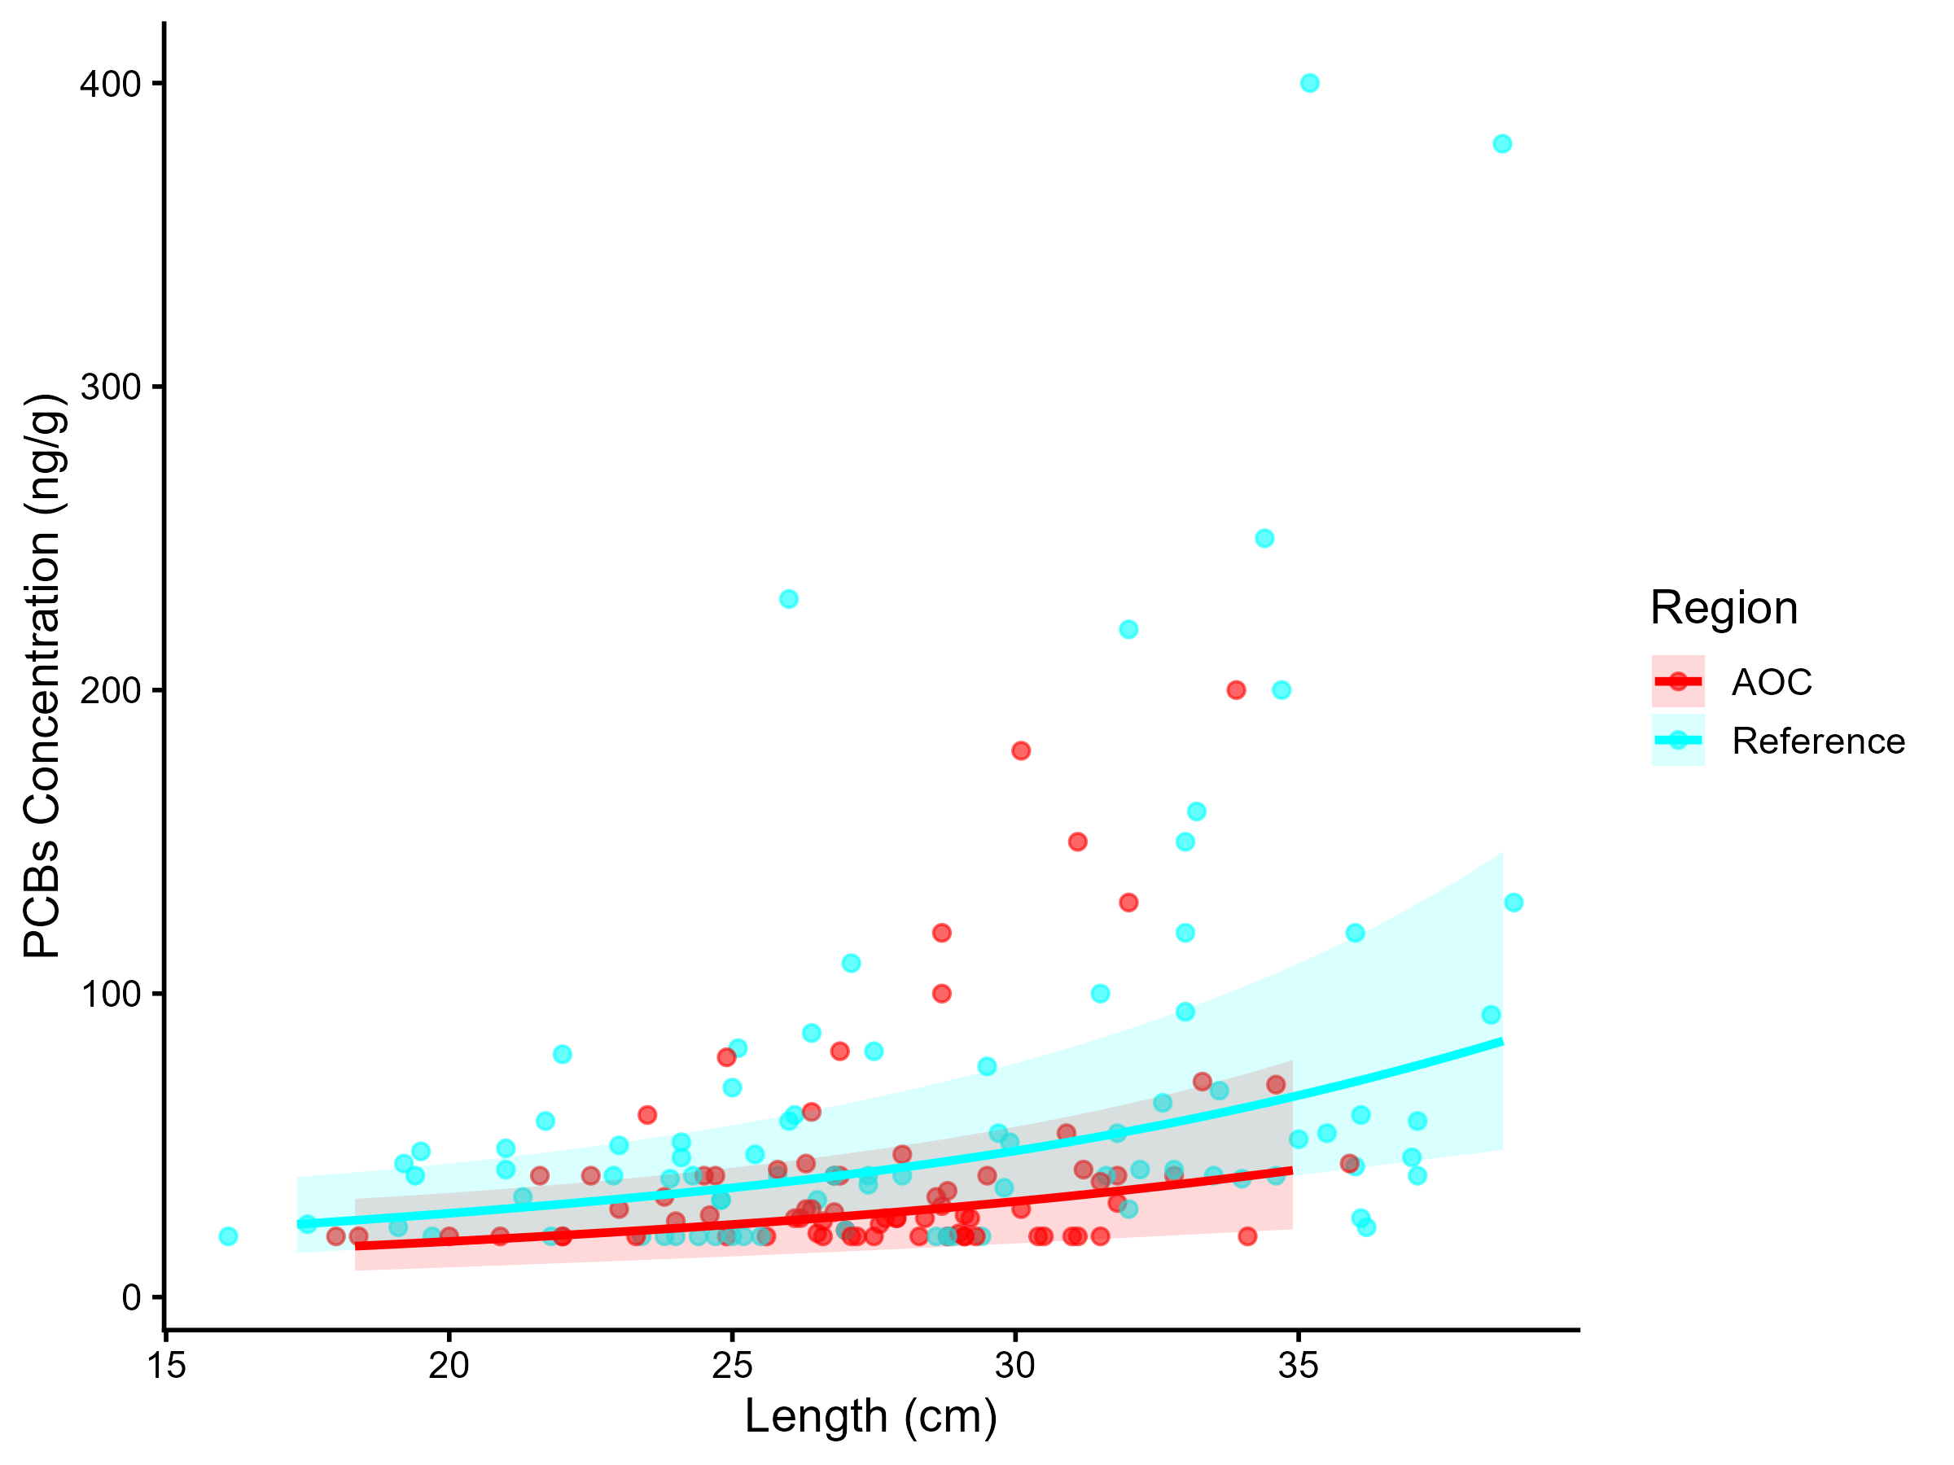
Figure 4.2: PCB concentration in Brown Bullhead by length in the AOC compared to reference sites. Points are observed contaminant values, curves represent GAM model fit (with random effects dropped for simplicity,), ribbons represent 95% confidence interval.

Generalized Additive Models (GAMs) were used to model the relationship between fish length and total PCBs concentrations for brown bullhead in the AOC and reference regions. The length-contaminant relationship did not differ significantly between sites (interaction test p = NA). Marginal mean concentrations were estimated across the full size distribution using a reduced model with shared smooths. The estimated marginal mean PCBs concentration in the AOC was 3.66 units (95% CI: 3.32–4). Estimated values for reference site(s): Reference: 3.88 units (95% CI: 3.62–4.14).
The AOC does not exceed reference in marginal mean concentration, suggesting comparable contamination levels in this species. Therefore, Tier 3B analysis of brown bullhead is considered supportive for redesignation.
Tier 3B Overall Decision: Supportive

4.3.1.2.3 Tier 3C: Temporal Trends
Table 4.6: Estimated time to unrestrictive PCB threshold for median, upper-quartile, and lower-quartile-sized brown bullhead in the AOC, using GAMM-derived half-life decay model. The model-predicted concentration of representative-length fish is reported for the most recent year of observation, and the target concentration corresponding to the earliest of either Tier 1 or Tier 2 thresholds. Tier 1 thresholds representitive an "unrestrictive" advisory for the Sensitive population of 8, based on survey results and MECP advisory thresholds. Tier 2 thresholds are size-matched Sensitive reference medians.
Representative group | Length (cm) | Predicted Conc. (Current Year) | Desired Consumption Rate | Tier 1 threshold conc. | Tier 2 median (Sensitive) meals/mo | Tier 2 Threshold conc. | Target Threshold (earliest) | Years to Threshold | 95% CI | Outcome
Lower quartile | 25 | 28.23 | 8 | 70.00 | 16 | 26.00 | 70.00 | 0.0 | -100.4–100.4 | Supportive
Median | 30 | 36.23 | 8 | 70.00 | 8 | 70.00 | 70.00 | 0.0 | -103.6–103.6 | Supportive
Upper quartile | 30 | 36.23 | 8 | 70.00 | 8 | 70.00 | 70.00 | 0.0 | -103.6–103.6 | Supportive

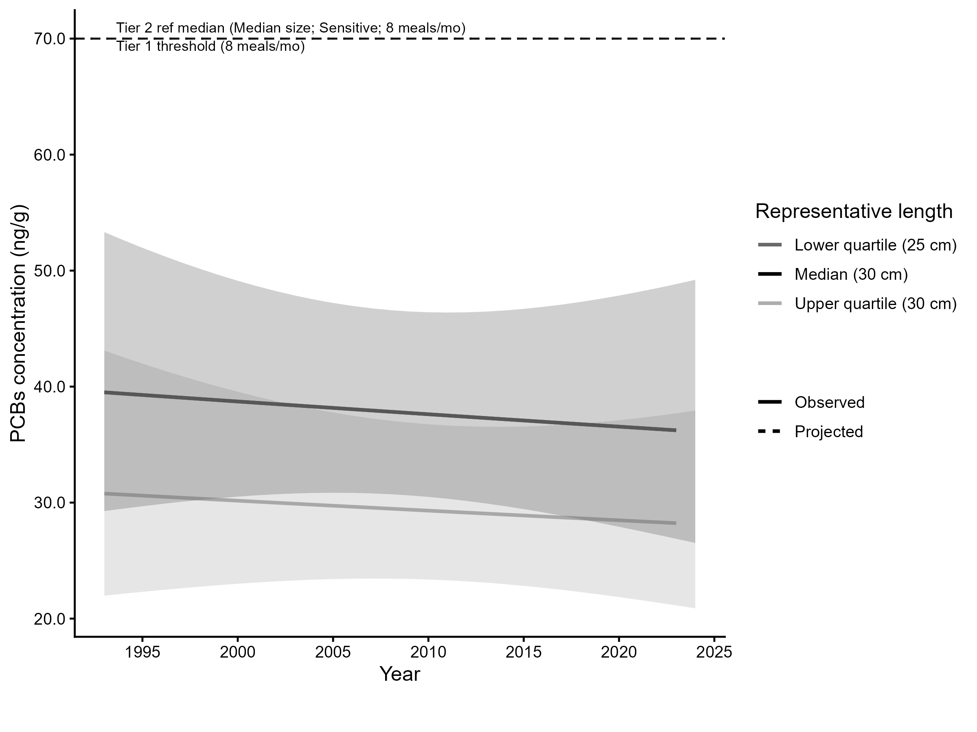
Figure 4.3: Projected PCB concentration in median, lower-, and upper-quartile-length brown bullhead in the AOC. Predicted concentration is based on GAMM-derived half-life decay model. The solid line represents predicted values within the temporal range of observations, the dashed line represents projected future concentrations, ribbons show 95% CI, and the horizontal dotted line represents the unrestrictive PCB threshold for the sensitive population, based on community desired consumption rate and MECP advisory thresholds.
For upper-quartile-length (30 cm) fish, predicted concentrations are already within the unrestrictive advisory range for the Sensitive population (≥ 8 meals/month). Therefore, Tier 3C is considered supportive.
Tier 3C Overall Decision: Supportive

4.3.1.2.4 Summary
A summary of Tier 3 assessment results can be found in table 4.7. Overall, results from this species are supportive of redesignation.
Table 4.7: Summary of Tier 3 assessment results in the Bay of Quinte Area of Concern.
Tier | Description | Metric | Outcome
Tier 3A | Virtual Advisory | General: 0/6 size bins restrictive or more restrictive than reference | Supportive
Tier 3B | Contaminant Concentration vs Reference | No significant difference in smooth terms (p = NA); AOC marginal mean not higher than reference | Supportive
Tier 3C | Temporal Trends | 0/3 representative size groups (lower quartile, median, upper quartile) are restrictive based on time-to-threshold results. | Supportive

4.3.1.3 Lake Whitefish
The following reference sites were used in the tier 3 analysis of lake whitefish in the Bay of Quinte AOC:

AOC
- Lake Ontario 10 - Middle Bay of Quinte
- Lake Ontario 11 - Lower Bay of Quinte/Eastern Lake Ontario
- Lake Ontario 9 - Upper Bay of Quinte

Reference
- Lake Ontario 8

4.3.1.3.1 Tier 3A
Virtual advisory values were generated using by modelling the relationship between fish length and contaminant concentration for lake whitefish and PCB.
Model Summary by Region
Reference: There is a statistically significant relationship between fish length and contaminant concentration. The power model used was: concentration = 1.39 × Length1.046 (R² = 0.284, p = < 0.001).
AOC: There is a statistically significant relationship between fish length and contaminant concentration. The power model used was: concentration = 0.155 × Length1.523 (R² = 0.192, p = < 0.001).
General population: Of 11 size bins, 0 were below the desired consumption rate of 8 meals/month. Of these, 0 were more restrictive than reference. Therefore, Tier 3A analysis of lake whitefish is considered supportive for redesignation.

4.3.1.3.2 Tier 3B
Generalized Additive Models (GAMs) were used to model the relationship between fish length and pcbs concentrations for lake whitefish in the AOC and reference regions. The length-contaminant relationship did not differ significantly between sites (interaction test p = NA). Marginal mean concentrations were estimated across the full size distribution using a reduced model with shared smooths. The estimated marginal mean PCBs concentration in the AOC was 3.92 ng/g (95% CI: 3.61–4.24). Estimated values for reference site(s): Reference: 4.23 ng/g (95% CI: 3.75–4.71).
The AOC does not exceed reference in marginal mean concentration, suggesting comparable contamination levels in this species. Therefore, Tier 3B analysis of lake whitefish is considered supportive for redesignation.

4.3.1.3.3 Tier 3C
Temporal trends in lake whitefish for PCBs were assessed using generalized additive mixed models (GAMMs) across all years of data, and a model test was performed to estimate the time required to reach a nonrestrictive monthly meal allowance for the upper quantile fish length (rounded to the nearest 5 cm) for sensitive populations. For upper-quartile-length (55 cm) fish, predicted concentrations are already within the unrestrictive advisory range for the Sensitive population (≥ 8 meals/month). Therefore, Tier 3C is considered supportive for redesignation.

4.3.1.3.4 Tier 3 Summary
Tier | Description | Metric | Outcome
Tier 3A | Virtual Advisory | General: 0/11 size bins restrictive or more restrictive than reference | Supportive
Tier 3B | Contaminant Concentration vs Reference | No significant difference in smooth terms (p = NA); AOC marginal mean not higher than reference | Supportive
Tier 3C | Temporal Trends | 0/3 representative size groups (lower quartile, median, upper quartile) are restrictive based on time-to-threshold results. | Supportive

4.3.1.4 Northern Pike
The following reference sites were used in the tier 3 analysis of northern pike in the Bay of Quinte AOC:

AOC
- Lake Ontario 10 - Middle Bay of Quinte
- Lake Ontario 11 - Lower Bay of Quinte/Eastern Lake Ontario
- Lake Ontario 9 - Upper Bay of Quinte

Reference
- Lake Ontario - Cataraqui Bay
- Lake Ontario 2 - Twelve Mile Creek Port Dalhousie
- Lake Ontario 4a - Ashbridges Bay
- Lake Ontario 4a - Humber Bay
- Lake Ontario 4a - Toronto Waterfront
- Lake Ontario 6a - Frenchman Bay
- Lake Ontario 8
- St. Lawrence River 12 - Lower Thousand Island

4.3.1.4.1 Tier 3A
Virtual advisory values were generated using by modelling the relationship between fish length and contaminant concentration for northern pike and PCBs.
Model Summary by Region
Reference: There is no significant relationship between fish length and contaminant concentration. Bin-level means were used instead. The power model used was: concentration = 7.62 × Length0.439 (R² = 0.024, p = 2.36e-01).
AOC: There is no significant relationship between fish length and contaminant concentration. Bin-level means were used instead. The power model used was: concentration = 5.88 × Length0.384 (R² = 0.036, p = 3.15e-01).
General population: Of 9 size bins, 0 were below the desired consumption rate of 8 meals/month. Of these, 0 were more restrictive than reference. Therefore, Tier 3A analysis of northern pike is considered supportive for redesignation.

4.3.1.4.2 Tier 3B
Generalized Additive Models (GAMs) were used to model the relationship between fish length and pcbs concentrations for northern pike in the AOC and reference regions. The length-contaminant relationship did not differ significantly between sites (interaction test p = 0.159). Marginal mean concentrations were estimated across the full size distribution using a reduced model with shared smooths. The estimated marginal mean PCBs concentration in the AOC was 3.37 ng/g (95% CI: 2.93–3.81). Estimated values for reference site(s): Reference: 3.93 ng/g (95% CI: 3.65–4.22).
The AOC does not exceed reference in marginal mean concentration, suggesting comparable contamination levels in this species. Therefore, Tier 3B analysis of northern pike is considered supportive for redesignation.

4.3.1.4.3 Tier 3C
Temporal trends in northern pike for PCBs were assessed using generalized additive mixed models (GAMMs) across all years of data, and a model test was performed to estimate the time required to reach a nonrestrictive monthly meal allowance for the upper quantile fish length (rounded to the nearest 5 cm) for sensitive populations. For upper-quartile-length (80 cm) fish, predicted concentrations are already within the unrestrictive advisory range for the Sensitive population (≥ 8 meals/month). Therefore, Tier 3C is considered supportive for redesignation.

4.3.1.4.4 Tier 3 Summary
Tier | Description | Metric | Outcome
Tier 3A | Virtual Advisory | General: 0/9 size bins restrictive or more restrictive than reference | Supportive
Tier 3B | Contaminant Concentration vs Reference | No significant difference in smooth terms (p = 0.159); AOC marginal mean not higher than reference | Supportive
Tier 3C | Temporal Trends | 0/3 representative size groups (lower quartile, median, upper quartile) are restrictive based on time-to-threshold results. | Supportive

4.3.1.5 Smallmouth Bass
The following reference sites were used in the tier 3 analysis of smallmouth bass in the Bay of Quinte AOC:

AOC
- Lake Ontario 10 - Middle Bay of Quinte
- Lake Ontario 11 - Lower Bay of Quinte/Eastern Lake Ontario
- Lake Ontario 9 - Upper Bay of Quinte

Reference
- Lake Ontario 2 - Twelve Mile Creek Port Dalhousie
- Lake Ontario 4 - Colonel Sams Bay
- Lake Ontario 4a - Humber Bay
- Lake Ontario 4a - Mimico Bay
- Lake Ontario 4a - Toronto Waterfront
- Lake Ontario 8
- St. Lawrence River 12 - Lower Thousand Island

4.3.1.5.1 Tier 3A
Virtual advisory values were generated using by modelling the relationship between fish length and contaminant concentration for smallmouth bass and PCB.
Model Summary by Region
Reference: There is a statistically significant relationship between fish length and contaminant concentration. The power model used was: concentration = 2.11 × Length0.927 (R² = 0.203, p = < 0.001).
AOC: There is no significant relationship between fish length and contaminant concentration. Bin-level means were used instead. The power model used was: concentration = 2.69 × Length0.835 (R² = 0.116, p = 1.43e-01).
General population: Of 9 size bins, 0 were below the desired consumption rate of 8 meals/month. Of these, 0 were more restrictive than reference. Therefore, Tier 3A analysis of smallmouth bass is considered supportive for redesignation.

4.3.1.5.2 Tier 3B
Generalized Additive Models (GAMs) were used to model the relationship between fish length and pcbs concentrations for smallmouth bass in the AOC and reference regions. The length-contaminant relationship did not differ significantly between sites (interaction test p = NA). Marginal mean concentrations were estimated across the full size distribution using a reduced model with shared smooths. The estimated marginal mean PCBs concentration in the AOC was 3.81 ng/g (95% CI: 3.3–4.31). Estimated values for reference site(s): Reference: 3.89 ng/g (95% CI: 3.54–4.24).
The AOC does not exceed reference in marginal mean concentration, suggesting comparable contamination levels in this species. Therefore, Tier 3B analysis of smallmouth bass is considered supportive for redesignation.

4.3.1.5.3 Tier 3C
Temporal trends in smallmouth bass for PCB were assessed using generalized additive mixed models (GAMMs) across all years of data, and a model test was performed to estimate the time required to reach a nonrestrictive monthly meal allowance for the upper quantile fish length (rounded to the nearest 5 cm) for sensitive populations. For upper-quartile-length (40 cm) fish, predicted concentrations are already within the unrestrictive advisory range for the Sensitive population (≥ 8 meals/month). Therefore, Tier 3C is considered supportive for redesignation.

4.3.1.5.4 Tier 3 Summary

Tier | Description | Metric | Outcome
Tier 3A | Virtual Advisory | General: 0/9 size bins restrictive or more restrictive than reference | Supportive
Tier 3B | Contaminant Concentration vs Reference | No significant difference in smooth terms (p = NA); AOC marginal mean not higher than reference | Supportive
Tier 3C | Temporal Trends | 0/3 representative size groups (lower quartile, median, upper quartile) are restrictive based on time-to-threshold results. | Supportive

4.3.1.6 Walleye
The following reference sites were used in the tier 3 analysis of walleye in the Bay of Quinte AOC:

AOC
- Lake Ontario 10 - Middle Bay of Quinte
- Lake Ontario 11 - Lower Bay of Quinte/Eastern Lake Ontario
- Lake Ontario 9 - Upper Bay of Quinte

Reference
- Lake Ontario 2 - Twelve Mile Creek Port Dalhousie
- Lake Ontario 4a - Toronto Waterfront
- Lake Ontario 6 - Northwestern
- Lake Ontario 8
- St. Lawrence River 12 - Lower Thousand Island

4.3.1.6.1 Tier 3A
Virtual advisory values were generated using by modelling the relationship between fish length and contaminant concentration for walleye and PCBs.
Model Summary by Region
Reference: There is a statistically significant relationship between fish length and contaminant concentration. The power model used was: concentration = 0.0667 × Length1.661 (R² = 0.265, p = < 0.001).
AOC: There is a statistically significant relationship between fish length and contaminant concentration. The power model used was: concentration = 5.84 × Length0.448 (R² = 0.108, p = 8.14e-03).
General population: Of 13 size bins, 10 were below the desired consumption rate of 8 meals/month. Of these, 1 were more restrictive than reference. Therefore, Tier 3A analysis of walleye is considered unsupportive for redesignation.

4.3.1.6.2 Tier 3B
Generalized Additive Models (GAMs) were used to model the relationship between fish length and pcbs concentrations for walleye in the AOC and reference regions. The length-contaminant relationship did not differ significantly between sites (interaction test p = 0.128). Marginal mean concentrations were estimated across the full size distribution using a reduced model with shared smooths. The estimated marginal mean PCBs concentration in the AOC was 3.4 ng/g (95% CI: 3.04–3.75). Estimated values for reference site(s): Reference: 3.68 ng/g (95% CI: 3.35–4).
The AOC does not exceed reference in marginal mean concentration, suggesting comparable contamination levels in this species. Therefore, Tier 3B analysis of walleye is considered supportive for redesignation.

4.3.1.6.3 Tier 3C
Temporal trends in walleye for PCBs were assessed using generalized additive mixed models (GAMMs) across all years of data, and a model test was performed to estimate the time required to reach a nonrestrictive monthly meal allowance for the upper quantile fish length (rounded to the nearest 5 cm) for sensitive populations. For upper-quartile-length (60 cm) fish, predicted concentrations are already within the unrestrictive advisory range for the Sensitive population (≥ 8 meals/month). Therefore, Tier 3C is considered supportive for redesignation.

4.3.1.6.4 Tier 3 Summary
Tier | Description | Metric | Outcome
Tier 3A | Virtual Advisory | General: 1/13 size bins restrictive or more restrictive than reference | Supportive
Tier 3B | Contaminant Concentration vs Reference | No significant difference in smooth terms (p = 0.128); AOC marginal mean not higher than reference | Supportive
Tier 3C | Temporal Trends | 0/3 representative size groups (lower quartile, median, upper quartile) are restrictive based on time-to-threshold results. | Supportive

4.3.1.7 Chinook Salmon and Rainbow Smelt
There were an insufficient number of observed records of Chinook salmon (26 observations across 5 years of data), and rainbow smelt (18 observations across 5 years of data) in the AOC from which to draw conclusions at the Tier 3 level. Thus, these species automatically fail Tier 3, and will be considered holistically as part of Tier 4 assessment.

4.3.2 Dioxins and Furans
Data availability for dioxins and furans contamination for species of interest within the Bay of Quinte is limited, and insufficient for tier 3 analysis for most species. However, there is sufficient data for limited scope analysis of brown bullhead. While PCBs are the major contaminant of concern in the Bay of Quinte AOC, analysis of dioxins and furans in brown bullhead helps to provide additional context for the state of organic contamination within the AOC, as brown bullhead are considered a sentinel species and generally accumulate larger amounts of organic contaminants than other lean predator fish such as brown bullhead. Dioxins and furans are estimated using the TEQWH4 method (World Health Organization Toxicity Equivalency Units).
Reference data availability is extremely limited for dioxins/furans in Lake Ontario, as testing is prohibitively expensive for most sites. It is likely that limited measurements are only taken from sites where these contaminants are known to be an issue, such as AOCs. Thus, the examination of dioxins and furans for brown bullhead focuses on the AOC context, and the “reference” areas (Toronto Waterfront and Whitby Harbour) provide some additional context on dioxin/furan contamination in other Lake Ontario sites.

4.3.2.1 Brown Bullhead
The following sites were used in the tier 3 analysis of brown bullhead (dioxins and furans) in the Bay of Quinte AOC:

AOC
- Lake Ontario 10 - Middle Bay of Quinte
- Lake Ontario 11 - Lower Bay of Quinte/Eastern Lake Ontario
- Lake Ontario 9 - Upper Bay of Quinte

Reference
- Lake Ontario 4a - Toronto Waterfront

4.3.2.1.1 Tier 3A
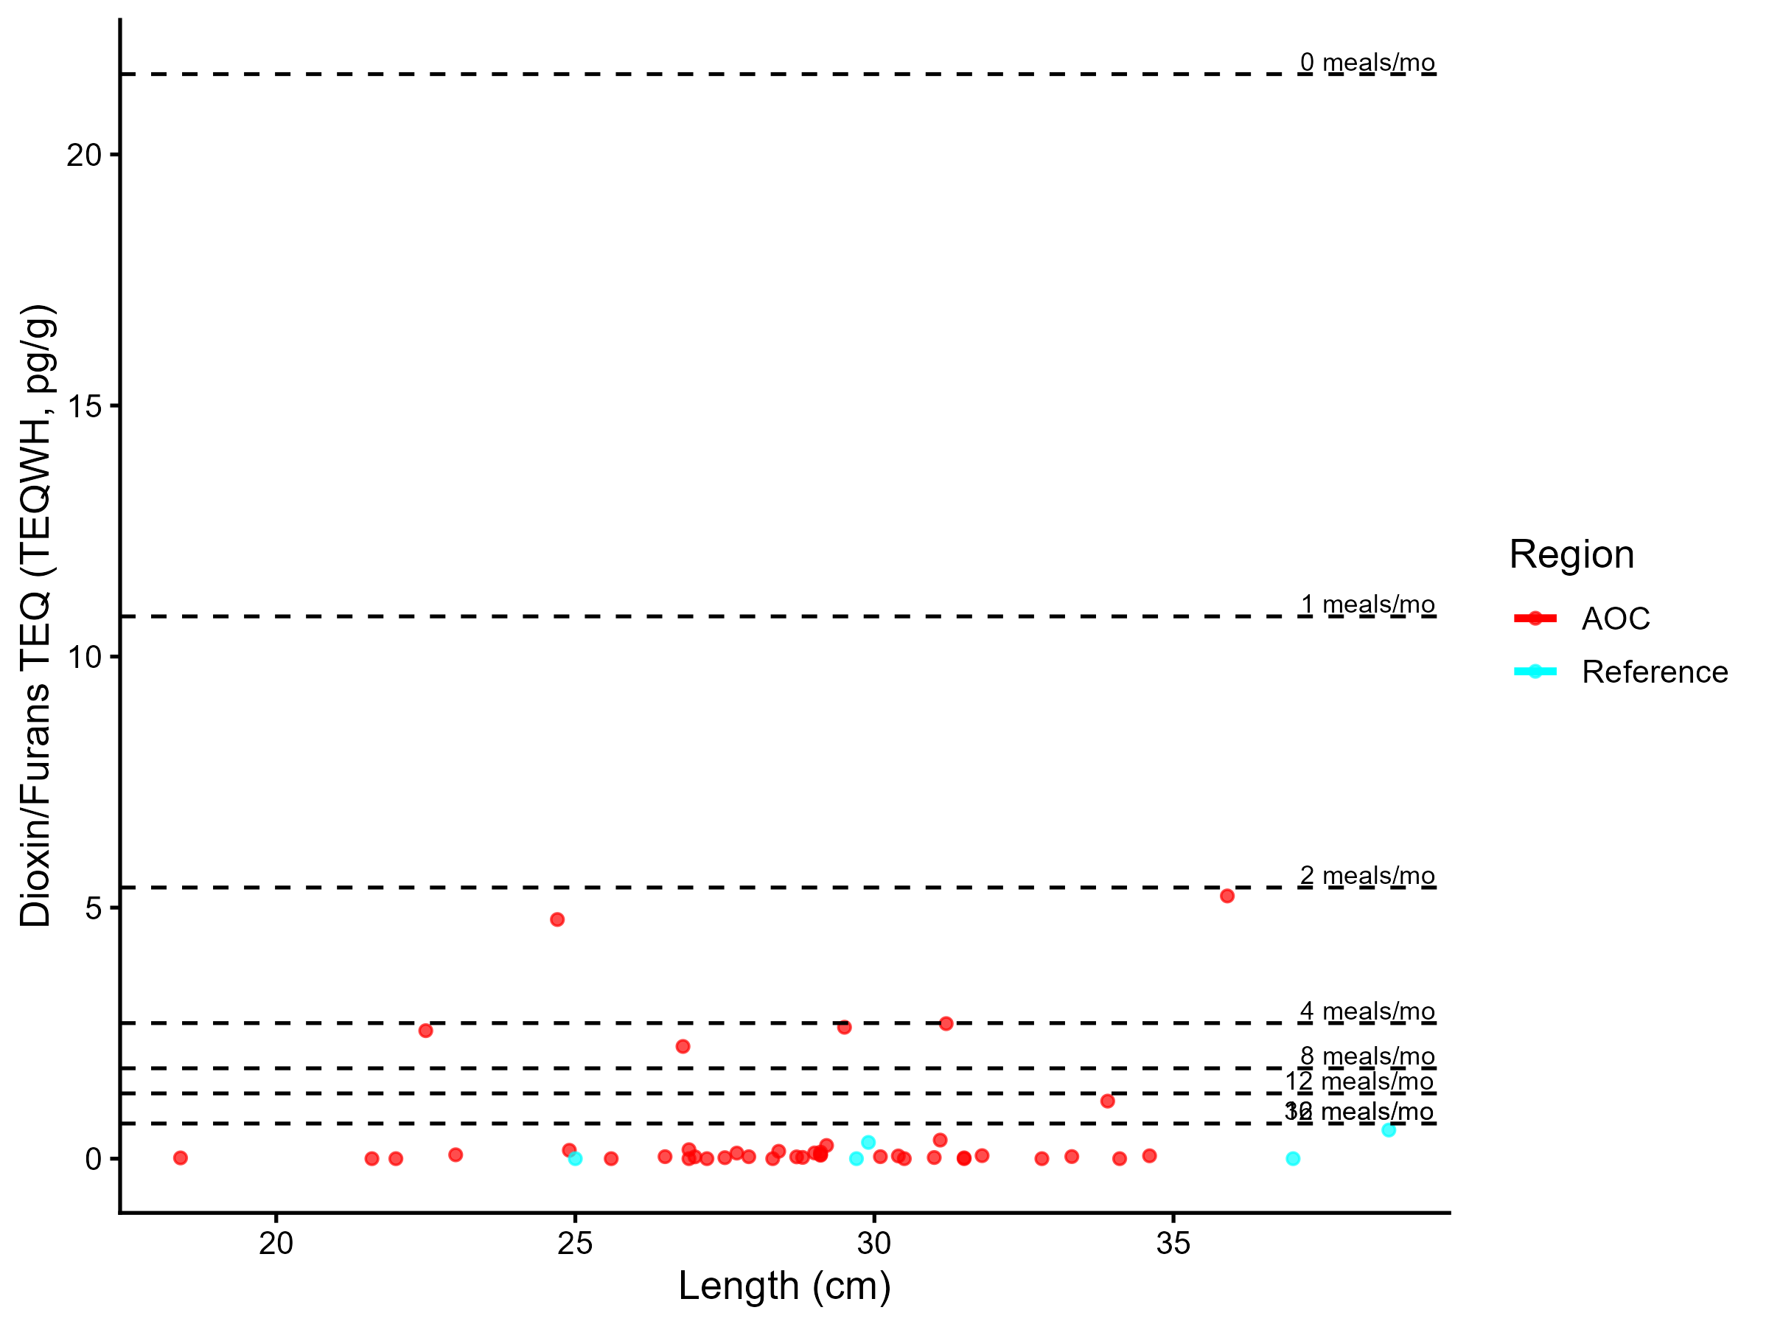
Figure 4.4: Virtual dioxins/furans advisories in brown bullhead. Predicted concentrations (curve) and observed values (points) by region using power regression model, compared to MECP advisory limits for PCB for the sensitive population (dashed lines). Curve is not displayed if there is no significant contaminant-size relationship.

Model Summary by Region
AOC: There is no significant relationship between fish length and contaminant concentration. Bin-level means were used instead. The power model used was: concentration = 0.00323 × Length1.128 (R² = 0.007, p = 6.45e-01).
Reference: There is no significant relationship between fish length and contaminant concentration. Bin-level means were used instead. The power model used was: concentration = 0.000174 × Length2.215 (R² = 1, p = NA). Most observations of dioxins/furans in brown bullhead in the AOC are below detection limits (Figure 4.4). Additionally, the low reference data induces a dramatic curve which may not represent actual patterns in dioxin/furan contamination within these two sites.
Table 4.8: Virtual advisory levels for dioxins/furans in brown bullhead across regions. Values represent meals/month recommendations. Red cells indicate restrictive virtual advisory below the desired consumption rate of 8 meals/month; green cells indicate unrestrictive virtual advisory equal to or above either the desired consumption rate. Reference values are shown for comparison, but are not used for the assessment of Tier 3A.
Population | Region | 15-20 | 20-25 | 25-30 | 30-35 | 35-40 | 40-45
General | AOC | 32 | 8 | 32 | 32 | 4 | 16
General | Reference | 32 | 32 | 32 | 32 | 32 | 32
General population: Of 6 size bins, 1 were below the desired consumption rate of 8 meals/month. Of these, 1 were more restrictive than reference. Overall, Tier 3A assessment for brown bullhead is unsupportive.
Tier 3A Overall Decision: Unsupportive

4.3.2.1.2 Tier 3B

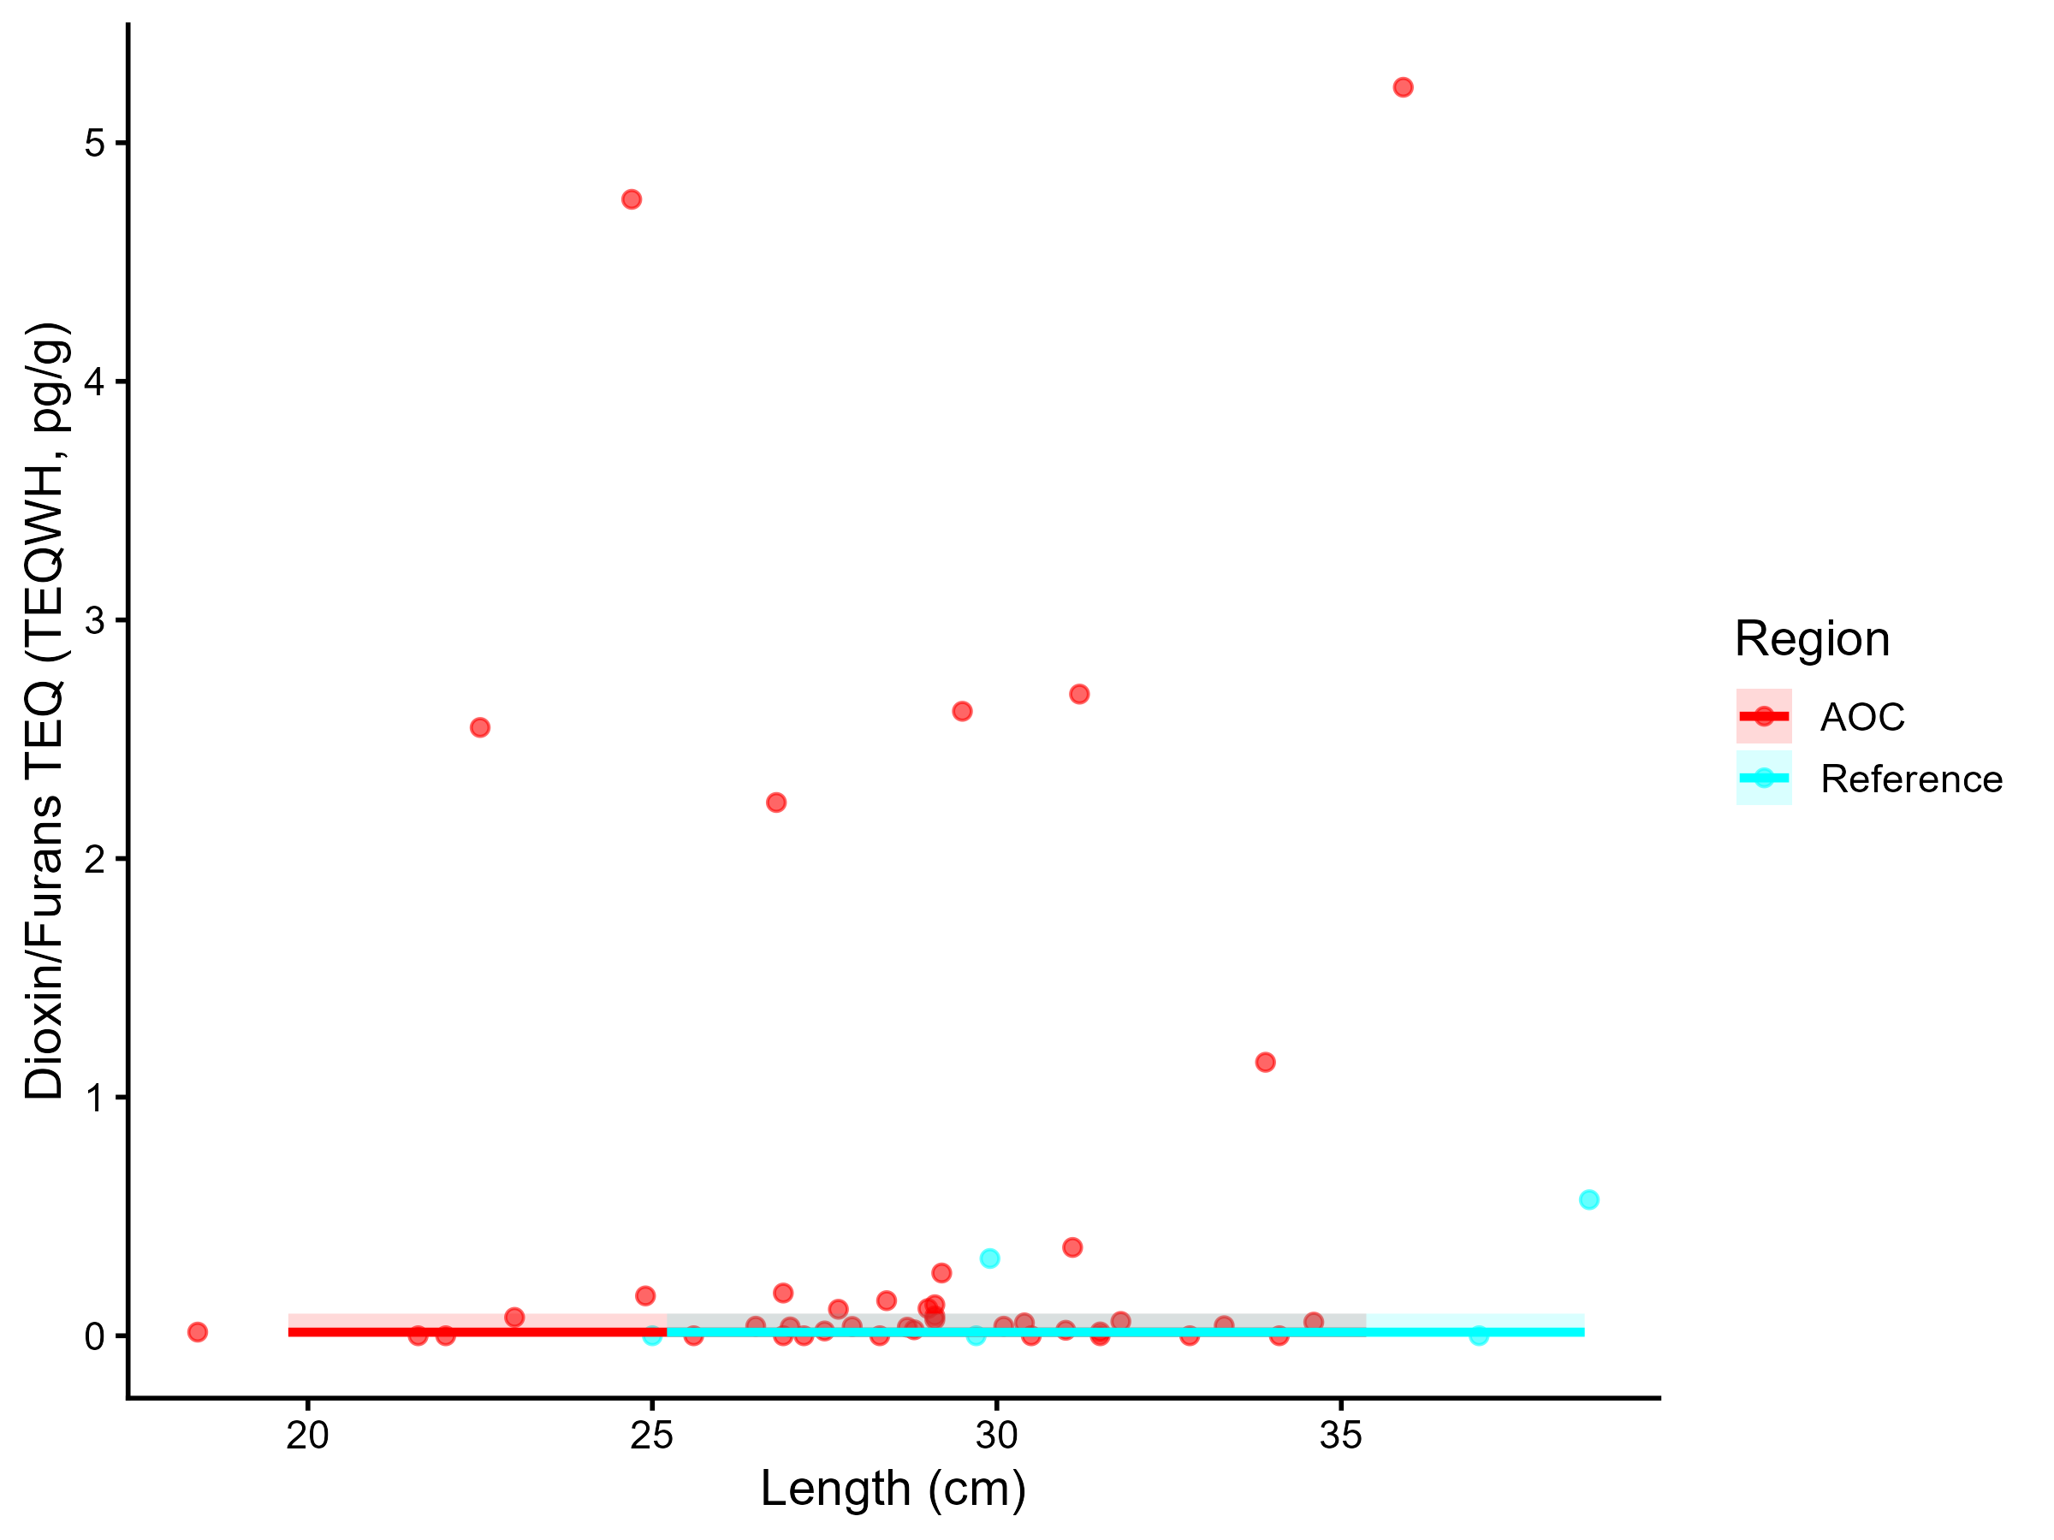
Figure 4.5: Dioxins/furans TEQ (TEQWH4, pg/g) concentration in Brown Bullhead by length in the AOC compared to reference sites. Points are observed contaminant values, curves represent GAM model fit (with random effects dropped for simplicity,), ribbons represent 95% confidence interval.

Generalized Additive Models (GAMs) were used to model the relationship between fish length and dioxin/furan TEQ concentrations for brown bullhead in the AOC and reference regions. The length-contaminant relationship did not differ significantly between sites (interaction test p = 0.48). Marginal mean concentrations were estimated across the full size distribution using a reduced model with shared smooths. The estimated marginal mean TEQWH4 concentration in the AOC was -3.44 pg/g (95% CI: -4.59–-2.3). Estimated values for reference site(s): Reference: -2.07 pg/g (95% CI: -4.24–0.11).
The AOC has a higher marginal mean concentration than reference, suggesting elevated contamination in this species compared to reference. Therefore, Tier 3B analysis of brown bullhead is considered unsupportive for redesignation.
Tier 3B Overall Decision: Unsupportive

4.3.2.1.3 Tier 3C

Table 4.9: Estimated time to unrestrictive dioxins/furans TEQ threshold for an upper-quartile-sized brown bullhead in the AOC, using GAMM-derived half-life decay model. The model-predicted concentration of an upper-quartile length fish is reported for the most recent year of observation, and the target concentration corresponding to an "unrestrictive" advisory for the Sensitive population of 8, based on survey results and MECP advisory thresholds.
Representative group | Length (cm) | Predicted Conc. (Current Year) | Desired Consumption Rate | Tier 1 threshold conc. | Tier 2 median (Sensitive) meals/mo | Tier 2 Threshold conc. | Target Threshold (earliest) | Years to Threshold | 95% CI | Outcome
Lower quartile | 25 | 0.06 | 8 | 1.80 | 16 | 0.70 | 1.80 | 0.0 | — | Supportive
Median | 30 | 0.16 | 8 | 1.80 | 8 | 1.80 | 1.80 | 0.0 | — | Supportive
Upper quartile | 30 | 0.16 | 8 | 1.80 | 8 | 1.80 | 1.80 | 0.0 | — | Supportive

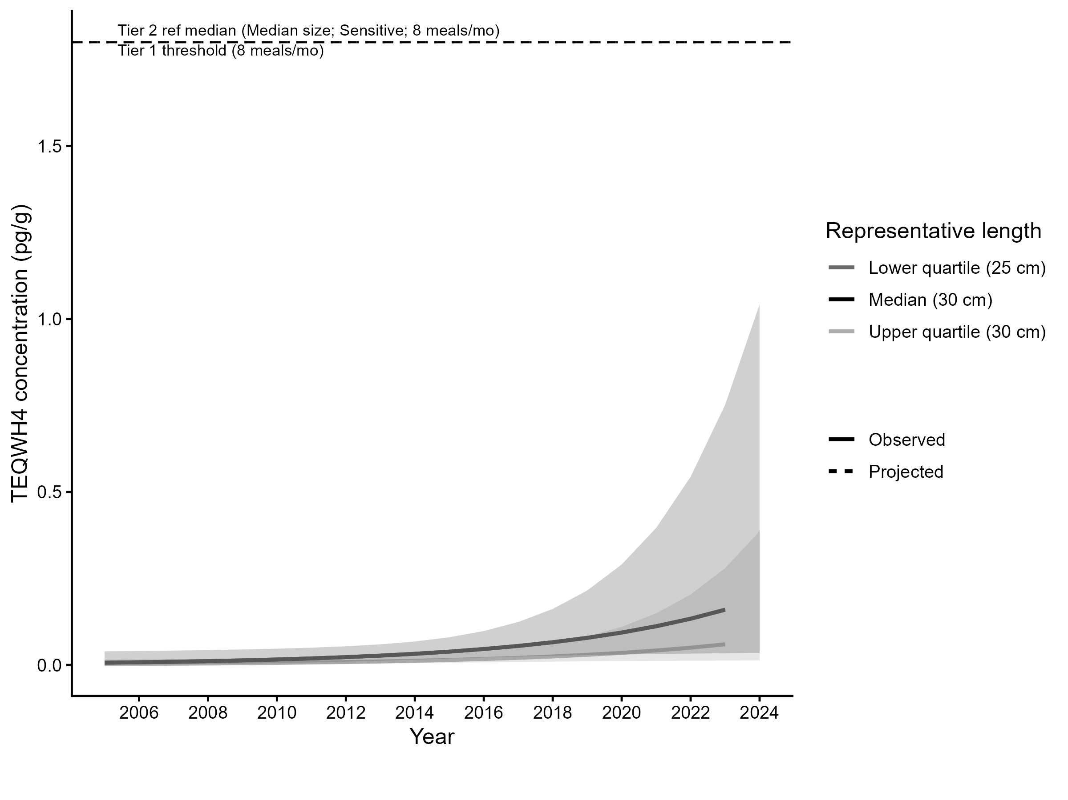
Figure 4.6: Projected dioxins/furans TEQ (TEQWH4, pg/g) concentration in upper-quartile-length brown bullhead in the AOC. Predicted concentration is based on GAMM-derived half-life decay model. The solid line represents predicted values within the temporal range of observations, the dashed line represents projected future concentrations, ribbons show 95% CI, and the horizontal dotted line represents the unrestrictive dioxins/furans threshold for the sensitive population, based on community desired consumption rate and MECP advisory thresholds.
For upper-quartile-length (30 cm) fish, predicted concentrations are already within the unrestrictive advisory range for the Sensitive population (≥ 8 meals/month). Therefore, Tier 3C is considered supportive.
Tier 3C Overall Decision: Supportive

4.3.2.1.4 Summary
A summary of Tier 3 assessment results can be found in table 4.10. Overall, results from this species are supportive of redesignation.
Table 4.10: Summary of Tier 3 assessment results of dioxins and furans in brown bullhead in the Bay of Quinte Area of Concern.
Tier | Description | Metric | Outcome
Tier 3A | Virtual Advisory | General: 1/6 size bins restrictive or more restrictive than reference | Supportive
Tier 3B | Contaminant Concentration vs Reference | No significant difference in smooth terms (p = 0.324); AOC marginal mean higher than reference | Unsupportive
Tier 3C | Temporal Trends | 0/3 representative size groups (lower quartile, median, upper quartile) are restrictive based on time-to-threshold results. | Supportive

5 Results: Measure 2
Measure 2 of the delisting criterion (Section 2.1 is assessed by comparing the intensity of consumption advisories for sentinel species such as Brown Bullhead and Yellow Perch in the Trenton and Belleville nearshore areas to those of the rest of the Bay of Quinte. However, due to the limitation of available data in these regions, the full tiered assessment approach cannot be applied for Measure 2 in the same way as for Measure 1. For yellow perch, assessment of Measure 2 consists of a simple comparison of consumption advisories in the nearshore areas with the rest of the Bay, similar to Tier 2 assessment. For brown bullhead, when data from Trenton and Belleville Nearshore areas are pooled, data are sufficient to make contaminant comparisons at a Tier 3 level in addition to Tier 1/2.

5.1 Tier 1 Results (Measure 2)

5.1.1 Tier 1: Belleville Nearshore

Table 5.1: Results of Tier 1 assessment for Belleville Nearshore. The consumption advisory for each species is compared to its desired consumption rate, as determined by community survey. Numbers in cells indicate advisory levels for a species, size class, and population type (General/Sensitive) in the AOC. Red cells indicate an advisory below the "Restrictive" meals/month threshold (indicated by community survey), and green cells indicate advisory levels equal to or above this threshold. The contaminants driving the advisories are displayed below each cell. Advisory causes: 1 = Dioxins/Furans; 2 = Mercury; 3 = PCB.
Species | Desired Consumption Rate (Meals/Month) | Population | 15-20cm | 20-25cm | 25-30cm | 30-35cm | 35-40cm | 45-50cm | 50-55cm | 55-60cm | 60-65cm | 65-70cm | 70-75cm
Black Crappie | 8 | General | 32 | 32 | 32
 |  | Adv cause
 |  | Sensitive | 32 | 16 | 16
 |  | Adv cause |  | 2 | 2
Bluegill | 8 | General | 32
 |  | Adv cause
 |  | Sensitive | 16
 |  | Adv cause | 2
Brown Bullhead | 8 | General |  | 4 | 4 | 4 | 4
 |  | Adv cause |  | 1 | 1 | 1 | 3
 |  | Sensitive |  | 4 | 4 | 4 | 0
 |  | Adv cause |  | 1 | 1 | 1 | 2
Channel Catfish | 8 | General |  |  |  |  |  | 32 | 16 | 16 | 12
 |  | Adv cause |  |  |  |  |  |  | 2 | 2 | 2, 3
 |  | Sensitive |  |  |  |  |  | 12 | 8 | 4 | 4
 |  | Adv cause |  |  |  |  |  | 2 | 2 | 2 | 2
Northern Pike | 4 | General |  |  |  |  |  |  |  |  | 16 | 16 | 16
 |  | Adv cause |  |  |  |  |  |  |  |  | 2 | 2 | 2
 |  | Sensitive |  |  |  |  |  |  |  |  | 8 | 8 | 8
 |  | Adv cause |  |  |  |  |  |  |  |  | 2 | 2 | 2
Pumpkinseed | 8 | General | 16
 |  | Adv cause | 3, 2
 |  | Sensitive | 8
 |  | Adv cause | 2
Rock Bass | 8 | General | 16 | 8
 |  | Adv cause | 2, 3 | 2
 |  | Sensitive | 8 | 4
 |  | Adv cause | 2 | 2
Smallmouth Bass | 8 | General | 16 | 16 | 16 | 16 | 16
 |  | Adv cause | 3 | 3 | 3 | 3 | 2, 3
 |  | Sensitive | 16 | 16 | 16 | 12 | 8
 |  | Adv cause | 3 | 2, 3 | 2, 3 | 2 | 2
White Perch | 8 | General | 16 | 16 | 8
 |  | Adv cause | 3 | 2, 3 | 2
 |  | Sensitive | 16 | 12 | 4
 |  | Adv cause | 3 | 2 | 2
Yellow Perch | 8 | General | 12 | 12 | 12
 |  | Adv cause | 3 | 3 | 3
 |  | Sensitive | 12 | 12 | 8
 |  | Adv cause | 3 | 2 | 2

Table 5.2: Results by species of Tier 1 assessment for Belleville Nearshore. The consumption advisory for each species is compared to its desired consumption rate, as determined by community survey. Species for which the consumption advisory is equal to or above the desired consumption rate pass Tier 1 and are excluded from further analysis; otherwise the species fails and moves forward to Tier 2.
Species | Tier 1
Black Crappie | ✔️
Bluegill | ✔️
Brown Bullhead | ❌
Channel Catfish | ❌
Northern Pike | ✔️
Pumpkinseed | ✔️
Rock Bass | ❌
Smallmouth Bass | ✔️
White Perch | ❌
Yellow Perch | ✔️

5.1.2 Tier 1: Trenton Nearshore

Table 5.3: Results of Tier 1 assessment for Trenton Nearshore. The consumption advisory for each species is compared to its desired consumption rate, as determined by community survey. Numbers in cells indicate advisory levels for a species, size class, and population type (General/Sensitive) in the AOC. Red cells indicate an advisory below the "Restrictive" meals/month threshold (indicated by community survey), and green cells indicate advisory levels equal to or above this threshold. The contaminants driving the advisories are displayed below each cell. Advisory causes: 1 = Dioxins/Furans; 2 = Mercury; 3 = PCB; 4 = PFAS.
Species | Desired Consumption Rate (Meals/Month) | Population | 15-20cm | 20-25cm | 25-30cm | 30-35cm | 35-40cm | 40-45cm | 45-50cm | 50-55cm | 55-60cm | 60-65cm | 65-70cm | 70-75cm | >75cm
Brown Bullhead | 8 | General | 8 | 8 | 8 | 4
 |  | Adv cause | 1 | 1 | 1 | 2
 |  | Sensitive | 8 | 8 | 8 | 0
Yellow Perch | 8 | General | 12
 |  | Adv cause | 3
 |  | Sensitive | 12
 |  | Adv cause | 3

Table 5.4: Results by species of Tier 1 assessment for Trenton Nearshore. The consumption advisory for each species is compared to its desired consumption rate, as determined by community survey. Species for which the consumption advisory is equal to or above the desired consumption rate pass Tier 1 and are excluded from further analysis; otherwise the species fails and moves forward to Tier 2.
Species | Tier 1
Brown Bullhead | ❌
Yellow Perch | ✔️

5.2 Tier 2 Results (Measure 2, Yellow Perch and Brown Bullhead)

5.2.0.1 Belleville Nearshore
Table 5.5: Results of Tier 2 assessment (Measure 2) for Belleville Nearshore. Advisory values in the Belleville Nearshore fishing zone are compared with that of advisories in the Lake Ontario (Eastern Basin) fishing zone. Numbers in cells indicate advisory levels for a species, size class, and population type (General/Sensitive) in the AOC, alongside the median advisory level of suitable reference sites. n values indicate the number of reference sites with advisories for this species, size class, and population type. Red cells indicate an advisory in the AOC lower than the median of reference sites, and solid green cells indicate advisories levels equal to or above the reference median. Transparent green cells indicate size classes that passed Tier 1 (i.e., the advisory value meets the desired consumption rate).
Species | Population | Site | 20-25cm | 25-30cm | 30-35cm | 35-40cm
Brown Bullhead | General | AOC | 4 | 4 | 4 | 4
 |  | Reference Median | 8 | 8 | 8 | 8
 | Sensitive | AOC | 4 | 4 | 4 | 0
 |  | Reference Median | 8 | 8 | 4 | 0

Table 5.6: Results by species of Tier 2 assessment (Measure 2) for Belleville Nearshore. The consumption advisory for each species is compared to its desired consumption rate, as determined by community survey. Species for which the consumption advisory is equal to or above the desired consumption rate pass Tier 1 and are excluded from further analysis; otherwise the species fails and moves forward to Tier 2.
Species | Tier 2
Brown Bullhead | ❌

5.2.0.2 Trenton Nearshore
Table 5.7: Results of Tier 2 assessment (Measure 2) for Trenton Nearshore. Advisory values in the Trenton Nearshore fishing zone are compared with that of advisories in the Lake Ontario (Eastern Basin) fishing zone. Numbers in cells indicate advisory levels for a species, size class, and population type (General/Sensitive) in the AOC, alongside the median advisory level of suitable reference sites. n values indicate the number of reference sites with advisories for this species, size class, and population type. Red cells indicate an advisory in the AOC lower than the median of reference sites, and solid green cells indicate advisories levels equal to or above the reference median. Transparent green cells indicate size classes that passed Tier 1 (i.e., the advisory value meets the desired consumption rate).
Species | Population | Site | 15-20cm | 20-25cm | 25-30cm | 30-35cm
Brown Bullhead | General | AOC | 8 | 8 | 8 | 4
 |  | Reference Median | 8 | 8 | 8 | 8
 | Sensitive | AOC | 8 | 8 | 8 | 0
 |  | Reference Median | 8 | 8 | 8 | 4
Table 5.8: Results by species of Tier 2 assessment for Trenton Nearshore. The consumption advisory for each species is compared to its desired consumption rate, as determined by community survey. Species for which the consumption advisory is equal to or above the desired consumption rate pass Tier 1 and are excluded from further analysis; otherwise the species fails and moves forward to Tier 2.

Species | Tier 2
Brown Bullhead | ❌

5.3 Tier 3 (Measure 2, Brown Bullhead)

5.3.1 PCBs

5.3.1.1 Tier 3A: Virtual Advisory
Tier 3A constructs virtual advisories for the contaminant of concern, and compares the values to the desired consumption rate, and reference values.
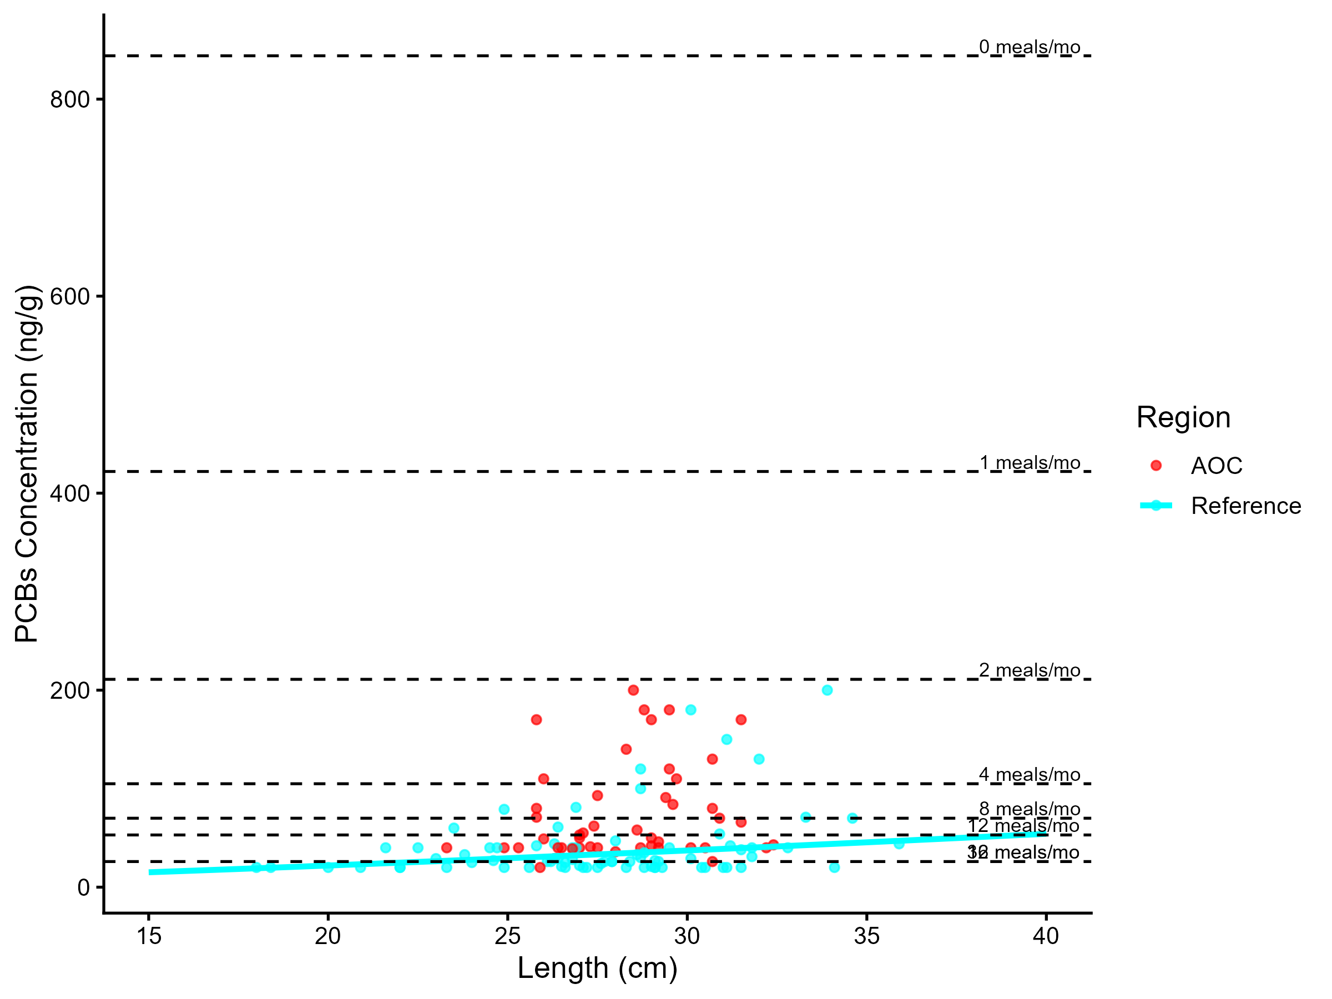
Figure 5.1: Virtual PCB advisories in brown bullhead. Predicted concentrations (curve) and observed values (points) by region using power regression model, compared to MECP advisory limits for PCB for the sensitive population (dashed lines).

Model Summary by Region
AOC: There is no significant relationship between fish length and contaminant concentration. Bin-level means were used instead. The power model used was: concentration = 0.179 × Length1.753 (R² = 0.049, p = 1.34e-01).
Reference: There is a statistically significant relationship between fish length and contaminant concentration. The power model used was: concentration = 0.446 × Length1.301 (R² = 0.098, p = 5.50e-03).
Table 5.9: Virtual advisory levels for PCB in brown bullhead across regions. Values represent meals/month recommendations. Red cells indicate restrictive virtual advisory below the desired consumption rate of 8 meals/month AND that of reference; green cells indicate unrestrictive virtual advisory equal to or above either the desired consumption rate or reference advisory.
Population | Region | 15-20 | 20-25 | 25-30 | 30-35 | 35-40 | 40-45
General | AOC | 8 | 16 | 8 | 8 | 8 | 8
General | Reference | 32 | 32 | 16 | 16 | 16 | 12
General population: Of 6 size bins, 0 were below the desired consumption rate of 8 meals/month. Of these, 0 were more restrictive than reference. Overall, Tier 3A assessment for brown bullhead is supportive.
Tier 3A Overall Decision: Supportive

5.3.1.2 Tier 3B: Contaminant Concentration, Nearshore vs. Bay of Quinte
Generalized Additive Models (GAMs) were used to model the relationship between fish length and pcbs concentrations for brown bullhead in the AOC and reference regions. The length-contaminant relationship did not differ significantly between sites (interaction test p = NA). Marginal mean concentrations were estimated across the full size distribution using a reduced model with shared smooths. The estimated marginal mean PCBs concentration in the AOC was 4.09 units (95% CI: 3.66–4.52). Estimated values for reference site(s): Reference: 3.38 units (95% CI: 3.01–3.74)
Predicted PCB concentrations (µg/g) in Brown Bullhead, estimated using generalized additive models (GAMs) across the observed range of fish lengths where data is available for both groups. Values represent model-predicted means with 95% confidence intervals. Asterisks (*) indicate size classes where the AOC differs significantly (p < 0.05) from reference. Predicted PCB concentrations (µg/g) in Brown Bullhead, estimated using generalized additive models (GAMs) across the observed range of fish lengths where data is available for both groups. Values represent model-predicted means with 95% confidence intervals. Asterisks (*) indicate size classes where the AOC differs significantly (p < 0.05) from reference.
The AOC has a higher marginal mean concentration than reference, suggesting elevated contamination in this species compared to reference. Therefore, Tier 3B analysis of brown bullhead is considered unsupportive for redesignation.
Tier 3B Overall Decision: Unsupportive

5.3.1.3 Tier 3C: Temporal Projections of Contaminant Concentrations
Tier 3C uses GAMM models to indicate whether contaminant concentrations are increasing, stable, or declining over time, and predicts the amount of time to reach an unrestrictive consumption threshold in the future.

Table 5.10: Estimated time to unrestrictive PCB threshold for median, upper-quartile, and lower-quartile-sized brown bullhead in the AOC, using GAMM-derived half-life decay model. The model-predicted concentration of representative-length fish is reported for the most recent year of observation, and the target concentration corresponding to the earliest of either Tier 1 or Tier 2 thresholds. Tier 1 thresholds representative an “unrestrictive” advisory for the Sensitive population of 8, based on survey results and MECP advisory thresholds. Tier 2 thresholds are size-matched Sensitive reference medians.
Representative group | Length (cm) | Predicted Conc. (Current Year) | Desired Consumption Rate | Tier 1 threshold conc. | Tier 2 median (Sensitive) meals/mo | Tier 2 Threshold conc. | Target Threshold (earliest) | Years to Threshold | 95% CI | Outcome
Lower quartile | 25 | 31.46 | 8 | 70.00 | 16 | 26.00 | 70.00 | 0.0 | -9.5–9.5 | Supportive
Median | 30 | 54.14 | 8 | 70.00 | 8 | 70.00 | 70.00 | 0.0 | -8.6–8.6 | Supportive
Upper quartile | 30 | 54.14 | 8 | 70.00 | 8 | 70.00 | 70.00 | 0.0 | -8.6–8.6 | Supportive

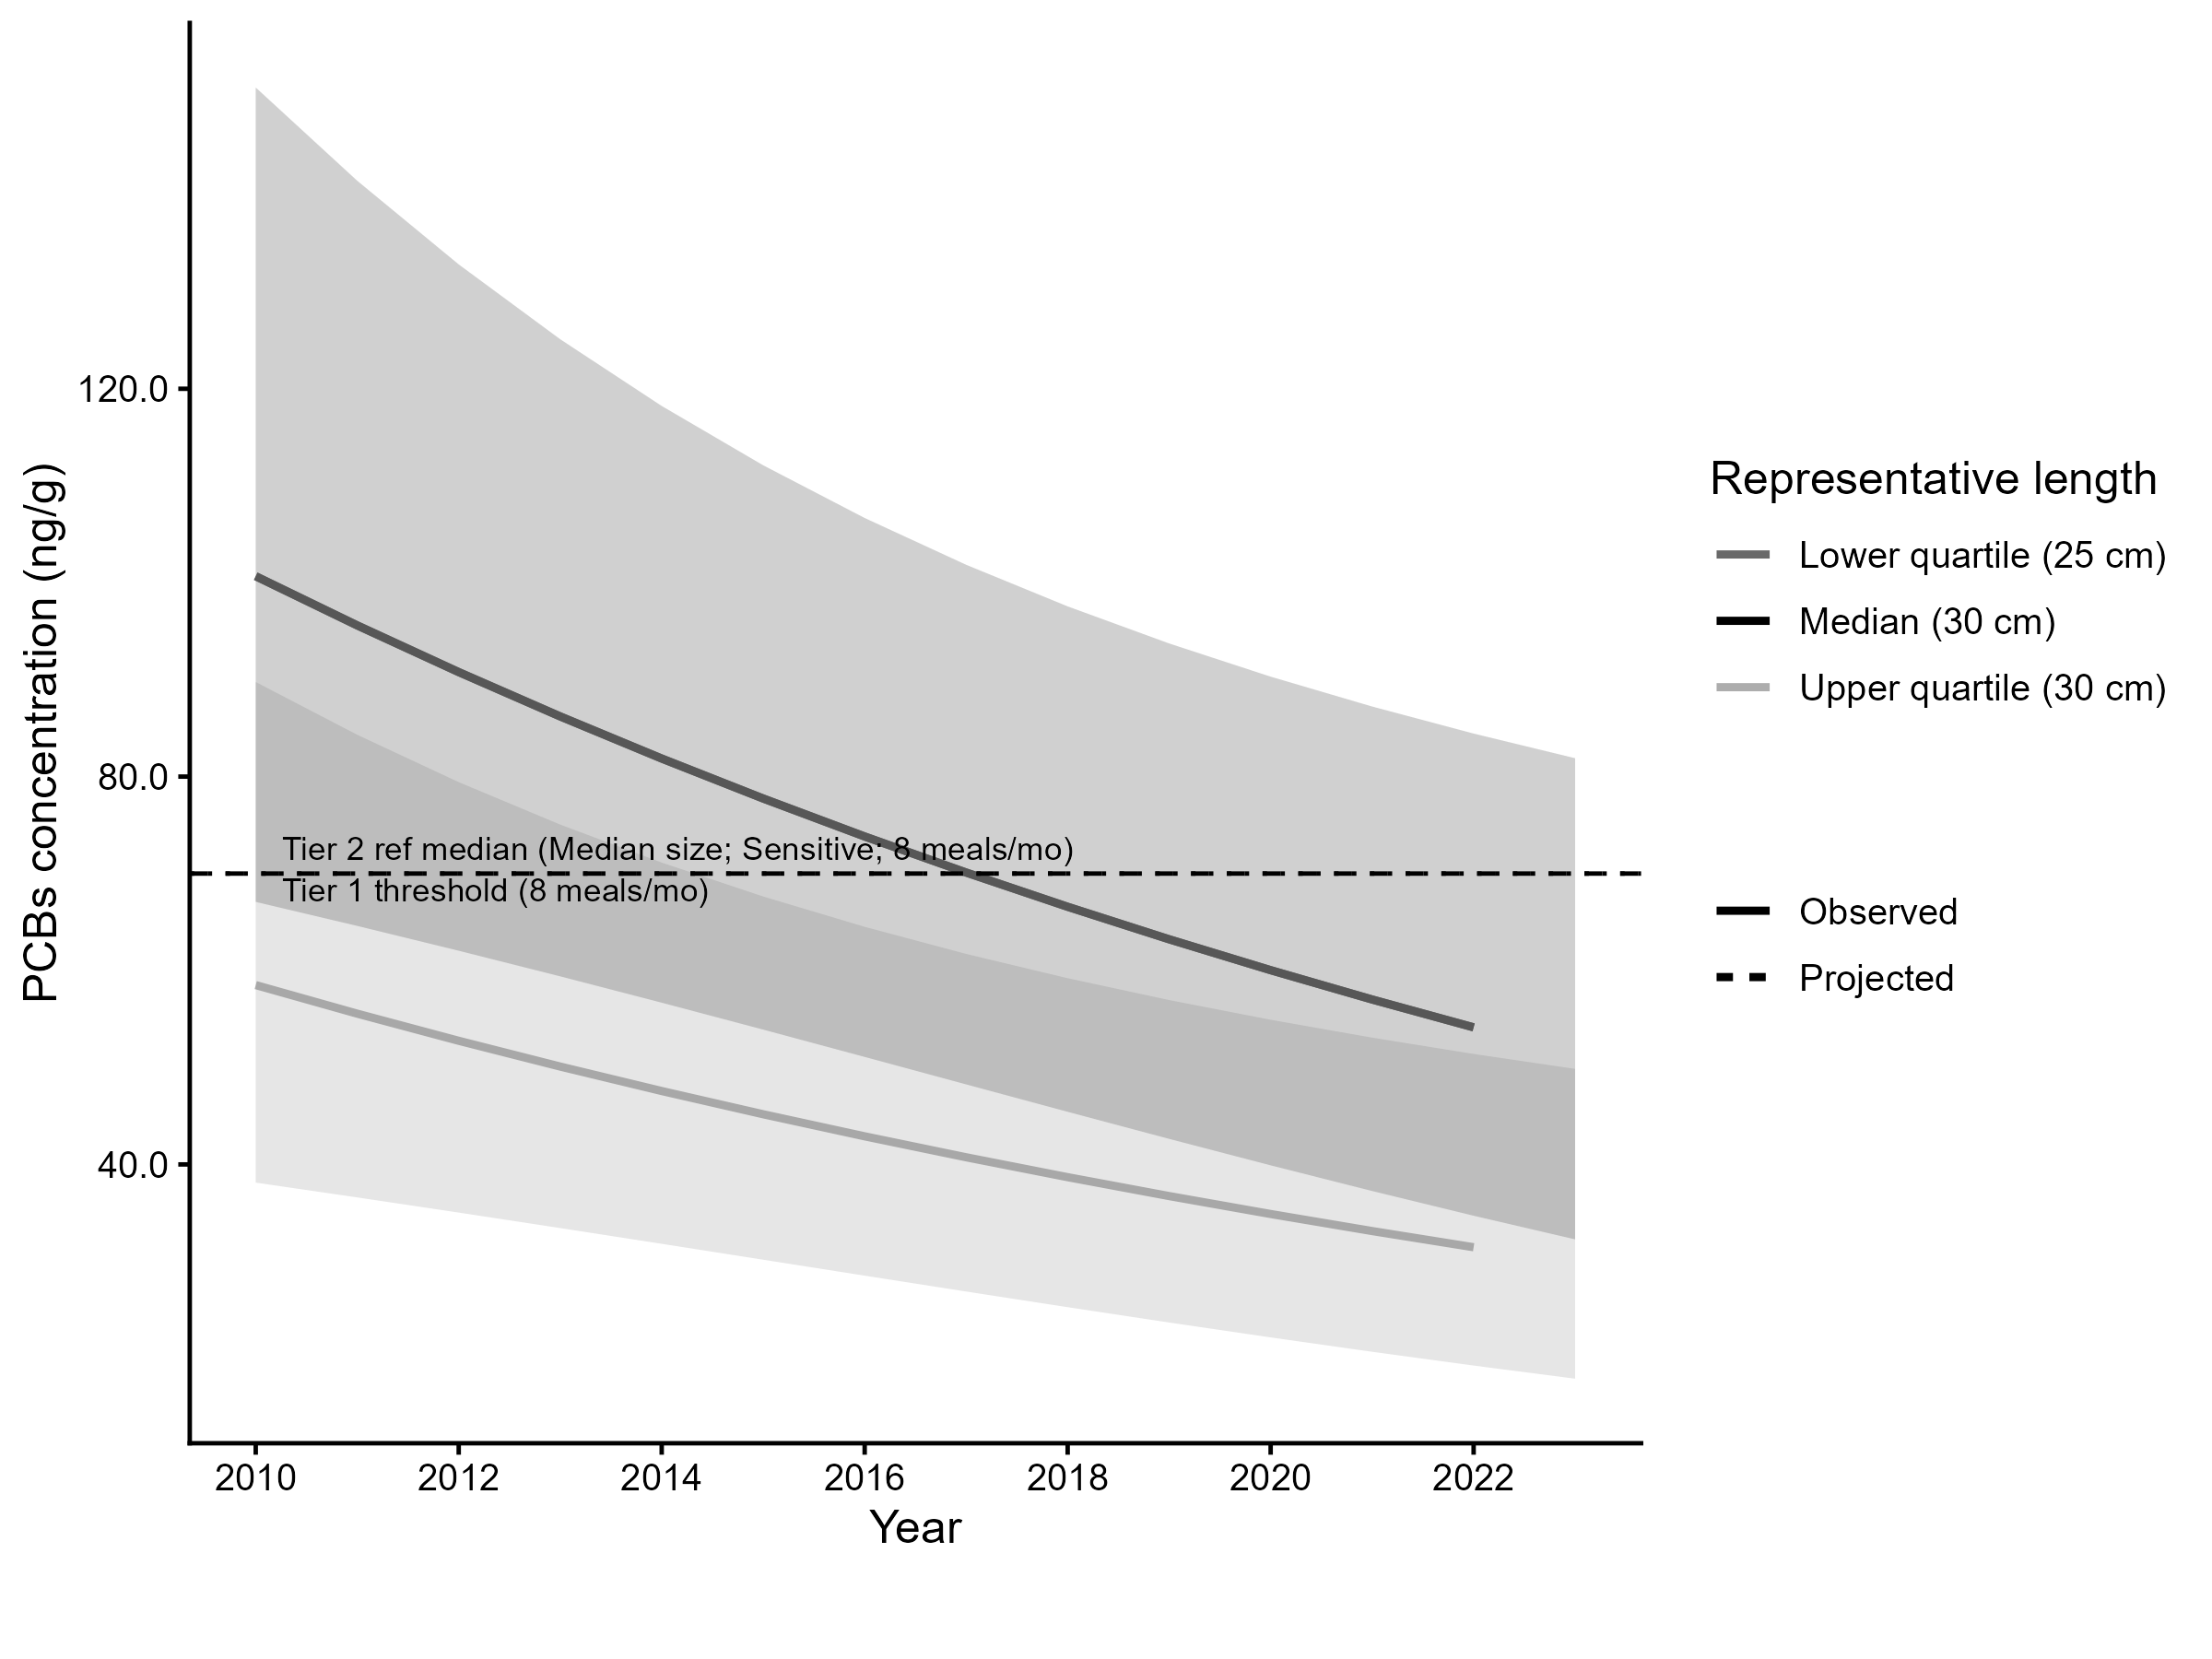
Figure 5.2: Projected PCB concentration in upper-quartile-length brown bullhead in the AOC. Predicted concentration is based on GAMM-derived half-life decay model. The solid line represents predicted values within the temporal range of observations, the dashed line represents projected future concentrations, ribbons show 95% CI, and the horizontal dotted line represents the unrestrictive PCB threshold for the sensitive population, based on community desired consumption rate and MECP advisory thresholds.
For upper-quartile-length (30 cm) fish, predicted concentrations are already within the unrestrictive advisory range for the Sensitive population (≥ 8 meals/month). Therefore, Tier 3C is considered supportive.
Tier 3C Overall Decision: Supportive

5.3.1.4 Summary
Tier 3 evidence lines indicate brown bullhead is not substantially more impaired due to PCBs in Trenton/Belleville Nearshore areas than the rest of the Bay of Quinte. While PCB concentrations remain higher than surrounding areas on average, the concentrations are not high enough to cause restrictive consumption advice. Therefore, measure 2 of the delisting criterion for BUI 1 can be said to be met.
Table 5.11: Summary of Tier 3 assessment results for measure 2 of brown bullhead (PCBs) in the Bay of Quinte Area of Concern.
Tier | Description | Metric | Outcome
Tier 3A | Virtual Advisory | General: 0/6 size bins restrictive or more restrictive than reference | Supportive
Tier 3B | Contaminant Concentration vs Reference | No significant difference in smooth terms (p = NA); AOC marginal mean higher than reference | Unsupportive
Tier 3C | Temporal Trends | 0/3 representative size groups (lower quartile, median, upper quartile) are restrictive based on time-to-threshold results. | Supportive

5.3.2 Dioxins/Furans

5.3.2.1 Tier 3A: Virtual Advisory
Tier 3A constructs virtual advisories for the contaminant of concern, and compares the values to the desired consumption rate, and reference values.
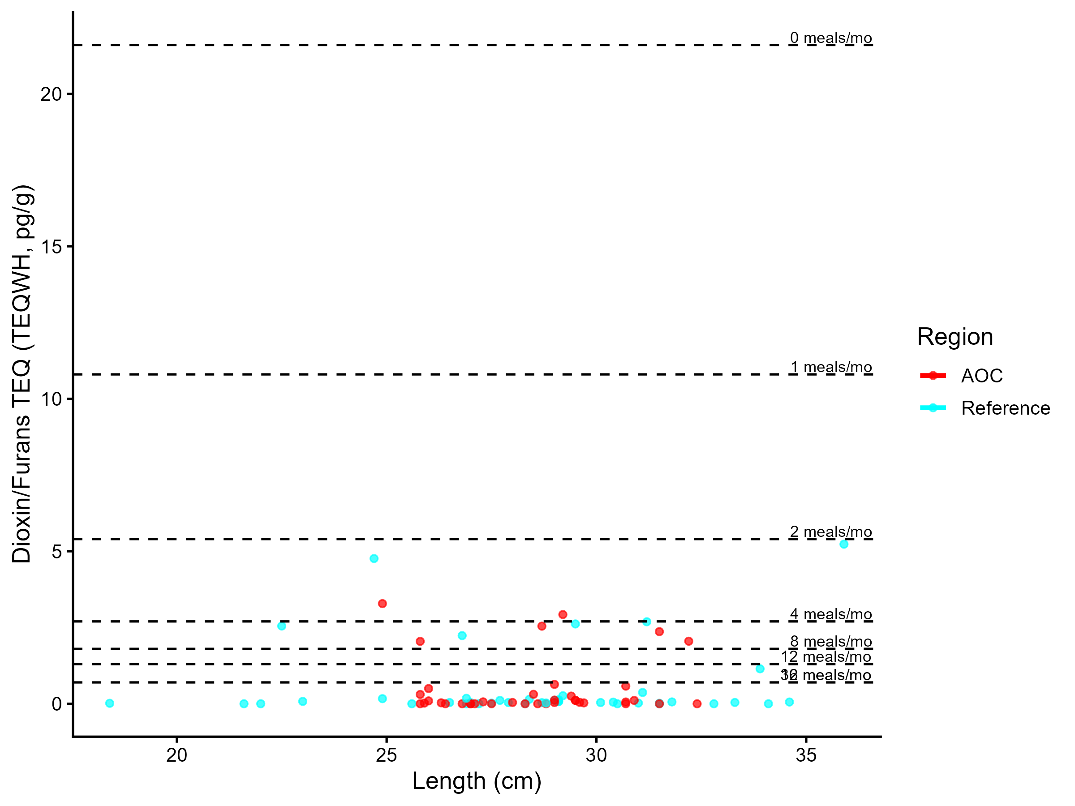
Figure 5.3: Virtual PCB advisories in brown bullhead. Predicted concentrations (curve) and observed values (points) by region using power regression model, compared to MECP advisory limits for PCB for the sensitive population (dashed lines).

Model Summary by Region
Reference: There is no significant relationship between fish length and contaminant concentration. Bin-level means were used instead. The power model used was: concentration = 0.00323 × Length1.128 (R² = 0.007, p = 6.45e-01).
AOC: There is no significant relationship between fish length and contaminant concentration. Bin-level means were used instead. The power model used was: concentration = 0.00434 × Length1.183 (R² = 0.003, p = 8.08e-01).
Table 5.12: Virtual advisory levels for PCB in brown bullhead across regions. Values represent meals/month recommendations. Red cells indicate restrictive virtual advisory below the desired consumption rate of 8 meals/month AND that of reference; green cells indicate unrestrictive virtual advisory equal to or above either the desired consumption rate or reference advisory.
Population | Region | 15-20 | 20-25 | 25-30 | 30-35 | 35-40 | 40-45
General | AOC | 16 | 4 | 32 | 16 | 16 | 16
General | Reference | 32 | 8 | 32 | 32 | 4 | 16
General population: Of 6 size bins, 1 were below the desired consumption rate of 8 meals/month. Of these, 1 were more restrictive than reference. Overall, Tier 3A assessment for brown bullhead is unsupportive.
Tier 3A Overall Decision: Unsupportive

5.3.2.2 Tier 3B: Contaminant Concentration, Nearshore vs. Bay of Quinte
Tier 3B compares the contaminant concentrations in target sites with that of reference sites using GAM models.

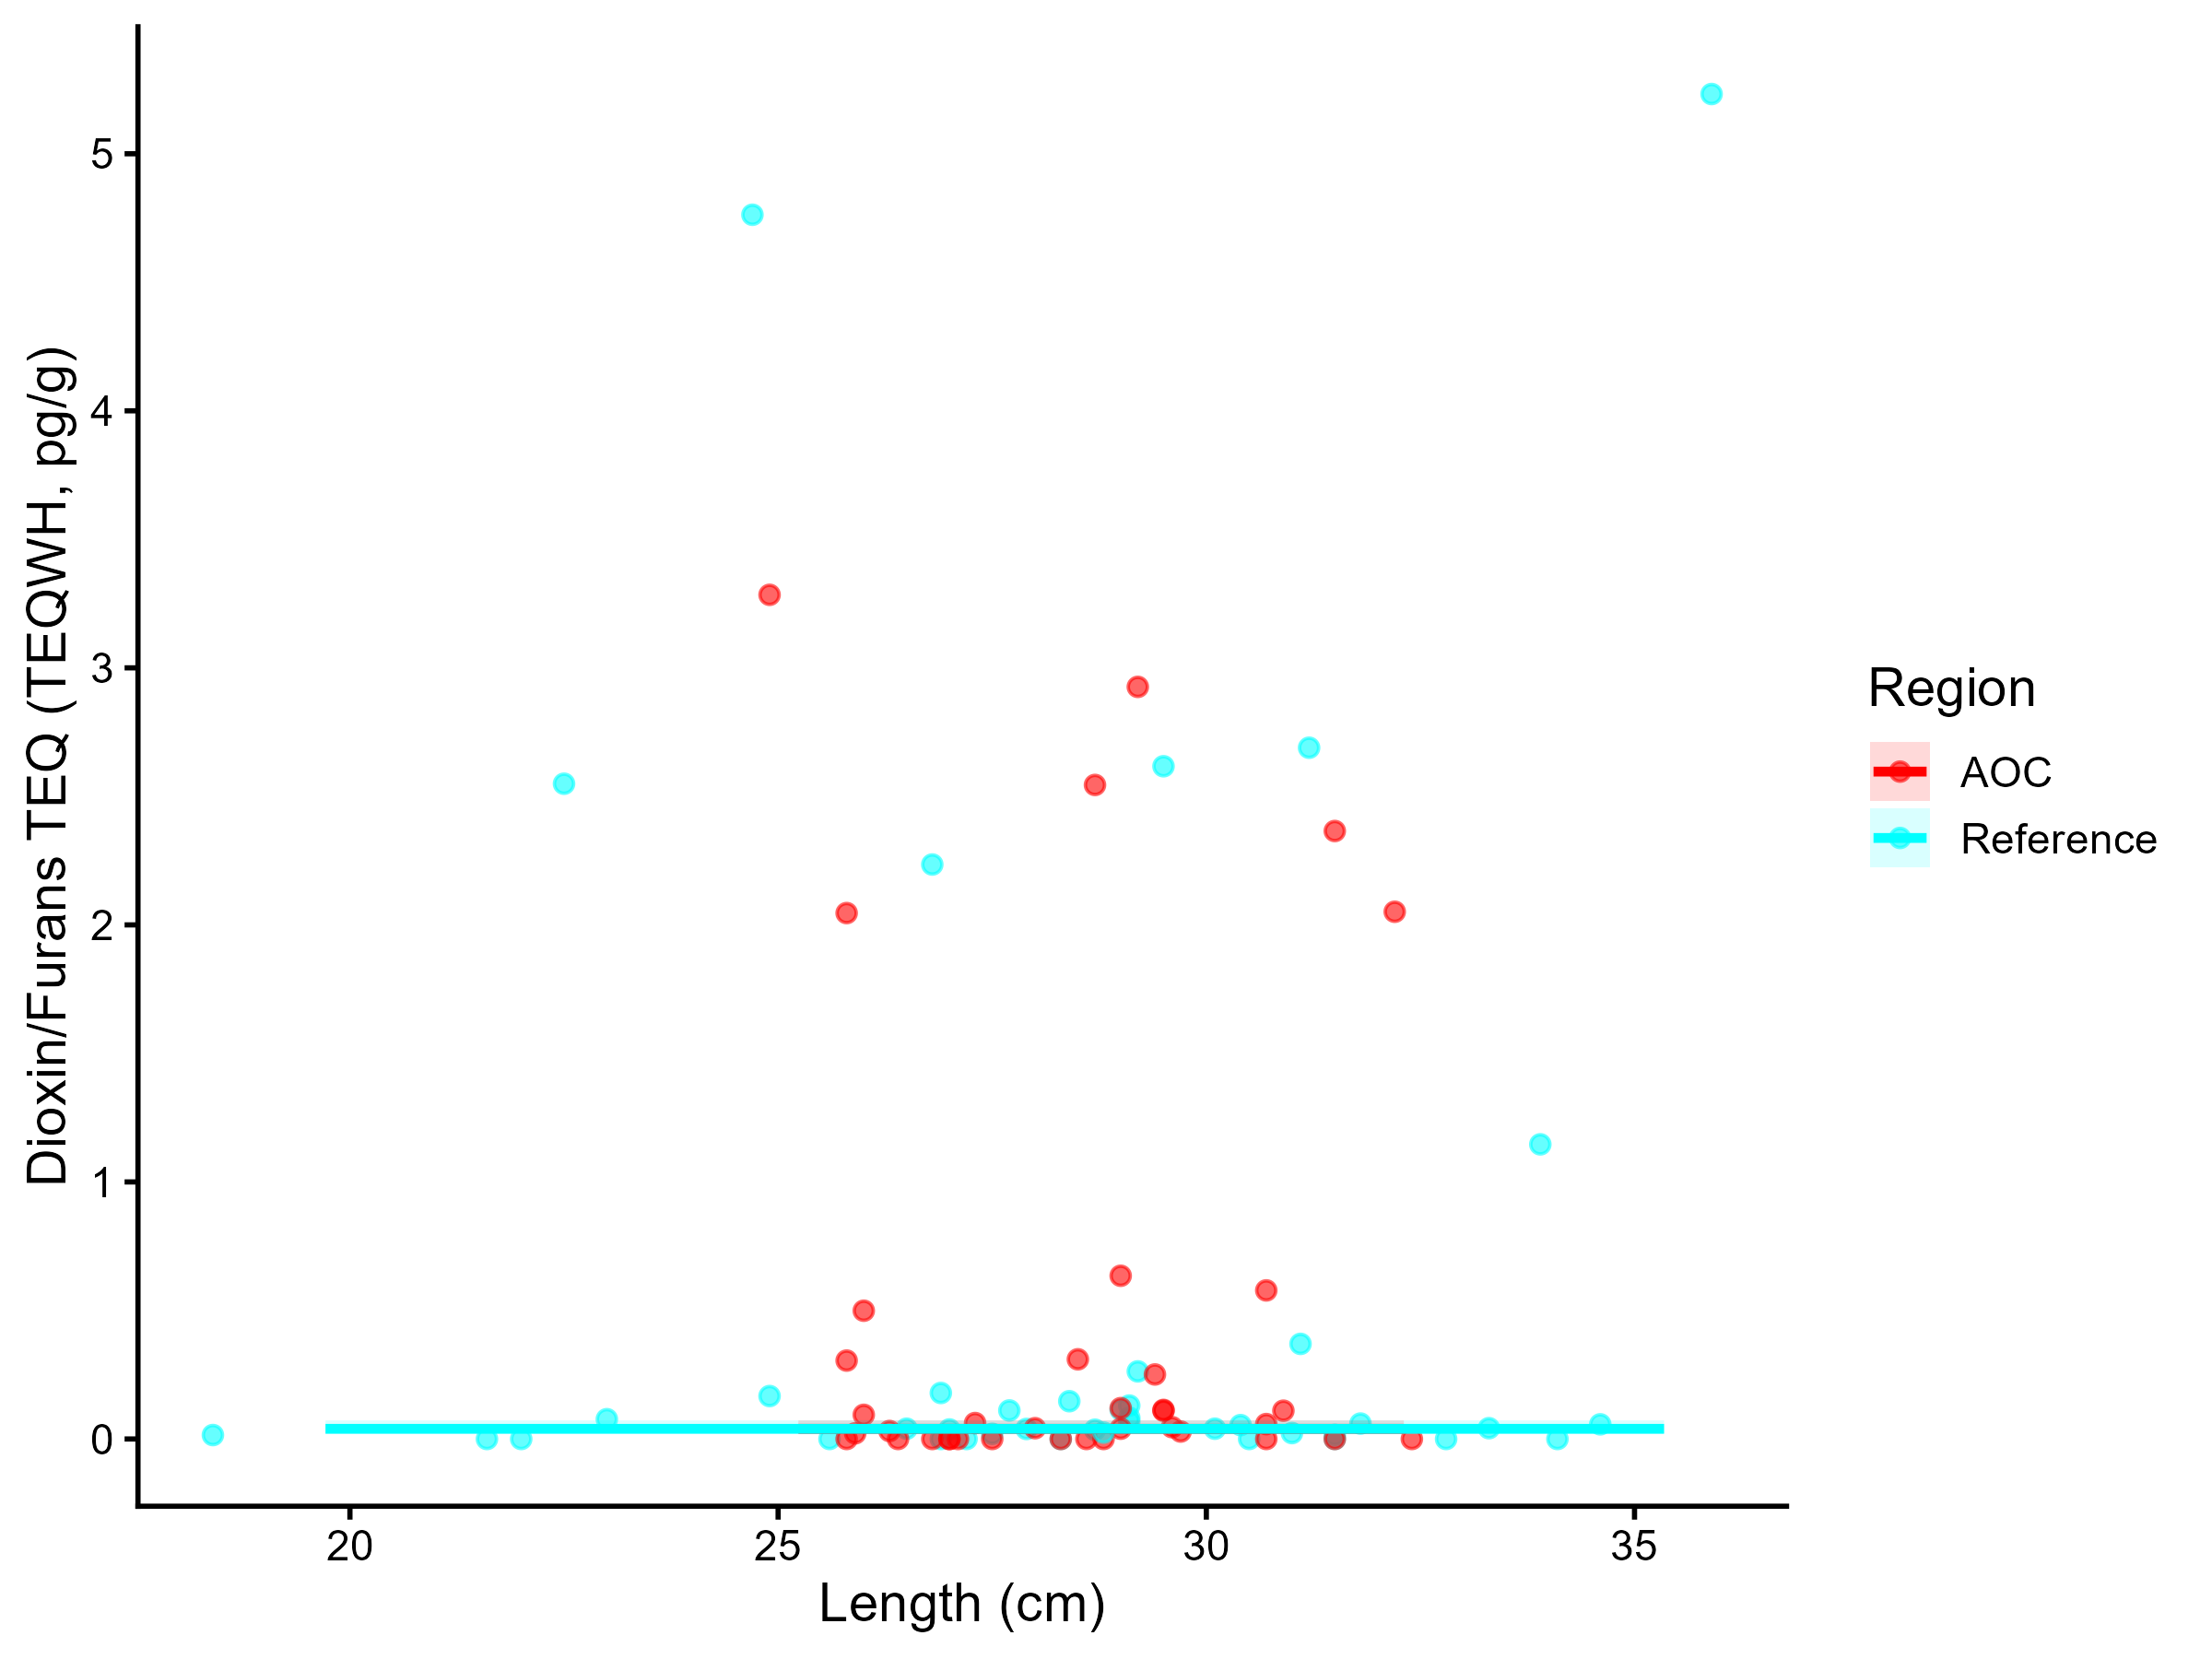
Figure 5.4: Dioxins/furans TEQ (TEQWH4, pg/g) concentration in brown bullhead by length in Trenton and Belleville nearshore sites compared to the rest of the Bay of Quinte. Points are observed contaminant values, curves represent GAM model fit (with random effects dropped for simplicity,), ribbons represent 95% confidence interval.

Generalized Additive Models (GAMs) were used to model the relationship between fish length and TEQWH4 concentrations for brown bullhead in the AOC and reference regions. The length-contaminant relationship did not differ significantly between sites (interaction test p = 0.692). Marginal mean concentrations were estimated across the full size distribution using a reduced model with shared smooths. The estimated marginal mean TEQWH4 concentration in the AOC was -3.33 pg/g (95% CI: -4.23–-2.43). Estimated values for reference site(s): Reference: -3.14 pg/g (95% CI: -4–-2.28).
Predicted PCB concentrations (µg/g) in Brown Bullhead, estimated using generalized additive models (GAMs) across the observed range of fish lengths where data is available for both groups. Values represent model-predicted means with 95% confidence intervals. Asterisks (*) indicate size classes where the AOC differs significantly (p < 0.05) from reference. Predicted PCB concentrations (µg/g) in Brown Bullhead, estimated using generalized additive models (GAMs) across the observed range of fish lengths where data is available for both groups. Values represent model-predicted means with 95% confidence intervals. Asterisks (*) indicate size classes where the AOC differs significantly (p < 0.05) from reference.
The AOC does not exceed reference in marginal mean concentration, suggesting comparable contamination levels in this species. Therefore, Tier 3B analysis of brown bullhead is considered supportive for redesignation.
Tier 3B Overall Decision: Supportive

5.3.2.3 Tier 3C: Temporal Projections of Contaminant Concentrations
Tier 3C uses GAMM models to indicate whether contaminant concentrations are increasing, stable, or declining over time, and predicts the amount of time to reach an unrestrictive consumption threshold in the future.

Table 5.13: Estimated time to unrestrictive PCB threshold for median, upper-quartile, and lower-quartile-sized brown bullhead in the AOC, using GAMM-derived half-life decay model. The model-predicted concentration of representative-length fish is reported for the most recent year of observation, and the target concentration corresponding to the earliest of either Tier 1 or Tier 2 thresholds. Tier 1 thresholds representative an “unrestrictive” advisory for the Sensitive population of 8, based on survey results and MECP advisory thresholds. Tier 2 thresholds are size-matched Sensitive reference medians.
Representative group | Length (cm) | Predicted Conc. (Current Year) | Desired Consumption Rate | Tier 1 threshold conc. | Tier 2 median (Sensitive) meals/mo | Tier 2 Threshold conc. | Target Threshold (earliest) | Years to Threshold | 95% CI | Outcome
Lower quartile | 25 | 5.54 | 8 | 1.80 | 16 | 0.70 | 1.80 | — | — | Unsupportive
Median | 30 | 6.65 | 8 | 1.80 | 8 | 1.80 | 1.80 | — | — | Unsupportive
Upper quartile | 30 | 6.65 | 8 | 1.80 | 8 | 1.80 | 1.80 | — | — | Unsupportive

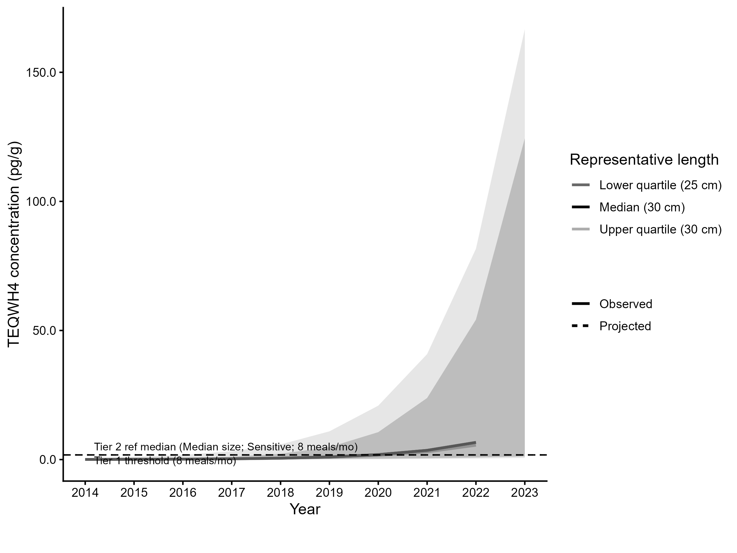
Figure 5.5: Projected dioxins/furans TEQ (TEQWH4, pg/g) concentration in lower, median, and upper-quartile-length brown bullhead in the Trenton/Belleville nearshore sites. Predicted concentration is based on GAMM-derived half-life decay model. The solid line represents predicted values within the temporal range of observations, the dashed line represents projected future concentrations, ribbons show 95% CI, and the horizontal dotted line represents the unrestrictive dioxin/furan threshold for the sensitive population, based on community desired consumption rate and MECP advisory thresholds.
For upper-quartile length (30 cm) fish, the current trend does not indicate declining dioxins/furan concentrations. Under the present trend, reaching an unrestrictive monthly meal allowance of 8 meals/month for the Sensitive population is not expected. Therefore, Tier 3C is considered unsupportive.
However, the increasing trend is driven by a small number of samples collected in 2022 and 2023 which have elevated TEQWH4 values than those from previous years. In total, all 3 samples from the Belleville nearshore site, all 3 samples from the Trenton nearshore site, and all 6 samples from the rest of the Bay of Quinte collected in 2022 and 2023 have TEQWH4 values above 2 pg/g, whereas most other samples collected between 2005 and 2019 are below 0.5 pg/g TEQWH4, with many below detection limits. It is therefore worth investigating whether these high TEQWH4 values are due to analytical errors or represent a sudden increase in dioxins/furans in the Bay of Quinte.
Tier 3C Overall Decision: Unsupportive

5.3.2.4 Summary
Table 5.14: Summary of tier 3 results for measure 2 of brown bullhead (dioxins/furans) in the Bay of Quinte AOC.
Tier | Description | Metric | Outcome
Tier 3A | Virtual Advisory | General: 1/6 size bins restrictive or more restrictive than reference | Supportive
Tier 3B | Contaminant Concentration vs Reference | No significant difference in smooth terms (p = 0.692); AOC marginal mean not higher than reference | Supportive
Tier 3C | Temporal Trends | 3/3 representative size groups (lower quartile, median, upper quartile) are restrictive based on time-to-threshold results. | Unsupportive

5.4 Measure 2 Summary
Analysis of measure 2 in the Bay of Quinte AOC reveals that, while PCB concentrations are significantly higher in brown bullhead in Trenton and Belleville nearshore areas, the concentrations are not driving restrictive consumption advisories in the areas. However, tier 3 evidence lines cannot conclude whether brown bullhead is substantially more impaired due to dioxins/furans in Trenton/Belleville Nearshore areas than the rest of the Bay of Quinte. Data from 2005-2019 suggest that dioxin/furan concentrations are not significantly higher in the nearshore areas than the rest of the Bay, recent samples collected in 2022/2023 indicate a sudden and substantial increase in dioxins/furans throughout the Bay of Quinte. Temporal modelling suggests that, due to this recent increase, dioxin/furan TEQ concentrations are have risen above the threshold corresponding with restrictive consumption advisories. This may be why currently issued consumption advisories are restrictive for brown bullhead in the Trenton and Belleville nearshore areas (Tables 5.5 and 5.7). Therefore, it is recommended that these recent TEQWH4 values are investigated further to determine if they are due to anomalies in analysis or if they are true reflections in current dioxin/furan contamination in nearshore brown bullhead.

6 Discussion and Recommendations

References
Bhavsar, S. 2016. Assessment of Fish Consumption Beneficial Use Impairment (BUI) at the Toronto and Region Area of Concern.
Bhavsar, S., K. G. Drouillard, R. W. K. Tang, L. Matos, and M. Neff. 2018. Assessing fish consumption Beneficial Use Impairment at Great Lakes Areas of Concern: Toronto case study. Aquatic Ecosystem Health & Management 21:318–330.
Drouillard, K. G. 2022. Toronto & Region BUI #1 Assessment Draft Report.
Drouillard, K. G. 2023. Final Report Detroit River AOC BUI #1 Assessment.
IJC. 1991, March. Commission Approves List/Delist Criteria for Great Lakes Areas of Concern.

Appendix

7 Tier 3 Supplementary Figures for Bay of Quinte AOC

7.0.1 Walleye
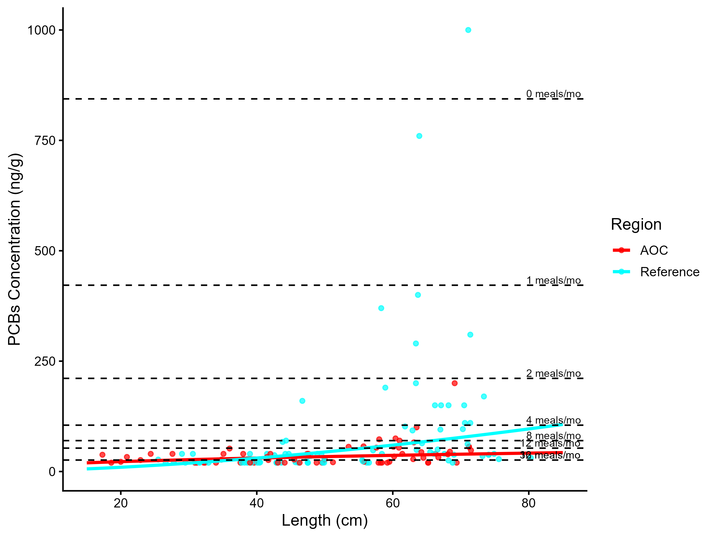
Figure 7.1: Virtual PCB advisories in walleye. Predicted concentrations (curve) and observed values (points) by region using power regression model, compared to MECP advisory limits for PCB for the Sensititve population (dashed lines).
Table 7.1: Virtual advisory levels for PCB in walleye across regions. Values represent meals/month recommendations. Red cells indicate restrictive virtual advisory below the desired consumption rate of 32 meals/month AND that of reference; green cells indicate unrestrictive virtual advisory equal to or above either the desired consumption rate or reference advisory.
Population | Region | 15-20 | 20-25 | 25-30 | 30-35 | 35-40 | 40-45 | 45-50 | 50-55 | 55-60 | 60-65 | 65-70 | 70-75 | 75+
General | AOC | 32 | 32 | 32 | 16 | 16 | 16 | 16 | 16 | 16 | 16 | 16 | 16 | 16
General | Reference | 32 | 32 | 32 | 32 | 16 | 16 | 16 | 16 | 12 | 12 | 8 | 8 | 8

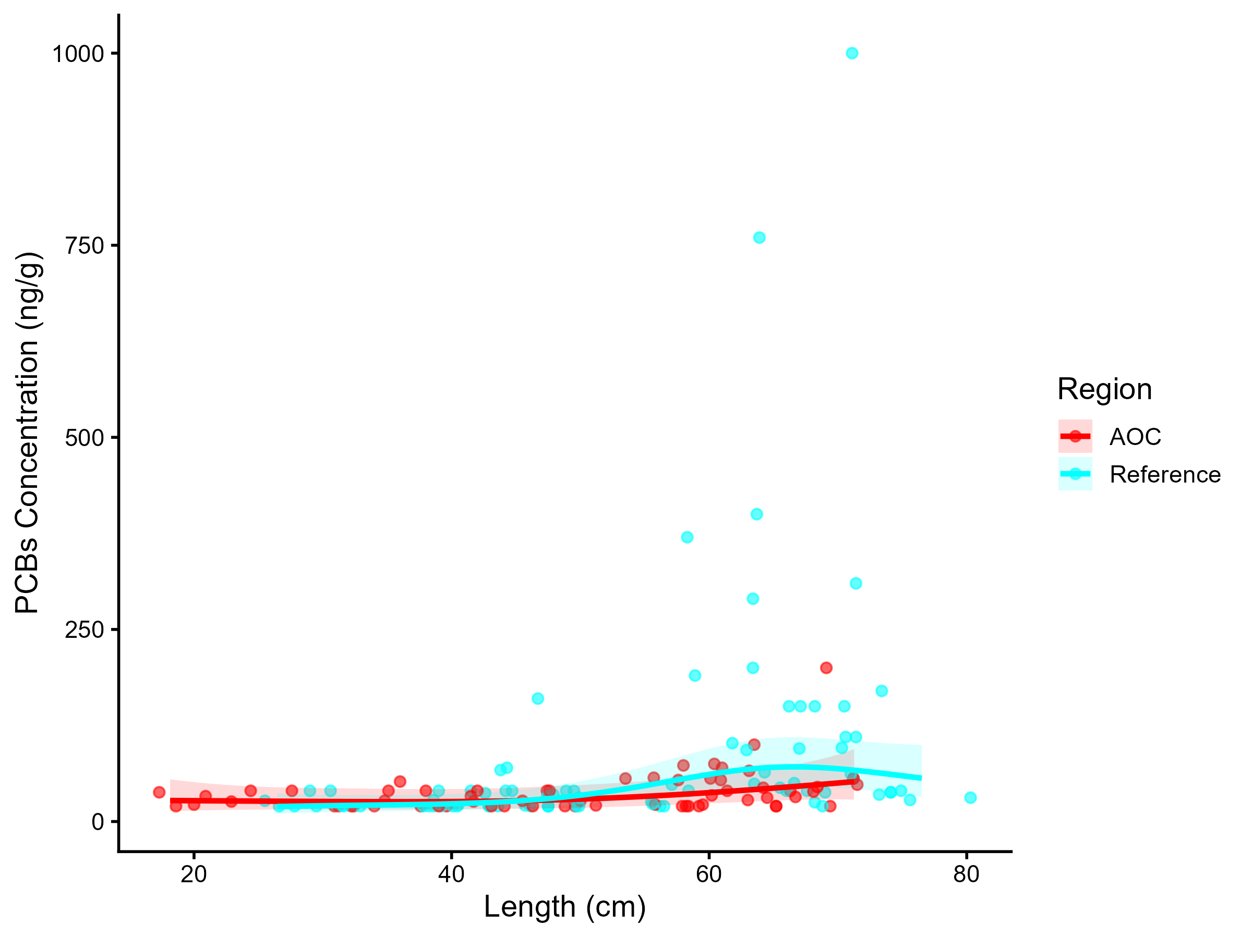
Figure 7.2: PCBs concentration in Walleye by length in the AOC compared to reference sites. Points are observed contaminant values, curves represent GAM model fit (with random effects dropped for simplicity, fitted across the 1st to 99th percentile of data to ensure reasonable support), riwalons represent 95% confidence interval.

Table 7.2: Estimated time to unrestrictive PCB threshold for an upper-quartile-sized walleye in the AOC, using GAMM-derived half-life decay model. The model-predicted concentration of an upper-quartile length fish is reported for the most recent year of observation, and the target concentration corresponding to an "unrestrictive" advisory for the Sensitive population of 32, based on survey results and MECP advisory thresholds.
Representative group | Length (cm) | Predicted Conc. (Current Year) | Desired Consumption Rate | Tier 1 threshold conc. | Tier 2 median (Sensitive) meals/mo | Tier 2 Threshold conc. | Target Threshold (earliest) | Years to Threshold | 95% CI | Outcome
Lower quartile | 40 | 15.44 | 8 | 70.00 | 8 | 70.00 | 70.00 | 0.0 | -7.0–7.0 | Supportive
Median | 50 | 22.55 | 8 | 70.00 | 4 | 105.00 | 105.00 | 0.0 | -7.0–7.0 | Supportive
Upper quartile | 60 | 34.27 | 8 | 70.00 | 0 | 844.00 | 844.00 | 0.0 | -6.9–6.9 | Supportive

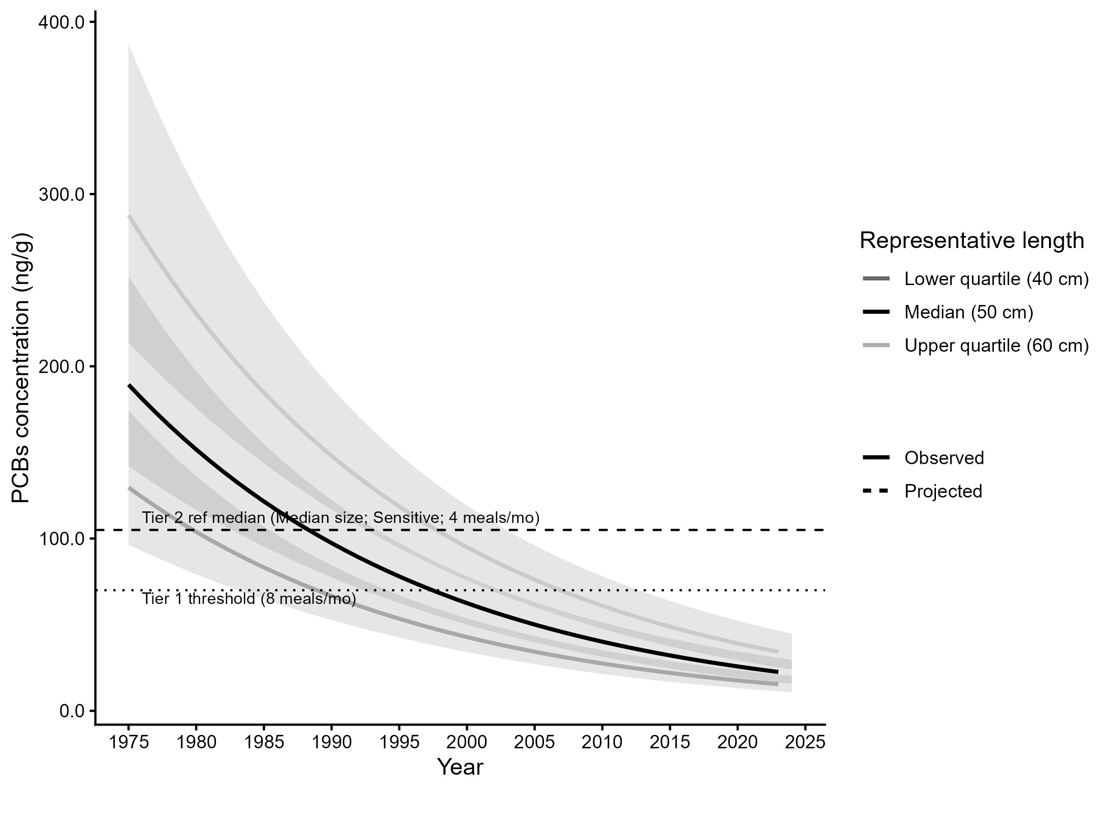
Figure 7.3: Projected PCBs concentration in upper-quartile-length Walleye in the AOC. Predicted concentration is based on GAMM-derived half-life decay model. The solid line represents predicted values within the temporal range of observations, the dashed line represents projected future concentrations, riwalons show 95% CI, and the horizontal dotted line represents the unrestrictive PCBs threshold for the sensitive population, based on community desired consumption rate and MECP advisory thresholds.

7.0.2 Lake Whitefish
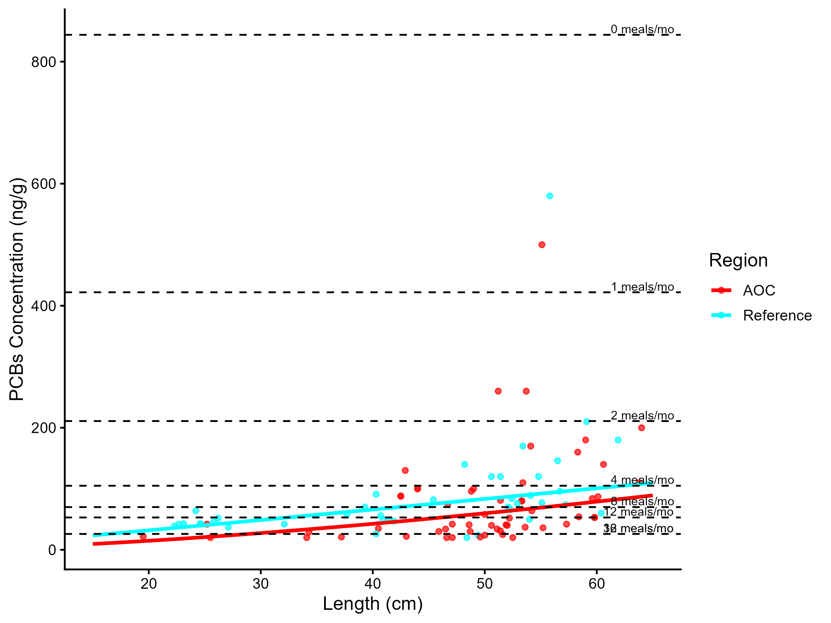
Figure 7.4: Virtual PCB advisories in lake whitefish. Predicted concentrations (curve) and observed values (points) by region using power regression model, compared to MECP advisory limits for PCB for the Sensititve population (dashed lines).
Table 7.3: Virtual advisory levels for PCB in lake whitefish across regions. Values represent meals/month recommendations. Red cells indicate restrictive virtual advisory below the desired consumption rate of 8 meals/month AND that of reference; green cells indicate unrestrictive virtual advisory equal to or above either the desired consumption rate or reference advisory.
Population | Region | 15-20 | 20-25 | 25-30 | 30-35 | 35-40 | 40-45 | 45-50 | 50-55 | 55-60 | 60-65 | 65-70
General | AOC | 32 | 32 | 32 | 16 | 16 | 16 | 12 | 12 | 8 | 8 | 8
General | Reference | 16 | 16 | 16 | 16 | 12 | 12 | 8 | 8 | 8 | 8 | 4

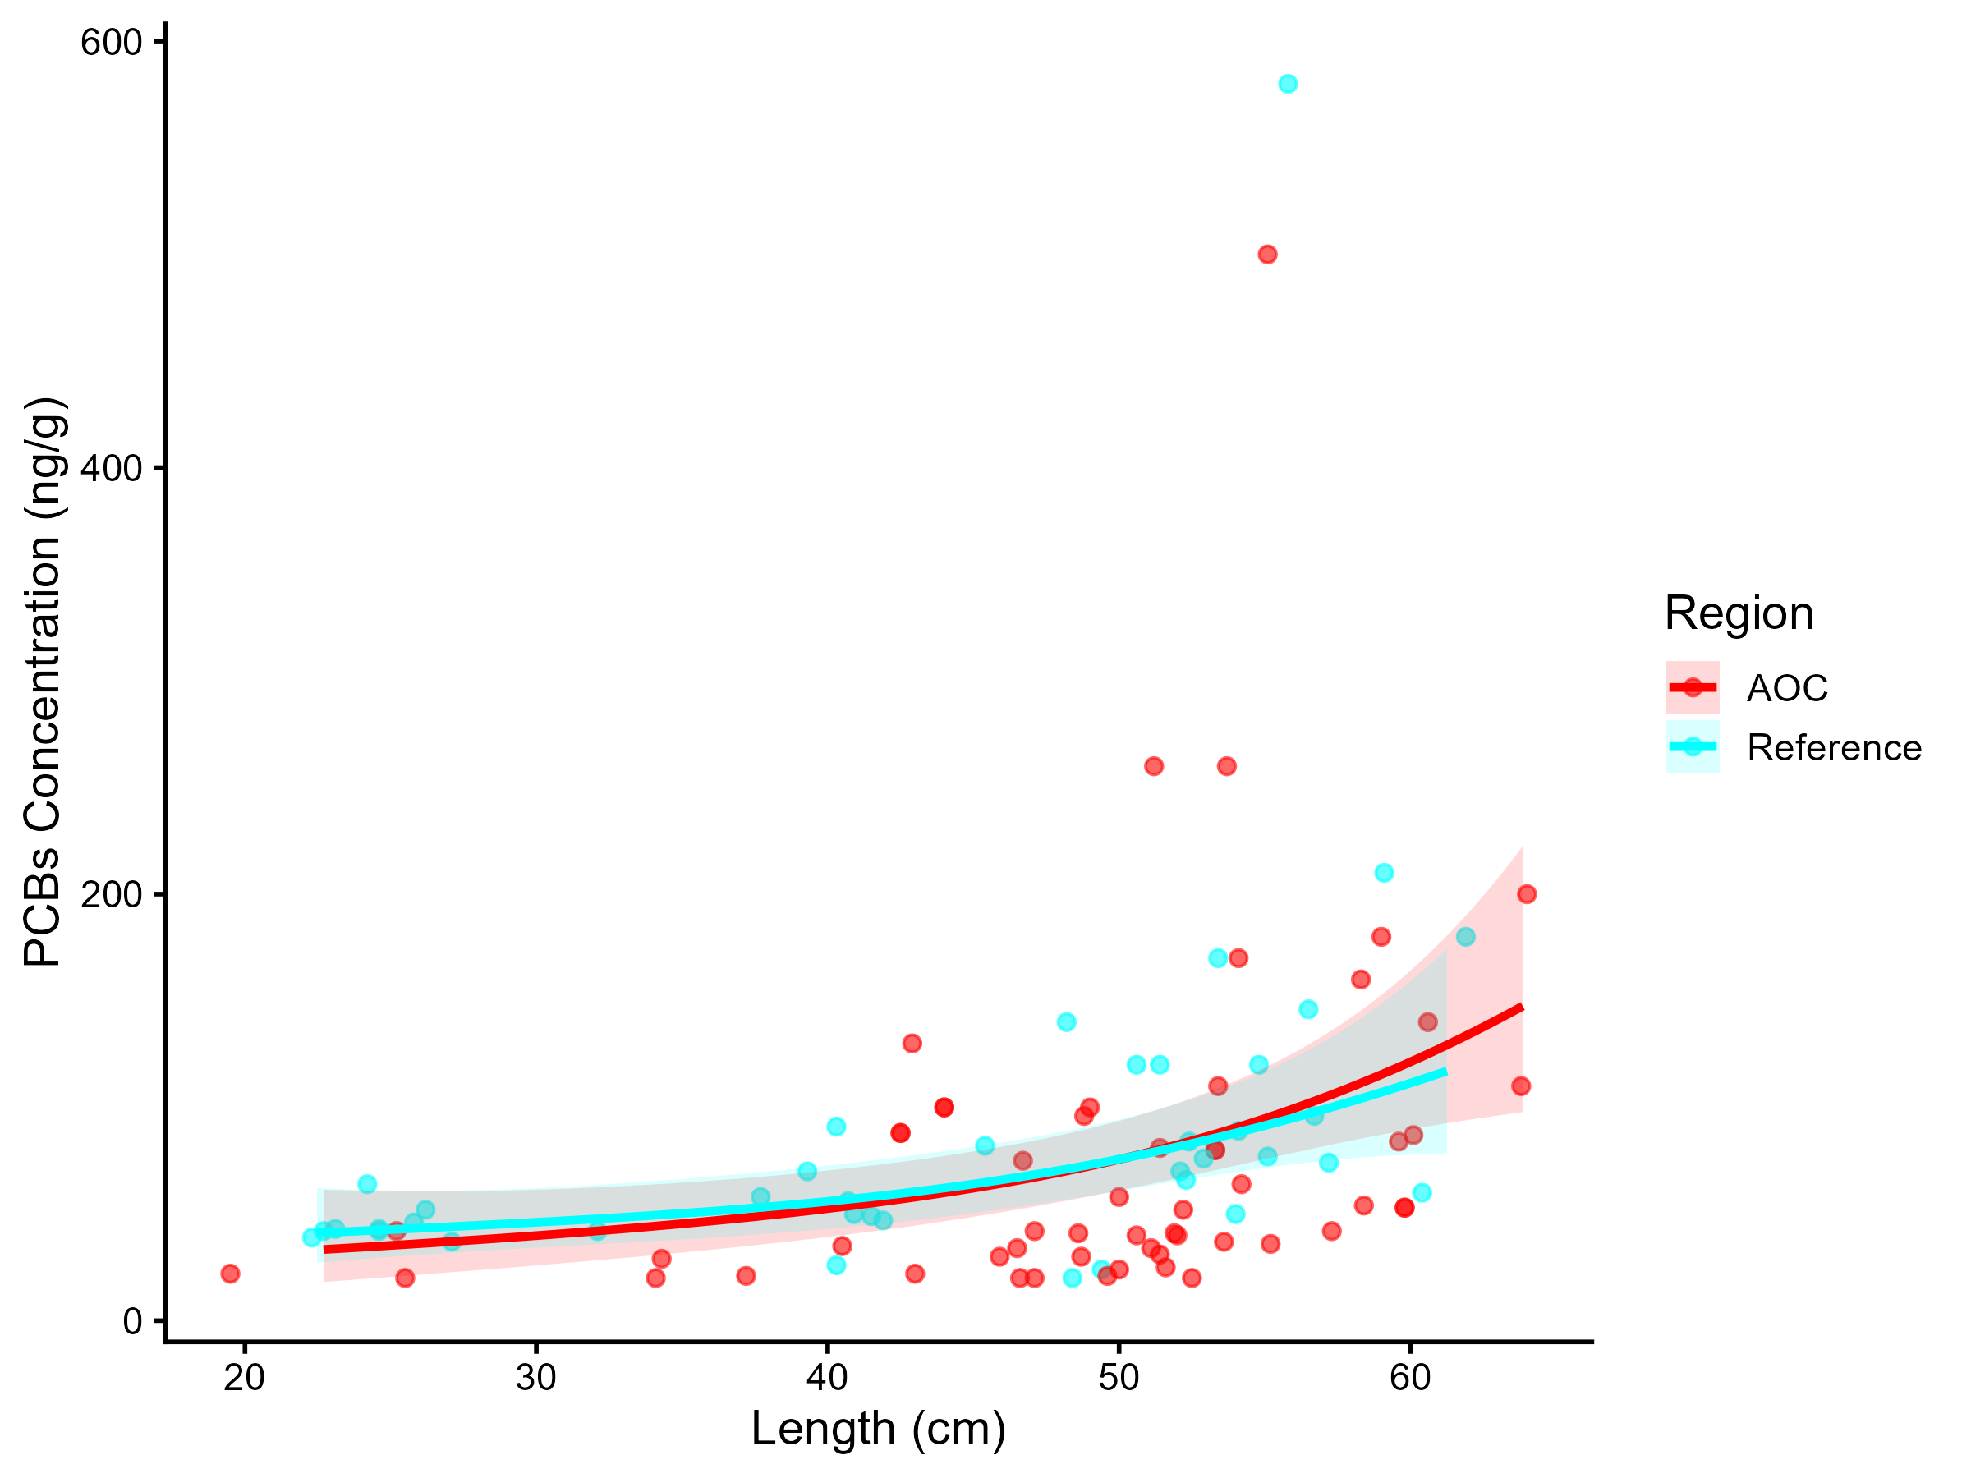
Figure 7.5: PCBs concentration in Lake Whitefish by length in the AOC compared to reference sites. Points are observed contaminant values, curves represent GAM model fit (with random effects dropped for simplicity, fitted across the 1st to 99th percentile of data to ensure reasonable support), rilwons represent 95% confidence interval.

Table 7.4: Estimated time to unrestrictive PCB threshold for an upper-quartile-sized lake whitefish in the AOC, using GAMM-derived half-life decay model. The model-predicted concentration of an upper-quartile length fish is reported for the most recent year of observation, and the target concentration corresponding to an "unrestrictive" advisory for the Sensitive population of 8, based on survey results and MECP advisory thresholds.
Representative group | Length (cm) | Predicted Conc. (Current Year) | Desired Consumption Rate | Tier 1 threshold conc. | Tier 2 median (Sensitive) meals/mo | Tier 2 Threshold conc. | Target Threshold (earliest) | Years to Threshold | 95% CI | Outcome
Lower quartile | 45 | 32.84 | 8 | 70.00 | — | — | 70.00 | 0.0 | -5.5–5.5 | Supportive
Median | 50 | 41.82 | 8 | 70.00 | — | — | 70.00 | 0.0 | -5.4–5.4 | Supportive
Upper quartile | 55 | 53.25 | 8 | 70.00 | — | — | 70.00 | 0.0 | -5.5–5.5 | Supportive

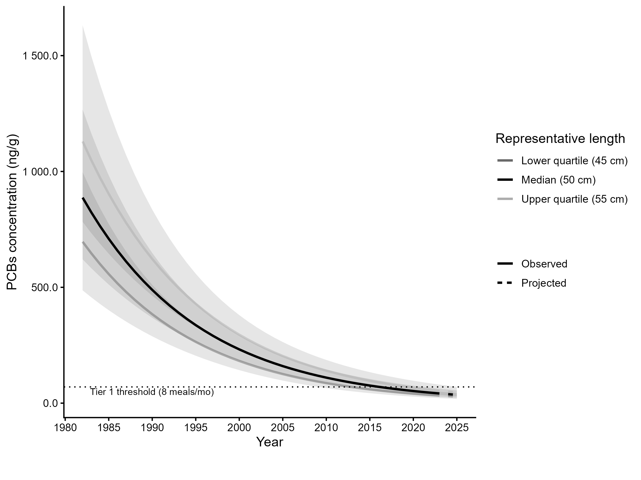
Figure 7.6: Projected PCBs concentration in upper-quartile-length Lake Whitefish in the AOC. Predicted concentration is based on GAMM-derived half-life decay model. The solid line represents predicted values within the temporal range of observations, the dashed line represents projected future concentrations, ribbons show 95% CI, and the horizontal dotted line represents the unrestrictive PCBs threshold for the sensitive population, based on community desired consumption rate and MECP advisory thresholds.

7.0.3 Northern Pike
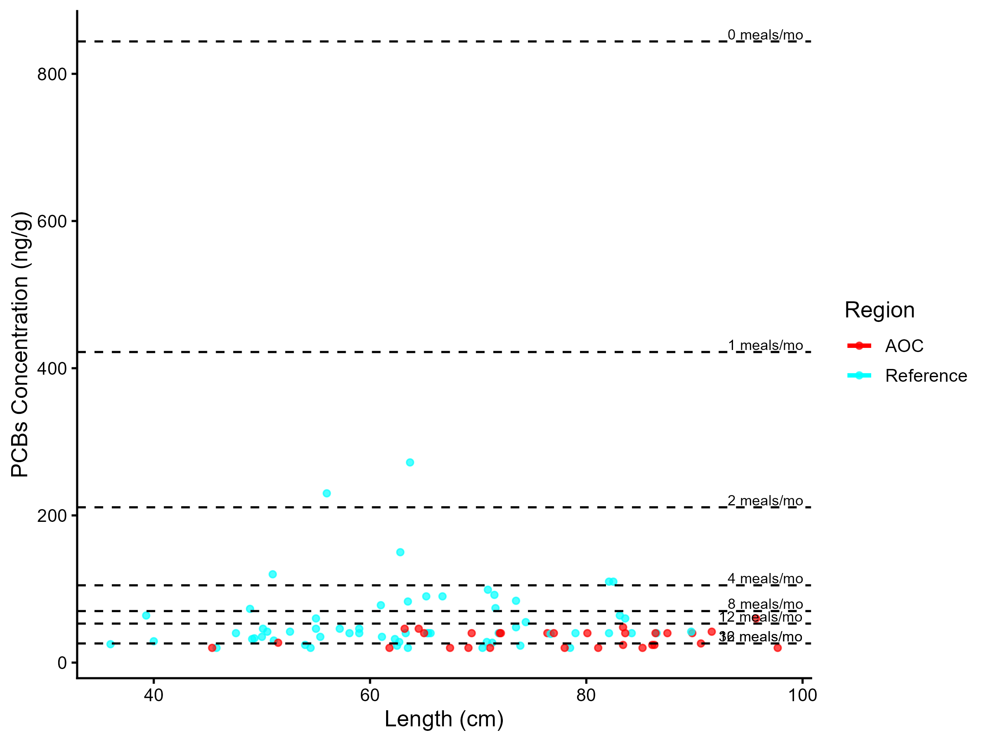
Figure 7.7: Virtual PCB advisories in northern pike. Predicted concentrations (curve) and observed values (points) by region using power regression model, compared to MECP advisory limits for PCB for the Sensititve population (dashed lines).
Table 7.5: Virtual advisory levels for PCB in northern pike across regions. Values represent meals/month recommendations. Red cells indicate restrictive virtual advisory below the desired consumption rate of 4 meals/month AND that of reference; green cells indicate unrestrictive virtual advisory equal to or above either the desired consumption rate or reference advisory.
Population | Region | 35-40 | 40-45 | 45-50 | 50-55 | 55-60 | 60-65 | 65-70 | 70-75 | 75+
General | AOC | 16 | 16 | 32 | 16 | 16 | 16 | 16 | 16 | 16
General | Reference | 16 | 16 | 16 | 16 | 12 | 8 | 12 | 12 | 16

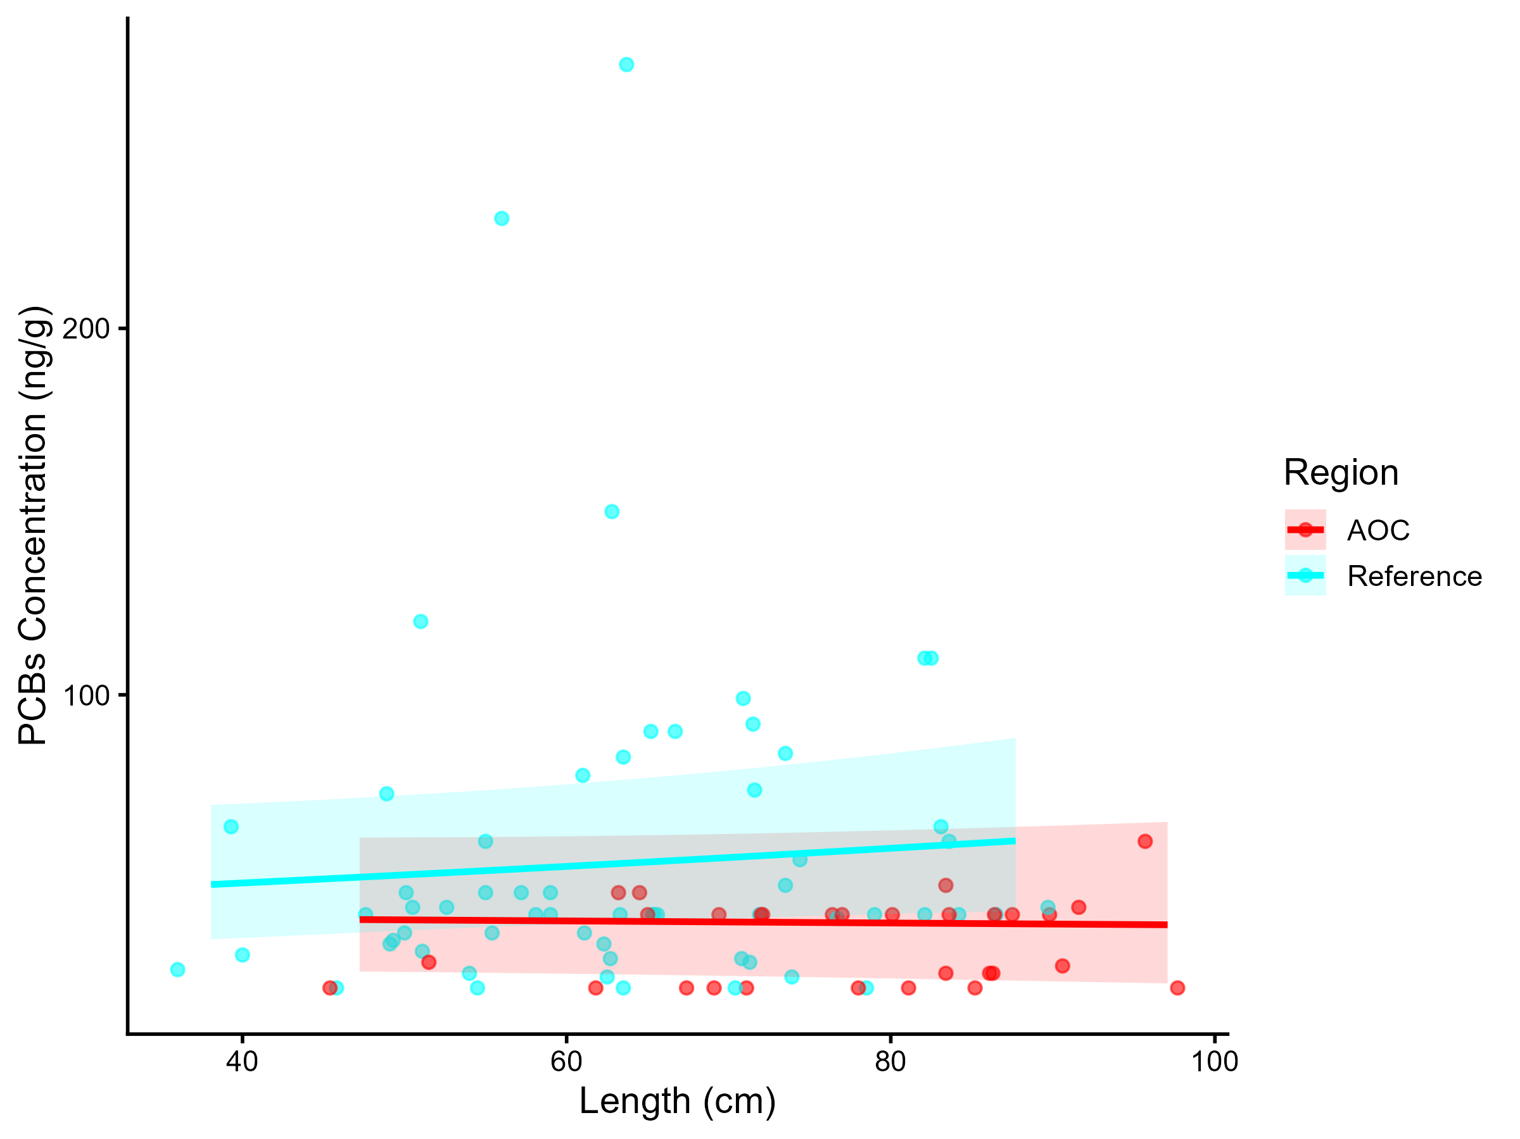
Figure 7.8: PCBs concentration in Northern Pike by length in the AOC compared to reference sites. Points are observed contaminant values, curves represent GAM model fit (with random effects dropped for simplicity, fitted across the 1st to 99th percentile of data to ensure reasonable support), ribbons represent 95% confidence interval.

Table 7.6: Estimated time to unrestrictive PCB threshold for an upper-quartile-sized northern pike in the AOC, using GAMM-derived half-life decay model. The model-predicted concentration of an upper-quartile length fish is reported for the most recent year of observation, and the target concentration corresponding to an "unrestrictive" advisory for the Sensitive population of 4, based on survey results and MECP advisory thresholds.
Representative group | Length (cm) | Predicted Conc. (Current Year) | Desired Consumption Rate | Tier 1 threshold conc. | Tier 2 median (Sensitive) meals/mo | Tier 2 Threshold conc. | Target Threshold (earliest) | Years to Threshold | 95% CI | Outcome
Lower quartile | 65 | 12.26 | 8 | 70.00 | 4 | 105.00 | 105.00 | 0.0 | -10.7–10.7 | Supportive
Median | 75 | 12.17 | 8 | 70.00 | 4 | 105.00 | 105.00 | 0.0 | -10.7–10.7 | Supportive
Upper quartile | 80 | 12.13 | 8 | 70.00 | 4 | 105.00 | 105.00 | 0.0 | -10.7–10.7 | Supportive

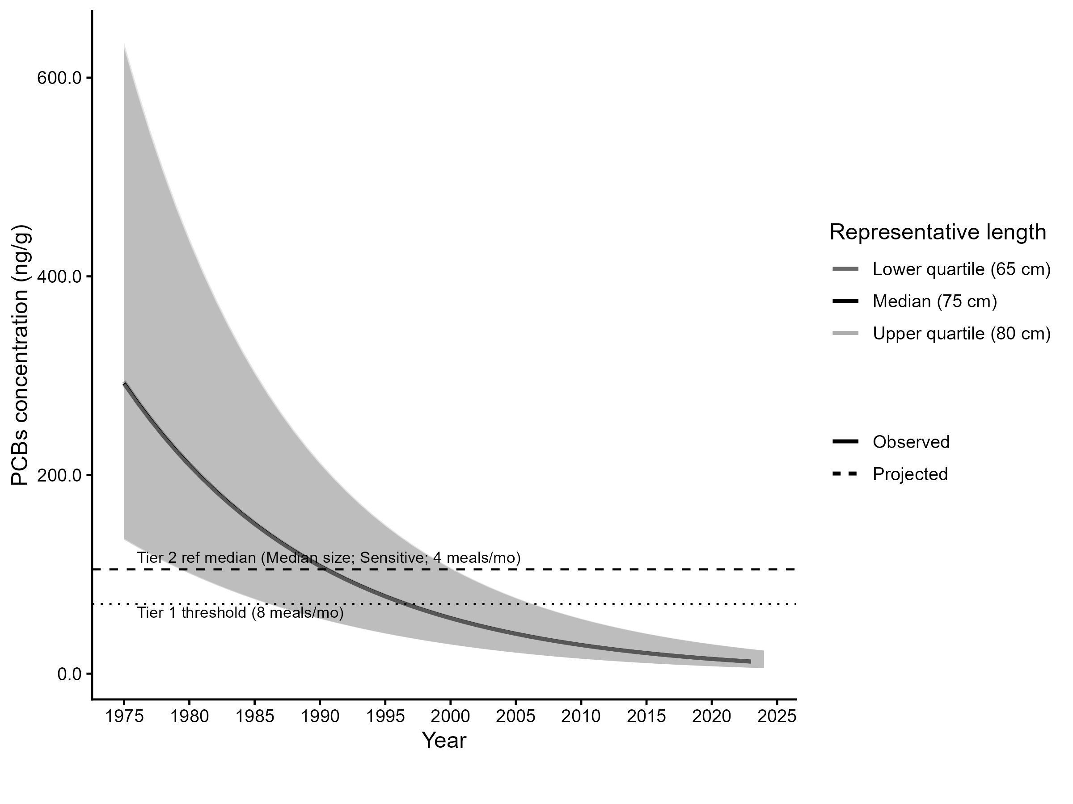
Figure 7.9: Projected PCBs concentration in upper-quartile-length Northern Pike in the AOC. Predicted concentration is based on GAMM-derived half-life decay model. The solid line represents predicted values within the temporal range of observations, the dashed line represents projected future concentrations, ribbons show 95% CI, and the horizontal dotted line represents the unrestrictive PCBs threshold for the sensitive population, based on community desired consumption rate and MECP advisory thresholds.

7.0.4 Smallmouth Bass
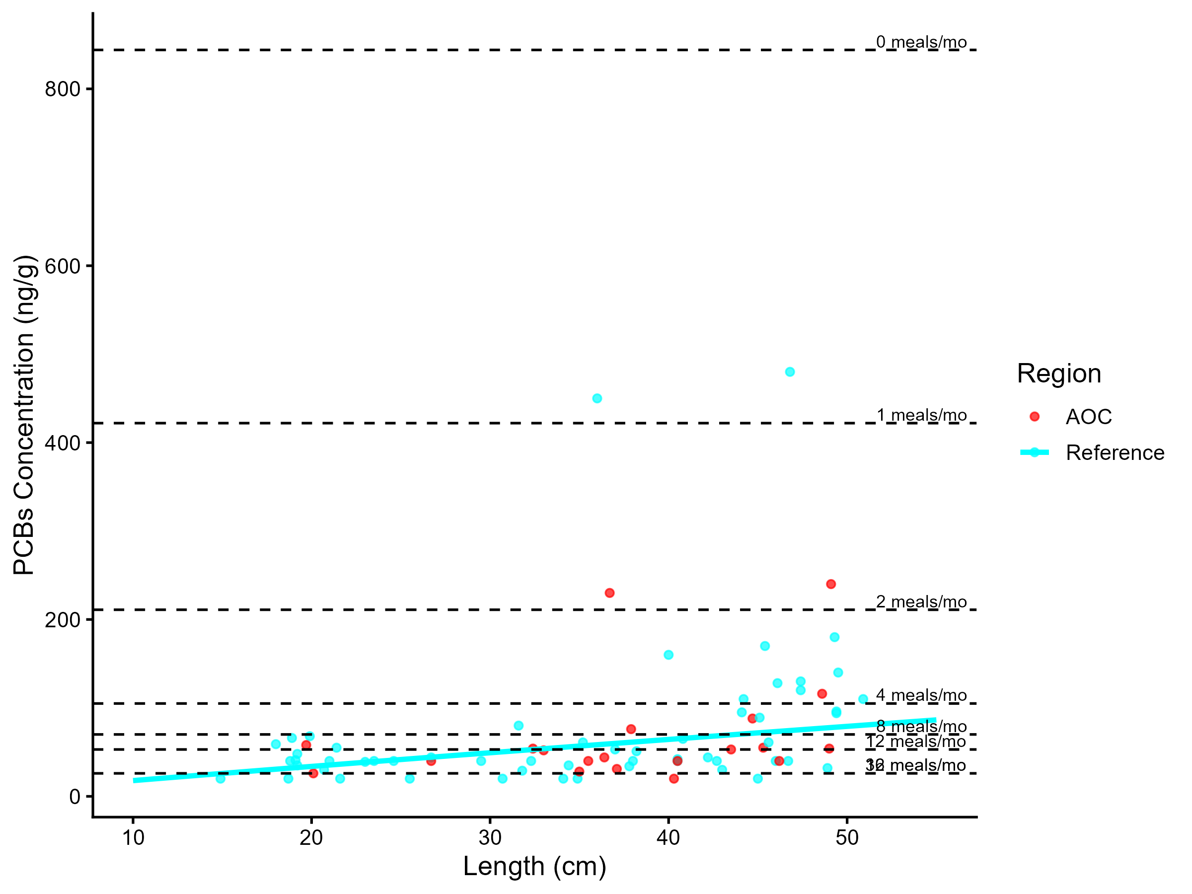
Figure 7.10: Virtual PCB advisories in smallmouth bass. Predicted concentrations (curve) and observed values (points) by region using power regression model, compared to MECP advisory limits for PCB for the Sensititve population (dashed lines).
Table 7.7: Virtual advisory levels for PCB in smallmouth bass across regions. Values represent meals/month recommendations. Red cells indicate restrictive virtual advisory below the desired consumption rate of 8 meals/month AND that of reference; green cells indicate unrestrictive virtual advisory equal to or above either the desired consumption rate or reference advisory.
Population | Region | 15-20 | 20-25 | 25-30 | 30-35 | 35-40 | 40-45 | 45-50 | 50-55 | 55-60
General | AOC | 12 | 32 | 16 | 16 | 8 | 16 | 8 | 12 | 12
General | Reference | 16 | 16 | 16 | 16 | 12 | 12 | 8 | 8 | 8

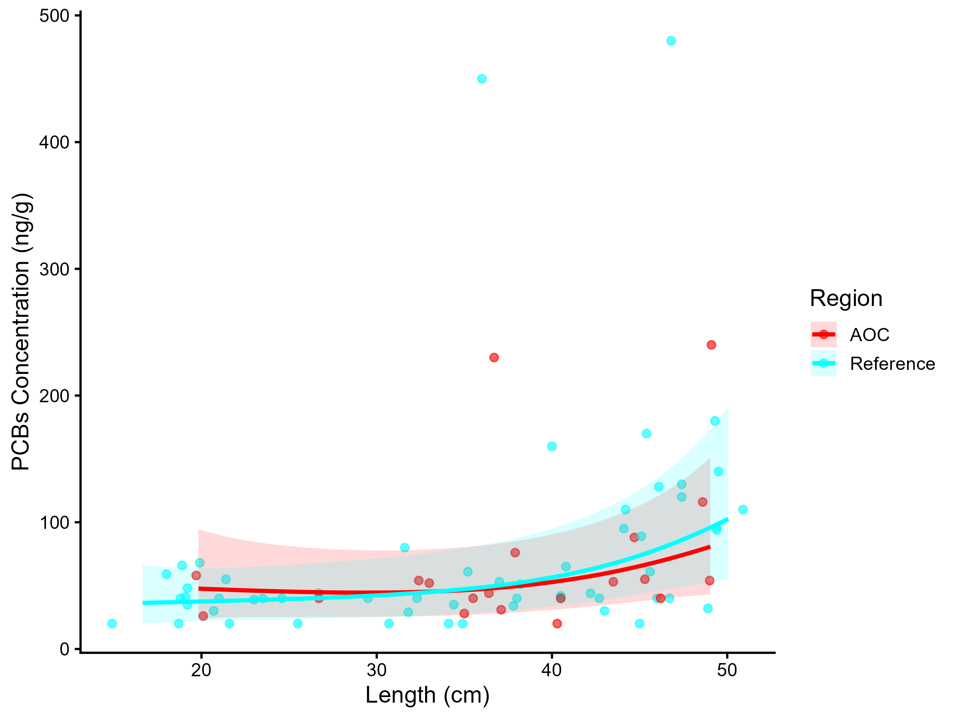
Figure 7.11: PCBs concentration in Smallmouth Bass by length in the AOC compared to reference sites. Points are observed contaminant values, curves represent GAM model fit (with random effects dropped for simplicity, fitted across the 1st to 99th percentile of data to ensure reasonable support), ribbons represent 95% confidence interval.

Table 7.8: Estimated time to unrestrictive PCB threshold for an upper-quartile-sized smallmouth bass in the AOC, using GAMM-derived half-life decay model. The model-predicted concentration of an upper-quartile length fish is reported for the most recent year of observation, and the target concentration corresponding to an "unrestrictive" advisory for the Sensitive population of 8, based on survey results and MECP advisory thresholds.
Representative group | Length (cm) | Predicted Conc. (Current Year) | Desired Consumption Rate | Tier 1 threshold conc. | Tier 2 median (Sensitive) meals/mo | Tier 2 Threshold conc. | Target Threshold (earliest) | Years to Threshold | 95% CI | Outcome
Lower quartile | 25 | 16.58 | 8 | 70.00 | 8 | 70.00 | 70.00 | 0.0 | -9.4–9.4 | Supportive
Median | 35 | 29.22 | 8 | 70.00 | 4 | 105.00 | 105.00 | 0.0 | -8.7–8.7 | Supportive
Upper quartile | 40 | 38.79 | 8 | 70.00 | 0 | 844.00 | 844.00 | 0.0 | -8.7–8.7 | Supportive

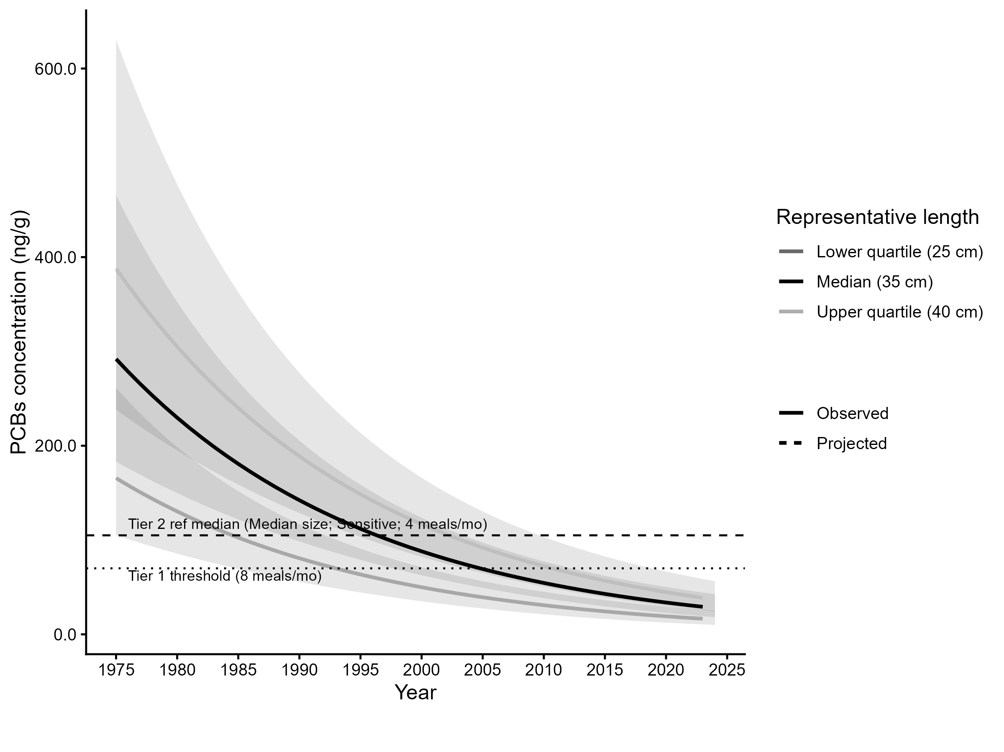
Figure 7.12: Projected PCBs concentration in upper-quartile-length Smallmouth Bass in the AOC. Predicted concentration is based on GAMM-derived half-life decay model. The solid line represents predicted values within the temporal range of observations, the dashed line represents projected future concentrations, ribbons show 95% CI, and the horizontal dotted line represents the unrestrictive PCBs threshold for the sensitive population, based on community desired consumption rate and MECP advisory thresholds.

