SLR BUI 1 Technical Report Draft 3
Aaron Dain
2025-12-22
Table of Contents
1 Introduction 1
1.1 Brief history of BUI in AOC and previous actions 1
1.2 Actions since 2017 report 1
1.3 Delisting criteria 1
Tiered Assessment Approach for Criterion 1.1 1
2 Methods 1
2.1 Generic criteria 1
2.2 Tiered assessment framework 1
2.2.1 Tier 1: Comparison of AOC Fish Consumption Advisories to Desired Consumption Rates 1
2.2.2 Tier 2: Comparison of AOC Advisories to Reference Sites 1
2.2.3 Tier 3: Weight of Evidence Approach 1
2.2.4 Tier 4: Legacy Sources of Mercury in the AOC 1
2.3 Community fish consumption survey 1
2.4 Data Sources 1
3 Results 1
3.1 Species of Interest and Desired Consumption Rate 1
3.2 Tier 1 Assessment for the St. Lawrence River (Cornwall/Akwesasne) AOC 1
3.3 Tier 2 Assessment for the St. Lawrence River (Cornwall/Akwesasne) AOC 1
3.4 Tier 3 Assessment for the St. Lawrence River (Cornwall/Akwesasne) AOC 1
3.4.1 Walleye 1
3.4.2 Largemouth Bass 1
3.4.3 Northern Pike 1
3.4.4 Smallmouth Bass 1
3.4.5 Yellow Perch 1
3.4.6 Channel Catfish, Rock Bass, and White Perch 1
3.5 Tier 4 1
4 Discussion and Recommendations 1
References 1
Appendix 1
5 Tier 3 Supplementary Figures for St. Lawrence River (Cornwall/Akwesasne) AOC 1
5.0.1 Largemouth Bass 1
5.0.2 Northern Pike 1
5.0.3 Smallmouth Bass 1
5.0.4 Yellow Perch 1

1 Introduction

1.1 Brief history of BUI in AOC and previous actions

1.2 Actions since 2017 report

1.3 Delisting criteria

Tiered Assessment Approach for Criterion 1.1

2 Methods

2.1 Generic criteria
In 1991, the IJC recommended the Fish and Wildlife Consumption BUI delisting guideline:
“When contaminant levels in fish and wildlife populations do not exceed current standards, objectives or guidelines, and no public health advisories are in effect for human consumption of fish or wildlife. Contaminant levels in fish and wildlife must not be due to contaminant input from the watershed.” (IJC 1991)
In the following decades, the original delisting guideline from 1991 proved inadequate for assessing this BUI. Though contaminant concentrations in fish have improved in AOCs since these delisting guidelines were proposed (Bhavsar et al. 2018), advisories remain in place throughout the Great Lakes because the contaminants of concern are more toxic and persistent than previously thought (Bhavsar et al. 2018). To rectify the inconsistencies among AOCs in addressing this BUI, Bhavsar (2016) utilized the following delisting statement in the Toronto and Region AOC’s BUI 1 Assessment Report:
“Consumption advisories for fish of interest in the AOC are unrestricted or no more restrictive than the advisories for suitable reference site(s) due to contaminants from locally-controllable sources.”
In 2018, Bhavsar recommended the delisting criterion be used as a generic delisting criterion for BUI 1 among Canadian AOCs (Bhavsar et al. 2018). In 2021, following a series of workshops attended by RAP leaders and stakeholders, the shared generic delisting criterion and assessment framework were adopted by several Canadian AOCs. The intent was to draw from the experiences of the Toronto and Region, Niagara River, and Detroit River AOCs in using a tiered framework for assessing BUI 1. Through these workshops, a standardized operating procedure, common data sources, and data interpretation guidelines were developed to be applied in the tiered framework.
In the St. Lawrence River (Cornwall/Akwesasne) AOC, the following delisting criteria for BUI 1 were adopted following the Stage 1 report (reference):
- “Contaminant levels in fish in the AOC are the same or less than those in upstream non-AOC areas in the St. Lawrence River.
- Restrictions same or fewer/less restrictive than upstream non-AOC areas in the St. Lawrence River.
- No restrictions on the consumption of snapping turtles in the AOC.”
In 2024, the St. Lawrence River Restoration Council (SLRRC) and the Mohawk Council of Akwesasne (MCA) adopted the generic delisting criterion and its associated tiered assessment framework, in addition to a new biocultural criterion designed to address impairments to biocultural practices that fall outside the scope of official consumption advisories. For example, the third delisting criterion, “No restrictions on the consumption of snapping turtles in the AOC”, was dropped because consumption advisories are not issued for snapping turtles in the AOC. Rather, consumption of snapping turtles and other wildlife are addressed under the biocultural criterion.The delisting criteria were accepted as the following:
“This BUI can be redesignated as “Not Impaired” when the following delisting criteria have been met:
1.1 Consumption advisories for fish of interest in the AOC are non-restrictive or no more restrictive than the advisories for suitable reference site(s) due to contaminants from locally controllable sources.
1.2 An increase in the Akwesasne community knowledge and/or willingness to engage in safe biocultural and traditional consumption of fish and wildlife.”
Criterion 1.1 is assessed through the tiered framework, whereas criterion 1.2 is an additional metric for the BUI that is assessed in a separate technical report.

2.2 Tiered assessment framework
The tiered assessment framework, as adapted for use in the St. Lawrence River AOC, comprises 4 tiers, each compiling different evidence lines to determine if delisting criterion 1.1 is met (Figure 2.1):
Tier 1: Are monthly meal allowances for fish of interest in the AOC considered unrestrictive relative to the desired fish consumption rates?
Tier 2: Are fish consumption restrictions in the AOC similar or less restrictive than suitable reference sites?
Tier 3: Do lines of evidence indicate that the beneficial use is not impaired due to priority contaminants?
Tier 4: Have all feasible remedial actions to address local legacy contamination in the AOC been implemented?
The framework is designed such that if all fish of interest in the AOC pass a particular tier, the delisting criterion can be said to be met. Otherwise, analysis moves to the next tier. If all tiers are failed, then the delisting criterion cannot be said to be met. It should be noted that, in the St. Lawrence River (Cornwall/Akwesasne) AOC, the primary contaminant of concern is mercury. Thus, analyses of contaminants are limited strictly to the sources and concentrations of mercury in AOC fish.
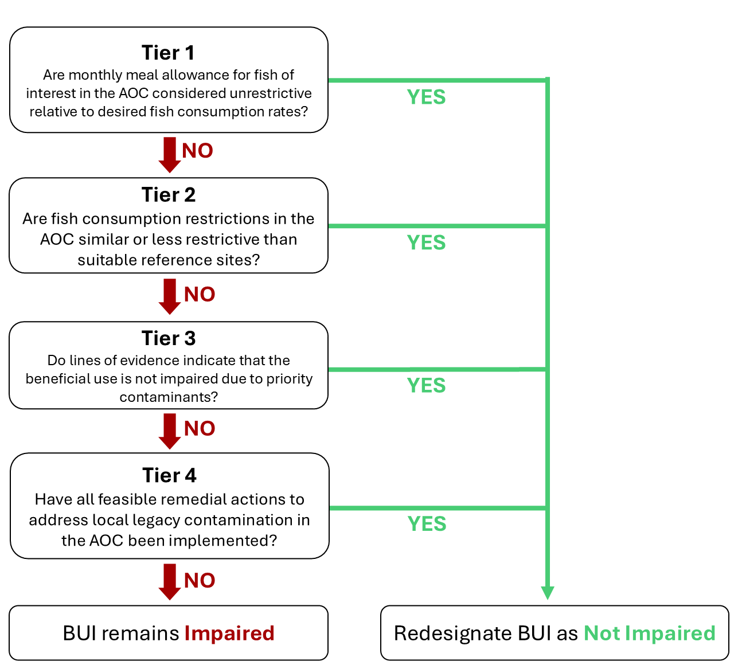
Figure 2.1: Modified tiered assessment framework applied in the 2025 BUI 1 Assessment for the St. Lawrence River (Cornwall/Akwesasne) AOC. Adapted from Drouillard (2022).
Since the previous St. Lawrence River (Cornwall/Akwesasne) BUI 1 Assessment Report in 2017 (reference), the Guide to Eating Ontario Fish has been updated with new fish contaminant data (which was collected on an annual basis, excluding 2020 due to the Covid-19 pandemic [could use citation]) where available, including collections of targeted species (such as walleye and yellow perch) following recommendations from the report. Furthermore, a combination of angler surveys and scientific publications were used to assess the BUI in terms of community desired consumption rates of fish of interest, rather than using MECP definitions of restrictive consumption advice (MECP, 2025). These new data were used to make up-do-date comparisons of fish consumption advisories within the AOC and reference areas in the Upper St. Lawrence River and Lake Ontario. Below is a summary of each tier, and the methods for which they are evaluated.

2.2.1 Tier 1: Comparison of AOC Fish Consumption Advisories to Desired Consumption Rates
The first step of the tiered framework provides a coarse screening of whether fish consumption advisories in the AOC are restrictive in relation to locally desired consumption rates. Given that virtually all fishing zones in Ontario have some fish consumption restrictions in place, there is a need to define a benchmark for the degree of restrictiveness that is considered non-restrictive relative to the normal consumption patterns of fish in a given waterbody by the local community. Advisory values, expressed as the number of meals per month recommended for the general and sensitive population groups, were compiled from the Guide to Eating Ontario Fish, published by the Ontario Ministry of the Environment, Conservation and Parks (MECP; see Section 2.4.0.1). These advisories are based on contaminant concentrations measured in fish flesh and translated into species- and size-specific consumption categories using contaminant thresholds (Table 2.1).
Table 2.1: MECP fish consumption advisory contaminant benchmarks (adapted from Bhavsar 2016). Contaminant concentration values correspond to advised maximum monthly fish meals. Mercury consumption advisories are issued separately for the general population and sensitive population (children under 15 years old and anyone who is pregnant or may become pregnant).
 | Hg (µg/g) |  | PCB (ng/g) | Dioxin/Furan/  dlPCB TEQ (pg/g) | Mirex (ng/g) | Photomirex (ng/g) | Toxaphene (ng/g)
Meals/  month | Sensitive | General
0 | >0.5 | >1.8 | >844 | >21.6 | >657 | >122 | >1877
1 |  |  | 422-844 | 10.8-21.6 | 329-657 | 61-122 | 939-1877
2 |  |  | 211-422 | 5.4-10.8 | 164-329 | 31-61 | 469-939
4 | 0.25-0.5 | 0.6-1.2 | 105-211 | 2.7-5.4 | 82-164 | 15-31 | 235-469
8 | 0.16-0.25 | 0.4-0.6 | 70-105 | 1.8-2.7 | 55-82 | 10-15 | 156-235
12 | 0.12-0.16 | 0.3-0.4 | 53-70 | 1.3-1.8 | 41-55 | 8-10 | 111-156
16 | 0.06-0.12 | 0.15-0.3 | 26-53 | 0.7-1.3 | 21-41 | 4-8 | 59-117
32 | <0.06 | <0.15 | <26 | <0.7 | <21 | <4 | <59

Advisory values for each fish of interest in the AOC were then compared against a benchmark representing acceptable levels of consumption, determined by the results of the community survey (see Section 2.3). Any advisory below this benchmark was considered restrictive, while those at or above the benchmark were considered non-restrictive. This step provides a baseline indication of potential impairment and allows the RAP team to identify species or size classes where consumption guidance is most restrictive, independent of regional comparisons. Additionally, Tier 1 excludes unrestricted fish from further analysis, since these species meet the delisting criteria at its most basic level. If all species pass Tier 1, delisting criterion 1.1 can be said to be met. Tier 1 uses a strict passing benchmark, where any number of restrictive size categories in either population type (General or Sensitive) will cause a species to fail and move to Tier 2.

2.2.2 Tier 2: Comparison of AOC Advisories to Reference Sites
Tier 2 assesses whether the fish consumption advisories for fish of interest in the AOC are comparable to those at suitable reference sites. If all the restrictive advisories for a given species in the AOC are less restrictive or equivalent to those in reference sites, the species passes Tier 2. Otherwise, the assessment of failing species moves to Tier 3. Similarly to Tier 1, Tier 2 uses official consumption advice provided by MECP. Species that passed Tier 1 assessment were excluded from Tier 2 analysis. Furthermore, size classes that pass Tier 1 within a species were excluded from Tier 2 analysis.
The advisory values for each species of interest in the AOC are compared to the median value of advisories for reference sites. In Tier 2, reference sites are selected as those representative of a broad measure of background intensity of advisories across a comparable geographic region. That is, selection of reference sites for Tier 2 does not consider similarity of ecology, environmental conditions, or history; nor does it select for pristine, undisturbed water bodies. Rather, reference sites are characterized as a broad geographical representation of the region that are removed from AOC sources of legacy contamination. Furthermore, reference sites need to have fish consumption advisories available for the selected species of interest as well as overlapping size ranges of each species with that of the AOC. For this analysis, we selected all non-AOC fishing zones in the Upper St. Lawrence River and Lake Ontario (including East Lake and West Lake) for which consumption advice is issued for the same species of interest in the AOC. The AOC fishing zones excluded were Toronto Waterfront, Hamilton Harbour, and the Niagara River (Upper and Lower). Fishing zones including the Bay of Quinte AOC (Lake Ontario (Eastern Basin), Trenton Nearshore, and Belleville Nearshore) were not excluded as the priority contaminants driving advisories are organic rather than mercury, and because the Bay of Quinte shares ecological and environmental similarities to the upper St. Lawrence River. Furthermore, tributaries, embayments, and harbours were excluded, as they generally do not encapsulate background conditions of the geographical region.
To compare the intensity of advisories, we compared the advisory value for each species and size class, each for the General and Sensitive populations, for available species of interest in the AOC (below the Tier 1 benchmark) to the median of reference advisories for which advisories were issued for the same species. Because meal/month consumption advisories are issued in discrete categories (see Section 2.4.0.1), reference median values were rounded up to the next advisory value when there were an even number of reference sites. For example, a median advisory value of 10 meals/month would be rounded up to 12 meals/month. This is because the median of an even number of sites would fall between two advisory categories (e.g., the median between 8 and 12 is 10). While this does not change the outcome of the analysis, it is a clearer representation of official consumption advice. AOC advisory values below the desired consumption benchmark (e.g., 8 meals/month) are compared to their respective reference medians, and those size categories equal to or above the reference median pass Tier 2 assessment, while those below the reference median fail Tier 2. Similarly to Tier 1, Tier 2 adopts a strict benchmark, where any number of size categories for either population type will cause a species to fail and move to Tier 3.

2.2.3 Tier 3: Weight of Evidence Approach
Tier 3 evaluates the status of the BUI using a weight of evidence approach, which considers multiple lines of evidence pertaining to fish contaminant concentrations in the AOC and reference areas. As with previous tiers, species are evaluated independently. However, the nuanced nature of the weighted evidence approach means that a single pass/fail metric for each species is inappropriate at this tier. The outcome of the weight of evidence available will be used to support or not support redesignation of the BUI. Tier 3 evidence lines are determined in aggregate, meaning that unlike the decision tree between tiers, all sub-categories of Tier 3 are considered jointly regardless if a species passes or fails one or more evidence lines. We considered the following lines of evidence for Tier 3:

2.2.3.1 Tier 3A: Virtual advisory
Tier 3A seeks to address the relationship between priority contaminants in the AOC and fish consumption advice. Because fish consumption advisories consider multiple fish contaminants, and are issued based on the strictest restriction from any contaminant (cite), it is important to isolate the effect of priority AOC contaminants on driving local fish consumption advisories. Additionally, in some cases, official advisories may be based on data that dates as far back as the 1970s. Thus, it is important that restrictions on fish consumption are considered using more recent data to account for restorative effects in the AOC associated with previous remedial actions. To achieve this, “virtual advisories” are created using the same fish contaminant data and methods used by MECP to generate official consumption advice. Fish contaminant data (obtained from MECP, see Section 2.4.0.2) is filtered to the contaminant of concern (mercury) and the previous 10 years of data (2014 and more recent), and this data is used to calculate virtual advisories using the MECP method.
Virtual advisory values were generated by modelling the relationship between fish length and contaminant concentration. For each region (AOC and reference), the function fits a log-log linear model (lm(log(Value) ~ log(Length)) to evaluate whether a significant relationship exists (p ≤ 0.05). If so, predicted concentrations are generated across a continuous length range (from smallest to largest observed value), and then averaged within fixed 5 cm fish length bins. Advisory levels are assigned using MECP-defined contaminant- and population-specific (General/Sensitive population) thresholds to the mean predicted concentrations. If no significant relationship is detected, advisory levels are based on the mean concentration of all observations within each fish length interval. If any size categories of the virtual advisory are restrictive compared to the desired consumption rate and to reference values, Tier 3A assessment is unsupportive of delisting for this species. Virtual advisories are not to be used as a replacement for official consumption advice and are limited strictly to the evaluation of this BUI.
The virtual advisories in this tier are evaluated similarly to Tiers 1 and 2; i.e. first it is determined if virtual advice for any size categories is restrictive compared to the community desired consumption rate (see Section 2.2.1), then if virtual advice for any size category are more restrictive than suitable reference sites. Similarly to Tiers 1 and 2, any number of restrictive size categories are considered a failure for Tier 3A.

2.2.3.2 Tier 3B: Comparisons of fish contaminants in the AOC vs Reference
To determine the degree of contamination in fish in the AOC by priority contaminants, the concentrations of mercury in fish tissue were compared between the AOC and suitable reference sites.
Reference sites for Tier 3B differ from those used in Tier 2 in that the MECP fish collection zones do not correlate directly with the zones used in the official advisories. For example, one official advisory zone (as is used in Tier 2) may comprise several collection areas. For Tier 3B, reference zones are similarly limited collections zones in the upper St. Lawrence River (upstream of the Moses-Saunders Dam) and Lake Ontario not influenced by AOC mercury sources for which collections of the evaluated species have occurred within the most recent 10 years of study (2014-2024). Since Tier 3B is limited to assessing mercury contamination, AOC fishing zones may be used as reference sites if the associated legacy contaminants are organic rather than mercury. For instance, the Bay of Quinte was used as a reference area where data were available, since the contaminants of concern in this AOC are PCBs, dioxins, and furans; there is no legacy industrial source of mercury in the area. The number and locations of reference sites may differ between species depending on the availability of data.
To assess differences in fish contamination between the AOC and reference sites, contaminant–length relationships were modeled using Generalized Additive Models (GAMs), allowing for non-linear associations. For this model, length was first log-transformed to control for skewed data distributions (contaminant-length relationships are often exponential), which was used as a fixed smooth effect along with region (AOC or reference), with collection area as a random effect to control for site-specific confounding variables. For each species of interest, we first tested whether the shape of the concentration–length relationship differed significantly between AOC and reference fish by comparing the full model to a null model with reduced terms using ANOVA. Where models supported statistically similar trends (non-significant interaction), we compared size-adjusted contaminant levels using estimated marginal means. Where shapes differed significantly, contaminant concentration values were compared by GAM-predicted values across the range of lengths of each fish species at 5 cm intervals. A threshold of α = 0.05 was used to evaluate statistical significance throughout.
Where contaminant-length relationships differed between AOC and reference, Tier 3B can be considered supportive of redesignation when the majority of size classes do not significantly differ in predicted contaminant concentration between AOC and reference. Where the contaminant-length relationship does not significantly differ, Tier 3B can be considered supportive of redesignation when the marginal mean of contaminant concentration does not significantly differ between AOC in reference. Otherwise, Tier 3B is considered not supportive of redesignation.

2.2.3.3 Tier 3C: Temporal trends of contaminants in fish
In Tier 3C, we evaluated the direction of trends in contaminants through time, and make predict how these trends will continue into the future. Temporal trends in mercury concentrations in AOC fish of interest were assessed using generalized additive mixed models (GAMMs) across all years of data. Log-contaminant concentration was modeled with a log-linear fixed effect for sample year to assess the temporal trends on an exponential scale, a smooth fixed effect for log-length to account for differences in contaminant concentration across fish length, and a site smooth random effect to account for regional differences in sampling and other confounding variables. The slope (on log scale) represents the annual rate of change in mercury concentration, defined as k = -slope (such that k > 0 indicates a decline, and k < 0 indicates an increase in contaminant concentration). Standard errors are obtained via the delta method. This model allows us to determine if contaminant trends are stable, increasing, or decreasing over time. If contaminant concentrations are stable or increasing, Tier 3C is unsupportive of delisting. If contaminant concentrations are decreasing, we use the model to predict future trends in contaminants.
Using this decay model, we estimated the time required to reach a nonrestrictive monthly meal allowance for sensitive populations for the median, upper quartile, and lower quartile fish lengths (rounded to the nearest 5 cm). Generally, community survey and MNR creel survey results indicated that the lower, median, and upper quartiles of fish lengths approximately correspond to the range of fish lengths consumed by most anglers in the AOC. The half-life of contamination in each species was derived from the fitted yearly slope of log-transformed concentrations in the GAMM. If concentrations are increasing, a doubling time is reported instead. To estimate time to unrestrictive advisory threshold, predictions were anchored at the most recent observed year and a representative length (upper quartile rounded to the nearest 5 cm), and the model assumed a continuous rate of change using the half-life estimate. The model projects the expected time required for contaminant concentrations of upper-quartile-length fish to fall below the restrictive benchmark established in Tier 1 for the sensitive population. For instance, if the desired consumption rate of a species is 8 meals per month, the threshold for the sensitive population would be 0.16 µg/g mercury (Table 2.1). A timeline of 10 years or fewer is considered supportive of delisting, whereas a timeline of 10 or more years is unsupportive of delisting for this species. This estimate supports the temporal assessment of Tier 3C by forecasting how long the BUI will remain impaired in the absence of additional remedial actions.

2.2.4 Tier 4: Legacy Sources of Mercury in the AOC
Tier 4 assessment, like Tier 3, uses several evidence lines to determine support for delisting the BUI. Tier 4 expands the scope from fish to the environment, assessing the history and impact of past remedial actions on environmental recovery and fish contamination, as well as identifying potential future actions. Using a combination of literature review, monitoring data, and ecological metrics, available data is weighed in relation the restoration actions identified in the Stage 2 and draft (unpublished) Stage 3 RAP reports, as well as the degree of completion of these actions. Data may include contaminant concentration and track-down studies in the water, sediments, young of year (YOY) forage fish, and benthic invertebrates within the AOC and tributaries. Tier 4 may also include modelling approaches to relate environmental conditions to fish contaminants, including mercury isotopic tracer studies to determine the sources and movement of mercury into the food web.
(This section to be expanded in future)

2.3 Community fish consumption survey
To properly address the needs of the community surrounding the AOC through this BUI assessment, it is important to understand the the impact of the BUI on the consumption habits of the community. By asking the community about consumption habits, we can identify a list of species of interest in the AOC, how often these species are being consumed, and the desired rate of consumption if there were no issues related to priority contaminants.
A fish consumption survey was conducted in within the AOC from April to November of 2025. The survey asked respondents about where community members fished, their fishing methods, whether they eat fish, which fish from the AOC they consume (or feed to others), how often they eat each kind of fish, their normal portion size for each fish, their methods of cooking, and how often they would eat each fish species if there were no issues related to contamination in the AOC. The survey also asked respondents the same questions about fish consumed from outside of the AOC. Additionally, the survey asked respondents if they had heard of the Guide to Eating Ontario Fish and the RAP program, and whether either of these resources have modified their consumption habits.
Responses from this survey were used to establish the community’s desired consumption rates for each species using several methods: First, species of interest are defined as those consumed by at least 5% of anglers who eat fish. Second, a weighted average for meal frequency was calculated by multiplying the number of respondents by their desired monthly meal rate (converted from survey response options to monthly meal equivalents, see Table 2.2), then dividing by the total number of respondents. Since the BUI assessment aims to address the level of impairment to fish consumption in the AOC, the desired consumption rate is set based on the amount of fish the community would eat if the BUI was not impaired, rather than the current consumption rate. Third, a weighted average meal size was calculated similarly to frequency, with survey response options converted to monthly meal equivalents as per Table 2.3. Finally, the weighted average frequency was multiplied by the weighted average portion size to get an average desired consumption rate, which was rounded up to the next advisory category for the Sensitive population (0, 4, 8, 12, 16, or 32 meals per month).
Table 2.2: Survey response conversion table for desired consumption frequency.
Consumption Rate (Survey) | Conversion
A few times per year | 1
A few times per month | 8
A few times per week | 16
Daily | 32

Table 2.3: Survey response conversion table for desired portion size
Portion Size (Survey) | Conversion
Less than 4 oz | 0.25
4 oz | 0.50
4-8 oz | 0.75
8 oz | 1.00
Greater than 8 oz | 2.00

2.4 Data Sources

2.4.0.1 MECP Advisory Data
Tier 1 and Tier 2 of the BUI 1 assessment framework are based on the official fish consumption advisories issued by the Ontario Ministry of Environment, Conservation and Parks (MECP) for the AOC and suitable reference sites. For this assessment report, the most recent advisories were obtained from the 2024 Guide to Eating Ontario Fish (at the time of writing, available here). The Guide provides monthly meal recommendations based on the size and species of fish available from collections in each area assessed. Recommendations are based on contaminant testing of fish within each zone, which are modeled and compared against concentration thresholds associated with a recommended monthly meal allowance. In the St. Lawrence River (Cornwall/Akwesasne) AOC, the monthly meal recommendations correspond to advisory tables issued for the “St. Lawrence River – Lake St. Francis” zone. Advisory information was collected for all available species for which advice is issued, at all size classes and for the two populations identified: General and Sensitive Populations. For reference sites, information was collected only for species that are also monitored in the AOC. Advisories for Sensitive Populations are intended to be used by women of childbearing age and children under the age of 15. Generally, for advisories are stricter for sensitive populations, with lower contaminant benchmarks for substances such as mercry, reflecting their greater vulnerabiliy to adverse health effects. Maximum monthly meal recommendation categories for the Sensitive Population include 32, 16, 12, 8, 4 and 0 meals/month. Maximum monthly meal recommendation categories for the General Population include 32, 16, 12, 8, 4, 2, 1 and 0 meals per month. For the purposes of this assessment, advisories for both populations were considered for Tiers 1 and 2.

2.4.0.2 MECP Contaminant Data
Tier 3 assessment is primarily based on contaminant data compiled by MECP, which is used to generate official consumption advice. This data is collected across the waters of Ontario by MECP and partner organizations, and comprises fish measurements such as sample site, length, sample year, weight, sex, and contaminant concentration for a number of fish of interest within each waterbody. These data were used to calculate virtual advisories, compare contaminant concentrations between AOC and reference sites, and make predictions of temporal trends of contaminants within the AOC.

2.4.0.3 MNR Survey Data
To support the identification of fishes of interest and desired consumption rates, we used angler surveys and fish population data collected by MNR. These data were used to confirm reasonable sizes for desired consumption and fish consumption habitats. For instance, fish size data was used to support the selection of representative fish lengths used in the temporal assessment of contaminants (Section 2.2.3). (Sarah et al please fill in for accuracy and completeness).

2.4.0.4 Tier 4 data sources
(to be expanded)

3 Results

3.1 Species of Interest and Desired Consumption Rate
The following species were identified as species of interest, with the respective desired consumption rates (see Section 2.3):
Table 3.1: Community survey results in the St. Lawrence River (Cornwall/Akwesasne) AOC. Species are listed with the percent of survey respondents that eat them, the current consumption rate weighted by average portion size (in meals/month, rounded up to nearest advisory category), and the desired consumption rate weighted by average portion size (in meals/month, rounded up to nearest advisory category). Bolded and asterisked species are consumed by at least 5% of respondents, and are therefore considered species of interest.
Species | Percent Eaten by Respondents | Current Weighted Consumption Rate (meals/month) | Desired Weighted Consumption Rate (meals/month)
Black Crappie* | 12% | 1 | 4
Bluegill* | 6% | 4 | 2
Brown Bullhead* | 6% | 4 | 4
Channel Catfish* | 5% | 1 | 2
Chinook Salmon* | 5% | 1 | 8
Common Carp | 1% | 2 | 8
Fallfish | 3% | 1 | 2
Freshwater Drum | 4% | 1 | 2
Largemouth Bass* | 25% | 4 | 8
Northern Pike* | 23% | 2 | 4
Rock Bass* | 10% | 4 | 8
Smallmouth Bass* | 35% | 2 | 4
Walleye* | 61% | 4 | 8
White Perch* | 8% | 4 | 8
White Sucker | 0% | 0 | 12
Yellow Perch* | 62% | 4 | 8

Of the identified species of interest, neither black crappie or chinook salmon have official consumption advice in the AOC, and will therefore be excluded from the tiered assessment.

3.2 Tier 1 Assessment for the St. Lawrence River (Cornwall/Akwesasne) AOC
The Tier 1 assessment compares the official MECP consumption advisory information for each fish of interest to the desired consumption rate (in meals per month) as indicated by the community survey. Table 3.2 summarizes the MECP advisory values for fish of interest in the St. Lawrence River (Cornwall/Akwesasne) AOC for both General and Sensitive populations, compared to each species’ community desired consumption rate. In total, 2 of 10 species passed Tier 1 assessment (brown bullhead and bluegill), with the rest failing and moving to Tier 2 (Table 3.3).

Table 3.2: Results of Tier 1 assessment for St. Lawrence River (Cornwall/Akwesasne). The consumption advisory for each species is compared to its desired consumption rate, as determined by community survey. Numbers in cells indicate advisory levels for a species, size class, and population type (General/Sensitive) in the AOC. Red cells indicate an advisory below the "Restrictive" meals/month threshold (indicated by community survey), and green cells indicate advisory levels equal to or above this threshold. The contaminants driving the advisories are displayed below each cell. Advisory causes: 1 = Mercury; 2 = PCB; 3 = PFAS.
Species | Desired Consumption Rate (Meals/Month) | Population | 15-20cm | 20-25cm | 25-30cm | 30-35cm | 35-40cm | 40-45cm | 45-50cm | 50-55cm | 55-60cm | 60-65cm | 65-70cm | 70-75cm | >75cm
Bluegill | 2 | General | 4
 |  | Adv cause | 3
 |  | Sensitive | 4
 |  | Adv cause | 3
Brown Bullhead | 4 | General | 8 | 8 | 8 | 8 | 8
 |  | Adv cause | 3 | 3 | 3 | 3 | 3
 |  | Sensitive | 8 | 8 | 8 | 8 | 8
 |  | Adv cause | 3 | 3 | 3 | 3 | 3
Channel Catfish | 2 | General |  |  |  |  | 4 | 2 | 1 | 0 | 0 | 0 | 0
 |  | Adv cause |  |  |  |  | 2 | 2 | 2 | 2 | 2 | 2 | 1
 |  | Sensitive |  |  |  |  | 4 | 0 | 0 | 0 | 0 | 0 | 0
 |  | Adv cause |  |  |  |  | 1 | 2 | 2 | 2 | 2 | 1, 2 | 1, 2
Largemouth Bass | 8 | General | 8 | 8 | 8 | 8 | 8 | 4 | 4
 |  | Adv cause | 3 | 3 | 3 | 3 | 1, 3 | 1, 3 | 1, 3
 |  | Sensitive | 8 | 8 | 8 | 4 | 0 | 0 | 0
 |  | Adv cause | 3 | 3 | 1, 3 | 1 | 1 | 1 | 1
Northern Pike | 4 | General |  | 32 | 32 | 16 | 16 | 16 | 16 | 16 | 16 | 12 | 8 | 4 | 4
 |  | Adv cause |  |  |  | 2 | 1, 2 | 1, 2 | 1 | 1 | 1 | 1 | 1 | 1 | 1, 3
 |  | Sensitive |  | 16 | 16 | 16 | 16 | 12 | 8 | 8 | 8 | 4 | 4 | 0 | 0
 |  | Adv cause |  | 1 | 1 | 1 | 1 | 1 | 1 | 1 | 1 | 1 | 1 | 1 | 1
Rock Bass | 8 | General | 4 | 4
 |  | Adv cause | 3 | 3
 |  | Sensitive | 4 | 4
 |  | Adv cause | 1, 3 | 1, 3
Smallmouth Bass | 4 | General | 4 | 4 | 4 | 4 | 4 | 4 | 4 | 4
 |  | Adv cause | 3 | 3 | 3 | 3 | 3 | 3 | 1 | 3
 |  | Sensitive | 4 | 4 | 4 | 4 | 4 | 0 | 0 | 0
 |  | Adv cause | 3 | 3 | 1 | 1 | 1 | 1 | 1 | 1
Walleye | 8 | General | 4 | 4 | 4 | 4 | 4 | 4 | 4 | 4 | 4 | 4 | 4 | 4 | 0
 |  | Adv cause | 3 | 3 | 3 | 3 | 3 | 3 | 3 | 3 | 3 | 1, 3 | 1, 3 | 1, 3 | 1
 |  | Sensitive | 4 | 4 | 4 | 4 | 4 | 4 | 4 | 4 | 0 | 0 | 0 | 0 | 0
 |  | Adv cause | 3 | 3 | 3 | 3 | 1, 3 | 1, 3 | 1, 3 | 1, 3 | 1 | 1 | 1 | 1 | 1
White Perch | 8 | General | 8 | 4
 |  | Adv cause | 1 | 1
 |  | Sensitive | 4 | 0
 |  | Adv cause | 1 | 1
Yellow Perch | 8 | General | 4 | 4 | 4 | 4
 |  | Adv cause | 3 | 3 | 3 | 1, 3
 |  | Sensitive | 4 | 4 | 4 | 0
 |  | Adv cause | 3 | 3 | 3 | 1

Table 3.3: Results by species of Tier 1 assessment for St. Lawrence River (Cornwall/Akwesasne). The consumption advisory for each species is compared to its desired consumption rate, as determined by community survey. Species for which the consumption advisory is equal to or above the desired consumption rate pass Tier 1 and are excluded from further analysis; otherwise, the species fails and moves forward to Tier 2.
Species | Tier 1
Bluegill | ✔️
Brown Bullhead | ✔️
Channel Catfish | ❌
Largemouth Bass | ❌
Northern Pike | ❌
Rock Bass | ❌
Smallmouth Bass | ❌
Walleye | ❌
White Perch | ❌
Yellow Perch | ❌

3.3 Tier 2 Assessment for the St. Lawrence River (Cornwall/Akwesasne) AOC
Tier 2 assessment compares the intensity of fish consumption advisories in the AOC to suitable reference sites. Reference sites for Tier 2 assessment should reflect background levels of intensity of advisories, i.e., they should represent geographically similar locations that are not AOCs. For the St. Lawrence River (Cornwall/Akwesasne) AOC, reference sites were non-AOC fishing zones in the upper St. Lawrence River (upstream of the Moses-Saunders Dam) and Lake Ontario for which advisories for species located in the AOC were available. The following reference sites were used for the Tier 2 analysis of the SLR AOC:
- Jordan Harbour (Lake Ontario)
- Lake Ontario (Western Basin)
- Frenchman Bay (Lake Ontario)
- McLaughlin Bay (Lake Ontario)
- Oshawa Harbour (Lake Ontario)
- Whitby Harbour (Lake Ontario)
- East Lake
- West Lake
- Consecon Lake
- St. Lawrence River (Lake Ontario to Cornwall)
The consumption advisories for each fish of interest that failed Tier 1 in the AOC were compared to the median advisory (rounded to the nearest advisory level issued, see methods Section 2.2.2) level (in meals per month) of available reference sites for which advisories are issued for that species and size class. The results are summarized below in Table 3.4. Species where all size classes are equal to or above the median advisory level of the reference sites pass Tier 2 and are excluded from further analysis, otherwise the species fails Tier 2 and is carried forward to Tier 3 (Table 3.5). Only size classes that failed the Tier 1 criteria were assessed at Tier 2. Species and size classes with fewer than three reference sites are considered data-deficient and automatically fail Tier 2. For the purposes of this assessment, data-deficient species fail Tier 2 automatically.

Table 3.4: Results of Tier 2 assessment for St. Lawrence River (Cornwall/Akwesasne). Numbers in cells indicate advisory levels for a species, size class, and population type (General/Sensitive) in the AOC, alongside the median advisory level of suitable reference sites. n values indicate the number of reference sites with advisories for this species, size class, and population type. Red cells indicate an advisory in the AOC lower than the median of reference sites, and solid green cells indicate advisories levels equal to or above the reference median. Transparent green cells indicate size classes that passed Tier 1 (i.e., the advisory value meets the desired consumption rate). Grey cells are advisories in the AOC with an insufficient number (fewer than 3) of suitable reference sites. The drop-down menus display the advisory levels in each reference site for that species and population type.
Species | Population | Site | 15-20cm | 20-25cm | 25-30cm | 30-35cm | 35-40cm | 40-45cm | 45-50cm | 50-55cm | 55-60cm | 60-65cm | 65-70cm | 70-75cm | >75cm
Channel Catfish | General | AOC |  |  |  |  | 4 | 2 | 1 | 0 | 0 | 0 | 0
 |  | Reference Median |  |  |  |  | 2 | 2 | 2 | 1 | 1 | 0 | 0
 |  | n |  |  |  |  | 2 | 2 | 2 | 2 | 2 | 2 | 2
 | Sensitive | AOC |  |  |  |  | 4 | 0 | 0 | 0 | 0 | 0 | 0
 |  | Reference Median |  |  |  |  | 0 | 0 | 0 | 0 | 0 | 0 | 0
 |  | n |  |  |  |  | 2 | 2 | 2 | 2 | 2 | 2 | 2
Largemouth Bass | General | AOC | 8 | 8 | 8 | 8 | 8 | 4 | 4
 |  | Reference Median | 16 | 16 | 16 | 12 | 8 | 8 | 4
 |  | n | 6 | 8 | 8 | 8 | 8 | 4 | 2
 | Sensitive | AOC | 8 | 8 | 8 | 4 | 0 | 0 | 0
 |  | Reference Median | 8 | 8 | 8 | 4 | 4 | 4 | 0
 |  | n | 6 | 8 | 8 | 8 | 8 | 4 | 2
Northern Pike | General | AOC |  | 32 | 32 | 16 | 16 | 16 | 16 | 16 | 16 | 12 | 8 | 4 | 4
 |  | Reference Median |  | 8 | 8 | 16 | 16 | 12 | 8 | 8 | 8 | 8 | 8 | 8 | 4
 |  | n |  | 3 | 4 | 7 | 7 | 8 | 8 | 9 | 9 | 9 | 8 | 8 | 7
 | Sensitive | AOC |  | 16 | 16 | 16 | 16 | 12 | 8 | 8 | 8 | 4 | 4 | 0 | 0
 |  | Reference Median |  | 8 | 8 | 8 | 8 | 8 | 4 | 8 | 4 | 4 | 4 | 4 | 0
 |  | n |  | 3 | 4 | 7 | 7 | 8 | 8 | 9 | 9 | 9 | 8 | 8 | 7
Rock Bass | General | AOC | 4 | 4
 |  | Reference Median | 16 | 8
 |  | n | 7 | 5
 | Sensitive | AOC | 4 | 4
 |  | Reference Median | 8 | 4
 |  | n | 7 | 5
Smallmouth Bass | General | AOC | 4 | 4 | 4 | 4 | 4 | 4 | 4 | 4
 |  | Reference Median | 16 | 16 | 12 | 16 | 8 | 2 | 2 | 8
 |  | n | 3 | 4 | 4 | 6 | 5 | 4 | 3 | 1
 | Sensitive | AOC | 4 | 4 | 4 | 4 | 4 | 0 | 0 | 0
 |  | Reference Median | 12 | 12 | 8 | 8 | 4 | 0 | 0 | 4
 |  | n | 3 | 4 | 4 | 6 | 5 | 4 | 3 | 1
Walleye | General | AOC | 4 | 4 | 4 | 4 | 4 | 4 | 4 | 4 | 4 | 4 | 4 | 4 | 0
 |  | Reference Median | 12 | 12 | 12 | 16 | 16 | 12 | 8 | 12 | 8 | 8 | 4 | 4 | 0
 |  | n | 1 | 3 | 4 | 7 | 7 | 7 | 6 | 5 | 5 | 5 | 3 | 3 | 3
 | Sensitive | AOC | 4 | 4 | 4 | 4 | 4 | 4 | 4 | 4 | 0 | 0 | 0 | 0 | 0
 |  | Reference Median | 12 | 12 | 8 | 12 | 8 | 8 | 4 | 4 | 4 | 0 | 0 | 0 | 0
 |  | n | 1 | 3 | 4 | 7 | 7 | 7 | 6 | 5 | 5 | 5 | 3 | 3 | 3
White Perch | General | AOC | 8 | 4
 |  | Reference Median | 8 | 8
 |  | n | 4 | 4
 | Sensitive | AOC | 4 | 0
 |  | Reference Median | 8 | 8
 |  | n | 4 | 4
Yellow Perch | General | AOC | 4 | 4 | 4 | 4
 |  | Reference Median | 16 | 16 | 16 | 4
 |  | n | 10 | 8 | 5 | 3
 | Sensitive | AOC | 4 | 4 | 4 | 0
 |  | Reference Median | 12 | 8 | 4 | 4
 |  | n | 10 | 8 | 5 | 3

Table 3.5: Results by species of Tier 2 assessment for St. Lawrence River (Cornwall/Akwesasne). The consumption advisory for each species is compared to its desired consumption rate, as determined by community survey. Species for which the consumption advisory is equal to or above the desired consumption rate pass Tier 1 and are excluded from further analysis; otherwise the species fails and moves forward to Tier 2.
Species | Tier 2
Channel Catfish | ❌ ⚠️
Largemouth Bass | ❌
Northern Pike | ❌
Rock Bass | ❌
Smallmouth Bass | ❌
Walleye | ❌
White Perch | ❌
Yellow Perch | ❌
⚠️ - Species has low reference site count (<3) at more than 50% of size classes.

3.4 Tier 3 Assessment for the St. Lawrence River (Cornwall/Akwesasne) AOC
Tier 3 comprises multiple lines of evidence (virtual advisory, contaminant concentration comparisons, and temporal contaminant trends in fish of interest) to determine if redesignating the BUI is supported by contaminant trends in each species of interest. Table 3.6 summarizes the results of tier 3 assessment for each species. Lines of evidence are evaluated independently, and the overall decision for each species is based on whether or not the majority of evidence lines are supportive of redesignating.
Table 3.6: Summary of tier 3 results for each species of interest that failed Tiers 1 and 2 within the St. Lawrence River (Cornwall/Akwesasne) Area of Concern. For each species, the analytical metric is presented along with the outcome for each line of evidence, as described in the methods. The overall Tier 3 decision is based on whether or not the majority of evidence lines are supportive of redesignating.
Species | Tier 3A | Tier 3B | Tier 3C | Tier 3 Overall
Channel Catfish | Insufficient Data | Insufficient Data | Insufficient Data | Insufficient Data
 | Available years: 2; observations: 17 (require ≥5 years and ≥30 observations in the AOC) | Available years: 2; observations: 17 (require ≥5 years and ≥30 observations in the AOC) | Available years: 2; observations: 17 (require ≥5 years and ≥30 observations in the AOC)
Largemouth Bass | Unsupportive | Unsupportive | Supportive | Unsupportive
 | General: 3/9 size bins restrictive or more restrictive than reference; Sensitive: 7/9 size bins restrictive or more restrictive than reference | No significant difference in smooth terms (p = 0.431); AOC marginal mean higher than reference | 0/3 representative size groups (lower quartile, median, upper quartile) are restrictive based on time-to-threshold results.
Northern Pike | Unsupportive | Unsupportive | Unsupportive | Unsupportive
 | General: 0/12 size bins restrictive or more restrictive than reference; Sensitive: 2/12 size bins restrictive or more restrictive than reference | No significant difference in smooth terms (p = 0.811); AOC marginal mean higher than reference | 3/3 representative size groups (lower quartile, median, upper quartile) are restrictive based on time-to-threshold results.
Rock Bass | Insufficient Data | Insufficient Data | Insufficient Data | Insufficient Data
 | Available years: 3; observations: 24 (require ≥5 years and ≥30 observations in the AOC) | Available years: 3; observations: 24 (require ≥5 years and ≥30 observations in the AOC) | Available years: 3; observations: 24 (require ≥5 years and ≥30 observations in the AOC)
Smallmouth Bass | Unsupportive | Unsupportive | Supportive | Unsupportive
 | General: 0/9 size bins restrictive or more restrictive than reference; Sensitive: 3/9 size bins restrictive or more restrictive than reference | No significant difference in smooth terms (p = 0.418); AOC marginal mean higher than reference | 1/3 representative size groups (lower quartile, median, upper quartile) are restrictive based on time-to-threshold results.
Walleye | Unsupportive | Unsupportive | Unsupportive | Unsupportive
 | General: 3/13 size bins restrictive or more restrictive than reference; Sensitive: 6/13 size bins restrictive or more restrictive than reference | Significantly different smooth terms (p = 0.0410622); 11/11 lengths with higher AOC concentration | 3/3 representative size groups (lower quartile, median, upper quartile) are restrictive based on time-to-threshold results.
Yellow Perch | Unsupportive | Unsupportive | Supportive | Unsupportive
 | General: 0/5 size bins restrictive or more restrictive than reference; Sensitive: 2/5 size bins restrictive or more restrictive than reference | No significant difference in smooth terms (p = 0.516); AOC marginal mean higher than reference | 0/3 representative size groups (lower quartile, median, upper quartile) are restrictive based on time-to-threshold results.

Below, the full Tier 3 analysis is demonstrated for walleye. All other species of interest that passed Tier 2 are evaluated independently, and the results for which are presented in-text (with further details in Appendices). A full summary of Tier 3 results are summarized in Table 3.6.

3.4.1 Walleye
The following AOC and reference sites were used in the tier 3 analysis of walleye in the St. Lawrence River (Cornwall/Akwesasne) AOC:

AOC
- St. Lawrence River 15 - Cornwall - St Regis Island S
- St. Lawrence River 15 - Cornwall Island South
- St. Lawrence River 15 - Cornwall Waterfront
- St. Lawrence River 15 - Lake St. Francis

Reference
- Lake Ontario 10 - Middle Bay of Quinte
- Lake Ontario 11 - Lower Bay of Quinte/Eastern Lake Ontario
- Lake Ontario 2 - Twelve Mile Creek Port Dalhousie
- Lake Ontario 4a - Toronto Waterfront
- Lake Ontario 6 - Northwestern
- Lake Ontario 8
- Lake Ontario 9 - Upper Bay of Quinte
- Lake Ontario 9a - Trenton Nearshore
- Lake Ontario 9b - Belleville Nearshore
- St. Lawrence River 12 - Lower Thousand Island
- St. Lawrence River 13

3.4.1.1 Tier 3A: Virtual Advisory
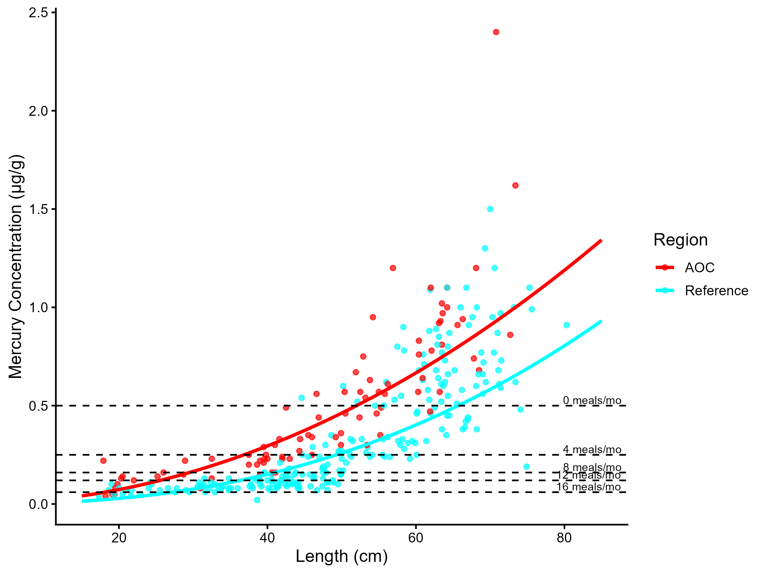
Figure 3.1: Virtual mercury advisories in walleye. Predicted concentrations (curve) and observed values (points) by region using power regression model, compared to MECP advisory limits for mercury for the sensitive population (dashed lines).

Model Summary by Region
AOC: There is a statistically significant relationship between fish length and contaminant concentration. The power model used was: concentration = 0.000178 × Length2.01 (R² = 0.807, p = < 0.001).
Reference: There is a statistically significant relationship between fish length and contaminant concentration. The power model used was: concentration = 2.06e-05 × Length2.412 (R² = 0.718, p = < 0.001).
Table 3.7: Virtual advisory levels for mercury in walleye across regions. Values represent meals/month recommendations. Red cells indicate restrictive virtual advisory below the desired consumption rate of 8 meals/month AND that of reference; green cells indicate unrestrictive virtual advisory equal to or above either the desired consumption rate or reference advisory.
Population | Region | 15-20 | 20-25 | 25-30 | 30-35 | 35-40 | 40-45 | 45-50 | 50-55 | 55-60 | 60-65 | 65-70 | 70-75 | 75+
General | AOC | 32 | 32 | 32 | 16 | 16 | 12 | 8 | 8 | 4 | 4 | 4 | 4 | 4
Sensitive | AOC | 32 | 16 | 12 | 8 | 4 | 4 | 4 | 0 | 0 | 0 | 0 | 0 | 0
General | Reference | 32 | 32 | 32 | 32 | 32 | 16 | 16 | 16 | 12 | 8 | 8 | 4 | 4
Sensitive | Reference | 32 | 32 | 32 | 16 | 12 | 8 | 8 | 4 | 4 | 4 | 0 | 0 | 0
General population: Of 13 size bins, 5 were below the desired consumption rate of 8 meals/month. Of these, 3 were more restrictive than reference. Sensitive population: Of 13 size bins, 9 were below the desired consumption rate of 8 meals/month. Of these, 6 were more restrictive than reference. Overall, Tier 3A assessment for walleye is unsupportive.
Tier 3A Overall Decision: Unsupportive

3.4.1.2 Tier 3B: Contaminant Comparison vs. Reference

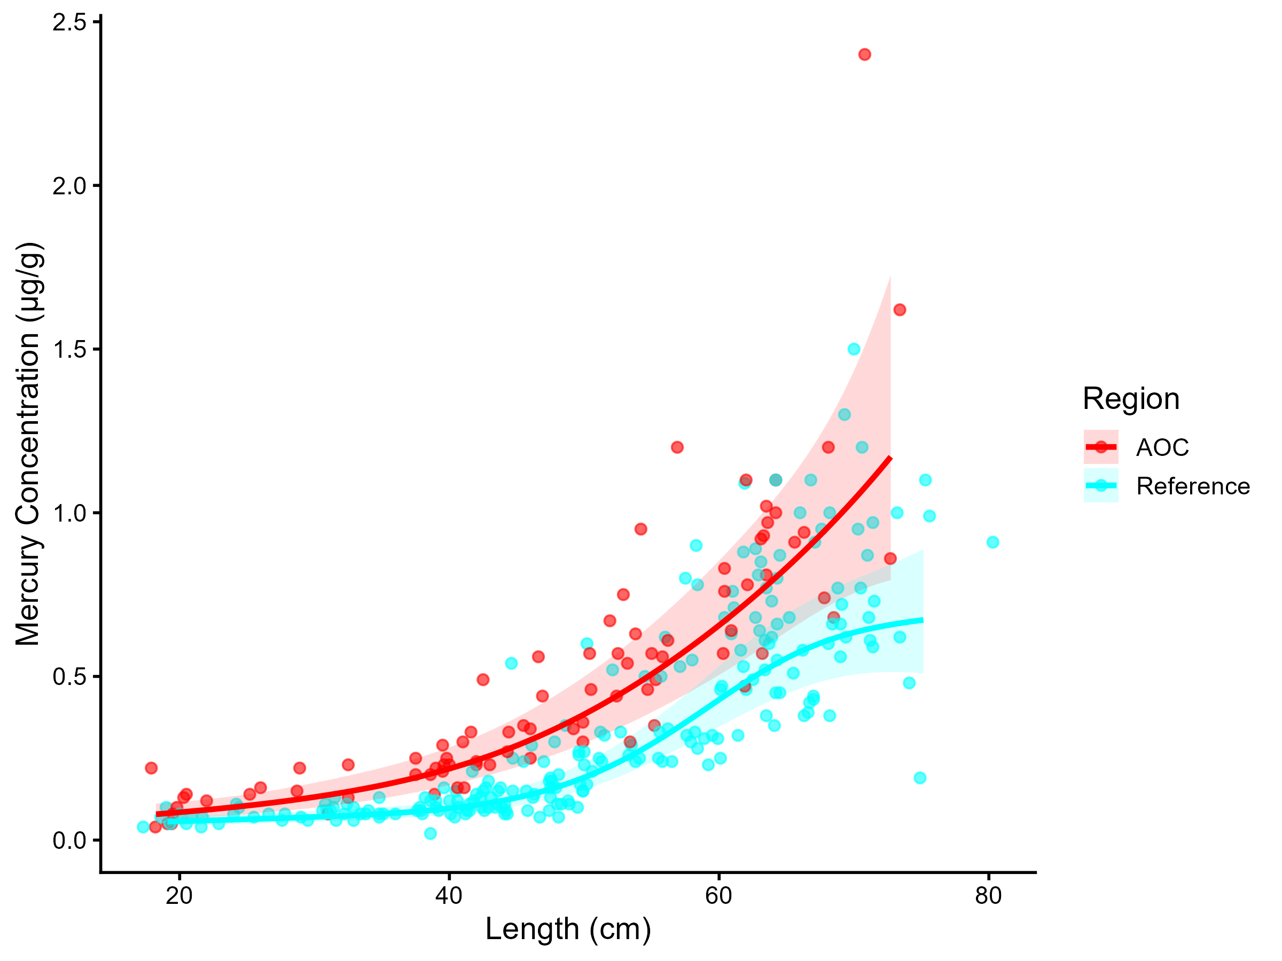
Figure 3.2: Mercury concentration in Walleye by length in the AOC compared to reference sites. Points are observed contaminant values, curves represent GAM model fit (with random effects dropped for simplicity,), ribbons represent 95% confidence interval.

Generalized Additive Models (GAMs) were used to model the relationship between fish length and mercury concentrations for walleye in the AOC and reference sites. The length–contaminant relationship differed significantly between sites (interaction test p = 0.0411). Model-predicted concentrations were calculated across the observed size range for which observations existed for both regions (every 5 cm from 20 to 70 cm) and are presented in Table 3.8.
Table 3.8: Predicted mercury concentrations (µg/g) in walleye, estimated using generalized additive models (GAMs) across the observed range of fish lengths where data is available for both groups. Values represent model-predicted means with 95% confidence intervals. Asterisks (*) indicate size classes where the AOC differs significantly (p < 0.05) from reference.
Region | 20 cm | 25 cm | 30 cm | 35 cm | 40 cm | 45 cm | 50 cm | 55 cm | 60 cm | 65 cm | 70 cm
AOC | 0.09 (0.06–0.12)* | 0.11 (0.08–0.14)* | 0.13 (0.1–0.18)* | 0.17 (0.13–0.22)* | 0.22 (0.17–0.28)* | 0.29 (0.22–0.37)* | 0.38 (0.3–0.5)* | 0.51 (0.39–0.66)* | 0.66 (0.5–0.85)* | 0.83 (0.64–1.09)* | 1.04 (0.75–1.43)*
Reference | 0.06 (0.04–0.08) | 0.06 (0.05–0.08) | 0.07 (0.06–0.09) | 0.08 (0.06–0.1) | 0.1 (0.08–0.12) | 0.13 (0.11–0.16) | 0.19 (0.16–0.24) | 0.29 (0.24–0.36) | 0.43 (0.35–0.53) | 0.56 (0.45–0.69) | 0.63 (0.51–0.8)
Of 11 fish lengths evaluated, 11 had significantly higher predicted mercury concentrations in the AOC compared to reference (p < 0.05). (Table 3.8). Therefore, Tier 3B analysis of walleye is considered unsupportive of redesignation.
Tier 3B Overall Decision: Unsupportive

3.4.1.3 Tier 3C: Temporal Trends

Table 3.9: Estimated time to unrestrictive mercury threshold for median, upper-quartile, and lower-quartile-sized walleye in the AOC, using GAMM-derived half-life decay model. The model-predicted concentration of representative-length fish is reported for the most recent year of observation, and the target concentration corresponding to the earliest of either Tier 1 or Tier 2 thresholds. Tier 1 thresholds representitive an "unrestrictive" advisory for the Sensitive population of 8, based on survey results and MECP advisory thresholds. Tier 2 thresholds are size-matched Sensitive reference medians.
Representative group | Length (cm) | Predicted Conc. (Current Year) | Desired Consumption Rate | Tier 1 threshold conc. | Tier 2 median (Sensitive) meals/mo | Tier 2 Threshold conc. | Target Threshold (earliest) | Years to Threshold | 95% CI | Outcome
Lower quartile | 45 | 0.31 | 8 | 0.16 | 4 | 0.25 | 0.25 | 13.3 | 7.5–19.0 | Unsupportive
Median | 50 | 0.38 | 8 | 0.16 | 4 | 0.25 | 0.25 | 27.7 | 20.2–35.3 | Unsupportive
Upper quartile | 60 | 0.59 | 8 | 0.16 | 0 | 0.50 | 0.50 | 11.2 | 4.7–17.8 | Unsupportive

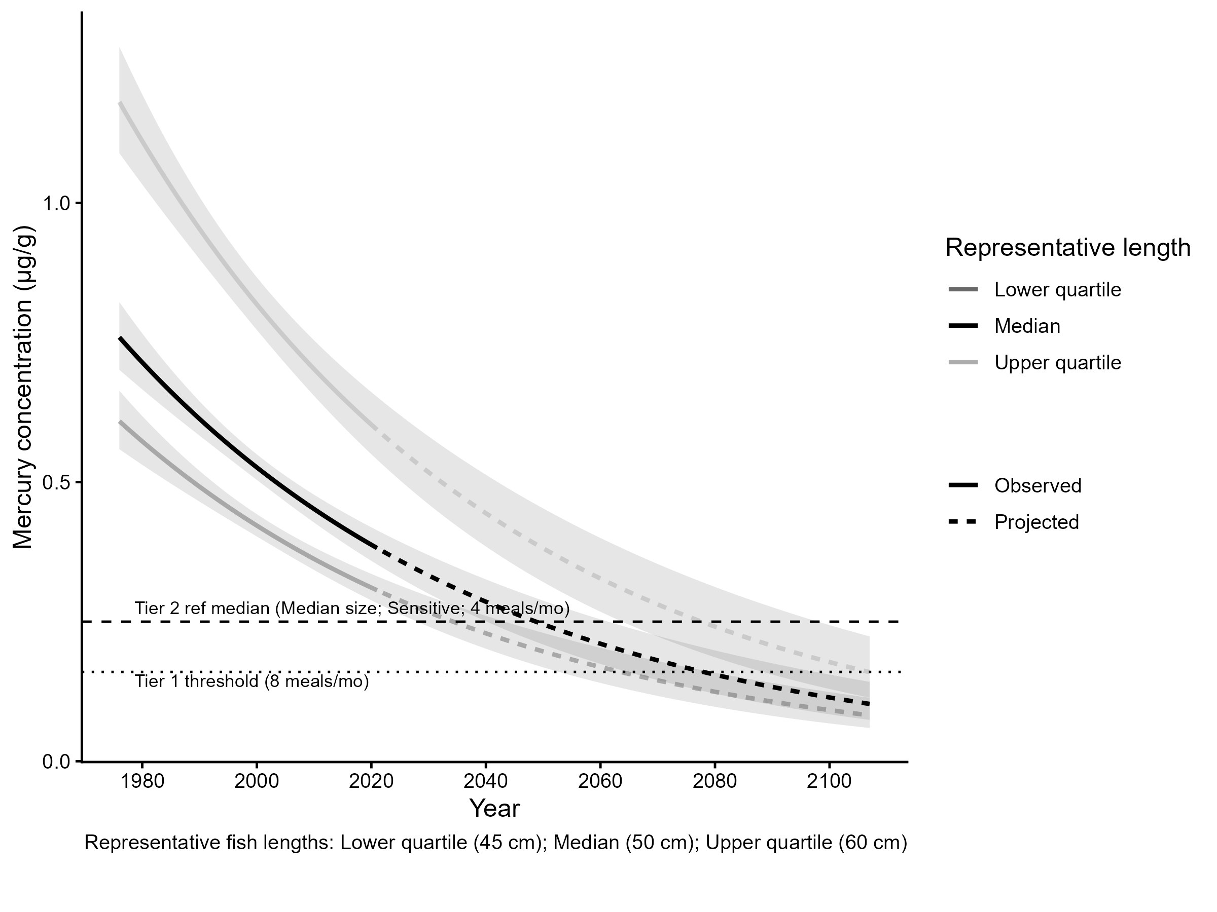
Figure 3.3: Projected mercury concentration in median, upper-quartile, and lower-quartile-length walleye in the AOC. Predicted concentration is based on GAMM-derived half-life decay model. Solid lines represent predicted values within the temporal range of observations, dashed lines represent projected future concentrations, ribbons show 95% CI, and horizontal dotted lines represent the unrestrictive mercury threshold for the sensitive population, based on community desired consumption rate and MECP advisory thresholds, and median tier 2 threshold.
For upper-quartile length (60 cm) fish, it is predicted to take about 85.8 years (95% CI 68–103.7) to reach an unrestrictive monthly meal allowance of 8 meals/month for the Sensitive population. Therefore, Tier 3C is considered unsupportive.
Tier 3C Overall Decision: Unsupportive

3.4.1.4 Summary
A summary of Tier 3 assessment results can be found in table 3.10. Overall, results from this species are unsupportive of redesignation.
Table 3.10: Summary of Tier 3 assessment results in the St. Lawrence River (Cornwall/Akwesasne) Area of Concern.
Tier | Description | Metric | Outcome
Tier 3A | Virtual Advisory | General: 3/13 size bins restrictive or more restrictive than reference; Sensitive: 6/13 size bins restrictive or more restrictive than reference | Unsupportive
Tier 3B | Contaminant Concentration vs Reference | Significantly different smooth terms (p = 0.0410622); 11/11 lengths with higher AOC concentration | Unsupportive
Tier 3C | Temporal Trends | 3/3 representative size groups (lower quartile, median, upper quartile) are restrictive based on time-to-threshold results. | Unsupportive

3.4.2 Largemouth Bass
The following reference sites were used in the tier 3 analysis of largemouth bass in the St. Lawrence River (Cornwall/Akwesasne) AOC:

AOC
- St. Lawrence River 15 - Cornwall Waterfront
- St. Lawrence River 15 - Lake St. Francis

Reference
- Lake Ontario - Cataraqui Bay
- Lake Ontario 10 - Middle Bay of Quinte
- Lake Ontario 11 - Lower Bay of Quinte/Eastern Lake Ontario
- Lake Ontario 4a - Humber Bay
- Lake Ontario 4a - Toronto Islands
- Lake Ontario 4a - Toronto Waterfront
- Lake Ontario 6a - Frenchman Bay
- Lake Ontario 6b - Whitby Harbour
- Lake Ontario 8
- Lake Ontario 9 - Upper Bay of Quinte
- Lake Ontario 9a - Trenton Nearshore
- St. Lawrence River 12 - Lower Thousand Island
- St. Lawrence River 13
- St. Lawrence River 14 - Lake St. Lawrence

3.4.2.1 Tier 3A
Virtual advisory values were generated using by modelling the relationship between fish length and contaminant concentration for largemouth bass and mercury.
Model Summary by Region
Reference: There is a statistically significant relationship between fish length and contaminant concentration. The power model used was: concentration = 0.000474 × Length1.724 (R² = 0.591, p = < 0.001).
AOC: There is a statistically significant relationship between fish length and contaminant concentration. The power model used was: concentration = 0.00188 × Length1.502 (R² = 0.616, p = < 0.001).
General population: Of 9 size bins, 3 were below the desired consumption rate of 8 meals/month. Of these, 3 were more restrictive than reference. Sensitive population: Of 9 size bins, 7 were below the desired consumption rate of 8 meals/month. Of these, 7 were more restrictive than reference. Therefore, Tier 3A analysis of largemouth bass is considered unsupportive for redesignation.

3.4.2.2 Tier 3B
Generalized Additive Models (GAMs) were used to model the relationship between fish length and mercury concentrations for largemouth bass in the AOC and reference regions. The length-contaminant relationship did not differ significantly between sites (interaction test p = 0.431). Marginal mean concentrations were estimated across the full size distribution using a reduced model with shared smooths. The estimated marginal mean Mercury concentration in the AOC was -1.45 µg/g (95% CI: -1.86–-1.04). Estimated values for reference site(s): Reference: -2.02 µg/g (95% CI: -2.19–-1.84).
The AOC has a higher marginal mean concentration than reference, suggesting elevated contamination in this species compared to reference. Therefore, Tier 3B analysis of largemouth bass is considered unsupportive for redesignation.

3.4.2.3 Tier 3C
Temporal trends in largemouth bass for mercury were assessed using generalized additive mixed models (GAMMs) across all years of data, and a model test was performed to estimate the time required to reach a nonrestrictive monthly meal allowance for the upper quantile fish length (rounded to the nearest 5 cm) for sensitive populations. For upper-quartile length (30 cm) fish, it is predicted to take about 14.3 years (95% CI 5–23.7) to reach an unrestrictive monthly meal allowance of 8 meals/month for the Sensitive population. Therefore, Tier 3C is considered unsupportive for redesignation.

3.4.2.4 Tier 3 Summary
Tier | Description | Metric | Outcome
Tier 3A | Virtual Advisory | General: 3/9 size bins restrictive or more restrictive than reference; Sensitive: 7/9 size bins restrictive or more restrictive than reference | Unsupportive
Tier 3B | Contaminant Concentration vs Reference | No significant difference in smooth terms (p = 0.431); AOC marginal mean higher than reference | Unsupportive
Tier 3C | Temporal Trends | 0/3 representative size groups (lower quartile, median, upper quartile) are restrictive based on time-to-threshold results. | Supportive

3.4.3 Northern Pike
The following reference sites were used in the tier 3 analysis of northern pike in the St. Lawrence River (Cornwall/Akwesasne) AOC:

AOC
- St. Lawrence River 15 - Cornwall - St Regis Island S
- St. Lawrence River 15 - Cornwall Island South
- St. Lawrence River 15 - Cornwall Waterfront
- St. Lawrence River 15 - Lake St. Francis

Reference
- Lake Ontario - Cataraqui Bay
- Lake Ontario 10 - Middle Bay of Quinte
- Lake Ontario 11 - Lower Bay of Quinte/Eastern Lake Ontario
- Lake Ontario 2 - Twelve Mile Creek Port Dalhousie
- Lake Ontario 4a - Ashbridges Bay
- Lake Ontario 4a - Humber Bay
- Lake Ontario 4a - Toronto Waterfront
- Lake Ontario 6a - Frenchman Bay
- Lake Ontario 6b - Whitby Harbour
- Lake Ontario 8
- Lake Ontario 9 - Upper Bay of Quinte
- Lake Ontario 9a - Trenton Nearshore
- Lake Ontario 9b - Belleville Nearshore
- St. Lawrence River 12 - Lower Thousand Island
- St. Lawrence River 13

3.4.3.1 Tier 3A
Virtual advisory values were generated using by modelling the relationship between fish length and contaminant concentration for northern pike and mercury.
Model Summary by Region
Reference: There is a statistically significant relationship between fish length and contaminant concentration. The power model used was: concentration = 9.55e-06 × Length2.412 (R² = 0.365, p = < 0.001).
AOC: There is a statistically significant relationship between fish length and contaminant concentration. The power model used was: concentration = 5e-05 × Length2.168 (R² = 0.709, p = < 0.001).
General population: Of 12 size bins, 0 were below the desired consumption rate of 8 meals/month. Of these, 0 were more restrictive than reference. Sensitive population: Of 12 size bins, 2 were below the desired consumption rate of 8 meals/month. Of these, 2 were more restrictive than reference. Therefore, Tier 3A analysis of northern pike is considered unsupportive for redesignation.

3.4.3.2 Tier 3B
Generalized Additive Models (GAMs) were used to model the relationship between fish length and mercury concentrations for northern pike in the AOC and reference regions. The length-contaminant relationship did not differ significantly between sites (interaction test p = 0.811). Marginal mean concentrations were estimated across the full size distribution using a reduced model with shared smooths. The estimated marginal mean Mercury concentration in the AOC was -0.91 µg/g (95% CI: -1.37–-0.46). Estimated values for reference site(s): Reference: -1.46 µg/g (95% CI: -1.69–-1.23).
The AOC has a higher marginal mean concentration than reference, suggesting elevated contamination in this species compared to reference. Therefore, Tier 3B analysis of northern pike is considered unsupportive for redesignation.

3.4.3.3 Tier 3C
Temporal trends in northern pike for mercury were assessed using generalized additive mixed models (GAMMs) across all years of data, and a model test was performed to estimate the time required to reach a nonrestrictive monthly meal allowance for the upper quantile fish length (rounded to the nearest 5 cm) for sensitive populations. For upper-quartile length (70 cm) fish, it is predicted to take about 66.2 years (95% CI 43.1–89.3) to reach an unrestrictive monthly meal allowance of 8 meals/month for the Sensitive population. Therefore, Tier 3C is considered unsupportive for redesignation.

3.4.3.4 Tier 3 Summary
Tier | Description | Metric | Outcome
Tier 3A | Virtual Advisory | General: 0/12 size bins restrictive or more restrictive than reference; Sensitive: 2/12 size bins restrictive or more restrictive than reference | Unsupportive
Tier 3B | Contaminant Concentration vs Reference | No significant difference in smooth terms (p = 0.811); AOC marginal mean higher than reference | Unsupportive
Tier 3C | Temporal Trends | 3/3 representative size groups (lower quartile, median, upper quartile) are restrictive based on time-to-threshold results. | Unsupportive

3.4.4 Smallmouth Bass
The following reference sites were used in the tier 3 analysis of smallmouth bass in the St. Lawrence River (Cornwall/Akwesasne) AOC:

AOC
- St. Lawrence River 15 - Cornwall - St Regis Island S
- St. Lawrence River 15 - Cornwall Island South
- St. Lawrence River 15 - Cornwall Waterfront
- St. Lawrence River 15 - Lake St. Francis

Reference
- Lake Ontario 10 - Middle Bay of Quinte
- Lake Ontario 11 - Lower Bay of Quinte/Eastern Lake Ontario
- Lake Ontario 2 - Twelve Mile Creek Port Dalhousie
- Lake Ontario 4 - Colonel Sams Bay
- Lake Ontario 4a - Humber Bay
- Lake Ontario 4a - Mimico Bay
- Lake Ontario 4a - Toronto Waterfront
- Lake Ontario 8
- Lake Ontario 9 - Upper Bay of Quinte
- Lake Ontario 9a - Trenton Nearshore
- Lake Ontario 9b - Belleville Nearshore
- St. Lawrence River 12 - Lower Thousand Island
- St. Lawrence River 13

3.4.4.1 Tier 3A
Virtual advisory values were generated using by modelling the relationship between fish length and contaminant concentration for smallmouth bass and mercury.
Model Summary by Region
AOC: There is a statistically significant relationship between fish length and contaminant concentration. The power model used was: concentration = 0.000724 × Length1.713 (R² = 0.722, p = < 0.001).
Reference: There is a statistically significant relationship between fish length and contaminant concentration. The power model used was: concentration = 0.000183 × Length1.973 (R² = 0.751, p = < 0.001).
General population: Of 9 size bins, 0 were below the desired consumption rate of 8 meals/month. Of these, 0 were more restrictive than reference. Sensitive population: Of 9 size bins, 3 were below the desired consumption rate of 8 meals/month. Of these, 3 were more restrictive than reference. Therefore, Tier 3A analysis of smallmouth bass is considered unsupportive for redesignation.

3.4.4.2 Tier 3B
Generalized Additive Models (GAMs) were used to model the relationship between fish length and mercury concentrations for smallmouth bass in the AOC and reference regions. The length-contaminant relationship did not differ significantly between sites (interaction test p = 0.418). Marginal mean concentrations were estimated across the full size distribution using a reduced model with shared smooths. The estimated marginal mean Mercury concentration in the AOC was -1.19 µg/g (95% CI: -1.44–-0.94). Estimated values for reference site(s): Reference: -1.73 µg/g (95% CI: -1.88–-1.57).
The AOC has a higher marginal mean concentration than reference, suggesting elevated contamination in this species compared to reference. Therefore, Tier 3B analysis of smallmouth bass is considered unsupportive for redesignation.

3.4.4.3 Tier 3C
Temporal trends in smallmouth bass for mercury were assessed using generalized additive mixed models (GAMMs) across all years of data, and a model test was performed to estimate the time required to reach a nonrestrictive monthly meal allowance for the upper quantile fish length (rounded to the nearest 5 cm) for sensitive populations. For upper-quartile length (45 cm) fish, it is predicted to take about 69.4 years (95% CI 57.8–81.1) to reach an unrestrictive monthly meal allowance of 8 meals/month for the Sensitive population. Therefore, Tier 3C is considered unsupportive for redesignation.

3.4.4.4 Tier 3 Summary
Tier | Description | Metric | Outcome
Tier 3A | Virtual Advisory | General: 0/9 size bins restrictive or more restrictive than reference; Sensitive: 3/9 size bins restrictive or more restrictive than reference | Unsupportive
Tier 3B | Contaminant Concentration vs Reference | No significant difference in smooth terms (p = 0.418); AOC marginal mean higher than reference | Unsupportive
Tier 3C | Temporal Trends | 1/3 representative size groups (lower quartile, median, upper quartile) are restrictive based on time-to-threshold results. | Supportive

3.4.5 Yellow Perch
The following reference sites were used in the tier 3 analysis of yellow perch in the St. Lawrence River (Cornwall/Akwesasne) AOC:

AOC
- St. Lawrence River - Cornwall Marina
- St. Lawrence River - Cornwall Zone 2
- St. Lawrence River 15 - Cornwall - St Regis Island S
- St. Lawrence River 15 - Cornwall Island South
- St. Lawrence River 15 - Cornwall Waterfront
- St. Lawrence River 15 - Lake St. Francis

Reference
- Lake Ontario - Bath
- Lake Ontario - Breakwater Landing
- Lake Ontario - Cataraqui Bay
- Lake Ontario - Cataraqui River - Anglin Bay
- Lake Ontario - Millhaven
- Lake Ontario 10 - Middle Bay of Quinte
- Lake Ontario 11 - Lower Bay of Quinte/Eastern Lake Ontario
- Lake Ontario 4a - Ashbridges Bay
- Lake Ontario 4a - Humber Bay
- Lake Ontario 4a - Toronto Islands
- Lake Ontario 4a - Toronto Waterfront
- Lake Ontario 6a - Frenchman Bay
- Lake Ontario 8
- Lake Ontario 8 - Presquille Bay
- Lake Ontario 9 - Upper Bay of Quinte
- Lake Ontario 9b - Bay of Quinte - South Foster Park
- St. Lawrence River - Cornwall zone 3
- St. Lawrence River - MacDonnel Island
- St. Lawrence River 12 - Lower Thousand Island
- St. Lawrence River 13
- St. Lawrence River 14 - Lake St. Lawrence

3.4.5.1 Tier 3A
Virtual advisory values were generated using by modelling the relationship between fish length and contaminant concentration for yellow perch and mercury.
Model Summary by Region
AOC: There is a statistically significant relationship between fish length and contaminant concentration. The power model used was: concentration = 0.00576 × Length1.095 (R² = 0.546, p = < 0.001).
Reference: There is a statistically significant relationship between fish length and contaminant concentration. The power model used was: concentration = 0.000817 × Length1.528 (R² = 0.67, p = < 0.001).
General population: Of 5 size bins, 0 were below the desired consumption rate of 8 meals/month. Of these, 0 were more restrictive than reference. Sensitive population: Of 5 size bins, 2 were below the desired consumption rate of 8 meals/month. Of these, 2 were more restrictive than reference. Therefore, Tier 3A analysis of yellow perch is considered unsupportive for redesignation.

3.4.5.2 Tier 3B
Generalized Additive Models (GAMs) were used to model the relationship between fish length and mercury concentrations for yellow perch in the AOC and reference regions. The length-contaminant relationship did not differ significantly between sites (interaction test p = 0.516). Marginal mean concentrations were estimated across the full size distribution using a reduced model with shared smooths. The estimated marginal mean Mercury concentration in the AOC was -2.31 µg/g (95% CI: -2.64–-1.98). Estimated values for reference site(s): Reference: -2.94 µg/g (95% CI: -3.12–-2.77).
The AOC has a higher marginal mean concentration than reference, suggesting elevated contamination in this species compared to reference. Therefore, Tier 3B analysis of yellow perch is considered unsupportive for redesignation.

3.4.5.3 Tier 3C
Temporal trends in yellow perch for mercury were assessed using generalized additive mixed models (GAMMs) across all years of data, and a model test was performed to estimate the time required to reach a nonrestrictive monthly meal allowance for the upper quantile fish length (rounded to the nearest 5 cm) for sensitive populations. For upper-quartile length (25 cm) fish, the current trend does not indicate declining mercury concentrations. Under the present trend, reaching an unrestrictive monthly meal allowance of 8 meals/month for the Sensitive population is not expected. Therefore, Tier 3C is considered unsupportive for redesignation.

3.4.5.4 Tier 3 Summary
Tier | Description | Metric | Outcome
Tier 3A | Virtual Advisory | General: 0/5 size bins restrictive or more restrictive than reference; Sensitive: 2/5 size bins restrictive or more restrictive than reference | Unsupportive
Tier 3B | Contaminant Concentration vs Reference | No significant difference in smooth terms (p = 0.516); AOC marginal mean higher than reference | Unsupportive
Tier 3C | Temporal Trends | 0/3 representative size groups (lower quartile, median, upper quartile) are restrictive based on time-to-threshold results. | Supportive

3.4.6 Channel Catfish, Rock Bass, and White Perch
There were an insufficient number of observed records of channel catfish (17 observations across 2 years of data), rock bass (24 observations across 3 years of data), and white perch (7 observations across 2 years of data) in the AOC from which to draw conclusions at the Tier 3 level. Thus, these species automatically fail Tier 3, and will be considered holistically as part of Tier 4 assessment.

3.5 Tier 4

4 Discussion and Recommendations

References

Appendix

5 Tier 3 Supplementary Figures for St. Lawrence River (Cornwall/Akwesasne) AOC

5.0.1 Largemouth Bass
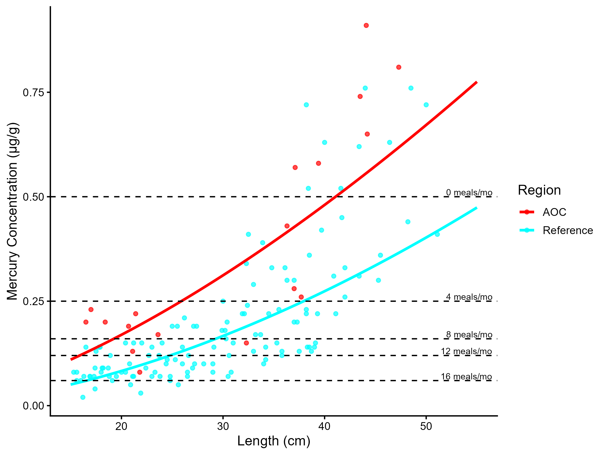
Figure 5.1: Virtual mercury advisories in largemouth bass. Predicted concentrations (curve) and observed values (points) by region using power regression model, compared to MECP advisory limits for mercury for the Sensititve population (dashed lines).
Table 5.1: Virtual advisory levels for mercury in largemouth bass across regions. Values represent meals/month recommendations. Red cells indicate restrictive virtual advisory below the desired consumption rate of 8 meals/month AND that of reference; green cells indicate unrestrictive virtual advisory equal to or above either the desired consumption rate or reference advisory.
Population | Region | 15-20 | 20-25 | 25-30 | 30-35 | 35-40 | 40-45 | 45-50 | 50-55 | 55-60
General | AOC | 32 | 16 | 16 | 12 | 8 | 8 | 4 | 4 | 4
Sensitive | AOC | 12 | 8 | 4 | 4 | 4 | 0 | 0 | 0 | 0
General | Reference | 32 | 32 | 32 | 16 | 16 | 16 | 12 | 8 | 8
Sensitive | Reference | 16 | 16 | 12 | 8 | 8 | 4 | 4 | 4 | 4

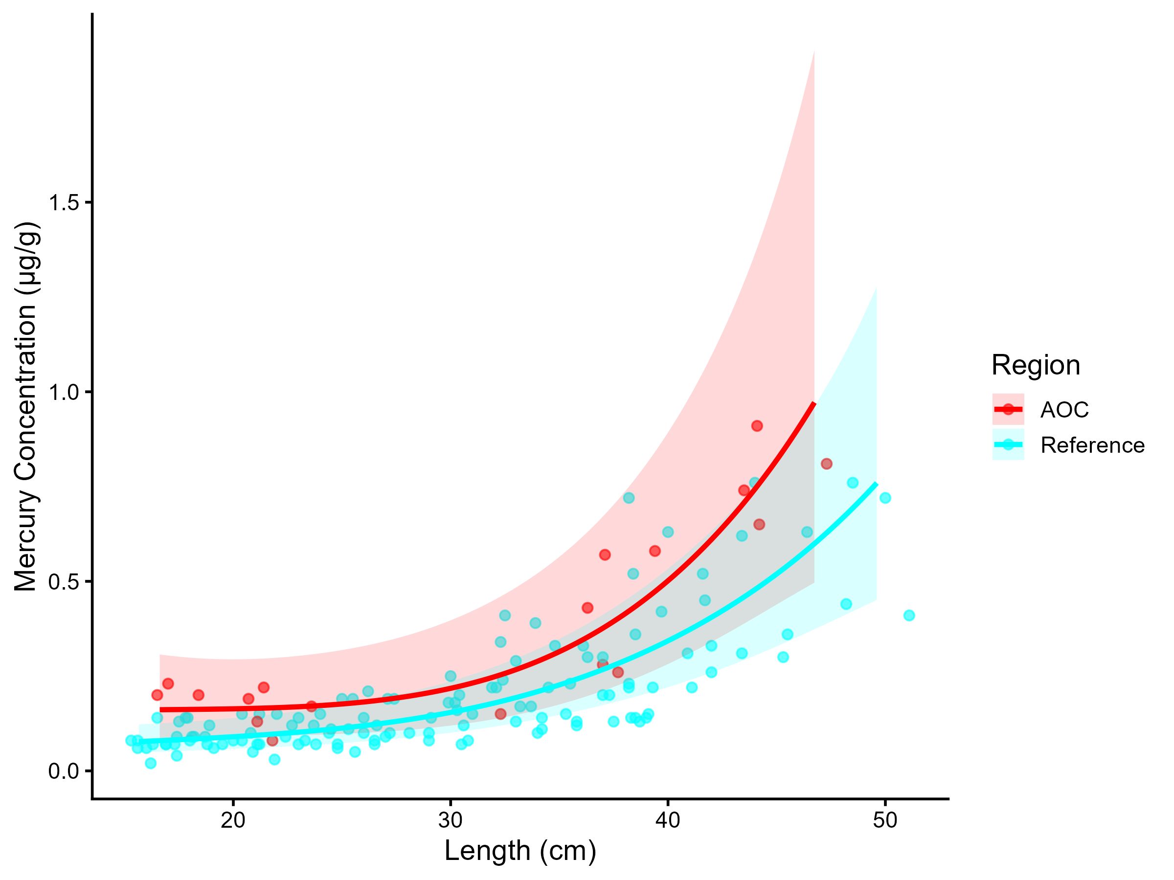
Figure 5.2: Mercury concentration in Largemouth Bass by length in the AOC compared to reference sites. Points are observed contaminant values, curves represent GAM model fit (with random effects dropped for simplicity, fitted across the 1st to 99th percentile of data to ensure reasonable support), ribbons represent 95% confidence interval.

Table 5.2: Estimated time to unrestrictive mercury threshold for an upper-quartile-sized largemouth bass in the AOC, using GAMM-derived half-life decay model. The model-predicted concentration of a median, upper-quartile, and lower quartile length fish is reported for the most recent year of observation, and the target concentration corresponding to an "unrestrictive" advisory for the Sensitive population of 8, based on survey results and MECP advisory thresholds.
Representative group | Length (cm) | Predicted Conc. (Current Year) | Desired Consumption Rate | Tier 1 threshold conc. | Tier 2 median (Sensitive) meals/mo | Tier 2 Threshold conc. | Target Threshold (earliest) | Years to Threshold | 95% CI | Outcome
Lower quartile | 15 | 0.13 | 8 | 0.16 | 8 | 0.16 | 0.16 | 0.0 | -5.0–5.0 | Supportive
Median | 20 | 0.16 | 8 | 0.16 | 8 | 0.16 | 0.16 | 0.0 | -5.8–5.8 | Supportive
Upper quartile | 30 | 0.23 | 8 | 0.16 | 4 | 0.25 | 0.25 | 0.0 | -7.9–7.9 | Supportive

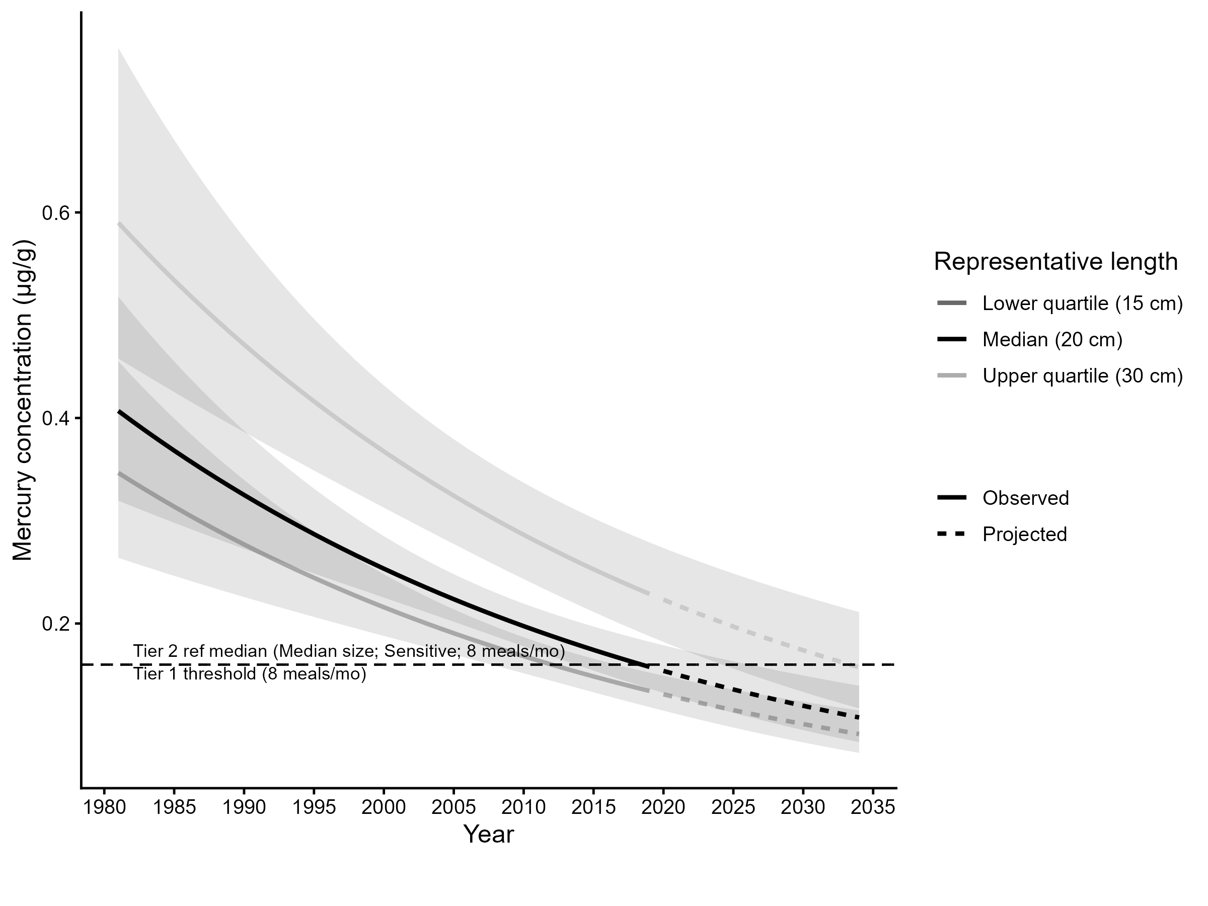
Figure 5.3: Projected mercury concentration in median, upper-quartile-, and lower-quartile-length Largemouth Bass in the AOC. Predicted concentration is based on GAMM-derived half-life decay model. Solid lines represents predicted values within the temporal range of observations, dashed lines represents projected future concentrations, ribbons show 95% CI, and the horizontal dotted line represents the unrestrictive mercury threshold for the sensitive population, based on community desired consumption rate and MECP advisory thresholds.

5.0.2 Northern Pike
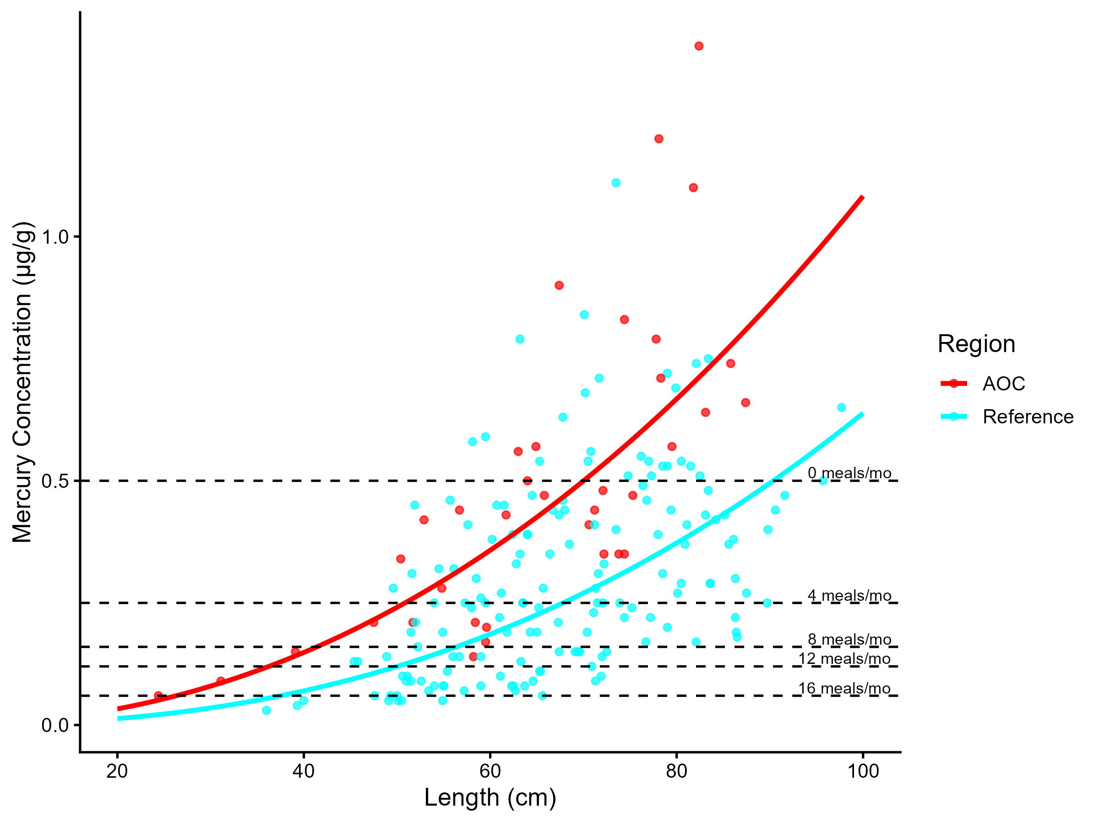
Figure 5.4: Virtual mercury advisories in northern pike. Predicted concentrations (curve) and observed values (points) by region using power regression model, compared to MECP advisory limits for mercury for the Sensititve population (dashed lines).
Table 5.3: Virtual advisory levels for mercury in northern pike across regions. Values represent meals/month recommendations. Red cells indicate restrictive virtual advisory below the desired consumption rate of 4 meals/month AND that of reference; green cells indicate unrestrictive virtual advisory equal to or above either the desired consumption rate or reference advisory.
Population | Region | 20-25 | 25-30 | 30-35 | 35-40 | 40-45 | 45-50 | 50-55 | 55-60 | 60-65 | 65-70 | 70-75 | 75+
General | AOC | 32 | 32 | 32 | 32 | 16 | 16 | 16 | 12 | 12 | 8 | 8 | 4
Sensitive | AOC | 32 | 16 | 16 | 12 | 8 | 8 | 4 | 4 | 4 | 4 | 0 | 0
General | Reference | 32 | 32 | 32 | 32 | 32 | 32 | 32 | 16 | 16 | 16 | 16 | 8
Sensitive | Reference | 32 | 32 | 32 | 32 | 16 | 16 | 12 | 8 | 8 | 8 | 4 | 4

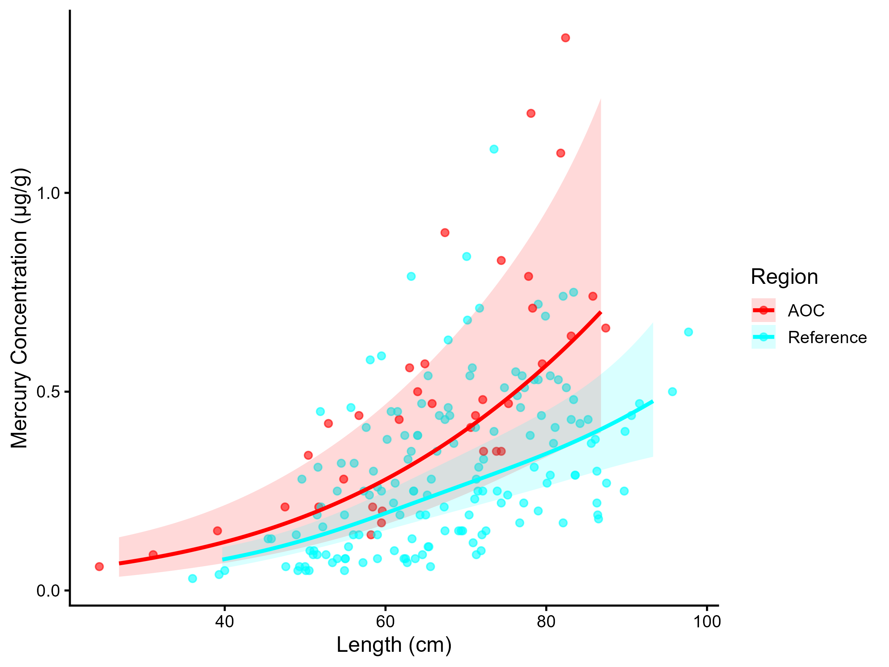
Figure 5.5: Mercury concentration in Northern Pike by length in the AOC compared to reference sites. Points are observed contaminant values, curves represent GAM model fit (with random effects dropped for simplicity, fitted across the 1st to 99th percentile of data to ensure reasonable support), ribbons represent 95% confidence interval.

Table 5.4: Estimated time to unrestrictive mercury threshold for an upper-quartile-sized northern pike in the AOC, using GAMM-derived half-life decay model. The model-predicted concentration of an median, upper-quartile, and lower quartile length fish is reported for the most recent year of observation, and the target concentration corresponding to an "unrestrictive" advisory for the Sensitive population of 4, based on survey results and MECP advisory thresholds.
Representative group | Length (cm) | Predicted Conc. (Current Year) | Desired Consumption Rate | Tier 1 threshold conc. | Tier 2 median (Sensitive) meals/mo | Tier 2 Threshold conc. | Target Threshold (earliest) | Years to Threshold | 95% CI | Outcome
Lower quartile | 50 | 0.21 | 8 | 0.16 | 8 | 0.16 | 0.16 | 16.8 | 3.7–29.9 | Unsupportive
Median | 60 | 0.30 | 8 | 0.16 | 4 | 0.25 | 0.25 | 12.7 | 0.6–24.8 | Unsupportive
Upper quartile | 70 | 0.45 | 8 | 0.16 | 4 | 0.25 | 0.25 | 37.4 | 21.3–53.4 | Unsupportive

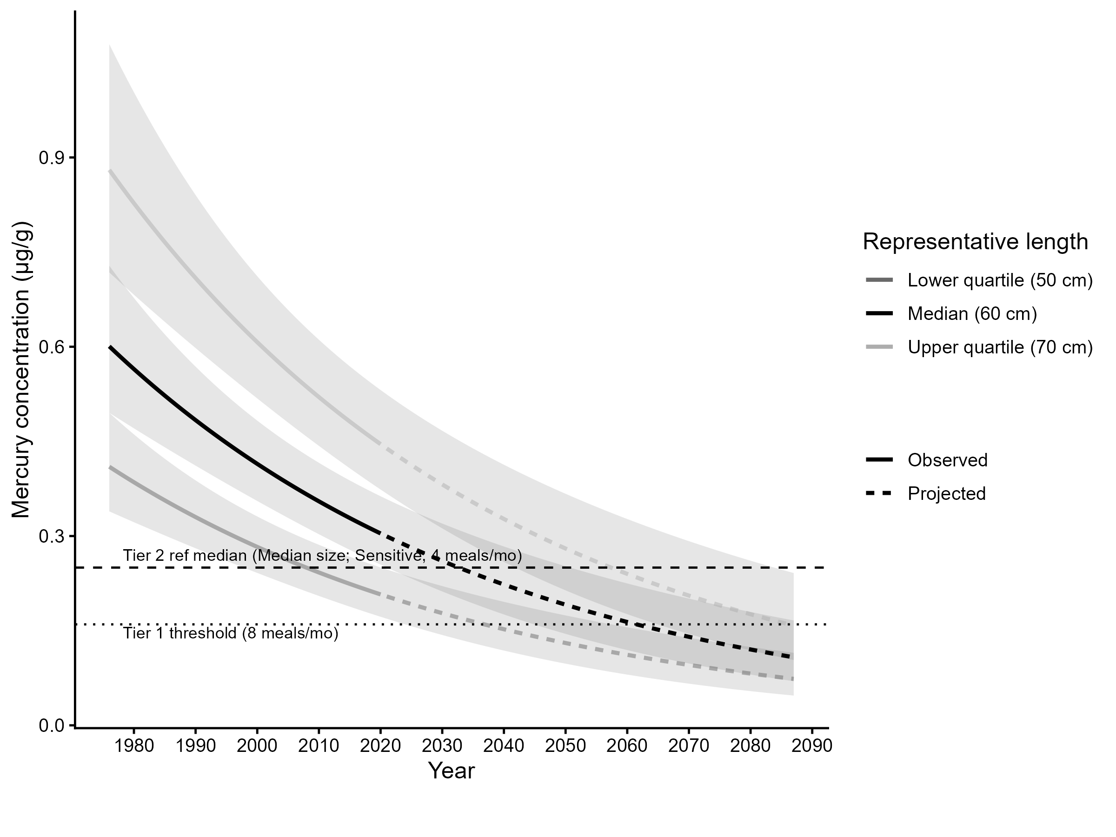
Figure 5.6: Projected mercury concentration in median, upper-quartile-, and lower-quartile-length Northern Pike in the AOC. Predicted concentration is based on GAMM-derived half-life decay model. Solid lines represents predicted values within the temporal range of observations, dashed lines represent projected future concentrations, ribbons show 95% CI, and the horizontal dotted line represents the unrestrictive mercury threshold for the sensitive population, based on community desired consumption rate and MECP advisory thresholds.

5.0.3 Smallmouth Bass
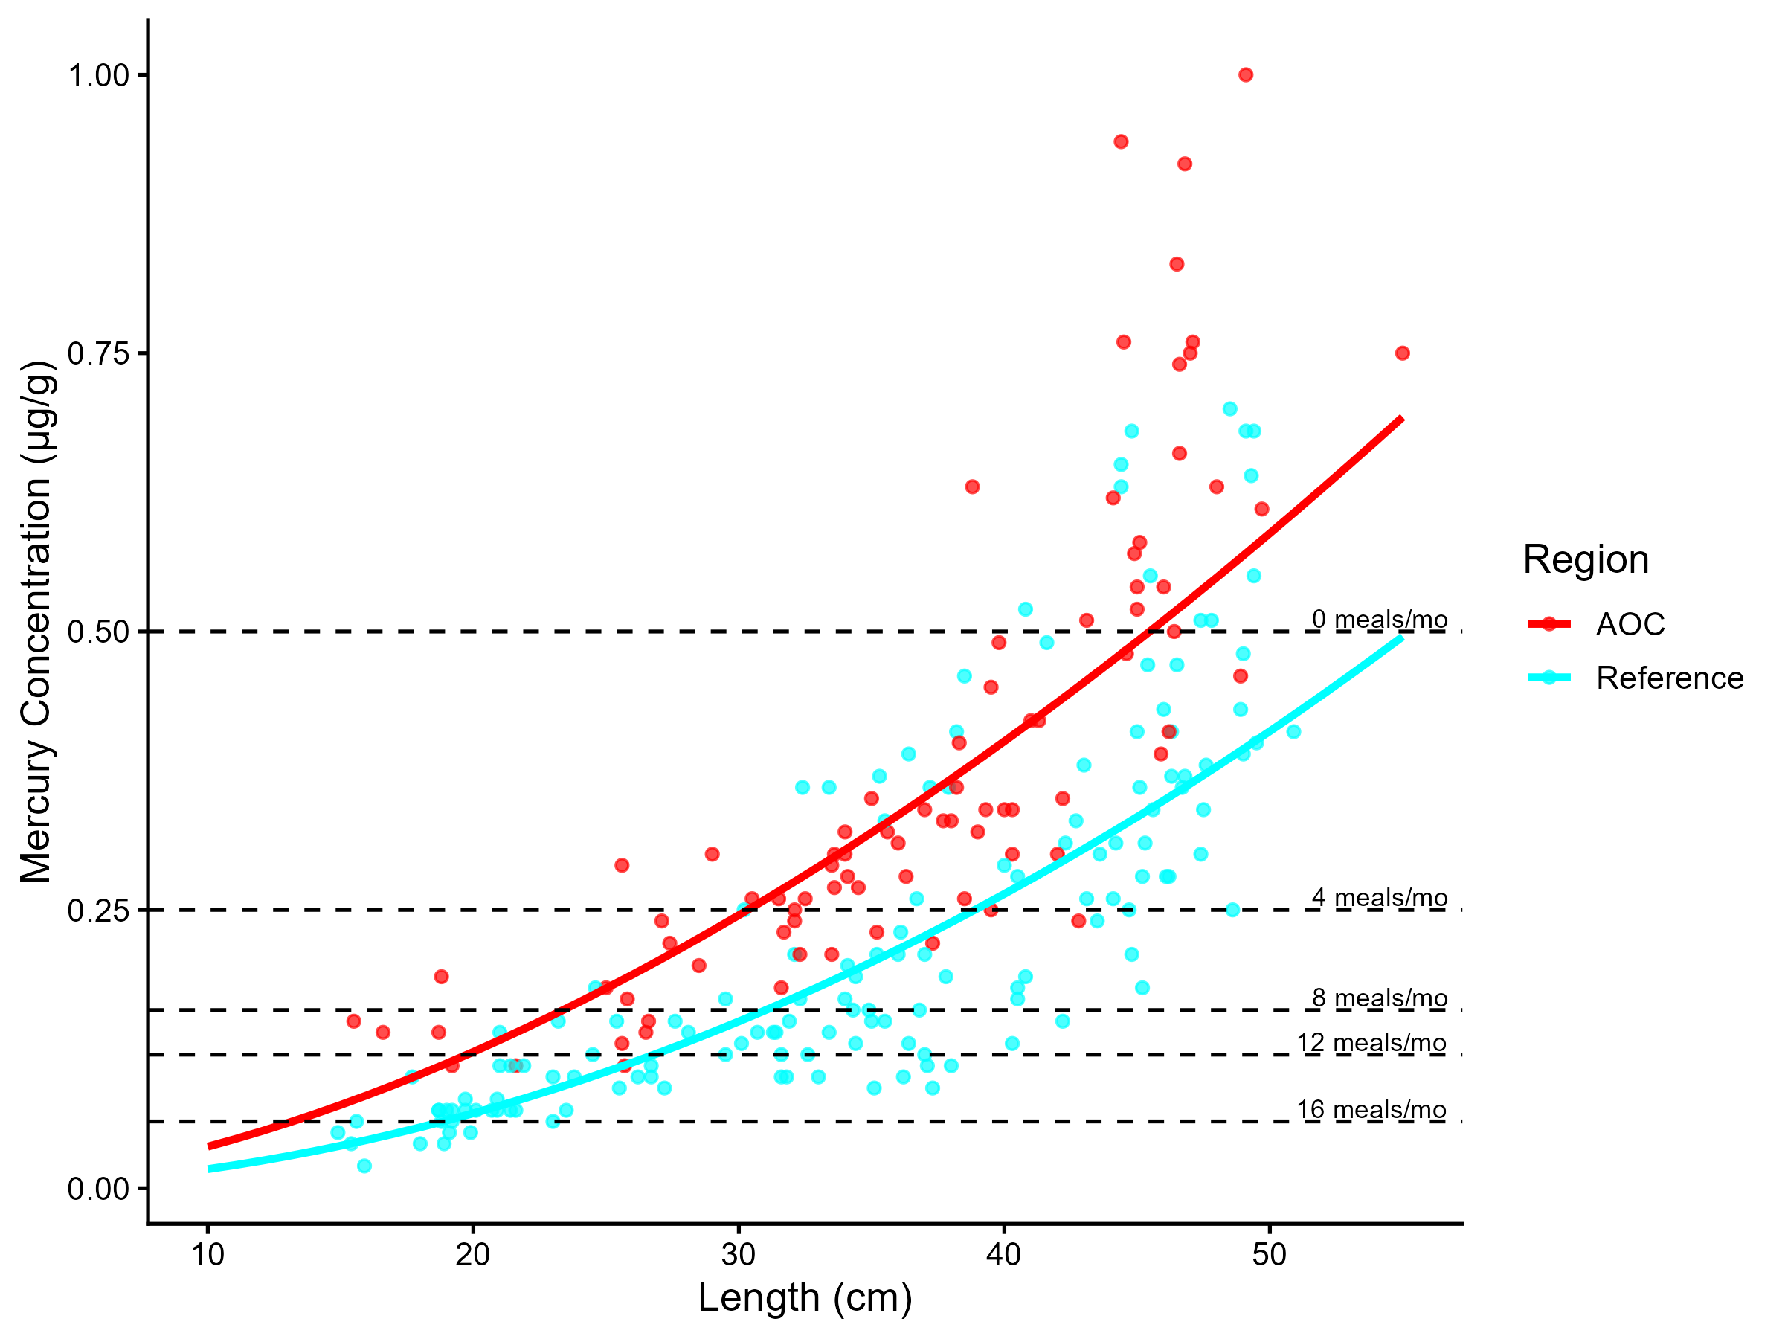
Figure 5.7: Virtual mercury advisories in smallmouth bass. Predicted concentrations (curve) and observed values (points) by region using power regression model, compared to MECP advisory limits for mercury for the Sensititve population (dashed lines).
Table 5.5: Virtual advisory levels for mercury in smallmouth bass across regions. Values represent meals/month recommendations. Red cells indicate restrictive virtual advisory below the desired consumption rate of 4 meals/month AND that of reference; green cells indicate unrestrictive virtual advisory equal to or above either the desired consumption rate or reference advisory.
Population | Region | 15-20 | 20-25 | 25-30 | 30-35 | 35-40 | 40-45 | 45-50 | 50-55 | 55-60
General | AOC | 32 | 32 | 16 | 16 | 12 | 8 | 8 | 4 | 4
Sensitive | AOC | 16 | 12 | 8 | 4 | 4 | 4 | 0 | 0 | 0
General | Reference | 32 | 32 | 32 | 16 | 16 | 16 | 12 | 8 | 8
Sensitive | Reference | 32 | 16 | 12 | 8 | 8 | 4 | 4 | 4 | 4

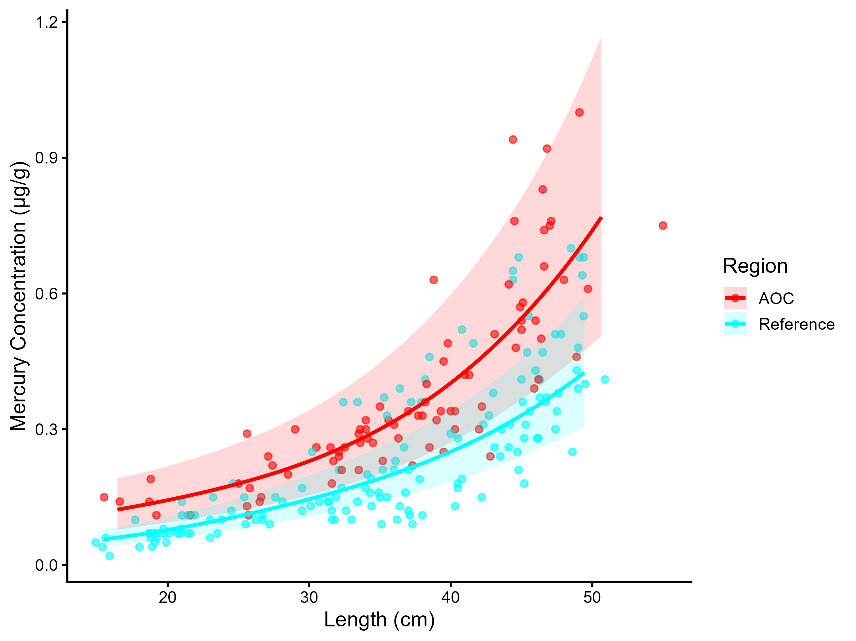
Figure 5.8: Mercury concentration in Smallmouth Bass by length in the AOC compared to reference sites. Points are observed contaminant values, curves represent GAM model fit (with random effects dropped for simplicity, fitted across the 1st to 99th percentile of data to ensure reasonable support), ribbons represent 95% confidence interval.

Table 5.6: Estimated time to unrestrictive mercury threshold for an upper-quartile-sized smallmouth bass in the AOC, using GAMM-derived half-life decay model. The model-predicted concentration of a median, upper-quartile, and lower quartile length fish is reported for the most recent year of observation, and the target concentration corresponding to an "unrestrictive" advisory for the Sensitive population of 4, based on survey results and MECP advisory thresholds.
Representative group | Length (cm) | Predicted Conc. (Current Year) | Desired Consumption Rate | Tier 1 threshold conc. | Tier 2 median (Sensitive) meals/mo | Tier 2 Threshold conc. | Target Threshold (earliest) | Years to Threshold | 95% CI | Outcome
Lower quartile | 30 | 0.22 | 8 | 0.16 | 8 | 0.16 | 0.16 | 20.5 | 15.1–25.9 | Unsupportive
Median | 40 | 0.36 | 8 | 0.16 | 0 | 0.50 | 0.50 | 0.0 | -4.0–4.0 | Supportive
Upper quartile | 45 | 0.49 | 8 | 0.16 | 0 | 0.50 | 0.50 | 0.0 | -4.0–4.0 | Supportive

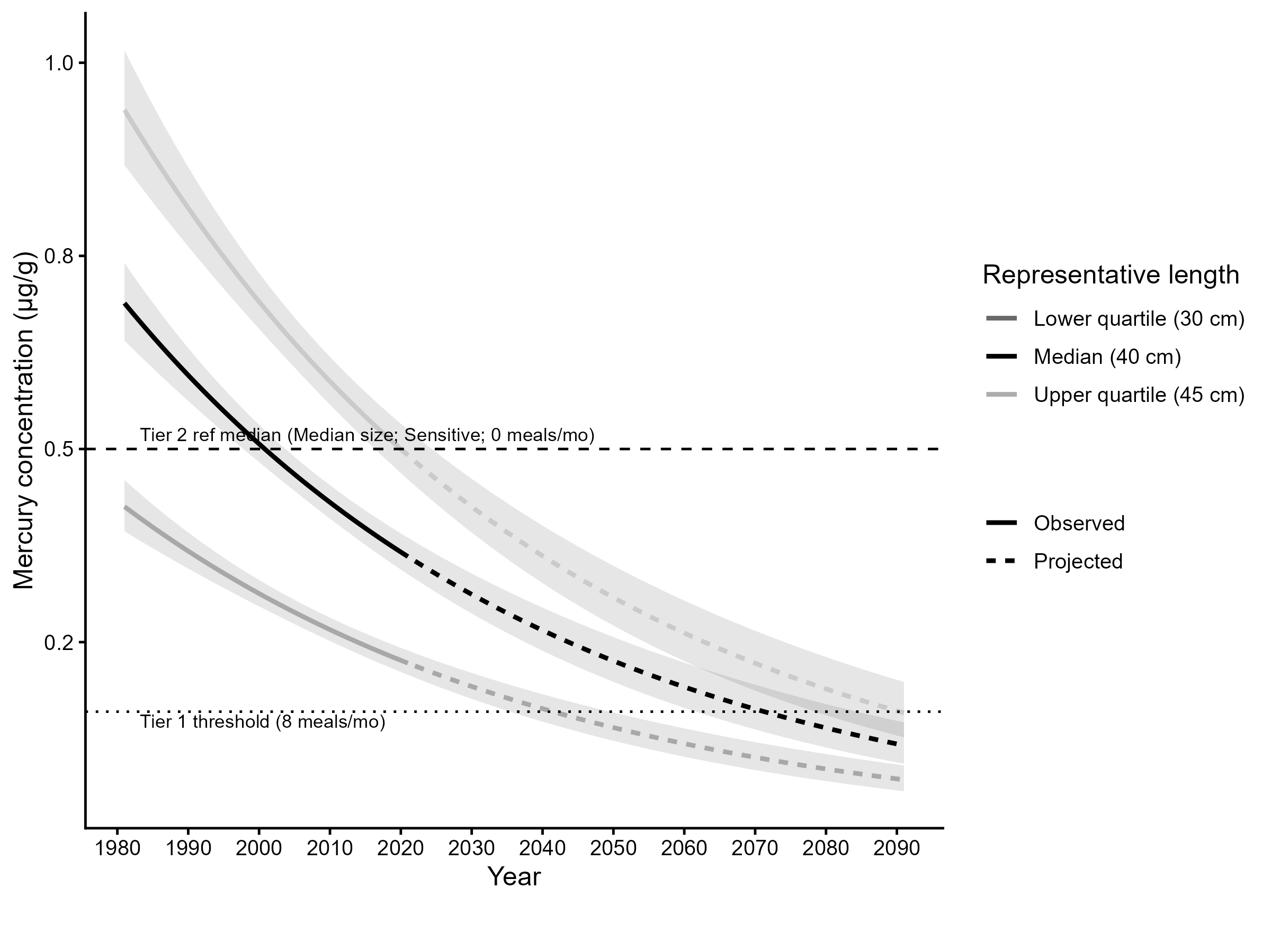
Figure 5.9: Projected mercury concentration in median, upper-quartile-, and lower-quartile-length Smallmouth Bass in the AOC. Predicted concentration is based on GAMM-derived half-life decay model. Solid lines represents predicted values within the temporal range of observations, dashed lines represents projected future concentrations, ribbons show 95% CI, and the horizontal dotted line represents the unrestrictive mercury threshold for the sensitive population, based on community desired consumption rate and MECP advisory thresholds.

5.0.4 Yellow Perch
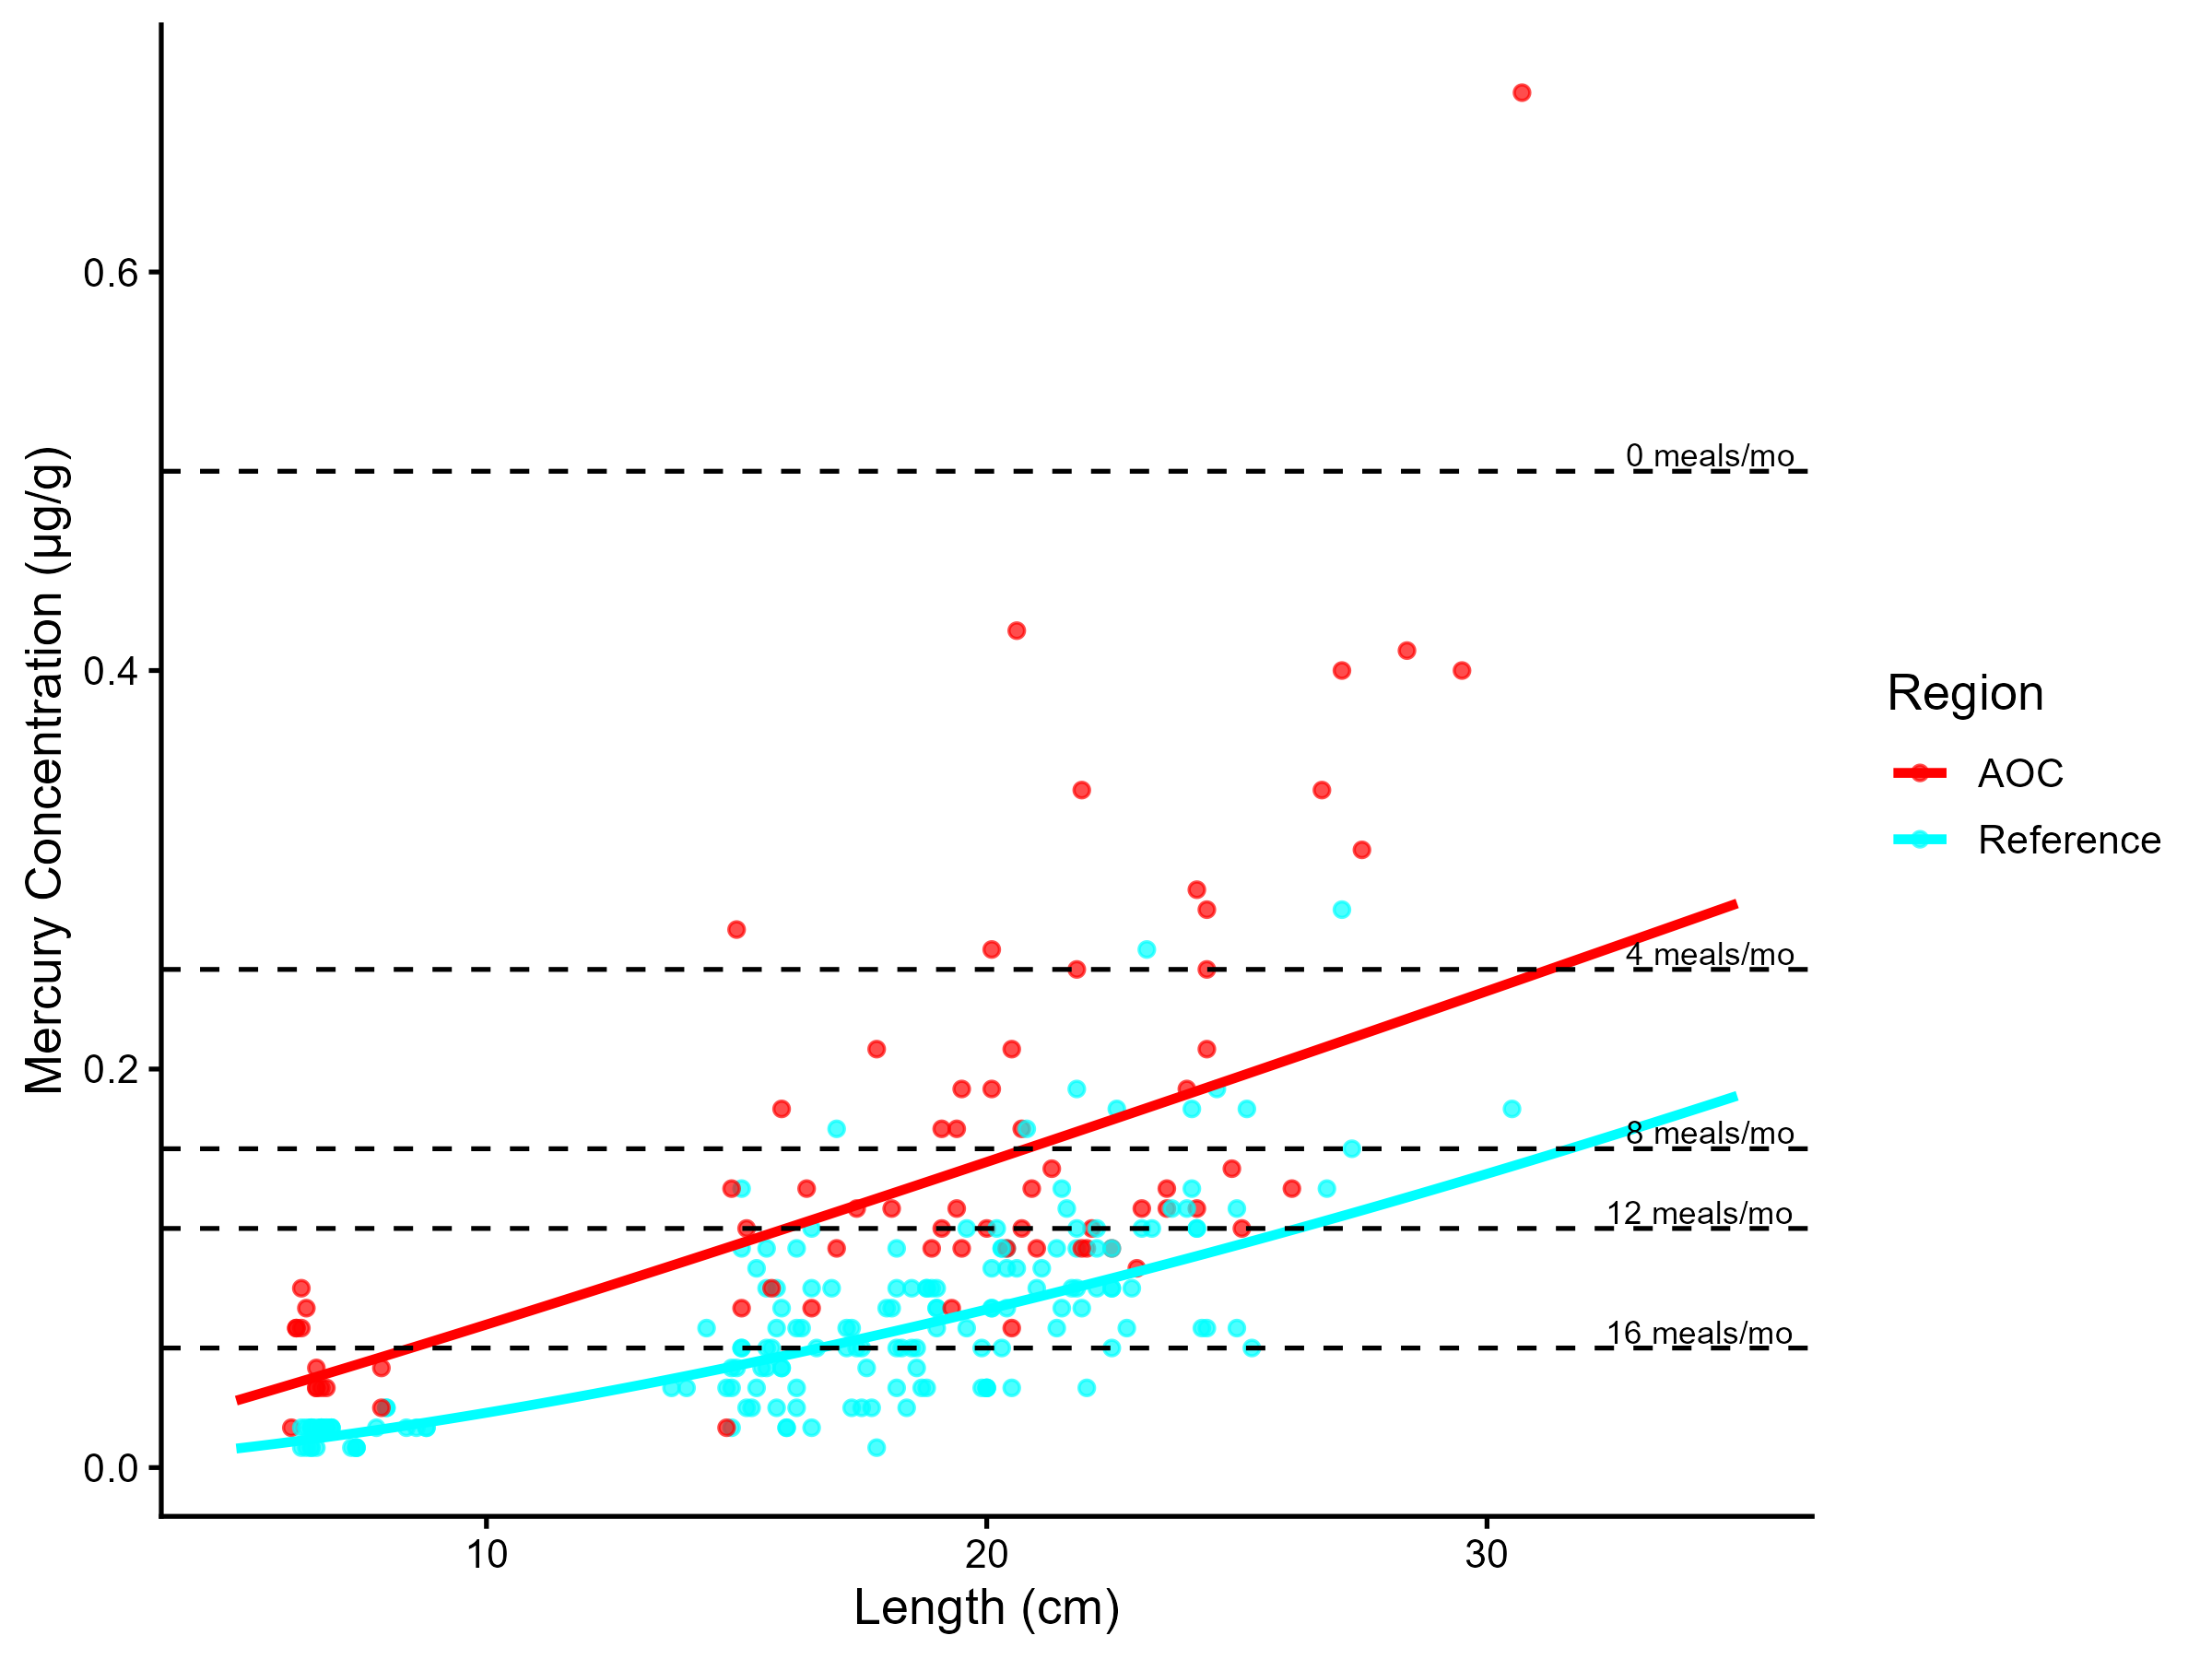
Figure 5.10: Virtual mercury advisories in yellow perch. Predicted concentrations (curve) and observed values (points) by region using power regression model, compared to MECP advisory limits for mercury for the Sensititve population (dashed lines).
Table 5.7: Virtual advisory levels for mercury in yellow perch across regions. Values represent meals/month recommendations. Red cells indicate restrictive virtual advisory below the desired consumption rate of 8 meals/month AND that of reference; green cells indicate unrestrictive virtual advisory equal to or above either the desired consumption rate or reference advisory.
Population | Region | 15-20 | 20-25 | 25-30 | 30-35 | 35-40
General | AOC | 32 | 16 | 16 | 16 | 16
Sensitive | AOC | 12 | 8 | 8 | 4 | 4
General | Reference | 32 | 32 | 32 | 16 | 16
Sensitive | Reference | 16 | 16 | 12 | 8 | 8

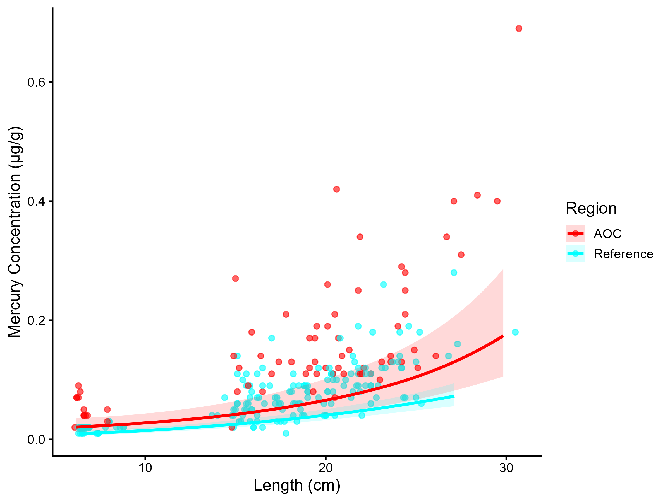
Figure 5.11: Mercury concentration in Yellow Perch by length in the AOC compared to reference sites. Points are observed contaminant values, curves represent GAM model fit (with random effects dropped for simplicity, fitted across the 1st to 99th percentile of data to ensure reasonable support), ribbons represent 95% confidence interval.

Table 5.8: Estimated time to unrestrictive mercury threshold for an upper-quartile-sized yellow perch in the AOC, using GAMM-derived half-life decay model. The model-predicted concentration of a median, upper-quartile, and lower quartile length fish is reported for the most recent year of observation, and the target concentration corresponding to an "unrestrictive" advisory for the Sensitive population of 8, based on survey results and MECP advisory thresholds.
Representative group | Length (cm) | Predicted Conc. (Current Year) | Desired Consumption Rate | Tier 1 threshold conc. | Tier 2 median (Sensitive) meals/mo | Tier 2 Threshold conc. | Target Threshold (earliest) | Years to Threshold | 95% CI | Outcome
Lower quartile | 20 | 0.14 | 8 | 0.16 | 8 | 0.16 | 0.16 | 0.0 | — | Supportive
Median | 20 | 0.14 | 8 | 0.16 | 8 | 0.16 | 0.16 | 0.0 | — | Supportive
Upper quartile | 25 | 0.19 | 8 | 0.16 | 4 | 0.25 | 0.25 | 0.0 | — | Supportive

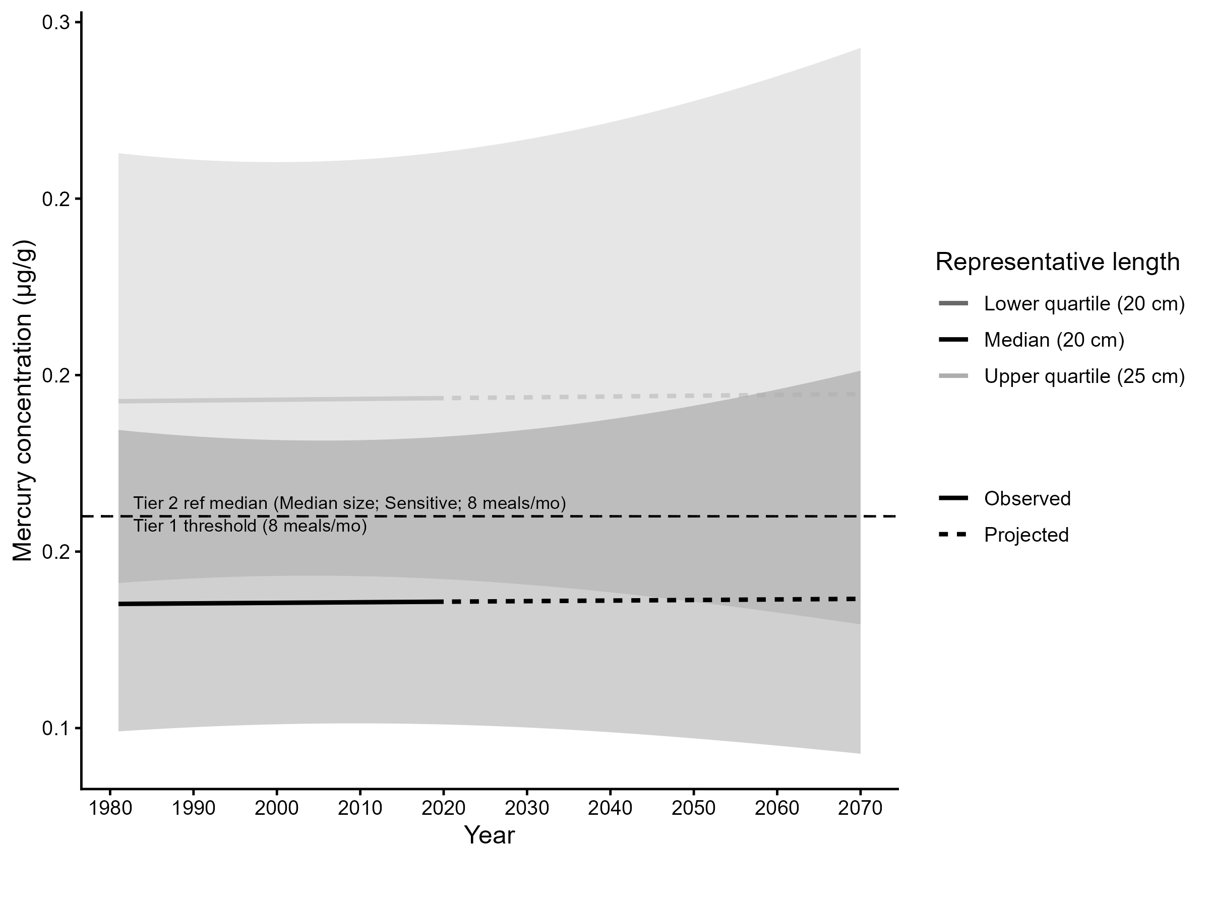
Figure 5.12: Projected mercury concentration in median, upper-quartile-, and lower-quartile-length Yellow Perch in the AOC. Predicted concentration is based on GAMM-derived half-life decay model. Solid lines represents predicted values within the temporal range of observations, dashed lines represents projected future concentrations, ribbons show 95% CI, and the horizontal dotted line represents the unrestrictive mercury threshold for the sensitive population, based on community desired consumption rate and MECP advisory thresholds.

