BOQ BUI 1 Technical Report DRAFT
Aaron Dain
2025-10-30
Table of Contents
1 Introduction 2
1.1 Brief history of BUI in AOC and previous actions 2
1.2 Actions since previous report 2
1.3 Delisting criteria change 2
1.4 2
(PART*) Tiered Assessment Approach for Criterion 1.1 2
2 Methods 2
2.1 Generic criteria 2
2.2 Tiered assessment framework 3
2.2.1 Tier 1 6
2.2.2 Tier 2 6
2.2.3 Tier 3 7
2.2.4 Tier 4 10
2.3 Community fish consumption survey 10
2.3.1 NOTE: This section is copied from the SLR version of the report, and may serve as a template for LTCA and MBQ to fill in their version. 10
2.4 Data Sources 12
3 Results 13
3.1 Species of Interest and Desired Consumption Rate 13
3.2 Tier 1 Assessment for the Bay of Quinte AOC 14
3.3 Tier 2 Assessment for the Bay of Quinte AOC 17
3.4 Tier 3 Assessment for the Bay of Quinte AOC 21
3.4.1 Walleye 22
3.4.2 Brown Bullhead 26
3.4.3 Lake Whitefish 27
3.4.4 Northern Pike 29
3.4.5 Smallmouth Bass 31
3.4.6 Chinook Salmon and Rainbow Smelt 32
3.4.7 Tier 3 Summary 32
3.5 Tier 4 33
4 Discussion and Recommendations 33
Appendix 33
5 Tier 3 Supplementary Figures for Bay of Quinte AOC 33
5.0.1 Brown Bullhead 33
5.0.2 Lake Whitefish 35
5.0.3 Northern Pike 37
5.0.4 Smallmouth Bass 40

1 Introduction

1.1 Brief history of BUI in AOC and previous actions

1.2 Actions since previous report

1.3 Delisting criteria change

1.4

(PART*) Tiered Assessment Approach for Criterion 1.1

2 Methods

2.1 Generic criteria
In 2021, following a series of workshops attended by RAP leaders and stakeholders, a shared generic delisting criterion and assessment framework were adopted by several Canadian AOCs. The intent was to draw from the experiences of the Toronto and Region, Niagara River, and Detroit River AOCs in using a tiered framework for assessing BUI 1. These workshops put forward a standardized operating procedure, data sources, and data interpretation guidelines applied in the tiered framework.
The 2016 preliminary assessment (Bhavsar 2016) utilized the following delisting statement as part of its BUI #1 assessment:
“Consumption advisories for fish of interest in the AOC are unrestricted or no more restrictive than the advisories for suitable reference site(s) due to contaminants from locally-controllable sources.”
In 2025, the Restoration Advisory Council for the Bay of Quinte AOC adopted a modified version of delisting criterion and its associated tiered assessment framework:
“The BUI is to be redesignated when it can be demonstrated that consumption advisories for fishes of interest in the Bay of Quinte are non-restrictive, declining or comparable to the advisories for suitable Lake Ontario reference site(s) due to contaminants (PCBs, dioxin-like PCBs, TCDDs (dioxins) and TCDFs (furans)) from locally-controllable sources specific to the AOC.”
The following measures of success were added to the delisting criterion:
(I don’t have them on hand at this time - please edit)

2.2 Tiered assessment framework
To evaluate the Criterion 1.1 of BUI 1, we applied a tiered framework originally developed for other Great Lakes Areas of Concern (AOCs) and adapted it for use in the Bay of Quinte AOC. This framework proceeds in a stepwise manner, beginning with simple threshold tests and progressing toward more complex statistical modeling. Each tier is designed to answer a progressively more nuanced question about the degree of impairment, with multiple lines of evidence integrated to provide a comprehensive assessment. The basis of the tiered assessment report is outlined in Bhavsar (2016) and Drouillard (2022), the latter of which being an adapted framework with additional methods, and on which the present assessment is based. The adapted framework as applied in the SLR AOC is outlined in Figure 2.1.
The framework sets out the order in which three evaluation methods, or tiers, are to be applied, and from which a recommendation on redesignation is made. Since its inception, the tiered assessment framework has been revised and adapted to better fit the needs of the redesignation process of BUI 1. The adoption of generic delisting criteria for BUI 1 across the remaining Canadian AOCs where BUI 1 is impaired has allowed for a more standardized approach to evaluate each aspect of the criteria. In the AOCs where the Tiered Framework has been applied, (cite Detroit and Toronto), the assessment tiers evaluate the degree of fish consumption advisories firstly to an “unrestrictive” monthly allowance, and then compared to the advisories in comparable reference sites. A combination of angler surveys and scientific publications allowed RAP teams to assess the BUI in terms of desired consumption rates of species consumed by local communities. New fish contaminant collections by MECP and MNR across the Great Lakes have allowed updated comparisons to be made to reference sites in Tier 2 and Tier 3. Furthermore, a fourth tier has been added, which aims to assess the local environmental conditions and previous remedial actions taken to address whether further actions are necessary following a failed Tier 3 outcome (Figure 2.1). In the Bay of Quinte AOC, the framework follows the procedure outlined by Drouillard in the 2022 Toronto AOC assessment report. Since the previous assessment report in 2017, the Guide to Eating Ontario fish has been updated with new collections following the report’s recommendations, and the BOQ AOC has adopted a version of the generic delisting criterion. Below is a summary of each tier, and the methods for which they are evaluated.
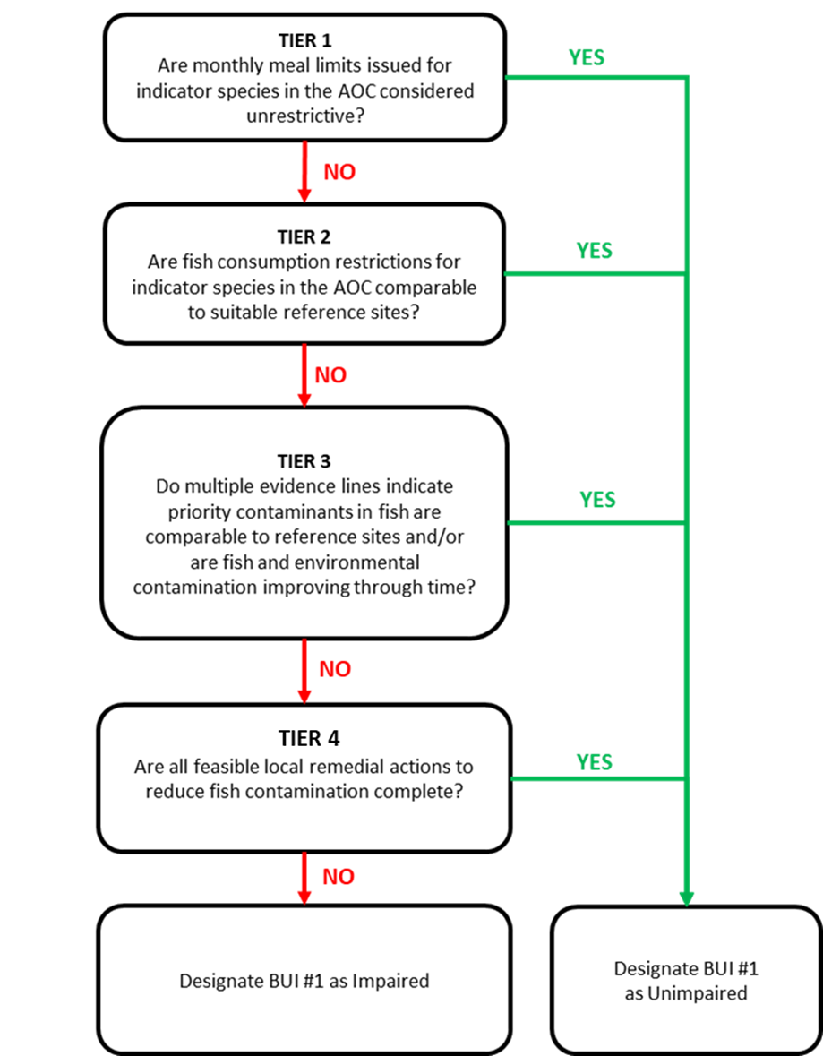
Figure 2.1: Modified 4 tiered evaluation framework applied in the 2022 BUI 1 Assessment for the Toronto and Region AOC. (Drouillard 2022)

2.2.1 Tier 1
The first step of the tiered framework provides a coarse screening of whether fish consumption advisories in the AOC are restrictive in absolute terms. Advisory values, expressed as the number of meals per month recommended for the general and sensitive population groups, were compiled from the Guide to Eating Ontario Fish, published by the Ontario Ministry of the Environment, Conservation and Parks (MECP) These advisories are based on contaminant concentrations measured in sportfish and translated into species- and size-specific consumption categories using contaminant thresholds.
Advisory values for each fish of interest in the AOC were then compared against a threshold representing acceptable levels of consumption, determined per-species by community survey (see Section 2.3. Any advisory below this benchmark was considered restrictive, while those at or above the threshold were considered non-restrictive. This step provides a baseline indication of potential impairment and allows the RAP team to quickly identify species or size classes where consumption guidance is most restrictive, independent of regional comparisons. Additionally, Tier 1 allows the RAP team to exclude unrestricted fish from further analysis, since these species meet the delisting criteria at its most basic level. Tier 1 uses a strict passing threshold, where any number of restrictive size categories in either population type (general or sensitive) will cause a species to fail and move to Tier 2.

2.2.2 Tier 2
Tier 2 assesses whether the environmental conditions pertaining to the BUI in the AOC are comparable to those at appropriate non-AOC reference sites. If the AOC conditions are better or equivalent to reference sites, the BUI in the AOC is redesignated “Not Impaired”, otherwise the assessment moves to Tier 3. Similarly to Tier 1, Tier 2 uses official consumption advice provided by MECP, using the same species of interest (except for those that passed Tier 1 assessment).
The advisory values in the AOC are compared to the median value of advisories for reference sites. In Tier 2, reference sites are selected as those representative of a broad measure of background intensity of advisories across a comparable region. That is, selection of reference sites for Tier 2 does not consider similarity of ecology, environmental conditions, or history; nor does it select for pristine, undisturbed water bodies. Rather, reference sites are characterized as a broad geographical representation of the region that are not AOCs. For this analysis, we selected all non-AOC fishing zones in Lake Ontario and the Upper St. Lawrence River for which consumption advice is issued for the same species of interest in the AOC.
To compare the intensity of advisories, we compared the advisory value for each species, size class, and population type for available species of interest in the AOC to the median of reference advisories for which similar advisories were issued. Because meal/month consumption advisories are issued in discreet categories (see Section 2.4.0.1), reference median values were rounded up to the next advisory value. AOC advisory values below the the desired consumption threshold (e.g., 8 meals/month) are compared to their respective reference medians, and those size categories equal to or above the reference median pass Tier 2 assessment, while those below the reference median fail Tier 2. Similarly to Tier 1, Tier 2 adopts a strict threshold, where any number of size categories for either population type will cause a species to fail and move to Tier 3.

2.2.3 Tier 3
Tier 3 evaluates the status of the BUI using a weight of evidence approach involving multiple lines of ecological and environmental evidence. The overall outcome of the weight of evidence available will support or not support redesignation of the BUI. Tier 3 evidence lines are determined in aggregate, meaning that unlike the decision tree between tiers, all sub-categories of Tier 3 are considered simultaneously regardless if a species passes or fails one or more evidence lines. Tier 3 adopts multiple evidence lines, including the following:

2.2.3.1 Tier 3A: Virtual advisory
Tier 3A seeks to address the relationship between priority contaminants in the AOC and fish consumption advice. Because fish consumption advisories consider multiple fish contaminants, and are issued based on the strictest restriction from any contaminant (cite), it is important to isolate the effect of priority AOC contaminants on driving local fish consumption advisories. Additionally, official advisories may be based on data that dates as far back as the 1970s. Thus, it is important that restrictions on fish consumption are considered using more recent data to account for restorative effects in the AOC associated with previous remedial actions. To achieve this, “virtual advisories” are created using parallel data sources and methods to that is used by MECP in generating official consumption advice. Fish contaminant data (obtained from MECP, see Section 2.4.0.2) is filtered to the contaminant of concern (in the case of the SLR AOC, this is mercury) and the previous 10 years of data (2014 and more recent), and this data is used to calculate virtual advisories based on the MECP method.
Virtual advisory values were generated using by modelling the relationship between fish length and contaminant concentration. For each region (AOC and reference), the function fits a log-log linear model (lm(log(Value) ~ log(Length)) to evaluate whether a significant relationship exists (p ≤ 0.05). If so, predicted concentrations are generated across a continuous length range, and then averaged within fixed 5 cm bins. Advisory levels are assigned using MECP-defined contaminant- and population-specific (General/Sensitive) thresholds to the mean predicted concentrations. If no significant relationship is detected, advisory levels are based on the mean concentration of all observations within each bin. If any size categories of the virtual advisory are restrictive compared to the desired consumption rate and to reference values, Tier 3A assessment is unsupportive of delisting for this species.
(Figure for power relationship)
(Table for thresholds)
Virtual advisories are not to be used as a replacement for official consumption advice, and are limited strictly to the evaluation of this BUI.
The virtual advisories in this tier are evaluated similarly to Tiers 1 and 2; i.e., first it is determined if virtual advice for any size categories are restrictive compared to the community desired consumption rate (see Section 2.2.1), then if virtual advice for any size category are more restrictive than suitable reference sites. Similarly to Tiers 1 and 2, any number of restrictive size categories are considered a failure for Tier 3A.

2.2.3.2 Tier 3B: Comparisons of fish contaminants in the AOC vs Reference
To determine the degree of contamination in fish in the AOC by priority contaminants, the concentration of contaminants (PCBs and dioxins/furans for BOQ) in fish tissue are compared between the AOC and suitable reference sites.
Reference sites for Tier 3B differ from those used in Tier 2 in that the MECP fish collection zones do not correlate directly with the zones used in the official advisories. For example, one official advisory zone (as is used in Tier 2) may comprise several collection areas. For Tier 3B, reference zones are similarly limited to non-AOC collections zones in the upper St. Lawrence River (upstream of the Moses-Saunders Dam) and Lake Ontario for which collections of the evaluated species have occurred within the most recent 10 years of study (2014-2024). The number and locations of reference sites may differ between species depending on the availability of data.
To assess differences in fish contamination between the AOC and reference sites, contaminant–length relationships were modeled using Generalized Additive Models (GAMs), allowing for non-linear associations. For this model, length was first log-transformed to control for skewed data distributions (contaminant-length relationships are often exponential), which was used as a fixed smooth effect along with region (AOC or reference), with collection area as a random effect to control for site-specific confounding variables. For each species of interest, we first tested whether the shape of the concentration–length relationship differed significantly between AOC and reference fish by comparing the full model to a null model with reduced terms using ANOVA. Where models supported statistically similar trends (non-significant interaction), we compared size-adjusted contaminant levels using estimated marginal means. Where shapes differed significantly, contaminant concentration values were compared by GAM-predicted values across the range of lengths of each fish species at 5 cm intervals. A threshold of α = 0.05 was used to evaluate statistical significance throughout.
Where contaminant-length relationships differed between AOC and reference, Tier 3B can be considered supportive of redesignation when the majority of size classes do not significantly differ in predicted contaminant concentration between AOC and reference. Where the contaminant-length relationship does not significantly differ, Tier 3B can be considered supportive of redesignation when the marginal mean of contaminant concentration does not significantly differ between AOC in reference. Otherwise, Tier 3B is considered not supportive of redesignation.

2.2.3.3 Tier 3C: Temporal trends of contaminants in fish
Tier 3C looks to evaluate the direction of trends in contaminants through time, and make predictions about how these trends will continue into the future. Temporal trends in contaminants of concern in AOC fish of interest were assessed using generalized additive mixed models (GAMMs) across all years of data. Log-contaminant concentration was modeled with a log-linear fixed effect for sample year to assess the temporal trends on an exponential scale, a smooth fixed effect for log-length to account for differences in contaminant concentration across fish length, and a site smooth random effect to account for regional differences in sampling and other confounding variables. The slope (on log scale) represents the annual rate of change in mercury concentration, defined as k = -slope (such that k > 0 indicates a decline, and k < 0 indicates an increase in contaminant concentration). Standard errors are obtained via the delta method. This model allows us to determine if contaminant trends are stable, increasing, or decreasing over time. If contaminant concentrations are stable or increasing, Tier 3C is unsupportive of delisting. If contaminant concentrations are decreasing, we use the model to predict future trends in contaminants.
Using this decay model, we estimated the time required to reach a nonrestrictive monthly meal allowance for a the upper quartile fish length (rounded to the nearest 5 cm) for sensitive populations. The half-life of contamination in each species was derived from the fitted yearly slope of log-transformed concentrations in the GAMM. If concentrations are increasing, a doubling time is reported instead. To estimate time to unrestrictive advisory threshold, predictions were anchored at the most recent observed year and a representative length (upper quartile rounded to the nearest 5 cm), and the model assumed a continuous rate of change using the half-life estimate. The model projects the expected time required for contaminant concentrations of upper-quartile-length fish to fall below the restrictive threshold established in Tier 1 for the sensitive population. For instance, if the desired consumption rate of a species is 8 meals per month, the threshold for the sensitive population would be 0.16 µg/g (Table ??). A timeline of 10 years or fewer is considered supportive of delisting, whereas a timeline of 10 or more years is unsupportive for delisting for this species. This estimate supports the temporal assessment of Tier 3C by forecasting how long the BUI will remain impaired in the absence of additional remedial actions.

2.2.4 Tier 4
Tier 4 assessment, like Tier 3, uses several evidence lines to determine support for delisting the BUI. Tier 4 expands the scope from fish to the environment, assessing the history and impact of past remedial actions on environmental recovery and fish contamination, as well as identifying potential future actions. Using a combination of literature review, monitoring data, and ecological metrics, available data is weighed in relation the restoration actions identified in the Stage 2 and draft (unpublished) Stage 3 RAP reports, as well as the degree of completion of these actions. Data may include contaminant concentration and track-down studies in the water, sediments, young of year (YOY) forage fish, and benthic invertebrates within the AOC and tributaries. Tier 4 may also include modelling approaches to relate environmental conditions to fish contaminants.
(This session to be expanded in future)

2.3 Community fish consumption survey

2.3.1 NOTE: This section is copied from the SLR version of the report, and may serve as a template for LTCA and MBQ to fill in their version.
To properly address the needs of the community surrounding the AOC through this BUI assessment, it is important to understand the the impact of the BUI on the consumption habits of the community. By asking the community about consumption habits, we can identify a list of species of interest in the AOC, how often these species are being consumed, and the desired rate of consumption if there were no issues related to priority contaminants.
A survey was conducted in Cornwall and surrounding regions from January to November of 2025. The survey asked respondents about where community members fished, their fishing methods, whether they eat fish, which fish from the AOC they consume (or feed to others), how often they eat each kind of fish, their normal portion size for each fish, their methods of cooking, and how often they would eat each fish species if there were no issues related to contamination in the AOC. The survey asked respondents the same questions about fish consumed from outside of the AOC. Additionally, the survey asked respondents if they had heard of the Guide to Eating Ontario Fish and the RAP program, and whether either of these resources have modified their consumption habits.
Responses from this survey were used to establish the community desired consumption rates for each species using the following methods: First, species of interest are defined as those consumed by at least 5% of anglers who eat fish. Second, a weighted average for meal frequency was calculated by multiplying the number of respondents by their desired monthly meal rate (converted from survey response options to monthly meal equivalents, see Table 2.1), then dividing by the total number of respondents. Since the BUI assessment aims to address the level of impairment to fish consumption in the AOC, the desired consumption rate is set based on the amount of fish the community would eat if the BUI was not impaired, rather than the current consumption rate. Third, a weighted average meal size was calculated similarly to frequency, with survey response options converted to monthly meal equivalents as per Table 2.2. Finally, the weighted average frequency was multiplied by the weighted average portion size to get an average desired consumption rate, which was rounded up to the next advisory category for the Sensitive population (0, 4, 8, 12, 16, or 32 meals per month).
Table 2.1: Survey response conversion table for desired consumption frequency
Consumption Rate (Survey) | Conversion
A few times per year | 1
A few times per month | 8
A few times per week | 16
Daily | 32
Table 2.2: Survey response conversion table for desired portion size
Portion Size (Survey) | Conversion
Less than 4 oz | 0.25
4 oz | 0.50
4-8 oz | 0.75
8 oz | 1.00
Greater than 8 oz | 2.00

2.4 Data Sources

2.4.0.1 MECP Advisory Data
Tier 1 and Tier 2 of the BUI 1 assessment framework are based on the official fish consumption advisories issued by the Ontario Ministry of Environment, Conservation and Parks (MECP) for the AOC and suitable reference sites. For this assessment report, the most recent advisories were pulled from the 2024 Guide to Eating Ontario Fish (at the time of writing, available at: [link]). The Guide provides monthly meal recommendations based on the size and species of fish available from collections in each area assessed. Recommendations are based on contaminant testing of fish within each zone, which are modeled and compared against concentration thresholds associated with a recommended monthly meal allowance. In the Bay of Quinte AOC, the monthly meal recommendations correspond to advisory tables issued for the “Lake Ontario (Eastern Basin”, “Belleville Nearshore”, and “Trenton Nearshore” zones, available at the time of writing at (link). Advisory information was collected for all available species for which advice is issued, at all size classes and for the two populations identified: General and Sensitive Populations. For reference sites, information was collected only for species that are also monitored in the AOC. Fish consumption advisories are provided for General and Sensitive Populations. Advisories for Sensitive Populations are intended to be used by women of childbearing age and children under the age of 15. Generally, advisories tend to be stricter for the Sensitive Populations, with lower contaminant concentration benchmarks for some contaminants such as mercury, due to the greater sensitivity of this population to negative health effects from some contaminants. Maximum monthly meal recommendation categories for the Sensitive Population include 32, 16, 12, 8, 4 and 0 meals/month. Maximum monthly meal recommendation categories for the General Population include 32, 16, 12, 8, 4, 2, 1 and 0 meals per month. For the purposes of this assessment, advisories for both populations will be considered for Tiers 1 and 2.

2.4.0.2 MECP Contaminant Data
Tier 3 assessment is primarily based on contaminant data compiled by MECP, which is used to generate official consumption advice. This data is collected across the waters of Ontario by MECP and partner organizations, and comprises fish measurements such as sample site, length, sample year, weight, sex, and contaminant concentration for a number of fish of interest within each waterbody. These data were used to calculate virtual advisories, compare contaminant concentrations between AOC and reference sites, and make predictions of temporal trends of contaminants within the AOC.

2.4.0.3 Tier 4 data sources
(to be expanded)

3 Results

3.1 Species of Interest and Desired Consumption Rate
The following species were identified as species of interest, with the respective desired consumption rates:
Table 3.1: Fish species of interest and desired consumption rate within the Bay of Quinte AOC.
Species | Desired Consumption Rate
Black Crappie | 8
Bluegill | 8
Brown Bullhead | 8
Channel Catfish | 8
Pumpkinseed | 8
Freshwater Drum | 8
Largemouth Bass | 8
Northern Pike | 4
Rock Bass | 8
Smallmouth Bass | 8
Walleye | 32
White Bass | 8
White Sucker | 8
Yellow Perch | 8
White Perch | 8
Chinook Salmon | 8
Lake Whitefish | 8
Rainbow Smelt | 8

3.2 Tier 1 Assessment for the Bay of Quinte AOC
Tier 1 assessment compares the official MECP consumption advisory information for each fish of interest to the desired consumption rate (in meals per month) as indicated by community survey. Table 3.2 summarizes the MECP advisory values for fish of interest in the Bay of Quinte AOC for both General and Sensitive, compared to each species’ community desired consumption rate. In total, 5 of 18 species passed Tier 1 assessment, with the rest failing and moving to Tier 2 (Table 3.3).

Table 3.2: Results of Tier 1 assessment for Bay of Quinte. The consumption advisory for each species is compared to its desired consumption rate, as determined by community survey. Numbers in cells indicate advisory levels for a species, size class, and population type (General/Sensitive) in the AOC. Red cells indicate an advisory below the "Restrictive" meals/month threshold (indicated by community survey), and green cells indicate advisories levels equal to or above this threshold. The contaminants driving the advisories are displayed below each cells.
Species | Unrestrictive Threshold | Population | 15-20cm | 20-25cm | 25-30cm | 30-35cm | 35-40cm | 40-45cm | 45-50cm | 50-55cm | 55-60cm | 60-65cm | 65-70cm | 70-75cm | >75cm
Black Crappie | 8 | General | 32 | 32 | 32 | 16 | 16
 |  | Adv cause |  |  |  | 2 | 2
 |  | Sensitive | 32 | 16 | 16 | 12 | 8
 |  | Adv cause |  | 2 | 2 | 2 | 2
Bluegill | 8 | General | 32 | 16
 |  | Adv cause |  | 2
 |  | Sensitive | 16 | 8
 |  | Adv cause | 2 | 2
Brown Bullhead | 8 | General | 8 | 8 | 8 | 8 | 8
 |  | Adv cause | 1 | 1 | 1 | 1 | 1
 |  | Sensitive | 8 | 8 | 8 | 4 | 0
 |  | Adv cause | 1 | 1 | 1 | 2 | 2
Channel Catfish | 8 | General | 32 | 32 | 32 | 32 | 32 | 16 | 16 | 12 | 8 | 4 | 4 | 4 | 0
 |  | Adv cause |  |  |  |  |  | 3 | 3 | 3 | 3 | 3 | 3 | 2 | 3, 2
 |  | Sensitive | 16 | 16 | 16 | 16 | 16 | 16 | 16 | 12 | 8 | 4 | 4 | 0 | 0
 |  | Adv cause | 2 | 2 | 2 | 2 | 2 | 2 | 2 | 2 | 2 | 2 | 2 | 2 | 2
Chinook Salmon | 8 | General | 32 | 32 | 16 | 16 | 12 | 8 | 8 | 4 | 1 | 1 | 1 | 1 | 1
 |  | Adv cause |  |  | 3 | 3 | 3 | 3 | 3 | 3 | 3 | 3 | 3 | 3 | 3
 |  | Sensitive | 32 | 32 | 16 | 16 | 12 | 8 | 8 | 4 | 0 | 0 | 0 | 0 | 0
 |  | Adv cause |  |  | 3 | 3 | 3 | 3 | 3 | 3 | 3 | 3 | 3 | 3 | 3
Freshwater Drum | 8 | General | 32 | 32 | 16 | 16 | 16 | 12 | 12 | 8 | 8 | 4 | 4
 |  | Adv cause |  |  | 3 | 3 | 3 | 3 | 3 | 3 | 3 | 3 | 3
 |  | Sensitive | 32 | 32 | 16 | 16 | 16 | 12 | 8 | 8 | 4 | 0 | 0
 |  | Adv cause |  |  | 2 | 2, 3 | 2 | 3 | 2 | 2 | 2 | 2 | 2
Lake Whitefish | 8 | General | 32 | 32 | 16 | 16 | 12 | 8 | 8 | 4 | 4 | 4 | 2
 |  | Adv cause |  |  | 3 | 3 | 3 | 3 | 3 | 3 | 3 | 3 | 3
 |  | Sensitive | 32 | 32 | 16 | 16 | 12 | 8 | 8 | 4 | 4 | 4 | 0
 |  | Adv cause |  |  | 3 | 3 | 3 | 3 | 3 | 3 | 3 | 3 | 3
Largemouth Bass | 8 | General | 32 | 32 | 16 | 16 | 16 | 16 | 8 | 0 | 0
 |  | Adv cause |  |  | 2 | 2 | 2 | 2 | 2 | 3 | 3
 |  | Sensitive | 16 | 12 | 8 | 8 | 8 | 4 | 4 | 0 | 0
 |  | Adv cause | 2 | 2 | 2 | 2 | 2 | 2 | 2 | 2 | 2
Northern Pike | 4 | General |  |  |  |  | 16 | 16 | 16 | 16 | 8 | 4 | 4 | 4 | 4
 |  | Adv cause |  |  |  |  | 2 | 2 | 2 | 2 | 1 | 1 | 1 | 1 | 1
 |  | Sensitive |  |  |  |  | 12 | 8 | 8 | 8 | 4 | 4 | 4 | 4 | 0
 |  | Adv cause |  |  |  |  | 2 | 2 | 2 | 2 | 2 | 2 | 2 | 2 | 2
Pumpkinseed | 8 | General | 16 | 16
 |  | Adv cause | 3 | 2
 |  | Sensitive | 12 | 8
 |  | Adv cause | 2 | 2
Rainbow Smelt | 8 | General | 4
 |  | Adv cause | 4, 3
 |  | Sensitive | 4
 |  | Adv cause | 4, 3
Rock Bass | 8 | General | 16 | 16 | 12
 |  | Adv cause | 2 | 2 | 2
 |  | Sensitive | 8 | 4 | 4
 |  | Adv cause | 2 | 2 | 2
Smallmouth Bass | 8 | General | 32 | 16 | 16 | 12 | 8 | 8 | 8 | 8
 |  | Adv cause |  | 3 | 3, 2 | 3 | 3 | 2 | 3, 2 | 2
 |  | Sensitive | 16 | 12 | 8 | 4 | 4 | 4 | 0 | 0
 |  | Adv cause | 2 | 2 | 2 | 2 | 2 | 2 | 2 | 2
Walleye | 32 | General | 32 | 32 | 16 | 16 | 16 | 16 | 16 | 12 | 8 | 4 | 4 | 2 | 0
 |  | Adv cause |  |  | 3 | 3 | 2, 3 | 2 | 2 | 2 | 2 | 2 | 2 | 2 | 2
 |  | Sensitive | 32 | 32 | 16 | 16 | 16 | 8 | 4 | 4 | 0 | 0 | 0 | 0 | 0
 |  | Adv cause |  |  | 2, 3 | 2 | 2 | 2 | 2 | 2 | 2 | 2 | 2 | 2 | 2
White Bass | 8 | General |  |  | 16 | 16 | 12 | 8
 |  | Adv cause |  |  | 4, 3 | 2, 4 | 2 | 2
 |  | Sensitive |  |  | 16 | 8 | 4 | 4
 |  | Adv cause |  |  | 2, 4, 3 | 2 | 2 | 2
White Perch | 8 | General | 32 | 32 | 16 | 8
 |  | Adv cause |  |  | 2 | 3
 |  | Sensitive | 16 | 12 | 8 | 4
 |  | Adv cause | 2 | 2 | 2 | 2
White Sucker | 8 | General | 8 | 8 | 8 | 8 | 8 | 8 | 8 | 8 | 8
 |  | Adv cause | 1 | 1 | 1 | 1 | 1 | 1 | 1 | 1 | 1
 |  | Sensitive | 8 | 8 | 8 | 8 | 8 | 8 | 8 | 8 | 8
 |  | Adv cause | 1 | 1 | 1 | 1 | 1 | 1 | 1 | 1 | 1
Yellow Perch | 8 | General | 16 | 16 | 16
 |  | Adv cause | 3 | 2 | 2, 3
 |  | Sensitive | 16 | 8 | 8
 |  | Adv cause | 2, 3 | 2 | 2
Advisory causes: 1 = Dioxins/Furans; 2 = Mercury; 3 = PCB; 4 = PFAS

Table 3.3: Results by species of Tier 1 assessment for Bay of Quinte. The consumption advisory for each species is compared to its desired consumption rate, as determined by community survey. Species for which the consumption advisory is equal to or above the desired consumption rate pass Tier 1 and are excluded from further analysis; otherwise the species fails and moves forward to Tier 2.
Species | Tier 1
Black Crappie | ✔️
Bluegill | ✔️
Brown Bullhead | ❌
Channel Catfish | ❌
Chinook Salmon | ❌
Freshwater Drum | ❌
Lake Whitefish | ❌
Largemouth Bass | ❌
Northern Pike | ❌
Pumpkinseed | ✔️
Rainbow Smelt | ❌
Rock Bass | ❌
Smallmouth Bass | ❌
Walleye | ❌
White Bass | ❌
White Perch | ❌
White Sucker | ✔️
Yellow Perch | ✔️

3.3 Tier 2 Assessment for the Bay of Quinte AOC
Tier 2 assessment compares the intensity of fish consumption advisories in the AOC to suitable reference sites. Reference sites for Tier 2 assessment should reflect background levels of intensity of advisories, i.e., they should represent geographically similar locations that are not AOCs. For the Bay of Quinte AOC, reference sites were non-AOC fishing zones in the upper St. Lawrence River (upstream of the Moses-Saunders Dam) and Lake Ontario for which advisories for species located in the AOC were available. The following reference sites were used for the Tier 2 analysis of the SLR AOC:
- Jordan Harbour (Lake Ontario)
- Lake Ontario (Western Basin)
- Frenchman Bay (Lake Ontario)
- McLaughlin Bay (Lake Ontario)
- Oshawa Harbour (Lake Ontario)
- Whitby Harbour (Lake Ontario)
- East Lake
- West Lake
- Consecon Lake
- St. Lawrence River (Lake Ontario to Cornwall)
The consumption advisories for each fish of interest that failed Tier 1 in the AOC were compared to the median advisory (rounded to the nearest advisory level issued, see methods section X) level (in meals per month) of available reference sites for which advisories are issued for that species and size class. The results are summarized below in Table 3.4. Species where ALL size classes are equal to or above the median advisory level of the reference sites pass Tier 2 and are excluded from further analysis, otherwise the species fails Tier 2 and is carried forward to Tier 3 (Table 3.5). Species and size classes with fewer than 3 reference sites are considered data-deficient and the results are to be interpreted with caution. For the purposes of this assessment, data-deficient species fail Tier 2 automatically.

Table 3.4: Results of Tier 2 assessment for Bay of Quinte. Numbers in cells indicate advisory levels for a species, size class, and population type (General/Sensitive) in the AOC, alongside the median advisory level of suitable reference sites. n values indicate the number of reference sites with advisories for this species, size class, and population type. Red cells indicate an advisory in the AOC lower than the median of reference sites, and green cells indicate advisories levels equal to or above the reference median. Grey cells are advisories in the AOC with no suitable reference sites. The drop-down menus display the advisory levels in each reference site for that species and population type.
Species | Population | Site | 15-20cm | 20-25cm | 25-30cm | 30-35cm | 35-40cm | 40-45cm | 45-50cm | 50-55cm | 55-60cm | 60-65cm | 65-70cm | 70-75cm | >75cm
Bluegill | General | AOC | 4
 |  | Ref. Median | 16
 |  | n | 4
 | Sensitive | AOC | 4
 |  | Ref Median | 16
 |  | n | 4
Freshwater Drum | General | AOC |  |  |  |  |  |  |  |  |  | 2 | 2 | 1
 |  | Ref Median |  |  |  |  |  |  |  |  |  | 1 | 4 | 4
 |  | n |  |  |  |  |  |  |  |  |  | 2 | 1 | 1
 | Sensitive | AOC |  |  |  |  |  |  |  |  |  | 0 | 0 | 0
 |  | Ref Median |  |  |  |  |  |  |  |  |  | 0 | 0 | 0
 |  | n |  |  |  |  |  |  |  |  |  | 2 | 1 | 1
Largemouth Bass | General | AOC | 8 | 8 | 8 | 8 | 8 | 4 | 4
 |  | Ref Median | 16 | 16 | 16 | 12 | 8 | 8 | 4
 |  | n | 6 | 8 | 8 | 8 | 8 | 4 | 2
 | Sensitive | AOC | 8 | 8 | 8 | 4 | 0 | 0 | 0
 |  | Ref Median | 8 | 8 | 8 | 4 | 4 | 4 | 0
 |  | n | 6 | 8 | 8 | 8 | 8 | 4 | 2
Northern Pike | General | AOC |  | 32 | 32 | 16 | 16 | 16 | 16 | 16 | 16 | 12 | 8 | 4 | 4
 |  | Ref Median |  | 8 | 8 | 16 | 16 | 12 | 8 | 8 | 8 | 8 | 8 | 8 | 4
 |  | n |  | 3 | 4 | 7 | 7 | 8 | 8 | 9 | 9 | 9 | 8 | 8 | 7
 | Sensitive | AOC |  | 16 | 16 | 16 | 16 | 12 | 8 | 8 | 8 | 4 | 4 | 0 | 0
 |  | Ref Median |  | 8 | 8 | 8 | 8 | 8 | 4 | 8 | 4 | 4 | 4 | 4 | 0
 |  | n |  | 3 | 4 | 7 | 7 | 8 | 8 | 9 | 9 | 9 | 8 | 8 | 7
Rock Bass | General | AOC | 4 | 4
 |  | Ref Median | 16 | 8
 |  | n | 7 | 5
 | Sensitive | AOC | 4 | 4
 |  | Ref Median | 8 | 4
 |  | n | 7 | 5
Smallmouth Bass | General | AOC | 4 | 4 | 4 | 4 | 4 | 4 | 4 | 4
 |  | Ref Median | 16 | 16 | 12 | 16 | 8 | 2 | 2 | 8
 |  | n | 3 | 4 | 4 | 6 | 5 | 4 | 3 | 1
 | Sensitive | AOC | 4 | 4 | 4 | 4 | 4 | 0 | 0 | 0
 |  | Ref Median | 12 | 12 | 8 | 8 | 4 | 0 | 0 | 4
 |  | n | 3 | 4 | 4 | 6 | 5 | 4 | 3 | 1
Walleye | General | AOC | 4 | 4 | 4 | 4 | 4 | 4 | 4 | 4 | 4 | 4 | 4 | 4 | 0
 |  | Ref Median | 12 | 12 | 12 | 16 | 16 | 12 | 8 | 12 | 8 | 8 | 4 | 4 | 0
 |  | n | 1 | 3 | 4 | 7 | 7 | 7 | 6 | 5 | 5 | 5 | 3 | 3 | 3
 | Sensitive | AOC | 4 | 4 | 4 | 4 | 4 | 4 | 4 | 4 | 0 | 0 | 0 | 0 | 0
 |  | Ref Median | 12 | 12 | 8 | 12 | 8 | 8 | 4 | 4 | 4 | 0 | 0 | 0 | 0
 |  | n | 1 | 3 | 4 | 7 | 7 | 7 | 6 | 5 | 5 | 5 | 3 | 3 | 3
White Perch | General | AOC | 8 | 4
 |  | Ref Median | 8 | 8
 |  | n | 4 | 4
 | Sensitive | AOC | 4 | 0
 |  | Ref Median | 8 | 8
 |  | n | 4 | 4
Yellow Perch | General | AOC | 4 | 4 | 4 | 4
 |  | Ref Median | 16 | 16 | 16 | 4
 |  | n | 10 | 8 | 5 | 3
 | Sensitive | AOC | 4 | 4 | 4 | 0
 |  | Ref Median | 12 | 8 | 4 | 4
 |  | n | 10 | 8 | 5 | 3

Table 3.5: Results by species of Tier 2 assessment for Bay of Quinte. The consumption advisory for each species is compared to its desired consumption rate, as determined by community survey. Species for which the consumption advisory is equal to or above the desired consumption rate pass Tier 1 and are excluded from further analysis; otherwise the species fails and moves forward to Tier 2.
Species | Tier 2
Brown Bullhead | ❌
Channel Catfish | ✔️ ⚠️
Chinook Salmon | ❌ ⚠️
Freshwater Drum | ✔️ ⚠️
Lake Whitefish | — ⚠️
Largemouth Bass | ✔️
Northern Pike | ❌
Rainbow Smelt | ❌ ⚠️
Rock Bass | ✔️
Smallmouth Bass | ❌
Walleye | ❌
White Bass | ✔️ ⚠️
White Perch | ✔️
⚠️ - Species has low reference site count (<3) at more than 50% of size classes.

3.4 Tier 3 Assessment for the Bay of Quinte AOC
Note: Analysis of measure 2 is not included here as of yet, and is yet to come. The methods will be the same, except using yellow perch and brown bullhead as the species of interest; Belleville/Trenton Nearshore as the AOC; and the rest of the Bay of Quinte sites as reference areas. Some analyses may be more limited for measure 2 due to limitations in data.
Note 2: Analysis of dioxins/furans is not included here as of yet. I have received the necessary data, but need to still develop the methods for calculating virtual advisories.
Below, the full Tier 3 analysis is demonstrated for walleye. All other species of interest that passed Tier 2 are evaluated independently, and the results for which are presented in-text (with further details in Appendices). A full summary of Tier 3 results are summarized in Table ??.

3.4.1 Walleye
The following reference sites were used in the tier 3 analysis of walleye in the St. Lawrence River (Cornwall/Akwesasne) AOC:

AOC
- Lake Ontario 10 - Middle Bay of Quinte
- Lake Ontario 11 - Lower Bay of Quinte/Eastern Lake Ontario
- Lake Ontario 9 - Upper Bay of Quinte

Reference
- Lake Ontario 2 - Twelve Mile Creek Port Dalhousie
- Lake Ontario 4a - Toronto Waterfront
- Lake Ontario 6 - Northwestern
- Lake Ontario 8
- Lake Ontario 9a - Trenton Nearshore
- Lake Ontario 9b - Belleville Nearshore
- St. Lawrence River 12 - Lower Thousand Island

3.4.1.1 Tier 3A Assessment for Walleye
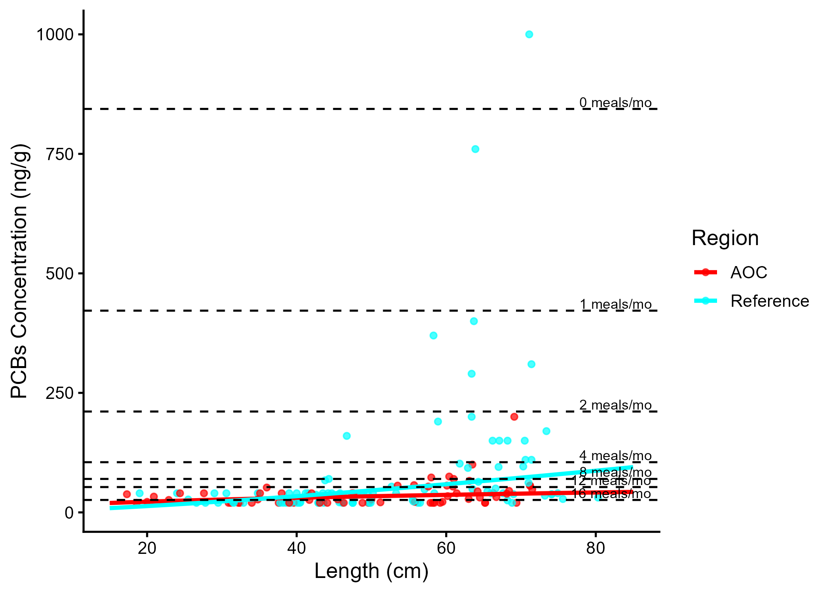
Figure 3.1: Virtual PCB advisories in walleye. Predicted concentrations (curve) and observed values (points) by region using power regression model, compared to MECP advisory limits for PCB for the sensitive population (dashed lines).

Model Summary by Region
Reference: There is a statistically significant relationship between fish length and contaminant concentration. The power model used was: concentration = 0.223 × Length1.362 (R² = 0.225, p = < 0.001).
AOC: There is a statistically significant relationship between fish length and contaminant concentration. The power model used was: concentration = 5.84 × Length0.448 (R² = 0.108, p = 8.14e-03).
Table 3.6: Virtual advisory levels for PCB in walleye across regions. Values represent meals/month recommendations. Red cells indicate restrictive virtual advisory below the desired consumption rate of 32 meals/month AND that of reference; green cells indicate unrestrictive virtual advisory equal to or above either the desired consumption rate or reference advisory.
Population | Region | 15-20 | 20-25 | 25-30 | 30-35 | 35-40 | 40-45 | 45-50 | 50-55 | 55-60 | 60-65 | 65-70 | 70-75 | 75+
General | AOC | 32 | 32 | 32 | 16 | 16 | 16 | 16 | 16 | 16 | 16 | 16 | 16 | 16
General | Reference | 32 | 32 | 32 | 32 | 16 | 16 | 16 | 16 | 12 | 12 | 12 | 8 | 8
General population: Of 13 size bins, 0 were below the desired consumption rate of 8 meals/month. Of these, 0 were more restrictive than reference. Overall, Tier 3A assessment for walleye is supportive.
Tier 3A Overall Decision: Supportive

3.4.1.2 Tier 3B

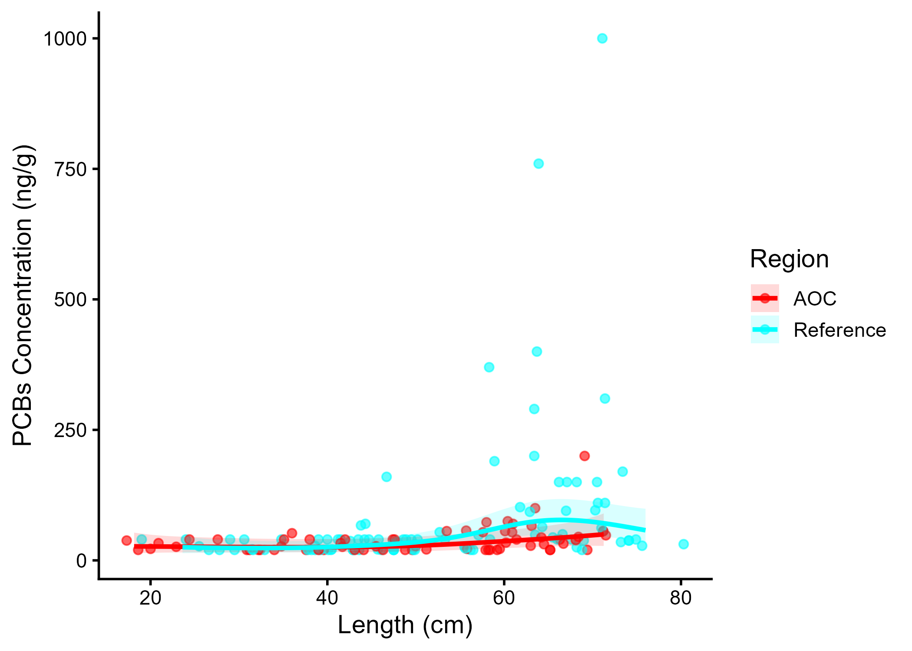
Figure 3.2: PCB concentration in Walleye by length in the AOC compared to reference sites. Points are observed contaminant values, curves represent GAM model fit (with random effects dropped for simplicity,), ribbons represent 95% confidence interval.

Generalized Additive Models (GAMs) were used to model the relationship between fish length and PCB concentrations for Walleye in the AOC and reference sites. The length–contaminant relationship differed significantly between sites (interaction test p = 0.0493) (Figure 3.2). Model-predicted concentrations were calculated across the observed size range for which observations existed for both regions (every 5 cm from 20 to 70 cm) and are presented in Table ??. Asterisks (*) denote sizes where the AOC differs significantly (p < 0.05) from one or more reference site(s); this occurred at 11 of 11 lengths evaluated
The AOC does not exceed reference in marginal mean concentration, suggesting comparable contamination levels in this species.(Table ??). Therefore, Tier 3B analysis of walleye is considered supportive for redesignation.
Tier 3B Overall Decision: Supportive

3.4.1.3 Tier 3C
Table 3.7: Estimated time to unrestrictive PCB threshold for an upper-quartile-sized walleye in the AOC, using GAMM-derived half-life decay model. The model-predicted concentration of an upper-quartile length fish is reported for the most recent year of observation, and the target concentration corresponding to an “unrestrictive” advisory for the Sensitive population of 32, based on survey results and MECP advisory thresholds.
Upper Quartile Length (cm)
Predicted Conc. (Current Year)
Unrestrictive Conc.
Years to Threshold
95% CI
Outcome
60
34.27
70.00
0.0
-6.9–6.9
Supportive

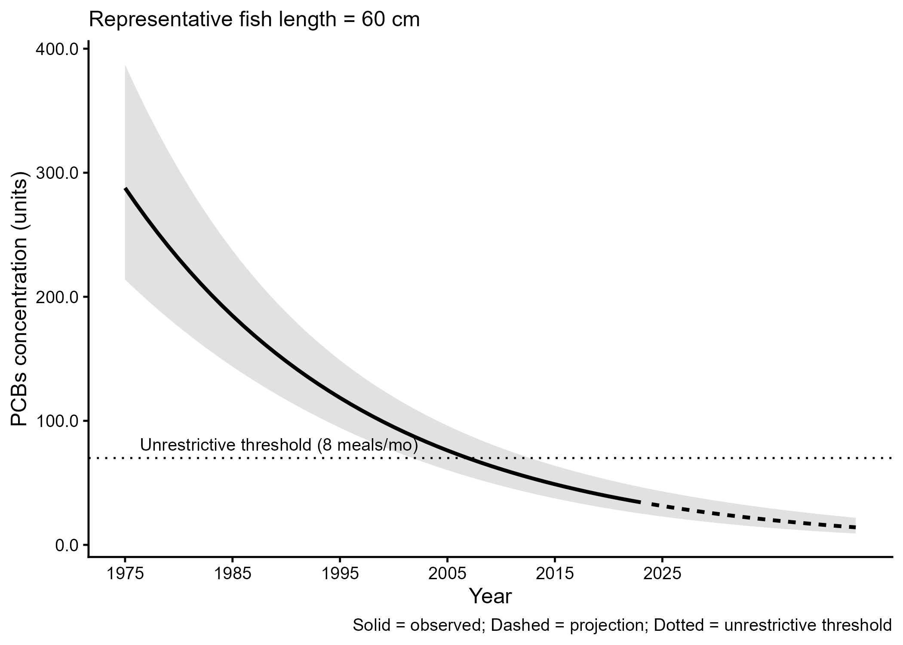
Figure 3.3: Projected PCB concentration in upper-quartile-length walleye in the AOC. Predicted concentration is based on GAMM-derived half-life decay model. The solid line represents predicted values within the temporal range of observations, the dashed line represents projected future concentrations, ribbons show 95% CI, and the horizontal dotted line represents the unrestrictive PCB threshold for the sensitive population, based on community desired consumption rate and MECP advisory thresholds.
For upper-quartile-length (60 cm) fish, predicted concentrations are already within the unrestrictive advisory range for the Sensitive population (≥ 8 meals/month). Therefore, Tier 3C is considered supportive.
Tier 3C Overall Decision: Supportive

3.4.1.4 Summary
A summary of Tier 3 assessment results can be found in table 3.8. Overall, results from this species are unsupportive of redesignation.
Table 3.8: Summary of Tier 3 assessment results in the St. Lawrence River (Cornwall/Akwesasne) Area of Concern.
Tier | Description | Metric | Outcome
Tier 3A | Virtual Advisory | General: 0/13 size bins restrictive or more restrictive than reference | Supportive
Tier 3B | Contaminant Concentration vs Reference | No significant difference in smooth terms (p = 0.215); AOC marginal mean not higher than reference | Supportive
Tier 3C | Temporal Trends | Already unrestrictive for upper-quartile-length (60 cm) fish. | Supportive

3.4.2 Brown Bullhead

3.4.2.1 Tier 3A
Virtual advisory values were generated using by modelling the relationship between fish length and contaminant concentration for brown bullhead and PCB.
Model Summary by Region
Reference: There is a statistically significant relationship between fish length and contaminant concentration. The power model used was: concentration = 0.164 × Length1.731 (R² = 0.2, p = < 0.001).
AOC: There is a statistically significant relationship between fish length and contaminant concentration. The power model used was: concentration = 0.446 × Length1.301 (R² = 0.098, p = 5.50e-03).
General population: Of 6 size bins, 0 were below the desired consumption rate of 8 meals/month. Of these, 0 were more restrictive than reference. Therefore, Tier 3A analysis of brown bullhead is considered supportive for redesignation.

3.4.2.2 Tier 3B
Generalized Additive Models (GAMs) were used to model the relationship between fish length and pcbs concentrations for brown bullhead in the AOC and reference regions. The length-contaminant relationship did not differ significantly between sites (interaction test p = NA). Marginal mean concentrations were estimated across the full size distribution using a reduced model with shared smooths. The estimated marginal mean PCBs concentration in the AOC was 3.38 units (95% CI: 3.01–3.74). Estimated values for reference site(s): Reference: 3.93 units (95% CI: 3.74–4.13).
The AOC does not exceed reference in marginal mean concentration, suggesting comparable contamination levels in this species. Therefore, Tier 3B analysis of brown bullhead is considered supportive for redesignation.

3.4.2.3 Tier 3C
Temporal trends in brown bullhead for PCB were assessed using generalized additive mixed models (GAMMs) across all years of data, and a model test was performed to estimate the time required to reach a nonrestrictive monthly meal allowance for the upper quantile fish length (rounded to the nearest 5 cm) for sensitive populations. For upper-quartile-length (30 cm) fish, predicted concentrations are already within the unrestrictive advisory range for the Sensitive population (≥ 8 meals/month). Therefore, Tier 3C is considered supportive for redesignation.

3.4.2.4 Tier 3 Summary
Tier | Description | Metric | Outcome
Tier 3A | Virtual Advisory | General: 0/6 size bins restrictive or more restrictive than reference | Supportive
Tier 3B | Contaminant Concentration vs Reference | No significant difference in smooth terms (p = NA); AOC marginal mean not higher than reference | Supportive
Tier 3C | Temporal Trends | Already unrestrictive for upper-quartile-length (30 cm) fish. | Supportive

3.4.3 Lake Whitefish

3.4.3.1 Tier 3A
Virtual advisory values were generated using by modelling the relationship between fish length and contaminant concentration for lake whitefish and PCB.
Model Summary by Region
Reference: There is a statistically significant relationship between fish length and contaminant concentration. The power model used was: concentration = 1.39 × Length1.046 (R² = 0.284, p = < 0.001).
AOC: There is a statistically significant relationship between fish length and contaminant concentration. The power model used was: concentration = 0.155 × Length1.523 (R² = 0.192, p = < 0.001).
General population: Of 11 size bins, 0 were below the desired consumption rate of 8 meals/month. Of these, 0 were more restrictive than reference. Therefore, Tier 3A analysis of lake whitefish is considered supportive for redesignation.

3.4.3.2 Tier 3B
Generalized Additive Models (GAMs) were used to model the relationship between fish length and pcbs concentrations for lake whitefish in the AOC and reference regions. The length-contaminant relationship did not differ significantly between sites (interaction test p = NA). Marginal mean concentrations were estimated across the full size distribution using a reduced model with shared smooths. The estimated marginal mean PCBs concentration in the AOC was 3.92 units (95% CI: 3.61–4.24). Estimated values for reference site(s): Reference: 4.23 units (95% CI: 3.75–4.71).
The AOC does not exceed reference in marginal mean concentration, suggesting comparable contamination levels in this species. Therefore, Tier 3B analysis of lake whitefish is considered supportive for redesignation.

3.4.3.3 Tier 3C
Temporal trends in lake whitefish for PCB were assessed using generalized additive mixed models (GAMMs) across all years of data, and a model test was performed to estimate the time required to reach a nonrestrictive monthly meal allowance for the upper quantile fish length (rounded to the nearest 5 cm) for sensitive populations. For upper-quartile-length (55 cm) fish, predicted concentrations are already within the unrestrictive advisory range for the Sensitive population (≥ 8 meals/month). Therefore, Tier 3C is considered supportive for redesignation.

3.4.3.4 Tier 3 Summary
Tier | Description | Metric | Outcome
Tier 3A | Virtual Advisory | General: 0/11 size bins restrictive or more restrictive than reference | Supportive
Tier 3B | Contaminant Concentration vs Reference | No significant difference in smooth terms (p = NA); AOC marginal mean not higher than reference | Supportive
Tier 3C | Temporal Trends | Already unrestrictive for upper-quartile-length (55 cm) fish. | Supportive

3.4.4 Northern Pike

3.4.4.1 Tier 3A
Virtual advisory values were generated using by modelling the relationship between fish length and contaminant concentration for northern pike and PCB.
Model Summary by Region
Reference: There is no significant relationship between fish length and contaminant concentration. Bin-level means were used instead. The power model used was: concentration = 8.99 × Length0.396 (R² = 0.02, p = 2.62e-01).
AOC: There is no significant relationship between fish length and contaminant concentration. Bin-level means were used instead. The power model used was: concentration = 5.88 × Length0.384 (R² = 0.036, p = 3.15e-01).
General population: Of 9 size bins, 0 were below the desired consumption rate of 8 meals/month. Of these, 0 were more restrictive than reference. Therefore, Tier 3A analysis of northern pike is considered supportive for redesignation.

3.4.4.2 Tier 3B
Generalized Additive Models (GAMs) were used to model the relationship between fish length and pcbs concentrations for northern pike in the AOC and reference regions. The length-contaminant relationship did not differ significantly between sites (interaction test p = 0.0749). Marginal mean concentrations were estimated across the full size distribution using a reduced model with shared smooths. The estimated marginal mean PCBs concentration in the AOC was 3.37 units (95% CI: 2.96–3.77). Estimated values for reference site(s): Reference: 3.89 units (95% CI: 3.64–4.13).
The AOC does not exceed reference in marginal mean concentration, suggesting comparable contamination levels in this species. Therefore, Tier 3B analysis of northern pike is considered supportive for redesignation.

3.4.4.3 Tier 3C
Temporal trends in northern pike for PCB were assessed using generalized additive mixed models (GAMMs) across all years of data, and a model test was performed to estimate the time required to reach a nonrestrictive monthly meal allowance for the upper quantile fish length (rounded to the nearest 5 cm) for sensitive populations. For upper-quartile-length (80 cm) fish, predicted concentrations are already within the unrestrictive advisory range for the Sensitive population (≥ 8 meals/month). Therefore, Tier 3C is considered supportive for redesignation.

3.4.4.4 Tier 3 Summary
Tier | Description | Metric | Outcome
Tier 3A | Virtual Advisory | General: 0/9 size bins restrictive or more restrictive than reference | Supportive
Tier 3B | Contaminant Concentration vs Reference | No significant difference in smooth terms (p = 0.075); AOC marginal mean not higher than reference | Supportive
Tier 3C | Temporal Trends | Already unrestrictive for upper-quartile-length (80 cm) fish. | Supportive

3.4.5 Smallmouth Bass

3.4.5.1 Tier 3A
Virtual advisory values were generated using by modelling the relationship between fish length and contaminant concentration for smallmouth bass and PCB.
Model Summary by Region
Reference: There is a statistically significant relationship between fish length and contaminant concentration. The power model used was: concentration = 3.11 × Length0.812 (R² = 0.179, p = < 0.001).
AOC: There is no significant relationship between fish length and contaminant concentration. Bin-level means were used instead. The power model used was: concentration = 2.69 × Length0.835 (R² = 0.116, p = 1.43e-01).
General population: Of 9 size bins, 0 were below the desired consumption rate of 8 meals/month. Of these, 0 were more restrictive than reference. Therefore, Tier 3A analysis of smallmouth bass is considered supportive for redesignation.

3.4.5.2 Tier 3B
Generalized Additive Models (GAMs) were used to model the relationship between fish length and pcbs concentrations for smallmouth bass in the AOC and reference regions. The length-contaminant relationship did not differ significantly between sites (interaction test p = NA). Marginal mean concentrations were estimated across the full size distribution using a reduced model with shared smooths. The estimated marginal mean PCBs concentration in the AOC was 3.77 units (95% CI: 3.31–4.22). Estimated values for reference site(s): Reference: 3.83 units (95% CI: 3.54–4.11).
The AOC does not exceed reference in marginal mean concentration, suggesting comparable contamination levels in this species. Therefore, Tier 3B analysis of smallmouth bass is considered supportive for redesignation.

3.4.5.3 Tier 3C
Temporal trends in smallmouth bass for PCB were assessed using generalized additive mixed models (GAMMs) across all years of data, and a model test was performed to estimate the time required to reach a nonrestrictive monthly meal allowance for the upper quantile fish length (rounded to the nearest 5 cm) for sensitive populations. For upper-quartile-length (40 cm) fish, predicted concentrations are already within the unrestrictive advisory range for the Sensitive population (≥ 8 meals/month). Therefore, Tier 3C is considered supportive for redesignation.

3.4.5.4 Tier 3 Summary
Tier | Description | Metric | Outcome
Tier 3A | Virtual Advisory | General: 0/9 size bins restrictive or more restrictive than reference | Supportive
Tier 3B | Contaminant Concentration vs Reference | No significant difference in smooth terms (p = NA); AOC marginal mean not higher than reference | Supportive
Tier 3C | Temporal Trends | Already unrestrictive for upper-quartile-length (40 cm) fish. | Supportive

3.4.6 Chinook Salmon and Rainbow Smelt
There were an insufficient number of observed records of Chinook salmon (26 observations across 5 years of data), and rainbow smelt (18 observations across 5 years of data) in the AOC from which to draw conclusions at the Tier 3 level. Thus, these species automatically fail Tier 3, and will be considered holistically as part of Tier 4 assessment.

3.4.7 Tier 3 Summary
Table ?? summarizes the results of tier 3 assessment for each species. Lines of evidence are evaluated independently, and the overall decision for each species is based on whether or not the majority of evidence lines are supportive of redesignating.

Table ?? Summary of tier 3 results for each species of interest that failed Tiers 1 and 2 within the St. Lawrence River (Cornwall/Akwesasne) Area of Concern. For each species, the analytical metric is presented along with the outcome for each line of evidence, as described in the methods. The overall Tier 3 decision is based on whether or not the majority of evidence lines are supportive of redesignating for each species.
Species | Tier 3A | Tier 3B | Tier 3C | Tier 3 Overall
Brown Bullhead | Supportive | Supportive | Supportive | Supportive
 | General: 0/6 size bins restrictive or more restrictive than reference | No significant difference in smooth terms (p = NA); AOC marginal mean not higher than reference | Already unrestrictive for upper-quartile-length (30 cm) fish.
Chinook Salmon | Insufficient Data | Insufficient Data | Insufficient Data | Unsupportive
 | Available years: 5; observations: 26 (require ≥5 years and ≥30 observations in the AOC) | Available years: 5; observations: 26 (require ≥5 years and ≥30 observations in the AOC) | Available years: 5; observations: 26 (require ≥5 years and ≥30 observations in the AOC)
Lake Whitefish | Supportive | Supportive | Supportive | Supportive
 | General: 0/11 size bins restrictive or more restrictive than reference | No significant difference in smooth terms (p = NA); AOC marginal mean not higher than reference | Already unrestrictive for upper-quartile-length (55 cm) fish.
Northern Pike | Supportive | Supportive | Supportive | Supportive
 | General: 0/9 size bins restrictive or more restrictive than reference | No significant difference in smooth terms (p = 0.075); AOC marginal mean not higher than reference | Already unrestrictive for upper-quartile-length (80 cm) fish.
Rainbow Smelt | Insufficient Data | Insufficient Data | Insufficient Data | Unsupportive
 | Available years: 5; observations: 18 (require ≥5 years and ≥30 observations in the AOC) | Available years: 5; observations: 18 (require ≥5 years and ≥30 observations in the AOC) | Available years: 5; observations: 18 (require ≥5 years and ≥30 observations in the AOC)
Smallmouth Bass | Supportive | Supportive | Supportive | Supportive
 | General: 0/9 size bins restrictive or more restrictive than reference | No significant difference in smooth terms (p = NA); AOC marginal mean not higher than reference | Already unrestrictive for upper-quartile-length (40 cm) fish.
Walleye | Supportive | Supportive | Supportive | Supportive
 | General: 0/13 size bins restrictive or more restrictive than reference | No significant difference in smooth terms (p = 0.215); AOC marginal mean not higher than reference | Already unrestrictive for upper-quartile-length (60 cm) fish.

3.5 Tier 4

4 Discussion and Recommendations

Appendix

5 Tier 3 Supplementary Figures for Bay of Quinte AOC

5.0.1 Brown Bullhead
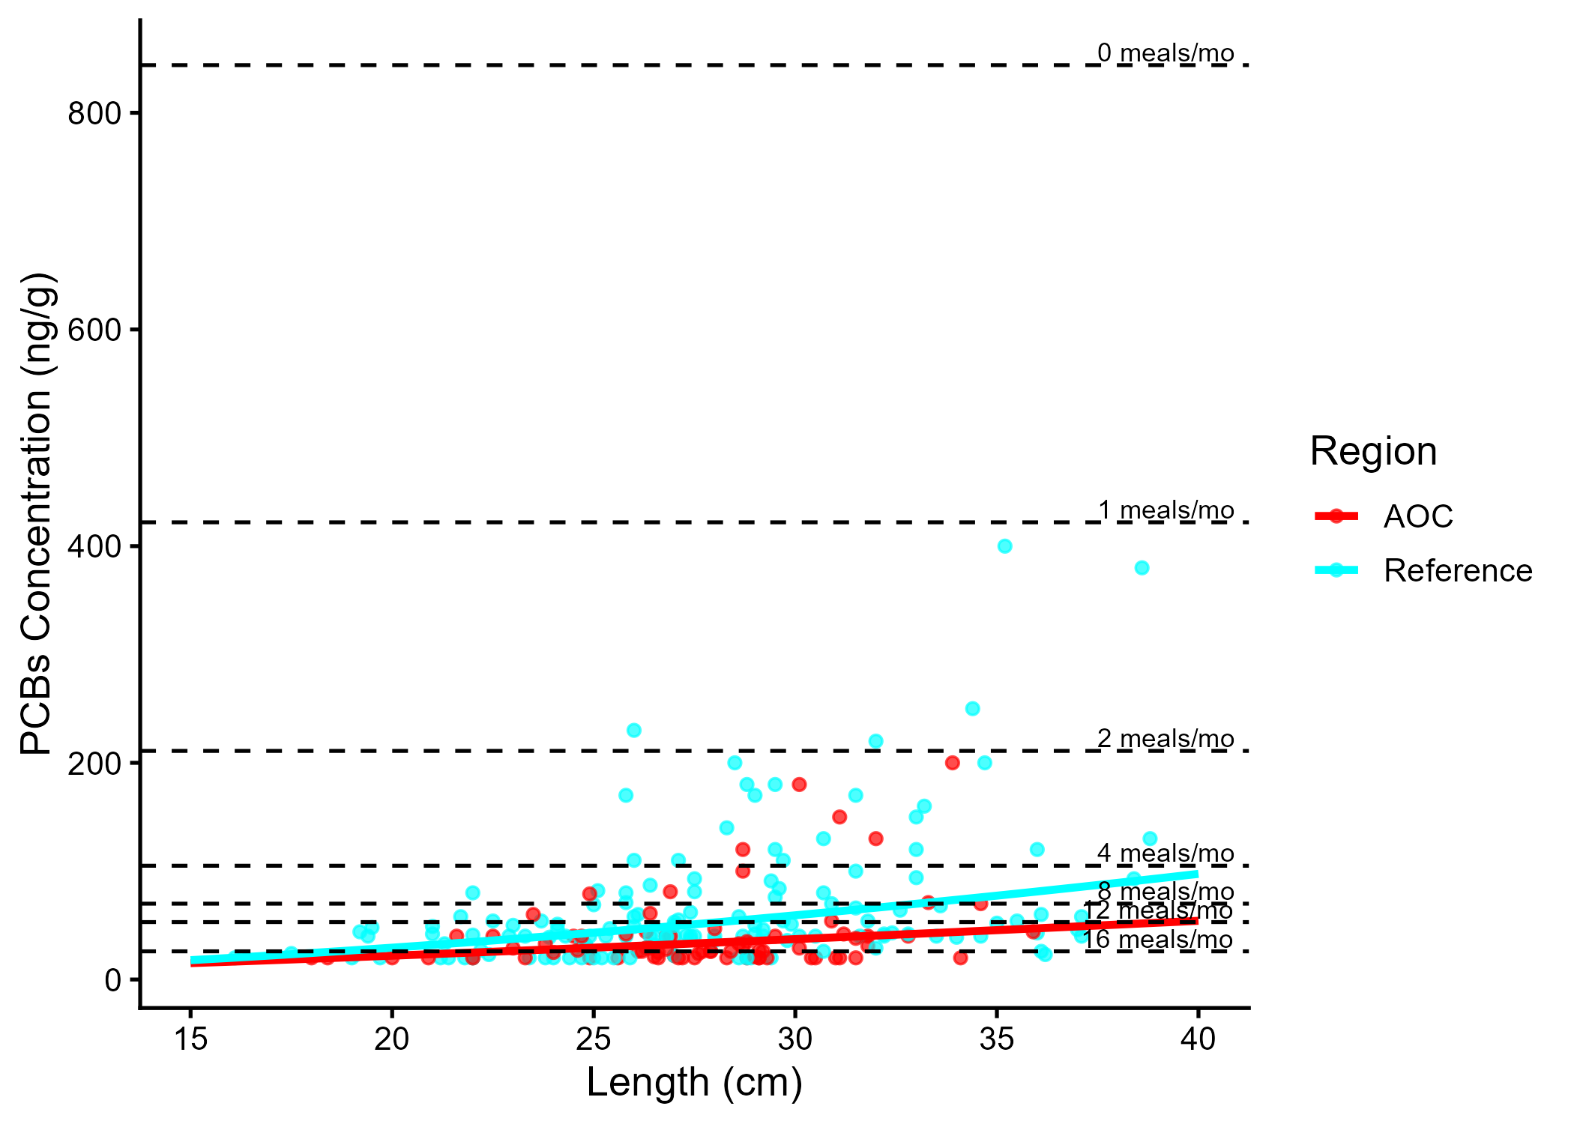
Figure 5.1: Virtual PCB advisories in brown bullhead. Predicted concentrations (curve) and observed values (points) by region using power regression model, compared to MECP advisory limits for PCB for the Sensititve population (dashed lines).
Table 5.1: Virtual advisory levels for PCB in brown bullhead across regions. Values represent meals/month recommendations. Red cells indicate restrictive virtual advisory below the desired consumption rate of 8 meals/month AND that of reference; green cells indicate unrestrictive virtual advisory equal to or above either the desired consumption rate or reference advisory.
Population | Region | 15-20 | 20-25 | 25-30 | 30-35 | 35-40 | 40-45
General | AOC | 32 | 32 | 16 | 16 | 16 | 12
General | Reference | 32 | 16 | 16 | 12 | 8 | 8

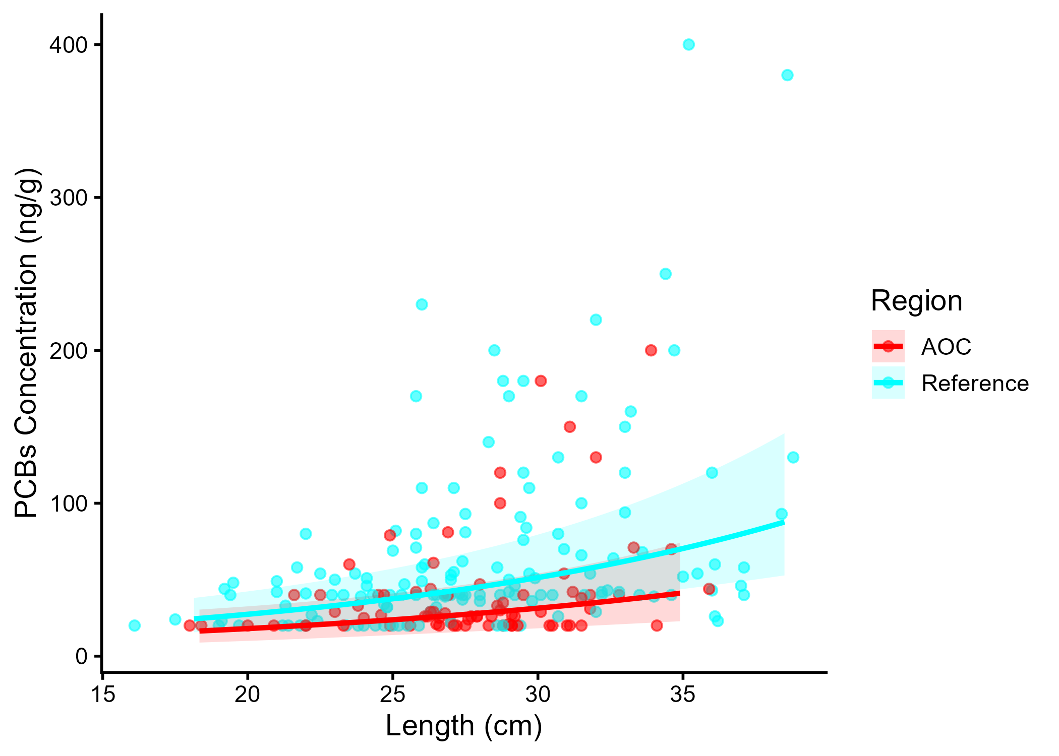
Figure 5.2: PCBs concentration in Brown Bullhead by length in the AOC compared to reference sites. Points are observed contaminant values, curves represent GAM model fit (with random effects dropped for simplicity, fitted across the 1st to 99th percentile of data to ensure reasonable support), ribbons represent 95% confidence interval.
Table 5.2: Estimated time to unrestrictive PCB threshold for an upper-quartile-sized brown bullhead in the AOC, using GAMM-derived half-life decay model. The model-predicted concentration of an upper-quartile length fish is reported for the most recent year of observation, and the target concentration corresponding to an “unrestrictive” advisory for the Sensitive population of 8, based on survey results and MECP advisory thresholds.
Upper Quartile Length (cm)
Predicted Conc. (Current Year)
Unrestrictive Conc.
Years to Threshold
95% CI
Outcome
30
52.40
70.00
0.0
-2032.3–2032.3
Supportive

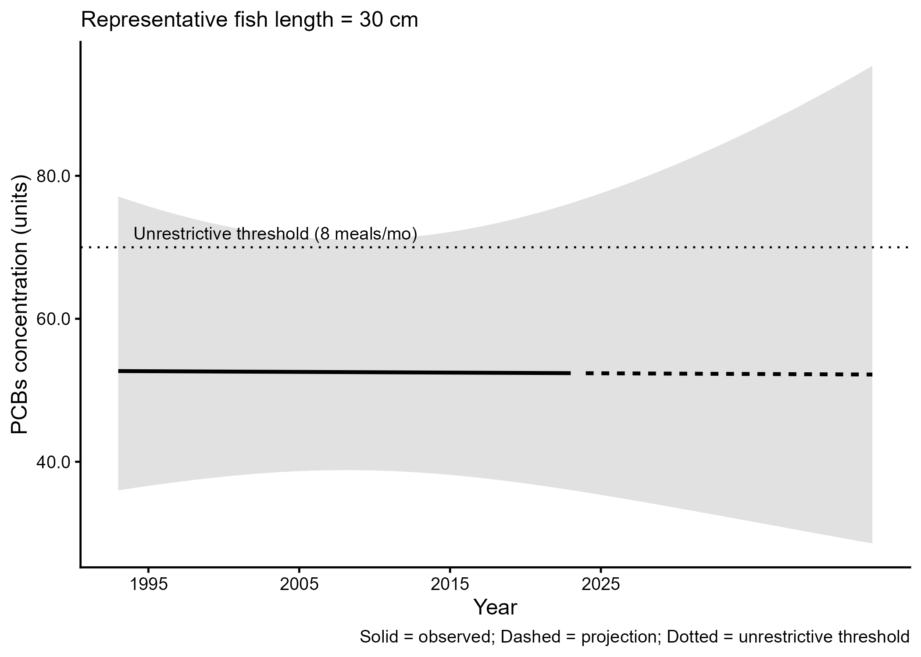
Figure 5.3: Projected PCBs concentration in upper-quartile-length Brown Bullhead in the AOC. Predicted concentration is based on GAMM-derived half-life decay model. The solid line represents predicted values within the temporal range of observations, the dashed line represents projected future concentrations, ribbons show 95% CI, and the horizontal dotted line represents the unrestrictive PCBs threshold for the sensitive population, based on community desired consumption rate and MECP advisory thresholds.

5.0.2 Lake Whitefish
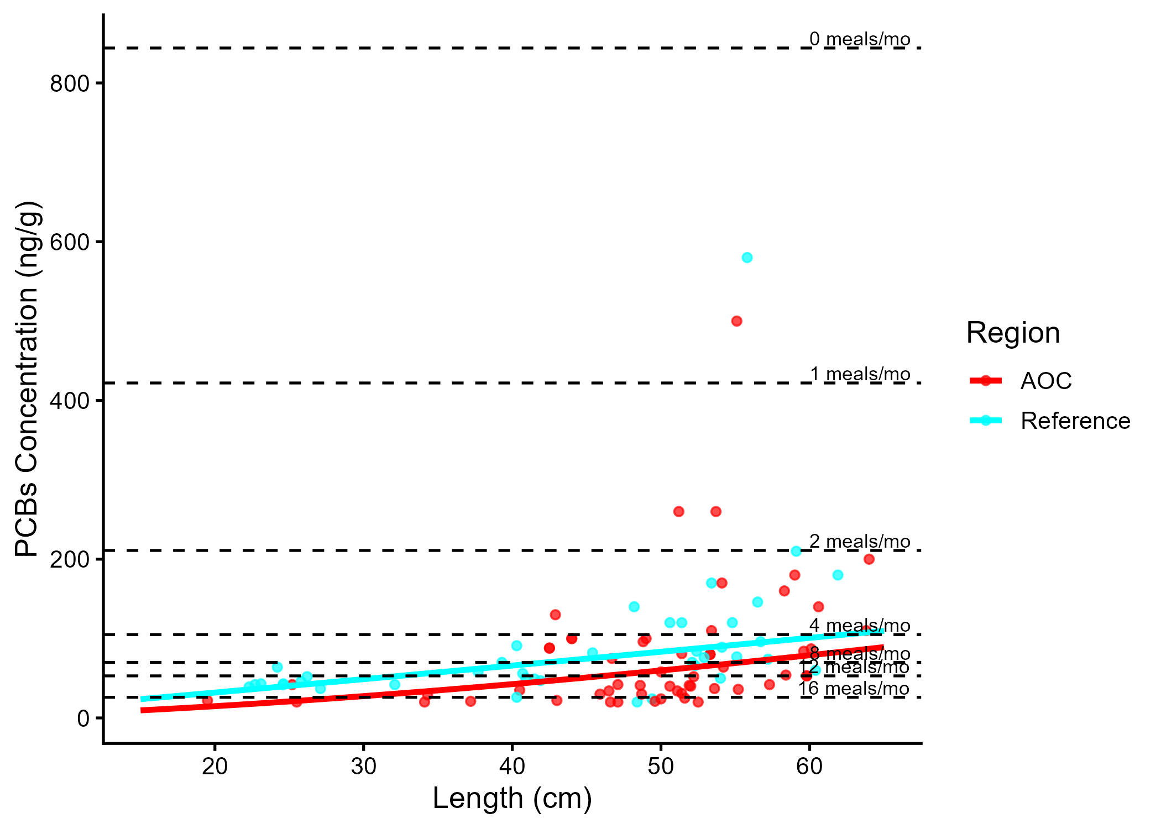
Figure 5.4: Virtual PCB advisories in lake whitefish. Predicted concentrations (curve) and observed values (points) by region using power regression model, compared to MECP advisory limits for PCB for the Sensititve population (dashed lines).
Table 5.3: Virtual advisory levels for PCB in lake whitefish across regions. Values represent meals/month recommendations. Red cells indicate restrictive virtual advisory below the desired consumption rate of 8 meals/month AND that of reference; green cells indicate unrestrictive virtual advisory equal to or above either the desired consumption rate or reference advisory.
Population | Region | 15-20 | 20-25 | 25-30 | 30-35 | 35-40 | 40-45 | 45-50 | 50-55 | 55-60 | 60-65 | 65-70
General | AOC | 32 | 32 | 32 | 16 | 16 | 16 | 12 | 12 | 8 | 8 | 8
General | Reference | 16 | 16 | 16 | 16 | 12 | 12 | 8 | 8 | 8 | 8 | 4

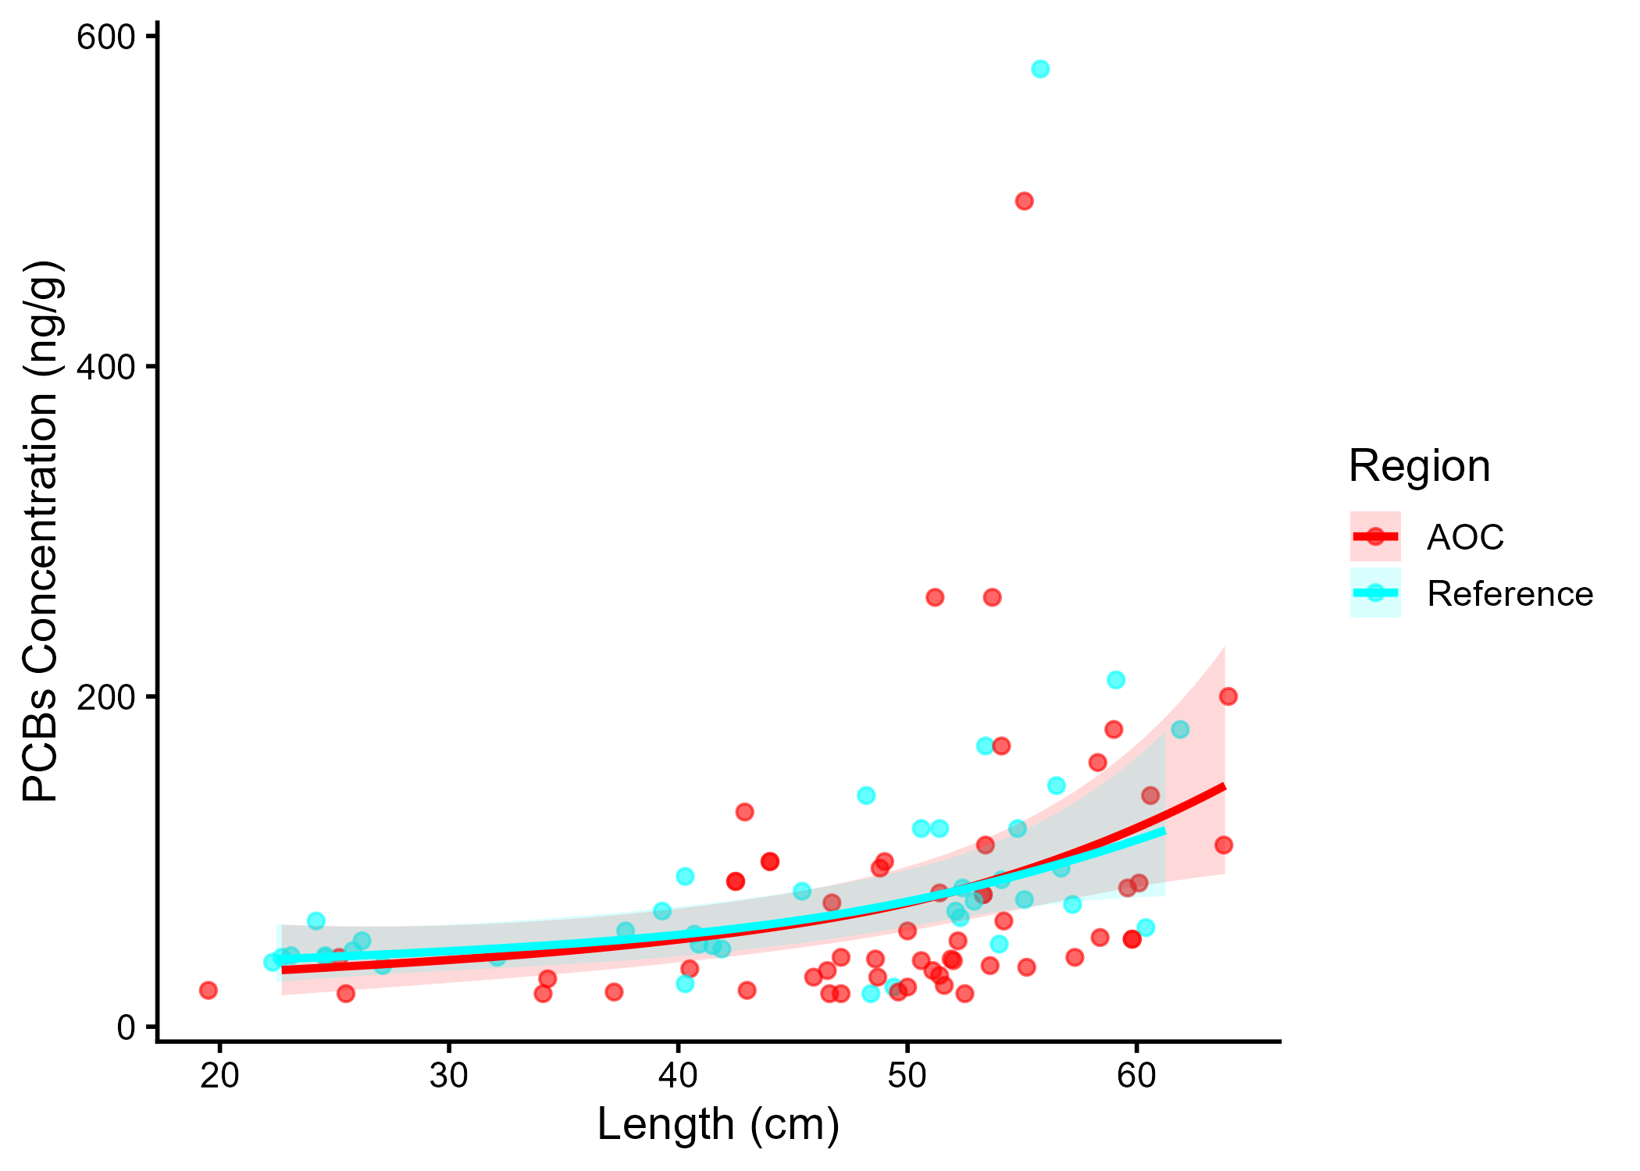
Figure 5.5: PCBs concentration in Lake Whitefish by length in the AOC compared to reference sites. Points are observed contaminant values, curves represent GAM model fit (with random effects dropped for simplicity, fitted across the 1st to 99th percentile of data to ensure reasonable support), rilwons represent 95% confidence interval.
Table 5.4: Estimated time to unrestrictive PCB threshold for an upper-quartile-sized lake whitefish in the AOC, using GAMM-derived half-life decay model. The model-predicted concentration of an upper-quartile length fish is reported for the most recent year of observation, and the target concentration corresponding to an “unrestrictive” advisory for the Sensitive population of 8, based on survey results and MECP advisory thresholds.
Upper Quartile Length (cm)
Predicted Conc. (Current Year)
Unrestrictive Conc.
Years to Threshold
95% CI
Outcome
55
53.25
70.00
0.0
-5.5–5.5
Supportive

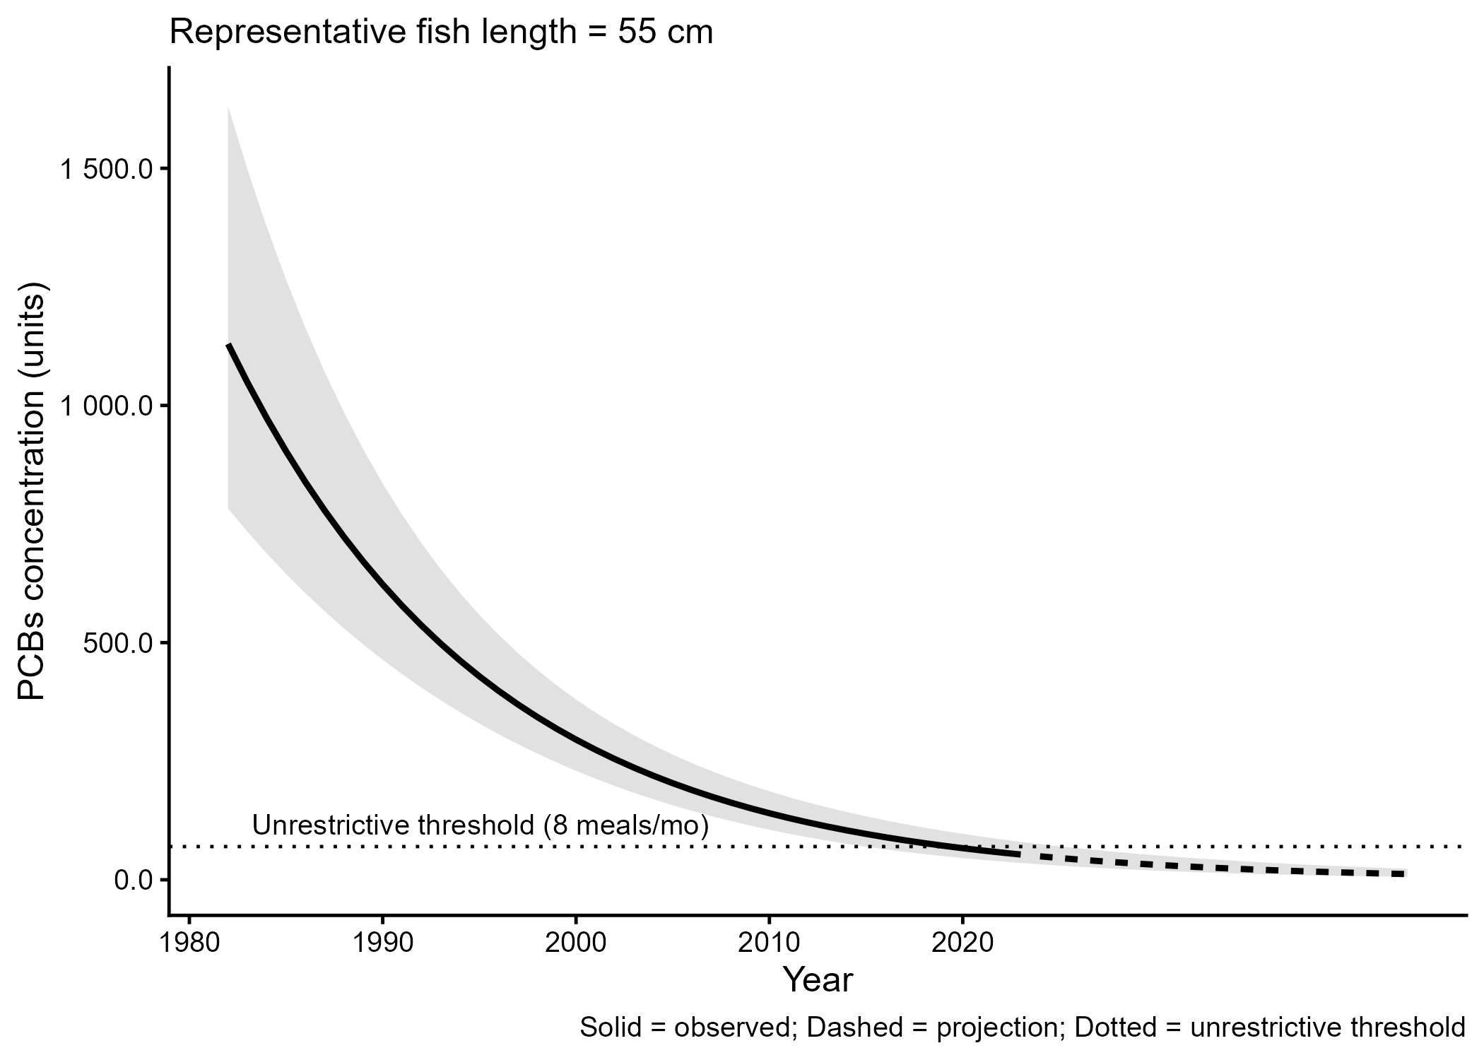
Figure 5.6: Projected PCBs concentration in upper-quartile-length Lake Whitefish in the AOC. Predicted concentration is based on GAMM-derived half-life decay model. The solid line represents predicted values within the temporal range of observations, the dashed line represents projected future concentrations, ribbons show 95% CI, and the horizontal dotted line represents the unrestrictive PCBs threshold for the sensitive population, based on community desired consumption rate and MECP advisory thresholds.

5.0.3 Northern Pike
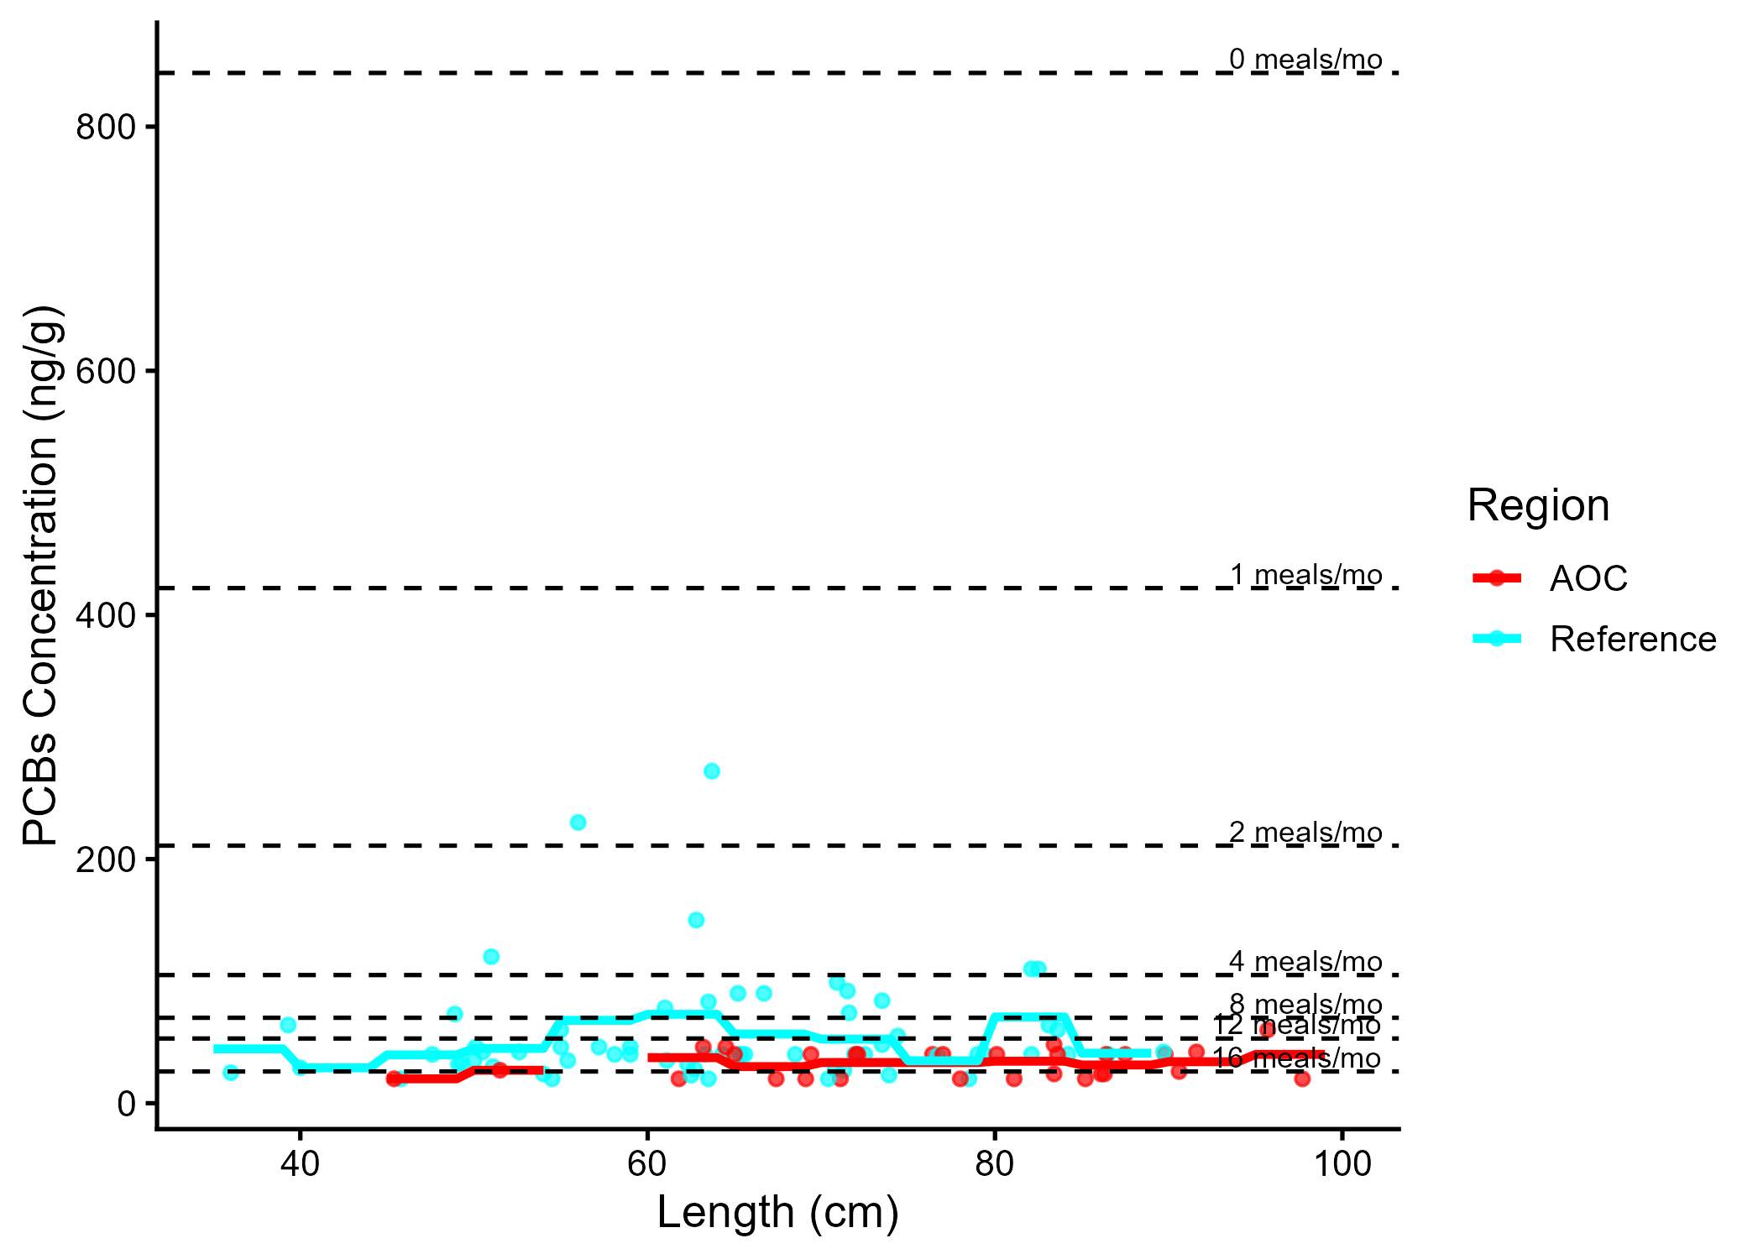
Figure 5.7: Virtual PCB advisories in northern pike. Predicted concentrations (curve) and observed values (points) by region using power regression model, compared to MECP advisory limits for PCB for the Sensititve population (dashed lines).
Table 5.5: Virtual advisory levels for PCB in northern pike across regions. Values represent meals/month recommendations. Red cells indicate restrictive virtual advisory below the desired consumption rate of 4 meals/month AND that of reference; green cells indicate unrestrictive virtual advisory equal to or above either the desired consumption rate or reference advisory.
Population | Region | 35-40 | 40-45 | 45-50 | 50-55 | 55-60 | 60-65 | 65-70 | 70-75 | 75+
General | AOC | 32 | 32 | 32 | 16 | 32 | 16 | 16 | 16 | 16
General | Reference | 16 | 16 | 16 | 16 | 12 | 8 | 12 | 16 | 16

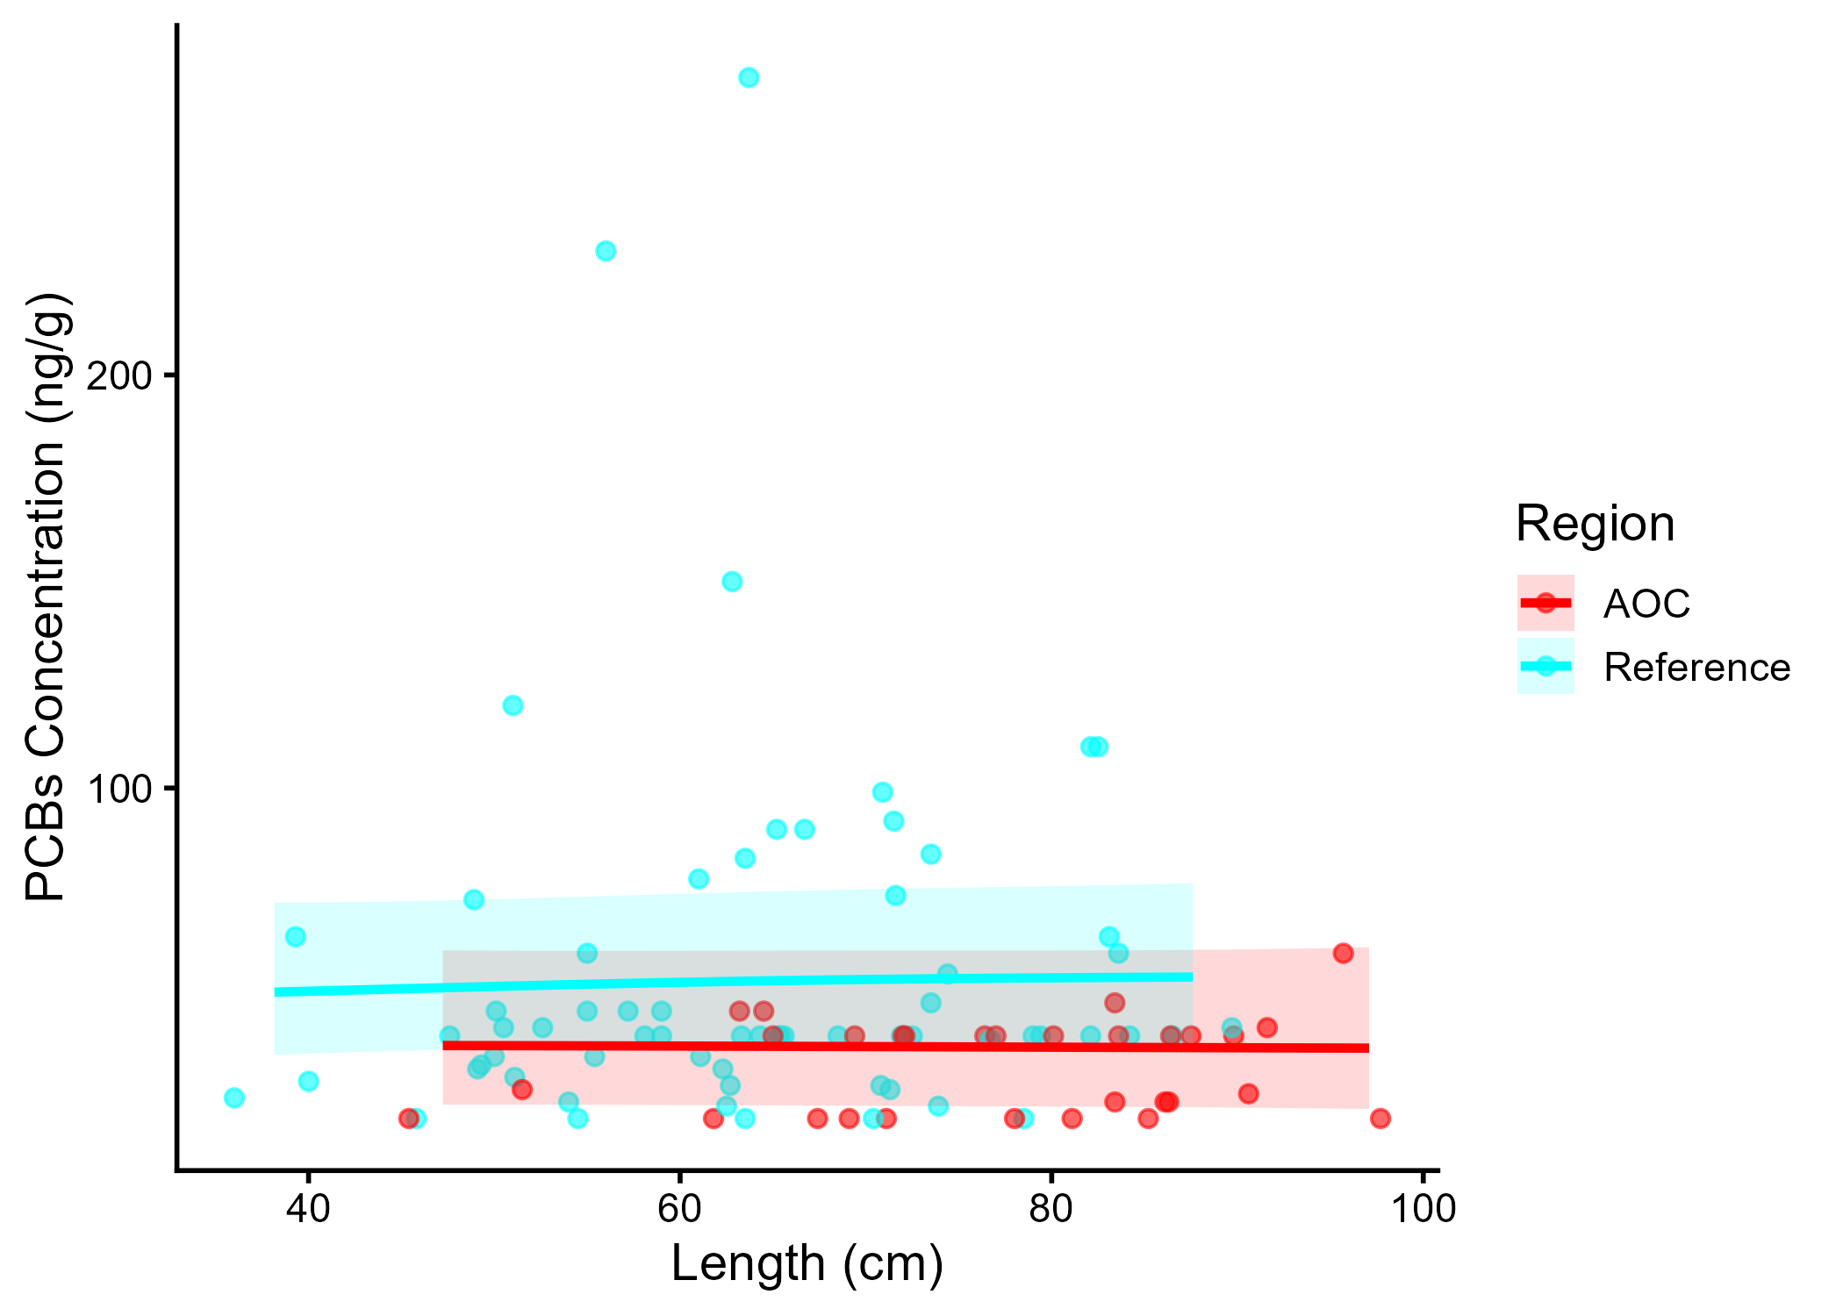
Figure 5.8: PCBs concentration in Northern Pike by length in the AOC compared to reference sites. Points are observed contaminant values, curves represent GAM model fit (with random effects dropped for simplicity, fitted across the 1st to 99th percentile of data to ensure reasonable support), ribbons represent 95% confidence interval.
Table 5.6: Estimated time to unrestrictive PCB threshold for an upper-quartile-sized northern pike in the AOC, using GAMM-derived half-life decay model. The model-predicted concentration of an upper-quartile length fish is reported for the most recent year of observation, and the target concentration corresponding to an “unrestrictive” advisory for the Sensitive population of 4, based on survey results and MECP advisory thresholds.
Upper Quartile Length (cm)
Predicted Conc. (Current Year)
Unrestrictive Conc.
Years to Threshold
95% CI
Outcome
80
12.13
70.00
0.0
-10.7–10.7
Supportive

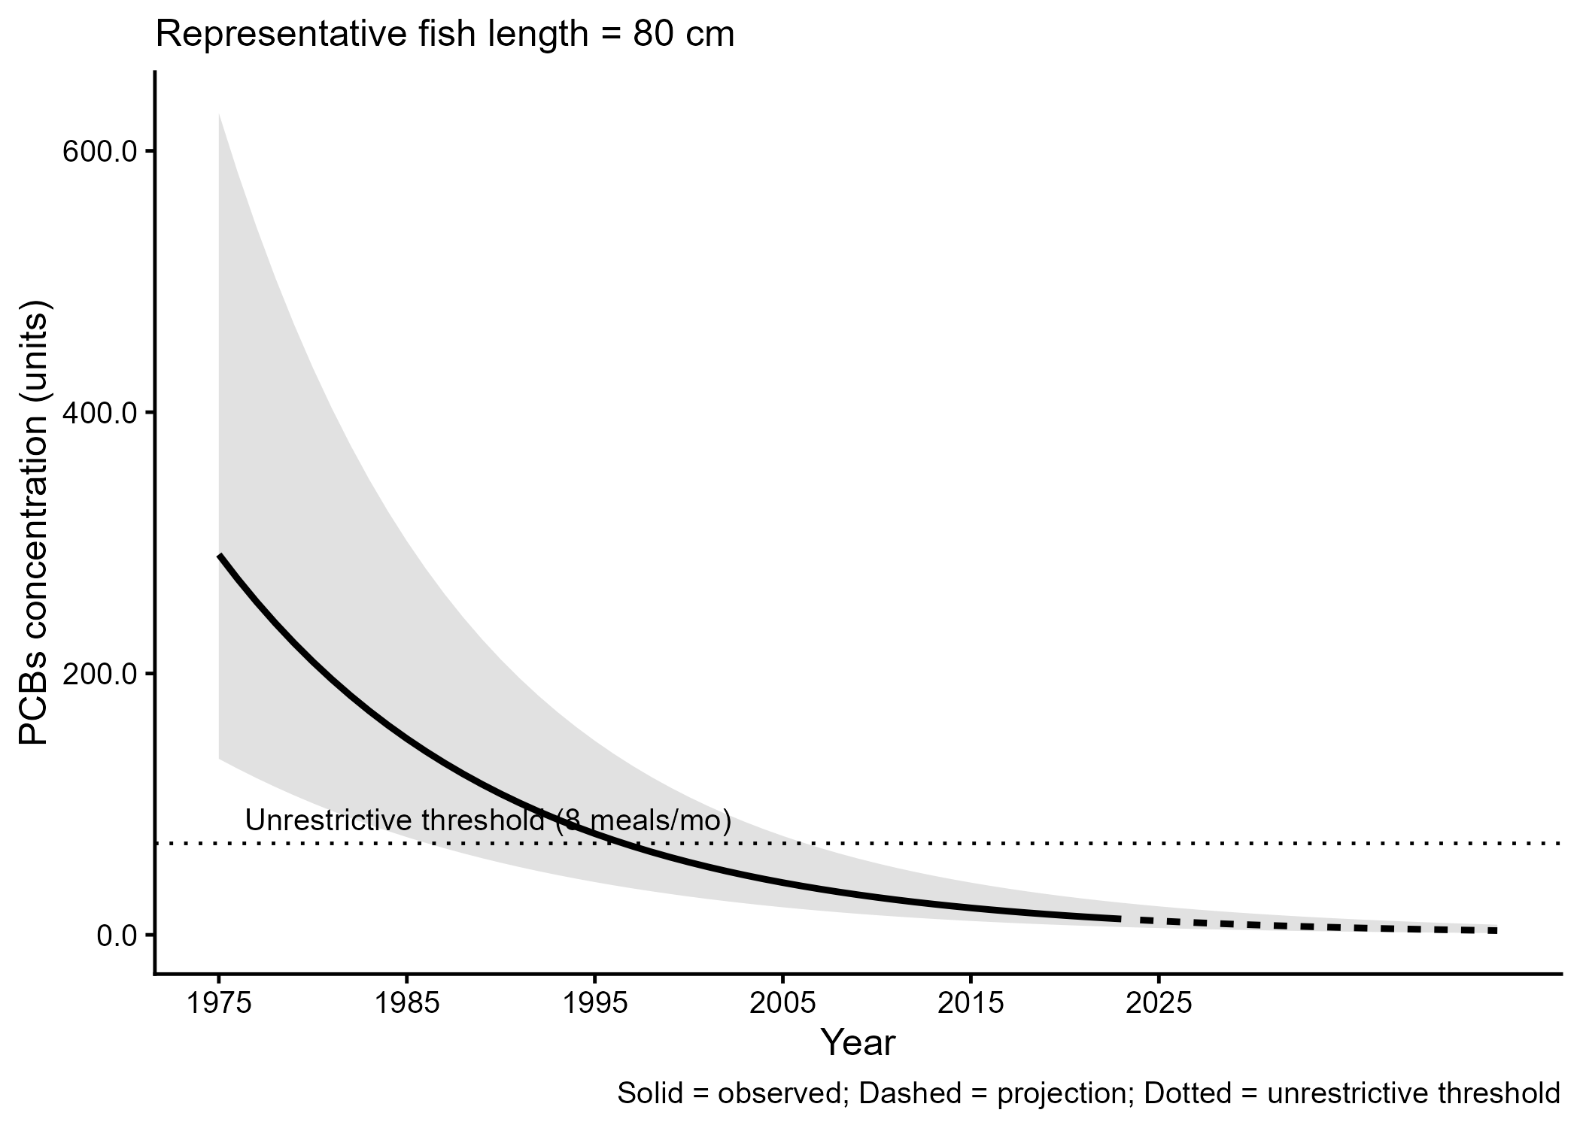
Figure 5.9: Projected PCBs concentration in upper-quartile-length Northern Pike in the AOC. Predicted concentration is based on GAMM-derived half-life decay model. The solid line represents predicted values within the temporal range of observations, the dashed line represents projected future concentrations, ribbons show 95% CI, and the horizontal dotted line represents the unrestrictive PCBs threshold for the sensitive population, based on community desired consumption rate and MECP advisory thresholds.

5.0.4 Smallmouth Bass
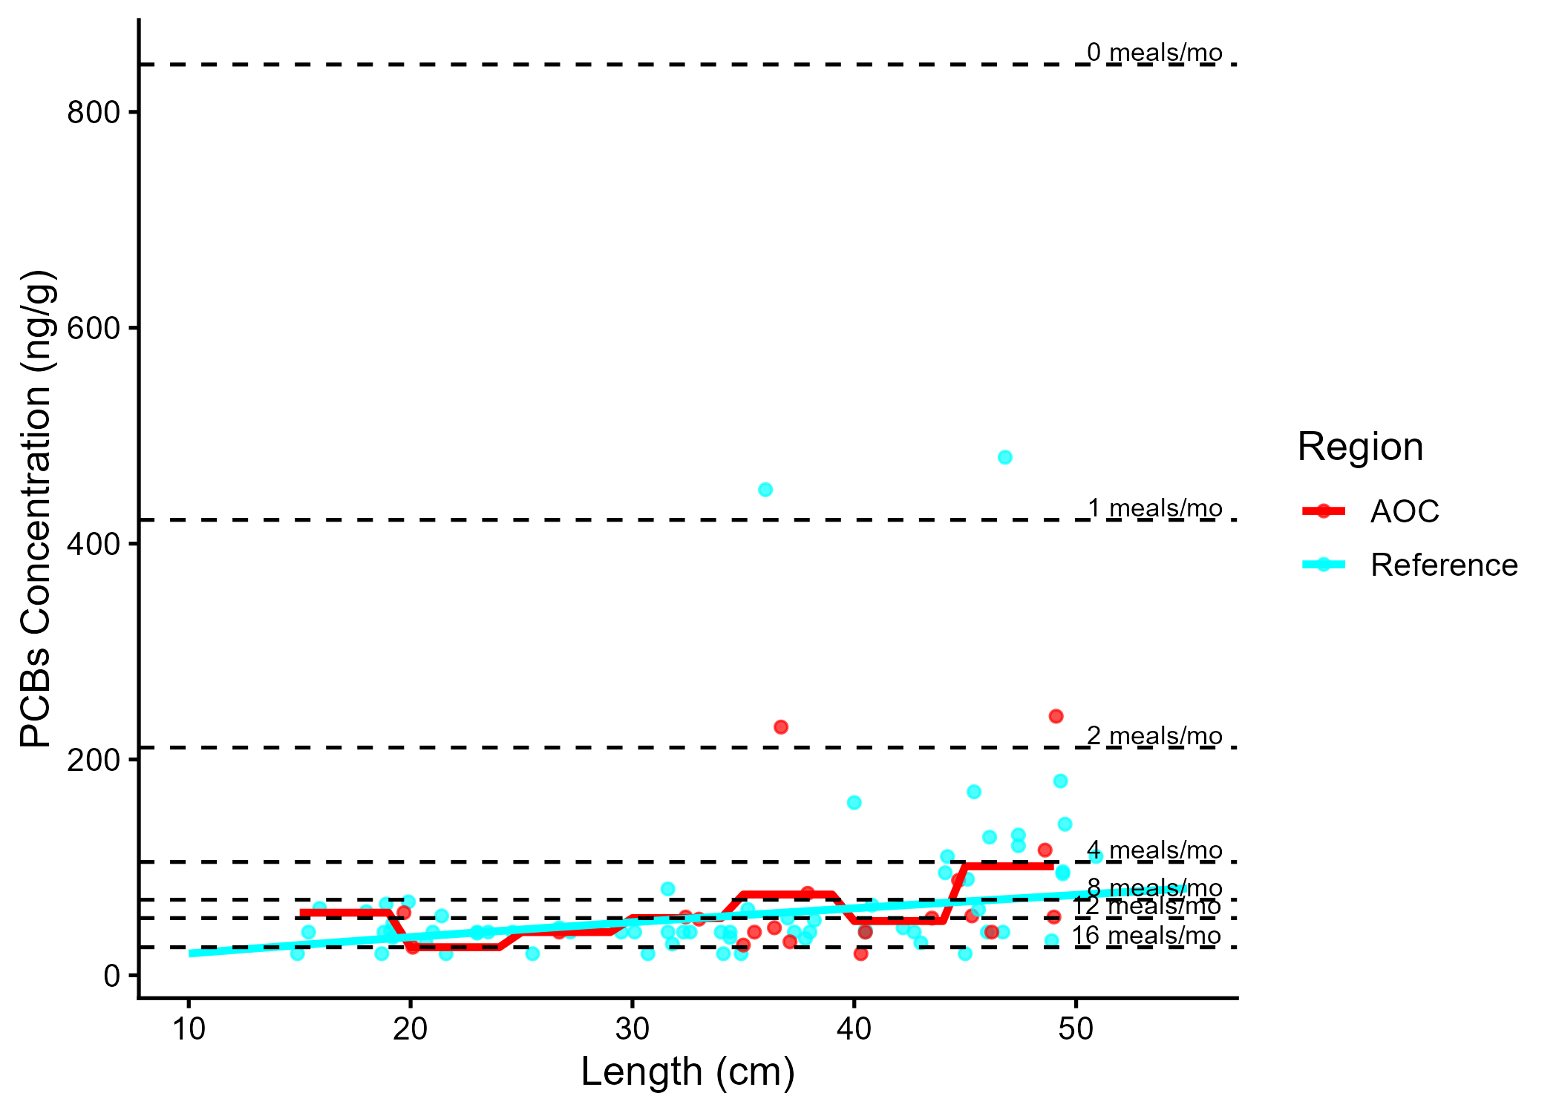
Figure 5.10: Virtual PCB advisories in smallmouth bass. Predicted concentrations (curve) and observed values (points) by region using power regression model, compared to MECP advisory limits for PCB for the Sensititve population (dashed lines).
Table 5.7: Virtual advisory levels for PCB in smallmouth bass across regions. Values represent meals/month recommendations. Red cells indicate restrictive virtual advisory below the desired consumption rate of 8 meals/month AND that of reference; green cells indicate unrestrictive virtual advisory equal to or above either the desired consumption rate or reference advisory.
Population | Region | 15-20 | 20-25 | 25-30 | 30-35 | 35-40 | 40-45 | 45-50 | 50-55 | 55-60
General | AOC | 12 | 32 | 16 | 16 | 8 | 16 | 8 | 32 | 32
General | Reference | 16 | 16 | 16 | 16 | 12 | 12 | 8 | 8 | 8

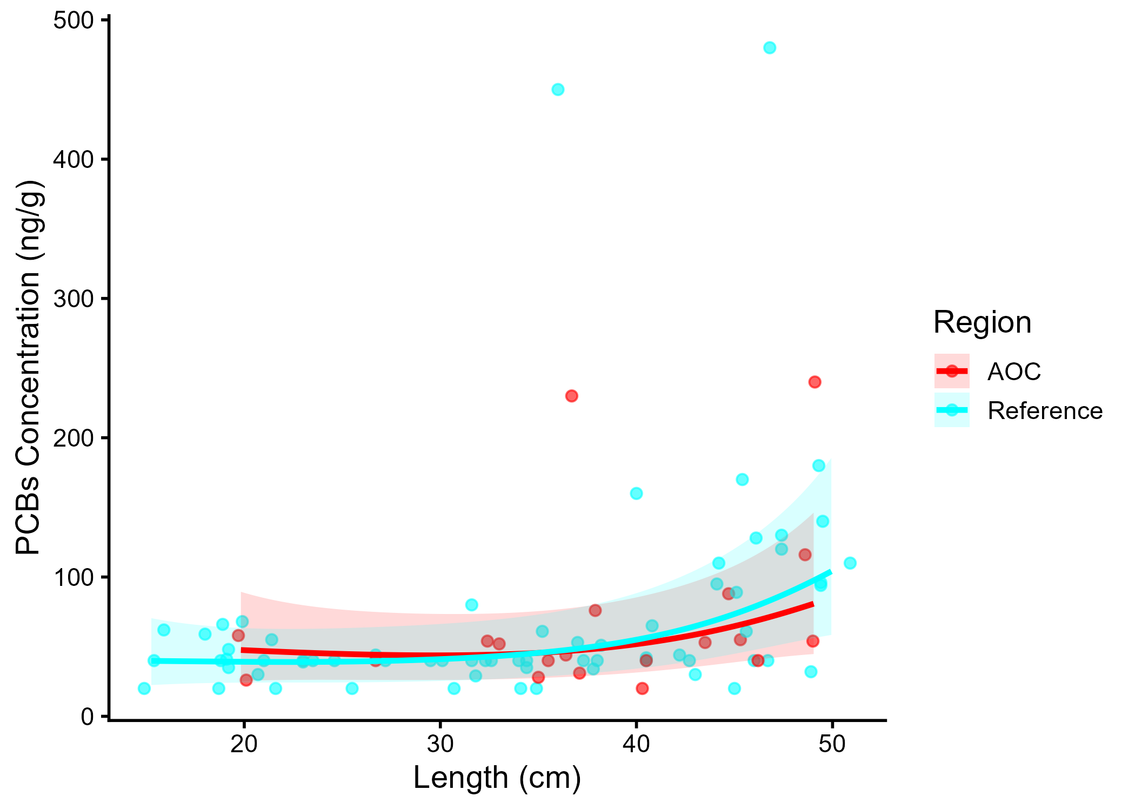
Figure 5.11: PCBs concentration in Smallmouth Bass by length in the AOC compared to reference sites. Points are observed contaminant values, curves represent GAM model fit (with random effects dropped for simplicity, fitted across the 1st to 99th percentile of data to ensure reasonable support), ribbons represent 95% confidence interval.
Table 5.8: Estimated time to unrestrictive PCB threshold for an upper-quartile-sized smallmouth bass in the AOC, using GAMM-derived half-life decay model. The model-predicted concentration of an upper-quartile length fish is reported for the most recent year of observation, and the target concentration corresponding to an “unrestrictive” advisory for the Sensitive population of 8, based on survey results and MECP advisory thresholds.
Upper Quartile Length (cm)
Predicted Conc. (Current Year)
Unrestrictive Conc.
Years to Threshold
95% CI
Outcome
40
38.79
70.00
0.0
-8.7–8.7
Supportive

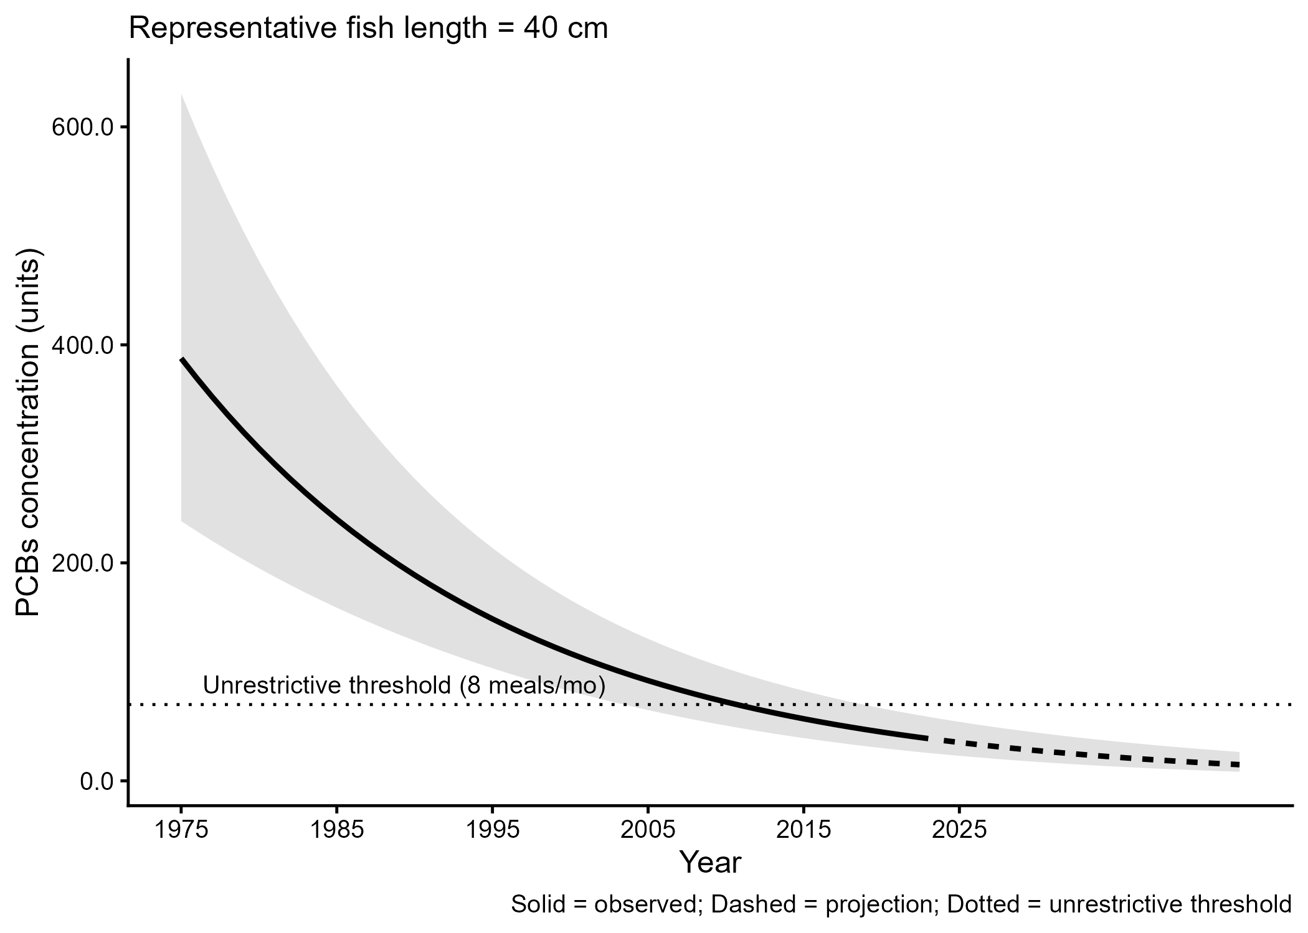
Figure 5.12: Projected PCBs concentration in upper-quartile-length Smallmouth Bass in the AOC. Predicted concentration is based on GAMM-derived half-life decay model. The solid line represents predicted values within the temporal range of observations, the dashed line represents projected future concentrations, ribbons show 95% CI, and the horizontal dotted line represents the unrestrictive PCBs threshold for the sensitive population, based on community desired consumption rate and MECP advisory thresholds.

