hostscan 扫描报告

# 测试范围

117.136.190.172, 117.136.190.162, 117.136.190.163, 117.136.190.164, 117.136.190.165, 117.136.190.166, 117.136.190.167, 117.136.190.168, 117.136.190.188, 218.206.190.14, 221.176.64.195, 221.176.64.198, 221.176.64.200, 221.176.64.202, 221.176.64.203, 117.136.190.191, 117.136.129.9, 117.136.129.8, 117.136.129.209, 117.136.129.197, 117.136.129.198, 117.136.129.199, 117.136.129.200, 117.136.129.213, 117.136.129.214, 117.136.129.215, 117.136.129.216, 117.136.129.217, 117.136.129.218, 117.136.1329.13, 117.136.190.254, 117.128.1.204, 221.176.60.131, 221.176.60.132, 221.176.60.134, 221.176.60.140, 221.176.60.139, 221.176.60.138, 221.176.60.136, 221.176.60.137, 221.176.60.135, 221.176.60.132, 221.176.60.140, 221.176.60.135, 221.176.60.132, 117.136.129.109, 221.176.60.142

# 存活地址

# 图表数据

### 资产存活饼状图

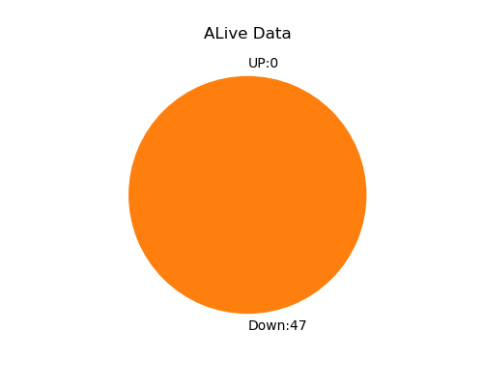

### Total Data

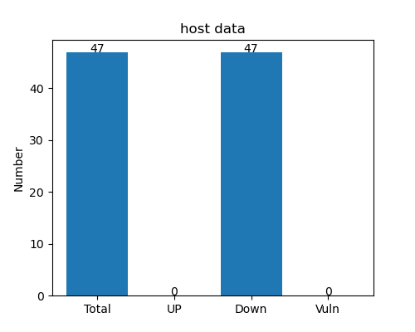

# 端口开放详情

|  |  |
| --- | --- |
| IP | 端口 |

# 漏洞风险

没有进行漏洞扫描或不存在漏洞

# 报告声明

本报告由ADYHostScan工具扫描生成

脚本地址：https://github.com/aydcyhr/ADYHostScan