hostscan 扫描报告

# 测试范围

117.136.190.172, 117.136.190.162, 117.136.190.163, 117.136.190.164, 117.136.190.165, 117.136.190.166, 117.136.190.167, 117.136.190.168, 117.136.190.188, 218.206.190.14, 221.176.64.195, 221.176.64.198, 221.176.64.200, 221.176.64.202, 221.176.64.203, 117.136.190.191, 117.136.129.9, 117.136.129.8, 117.136.129.209, 117.136.129.197, 117.136.129.198, 117.136.129.199, 117.136.129.200, 117.136.129.213, 117.136.129.214, 117.136.129.215, 117.136.129.216, 117.136.129.217, 117.136.129.218, 117.136.1329.13, 117.136.190.254, 117.128.1.204, 221.176.60.131, 221.176.60.132, 221.176.60.134, 221.176.60.140, 221.176.60.139, 221.176.60.138, 221.176.60.136, 221.176.60.137, 221.176.60.135, 221.176.60.132, 221.176.60.140, 221.176.60.135, 221.176.60.132, 117.136.129.109, 221.176.60.142

# 存活地址

117.128.1.204  
117.136.129.214  
117.136.129.216  
117.136.129.215  
117.136.190.188  
117.136.129.217  
117.136.129.213  
117.136.129.209

# 图表数据

### 资产存活饼状图

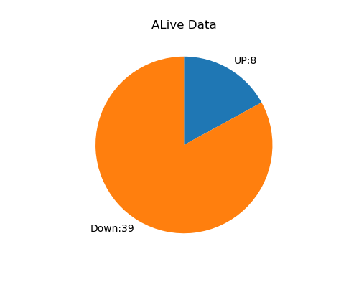

### Total Data

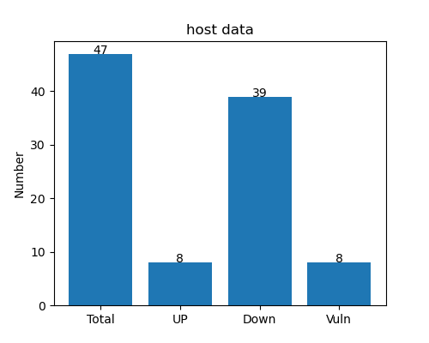

# 端口开放详情

|  |  |
| --- | --- |
| IP | 端口 |
| 117.128.1.204 | 25,110, |
| 117.136.129.209 | 25,110, |
| 117.136.129.213 | 25,110, |
| 117.136.129.214 | 25,110, |
| 117.136.129.215 | 25,110, |
| 117.136.129.216 | 25,110, |
| 117.136.129.217 | 25,110, |
| 117.136.190.188 | 25,110,85,80,81, |

# 漏洞风险

117.128.1.204:110:110端口开放，请检测是否存在POP存在弱口令

117.136.129.214:110:110端口开放，请检测是否存在POP存在弱口令

117.136.129.216:110:110端口开放，请检测是否存在POP存在弱口令

117.136.129.215:110:110端口开放，请检测是否存在POP存在弱口令

117.136.190.188:110:110端口开放，请检测是否存在POP存在弱口令

117.136.129.217:110:110端口开放，请检测是否存在POP存在弱口令

117.136.129.213:110:110端口开放，请检测是否存在POP存在弱口令

117.136.129.209:110:110端口开放，请检测是否存在POP存在弱口令

# 报告声明

本报告由ADYHostScan工具扫描生成

脚本地址：https://github.com/aydcyhr/ADYHostScan