Tham Jit 1005036 AFC HW1

1)

|  |  |
| --- | --- |
| CCF | CCF |
| OCF | OCF |

2)

State space representation:

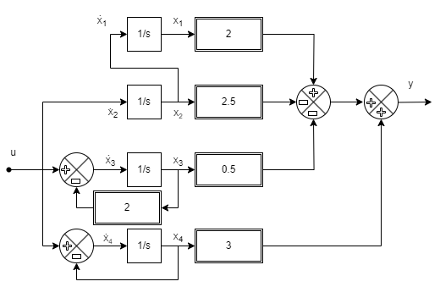

3)

4)

5a)

|  |  |  |
| --- | --- | --- |
|  |  |  |

5b)

Mechanical values = -1,-2,-3

5c)

(shown)

6a)

6b)

For small angle,

|  |  |
| --- | --- |
| CCF | OCF |

7)

A is already in Jordan form

8)

Since