Tham Jit 1005036 HW3

2. 1. 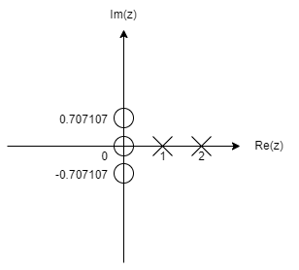Poles zeros $=0, ±\sqrt{\frac{j}{2}}$
 $$\frac{X\left(z\right)}{z}=\frac{2z^{2}+1}{{\left(z-2\right)}^{2}\left(z-1\right)}=\frac{3}{z-1}-\frac{1}{z-2}+\frac{9}{{\left(z-2\right)}^{2}}$$

 $$X\left(z\right)=\frac{3}{1-z^{-1}}-\frac{1}{1-2z^{-1}}+\frac{9z^{-1}}{{\left(1-2z^{-1}\right)}^{2}}$$

 $$x\left(k\right)=3+2^{k}+9k2^{k-1} , k=0,1,2…$$

2. Poles = 0,0,2 zeros=-2

$$X\left(z\right)=\frac{1}{z-2}-\frac{1}{z}-\frac{1}{z^{2}}=\frac{z^{-1}}{1-2z^{-1}}-z^{-1}+z^{-2}$$

$$x\left(k\right)=2^{k-1}(k - 1) - δ(k - 1) - δ(k - 2)$$

$$x{\left(k\right)}_{k=0}=0-0-0=0$$

$$x{\left(k\right)}_{k=1}=2^{0}-1-0=0$$

$$x{\left(k\right)}_{k=2}=2^{1}-0-1=1$$

$$x{\left(k\right)}_{k=3,4…}=2^{k}-1-1=2^{k-1}$$

Direct division:

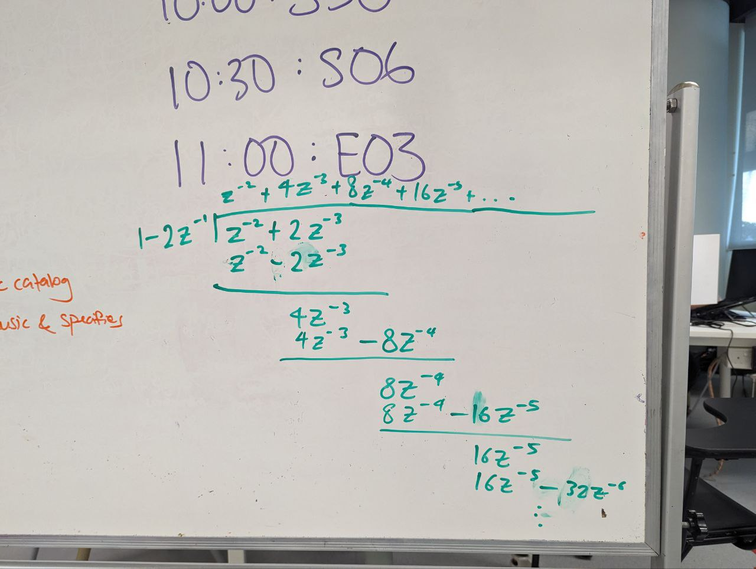

* 1. Poles = 1,2

|  |  |
| --- | --- |
| $$X\left(z\right)=\frac{5}{z-2}-\frac{5}{z-1}=\frac{5z^{-1}}{1-2z^{-1}}-\frac{5z^{-1}}{1-z^{-1}}$$ $${x\left(k\right)=5*2}^{k-1}-5*1^{k-1}=5\left(2^{k-1}-1 \right)$$ $$k≥1$$ | $$x\left(kT\right)=x\left(K\right)=$$ $$\lim_{z→1}\left(\frac{5\left(z-1\right)z^{k-1}}{\left(z-2\right)\left(z-1\right)}\right)+\lim_{z→2}\left(\frac{5\left(z-2\right)z^{k-1}}{\left(z-2\right)\left(z-1\right)}\right)$$ $$=\frac{5*1}{1-2}+\frac{5*2^{k-1}}{2-1}$$ $$=5\left(2^{k-1}-1\right)$$ |

$$X\left(z\right)=\frac{0.5z\left(z-2\right)}{\left(z-0.5\right){\left(z-0.8\right)}^{2}}$$

Poles = 0.5,0.8,0.8

$$\frac{X\left(z\right)}{z}=\frac{25}{3\left(z-0.8\right)}-\frac{10}{{\left(z-0.8\right)}^{2}}-\frac{25}{3\left(z-0.5\right)}$$

$$X\left(z\right)=\frac{\frac{25}{3}}{1-0.8z^{-1}}-\frac{10z^{-1}}{{\left(1-0.8z^{-1}\right)}^{2}}-\frac{\frac{25}{3}}{1-0.5z^{-1}}$$

$$x\left(k\right)={\frac{25}{3}(0.8}^{k}-{0.5}^{k})-10k*{0.8}^{k-1}$$

Since poles are within unit circle, system is stable



$Z\left[x\left(k + 2\right)- 1.3679x\left(k + 1\right)+ 0.3679x\left(k\right)\right]=Z\left[ 0.3679u\left(k + 1\right)+ 0.2642u\left(k\right)\right]$

$$z^{2}X\left(z\right)-z^{2}x\left(0\right)-zx\left(1\right)-13679\left(zX\left(z\right)-zx\left(0\right)\right)+0.3679X\left(z\right)=0.3679\left(zU\left(z\right)-zu\left(0\right)\right)+0.2642U(z)$$

$$\left(z^{2}-1.3679z+0.3679\right)X\left(z\right)-zx\left(1\right)=\left(0.3679z+0.2642\right)U\left(z\right)-0.3679z$$

$$X\left(z\right)=\frac{0.3679z+0.2642}{z^{2}-1.3679z+0.3679}U\left(z\right)+\frac{x\left(1\right)-0.3679}{z^{2}-1.3679z+0.3679}z$$

$$x\left(k + 2\right)- 1.3679x\left(k + 1\right)+ 0.3679x\left(k\right)= 0.3679u\left(k + 1\right)+ 0.2642u\left(k\right)$$

Let $k=-1$

$$x\left(1\right)- 1.3679x\left(0\right)+ 0.3679x\left(-1\right)= 0.3679u\left(0\right)+ 0.2642u\left(-1\right)$$

$$x\left(1\right)=0.3679$$

$$U\left(z\right)=\sum_{k=0}^{∞}{\left[x\left(k\right)z^{-k}\right]}$$

$$=u\left(0\right)+u\left(1\right)z^{-1}+u\left(2\right)z^{-2}+u\left(3\right)z^{-3}+…$$

$$=1+0.2142z^{-1}-0.2142z^{-2}+0z^{-3}+…$$

$$=1+0.2142z^{-1}-0.2142z^{-2}$$

$$X\left(z\right)=\frac{0.3679z+0.2642}{z^{2}-1.3679z+0.3679}\left(1+0.2142z^{-1}-0.2142z^{-2}\right)+\frac{0.3679-0.3679}{z^{2}-1.3679z+0.3679}z$$

$$X\left(z\right)= \frac{\left(0.3679z+0.2642\right)\left(1+0.2142z^{-1}-0.2142z^{-2}\right)}{z^{2}-1.3679z+0.3679}$$

$$=\frac{0.3679z + 0.2642 + 0.0788 + 0.0566z^{-1} - 0.0788z^{-1} - 0.0566z^{-2}}{z^{2}-1.3679z+0.3679}$$

$$=\frac{0.3679z^{-1}+0.343z^{-2}-0.0222z^{-3}- 0.0566z^{-4}}{1-1.3679z^{-1}+0.3679z^{-2}}$$

Direct division:

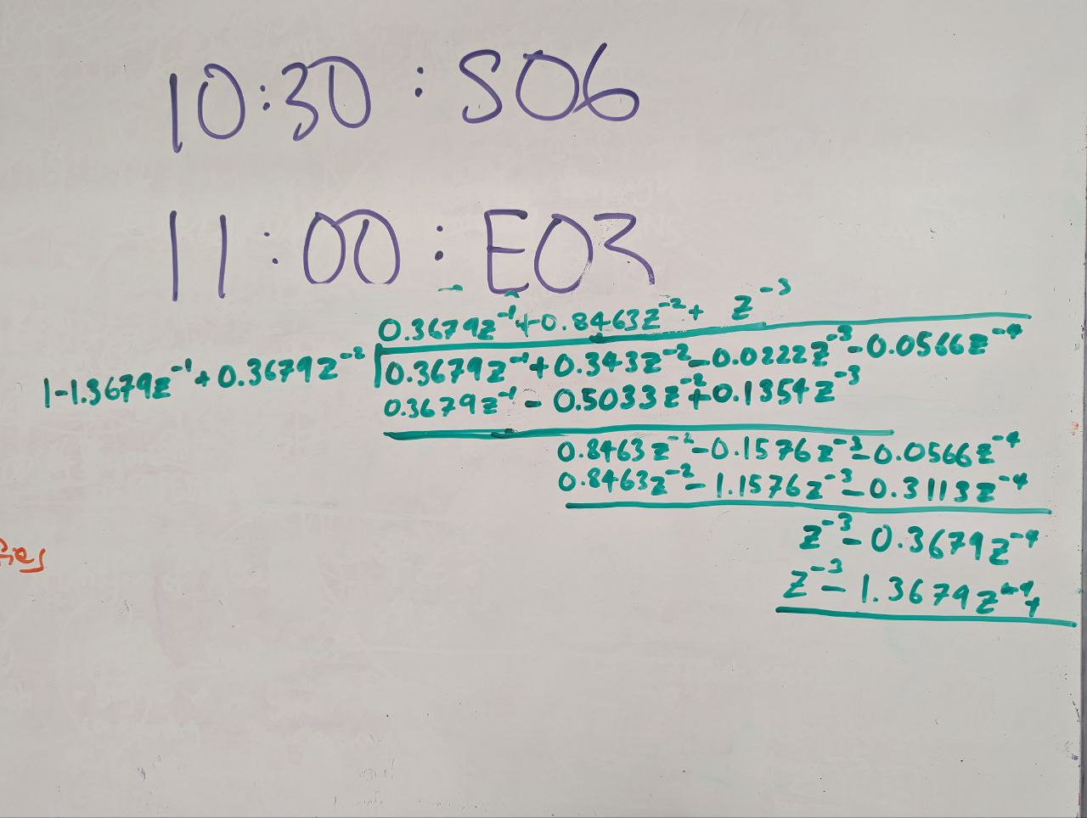



$$x\left(k\right)=\left\{\begin{matrix}0 & k=0 \\ 0.3679 & k=1 \\ 0.8463 & k=2 \\ 1 & k≥3\end{matrix}\right.$$

$$Z\left[y\left(k\right)-0.6y\left(k-1\right)-0.81y\left(k-2\right)+0.67y\left(k-3\right)-0.12y\left(k-4\right)\right]=Z\left[ x\left(k\right)\right]$$

$$Y\left(z\right)-0.6z^{-1}Y\left(z\right)-0.81z^{-2}Y\left(z\right)+0.67z^{-3}Y\left(z\right)-0.12z^{-4}Y\left(z\right)=X(z)$$

$$\frac{Y\left(z\right)}{X\left(z\right)}=\frac{z^{4}}{z^{4}-0.6z^{3}-0.81z^{2}+0.67z+0.12}$$

$$P\left(z\right)=z^{4}-0.6z^{3}-0.81z^{2}+0.67z+0.12=0$$

Jury Stability

|  |
| --- |
| passed |
| passed |
| Since pole on unit circle, system is marginally stable |
| |  |  |  |  |  |  |  | | --- | --- | --- | --- | --- | --- | --- | | Row |  |  |  |  |  |  | |  |  |  |  |  |  |  | |  |  |  |  |  |  |  | |  |  | | | | |  | |  |  | | | | |  | |  |  | | | | |  | |  |  | | | | |  | |  |  |  |  |  |  |  | |  |  |  |  |  |  |  | |  |  | | | | |  | |  |  | | | | |  | |  |  | | | | |  | |  |  |  |  |  |  |  |   Jury Stability Table  passed |

System is marginally stable

$$P\left(z\right)=0.32+1.44z+2.1z^{2}+z^{3}=0$$

Jury Stability

|  |
| --- |
| passed |
| passed |
| passed |
| |  |  |  |  |  |  | | --- | --- | --- | --- | --- | --- | |  |  |  |  |  |  | |  |  |  |  |  |  | |  |  |  |  |  |  | |  |  | | | |  | |  |  | | | |  | |  |  | | | |  | |  |  |  |  |  |  |   Jury Stability Table  passed |

System is stable. Hence, there are no roots that lie outside the unit circle



$$\frac{Y\left(z\right)}{X\left(z\right)}=\frac{2}{z^{3}+0.4z^{2}-1.34z+0.28}$$

$$P\left(z\right)=z^{3}+0.4z^{2}-1.34z+0.28=0$$

Jury Stability

|  |
| --- |
| passed |
| passed |
| failed |

System is unstable