Assignment1 partA

1.

(a)

class, country(bore>=16(Classes))

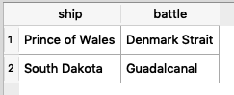

(b)

name(launched<1921(Ships))

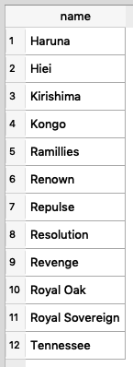

(c)

ship(battle = “Denmark Strait” AND result = “sunk”(Outcomes))

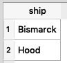

(d)

name(launched >= 1921 AND displacement >= 35000(ClassjoinopShips))

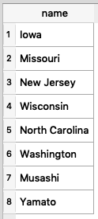

(e)

ship, displacement, numGuns(battle = “Guadalcanal”( Classjoinop Outcomes))

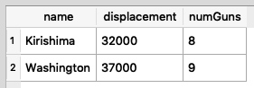

(f)

 **ρ** shipName/name (Ships) ∪  **ρ** shipName/ship (Ships)

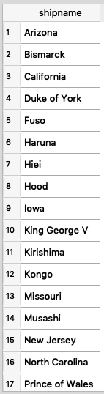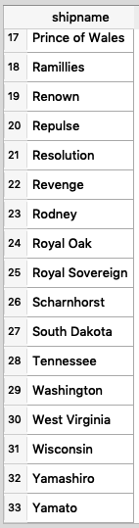

(g)

class **γ**class  COUNT(name)=1 (Ships)

None

(h)

country (type = “bb”(Classes)) ∩  country (type = “bc”(Classes))

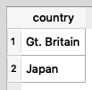

(i)

R1 = date, ship, result(Battle joinop Outcomes)

R2 = result = “damaged”(R1)

R3 =  R2.name, R2.date, R1.name, R1.date(R2****R1)

R4 = R2.name = R1.name (R3)

R5 = R2.date= R1.date (R4)

R6 =  R2.name(R5)