Assignment1 Part B: SQL queries

2.

(a)

SELECT maker, speed FROM Product NATURAL JOIN Laptop

WHERE hd >= 30

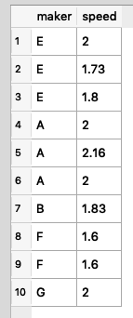

(b)

SELECT model, price FROM Product NATURAL JOIN PC WHERE maker = 'B'

UNION

SELECT model, price FROM Product NATURAL JOIN Laptop WHERE maker = 'B'

UNION

SELECT model, price FROM Product NATURAL JOIN Printer WHERE maker = 'B'

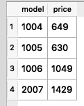

(c)

SELECT maker FROM Laptop NATURAL JOIN Product

EXCEPT

SELECT maker FROM PC NATURAL JOIN Product

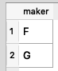

(d)

SELECT hd

FROM PC

GROUP BY hd

HAVING COUNT(model) >= 2;

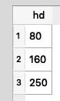

(e)

SELECT P1.model, P2.model

FROM PC P1, PC P2  
WHERE P1.model < P2.model AND P1.speed = P2.speed AND P1.ram = P2.ram

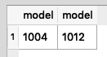

(f)

SELECT maker FROM

(SELECT model FROM PC WHERE speed >= 3.0

UNION

SELECT model FROM Laptop WHERE speed >= 3.0)

NATURAL JOIN Product

GROUP BY maker

HAVING COUNT(maker) >= 2

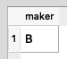

(g)

SELECT DISTINCT maker

FROM PC NATURAL JOIN Product

WHERE speed >= 3.0

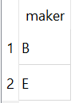

(h)

SELECT model FROM Printer

WHERE price = (SELECT MAX(price) FROM printer)

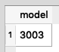

(i)

SELECT model FROM Laptop

WHERE speed < (SELECT MIN(speed) FROM PC)

(None returned)

(j)

SELECT model FROM

(SELECT model, price FROM PC

UNION

SELECT model, price

FROM Laptop

UNION

SELECT model, price

FROM Printer)

ORDER BY price DESC

LIMIT 1



(k)

SELECT maker FROM(

((SELECT model, price FROM Printer WHERE color = “true”)

NATURAL JOIN

(SELECT MIN(price) AS price

FROM (SELECT model, price FROM Printer WHERE color = “true”)))

NATURAL JOIN Product)

(None returned)

(l)

SELECT DISTINCT maker

FROM PC NATURAL JOIN Product

WHERE speed = (SELECT MAX(speed) FROM PC)

AND RAM = (SELECT MIN(RAM) FROM PC)

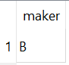

(m)

CREATE TABLE information AS

SELECT * FROM Laptop NATURAL JOIN Product

UNION

SELECT * FROM PC NATURAL JOIN Product

UNION

SELECT type AS printer_type, model, color, price FROM Printer NATURAL JOIN Product

3.

SELECT L FROM

R1 CROSS JOIN R2 CROSS JOIN R3…CROSS JOIN Rn

WHERE C