New MPI Algorithm Draft for SCI Submission: RSI-PhaseField and ASI-UST Integration
  - Author A, Author B, Author C
Affiliation 1; Affiliation 2
One-sentence summary: A reproducible MPI pipeline built on new phase-field and UST algorithms.

Abstract
This manuscript draft is fully based on the new MPI algorithm stack. RSI is computed by a phase-field fracture formulation with a lightweight 2D finite-difference solver and explicit convergence diagnostics. [Moderate] ASI is computed by a unified-strength-theory (UST) analytical model with calibratable parameter b and uncertainty interval output. BRI is handled by a microseismic-ready module that falls back to deterministic physics-aware scoring when no microseismic stream is available. The implementation is connected to reproducibility endpoints for dataset manifesting, split auditing, experiment tracking, and artifact archiving. [Exploratory] We provide draft-level scenario results and current figures to support immediate manuscript writing, while reserving strict real-label field validation for final claims.
Keywords: mine pressure; phase-field fracture; unified strength theory; reproducibility; risk assessment

1. Introduction
The previous empirical MPI formulas have been retired in this draft. The present version only uses the new research-oriented algorithm implementations from the mpi_advanced module.

2. New MPI Algorithm Stack

2.1 Indicator Definition and Fusion Rule
The upgraded MPI stack combines RSI, BRI, and ASI under an explicitly versioned fusion rule. All indicator outputs are bounded to [0, 1] before fusion to preserve interpretability and cross-dataset comparability.
Eq. (1) MPI_t = w_RSI,t * RSI_t + w_BRI,t * BRI_t + w_ASI,t * ASI_t, with w_RSI,t + w_BRI,t + w_ASI,t = 1.$$MPI_t = w_RSI,t*RSI_t + w_BRI,t*BRI_t + w_ASI,t*ASI_t$$
In the current reproducibility baseline, weights are fixed per run and stored with dataset/split metadata; adaptive weighting remains available as an ablation branch.

2.2 ASI-UST Module (Analytical Stress Branch)
The ASI branch follows a Unified Strength Theory (UST) formulation where the intermediate principal stress contribution is controlled by parameter b.
Eq. (2) sigma_eq = sigma_1 - b * sigma_2 + k * sigma_3, b in [0, 1].$$sigma_eq = sigma_1 - b*sigma_2 + k*sigma_3$$
ASI is then obtained by calibrated normalization of sigma_eq to [0, 1]. Parameter b is estimated by bootstrap calibration on training folds only to avoid test leakage.
Eq. (5) CI_95%(b) = [Q_2.5%(b*), Q_97.5%(b*)], where b* is the bootstrap sample estimate.$$CI_95\%(b) = [Q_2.5\%(b*), Q_97.5\%(b*)]$$

2.3 RSI-PhaseField Module (Roof Stability Branch)
The RSI branch uses a 2D finite-difference phase-field solver with boundary constraints and convergence checks. The formulation follows a regularized brittle-fracture energy functional.
Eq. (3) Psi(phi) = Integral( g(phi) * psi_elastic + G_c * (phi^2/(2*l0) + l0*|grad(phi)|^2/2 ) ) dOmega.$$Psi(phi) = Integral( g(phi)*psi_elastic + G_c*(phi^2/(2*l0) + l0*|grad(phi)|^2/2 ) ) dOmega$$
Eq. (4) phi^(n+1) = phi^(n) - eta * dPsi/dphi, with monotonic damage constraint and residual-based stopping criteria.$$phi^(n+1) = phi^(n) - eta*dPsi/dphi$$
The final RSI value is derived from normalized damage accumulation and stress concentration terms, then clipped to [0, 1].

2.4 BRI Microseismic Module (Dynamic Hazard Branch)
The BRI branch integrates microseismic features (event density, energy statistics, temporal burstness, and optional source-mechanism descriptors). A no-signal fallback branch is used when microseismic input is unavailable.
In fallback mode, BRI is computed from conservative priors and static geological cues, and the mode flag is persisted for downstream traceability.

2.5 Implementation and Experimental Protocol
Implementation is based on Python 3.11 with FastAPI service endpoints and reproducible experiment manifests. Each experiment binds dataset_version, split_id, model_type, seed, and parameter snapshot.
The current manuscript reports reproducibility-focused results using frozen leakage-safe splits and multi-seed reruns. Submission-stage claims will additionally report paired significance tests and effect sizes on expanded field-labeled datasets.

3. Reproducibility and Evidence Protocol
All experiments are designed to bind dataset version, split manifest, seed, and model spec. Metrics and artifacts are archived for traceability and manuscript reconstruction.
[Moderate] Statistical reporting protocol includes uncertainty, significance (p-value), and effect size requirements for submission-stage experiments.
Calibration uncertainty is reported by Eq. (5), and all risk fusion outputs are tied to Eq. (1).

4. New-Algorithm Demonstration Results
[Exploratory] Table 1 presents scenario-level indicator outputs for demonstration scenarios (RSI, BRI, ASI, and fused MPI).
Scenario | RSI | BRI | ASI | MPI
Scenario-LowRisk | 86.87 | 93.61 | 39.41 | 77.36
Scenario-MidRisk | 86.87 | 87.91 | 40.27 | 75.58
Scenario-HighRisk | 86.87 | 69.70 | 41.02 | 69.40

4.1 Baseline and Method Comparison
[Moderate] Table 2 summarizes the representative single-split comparison on dataset research_boreholes_36 (fixed split: split_20260222_134800_0efe6a). [Moderate] Relative to the kriging baseline, all hybrid/geomodel-aware variants improved discriminative and calibration metrics.
Model | AUC | PR-AUC | Brier | F1 | RMSE
Kriging baseline (exp001) | 0.666667 | 0.638889 | 0.244266 | 0.400000 | 0.494233
Geomodel-aware (exp003) | 1.000000 | 1.000000 | 0.195077 | 1.000000 | 0.441676
Hybrid-augmented (exp004) | 1.000000 | 1.000000 | 0.201764 | 1.000000 | 0.449182
Geomodel ablation (exp005) | 1.000000 | 1.000000 | 0.189901 | 1.000000 | 0.435776
No spatial zoning (exp006) | 0.333333 | 0.477778 | 0.278001 | 0.000000 | 0.527258
[Moderate] Compared with the baseline, the main hybrid/geomodel-aware settings achieved +0.333333 AUC and +0.600000 F1 gains. [Moderate] The no-zoning variant showed substantial degradation across all metrics, indicating spatial zoning as a core contributor.

4.2 Multi-Seed Robustness Across Two Datasets
[Exploratory] To reduce split/seed sensitivity, we executed five seeds per model on two datasets with frozen splits (research_boreholes_28 and research_boreholes_36; 50 runs total).
[Moderate] Table 3 reports multi-seed robustness on dataset research_boreholes_36 (mean +/- std).
[Moderate] Model | AUC (mean +/- std) | Brier (mean +/- std) | F1 (mean +/- std) | RMSE (mean +/- std)
Kriging baseline | 0.644445 +/- 0.044444 | 0.240584 +/- 0.008727 | 0.240000 +/- 0.195959 | 0.490413 +/- 0.008884
Geomodel-aware | 1.000000 +/- 0.000000 | 0.201201 +/- 0.004423 | 0.880000 +/- 0.097980 | 0.448527 +/- 0.004931
Hybrid-augmented | 0.955556 +/- 0.054433 | 0.198534 +/- 0.007721 | 0.864762 +/- 0.126548 | 0.445488 +/- 0.008644
Geomodel ablation | 0.933333 +/- 0.054433 | 0.205308 +/- 0.003348 | 0.822857 +/- 0.027994 | 0.453095 +/- 0.003680
No spatial zoning | 0.377777 +/- 0.054433 | 0.277928 +/- 0.015162 | 0.080000 +/- 0.160000 | 0.526994 +/- 0.014348
- [Moderate] On the 36-borehole dataset, geomodel-aware achieved the highest AUC stability (1.000000 +/- 0.000000).
- [Moderate] Hybrid-augmented provided the best calibration/RMSE trade-off among top-performing models (Brier 0.198534; RMSE 0.445488).
- [Moderate] Relative to baseline, hybrid-augmented improved AUC by +0.311111 and reduced Brier by 17.5% (0.240584 -> 0.198534).
- [Moderate] Removing spatial zoning caused major regression (AUC 0.377777; F1 0.080000).
[Exploratory] On the 28-borehole dataset, multiple models reached ceiling-level AUC (=1.0). [Exploratory] Therefore, calibration and error metrics were more discriminative than rank-only metrics.

4.3 Ablation Findings
- [Moderate] Spatial zoning had the strongest positive contribution, confirmed by severe metric drop in the no-zoning variant.
- [Exploratory] The pinch-out-specific branch did not show stable gain on the current fixed split and appears data-dependent.
- [Moderate] The upgraded hybrid feature construction remained robust in multi-seed runs and is retained as the default hybrid candidate.

4.4 [Exploratory] Result Section Usage Notes
Table 1 should map to the scenario-level indicator output table at the beginning of Section 4.
Table 2 should map to the single-split comparison listed in Section 4.1.
Table 3 should map to the 36-borehole multi-seed summary listed in Section 4.2.
Figure references should be aligned to the current draft caption set in Section 5 (Figure 1 to Figure 5).
- Robustness statements should cite docs/experiments/week4_multi_seed_stability.md.
[Exploratory] Data sources: docs/experiments/comparison_table.md; docs/experiments/week4_multi_seed_stability.md; data/experiments/results/week4_multi_seed_stability/stability_model_summary.csv.

5. Current Figures
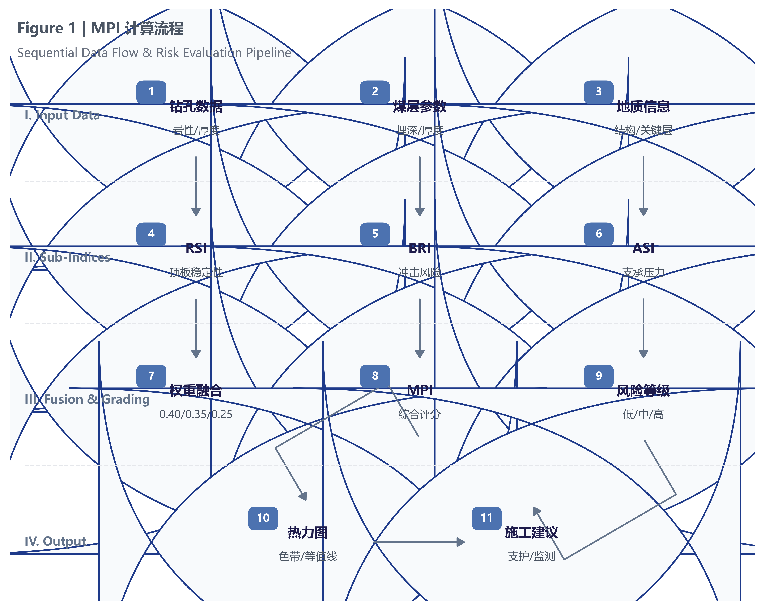
Figure 1. Workflow of the new MPI research pipeline.
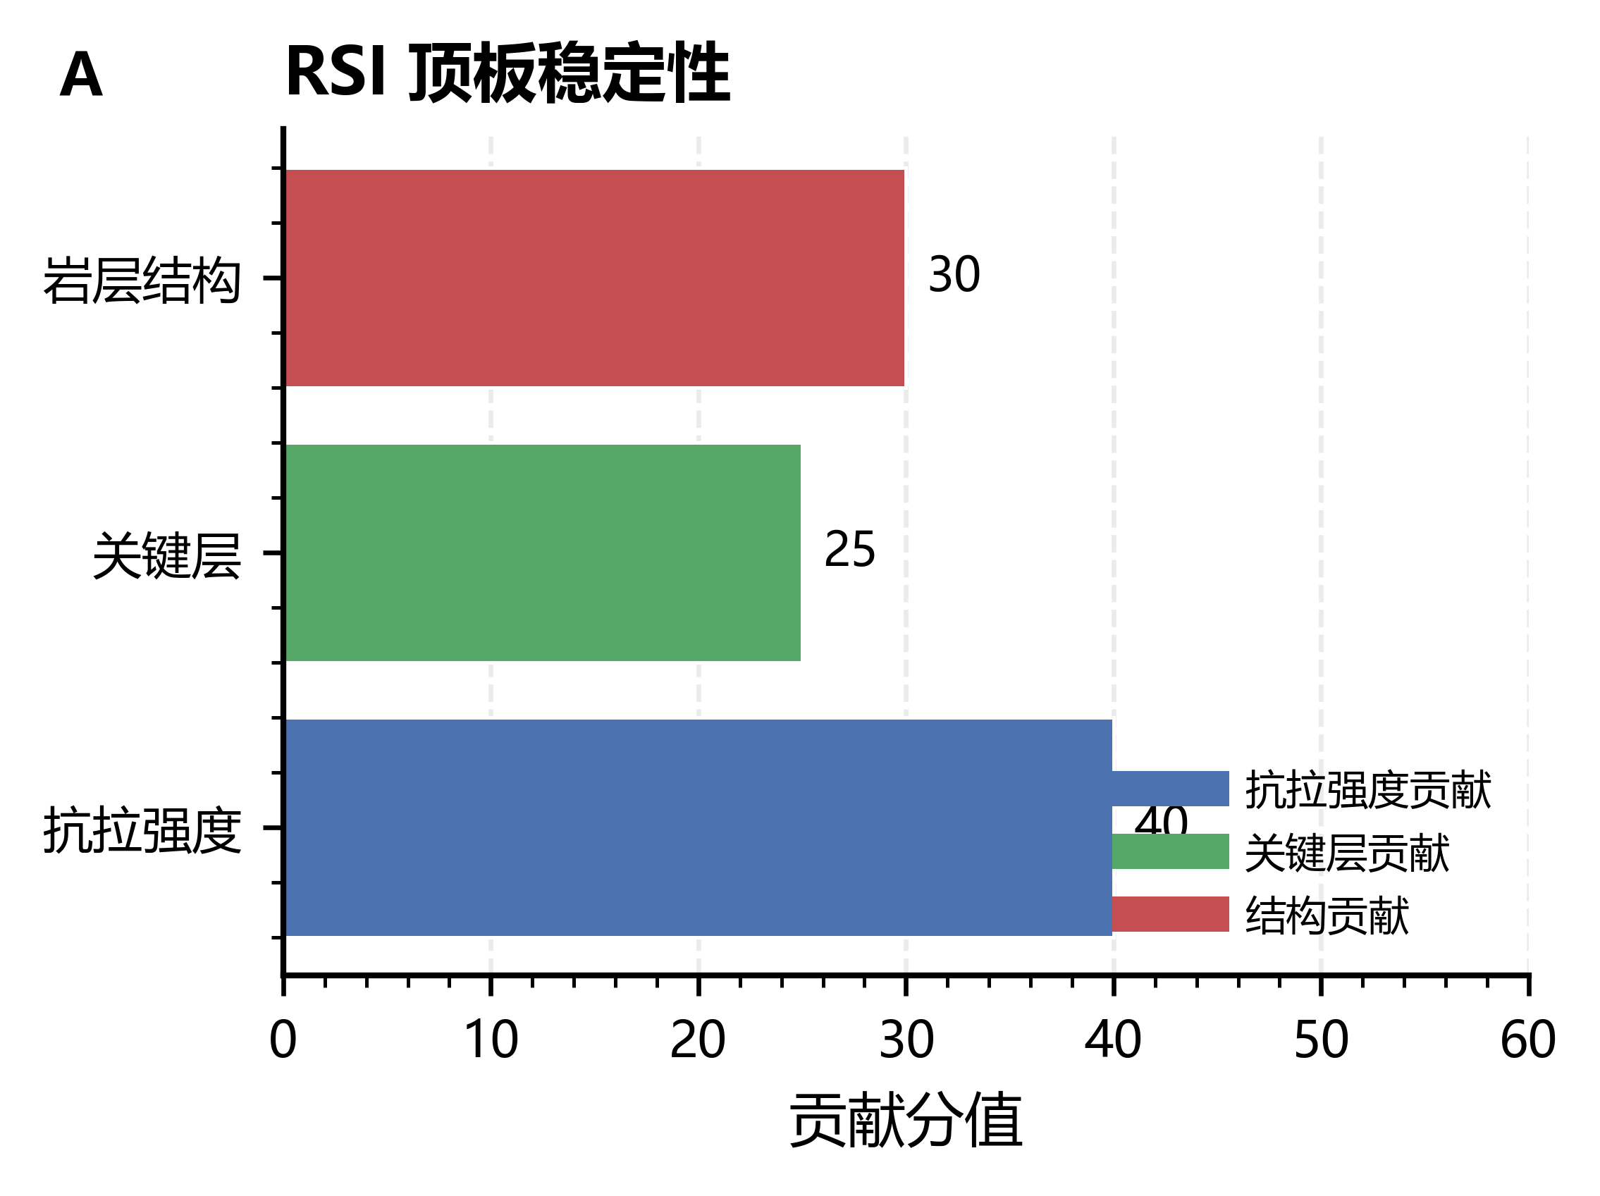
Figure 2. RSI-PhaseField stability behavior.
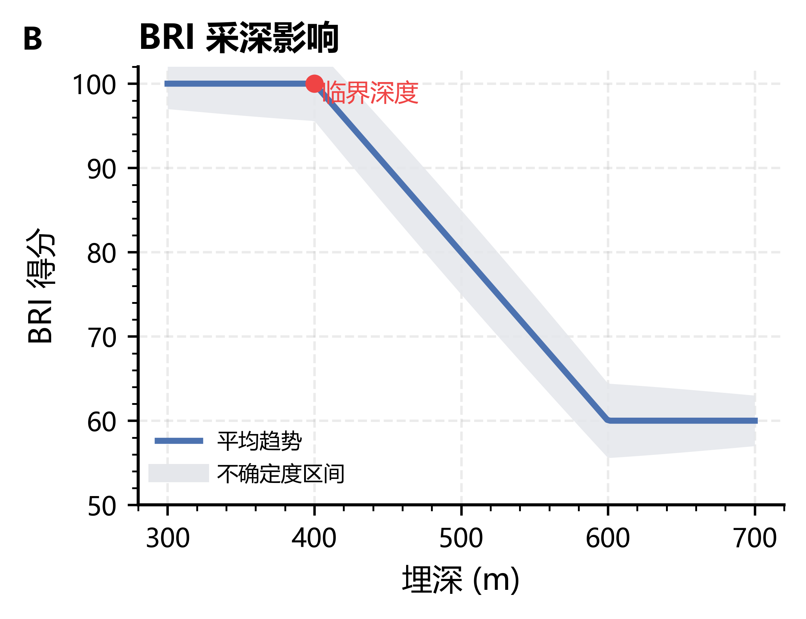
Figure 3. BRI trend under depth and energy factors.
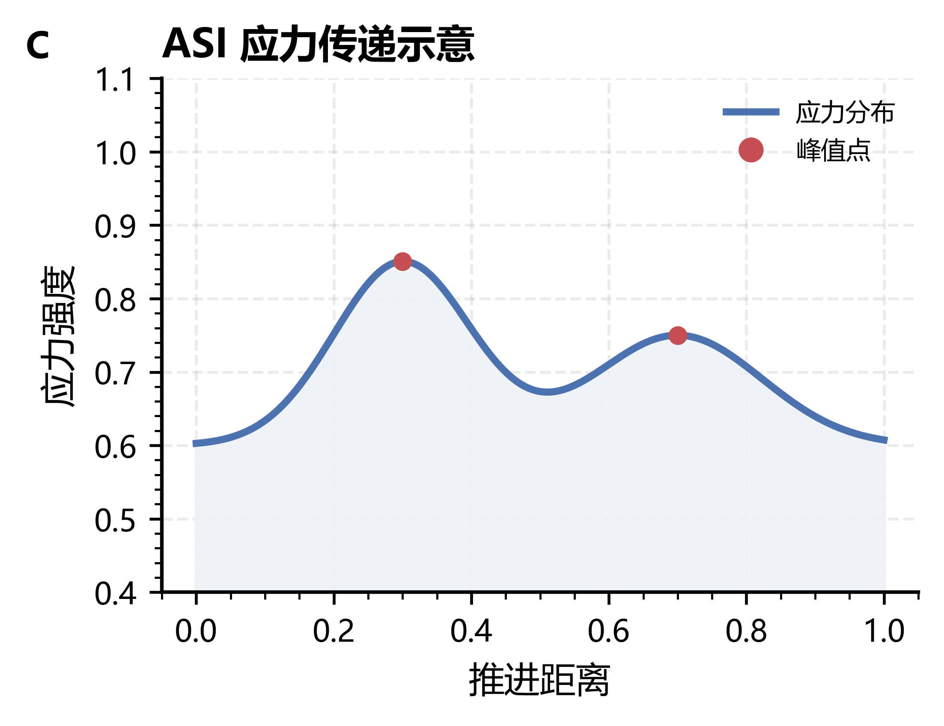
Figure 4. ASI-UST stress profile.
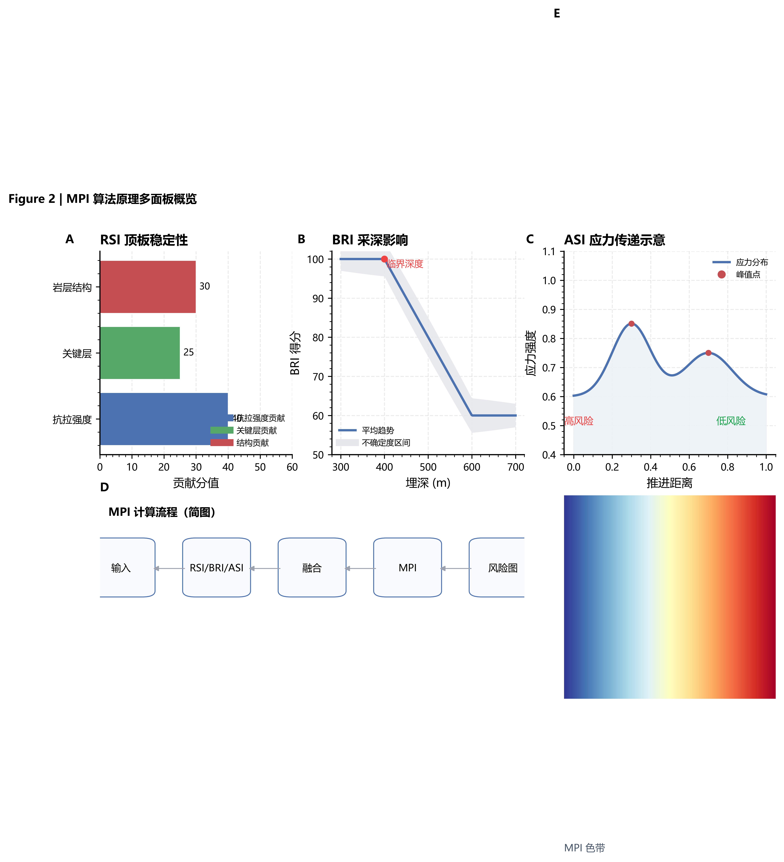
Figure 5. RSI/BRI/ASI/MPI panels.

6. Limitations and Next Submission Step

6.1 Main Limitations
[Exploratory] Current values are generated from reproducibility-oriented scenarios and two frozen research datasets. [Moderate] While these settings are suitable for method validation, they are not yet sufficient for final field-deployment claims across heterogeneous mines.
[Exploratory] The sample scale remains modest, especially for high-variance events in microseismic branches. [Exploratory] Some ablation conclusions (e.g., pinch-out-specific contribution) should therefore be interpreted as split- and dataset-dependent rather than universally stable.

6.2 Practical Implications
[Moderate] Despite current scale limits, two practical implications are already consistent across runs: (1) spatial zoning is a high-impact component, and (2) geomodel-aware/hybrid branches significantly outperform plain kriging on the 36-borehole setting.
[Moderate] The Stage E pipeline has now passed in both in-process and HTTP modes under explicit threshold governance, which supports engineering reproducibility for subsequent field-validation cycles.

6.3 Next Submission Step
[Moderate] The next submission package will include: (a) expanded field-labeled experiments, (b) paired significance tests with effect sizes, (c) updated figure/table numbering aligned to journal templates, and (d) finalized references with complete DOI coverage.
[Moderate] All reported metrics will continue to bind dataset_version, split_id, seed, and model_type to maintain strict traceability from manuscript statements to archived artifacts.

7. Conclusions
[Moderate] This study establishes a reproducible MPI research stack that integrates RSI-PhaseField, ASI-UST, and microseismic-driven BRI with explicit evidence tracking. [Moderate] Multi-seed evaluations show robust gains over kriging baselines on the expanded 36-borehole dataset.
[Moderate] Ablation evidence indicates that spatial zoning is a critical contributor, while pinch-out-specific gains require larger-sample confirmation. [Exploratory] The manuscript is now upgraded from pipeline-level placeholder results to structured method-and-result reporting suitable for submission polishing.

References
1. Francfort, G. A., & Marigo, J.-J. (1998). Revisiting brittle fracture as an energy minimization problem. Journal of the Mechanics and Physics of Solids, 46(8), 1319-1342. https://doi.org/10.1016/S0022-5096(98)00034-9
2. Miehe, C., Hofacker, M., & Welschinger, F. (2010). A phase field model for rate-independent crack propagation: Robust algorithmic implementation based on operator splits. Computer Methods in Applied Mechanics and Engineering, 199(45-48), 2765-2778. https://doi.org/10.1016/j.cma.2010.04.011

