NEWS
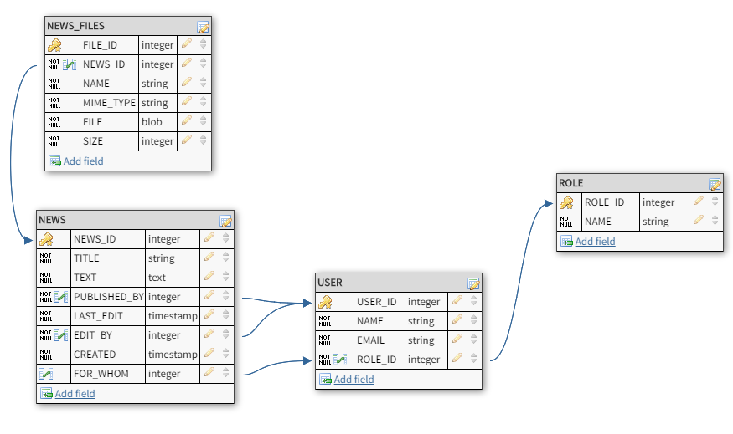
set schema 'NEWS';

CREATE TABLE "NEWS" (
"NEWS_ID" serial NOT NULL,
"TITLE" VARCHAR(255) NOT NULL,
"TEXT" TEXT NOT NULL,
"PUBLISHED_BY" integer NOT NULL,
"LAST_EDIT" TIMESTAMP NOT NULL,
"EDIT_BY" integer NOT NULL,
"CREATED" TIMESTAMP NOT NULL,
"FOR_WHOM" integer,
CONSTRAINT NEWS_pk PRIMARY KEY ("NEWS_ID")
);

CREATE TABLE "NEWS_FILES" (
"FILE_ID" serial NOT NULL UNIQUE,
"NEWS_ID" integer NOT NULL,
"NAME" VARCHAR(255) NOT NULL,
"MIME_TYPE" VARCHAR(255) NOT NULL,
"FILE" bytea NOT NULL,
"SIZE" integer NOT NULL,
CONSTRAINT NEWS_FILES_pk PRIMARY KEY ("FILE_ID")
);

CREATE TABLE "USER" (
"USER_ID" serial NOT NULL UNIQUE,
"ROLE_ID" integer NOT NULL UNIQUE,
"NAME" VARCHAR(255) NOT NULL,
"EMAIL" VARCHAR(255) NOT NULL,
CONSTRAINT USER_pk PRIMARY KEY ("USER_ID")
);

CREATE TABLE "ROLE" (
"ROLE_ID" serial NOT NULL UNIQUE,
"NAME" VARCHAR(255) NOT NULL UNIQUE,
CONSTRAINT ROLE_pk PRIMARY KEY ("ROLE_ID")
);

ALTER TABLE "NEWS" ADD CONSTRAINT "NEWS_fk0" FOREIGN KEY ("PUBLISHED_BY") REFERENCES "USER"("USER_ID");
ALTER TABLE "NEWS" ADD CONSTRAINT "NEWS_fk1" FOREIGN KEY ("EDIT_BY") REFERENCES "USER"("USER_ID");
ALTER TABLE "NEWS" ADD CONSTRAINT "NEWS_fk2" FOREIGN KEY ("FOR_WHOM") REFERENCES "USER"("ROLE_ID");
ALTER TABLE "NEWS_FILES" ADD CONSTRAINT "NEWS_FILES_fk0" FOREIGN KEY ("NEWS_ID") REFERENCES "NEWS"("NEWS_ID");
ALTER TABLE "USER" ADD CONSTRAINT "USER_fk0" FOREIGN KEY ("ROLE_ID") REFERENCES "ROLE"("ROLE_ID");

HAREM
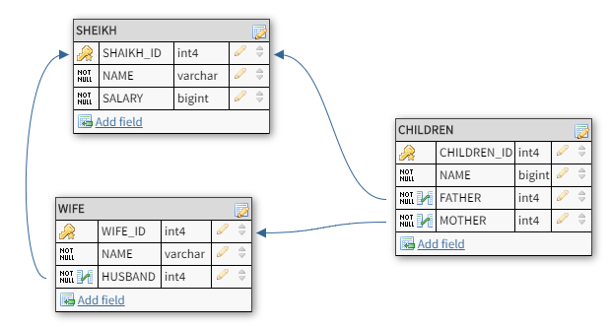
set schema 'HAREM';

CREATE TABLE "WIFE" (
"WIFE_ID" serial NOT NULL,
"NAME" varchar NOT NULL,
"HUSBAND" int4 NOT NULL,
CONSTRAINT WIFE_pk PRIMARY KEY ("WIFE_ID")
);

CREATE TABLE "CHILDREN" (
"CHILDREN_ID" serial NOT NULL UNIQUE,
"NAME" bigint NOT NULL,
"FATHER" int4 NOT NULL,
"MOTHER" int4 NOT NULL,
CONSTRAINT CHILDREN_pk PRIMARY KEY ("CHILDREN_ID")
);

CREATE TABLE "SHEIKH" (
"SHAIKH_ID" serial NOT NULL,
"NAME" varchar NOT NULL,
"SALARY" bigint NOT NULL,
CONSTRAINT SHEIKH_pk PRIMARY KEY ("SHAIKH_ID")
);

ALTER TABLE "WIFE" ADD CONSTRAINT "WIFE_fk0" FOREIGN KEY ("HUSBAND") REFERENCES "SHEIKH"("SHAIKH_ID");
ALTER TABLE "CHILDREN" ADD CONSTRAINT "CHILDREN_fk0" FOREIGN KEY ("FATHER") REFERENCES "SHEIKH"("SHAIKH_ID");
ALTER TABLE "CHILDREN" ADD CONSTRAINT "CHILDREN_fk1" FOREIGN KEY ("MOTHER") REFERENCES "WIFE"("WIFE_ID");

LIBRARY

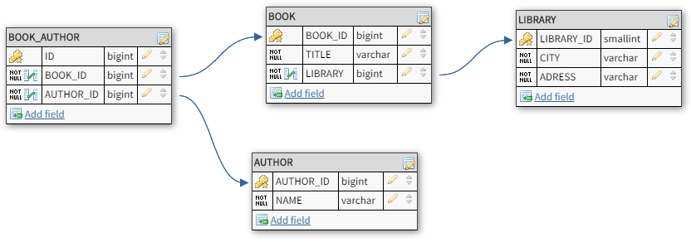

set schema 'LIBRARY';

CREATE TABLE "BOOK" (
"BOOK_ID" serial NOT NULL UNIQUE,
"TITLE" varchar NOT NULL,
"LIBRARY" bigint NOT NULL,
CONSTRAINT BOOK_pk PRIMARY KEY ("BOOK_ID")
);

CREATE TABLE "AUTHOR" (
"AUTHOR_ID" serial NOT NULL UNIQUE,
"NAME" varchar NOT NULL,
CONSTRAINT AUTHOR_pk PRIMARY KEY ("AUTHOR_ID")
);

CREATE TABLE "LIBRARY" (
"LIBRARY_ID" serial NOT NULL UNIQUE,
"CITY" varchar NOT NULL,
"ADRESS" varchar NOT NULL,
CONSTRAINT LIBRARY_pk PRIMARY KEY ("LIBRARY_ID")
);

CREATE TABLE "BOOK_AUTHOR" (
"ID" serial NOT NULL UNIQUE,
"BOOK_ID" bigint NOT NULL,
"AUTHOR_ID" bigint NOT NULL,
CONSTRAINT BOOK_AUTHOR_pk PRIMARY KEY ("ID")
);

ALTER TABLE "BOOK" ADD CONSTRAINT "BOOK_fk0" FOREIGN KEY ("LIBRARY") REFERENCES "LIBRARY"("LIBRARY_ID");
ALTER TABLE "BOOK_AUTHOR" ADD CONSTRAINT "BOOK_AUTHOR_fk0" FOREIGN KEY ("BOOK_ID") REFERENCES "BOOK"("BOOK_ID");
ALTER TABLE "BOOK_AUTHOR" ADD CONSTRAINT "BOOK_AUTHOR_fk1" FOREIGN KEY ("AUTHOR_ID") REFERENCES "AUTHOR"("AUTHOR_ID");

SELECT A."NAME", B."TITLE"
FROM "LIBRARY"."AUTHOR" AS A, "LIBRARY"."BOOK" AS B, "LIBRARY"."BOOK_AUTHOR" AS BA
WHERE BA."AUTHOR_ID" = A."AUTHOR_ID"
AND BA."BOOK_ID" = B."BOOK_ID";

Set Code page in cmd: CHCP 1251

