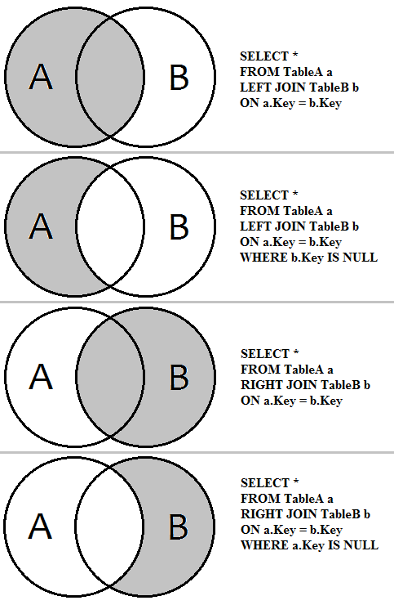  -- create table with N rows  CREATE TABLE foo (c1 integer, c2 text);  INSERT INTO foo  SELECT i, md5(random()::text)  FROM generate_series(1, 1000000) AS i; | 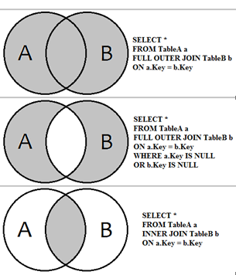  -- add const for column  alter table users alter column name set not null;  -- change field data type  alter table users alter column name  set data type varchar(10);  -- table rename  alter table users rename to user;  -- analyze run time  EXPLAIN (ANALYZE) SELECT * FROM foo; | -- create schema and table  CREATE SCHEMA test;  SET SCHEMA 'test';  CREATE TABLE refs (  user_id integer NOT NULL,  manager_id integer NOT NULL  );  --add pr key  ALTER TABLE test.users  ADD CONSTRAINT pk_users PRIMARY KEY(user_id);  -- add fr key  ALTER TABLE test.refs  ADD CONSTRAINT fk0_refs FOREIGN KEY (user_id)  REFERENCES test.users (user_id);  -- insert  INSERT INTO users (user_id, name) VALUES (1, 'Tatiana');  -- add field  ALTER TABLE table_name  ADD COLUMN column_name datatype;  -- drop field  ALTER TABLE table_name  DROP COLUMN column_name;  -- rename field  ALTER TABLE t_name RENAME c_name TO c_new_name;  -- drop const for column  alter table users alter column name drop not null;

