**Create a new workspace & Import Project under Eclipse**

File -> Import -> General -> Existing Project into Workspace

Select Root Directory (to the most recent code) -> Finish

If encounter path errors, right click inside of the Package Explorer -> Build Path -> then redirect the .jar files to the right ones (all .jar files can be found in the *lib* folder)

**Compile the Code**

The *systemdynamics.jar* file can be compiled from file *SystemDynamicsCommandLine.java* under the following directory:

src/de.uka.aifb.com.systemDynamics/

**Chart Resolution**

Under *src/de.uka.aifb.com.systemDynamics/*, change the following line in *DrawGraphs.java* and *DrawGraphs_Init.java*:

For JPEG files:

File imgFile = **new** File(folder + "/" + chartObj.getFile() + "_" + run + ".jpg");

ChartUtilities.*saveChartAsJPEG*(imgFile, chart, 900, 500);

For PNG files:

File imgFile = **new** File(folder + "/" + chartObj.getFile() + "_" + run + ".png");

ChartUtilities.*saveChartAsPNG*(imgFile, chart, 900, 500);

**Background Color**

Under *src/de.uka.aifb.com.systemDynamics/*, change the following line in *DrawGraphs.java* and *DrawGraphs_Init.java*:

plot.setBackgroundPaint(Color.GRAY);

Originally LIGHT_GRAY (plot.setBackgroundPaint(Color.LIGHT_GRAY);), now GRAY

To customize color, modify the following line. e.g. (80, 80, 80) is a dark gray and (240, 240, 240 is a lighter gray (see next page).

//plot.setBackgroundPaint(new Color(80, 80, 80));

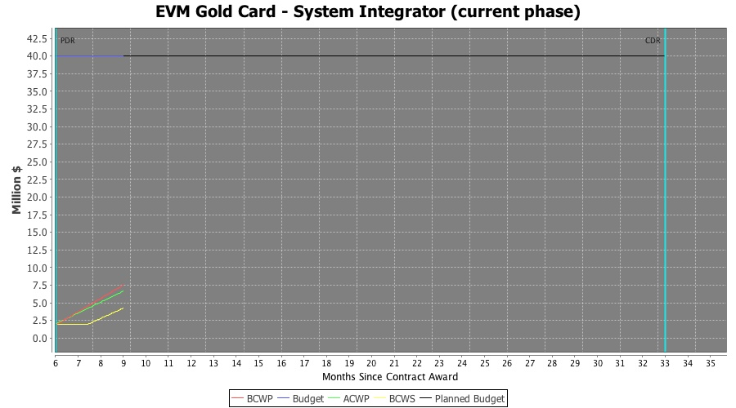

*GRAY*

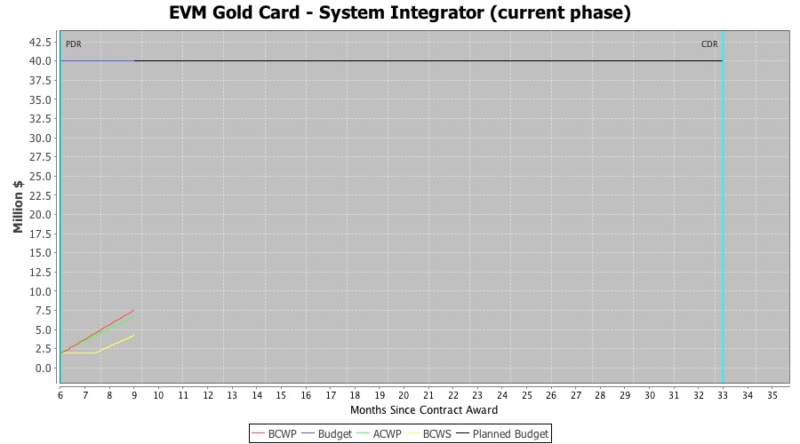

*LIGHT_GRAY*

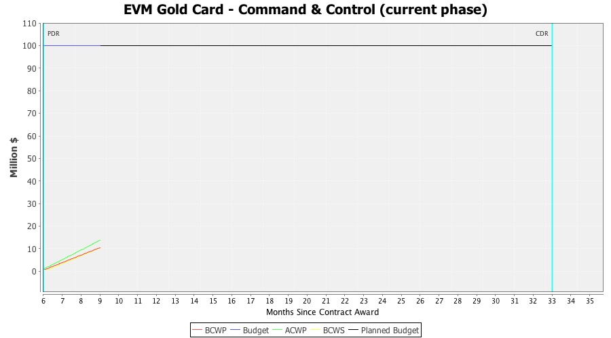

*(240, 240, 240)*