Create or replace view test2_01 as

(select sid,name

from test1_student s)

minus

(select distinct s.sid,s.name

from test1_student s,test1_student_course sc

where s.sid = sc.sid)



改：

Create or replace view test2_01 as

(select sid,name

from pub.student s)

minus

(select distinct s.sid,s.name

from pub.student s,pub.student_course sc

where s.sid = sc.sid)

2

Create or replace view test2_02 as

(不用minus

select sid,name from

(

(

select * from

(select cid from pub.student_course where sid = 200900130417)

natural join

(pub.student_course)

)

natural join

(select * from pub.student where sid <> 200900130417)

)

)

3自底向下设计法

Create or replace view test2_03 as

select sid,name from

(

select distinct sid

from

(select cid from pub.course where fcid = '300002') ca

natural join

pub.student_course

)

natural join

pub.student

4

Create or replace view test2_04 as

select sid,name from

(

(

(

select distinct sid from

(select cid from pub.course where name = '操作系统')

natural join

(pub.student_course)

)

intersect

(

select distinct sid from

(select cid from pub.course where name = '数据结构')

natural join

(pub.student_course)

)

minus

(

select distinct sid from

(select cid from pub.course where name = '程序设计语言')

natural join

(pub.student_course)

)

)

natural join

(pub.student)

)

5. 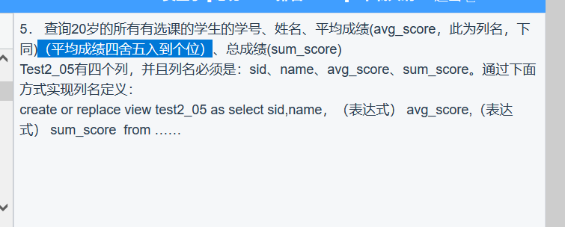

create or replace view test2_05 as

select sid,name,round(avg(score)) avg_score,sum(score) sum_score from

(

(select sid,name from pub.student where age = 20)

natural join

(pub.student_course)

)

group by sid,name

6

笛卡尔积问题

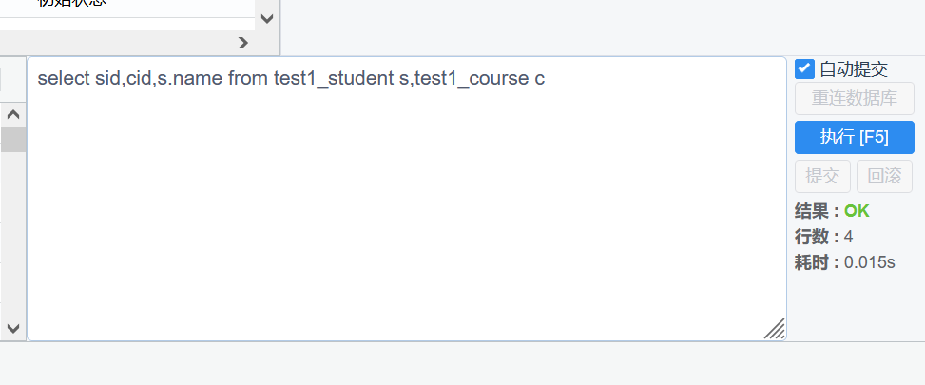

select * from

(select cid,name,max(score) max_score from

(pub.student_course

natural join

pub.course)

group by cid,name) a,

()

select distinct cid,sid from

(select * from

(select cid,max(score) max_score from pub.student_course group by cid)

natural join

(pub.student_course))

where score = max_score

答案：

create or replace view test2_06 as

select cid,name,max_score,count(sid) max_score_count from

(

(select cid,name,max(score) max_score from

(pub.student_course

natural join

pub.course)

group by cid,name)

natural join

(

select distinct cid,sid from

(select * from

(select cid,max(score) max_score from pub.student_course group by cid)

natural join

(pub.student_course))

where score = max_score

)

)

group by cid,name,max_score

7

create or replace view test2_07 as

select sid,name from pub.student

where name not like '张%' and name not like '李%' and name not like '王%'

8

create or replace view test2_08 as

select substr(name, 0, 1) second_name,count(substr(name, 0, 1)) p_count from pub.student

group by substr(name, 0, 1)

9

create or replace view test2_09 as

select sid,name,score from

(select distinct sid,score from pub.student_course where cid = 300003)

natural join

pub.student

10

create or replace view test2_10 as

select sid,name from

(

select sid from pub.student_course

where score < 60

group by sid,cid

having count(score)>1

)

natural join

pub.student