create table test4_01 as

select * from pub.student_41

1

alter table test4_01 add sum_score numeric(10,1)

update test4_01 ts

set sum_score = (

select sum(score) from pub.student_course ps

where ts.sid = ps.sid

group by ps.sid

)

2

alter table test4_02

add avg_score numeric(5,1)

update test4_02 ts

set avg_score = (

select avg(score) from pub.student_course ps

where ts.sid = ps.sid

group by ps.sid

)

3

alter table test4_03

add sum_credit numeric(4,1)

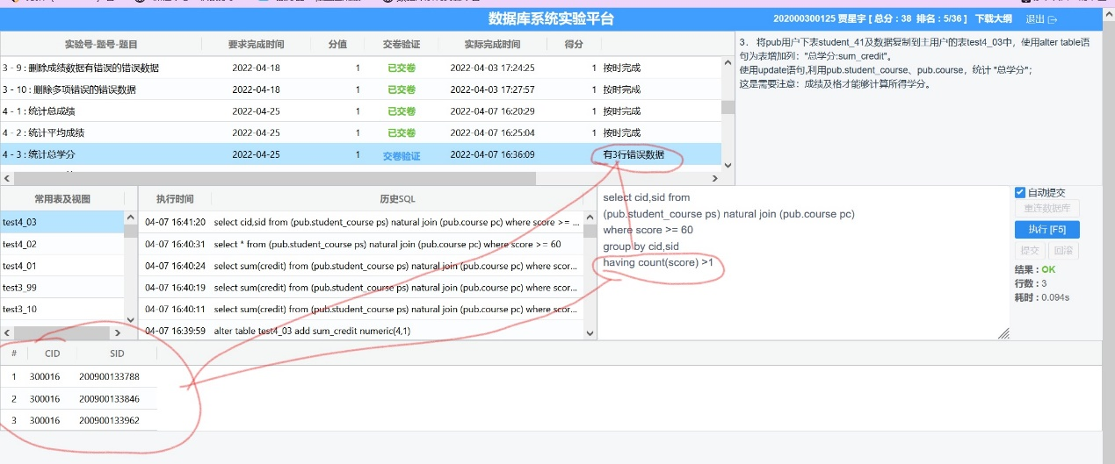

update test4_03 ts set sum_credit =

(select sum(credit) from

((select cid,sid,sum(score) from pub.student_course where score>=60 group by cid,sid)

1.学了一次、多次没及格

2.学了两次，一次及格

3.学了两次，都及格

natural join

(pub.course))

where sid = ts.sid

group by sid)

4

update test4_04 ts set dname=(

select did from pub.department d where ts.dname = d.dname

)

where sid in(

select sid from

test4_04 s natural join pub.department d)

5.

alter table test4_05 add

(sum_score numeric(10,1),

avg_score numeric(5,1),

sum_credit numeric(10,1),

did varchar2(2))

update test4_05 ts set

sum_score = (

select sum(score) from pub.student_course ps

where ts.sid = ps.sid

group by ps.sid

),

avg_score = (

select avg(score) from pub.student_course ps

where ts.sid = ps.sid

group by ps.sid

),

sum_credit =

(select sum(credit) from

((select cid,sid,sum(score) from pub.student_course where score>=60 group by cid,sid)

natural join

(pub.course))

where sid = ts.sid

group by sid),

update test4_05 ts set did = (

select did from

((select * from

(select dname,sid,name from test4_05) natural join pub.department)

union

(select * from

(select dname,sid,name from test4_05) natural join pub.department_41))

where sid = ts.sid

)

update test4_05 ts set did = ‘00’ where sid not in(

select sid from

((select * from

(select dname,sid,name from test4_05) natural join pub.department)

union

(select * from

(select dname,sid,name from test4_05) natural join pub.department_41))

)

6.

update test4_06 ts

set name = (

select replace(name,' ','') from test4_06 ts1 where ts.sid = ts1.sid ⬄ trim只能改前后！！！

)

where name like '% %'

7

不规范的：男性、女性、男/女加空格

update test4_07 set sex = '男' where sex = '男性'

update test4_07 set sex = '女' where sex = '女性'

update test4_07 ts1 set sex = (

select trim(sex) from test4_07 ts2 where ts1.sid = ts2.sid

)

where sex like '% %'

8

update test4_08

set class = substr(class,1,4)

where trim(translate(class,'0123456789',' ')) is not NULL

9

update test4_09

set age = (2012-extract (year from birthday))

where age is null

10

update test4_10 ts

set name = replace(name,' ','')

where name like '% %'

update test4_10 ts

set dname = replace(dname,' ','')

where dname like '% %'

update test4_10 ts

set sex = (case

when sex = '男性' then '男'

when sex = '女性' then '女'

when sex like '% %' then trim(sex)

else sex

end

)

update test4_10 ts

set class = substr(class,1,4)

where class like '%级%'

update test4_10 ts

set age = (2012 - extract(year from birthday))

where age is null