1

create table test5_01(

First_name varchar2(4),

frequency numeric(4)

)

insert into test5_01(first_name,frequency)

(select the_name First_name,count(the_name) frequency from

(select substr(name,2) the_name from pub.student)

group by the_name)

2

insert into test5_02(letter,frequency)

(

select subname,count(subname) from(

select substr(name,2,1) subname from pub.student

union all

select substr(name,3,1) subname from pub.student where substr(name,3,1) is not null

)

group by subname

)

3

一整个年级学院的同学都没选课

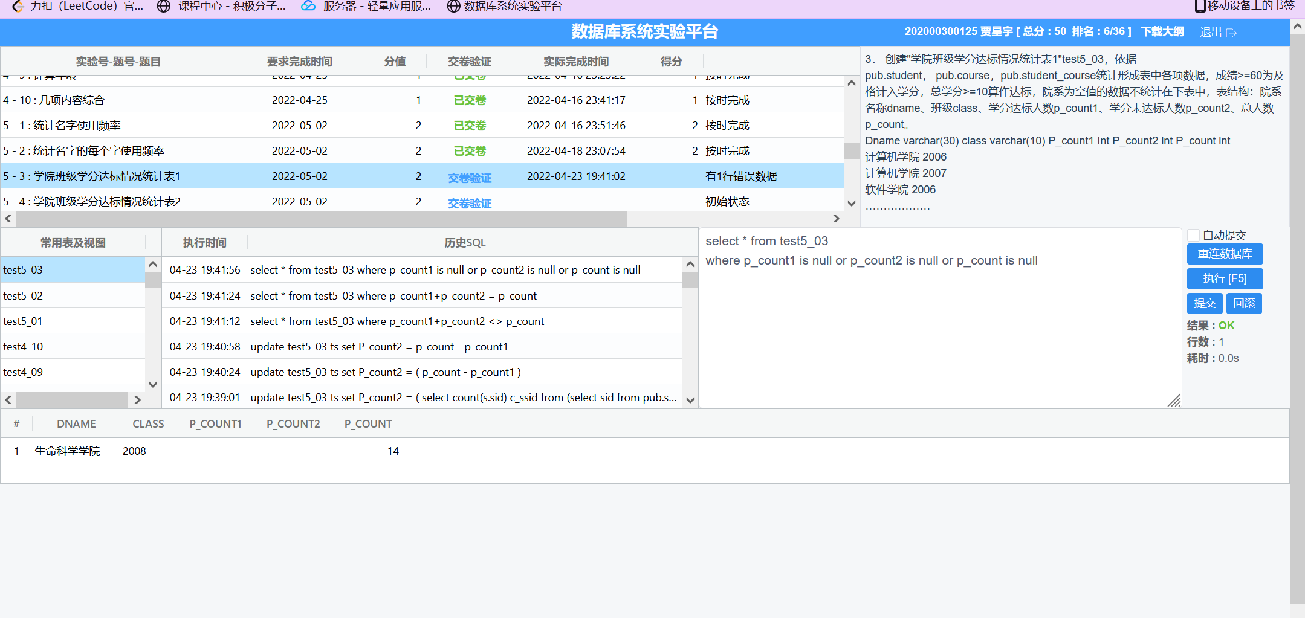

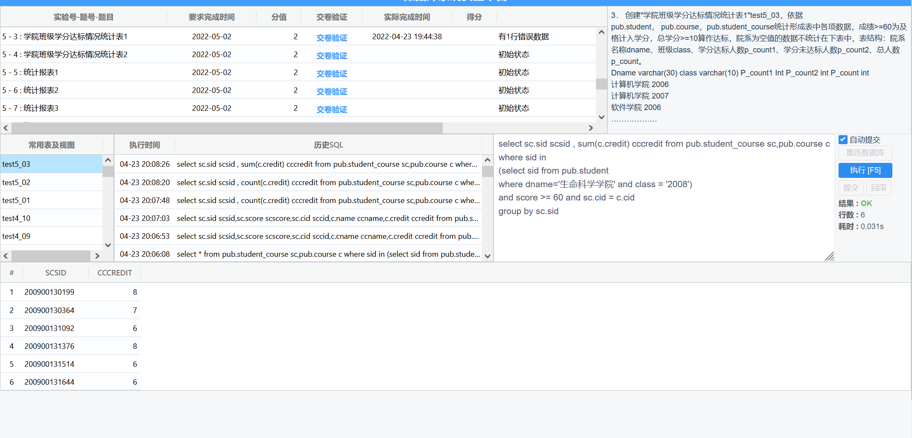

insert into test5_03 (class,dname)

select class,dname from pub.student

where dname is not null

group by class,dname

update test5_03 ts set p_count1=(

select count(ss.sid) c_ssid from

(select sc.sid sid from

(select sid,cid from pub.student_course

where score >=60

group by sid,cid) sc,pub.course c

where sc.cid = c.cid

group by sc.sid

having sum(c.credit)>=10) scc,

(select * from pub.student where dname is not null) ss

where ss.sid = scc.sid and ss.dname = ts.dname and ss.class=ts.class

group by dname,class

)

update test5_03 ts set P_count2 = (

select count(s.sid) c_ssid from

(select sid from pub.student s where sid not in

(select sc.sid sid from

(select sid,cid from pub.student_course

where score >=60

group by sid,cid) sc,pub.course c

where sc.cid = c.cid

group by sc.sid

having sum(c.credit)>=10)) sc,

(select * from pub.student where dname is not null) s

where sc.sid = s.sid and s.dname = ts.dname and s.class = ts.class

group by s.dname,s.class

)

update test5_03 ts set p_count = (

select count(sid) csid from pub.student s

where dname is not null and s.class = ts.class and s.dname = ts.dname

group by dname,class

)

update test5_03 set p_count2 = p_count - p_count1

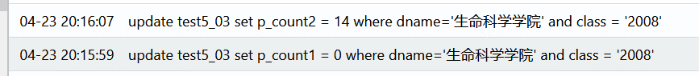

4.

insert into test5_04(dname,class)

select dname,class from pub.student

where dname is not null

group by dname,class

update test5_04 ts set p_count1=(

select count(ss.sid) c_ssid from

(select sc.sid sid from

(select sid,cid from pub.student_course

where score >=60

group by sid,cid) sc,pub.course c

where sc.cid = c.cid

group by sc.sid

having sum(c.credit)>=10) scc,

(select * from pub.student where dname is not null and class>2008) ss

where ss.sid = scc.sid and ss.dname = ts.dname and ss.class=ts.class

group by dname,class)

where ts.class > 2008

update test5_04 ts set p_count1=(

select count(ss.sid) c_ssid from

(select sc.sid sid from

(select sid,cid from pub.student_course

where score >=60

group by sid,cid) sc,pub.course c

where sc.cid = c.cid

group by sc.sid

having sum(c.credit)>=8) scc,

(select * from pub.student where dname is not null and class<=2008) ss

where ss.sid = scc.sid and ss.dname = ts.dname and ss.class=ts.class

group by dname,class)

where ts.class <= 2008

update test5_03 ts set p_count = (

select count(sid) csid from pub.student s

where dname is not null and s.class = ts.class and s.dname = ts.dname

group by dname,class

)

update test5_04 set p_count2 = p_count - p_count1

5

create view test5_05 as

select a.sdname dname,a.avg_ds_score avg_ds_score,b.avg_os_score avg_os_score

from

(select s.dname sdname,round(avg(sc.score)) avg_ds_score

from (select * from pub.student where dname is not null) s,

(select sid,cid,max(score) score from pub.student_course group by sid,cid) sc,

pub.course c

where s.sid = sc.sid and c.cid = sc.cid

and c.name = '数据结构'

group by s.dname) a,

(select s.dname sdname,round(avg(sc.score)) avg_os_score

from (select * from pub.student where dname is not null) s,

(select sid,cid,max(score) score from pub.student_course group by sid,cid) sc,

pub.course c

where s.sid = sc.sid and c.cid = sc.cid

and c.name = '操作系统'

group by s.dname) b

where a.sdname = b.sdname

6

create view test5_06 as

select satisfy_info.sid sid,satisfy_info.name name,satisfy_info.dname dname,sc1.score ds_score,sc2.score os_score from

(select s.sid sid,s.name name,s.dname dname

from (select * from pub.student where dname='计算机科学与技术学院') s,

pub.student_course sc,pub.course c

where s.sid = sc.sid and c.cid = sc.cid

and (c.name='操作系统' or c.name='数据结构')

group by s.sid,s.name,s.dname

having count(*)>=2) satisfy_info,

(select sid,cid,max(score) score from pub.student_course group by sid,cid) sc1,

(select sid,cid,max(score) score from pub.student_course group by sid,cid) sc2

where sc1.sid=satisfy_info.sid and sc2.sid=satisfy_info.sid

and sc1.cid=(select cid from pub.course where name='数据结构')

and sc2.cid=(select cid from pub.course where name='操作系统')

7

create view test5_07 as

(

select info.sid,info.name,info.dname,ds.ds_score,os.os_score

from(

select s.sid sid,s.name name,s.dname dname from

(select * from pub.student where dname='计算机科学与技术学院') s,

(select sid,cid,max(score) score from pub.student_course group by sid,cid) sc,

pub.course c

where s.sid = sc.sid and c.cid = sc.cid

and (c.name='操作系统' or c.name='数据结构')

) info,

(

select sid,cid,max(score) ds_score from pub.student_course

where cid=(select cid from pub.course where name='数据结构')

group by sid,cid

) ds,

(

select sid,cid,max(score) os_score from pub.student_course

where cid=(select cid from pub.course where name='操作系统')

group by sid,cid

) os

where ds.sid(+)=info.sid and os.sid(+)=info.sid

)

8

create view test5_08 as

select info.sid,info.name,info.dname,ds.score ds_score,os.score os_score

from(

select s.sid,s.name,s.dname

from (select * from pub.student where dname='计算机科学与技术学院') s

) info,

(

select sid,cid,max(score) score from pub.student_course

where cid=(select cid from pub.course where name='数据结构')

group by sid,cid

) ds,

(

select sid,cid,max(score) score from pub.student_course

where cid=(select cid from pub.course where name='操作系统')

group by sid,cid

) os

where info.sid=ds.sid(+) and info.sid=os.sid(+)

9

create view test5_09 as

select b.score,b.certain_score count1,a.allscore count0,round((b.certain_score/a.allscore),4)*100 percentage from

(

select count(*) allscore from pub.student_course where score>=60

) a,

(

select score,count(*) certain_score

from pub.student_course

where score>=60

group by score

) b

10

create view test5_10 as

select b.cid,name cname,score,cc1 count1,a.cc count0,round(cc1/a.cc,4)*100 percentage

from

(select cid,count(*) cc from pub.student_course where score>=60 and score<=99 group by cid) a,

((

select c.cid,c.name,('60-69') score,count(*) cc1 from pub.student_course sc,pub.course c

where sc.cid=c.cid and sc.score>=60 and sc.score<=69

group by c.cid,c.name

)

union

(

select c.cid,c.name,('70-79') score,count(*) cc1 from pub.student_course sc,pub.course c

where sc.cid=c.cid and sc.score>=70 and sc.score<=79

group by c.cid,c.name

)

union

(

select c.cid,c.name,('80-89') score,count(*) cc1 from pub.student_course sc,pub.course c

where sc.cid=c.cid and sc.score>=80 and sc.score<=89

group by c.cid,c.name

)

union

(

select c.cid,c.name,('90-99') score,count(*) cc1 from pub.student_course sc,pub.course c

where sc.cid=c.cid and sc.score>=90 and sc.score<=99

group by c.cid,c.name

)

) b

where a.cid = b.cid