1

create table test7_01 (sid,name,birthday) as

select sid,name,birthday from pub.student

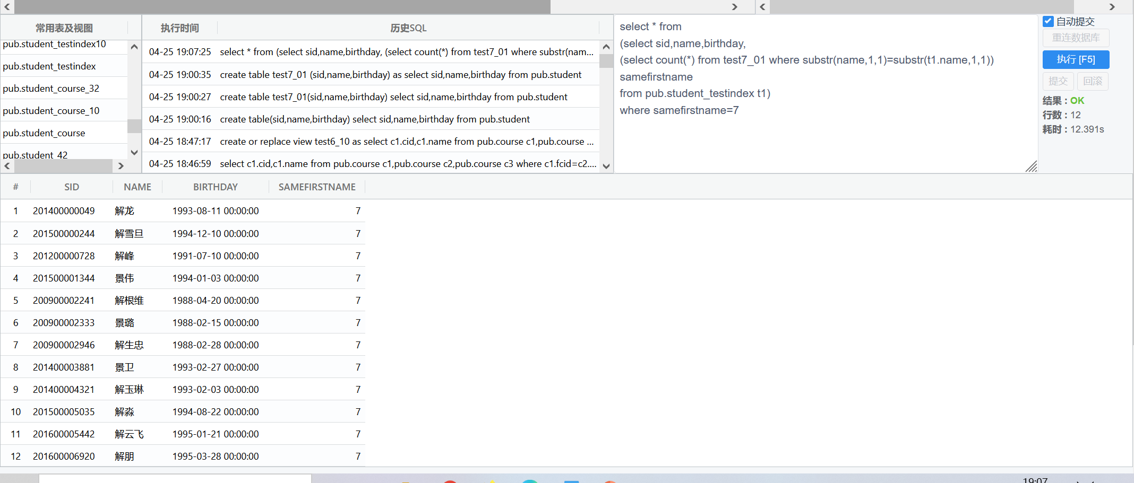

在什么上建立索引往往取决于 where 中的判断条件。一般判断条件是什么，就在什么上建立索引；

create index ts_firstname on test7_01(substr(name, 1, 1))

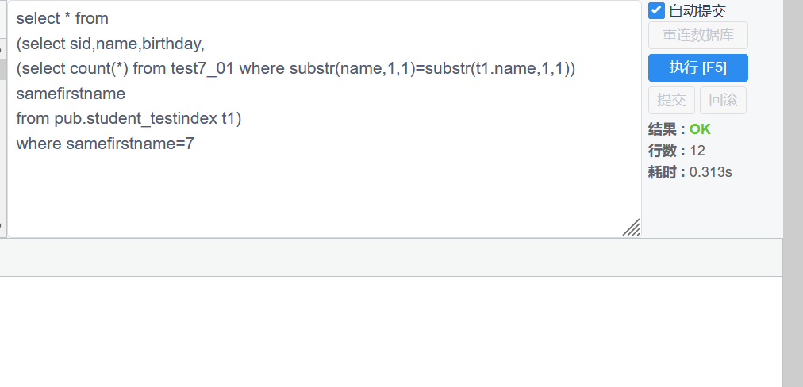

2

create index ts_bir_name on test7_02(birthday,name)

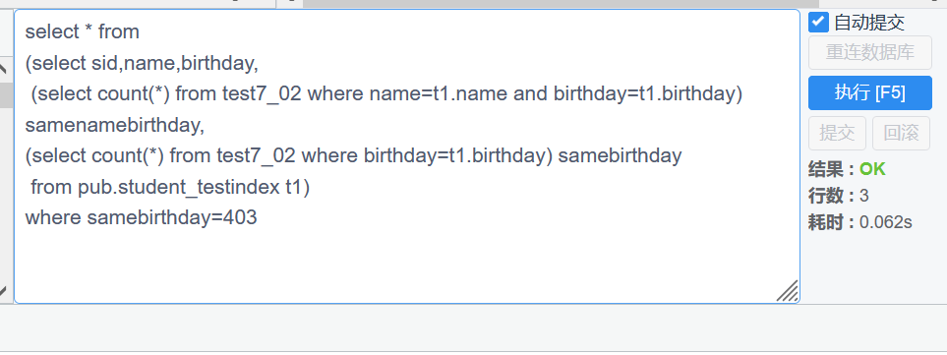

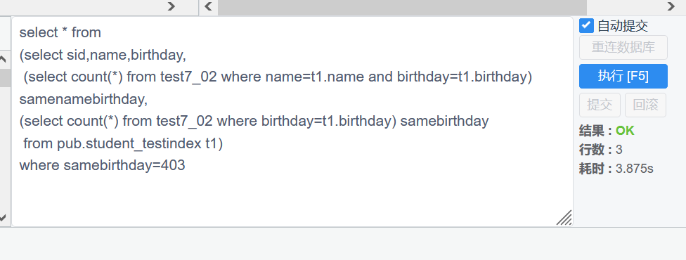

3

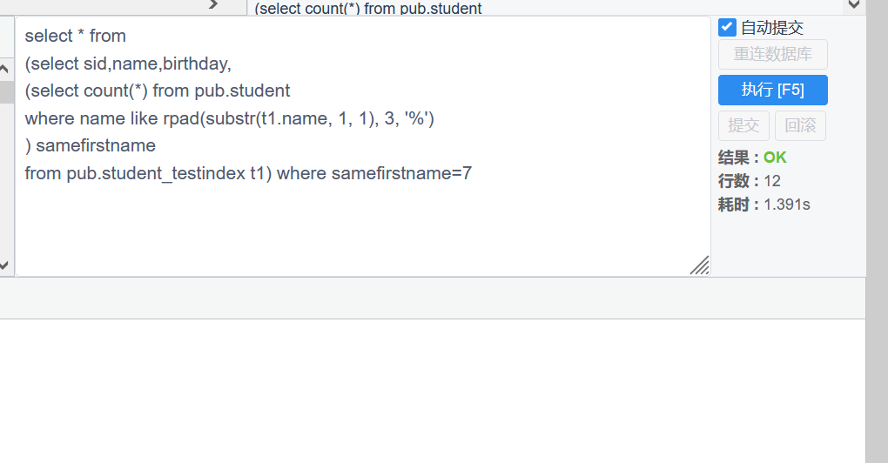

select * from

(select sid,name,birthday,

(select count(*) from pub.student

where name like rpad(substr(t1.name, 1, 1), 3, '%')

) samefirstname

from pub.student_testindex t1) where samefirstname=7

RPAD( string1, padded_length [, pad_string] )

参数或参数

字符串1

要将字符填充到的字符串（右侧）。

padded_length

要返回的字符数。如果padded_length小于原始字符串，则 RPAD 函数会将字符串截断为 padded_length 的大小。

pad_string

自选。这是将填充到 string1 右侧的字符串。如果省略此参数，RPAD 函数将在 string1 的右侧填充空格。

4

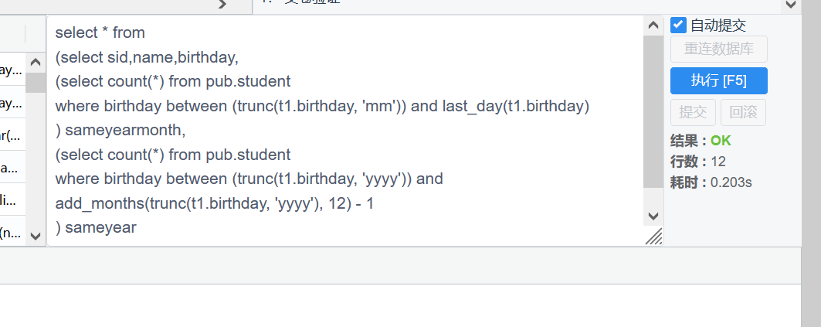

select * from

(select sid,name,birthday,

(select count(*) from pub.student

where birthday between (trunc(t1.birthday, 'mm')) and last_day(t1.birthday)

) sameyearmonth,

(select count(*) from pub.student

where birthday between (trunc(t1.birthday, 'yyyy')) and add_months(trunc(t1.birthday, 'yyyy'), 12) - 1

) sameyear

from pub.student_testindex t1) where sameyearmonth=35

5

create view test7_05 as

select * from

(select sid,name,birthday,

(select count(*) from pub.student

where birthday=t1.birthday+1

) nextbirthday

from pub.student_testindex t1) where nextbirthday=7