**ACADEMIC PROFILE AND TEACHING PORTFOLIO**

Submitted in partial fulfillment of the requirements

for the award of the degree of

**BACHELOR OF SCIENCE IN COMPUTER SCIENCE**

Submitted by

#### Name : DAKSHESH R

**Reg. No: 2222K1104**

Under the Guidance of

**Mrs. R. KANCHANA, MCA., M.Phil.**

##### Assistant professor in Department of Computer Science



**PG AND RESEARCH DEPARTMENT OF COMPUTER SCIENCE**

##### PIONEER COLLEGE OF ARTS AND SCIENCE

(Affiliated to Bharathiar University)

Coimbatore-47.

**2022-2024**

**DECLARATION**

I hereby declare that this Project entitled

**“ACADEMIC PROFILE AND TEACHING PORTFOLIO”**

Submitted to **Pioneer College of Arts and Science**, Coimbatore-47

in partial fulfillment of the requirement for the degree

**BACHELOR OF SCIENCE IN COMPUTER SCIENCE**

is a record of the original project work done by me during the period of my study 2024 – 2025 at Pioneer College of Arts and Science,

Coimbatore-47

Under the Guidance of

**Mrs. R. KANCHANA, MCA., M.Phil.**

**(Assistant professor Department of Computer Science)** Pioneer College of Arts and Science,

Coimbatore-47.

**____________________________**

**DAKSHESH R**

**(2222K1104)**

**CERTIFICATE**

This is to certify that this project work entitled

**“ACADEMIC PROFILE AND TEACHING PORTFOLIO”**

is a bonafide record of project work done by

**Name : DAKSHESH R Reg. No: 2222K1104**

is submitted for the award of the degree of

**BACHELOR OF SCIENCE IN COMPUTER SCIENCE**

Viva Voce examination held on ………………... at

**PIONEER COLLEGE OF ARTS AND SCIENCE**

Coimbatore-47

During the academic year 2024-2025

**____________________________ ____________________________**

#### HEAD OF THE DEPARTMENT INTERNAL GUIDE

**Mrs. K. VASANTHI, MCA., M.Phil., (Ph.D.) Mrs. R. KANCHANA, MCA., M.Phil.**

**____________________________**

**COUNTERSIGNED**

**(PRINCIPAL)**

**____________________________ ____________________________**

**INTERNAL EXAMINER EXTERNAL EXAMINER**

**ACKNOWLEDGEMENT**

At the outset I record my profound thanks to **Smt. APARNA RAJKUMAR** Secretary, Pioneer College of Arts and Science for permitting me to carry my project work.

I place it on record my gratefulness and convey my thanks to our respected principal, **Mr. P. RAJAPPANAN., MBA., M.Phil., PGDCA.,** for the valuable encouragement and direction extended towards the completion of my project.

I warmly extend my thanks to **Mrs. K. VASANTHI, MCA., M.Phil., (Ph.D.),** Head, UG and Research Department of Computer Science for her timely support.

It is a special privilege to convey my everlasting thanks to my internal guide **Mrs. R. KANCHANA, MCA., M.Phil.,** Assistant professor Department of Computer Science [PG], for her immense help, insightful suggestions, valuable advice, and constructive comments.

I specially thank my beloved Tutor **Mrs. S. MANTHERA, M.Sc. CS.,** Assistant professor, PG and Research Department of computer science, for her valuable guidance and encouragement throughout the project.

I would like to express my sincere thanks to my family members, friends and all others for their help and support.

**CONTENTS**

_________________________________________________________________________________________

**CONTENTS**

**TITLE PAGE NO**

**ACKNOWLEDGEMENT**

**SYNOPSIS**

1. **INTRODUCTION 1** 
   1. SYSTEM SPECIFICATION
      1. HARDWARE SPECIFICATION
      2. SOFTWARE REQUIREMENTS
2. **SYSTEM STUDY 2** 
   1. EXISTING SYSTEM
      1. DRAWBACKS
   2. PROPOSED SYSTEM
      1. ADVANTAGES
3. **SYSTEM DESIGN AND DEVELOPMENT 3** 
   1. FILE DESIGN
   2. INPUT DESIGN
   3. OUTPUT DESIGN
   4. DATABASE DESIGN
   5. SYSTEM DEVELOPMENT
      1. DESCRIPTION OF MODULES
4. **TESTING AND IMPLEMENTATION 8** 
   1. SOFTWARE TESTING
   2. SOFTWARE TESTING LIFE CYCLE
   3. TESTING METHODS
   4. IMPLEMENTATION

**CONCLUSION 12**

**BIBLIOGRAPHY 13**

**APPENDICES**

* + - 1. DATA FLOW DIAGRAM
      2. TABLE STRUCTURE
      3. SAMPLE CODING
      4. SAMPLE INPUT
      5. SAMPLE OUTPUT

# SYNOPSIS

_________________________________________________________________________________________

**SYNOPSIS**

This website for an English Assistant Professor is designed to establish a professional online presence,

showcasing their academic background, achievements, and ongoing contributions to the field. It features a comprehensive biography section that highlights the professor's educational qualifications, career history, and academic experiences, offering a clear understanding of their professional journey. A dedicated research portfolio will display the professor's ongoing projects, published papers, and presentations at conferences, providing valuable resources for students and fellow academics. This section serves as a digital archive of their scholarly work and a platform for sharing knowledge.

The blog or publications section will allow the professor to share articles, essays, and academic writings

on various literary topics, fostering intellectual engagement. A real-time comment feature will enable readers to interact with the content and participate in discussions. Additionally, the website will include links to the professor's professional networks, such as LinkedIn, allowing students, colleagues, and prospective collaborators to easily connect. With an intuitive design and user-friendly navigation, the website will reflect the professor’s professional identity while providing a platform for academic communication and collaboration, strengthening their presence within the academic community.

**INTRODUCTION**

1. **INTRODUCTION**

This website serves as a professional platform for an English Assistant Professor, highlighting their

academic background, qualifications, and contributions to the field of English literature. It includes a detailed biography, showcasing education and career milestones, along with a research portfolio that features ongoing projects and published works. The blog or publications section allows the professor to share essays and articles, fostering intellectual engagement through real-time comments. LinkedIn links enable easy professional networking. With its user-friendly design, the website reflects the professor’s academic identity and encourages collaboration, communication, and knowledge-sharing within the academic community.

**1.1 SYSTEM SPECIFICATION**

System requirements refer to the hardware, software, and network specifications needed for a program,

application, or system to function properly. These include processor speed, memory, storage, operating system version, and other essential components for optimal performance.

#### 1.1.1 HARDWARE SPECIFICATION

* Processor : 11th Gen Intel(R) Core(TM) i3-1115G4 @ 3.00GHz,

2995 Mhz, 2 Core(s), 4 Logical Processor(s)

* RAM : 8.00 GB (7.76 GB usable)
* OS Name : MS Windows 11
* System Type : 64-bit operating system, x64-based processor

#### 1.1.2 SOFTWARE REQUIREMENTS

* Front End: HTML, CSS, JAVASCRIPT
* Back End: PHP, MySQL

1

**SYSTEM STUDY**

**2. SYSTEM STUDY**

A System Study typically involves an in-depth analysis of a system, its components, and the processes

within it. It is an essential phase in system development, helping identify the system’s requirements, structure, and functionality.

**2.1 EXISTING SYSTEM**

In the existing systems, there is a significant gap in communication among educators and learners. Professors and students need a platform to interact more effectively, share knowledge, and receive feedback for improvement. Current educational systems do not have a dedicated space for academic discussions or peer reviews. Many rely on external platforms like LinkedIn, Instagram, and YouTube to network, share academic insights, or showcase their work. However, these platforms are not designed specifically for academic engagement or focused learning. There is no centralized system that caters exclusively to academics, educators, and students for meaningful discourse and collaboration.

#### 2.1.1 DRAWBACKS

* Limited Networking Opportunities
* Lack of Mentorship and Guidance
* Limited Professional Development Resources

**2.2 PROPOSED SYSTEM**

The proposed system will provide a dedicated platform for educators and students to interact, share

knowledge, and receive constructive feedback. It will include features such as discussion forums, academic blogs, peer review sections, and resources for professional development. The system will foster collaboration, offering opportunities for mentorship, networking, and career growth. With its focused academic environment, it will bridge the communication gap and enhance the learning experience, allowing participants to engage in meaningful academic discourse and share their work with a targeted audience.

#### 2.2.1 ADVANTAGES

* Facilitates direct communication and collaboration between educators and students.
* Offers a centralized space for sharing academic work, feedback, and resources.
* Enhances professional development through networking, mentorship, and career-focused tools.

2

**SYSTEM DESIGN AND DEVELOPMENT**

# SYSTEM DESIGN AND DEVELOPMENT

The system will be designed with a user-friendly interface that allows easy navigation for both educators

and students. It will incorporate features such as academic forums, blogs, peer reviews, and career resources. The backend will be developed using scalable technologies, ensuring smooth operation even with growing users. Security protocols will be implemented for user data protection. Continuous updates and feedback loops will ensure the system evolves with user needs.

**3.1 FILE DESIGN**

The proposed system will implement a file structure designed to organize academic data effectively. Files

will be categorized based on user roles, such as faculty research, publications, and forum discussions. Each file will have a distinct naming convention for easy identification and retrieval. The file system will be designed to store documents, images, and other resources related to academic work, while providing structured access based on user permissions.

**3.2 INPUT DESIGN**

Input design in the context of a project refers to the process of defining how data will be entered into a

system, including designing the user interface elements like forms, screens, and fields, to ensure accurate and efficient data capture.

For this website design, the Home page will feature an introduction with fields for text input, showcasing the professor’s academic focus and achievements. The Education section will include tables for biographical details. The Career section will have fields for positions, projects, and research interests. Achievements will use list type inputs for awards and publications. The Blog will provide a text editor for posting comments on academic essays. The Contact form will include profile name with icons linking to social media profiles for efficient communication.

**3.3 OUTPUT DESIGN**

Output design in a project refers to the process of defining how the final results of a project will be presented and formatted, ensuring they are clear, useful, and meet the needs of the audience, including the format, structure, and content of the final outputs like reports, presentations, or data visualizations.

This website will present content in a clear, engaging format with sections designed for easy navigation. Home will offer a concise introduction, showcasing key achievements and recent content. Education will provide a narrative-style layout with visual elements. Career will include structured content, highlighting positions, projects, and research. Achievements will be listed in a clean, accessible format for awards and publications. Blog will offer categorized posts with easy-to-read portions. Contact will have a user-friendly form and direct links to social media.

**3.4 DATABASE DESIGN**

Database design for a project refers to the process of planning and structuring how data will be organized

and stored within a database specifically for the needs of a particular project, including defining tables, columns, relationships between data, and constraints to ensure efficient data management and retrieval within the project’s website.

**3.5 SYSTEM DEVELOPMENT**

System Development involves several stages for building a robust academic platform

* Requirement Analysis: Understand the needs of educators, students, and academic professionals.
* System Design: Create both backend architecture and frontend user interface.
* Development: Build modules for user profiles, research submissions, and academic interactions.
* Testing: Conduct unit testing, integration testing, and user acceptance testing.
* Deployment: Launch the platform on a secure web server.
* Maintenance: Continuously monitor, fix bugs, and update features.

### 3.5.1 DESCRIPTION OF MODULES

Home

* Purpose:

This module serves as the landing page of the website. It provides visitors with an overview of Prof.

Gowrishankar’s profile and academic journey.

* Content:

Includes the name, qualifications, and a brief introduction to Prof. Gowrishankar’s career and achievements. The home page also contains navigation links to other sections like Education, Career, Achievements, and Blog.

* Functionality:

It should display an introduction to the website with a profile picture, and users can easily navigate to the other sections.

Education

* Purpose:

This module is dedicated to listing and describing Prof. Gowrishankar’s educational qualifications.

* Content:

Displays a detailed table of education history, including the institutions attended, years of completion,

and the degrees obtained.

* Functionality:

Users can see the full academic background of the professor, from his early schooling to ongoing doctoral studies.

Career

* Purpose:

This section outlines Prof. Gowrishankar’s career path, including his teaching experience and professional journey.

* Content:

Describes his roles in various educational institutions, including job titles, time periods, and responsibilities. It also includes a personal biography that explains his early life, work experiences, and transition into academia.

* Functionality:

It helps visitors understand the professional trajectory and teaching expertise of Prof. Gowrishankar.

Achievements

* Purpose:

To highlight the professional milestones and recognitions Prof. Gowrishankar has achieved throughout his career.

* Content:

Lists academic achievements such as papers presented at seminars, conferences, and workshops. It also includes details on completed training programs and faculty development activities.

* Functionality:

Users can explore Prof. Gowrishankar’s contributions to academic discourse, including his active participation in scholarly events.

Blog

* Purpose:

The blog module allows Prof. Gowrishankar to share his insights on various topics related to teaching, literature, and academic life.

* Content:

Features blog posts such as "The Art of Teaching: Cultivating a Love for Literature," which offers advice for educators and shares educational tips and literature-related discussions.

* Functionality:

Users can read blog posts, leave comments, and interact with the content. The module allows visitors to

engage with educational content that showcases the professor's views and teaching philosophies. Comments Section under Blog

* Purpose:

The comments module allows visitors to interact with the blog posts.

* Content:

This section allows users to leave feedback, comments, or questions on the blog posts, enhancing the interaction between Prof. Gowrishankar and his audience.

* Functionality:

It includes fields for the user’s name, comment, and the option to submit it. There are also moderation features to ensure appropriate content.

LinkedIn and Social Media Integration

* Purpose:

To provide external links where users can connect with Prof. Gowrishankar on social media platforms like LinkedIn.

* Content:

Links to Prof. Gowrishankar’s professional social media profiles.

* Functionality:

Users can follow Prof. Gowrishankar on LinkedIn or other professional platforms for updates on his career and academic work.

Navigation and Design

* Purpose:

The navigation module ensures users can easily find their way around the website.

* Content:

This includes the menu bar, which is accessible throughout the website. The menu contains links to the main sections like Home, Education, Career, Achievements, Blog, and the social media links.

* Functionality:

Ensures an easy and intuitive user experience by providing consistent access to the key areas of the website.

Contact Information

* Purpose:

To provide users with a way to contact Prof. Gowrishankar.

* Content:

6

Includes linkedin id for connecting further.

* Functionality:

This allows visitors to reach out to Prof. Gowrishankar for academic inquiries, collaborations, or feedback.

These modules collectively form a cohesive platform that highlights Prof. Gowrishankar’s academic

journey, facilitates communication with students and peers, and provides an interactive space for sharing knowledge, achievements, and thoughts on literature.

7

**TESTING AND IMPLEMENTATION**

_________________________________________________________________________________________

# TESTING AND IMPLEMENTATION

**4.1 SOFTWARE TESTING**

Software testing is the process of evaluating and verifying that a software application or system works

as intended. It ensures the software is free of bugs and meets specified requirements. From the above info, testing could include various types like functional testing (ensuring features work as expected), performance testing (checking speed and scalability), security testing (validating protection against vulnerabilities), and usability testing (ensuring user-friendliness). Each type ensures the software's quality, reliability, and readiness for deployment.

**4.2 SOFTWARE TESTING LIFE CYCLE**

#### Requirement Analysis

This phase involves understanding and defining the software requirements to ensure clear goals for

testing. It helps identify what needs to be tested, based on user needs and software specifications.

#### Test Plan

A comprehensive document outlining the testing strategy, objectives, resources, schedule, and scope. It serves as a roadmap for the testing process.

#### Test Case Development

Creating detailed test cases to validate the software’s functionality. Each test case defines inputs, actions, and expected outcomes.

#### Test Environment Setup

Configuring hardware, software, and network conditions for testing. This ensures the test environment

replicates real-world scenarios.

#### Test Execution

Running the test cases to verify that the software functions as expected. It involves tracking any defects

or failures.

#### Test Closure

Finalizing the testing process, documenting results, and ensuring all objectives were met. It includes

reporting any remaining defects.

## TESTING METHODS

8

Different types of testing can be done (manual testing or automated testing).

Types of testing methods include

* Functional testing
* Performance testing
* Usability testing
* Security testing ➢ Compatibility testing

can be employed to ensure software quality across different parameters.

#### Functional Testing

Ensuring that all sections (Home, Education, Career, Achievements, Blog, Contact) are easy to access and function correctly via the navigation menu or internal links. Verifying that all text (e.g., professor’s biography, career information, publications) is accurate, up to date, and free from errors. Testing the comment form to ensure submissions work as intended, such as receiving name and messages sent through it. Ensuring comments can be added and displayed properly. Testing all social media icons to ensure they correctly link to the professor's professional profiles (LinkedIn, etc.).

Functional testing is a type of software testing that ensures the system’s features and functions perform

as intended. It involves checking user interactions, inputs, and outputs to verify they meet specified requirements, ensuring the website or application operates correctly. Functional elements like navigation, forms, and content should display and perform as expected.

#### Usability Testing

Simulating how a first-time visitor might navigate the site. Ensure the flow from one section to another is intuitive and logical. Ensuring that the website is accessible to people with disabilities (e.g., screen reader compatibility, colour contrast, keyboard navigation). Test the website on different devices (desktop, tablet, mobile) to ensure it adjusts correctly and remains readable and navigable. Ensure that the website loads quickly across different internet connections and devices.

Usability testing evaluates how easy and user-friendly a website or application is for its users. It involves assessing the site’s navigation, accessibility, and responsiveness across various devices and screen sizes. The goal is to ensure that first-time users can navigate intuitively, the design accommodates users with disabilities, and the website performs efficiently with quick load times and seamless functionality.

#### Performance Testing

Testing how fast individual pages load. Optimizing large images, scripts can improve load times and

9

performance. Simulating high traffic (e.g., many users accessing the site at the same time) to see if the website can handle the load without crashing or slowing down.

Performance testing evaluates how well a website or application performs under various conditions, focusing on factors like speed, responsiveness, and stability. It involves testing page load times, optimizing resources (e.g., images, scripts), and simulating high traffic scenarios to ensure the site can handle heavy user loads without performance degradation, crashes, or delays. The goal is to ensure smooth, efficient user experiences under varying usage conditions.

#### Security Testing

The comment form collects user information, so making sure it’s stored and processed securely. Ensuring compliance with data protection laws.

Security testing involves evaluating a website or application to identify vulnerabilities and ensure that sensitive user data is protected. This includes verifying that user information, such as details submitted via contact forms, is stored and processed securely. The testing also ensures that the system complies with data protection laws and regulations, safeguarding against threats like unauthorized access, data breaches, and other security risks to maintain user trust and confidentiality.

#### Compatibility Testing

Testing the website across different browsers (Chrome, Firefox, Safari, Edge, etc.) to ensure it displays correctly and behaves consistently. Ensure the website works seamlessly on various devices, including smartphones, tablets, laptops, and desktops.

Compatibility testing ensures that a website or application functions consistently and displays correctly across different browsers, operating systems, and devices. This testing checks for visual and functional issues, such as layout inconsistencies or broken features, when accessed on browsers like Chrome, Firefox, Safari, or Edge, and across various devices, including smartphones, tablets, laptops, and desktops. The goal is to ensure a seamless user experience, regardless of the platform or device used.

## IMPLEMENTATION

To implement the academic profile and teaching portfolio website, beginning with a responsive design that adapts to all devices. For the Home page, using a clean, visually appealing layout with a brief introduction, key achievements, and recent content previews (blog or publications). The Education section can feature a narrative or timeline of the professor’s background. In the Career section, organize the professor’s roles and contributions using expandable content embedded with academic works. The Achievements section should list awards, publications, and grants with links for further reading. The Blog section is for engagement. Lastly, the Contact page should include social media links, and professional profiles like LinkedIn for direct outreach.

10

#### Scope for Future Development

In the future, this website can be enhanced into a dynamic academic platform, integrating interactive

features to improve user engagement. A mobile-friendly version can be developed, ensuring accessibility across devices. This will provide better and more efficient services, such as real-time updates on publications, streamlined communication with students and researchers, and an interactive forum for academic discussions. The system will be designed for seamless navigation, reducing manual efforts and enabling easy access to research materials. By incorporating AI-driven recommendations and automated notifications, the platform will enhance academic networking and knowledge sharing.

11

**CONCLUSION**

**5. CONCLUSION**

In conclusion, the English Assistant Professor website is a comprehensive platform designed to establish

a strong professional presence and facilitate academic engagement. By incorporating key features such as a detailed biography, a research portfolio, a blog section, interactive discussions, and professional network links, the website provides a structured space for sharing scholarly work, connecting with students and colleagues, and showcasing academic achievements.

The system’s intuitive design ensures accessibility, efficiency, and a seamless user experience. With

organized content, secure functionality, and interactive elements, the website serves as a bridge between the professor and the academic community, fostering collaboration and intellectual growth. Ultimately, this platform aims to be a useful space for sharing knowledge, connecting with others in the academic field, and gaining recognition for research and expertise.

12

**BIBLIOGRAPHY**

**BIBLIOGRAPHY**

**Books referred:**

* Duckett, Jon. HTML and CSS: Design and Build Websites. John Wiley & Sons, 2011.
* Duckett, Jon. JavaScript and JQuery: Interactive Front-End Web Development. John Wiley & Sons, 2014. ➢ Nixon, Robin. Learning PHP, MySQL & JavaScript: With jQuery, CSS & HTML5. 5th Edition, O’Reilly Media, 2018.
* Ullman, Larry. PHP and MySQL for Dynamic Web Sites: Visual QuickPro Guide. 5th Edition, Peachpit Press, 2017.

**Online Resources:**

* W3Schools. Web Development Tutorials for HTML, CSS, JavaScript, PHP, and MySQL. Accessed 2025. [(https://www.w3schools.com/)](https://www.w3schools.com/)

13

**DATA FLOW DIAGRAM**

**A. DATA FLOW DIAGRAM**

The Data Flow Diagram (DFD) illustrates how data moves within the comment section of the website. DFDs are highly effective in visualizing the interaction between users and the system, as they break down the data flow into simple processes. This helps in understanding how comments are stored, retrieved, and displayed efficiently. In the comment section's database design, data flows from users who submit comments, which are then processed and stored in the database. The system retrieves these comments upon request and displays them

on the website.

The symbols used in the DFD are explained below:

Designation of data

Database

Single direction data flow

Bi Directional data flow

14

**Level 0: High-Level Overview**

Visitor

Professor

’

s website

Database

**Level 1: Detailed Flow of Data**

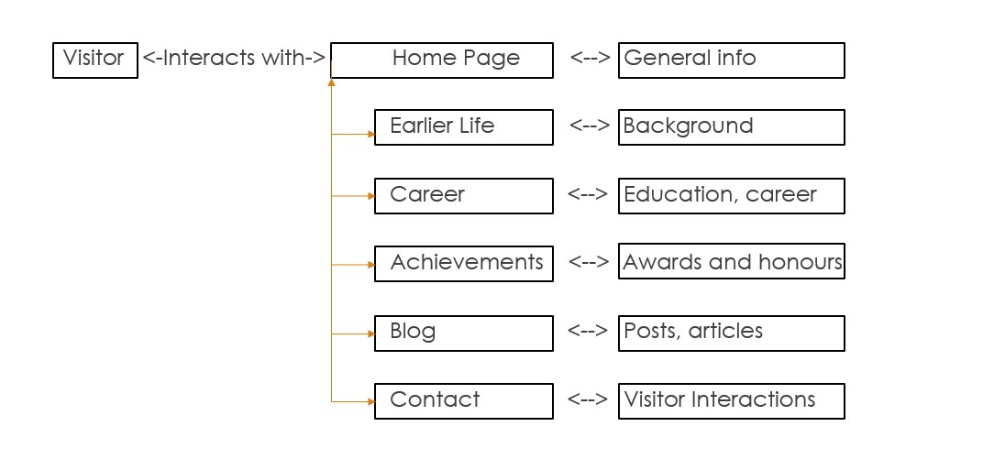

15

**TABLE STRUCTURE**

_________________________________________________________________________________________

1. **TABLE STRUCTURE**

|  |  |  |  |  |  |
| --- | --- | --- | --- | --- | --- |
| **Column Name** | **Data Type** |  | **Null** | **Description** | **Extra** |
| id | INT (Primary Key) | NO |  | Unique identifier for each comment | auto increment |
| author | VARCHAR (255) | NO |  | Name of the writer who wrote the comment | Nil |
| comment_text | TEXT | NO |  | Full content of the comment | Nil |
| date | TIMESTAMP | YES |  | Date the comment was  written | DEFAULT_GENERATED |

16

**SAMPLE CODING**

_________________________________________________________________________________________

1. **SAMPLE CODING**

<!DOCTYPEhtml>

<htmllang="en">

<head>

<metacharset="UTF-8"/>

<metaname="viewport"content="width=device-width,initial-scale=1.0"/>

<title>RGS</title>

<!--LinktoanexternalCSSfileforstyling-->

<linkrel="stylesheet"href="academicPortfolio.css"/>

<style> achive{ width:90%;

text-align:left; margin-left:auto; margin-right:auto; font-size:22px;

}

.a1{ box-shadow:02px10pxindigo; padding:10px; margin-top:5px; margin-bottom:10px;

}

/*Generaltablestyling*/ table{ width:80%; margin-left:auto; margin-right:auto;

}

/*Headerrowstyling*/ th{ background-color:#4caf50;

17

color:white; padding:12px15px;

text-align:left;

}

/*Tablecellstyling*/ td{ padding:12px15px; border:1pxsolid#ddd; text-align:left;

}

/*Hovereffectforrows*/ tr:hover{ background-color:#f5f5f5;

}

/*Zebrastripingeffectforrows*/ tr:nth-child(even){ background-color:#d1c8c8;

}

/*Addsomespacingandshadowtothetable*/ table{ box-shadow:02px5pxrgba(0,0,0,0.1);

}

</style>

</head>

<body>

<!--HeaderSection-->

<header>

<nav>

<ul>

<li><ahref="#home">Home</a></li>

<li><ahref="#earlierLife">Education</a></li>

<li><ahref="#career">Career</a></li>

<li><ahref="#achievements">Achievements</a></li> <li><ahref="#blog">Blog</a></li>

</ul>

</nav>

</header>

<section>

<!--<imgsrc="photos/img31.jpg"class="background-image"/>-->

<!--HomeSection-->

<sectionid="home"class="a1">

<divclass="custom-containercustom-mt-5">

<divclass="custom-row">

<divclass="custom-col-sm-5">

<h1class="fontchange"><b>GowriShankar</b></h1>

<imgsrc="photos/rgs1.jpeg"alt="pic1"class="rgs1"/>

</div>

<divclass="custom-col-sm-7">

<pclass="a1">

Name:GowrishankarNR<br/>

Qualification:M.A.,B.Ed.,M.Phil.,(Ph.D)<br/>

DoB:13.10.1987<br/> Siblings:Nirmala,Indira<br/>

Children:SharaShankar<br/>

</p>

<pclass="linespace">

Prof.NanjanRajuGowrishankarisaAssistantProfessorof EnglishatDr.SNSRajalakshmiCollegeofArtsandScience.With astrongbackgroundinEnglishLiteratureandEducation,Prof. Gowrishankarhascontributedextensivelytoacademicjournals, conferences,andbooks.Hisexpertiseanddedicationto educationcontinuetoinspire.Explorerecentarticles, publications,andinsightsfromhisenrichingacademicjourney.

</p>

</div>

</div>

</div>

</section>

<!--<divclass="horizontal-line"></div>-->

<!--CustomHorizontalline-->

<!--EarlierLifeSection-->

<sectionid="earlierLife"class="a1">

<h1class="lifestyle">Education</h1>

<table>

<tr>

<th>LevelofStudy</th>

<th>Institution/School/University</th>

<th>YearofCompletion</th>

<th>Degree/Program</th>

</tr>

<tr>

<td>1stGradeto10thGrade</td>

<td>GiriEashwaraMatricHigherSecondarySchool,Kagguchi</td>

<td>2003</td>

<td>N/A</td>

</tr>

<tr>

<td>11stGradeand12thGrade</td>

<td>RKRHigherSecondarySchool,Udumalaipet</td>

<td>2005</td>

<td>N/A</td>

</tr>

<tr>

<td>College/UG</td>

<td>GovernmentArtsCollege,Coimbatore</td>

<td>2008</td>

<td>B.A.EnglishLiterature</td>

</tr>

<tr>

<td>B.Ed</td>

<td>HindusthanCollegeofEducation,Coimbatore</td>

<td>2010</td>

<td>B.Ed</td>

</tr>

<tr>

<td>Postgraduate(PG)</td>

<td>GovernmentArtsCollege,Ooty</td>

<td>2012</td>

<td>M.A.EnglishLiterature</td>

</tr>

<tr>

<td>M.Phil</td>

<td>GovernmentArtsCollege,Coimbatore</td>

<td>2019</td>

<td>M.PhilinEnglishLiterature</td>

</tr>

<tr>

<td>Doctorate</td>

<td>GovernmentArtsCollege,Coimbatore</td>

<td>Pursuing</td>

<td>Ph.DinEnglishLiterature</td>

</tr>

</table>

</section>

21

**SAMPLE INPUT**

_________________________________________________________________________________________

**D. SAMPLE INPUT**

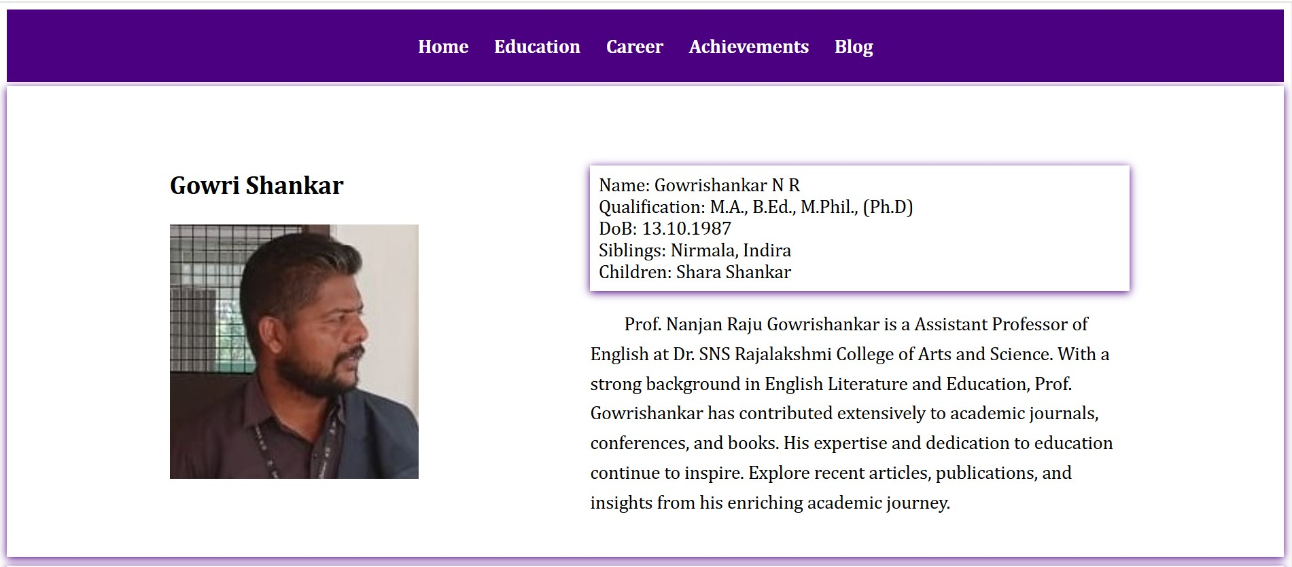

Fig.D.1 – Home page

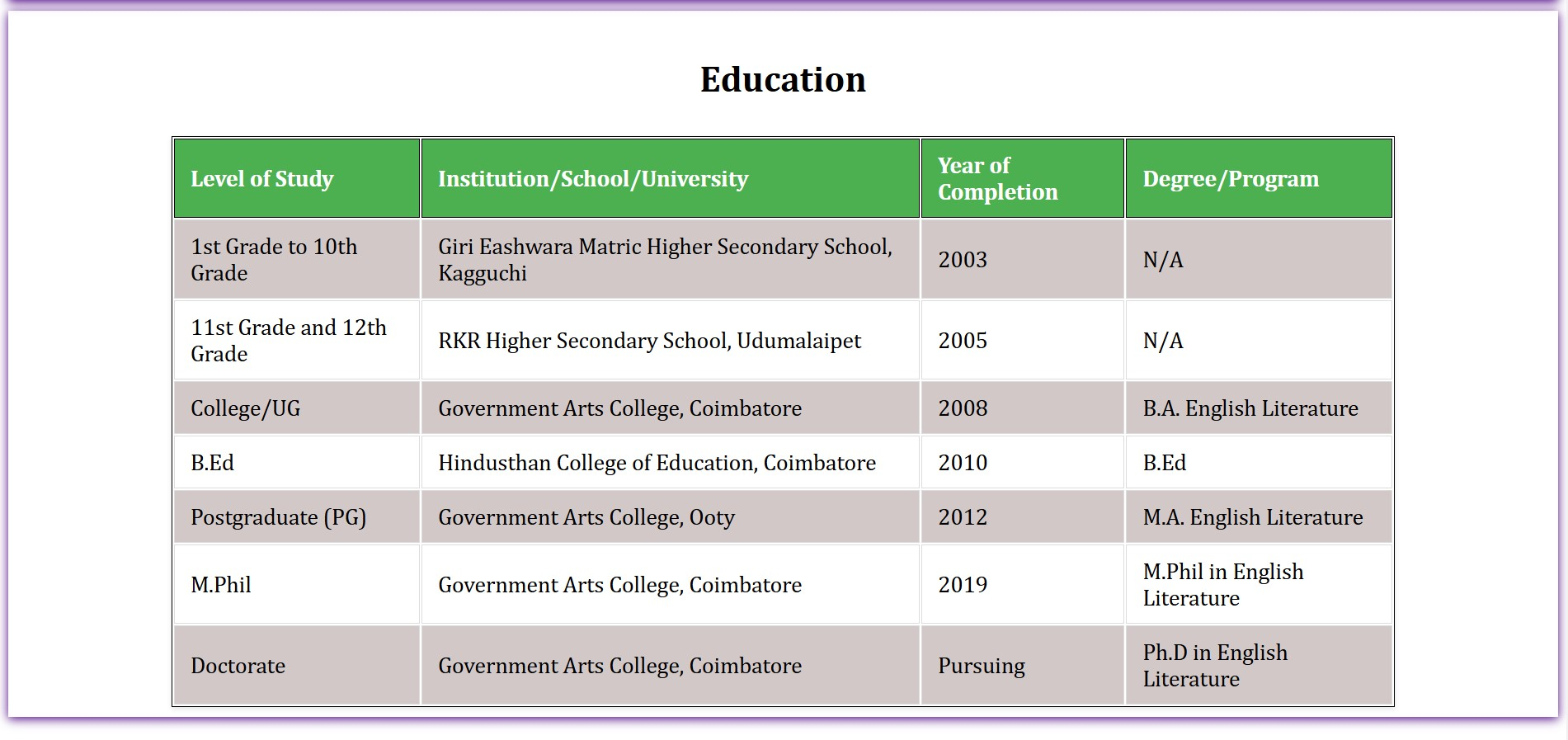

Fig.D.2 – Education section

22

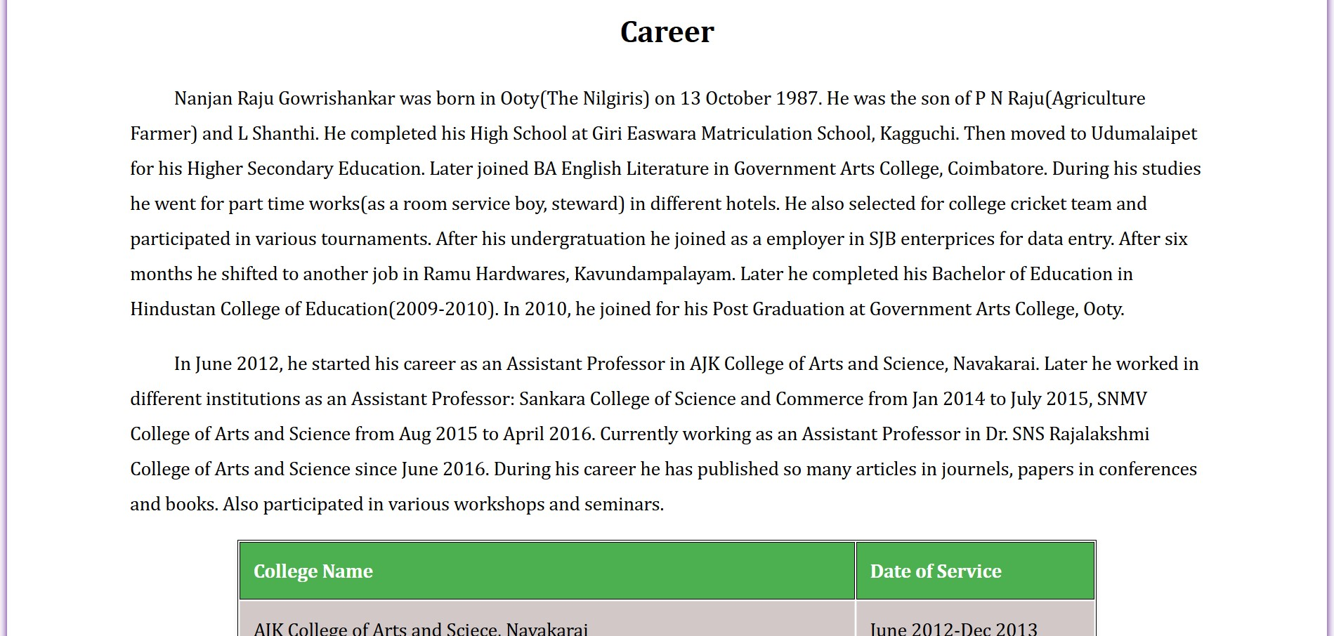

Fig.D.3 – Career section



Fig.D.4 – Achievements section

23



Fig.D.5 – Blog section

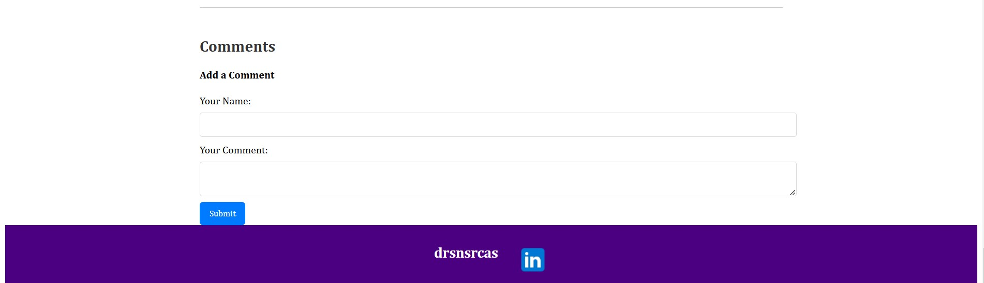

Form.D.1 – Comments form

24

**SAMPLE OUTPUT**

_________________________________________________________________________________________

**E. SAMPLE OUTPUT**

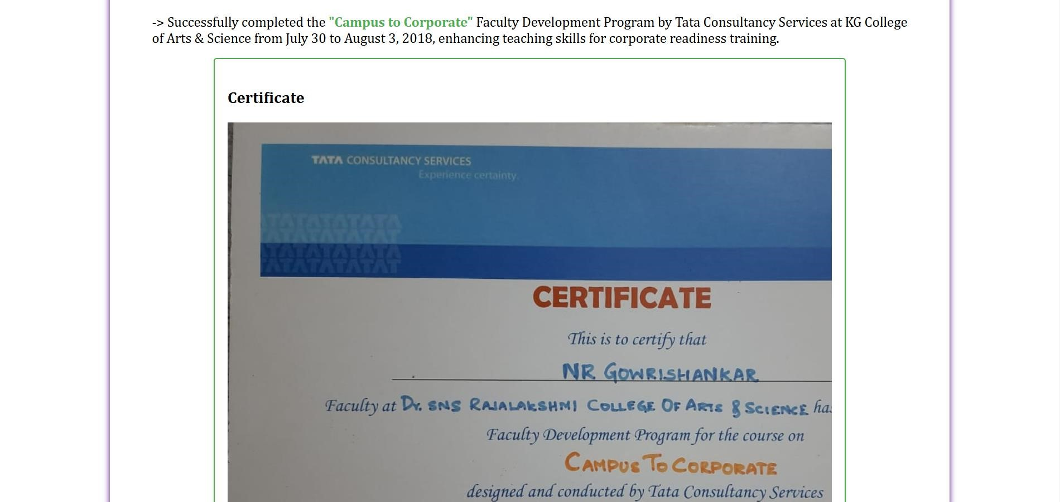

Fig.E.1 – Display of certificate

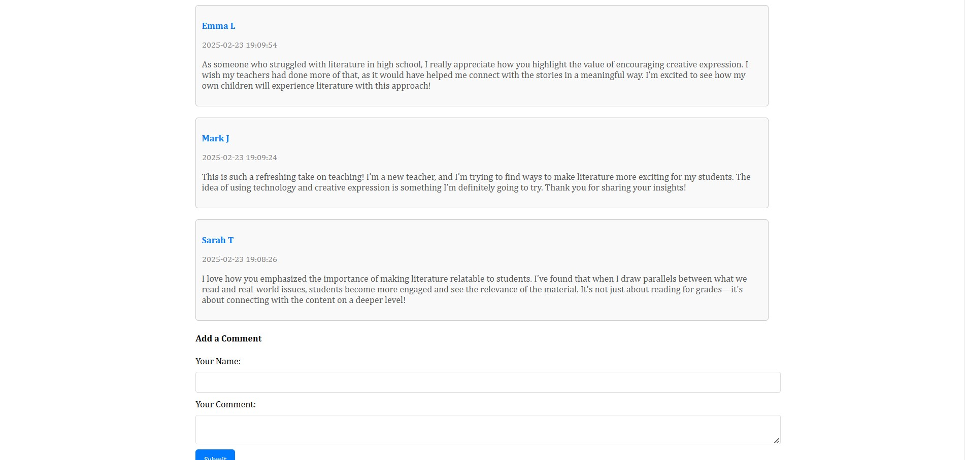

Fig.E.2 – Display of comments

25