**第一个Struts项目HelloWorld**

1. 文件目录

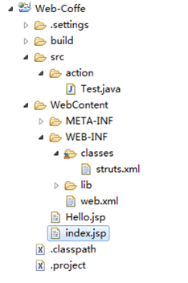

1. 用到的jar包

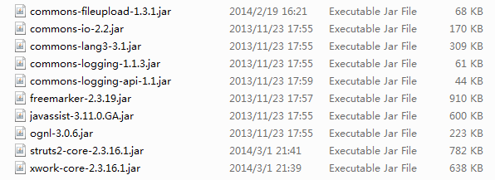

通过java build path导入这些包

1. web.xml文件

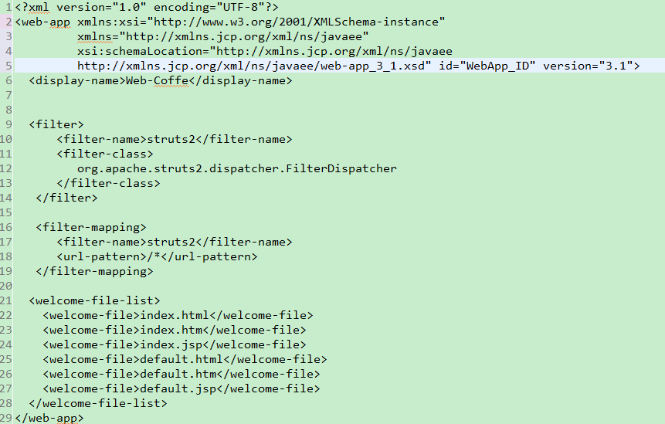

1. struts.xml文件

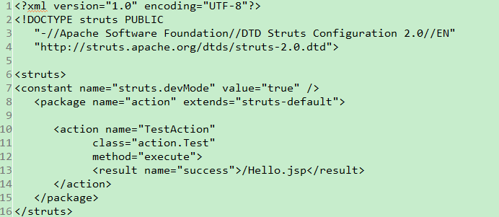

5. Test.java文件

**package** action;

**public** **class** Test {

**private** String name;

**public** String execute() **throws** Exception {

**return** "success";

}

**public** String getName() {

**return** name;

}

**public** **void** setName(String name) {

**this**.name = name;

}

}

6. index.jsp和Hello.jsp文件

index.jsp:

<body>

<h1>Hello World From Struts2</h1>

<form action=*"TestAction"*>

<label for=*"name"*>Please enter your name</label><br/>

<input type=*"text"* name=*"name"*/>

<input type=*"submit"* value=*"Say Hello"*/>

</form>

</body>

Hello.jsp:

<%@ taglib prefix="s" uri="/struts-tags" %>

<html>

<head>

<meta http-equiv=*"Content-Type"* content=*"text/html; charset=ISO-8859-1"*>

<title>Insert title here</title>

</head>

<body>

Hello World, <s:property value=*"name"*/>

</body>

</html>