Mumbai Region Ec2
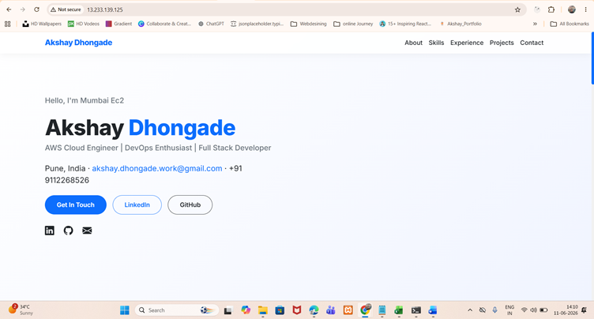

North virgenia Ec2
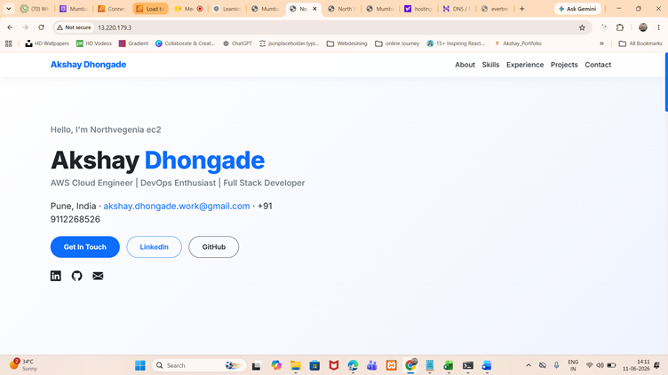

Mumbai ALB
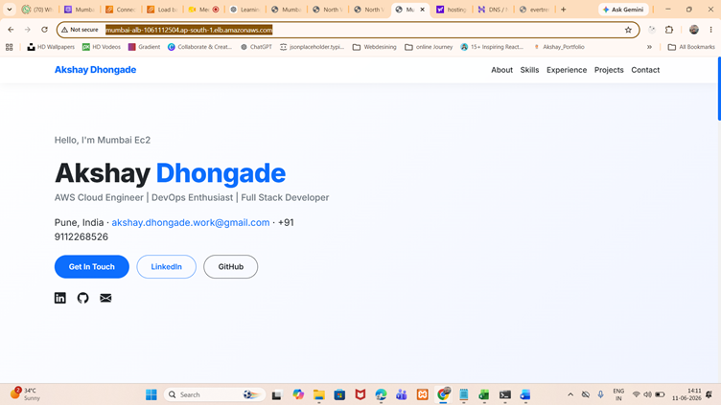

North virgenia ALB
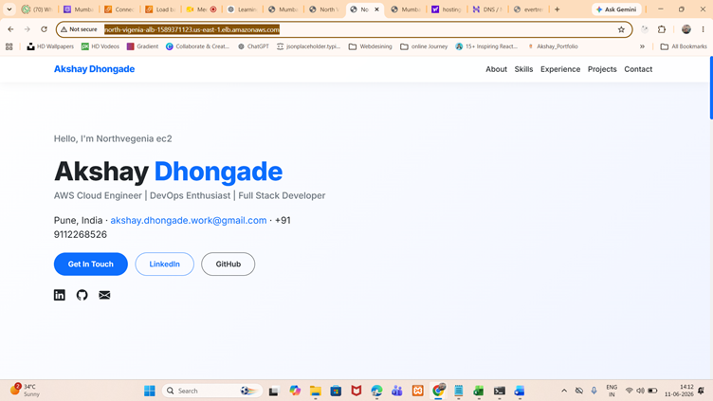
Created Hosted Zone
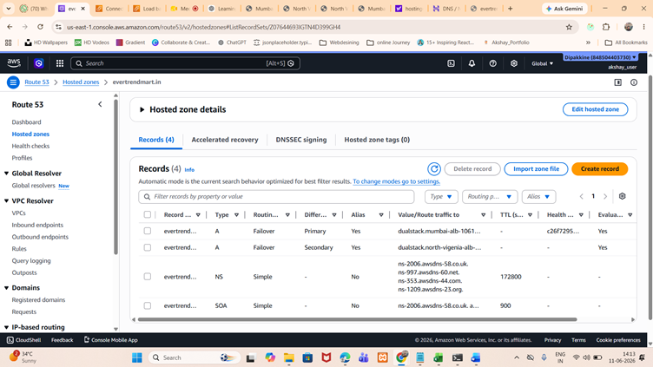

DNS Name servers changed
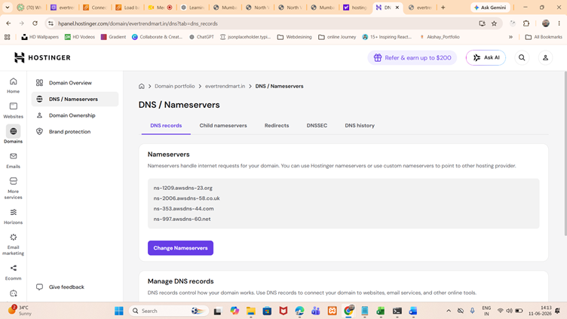

After Hit Domain http://evertrendmart.in/
Redirected traffic first to Mumbai region (Primary)
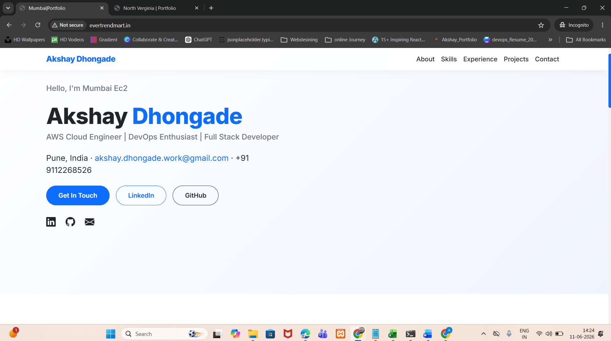

After Stop Nginx service of Mumbai region inside Ec2 , traffic redirected to North virgenia region(Secondary)

