**Prerequisites**

Environment: Windows

Hardware Specification: Minimally 8 GB of RAM and 5GB Space Installation

Installation Drive: C Drive

**Installation**

1. Clone git repository: <https://github.com/derrickpehjh/An-Affect-Intensity-Tool-by-Combining-Lexicon-and-Learning-Based-Approaches>
2. Weka - <https://www.cs.waikato.ac.nz/~ml/weka/downloading.html>

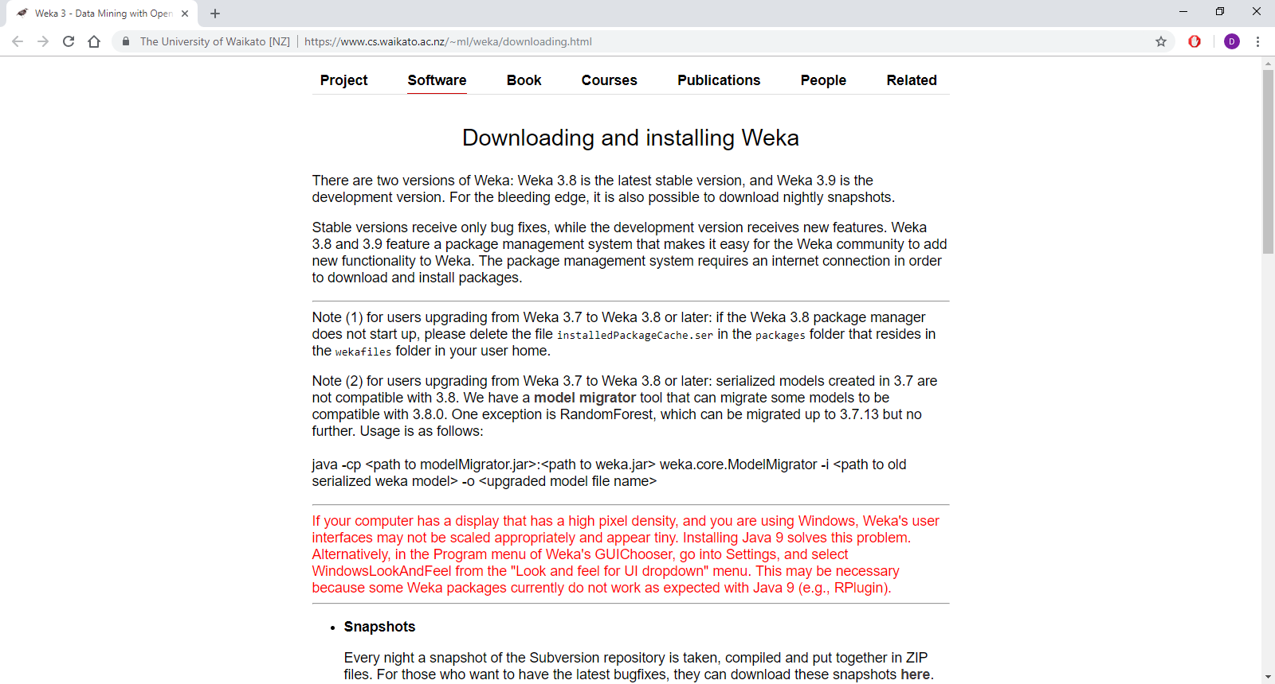

1. Python 3.7 - <https://www.python.org/downloads/>

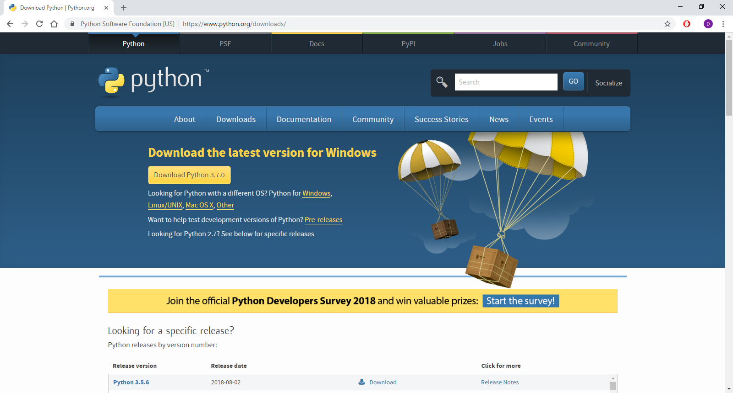

1. Java - <https://www.java.com/en/download/>

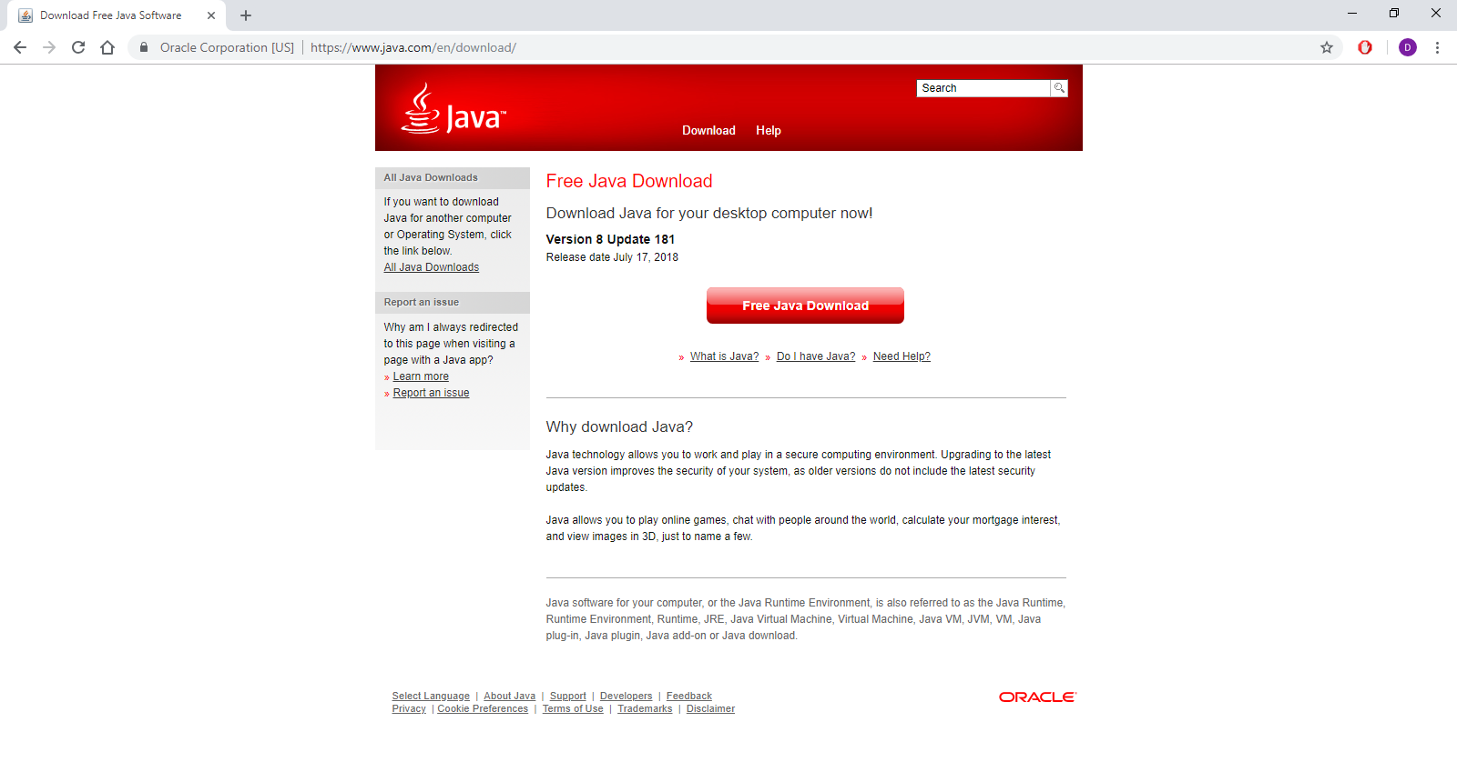

1. Associated python libraries
   1. python -m pip install --user numpy scipy sklearn

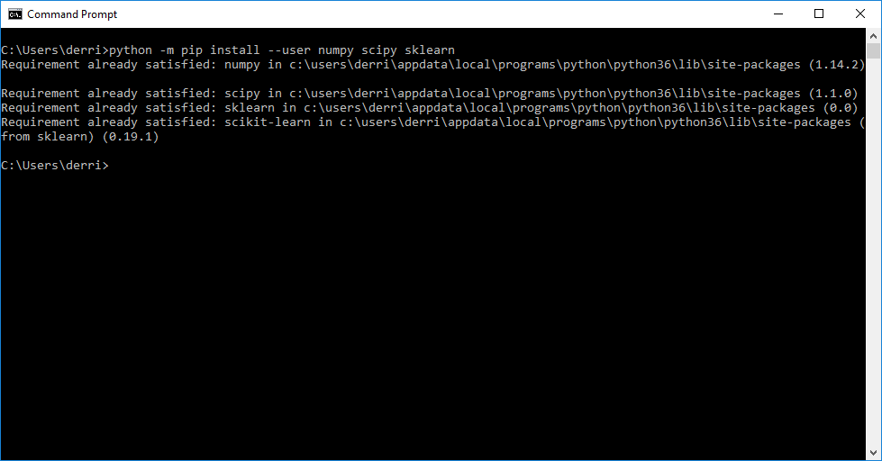

1. AffectiveTweets Package with external packages (LibLinear and Edinburgh corpus)
   1. java -cp $WEKA_PATH/weka.jar weka.core.WekaPackageManager -install-package AffectiveTweets

In case of having problems with the Weka packages repository, install the package as follows: C:\Program Files\Weka-3-8

* 1. java -cp $WEKA_PATH/weka.jar weka.core.WekaPackageManager -install-package <https://github.com/felipebravom/AffectiveTweets/releases/download/1.0.1/AffectiveTweets1.0.1.zip>

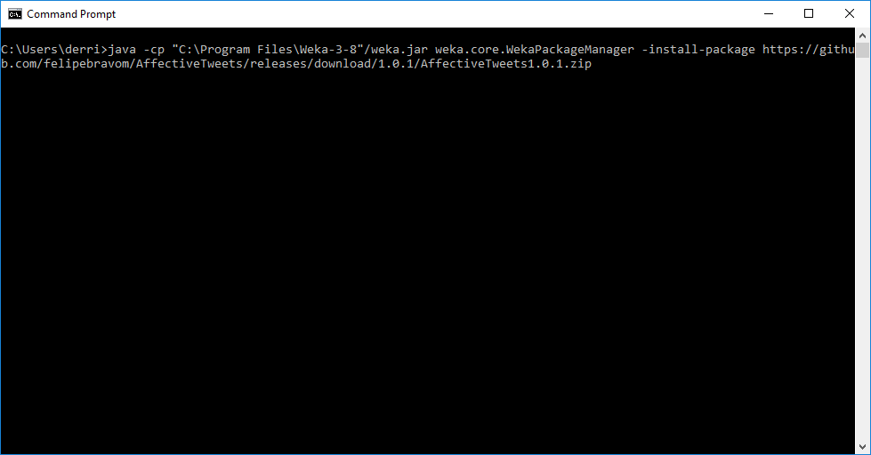

LibLinear

java -cp $WEKA_PATH/weka.jar weka.core.WekaPackageManager -install-package LibLINEAR

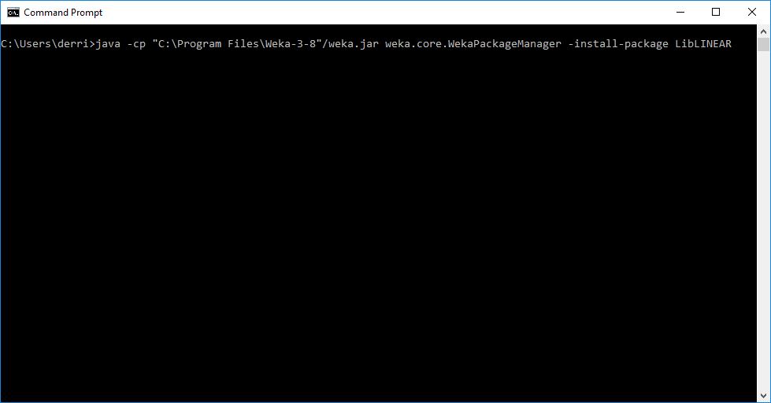

Edinburgh Corpus

<https://github.com/felipebravom/AffectiveTweets/releases/download/1.0.0/w2v.twitter.edinburgh10M.400d.csv.gz>

Download the file from the given link to C:\Users\{user}\wekafiles\packages\AffectiveTweets\resources

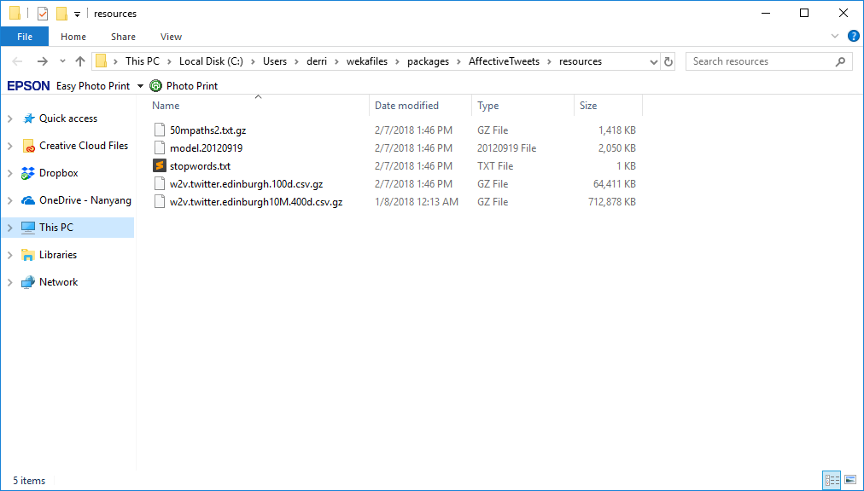

Note: Please add Python and Java to your Windows Environment to allow the programs to run in command prompt.