**Glossary of Folders**

#Documents – Contains files such as FYP Report, Installation Guide and User Manual

#Results – Contains output files of accuracy score

#Run – Contains batch files to run the experiments

Arff – Folder to store pre-processed data files

Config – Contains python scripts to evaluate accuracy scores and pre-process data files

Data – Contains all original datasets used in the experiments

Output – Contains output of test dataset after evaluation

**Instructions**

1. Go to “#Run” Folder in the git repo folder and execute #Config (Run this first as admin).bat with admin privileges

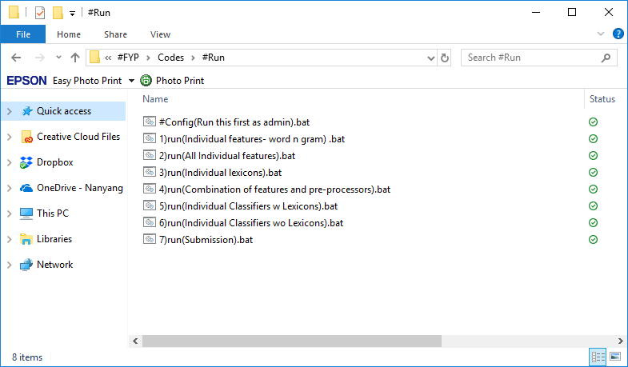

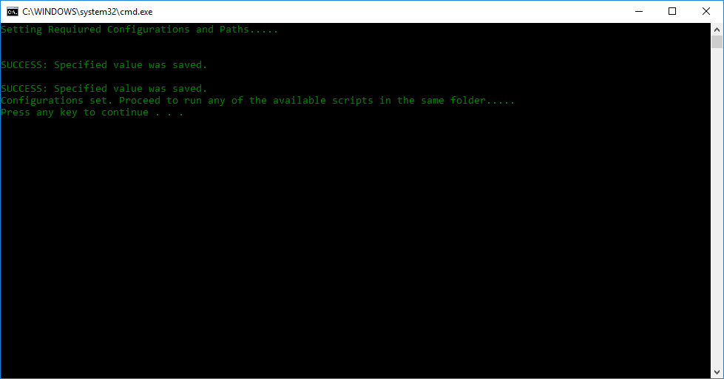

1. Run any of the 7 scripts available in the” #Run” Folder

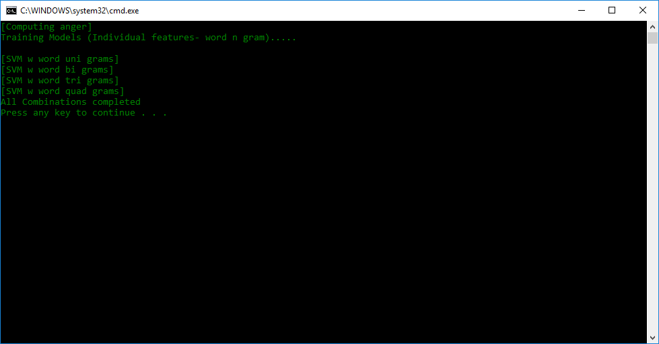

The current default emotion tested on is “anger”. To change the emotion (anger, fear, sadness, joy), please do the following:

* Open any one of the seven scripts
  + e.g. 1)run(Individual features- word n gram).bat
* Replace all occurrence of emotion to the new emotion

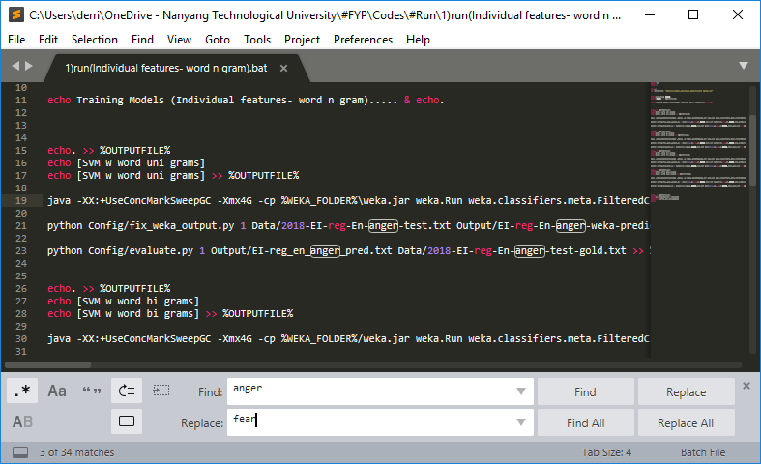

* Save the script and run it again.

1. To see the accuracy results, go to the “#Results” Folder

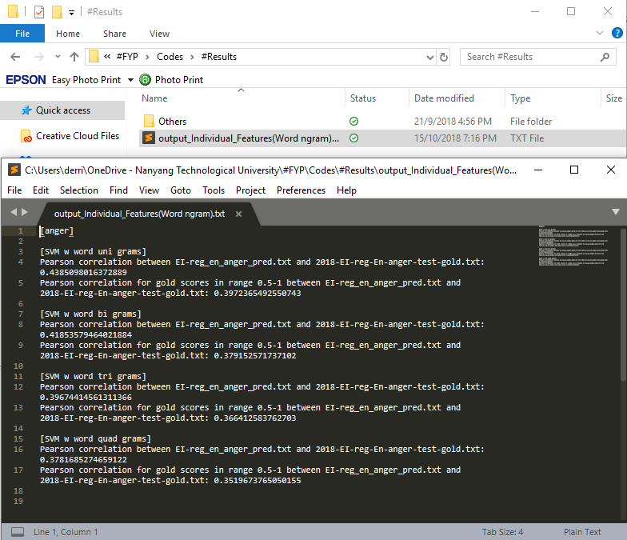

1. To see the content of the labelled data, go to the “Output” Folder

