Sphinx

<https://www.sphinx-doc.org/en/master/index.html#>

Sphinx is a library used to create visually pleasing documentation in many different formats (incl. HTML, PDF, LaTeX, man-pages, etc.). It also allows cross-referencing and many automated processes. There are many services/libraries that use Sphinx for their documentation’ most notably, Python itself (see below).

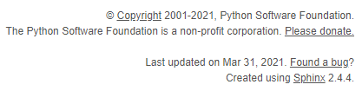

Figure 1: Shown here is the bottom of [docs.python.org](https://docs.python.org/)

Using reStructuredText as its markup language, Sphinx gives programmers the ability to create their own technical documentation while writing the code itself. Using docstrings below classes and functions, the programmer can then reference back from within Sphinx to automatically generate documentation. On page 2 is a section of my own documentation for Project 2.

While it’s not specifically Python code, it uses Python to create the documentation. I have also adopted this library for use in my senior project.

