Sales Performance Dashboard using Power BI
Name: Aseef Pinjar
Project: Power BI Sales Analysis
Tool Used: Microsoft Power BI
1. Introduction
This project focuses on analyzing sales data using Microsoft Power BI to create an interactive dashboard for monitoring business performance. The dashboard helps visualize important metrics such as revenue, profit, orders, and sales trends across different categories, regions, and customer segments.
The goal of this project is to transform raw sales data into meaningful insights using data visualization techniques. By using interactive charts and dashboards, businesses can better understand their performance and make data-driven decisions.

2. Objectives
The main objectives of this project are:
- To analyze sales performance using Power BI
- To visualize important business metrics such as revenue and profit
- To identify top-performing product categories
- To analyze regional sales distribution
- To understand sales trends over time
- To identify profitable and non-profitable product segments

3. Tools Used
The following tool was used in this project:
Microsoft Power BI
- Data visualization
- Dashboard creation
- Interactive reporting
Power BI helps convert raw data into interactive dashboards that provide clear business insights.

4. Dataset Description
The dataset used in this project contains sales transaction data. It includes information related to orders, products, regions, and financial performance.
Important fields in the dataset include:
- Order Date
- Product Category
- Sub-Category
- Customer Segment
- Region
- Sales
- Profit
- Order ID
This dataset allows the analysis of sales performance from multiple perspectives such as time, product category, and region.

5. Dashboard Overview
The Power BI dashboard provides a high-level overview of business performance through key performance indicators and visual charts.
Key metrics displayed in the dashboard include:
- Average Delivery Time: 4 Days
- Total Orders: 1381
- Total Revenue: 341K
- Total Profit: 27.5K
The dashboard also includes several visualizations such as:
- Sales by Category
- Sales by Region
- Profit by Sub-Category
- Sales by Customer Segment
- Geographic Sales Distribution Map
These visuals help users quickly understand the overall performance of the business.

6. Trend Analysis
The Trend Analysis page focuses on examining monthly sales and profit trends across different years.
This page includes line charts that compare sales and profit performance between 2019 and 2020.
Key observations include:
- Sales increase significantly during the last quarter of the year
- Profit trends fluctuate across months
- Strong sales performance occurs during September to December
This analysis helps identify seasonal demand patterns and periods of high sales activity.

7. Time Analysis and Forecasting
The time analysis section displays daily and yearly sales trends using time-series visualization.
This page allows users to explore sales patterns across:
- Years
- Quarters
- Months
- Days
The visualization shows that sales performance improved from 2019 to 2020, indicating business growth.

8. Key Insights
Based on the dashboard analysis, the following insights were identified:
- Technology products generate the highest revenue among all categories.
- The Consumer segment contributes the largest portion of sales.
- Sales performance increases significantly during the final quarter of the year.
- Some sub-categories show negative profit, indicating areas that may require pricing or cost improvements.
- Overall sales performance shows growth between 2019 and 2020.

9. Conclusion
This project demonstrates how Power BI dashboards can be used to analyze business data and generate meaningful insights. The interactive visualizations allow users to quickly understand sales trends, monitor business performance, and identify potential opportunities for improvement.
By transforming raw data into clear visual insights, businesses can make more informed and strategic decisions.
10. (Optional) Add Dashboard Screenshots
Figure 1: Sales Overview Dashboard
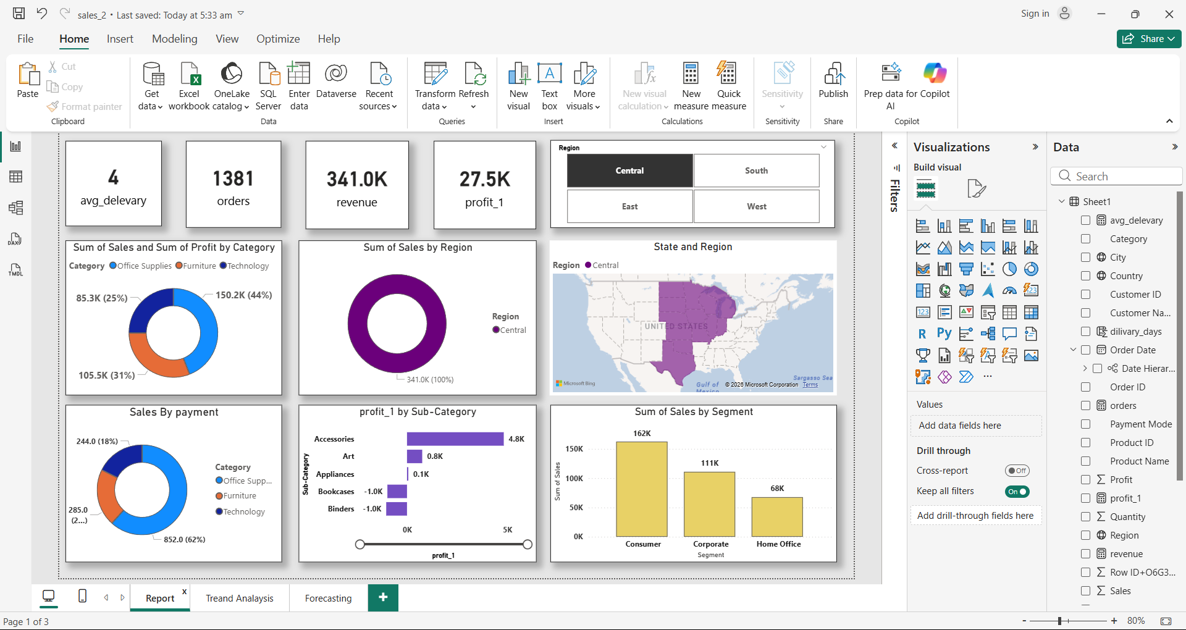
Figure 2: Trend Analysis Dashboard
