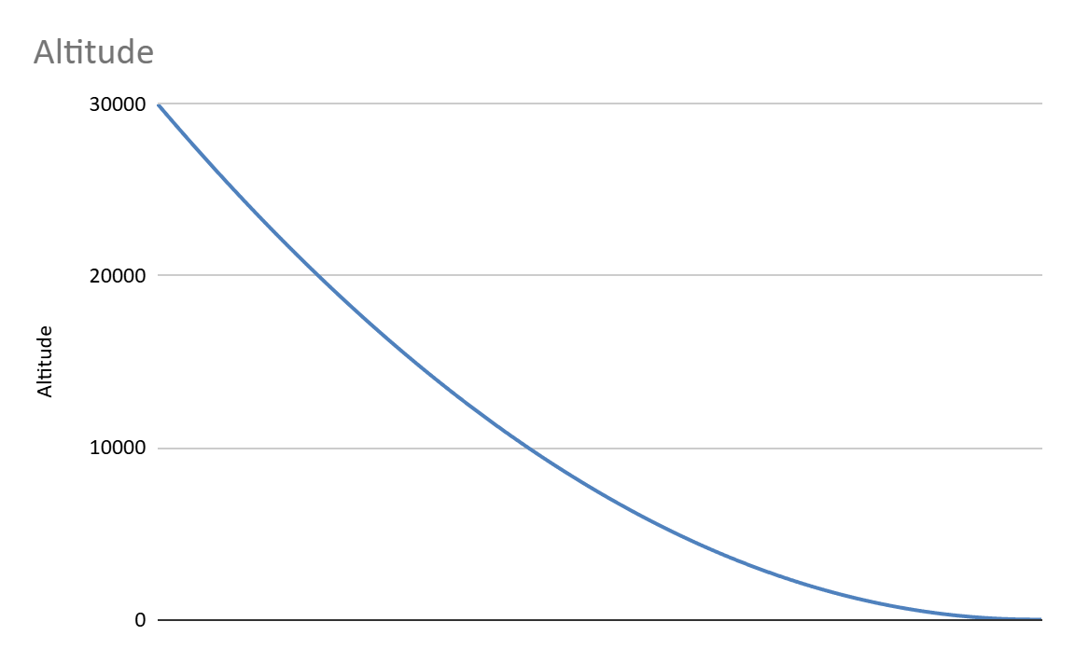The **altitude** steadily decreases from **30,000 meters** to values near **29,000 meters**, which is typical of a controlled descent. The curve represents the altitude loss over time, which is important to ensure a safe and gradual landing. The smoothness of the curve suggests that the descent is well-controlled, with adjustments in throttle and vertical speed to avoid a rapid descent.

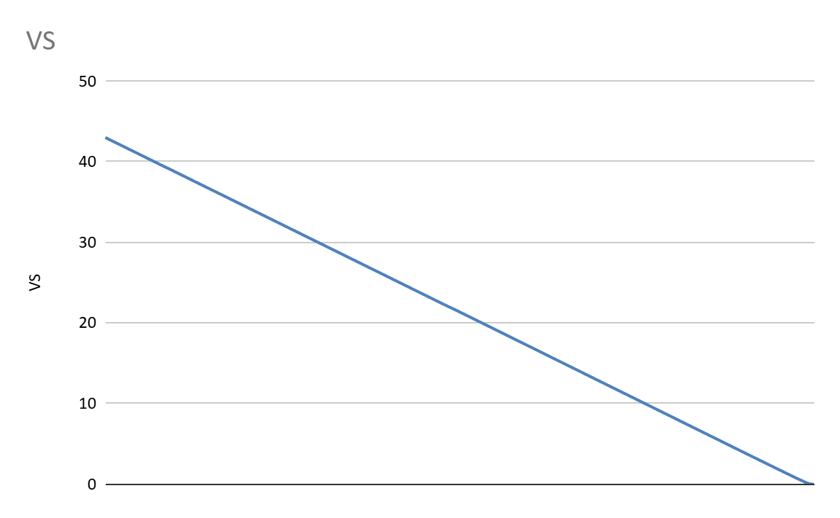**VS** - The graph and the results table indicate that the simulation is designed to control the vertical speed in a way that ensures a safe and smooth landing. The vertical speed reduction over time, as reflected in the graph, suggests that the spacecraft is gradually reducing its descent speed, likely through adjustments to throttle and other control systems.

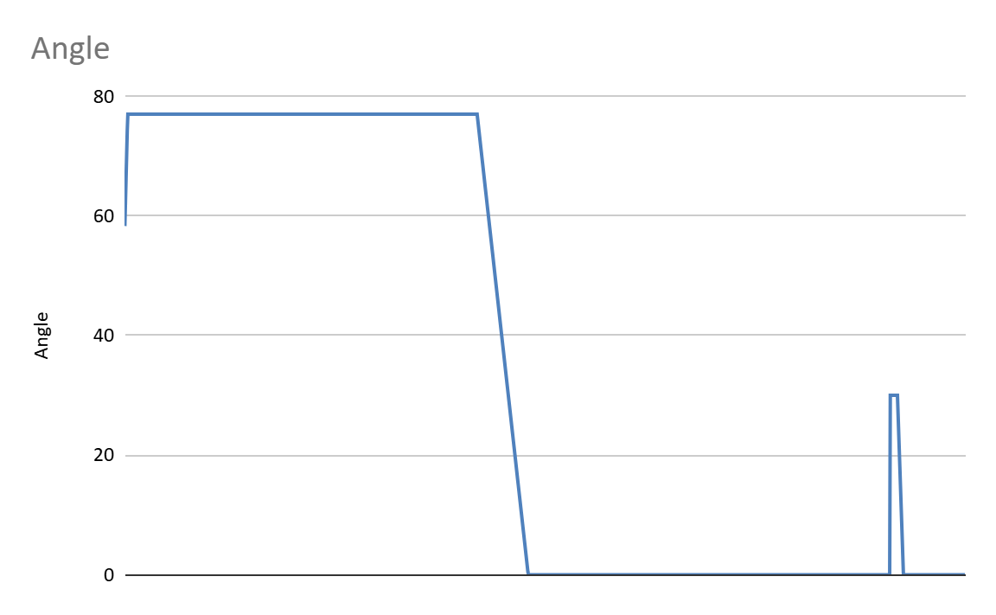

The graph depicting the **Angle** over time illustrates the dynamic adjustments made to the spacecraft's orientation during the descent phase. Initially, the angle is maintained at a high value, approximately **60-70 degrees**, indicating a stable orientation as the spacecraft begins its descent. However, at a specific point in the landing process, the angle sharply decreases to near **0 degrees**. This sudden drop signifies a critical maneuver aimed at aligning the spacecraft for its final landing approach.

The steep decline in the angle is a deliberate adjustment likely related to the spacecraft’s orientation relative to the landing surface. Such an adjustment is essential to ensure that the spacecraft is positioned optimally for a controlled and stable landing. The maneuver can be attributed to a feedback-based control system that monitors the spacecraft’s vertical speed, altitude, and other factors to make real-time adjustments.

The sharp reduction in the angle may correspond to the spacecraft’s final descent phase, where precise orientation is required to minimize the impact upon landing. This behavior aligns with the intended objective of the model, which is to control the spacecraft’s angle to facilitate a smooth and stable landing.

In conclusion, the graph effectively demonstrates the spacecraft’s ability to adjust its orientation dynamically during its descent, ensuring a safe and controlled landing.

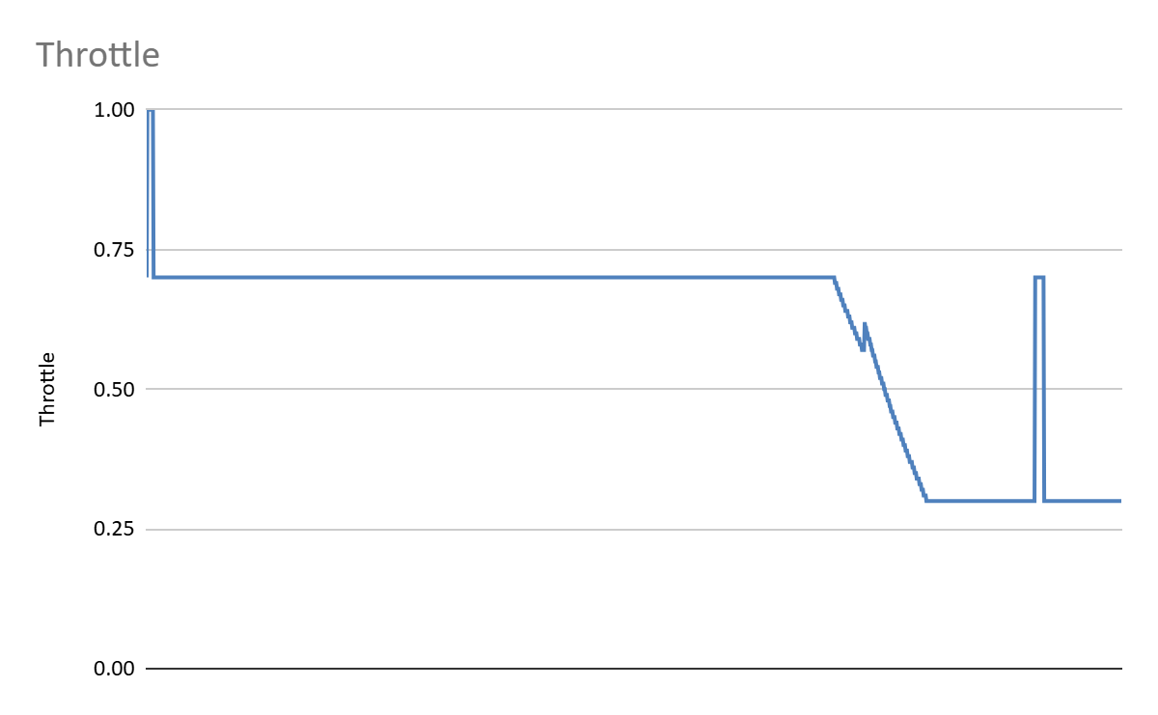

The graph representing the **Throttle** over time demonstrates the variation in throttle input throughout the descent and landing process. Initially, the throttle value is set at around **0.75**, indicating a moderate level of thrust being applied. This is consistent with a controlled descent, where a balanced thrust is required to slow the spacecraft's descent rate without overshooting the necessary speed.

At a specific point in the descent, the throttle is reduced significantly to **near 0.25**. This reduction is a deliberate action to decrease the thrust, slowing the spacecraft further and facilitating a more gradual descent. The decrease in throttle allows for a finer control over the vertical speed, which is crucial for ensuring that the spacecraft does not descend too rapidly, preventing a rough landing.

Following this reduction, a sudden increase in throttle to near **1.00** is observed. This sharp spike indicates an immediate adjustment made to provide additional thrust, likely to counteract a rapid increase in vertical speed or to stabilize the descent rate as the spacecraft nears the landing stage. The throttle then stabilizes, maintaining a low value, which aligns with the final descent phase where minimal thrust is needed to achieve a soft landing.

This throttling behavior is indicative of a feedback-controlled descent, where real-time adjustments are made based on sensor data to ensure a stable, controlled, and safe landing. The varying throttle levels demonstrate the spacecraft’s ability to adjust thrust dynamically in response to changes in altitude, vertical speed, and other parameters, ultimately ensuring a successful landing.