**-- (1)Perform inner join, Left join, and Right join on the tables.**

Select C.Id,C.Country_name,P.Fname,P.Rating

from persons1 as P INNER JOIN country1 as C on P.Country_Id=C.Id;

Select C.Id,C.Country_name,P.Fname,P.Rating

from persons1 as P LEFT JOIN country1 as C on P.Country_Id=C.Id;

Select C.Id,C.Country_name,P.Fname,P.Rating

from persons1 as P RIGHT JOIN country1 as C on P.Country_Id=C.Id;

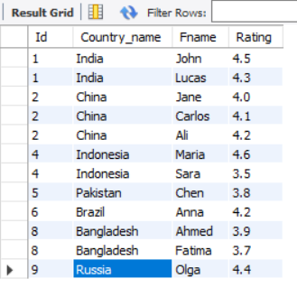

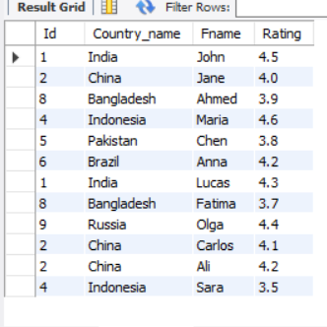

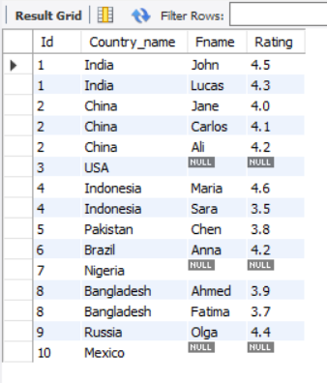

**-- (2)List all distinct country names from both the Country and Persons tables.**

SELECT DISTINCT Country_name FROM country1

UNION

SELECT DISTINCT Country_name FROM persons1

JOIN Country1 ON persons1.Country_Id = country1.Id;

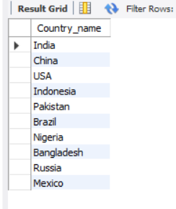

**-- (3)List all country names from both the Country and Persons tables, including duplicates.**

SELECT DISTINCT Country_name FROM country1

UNION ALL

SELECT DISTINCT Country_name FROM persons1

JOIN Country1 ON persons1.Country_Id = country1.Id;

**-- (4)Round the ratings of all persons to the nearest integer in the Persons table.**

SELECT Fname,Lname,round(Rating) AS RoundedRating FROM persons1;

