-- 1. Find the number of persons in each country.

Select Country_name,count(*) As Number_of_persons from persons group by Country_name;

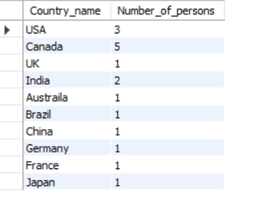

-- 2. Find the number of persons in each country sorted from high to low.

Select Country_name,count(*) As Number_of_persons from persons group by Country_name order by Number_of_persons desc ;

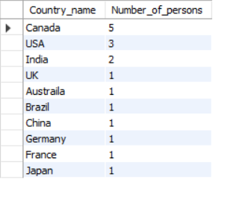

-- 3. Find out an average rating for Persons in respective countries if the average is greater than 3.0

select Country_name,avg(Rating) from persons group by Country_name having avg(Rating) >3.0;

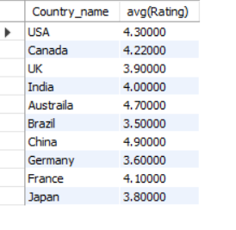

-- 4. Find the countries with the same rating as the USA. (Use Subqueries)

select avg(Rating) from persons where Country_name='USA';

select Country_name from persons where Rating=(select avg(Rating) from persons where Country_name='USA');

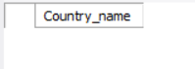

-- 5. Select all countries whose population is greater than the average population of all nations.

select country_name,population from country where population>(select avg(population) from country);

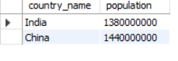

—----------------------------------------------------------------------------------------------------------------------------CREATE DATABASE Product;

USE Product;

CREATE TABLE Customer (

Customer_Id INT PRIMARY KEY,

First_name VARCHAR(50),

Last_name VARCHAR(50),

Email VARCHAR(100),

Phone_no VARCHAR(15),

Address VARCHAR(100),

City VARCHAR(50),

State VARCHAR(50),

Zip_code VARCHAR(10),

Country VARCHAR(50)

);

select * from customer;

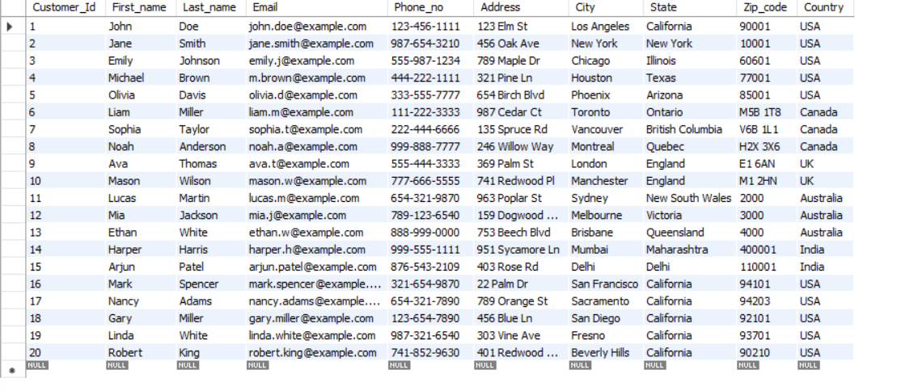

/*1. Create a view named customer_info for the Customer table that displays Customer’s Full name and email address.

Then perform the SELECT operation for the customer_info view. */

create view customer_info as select concat(First_name,' ',Last_name) as Full_Name,Email from Customer;

select * from customer_info;

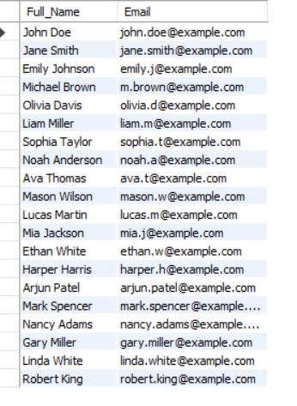

-- 2. Create a view named US_Customers that displays customers located in the US.

create view US_Customers as select First_Name,Country from Customer where Country='USA';

select * from US_Customers;

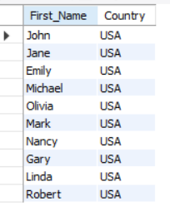

-- 3. Create another view named Customer_details with columns full name(Combine first_name and last_name), email, phone_no, and state.

create view Customer_Details as select concat(First_name,' ',Last_name) as Full_Name,Email,Phone_no,State from Customer;

select * from Customer_Details;

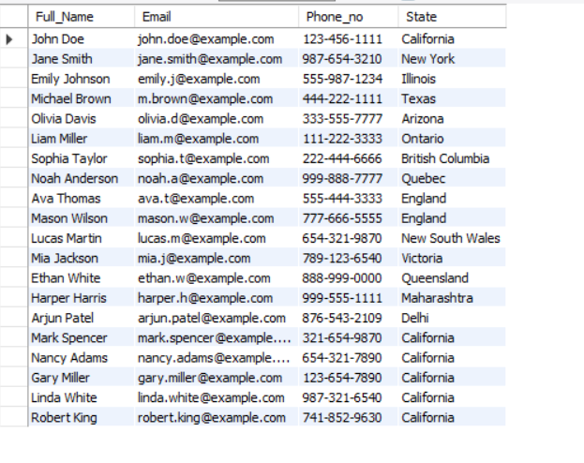

-- 4. Update phone numbers of customers who live in California for Customer_details view.

update Customer_Details set Phone_no = '123-456-1111' where State='California';

-- 5. Count the number of customers in each state and show only states with more than 5 customers

INSERT INTO Customer (Customer_Id, First_name, Last_name, Email, Phone_no, Address, City, State, Zip_code, Country) VALUES

(16, 'Mark', 'Spencer', 'mark.spencer@example.com', '321-654-9870', '22 Palm Dr', 'San Francisco', 'California', '94101', 'USA'),

(17, 'Nancy', 'Adams', 'nancy.adams@example.com', '654-321-7890', '789 Orange St', 'Sacramento', 'California', '94203', 'USA'),

(18, 'Gary', 'Miller', 'gary.miller@example.com', '123-654-7890', '456 Blue Ln', 'San Diego', 'California', '92101', 'USA'),

(19, 'Linda', 'White', 'linda.white@example.com', '987-321-6540', '303 Vine Ave', 'Fresno', 'California', '93701', 'USA'),

(20, 'Robert', 'King', 'robert.king@example.com', '741-852-9630', '401 Redwood Blvd', 'Beverly Hills', 'California', '90210', 'USA');

select * from Customer;

select state,count(*) as No_of_customers from customer group by state having count(*)>5;



-- 6. Write a query that will return the number of customers in each state, based on the "state" column in the "customer_details" view.

drop view customer_details;

select state,count(*) as No_of_Customers from customer_details group by state;

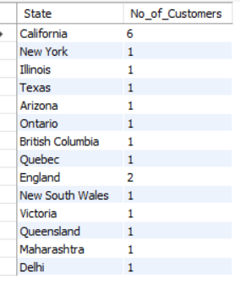

-- 7. Write a query that returns all the columns from the "customer_details" view, sorted by the "state" column in ascending order.

select * from customer_details order by state asc;

