Honolulu accessibility: a preliminary report

JT Keller and Alicia Seeley

2023-02-21

# Introduction

This report seeks to define and measure accessibility for Honolulu county.

## Definition of Accessibility and Explanation of Specific Accessibility Metric

We based our definition of level of accessibility on Susan Handy’s “Enough with the “D’s” Already — Let’s Get Back to “A”” which asserts that “the level of accessibility from a given place reflects the distribution of destinations around it, the ease with which those destinations can be reached by various modes, and the amount and character of activity found there.” For the purpose of this exercise, the ‘distribution of destinations’ refers to employment locations relative to a given origin, the ‘ease with which destinations can be reached by various modes’ is measured through travel times and other impedance weights (explained below) for driving and bus modes, and ‘character of activity’ refers specifically to employment.

# Metrics

## Calculating Perceived Travel Time

The assumption that most public transit riders are more bothered by out-of-vehicle waiting time than in-vehicle travel time seems to hold true for Honolulu. In fact, a bit of searching internet blogs and review sites (see Figures 1 and 2) revealed that a common complaint about the bus system was buses running very late or not arriving at all. This adds additional frustration to long headways. We thus decided to set the weight for out-of-vehicle time to be 3 times that of in-vehicle time.

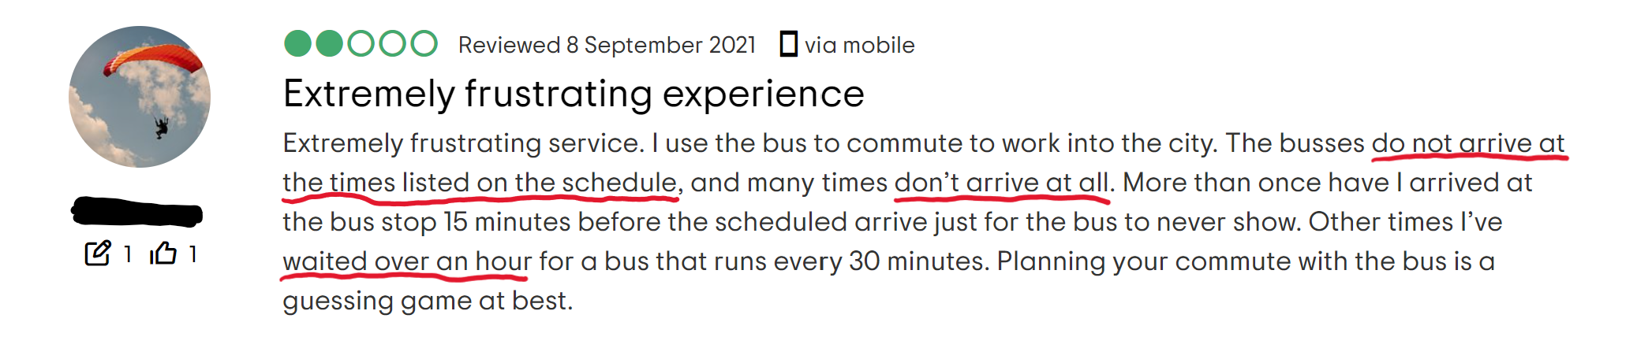

Figure 1: Annotated snapshot of TheBus review from anonymous user, TripAdvisor.com

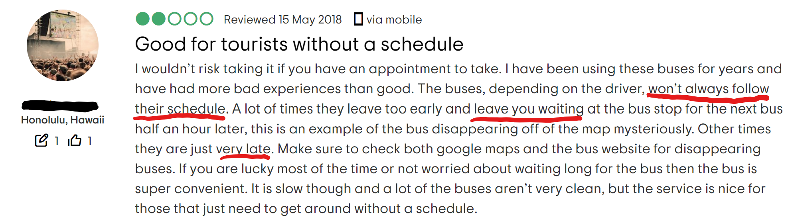

Figure 2: Annotated snapshot of another TheBus review from anonymous user, TripAdvisor.com

## Defining Decay Function

For Honolulu, we chose to use a logistic function to represent decay. Because of the large variation in travel times and generally long travel times on buses in Honolulu, we believe that the difference in accessibility for a 10-minute transit trip versus a 20-minute transit trip would influence perceived accessibility and impedance more than the difference between a 90-minute trip and a 100-minute trip, for example (Since they are already taking such a long bus ride, what is ten more minutes?), ruling out the logic behind exponential, step, or linear functions of decay.

We defined an inflection point of 45. Given the wide variability in bus trip durations across the island and its inconsistency, we believe that the perceived accessibility is likely to decline at a higher inflection point than (have a shallower rate of decline) than more urbanized areas like Boston.

As for standard deviation, we decided on a unit of 10 to account for variability in users, their respective reasons for traveling, and other individual characteristics. We thought it best to be generous here because of the high volume of tourists and visitors who generally have different standards than residents and daily commuters. This also relates to the variability in expectations based on geography, as the urban core is a small part of the island and those traveling within the urban core will have different perceptions of accessibility compared to those who start or end their trips in more mountainous or outlying areas.

## Weight Jobs For Each Origin-Destination Pair

As we start taking car trips into account, we (unsurprisingly) noticed a wider range in travel times by car. Because of this, we decided to continue using the logistic decay function, but to adjust the parameters to have an inflection point of 30 minutes and a standard deviation of 20 because we can assume that drivers are less amenable to longer travel times. In other words, given their relative independence compared to bus users, they would most likely expect a more fixed travel time and so the inflection point would be lower.

## Combine Absolute Transit and Car Access

We opted not to combine car accessibility with transit accessibility, keeping them as separate indices. We did not think calculating an absolute value for overall accessibility would be meaningful in the context of Honolulu. The island offers only one option for public transportation, which uses the same road network as cars. Given the perceived unreliability of the bus, we assume that those with access to cars will almost always drive because it will always be the more efficient option. Given these assumptions, we posit that each user would primarily only use one form of transportation or the other rather than a mix of the two, and thus an overall accessibility measure would not be useful.

# Results

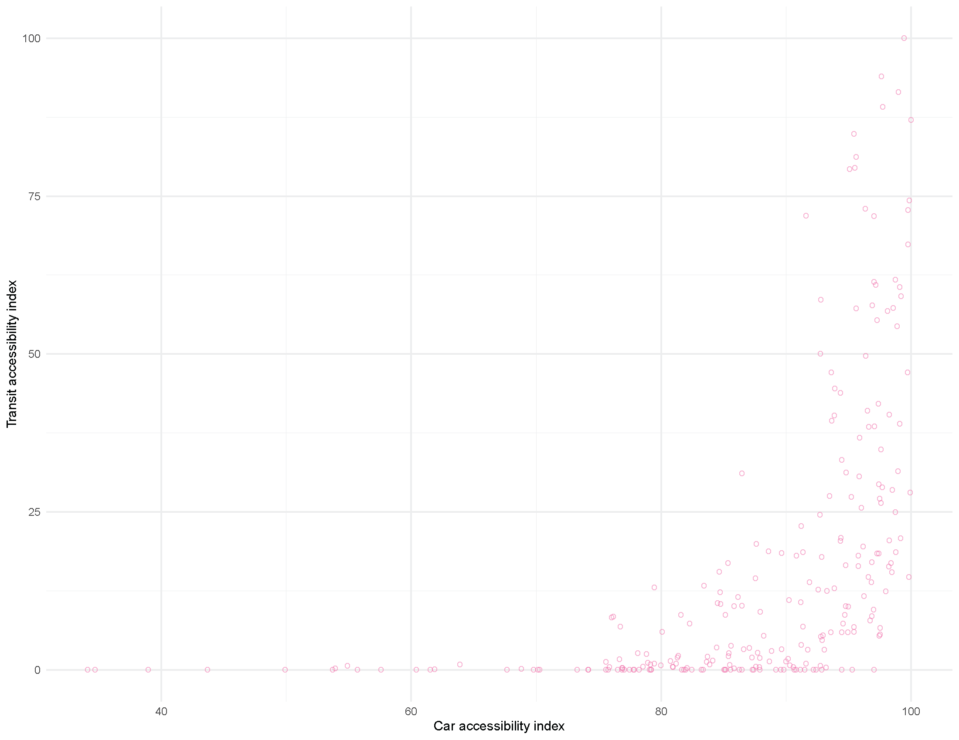 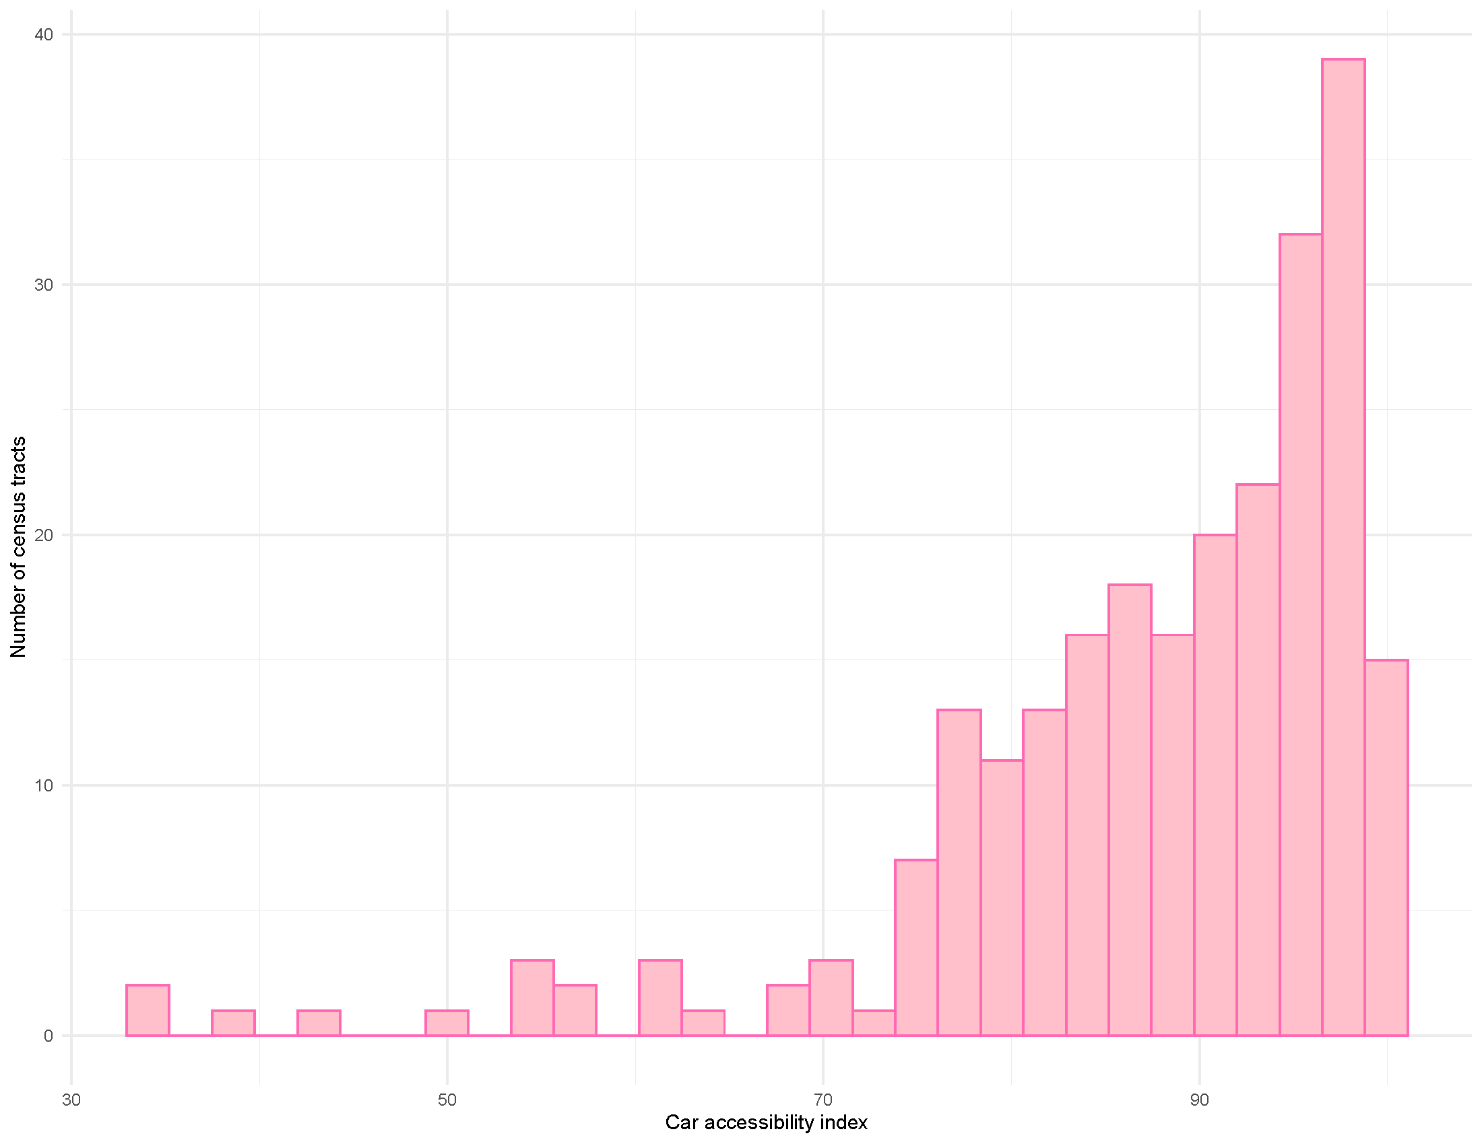

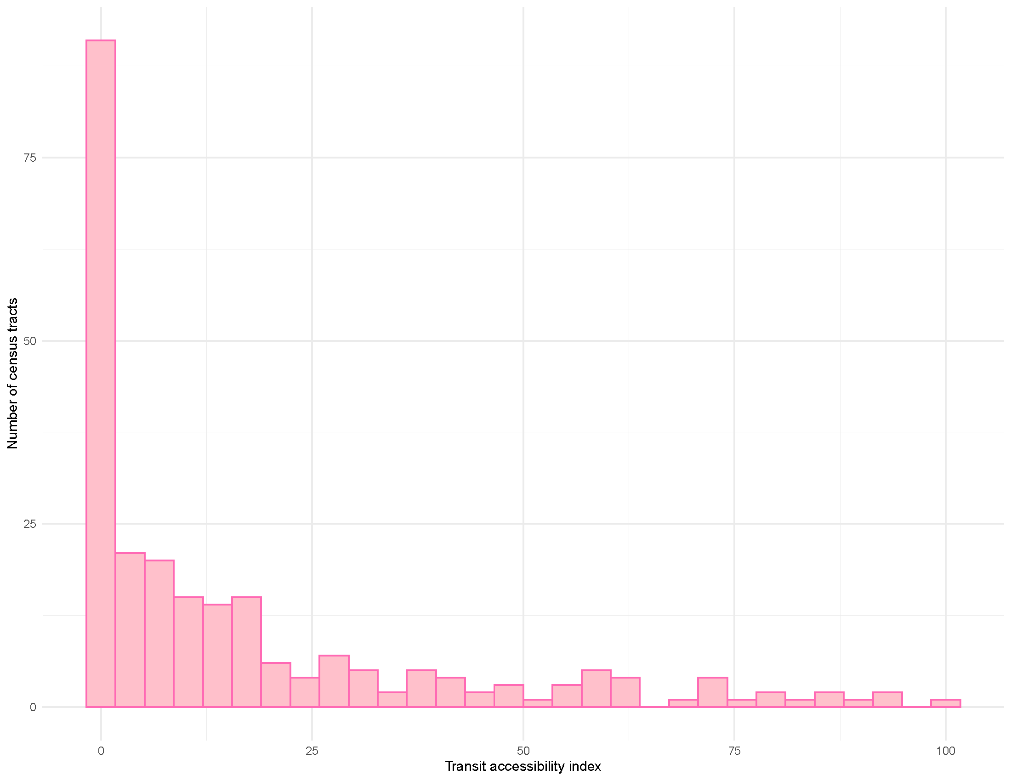

Figure 5: Transit accessibility skews very low

# Conclusion

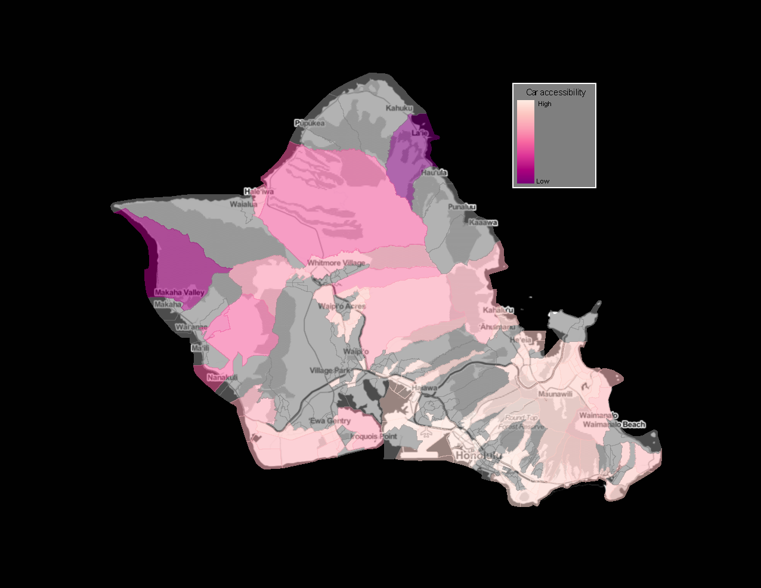

Spatialization of car accessibility.

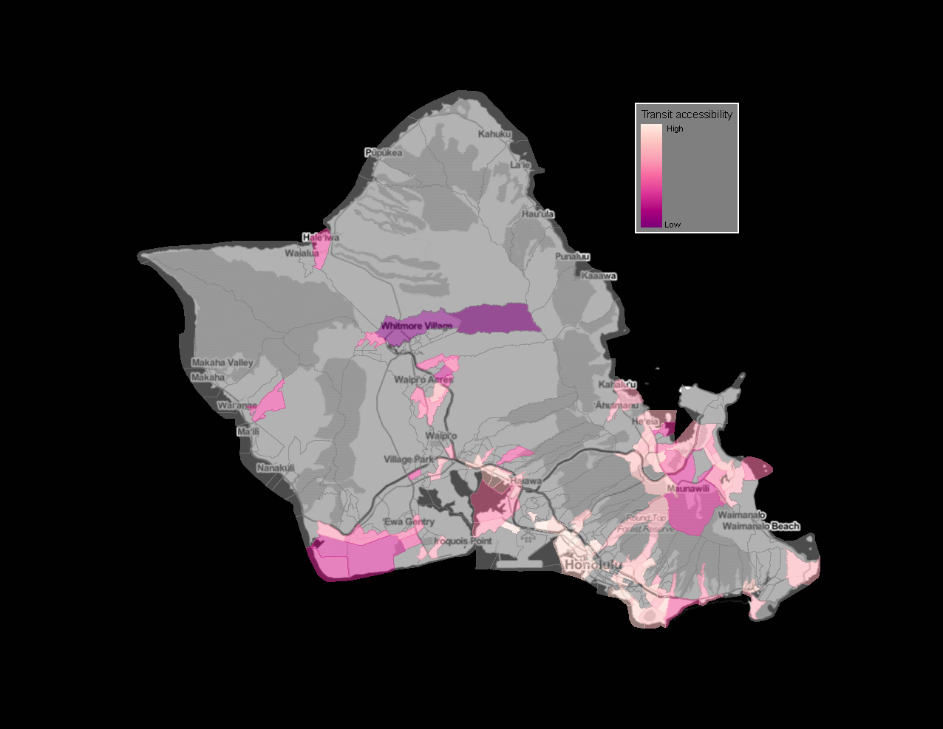 The results of this exercise showed some interesting trends when factoring employment as the accessibility factor rather than just showing what travel is possible from one census tract to another.

Generally, we would expect to see a high level of access centered around downtown, with the accessibility decreasing as distance from downtown increases. However, there are tracts directly adjacent to downtown that don’t even register on the accessibility index; while at the same time, there are tracts on the other side of the island that have high levels of accessibility. So, instead of a continuous scale of decreasing accessibility as distance increases from downtown, we see a patchwork map that almost indicates a binary variable for accessibility: the destinations are either accessible to some degree, or not at all. Even in the access by car map, we see a very random distribution of levels in access.

This can tell us a lot about where employment centers are concentrated throughout the island. Unsurprisingly, the transit accessibility map further filters down these employment centers. Although they are still scattered throughout the island, many more tracts are left empty. indicating that people commuting to those areas for work do not have the option of public transit.