Aseem Malhotra

101557400

**Question 1**

We should start by putting all values in

bears_cov <- matrix(c(3266.46, 1343.97, 731.54, 1175.50, 162.68, 238.37,

1343.97, 721.91, 324.25, 537.35, 80.17, 117.73,

731.54, 324.25, 179.28, 281.17, 39.15, 56.80,

1175.50, 537.35, 281.17, 474.98, 63.73, 94.85,

162.68, 80.17, 39.15, 63.73, 9.95, 13.88,

238.37, 117.73, 56.80, 94.85, 13.88, 21.26), ncol = 6, byrow = T)

bears_cov

isSymmetric(bears_cov) # TRUE

(a)

pca_bears_cov <- principal(bears_cov, nfactors = 6, rotate = "none")

Principal Components Analysis

Call: principal(r = bears_cov, nfactors = 6, rotate = "none")

Standardized loadings (pattern matrix) based upon correlation matrix

PC1 PC2 PC3 PC4 PC5 PC6 h2 u2 com

1 0.96 -0.23 0.07 0.06 0.13 0.02 1 0.0e+00 1.2

2 0.96 0.22 -0.05 0.16 -0.01 0.00 1 1.1e-16 1.2

3 0.97 -0.16 0.01 0.01 -0.12 -0.10 1 4.4e-16 1.1

4 0.98 -0.09 -0.14 -0.05 -0.05 0.09 1 0.0e+00 1.1

5 0.97 0.13 0.17 -0.06 -0.05 0.05 1 4.4e-16 1.1

6 0.97 0.13 -0.06 -0.11 0.10 -0.07 1 4.4e-16 1.1

PC1 PC2 PC3 PC4 PC5 PC6

SS loadings 5.64 0.18 0.06 0.05 0.05 0.03

Proportion Var 0.94 0.03 0.01 0.01 0.01 0.00

Cumulative Var 0.94 0.97 0.98 0.99 1.00 1.00

Proportion Explained 0.94 0.03 0.01 0.01 0.01 0.00

Cumulative Proportion 0.94 0.97 0.98 0.99 1.00 1.00

Mean item complexity = 1.1

Test of the hypothesis that 6 components are sufficient.

The root mean square of the residuals (RMSR) is 0

Fit based upon off diagonal values = 1

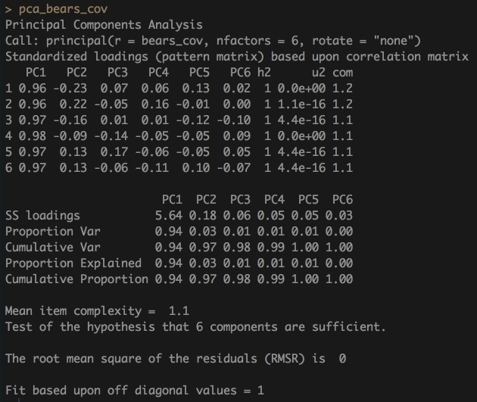

plot(pca_bears_cov$values, type = "l")

abline(h=1, lty =2)

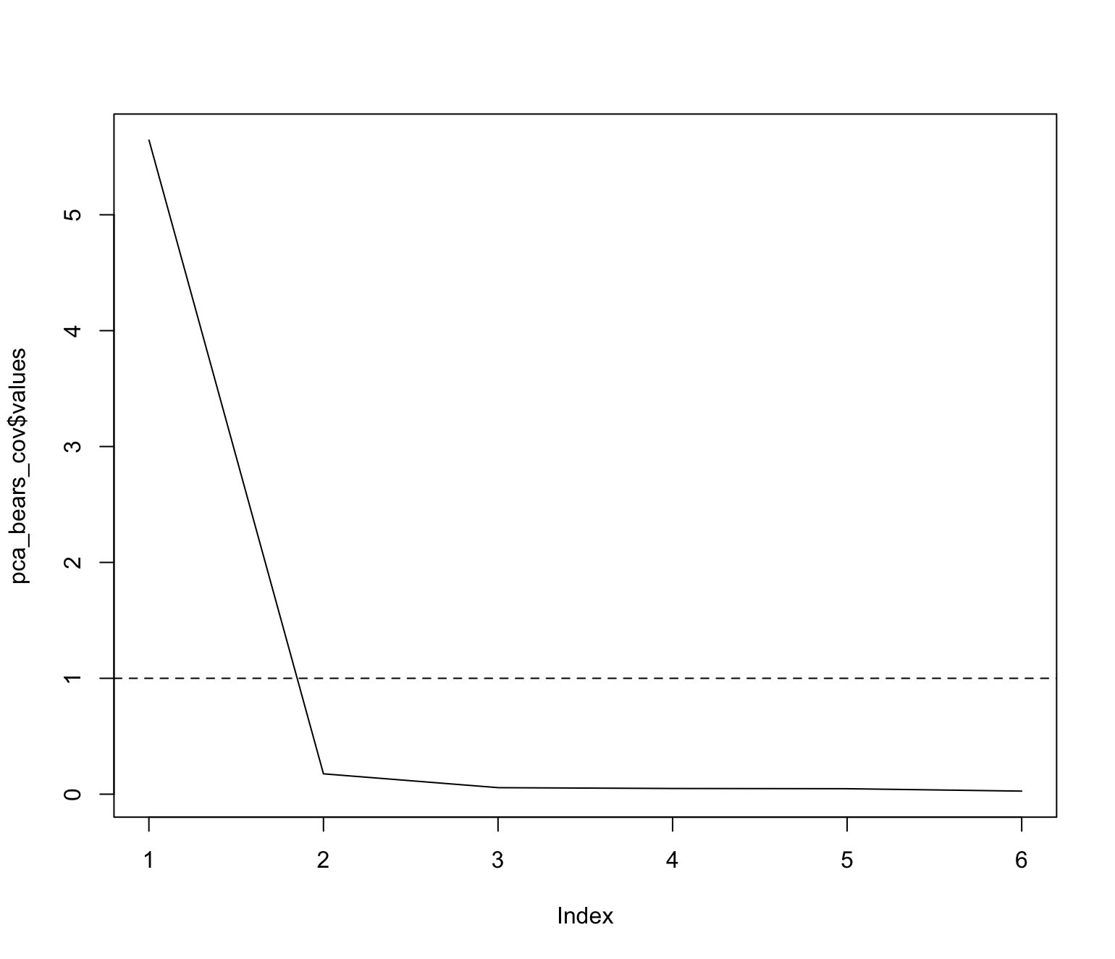

hornpa(k = 5, size = 61, reps = 500, seed = 100)

Parallel Analysis Results

Method: pca

Number of variables: 5

Sample size: 61

Number of correlation matrices: 500

Seed: 100

Percentile: 0.95

Compare your observed eigenvalues from your original dataset to the 95 percentile in the table below generated using random data. If your eigenvalue is greater than the percentile indicated (not the mean), you have support to retain that factor/component.

Component Mean 0.95

1 1.381 1.554

2 1.146 1.268

3 0.987 1.071

4 0.831 0.930

5 0.654 0.784

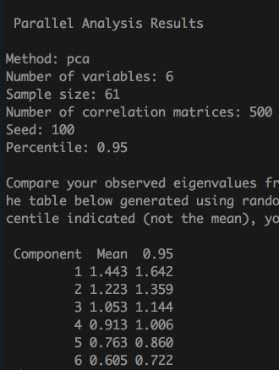

(b)

bears_cor <- cov2cor(bears_cov)

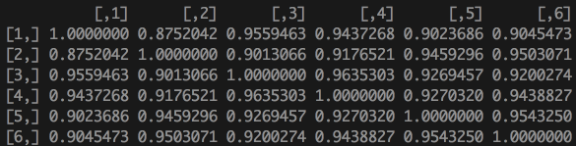

pca_bears_cor <- principal(bears_cor, nfactors = 6, rotate = "none")

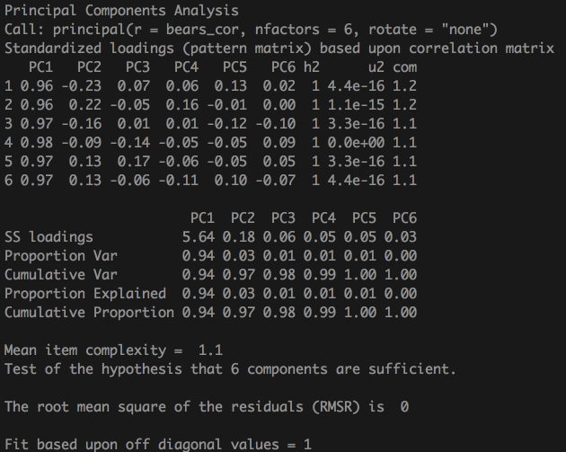

Principal Components Analysis

Call: principal(r = bears_cor, nfactors = 6, rotate = "none")

Standardized loadings (pattern matrix) based upon correlation matrix

PC1 PC2 PC3 PC4 PC5 PC6 h2 u2 com

1 0.96 -0.23 0.07 0.06 0.13 0.02 1 4.4e-16 1.2

2 0.96 0.22 -0.05 0.16 -0.01 0.00 1 1.1e-15 1.2

3 0.97 -0.16 0.01 0.01 -0.12 -0.10 1 3.3e-16 1.1

4 0.98 -0.09 -0.14 -0.05 -0.05 0.09 1 0.0e+00 1.1

5 0.97 0.13 0.17 -0.06 -0.05 0.05 1 3.3e-16 1.1

6 0.97 0.13 -0.06 -0.11 0.10 -0.07 1 4.4e-16 1.1

PC1 PC2 PC3 PC4 PC5 PC6

SS loadings 5.64 0.18 0.06 0.05 0.05 0.03

Proportion Var 0.94 0.03 0.01 0.01 0.01 0.00

Cumulative Var 0.94 0.97 0.98 0.99 1.00 1.00

Proportion Explained 0.94 0.03 0.01 0.01 0.01 0.00

Cumulative Proportion 0.94 0.97 0.98 0.99 1.00 1.00

Mean item complexity = 1.1

Test of the hypothesis that 6 components are sufficient.

The root mean square of the residuals (RMSR) is 0

Fit based upon off diagonal values = 1

plot(pca_bears_cor$values, type = "l")

abline(h=1, lty =2)

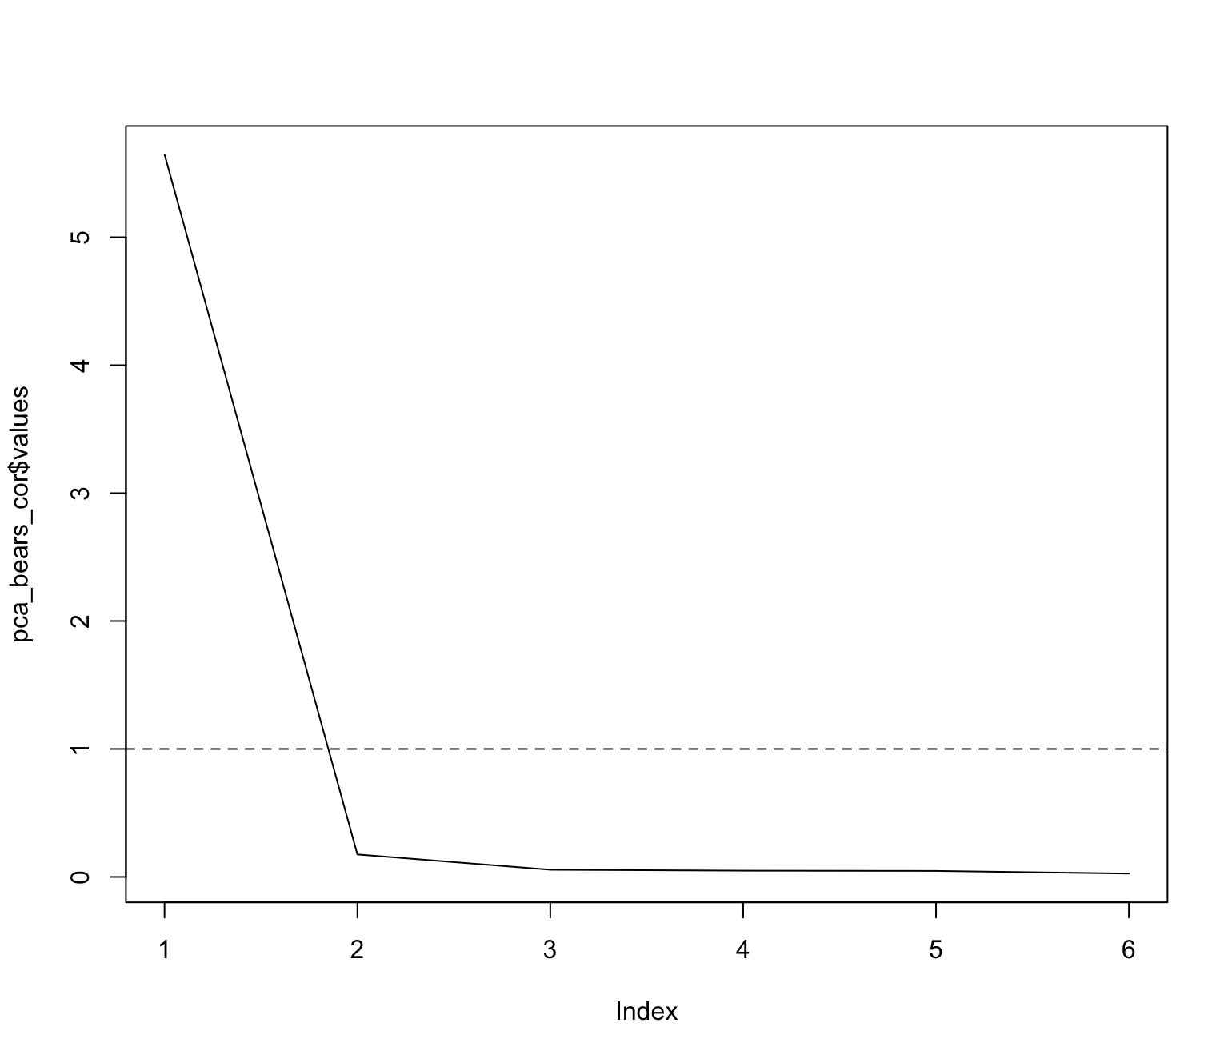

hornpa(k = 5, size = 61, reps = 500, seed = 100)

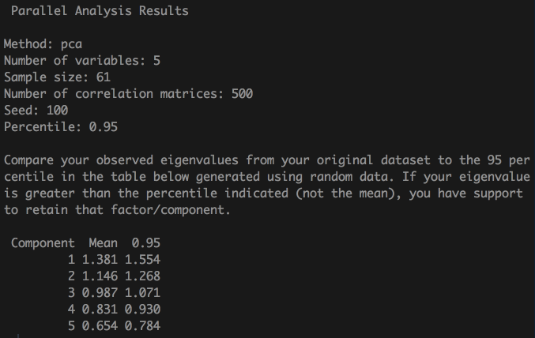

Parallel Analysis Results

Method: pca

Number of variables: 5

Sample size: 61

Number of correlation matrices: 500

Seed: 100

Percentile: 0.95

Compare your observed eigenvalues from your original dataset to the 95 percentile in the table below generated using random data. If your eigenvalue is greater than the percentile indicated (not the mean), you have support to retain that factor/component.

Component Mean 0.95

1 1.381 1.554

2 1.146 1.268

3 0.987 1.071

4 0.831 0.930

5 0.654 0.784