Software Testing
Coursework

Group 3(?)

Ben Shaw: s1368177
Chris Campbell: s1338564
Yashvir Surana: s1334028
Aseem Narang: s1338673

TASK 1: CATEGORY-PARTITION TESTING
Question 1)
Independently Testable Functions: *why are they independent?

I) replaces atomic region
Reasoning:

II) replaces composite region
Reasoning:

III) doesn’t find pattern
Reasoning:

IV) error
Reasoning:

Question 2)
i)Parameters:

Parameter Type | Parameter | Possible Values
String | inputText | Multiple characters
String | pattern | Empty, single character, multiple characters
String | replacement | Empty, one or more characters
Character | delimiter | Alphabet, numeric, special, escape
Boolean | inside | true

ii)Environment:
*something to do with Java Lang*

Question 3)
Characteristics(functional specifications that we are examining):

Patterns located within Atomic region(s) are replaced appropriately.

“spec6 - When a region is matched against the pattern, the search in that region is done in a left-to-right fashion.”

“spec5 - The escape character can be the same with the delimiter character.”

Question 4)
Partitions and Value Classes – what different values of classes do we use in order to test the characteristics + include reasoning.

Acronym | Meaning
SAR | Search and Replace
AR | Atomic Region
PAT | Pattern
REP | Replacement
EMP | Empty String
STR | String
ALPH | Alphabet
NUM | Numeric
SP | Special Character
ESC | Escape Character
*SSAR | Standard Search and Replace (1 atomic region, 1 pattern contained within atomic region)

Question 5)
Calculation of initial number of tests. (Possible values of each parameter multiplied together)
1 * 3 * 2 * 4 * 1 = 24 tests

Question 6)
We are not interested in every single possible combination of parameter combinations.
*for example, for the different possible values of delimiter, we introduce a ‘standard search and replace’ where we hold # of atomic regions constant and # of patterns to find constant.
*all we care about are the different ways of carrying out atomic region replacements?

Question 7)
(1*2) + (1*2) +(1*4) = 10

Characteristic | Partition | Value Classes | Comment
Single AR ok? | P1 | 1 PAT in AR | Search and replace with pattern contained in one atomic region
 | P2 | Multiple PATs in AR | Search and replace with multiple patterns in one atomic region
Two ARs ok? | P3 | PAT in each AR | Search and replace in two atomic regions, one pattern in each atomic region
 | P4 | Both PATs in same AR | Search and replace in two atomic regions, 2 patterns within one atomic region
Diff REP? | P5 | REP is EMP | Replacement is empty, delete pattern in atomic region
 | P6 | REP is STR | Replacement is a string, search and replace
Diff DEL? | P7 | SSAR with DEL is ALPH | Standard search and replace with delimiter as an alphabet character
 | P8 | SSAR with DEL is NUM | Standard search and replace with delimiter as numeric
 | P9 | SSAR with DEL is SP | Standard search and replace with delimiter as special character
 | P10 | SSAR with DEL is ESC | Standard search and replace with Delimiter as Escape Character

Test case Specification
Test | Specification | Partitions Covered
1
2
3
4
5
6
7
8
9
10

Question 8)

Question 9)
Actual tests chosen:

TASK 2: COVERAGE ANALYSIS

Question 1) Control flow graph (see appendices)

Question 2) Why is coverage under 90%?
The branch coverage is below 90% (i.e. ~43% because we are only testing one ITF – therefore there is a large number of branches in StringUtils that we have specifically not scrutinised/tested and intentionally left out. For example, we are not required to test parts of the code that handle empty input or the code that handles search and replaces within atomic regions. (This implies that all those branches that come under those segments and other similar segments do not get executed while using our testing suite. One can see the branches highlighted in green in the control flow graph diagram to be certain about which branches are getting taken.

Question 3) Can we improve branch coverage?
Branch coverage for the whole package can certainly be improved. For example, we could write tests for the non-main ITFs that we outlined in Task 1: replace within a composite region, doesn’t find pattern and error. The developed tests to increase branch coverage can be found in *test2.java. See appendices for evidence of improved coverage.

Question 4) Is branch coverage an adequate way to test the adequacy of test set?

In many ways, branch coverage is a crude way to test adequacy of a test set. For the scenario in Task 1, we are testing only one primary ITF (having outlined at least four), therefore we know and accept that there is functionality of the program that we are not going to test. Branch coverage does not take into account the branches which we actually aren’t interested in, but rather gives us the branches covered over the total number of branches. As a result, our reported Branch Coverage may lead us to believe that our test is less adequate than it actually is.

Our results confirm that branch coverage in general is not a good indicator of the quality of a test suite. In the experiments, more than 50% of the faults while writing the test suite were uncovered while coverage was at a plateau. One should test a program in multiple test runs to find as many faults as possible even though by doing so the branch coverage level will not be increased in general.
Question 5) Alternative coverage criterion: Line/Statement Coverage:
(number of statements called by test set / total number of relevant lines of code) * 100

Statement coverage is a code coverage method that tells you whether the flow of control reached every executable statement of source code at least once.
Although from rudimentary perspective this seems ideal but statement coverage does not adequately take into account the fact that many statements involve branching and decision-making. Statement coverage's insensitivity to control structures tends to defeat the purpose of code testing.
Statement coverage does not call for testing if-then-else statements. A simple if-then statement has no else-clause. To attain full statement coverage requires testing with the controlling decision true, but not with a false outcome. No source code exists for the false outcome, so statement coverage cannot measure it. Hence this metric is inadequate for our testing because most of our ITF and eventually method is based on simple if-then-else branching.

TASK 3: MUTATION-BASED TEST ADEQUACY

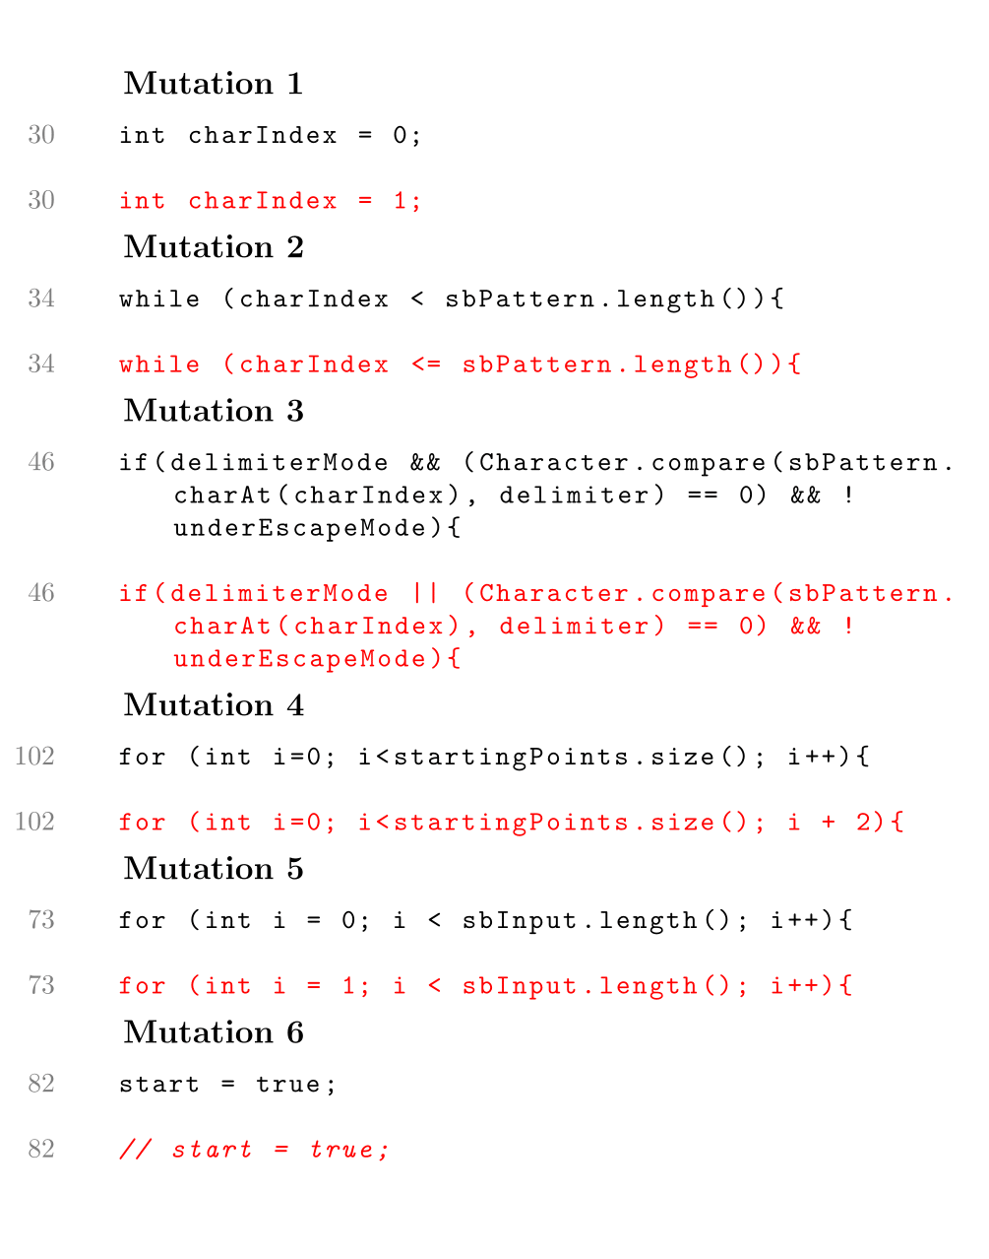

Mutation No  Test case | 1 | 2 | 3 | 4 | 5 | 6 | Mutation Adequacy
1 |  | ✓ | ✓ | ✓ |  |  | 50%
2 |  | ✓ | ✓ | ✓ |  | ✓ | 66%
3 |  | ✓ | ✓ |  |  |  | 33%
4 |  | ✓ | ✓ |  | ✓ |  | 50%
5 |  | ✓ | ✓ |  |  |  | 33%
6 |  | ✓ | ✓ |  | ✓ |  | 50%
7 |  | ✓ | ✓ |  |  |  | 33%
8 |  | ✓ | ✓ |  |  | ✓ | 50%
8 |  | ✓ | ✓ |  |  |  | 33%
10 |  | ✓ | ✓ |  |  |  | 33%

The test set fails to discover the first mutation. In this mutation we start the charIndex from 1 rather than 0. This works because in our test set we do not have a case in which the pattern match starts from index 0. Infact, we cannot make a test case that will catch the mutation/ Even if the pattern is matched in the beginning it cannot start from index 0 as the pattern has to be preceded by a delimiter as we are looking in the atomic region

The fifth mutation is caught by test 4 and 6. We can see these are the tests in which the delimiter is the first character and our mutation does not accommodate for that

The sixth mutation is caught by test 2 and 8. These are the cases in which we have multiple atomic regions. The mutation does not accommodate for that

the 2nd mutation results in an index out of bound error , thus is caught by all tests

the 3rd mutation results in an infinite loop and thus is caught by all tests as well

Appendices:

Control Flow Graph (Task 2)

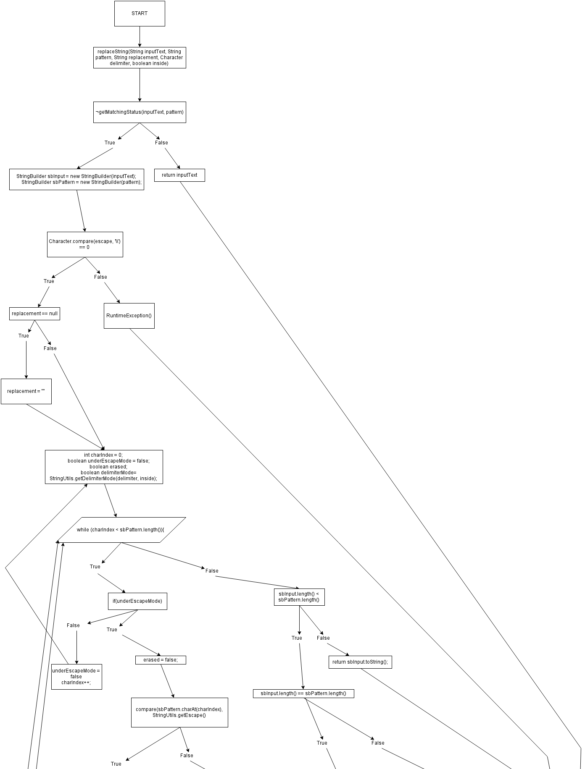

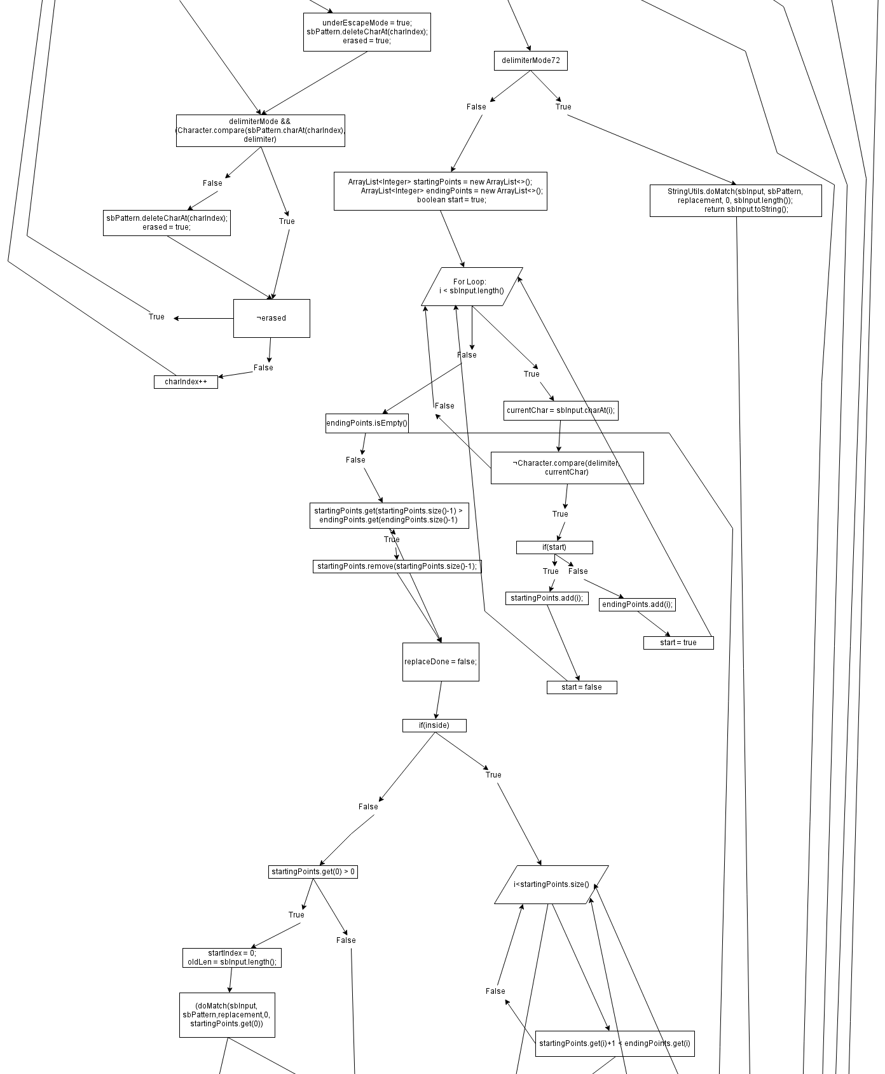

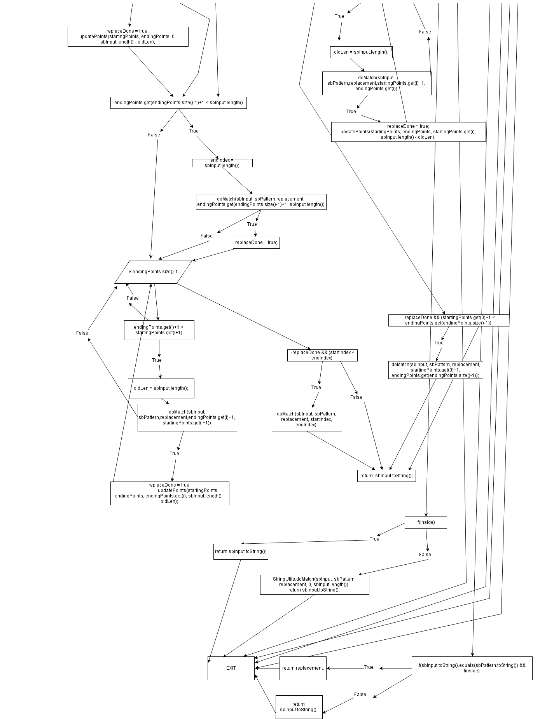
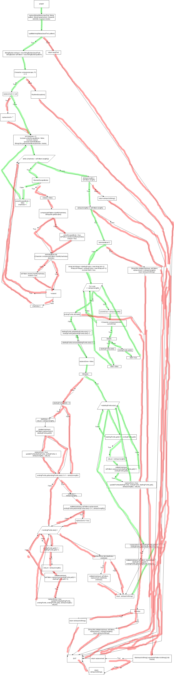

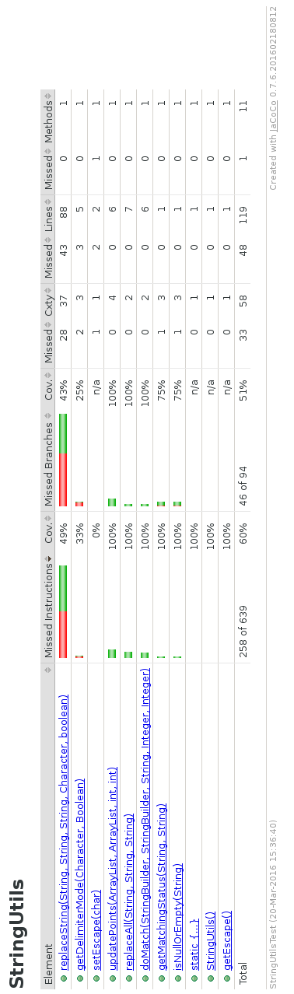
Branch coverage from test set developed for main ITF testing

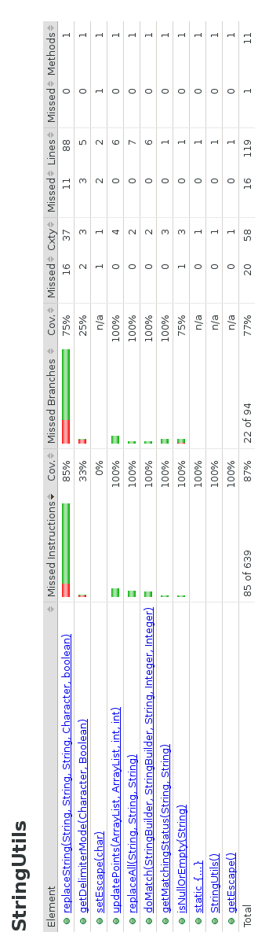
Task 2 extra tests to improve branch coverage

